

ADAA7000 Coexistent Perspectives Module

Name: Zhou Haodong
Student number: 2228352
Word Count:4000_________
Module Essay Question: This essay addresses Question 4: Time, Memory and the Archive.

- Please keep all drafts of your essay. You may be asked to produce these as evidence of your writing process.

- Please ensure you follow the AI guidance on the assessment brief and note when and how you are able to use AI.

- Please also note the guidance regarding plagerism on your assessment brief also refers to referencing the source of your material and that includes the use of AI.

For this assessment,
I confirm that I have not used Generative AI to support me in structuring my submission, including creating a draft argument structure, identifying parts and headings.
I confirm that I have not used Generative AI to create text for my submission.
I confirm that I have not used Generative AI for creative materials, such as images.

Student Signature: Zhou Haodong

Contents
Designed Memory: Time, Archive, and Non-Linear Narratives in Contemporary Visual Communication 1
University：University of Wales Trinity Saint David 1
Contents 2
Abstract 3
1. Introduction 3
2. Theoretical Framework: Time, Memory, and the Archive 4
2.1 Memory as a Social and Mediated Construction 4
2.2 The Archive and the Question of Neutrality 5
2.3 Non-Linear Temporality and Media Logic 6
3. Visual Archives and Non-Linear Narratives as Design Practice 7
4. Case Study: Hito Steyerl — Visual Archives, Image Politics, and Temporal Reconfiguration 8
4.1 Steyerl’s Practice in the Context of Visual Communication 8
4.2 How Not to Be Seen (2013): Fragmentation, Resolution, and Anti-Archival Logic 9
4.3 Archival Aesthetics and the Breakdown of Historical Authority 10
4.4 Factory of the Sun (2015): Time as an Immersive Visual System 11
4.5 Designed Memory in Steyerl’s Practice 12
4.6 Image Circulation, Compression, and the Temporal Politics of the Poor Image 12
5. Conclusion 18

Designed Memory: Time, Archive, and Non-Linear Image Narratives in Hito Steyerl and Walid Raad

Abstract

This paper will examine Hito Steyerl and Walid Raad and how archives and moving images produce non-linear narratives of memory. Memory in the contemporary age is more than just remembering the past, as it is made by images, technology, and the telling of stories. The paper will examine the role of modern image-making and the relationship of archives and non-linear time and how this produces memory. The ideas of collective memory, the archive, and the time of media will be explored as a framework for understanding how the archive is anything but an objective space. It is a designed space and has the ability to shape how we understand history and experience time. The relationship of Steyerl and her use of fractured archives, database concepts, and immersive images and how this disrupts the notion of direct, singular histories and the politics of the moving image will be explored in this paper. The role of visual communication as a translator of time and memory will be explored as the central argument of this paper, and the term “designed memory” will be introduced as a framework for understanding modern visual communication and its cultural implications.

1. Introduction

In the current media culture, time and memory are organized more by visual systems than by straight narratives. Online images and database systems are reworking the way memories are recorded, located, and remembered. Memory is increasingly delivered as images, search engines, and systems organized according to algorithms. Memory is thus a very flexible notion, always being reorganized by design and technology.

This change has implications for visual communication. Visual communication is more than just displaying information effectively, and it also shapes the way people view, notice, and understand information. Visual displays and designs control the way information is received and interpreted. Using these visual concepts to design archives and historical documents means they do more than display memory, they help to create it. Instead of the archive as the repository of truth with no bias, the archive increasingly becomes the visual system with order and meaning. The title of this work is: Time, Memory, and the Archive. This work questions: How do contemporary image-making practices shape memory through what archives look like and what non-linear narratives do to time and collective memory. This work will examine the moving image work of Hito Steyerl and Walid Raad to illustrate that memory is not only represented, it is also constituted by what archives do. Questions: What is the role of visual archives as designed systems, rather than mere documentation? What is the impact of non-linear narratives in our perception of time and collective memory? In addressing the questions, the paper will deploy theoretical notions from the fields of memory studies, archive studies, and media studies, and will apply them to the work of Steyerl. The thesis of the paper is that the role of visual communication in the creation of what can be termed as ‘designed memory’ is central.

2. Theoretical Framework: Time, Memory, and the Archive

2.1 Memory as a Social and Mediated Construction
Memory has traditionally been understood as a product of society, not just of an individual. This is because personal memory is always mediated by social norms, cultural narratives, and symbols. This is because memory is sustained through various channels, including language, rituals, and media. Visual media are among the most 、
Pictures are central to the way in which we remember events. Photographs, videos, and digital images do not simply represent the world; they frame the way in which we remember the world, promoting certain views and excluding others. By repetition and circulation, images become powerful and become the anchors for collective memory. The way in which we think about memory, from a perspective of visual communication, is a process that is governed by the principles of visual design.

This is evident in the digital world, where memory is accessed through screens. Search engines, photo galleries, and social networking sites break down memory into bits that can be located, assembled, and reinterpreted. Memory is no longer about one linear narrative but about what’s easy to locate and view through visual systems.

2.2 The Archive and the Question of Neutrality
The archive and the traditional view of the archive was that it was stable and objective, holding facts. However, the modern view of the archive rejects this. In the book Archive Fever by Jacques Derrida, the archive is associated with power and control. What is included and excluded, and the organization of the items, reflects the present, not the objectivity of the archive.

Michel Foucault recognizes that the archive is a system that determines knowledge. The archive not only functions as a storage space, but it determines what can be stated, what can be seen, and what can be remembered within a particular period of time, thereby meaning that the archive determines the historical narratives that can be constructed.

The archive in visual communication is also connected to its visuality. The choice, placement, ordering, and display of images impact the meaning of the archive. The visually organized connection between images and occurrences determines the interpretation of images and the concept of time. This means that archives are more like stories rather than mere histories.

2.3 Non-Linear Temporality and Media Logic

The conventional way of writing history is by using the straight line of time from the past to the present. This is challenged by Walter Benjamin when he states that history is made up of interruptions and breaks.

In the current digital culture, non-linear time is reinforced. Lev Manovich describes “database logic,” where digital media organize information according to space, not order. In databases, the emphasis is on searching for information and navigating it, rather than maintaining the integrity of one narrative. Time itself is visualized as an organization that you can surf and rearrange.

This is very significant when it comes to memory. Non-linear time erodes fixed stories of history and permits multiple interpretations to co-exist. In image-making, non-linear stories enable memory to evade fixed interpretation and create room for alternative models of remembrance. Through fragmentation, repetition, and editing, image-making practices transform time into an experience that is constructed and lived.

3. Visual Archives and Non-Linear Narratives as Design Practice

The role of archives today is more like the use of visual design systems rather than mere warehouses of “old” content. It is the way content is organized, both in visual design and access, that determines the experience of memory. Visual communication becomes “time design” to control the view of the past from the perspective of the present. One of the most important aspects of the archives is the use of non-linear narrative. Rather than taking the viewer through a linear story line, the archives offer information in a fragmented form which can be followed in a variety of different directions. This is a challenge to the dominance of the linear form of history and the realization that memory is a construct. Design-wise, non-linear narratives change the role of the audience. The audience is not only consuming information but creating it by navigating. The interactive element is very apparent in digital archives, where the system is designed to be browsed and searched. Memory in this instance is not static but an interaction with an image system. The visual archive therefore becomes a site wherein time becomes visible within space. Events from the past coexist within the same visual field, allowing different times to be simultaneously felt. These thoughts express the trend towards knowledge based on databases and reinforce the idea that memory is both recalled and constructed through visual communication practices.

4. Case Study: Hito Steyerl — Visual Archives, Image Politics, and Temporal Reconfiguration

4.1 Steyerl’s Practice in the Context of Visual Communication
The work of Hito Steyerl is at the significant juncture of the current visual culture. It examines the movement of the image, the depreciation of the image, and the use of the image for political ends in the current digital culture. Although people associate the work of Hito Steyerl with the art world, it also has implications for visual communication because it examines mediation, interface design, and the functioning of visual systems. Steyerl usually adopts the aesthetics of instructional videos, surveillance videos, video games, and online platforms. She adopts these aesthetics to demonstrate how the image acquires power and defines our vision.
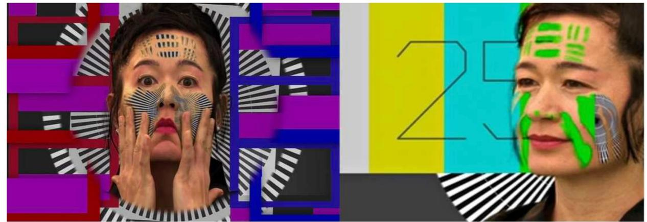
Figure 1. Hito Steyerl, How Not to Be Seen. A Fucking Didactic Educational .MOV File (2013), film still. Image courtesy of Eye Filmmuseum.
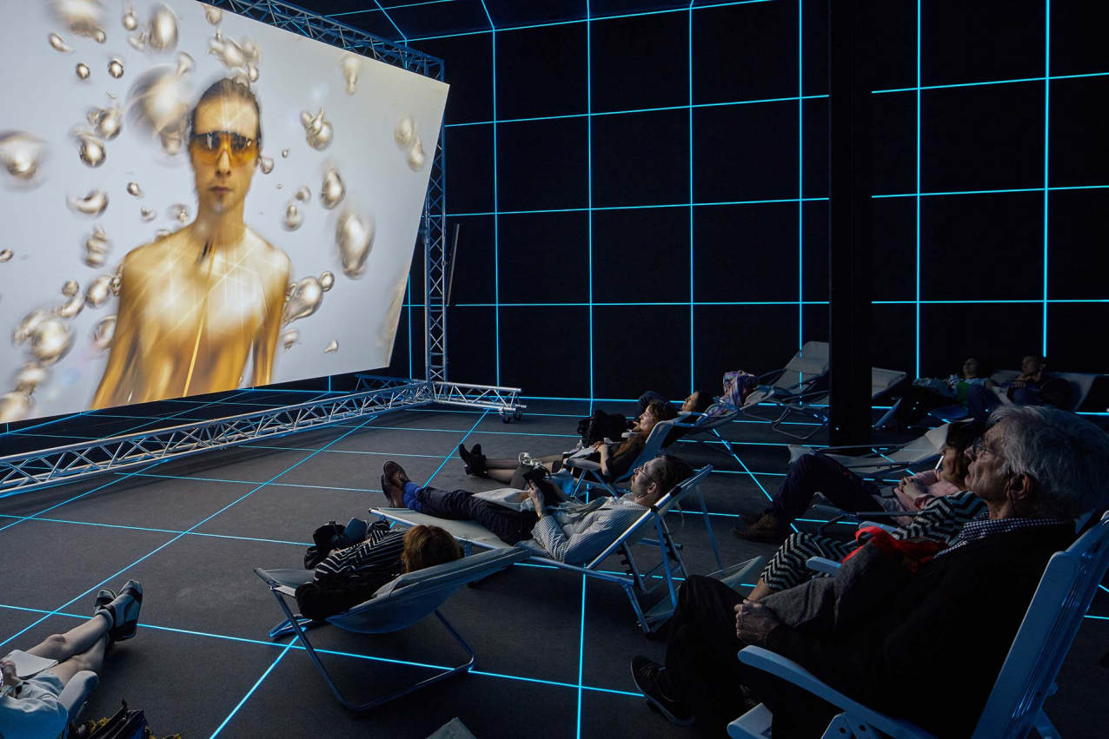
Figure 2. Hito Steyerl, Factory of the Sun (2015), installation view, Venice Biennale. Image courtesy of NGV.
The work of Hito Steyerl is at the significant juncture of the current visual culture. It examines the movement of the image, the depreciation of the image, and the use of the image for political ends in the current digital culture. Although people associate the work of Hito Steyerl with the art world, it also has implications for visual communication because it examines mediation, interface design, and the functioning of visual systems. Steyerl usually adopts the aesthetics of instructional videos, surveillance videos, video games, and online platforms. She adopts these aesthetics to demonstrate how the image acquires power and defines our vision.

An important aspect of Steyerl’s practice is the use of archives. Steyerl conceives of archives not as fixed and clear documents, but as something that is fragmented, unstable, and politicized. Steyerl achieves this by using non-linear editing techniques and layering images to create living systems that cannot be easily resolved or interpreted.

4.2 How Not to Be Seen (2013): Fragmentation, Resolution, and Anti-Archival Logic

How Not to Be Seen: A Fucking Didactic Educational .MOV File (2013) is a very influential piece by Steyerl, as it illustrates how she employs non-linear storytelling as a means of critiquing visual archives. The piece takes the form of an educational video, a “lesson” on invisibility that takes place within a world of digital surveillance, a world that has been over-saturated by imagery.

The images derive from an eclectic archive, which includes resolution test charts, military training footage, computer-generated images, performances shot against a green screen, and low-resolution videos. The different elements of the archive are joined by means of sudden cuts and jumps, so that there is no story to be made out. Rather than meaning, the archive becomes a space of confusion and contradiction.

From the aspect of visual communication, the project raises questions about the relationship between resolution and visibility. Resolution charts, designed to standardize images, are reproduced as symbols that demonstrate how visibility is managed. High-resolution images are linked with surveillance and control, and low-resolution images are associated with the space of resistance and disappearance. Therefore, the archive is not just an objective accumulation of images but a means by which we are controlled in what we are able to see and remember.

In terms of time, “How Not to Be Seen” is not a straight line. The instructions go back and forth and are interrupted by “visual tangents.” Time is a series of loops rather than a story. This reflects the way the digital archive functions. We “access information through repetition and retrieval rather than through a story.” This is because “memory is a flux rather than a story.”

4.3 Archival Aesthetics and the Break of Historical Authority

The notion of the fragmented archive in _How Not to Be Seen_ reduces the power of the archive. Steyerl combines documentary footage with the constructed footage to blur the fact and the construction in the footage. This indicates that the constructed footage in the archives derives its meaning not from the footage itself, but how it is presented.

The images support this concept. Green-screen effects, low res graphics, and deliberately artificial design allude to the construction of the world of images. Steyerl’s work reveals the mediation process, encouraging the viewer to wonder if images can ever be trusted as history.

This project illustrates the ways in which non-linear storytelling is a valuable resource in visual communication. By fragmenting the concept of time and demonstrating the way in which visual systems function, it calls into question the conventions that exist regarding the representation of history.

4.4 Factory of the Sun (2015): Time as an Immersive Visual System

How Not to Be Seen focuses on broken and unstable images from archives, while Factory of the Sun (2015) expands on how time and memory coexist in immersive environments of vision. The work is a video installation that combines elements of documentary footage, video game images, motion capture, and performance.

Visually, it’s as if it’s a game world where the viewers are inside the digital world. There’s glow-in-the-dark grids, motion capture artists, offices, and Forced Labor/Surveillance. All these elements aren’t put together in one narrative but all exist together inside the constantly shifting visual field. The time element isn’t about the narrative but about the experience.

From the point of view of visual communication, *Factory of the Sun* is more like an interface than an average film. The design is meant to guide your movement, your gaze, and your focus, so that time becomes space. Memory is not something you remember afterwards; memory is made while you are moving through the system of images.

The article also connects the creation of images to work and power. The motion capture artists create data from their actions, and there seems to be an implication that time, labor, and presence are being tapped and utilized. Therefore, the archive is not only about the past, but there seems to be an ongoing process of extracting and disseminating. Images are both documents and commodities, and there seems to be an blurring of lines between documenting and creating. In terms of time, _Factory of the Sun_ employs non-linear storytelling. Scenes are looped and overlapped. This is appropriate because the nature of digital media is such that content is constantly refreshed. Hence, history is made shallow and immediate. This is what is being expressed by the non-linear nature of the storytelling. Memory is always and is always immediate.
4.5 Designed Memory in Steyerl’s Practice Taken
Collectively, How Not to Be Seen and Factory of the Sun illustrate Steyerl’s rethinking of the archive as a designed visual system. Steyerl’s work contests the notion of the archive as a neutral entity and emphasizes instead the technical, political, and aesthetic conditions of image movement. Steyerl uses fragmentation, repetition, and immersive design to create non-linear experiences of time that contest canonical histories. In Steyerl’s artworks, memory is not a fixed image of the past but is instead constantly formed by visual communication networks. Images are not stable, degraded, and on the move; archives are incomplete and contentious; time is not continuous and linear but expansive. These characteristics define what this paper will call “designed memory,” or memory that is intentionally created through visual means.
4.6 Image Circulation, Compression, and the Temporal Politics of the Poor Image
One of the most influential concepts introduced by Hito Steyerl is that of the poor image, a term she uses to describe low-resolution, compressed, and degraded digital images that circulate rapidly across online platforms. While often dismissed as inferior or disposable, poor images play a crucial role in Steyerl’s critique of contemporary visual culture. From the perspective of visual communication, the poor image offers a critical framework for understanding how memory, time, and archival value are reshaped under conditions of digital circulation.
In traditional archival systems, image quality is closely associated with authenticity, authority, and historical value. High-resolution images, preserved in institutional archives, are treated as reliable documents of the past. By contrast, poor images—compressed, copied, and re-uploaded countless times—appear unstable and detached from original contexts. However, Steyerl argues that it is precisely this instability that gives poor images political and temporal significance. Poor images are not fixed historical records; they are dynamic traces of circulation, labour, and transformation over time.
Within Steyerl’s practice, poor images function as an alternative archive that challenges the hierarchy of visual value. Rather than preserving the past through stable representation, this archive records the movement of images through networks, platforms, and users. Memory, in this sense, is no longer anchored to origin or authenticity but emerges through circulation and repetition. Time is inscribed not as linear chronology but as layers of compression, degradation, and redistribution.
From a visual communication perspective, this shift has profound implications. Design decisions related to resolution, format, and platform compatibility directly affect how images circulate and how long they persist within cultural memory. Steyerl’s work foregrounds these decisions, exposing how technical standards and interface design participate in the construction of memory. The poor image becomes a visual marker of temporal acceleration, reflecting a culture in which images are consumed, forgotten, and replaced at increasing speed.
This temporal instability is evident in How Not to Be Seen, where resolution charts are repeatedly referenced as both technical tools and symbolic devices. Resolution functions not merely as a measure of visual clarity but as a threshold of visibility and control. Images that fall below certain resolution standards become invisible to systems of surveillance and data extraction, while high-resolution images are absorbed into regimes of monitoring and commodification. In this context, time and memory are regulated through visual quality: what is clearly visible is recorded and archived, while what is degraded risks disappearance.
Steyerl extends this critique in Factory of the Sun, where images are produced through motion capture and transformed into data streams. Here, image quality is no longer tied to optical realism but to computational value. The archive becomes a continuous process of extraction rather than preservation. Images do not represent past events; they generate data in real time. Memory is therefore displaced from historical reflection to ongoing production, collapsing the distinction between past, present, and future.
The circulation of poor images also disrupts conventional temporal hierarchies within archives. In traditional historical narratives, the past is positioned as distant and complete, while the present functions as a moment of interpretation. Poor images collapse this distance. Because they are constantly reactivated through sharing and remixing, they exist in a state of perpetual presentness. This condition aligns with what Steyerl identifies as a flattening of historical time within digital culture, where events from different periods coexist within the same visual field.
This flattening has direct consequences for collective memory. When images circulate without stable context, historical specificity becomes blurred. However, Steyerl does not interpret this as a simple loss of meaning. Instead, she frames it as a transformation of memory from a linear narrative into a networked process. Memory is produced through association rather than chronology, through connection rather than sequence. From a visual communication standpoint, this suggests a shift from narrative-based design to system-based design, where meaning emerges through interaction rather than storytelling.
Steyerl’s emphasis on circulation also foregrounds the role of labour in the production of memory. Poor images are not accidental by-products of digital culture; they are the result of economic and technological conditions that prioritise speed, accessibility, and scalability. Compression algorithms, platform standards, and user behaviours all contribute to the degradation of images. These processes embed labour—both human and machinic—into the visual archive. Time is thus not only represented but expended, extracted, and exploited.
In this sense, designed memory is inseparable from political economy. Visual communication systems determine which images circulate widely and which disappear, shaping collective memory through infrastructural design. Steyerl’s work exposes this process by refusing aesthetic refinement and embracing visual instability. Her use of poor images resists the archival impulse to stabilise and monumentalise history, instead presenting memory as contested, mobile, and unresolved.
Crucially, Steyerl’s approach challenges designers to reconsider their role in shaping temporal experience. If image quality, format, and circulation speed influence how memory is formed, then visual communication is deeply implicated in the politics of time. Design choices are not neutral technical decisions but interventions into how history is recorded, accessed, and remembered.
4.7 Walid Raad: Fictional Archives and the Politics of Evidence
While Steyerl foregrounds the circulation of images within digital networks, Walid Raad approaches the archive through fabrication, speculation, and narrative displacement. Working under the name The Atlas Group, Raad produces documents—photographs, notebooks, videos, and reports—that mimic archival material while intentionally destabilising the boundary between record and invention. This strategy reframes the archive not as a neutral repository but as a contested medium through which history is produced, authorised, and remembered.
From the perspective of visual communication, Raad’s practice emphasises the designed conditions of credibility. Typography, formatting, bureaucratic language, and documentary conventions operate as visual codes that signal truthfulness. By reproducing these codes while introducing fictional or uncertain content, Raad exposes how archives rely on design to appear objective. Memory, in this sense, emerges through institutional aesthetics: what looks like an archive becomes believable, and therefore memorable, regardless of its factual status.
Temporally, Raad constructs non-linear histories by rearranging sequences, withholding context, and layering multiple temporal registers within a single ‘document’. Rather than presenting time as a linear progression, his works stage history as a set of interruptions and returns—an unstable chronology shaped by conflict, trauma, and political narration. This resonates with Derrida’s argument that the archive is haunted by what it excludes and by the future it anticipates, suggesting that archival time is always deferred and incomplete.
Raad’s fictional archiving can also be read as a form of resistance. Where dominant archives marginalise or erase certain histories, the creation of alternative—or even invented—archives becomes a way to reveal the violence of official memory. At the same time, this approach raises ethical questions about evidence and authority: if the archive can be convincingly designed, then historical truth becomes vulnerable to manipulation. In the contemporary media landscape, where misinformation and platform circulation shape what counts as ‘evidence’, this tension becomes especially urgent.
Comparatively, Steyerl’s ‘poor image’ emphasises how platforms flatten historical context through speed, repetition, and loss of resolution, producing a present-tense archive governed by circulation. Raad, by contrast, focuses on how institutional visual codes manufacture credibility, revealing that archival authority is itself a design effect. Together, they suggest that non-linear temporality is not only an aesthetic choice but a political condition: time is shaped by systems of access, visibility, and validation.
Through her engagement with poor images, Steyerl articulates a model of the archive that is fundamentally non-linear and anti-hierarchical. Memory is no longer organised according to institutional authority or chronological order but through networks of circulation and use. Time becomes a variable condition shaped by technological mediation rather than a stable historical framework.
This essay has examined how contemporary visual communication practices design memory by shaping archival time and producing non-linear narratives, responding to Question 4: Time, Memory and the Archive.
Through a comparative analysis of Hito Steyerl and Walid Raad, the essay has shown two distinct yet complementary approaches to archival politics. Steyerl demonstrates how fragmentation, database logic, and image circulation transform memory into a networked and unstable present, while Raad reveals how documentary aesthetics and archival formats manufacture authority and thereby condition what can be remembered.
The concept of ‘designed memory’ proposed in this essay underscores that memory is constructed through visual systems—ranging from platform circulation to institutional archival codes. Recognising these mechanisms is essential for visual communication practitioners, as design decisions can reproduce dominant historical narratives or open space for alternative temporalities and critical remembrance.
The analysis of Steyerl’s work highlights the broader implications of designed memory for contemporary visual communication. Design decisions—such as image selection, narrative structure, and interface organisation—play a decisive role in determining how history is perceived and remembered. Far from being neutral, these decisions reflect power relations embedded within technological and cultural systems.
Non-linear narratives function as critical tools within this context. By disrupting chronological continuity, they expose the constructed nature of historical narratives and challenge dominant modes of representation. At the same time, non-linearity enables alternative forms of memory to emerge, particularly those that resist institutional or official histories.
For visual communication designers, this raises important ethical and political questions. If design participates in the construction of memory, then designers assume responsibility for how time and history are represented. Visual communication becomes a site where cultural memory is negotiated, contested, and reimagined.

5. Conclusion
This essay has examined how contemporary visual communication practices design memory through archival strategies and non-linear temporal structures. Drawing on theories of collective memory, archive studies, and media temporality, and through an in-depth analysis of Hito Steyerl’s work, the essay has argued that archives function as designed systems rather than neutral records of the past.
Steyerl’s visual practice demonstrates how fragmentation, database logic, and immersive design reshape temporal experience and challenge linear historical narratives. Her works reveal memory as an active and contested process shaped by visual, technological, and political conditions.
The concept of “designed memory” proposed in this essay underscores the critical role of visual communication in shaping historical consciousness within contemporary culture. As digital technologies continue to transform how time and memory are mediated, visual communication will remain central to the politics of remembering and forgetting.

References
Adriaansen, R.J. (2025) ‘Review: Collective memory and social media’, Current Opinion in Psychology, 60, 101893. Available at: https://www.sciencedirect.com/science/article/pii/S2352250X25000909 (Accessed: 14 January 2026).
Agnese, R. (2022) ‘Archival reenactment and the role of fiction’, in Critique in Times of Crisis. Available at: https://press.ici-berlin.org/doi/10.37050/ci-21/agnese_archival-reenactment.pdf (Accessed: 14 January 2026).
Assmann, J. and Czaplicka, J. (1995) ‘Collective memory and cultural identity’, New German Critique, 65, pp. 125–133. doi:10.2307/488538.
Bollington, L. (2025) Citational Media: Counter-Archives and Technology in Contemporary Video. Doctoral thesis. University College London. Available at: https://discovery.ucl.ac.uk/10209034/1/Citational%20Media.pdf (Accessed: 14 January 2026).
Callahan, S. (2024) ‘When the dust has settled: what was the archival turn, and is it still turning?’, Art Journal, 83(1), p. 74. doi:10.1080/00043249.2024.2317690.
Eichhorn, K. (2013) The archival turn in feminism: outrage in order. Philadelphia: Temple University Press.
Hobson, W.K. (2004) Review of Prosthetic memory: the transformation of American remembrance in the age of mass culture, by A. Landsberg, History: Reviews of New Books, 33(1), pp. 10–10. doi:10.1080/03612759.2004.10526373.
Kenny, M.G. (1999) ‘A place for memory: the interface between individual and collective history’, Comparative Studies in Society and History, 41(3), pp. 420–437. doi:10.1017/S0010417599002248.
Koivunen, A. (2016) ‘Affective historiography: archival aesthetics and the temporalities of televisual nation-building’, International Journal of Communication, 10, pp. 5270–5271.
Kunzru, H. (2021) ‘Easy chair: rich image, poor image’, Harper’s Magazine, 343(2058), pp. 5–7.
Martín Prada, J. (2025) ‘AI-based generative image production systems in the artistic sphere: an analysis of new creative practices’, AI & Society. Available at: https://link.springer.com/article/10.1007/s00146-024-02163-z (Accessed: 14 January 2026).
Wasielewski, A. (2023) ‘Authenticity and the poor image in the age of deep learning’, Photographies, 16(2), pp. 191–210. doi:10.1080/17540763.2023.2189158.
Wiehl, A. (2016) ‘Database aesthetics, modular storytelling, and the intimate small worlds of Korsakow documentaries’, NECSUS: European Journal of Media Studies, 5(1), pp. 177–197. doi:10.25969/mediarep/3331.

