
Skills for the Workplace
Module Assignment Submission
Student Name: | Tina Webb
Student Number: | 1910813
Module No: | BMSK 5001
Module Title: | Developing Workplace Critical Thinking

Statement of Confirmation of Authenticity
By the act of making this submission, the student declares that this is the work of the student named above. The work has not, in whole or in part, been knowingly presented elsewhere for assessment, or where assessment has been built on a previous assessment, this has been identified. Where materials have been used from other sources it has been properly acknowledged. If this statement is untrue, the student acknowledges that an assessment offence has been committed.
Attention is drawn to the plagiarism and unfair practice policies of both the University and of ILM.
Permission for ILM to use this script
ILM uses learners’ submissions – on an anonymous basis – for assessment standardisation. By submitting, both the centre and the learner agree that ILM may use this script on condition that identifying information is removed. However, if you are unwilling to allow ILM use this script, please refuse by ticking the box: □

Table of Contents
Introduction 3
My own, beliefs, values, and attitudes within my own workplace. 3
1.0 Beliefs 3
1.1 Values 4
1.2 Attitudes 5
1.4 Behaviours 6
2.1 Fredrick Taylor 9
Break down assignments into subtasks 11
Delegate responsibilities and train workers 11
Monitor performance 12
Allocate work between managers and employees 12
Maslow’s Hierarchy of Needs 12
conclusion 15
References 16
Appendix 1 20

Introduction

This assignment will be looking at the different managers, their beliefs, attitude, and values which effect their behaviour which can impact the behaviour of employees within the company and in my working environment. Aswell as giving insight on what’s happening how it affects you and others. Also, we will look at how our own Beliefs, Attitudes, Values, come into prospective in line with own behaviours, also looking into the management critical thinking theories, these will be aligned with two people Maslow management and his way of working with the people he has employed, what he valued what his beliefs were and his attitude towards them. Which showed in his behaviour towards them this will be based upon the three keys to critical thinking using the Pearsons RED model (Recognize Assumption Evaluate Arguments Draw Conclusion) the other will be Fredrick Taylor Scientific management controlling efficiency, we will be looking at their differences if any.

My own, beliefs, values, and attitudes within my own workplace.

1.0 Beliefs
The beliefs that I have within my workplace is having the confidence in speaking the truth and believing that any idea for which a person holds to be true. Also having to focus on the details that the client is giving me which will be the instructions to carry out a service, for a certain type of ceremony that they wish to have for their loved ones. Which involves attention to detail for their last wishes which will be treasured memories of the celebration of the life that their loved ones once knew. This is carried out with dignity and care and with the upmost respect, from the moment that the client first comes in through the door to the last stage of the ceremony. I personally believe that each one of us are all equal, there should be no such thing as anyone being labelled by their race or their wealth or their social class and not forgetting their gender. To me we are all the same, “religion” is something which is very personal to each one of us, something which connects us all to each other this in turn makes us all a better person. Our beliefs will give us the strength to carry on with our duties despite any hardships in between, it teaches each one of us the right way to lead our lives which means having the patience, respect, and kindness towards other people. If followed in the right way, it gives you knowledge, inner strength and peace, a sense of faith, happiness. Our beliefs, values and attitudes will show how each one of us how our behaviour will be represented.

1.1 Values
My values within my workplace are important for me as an individual, they are essential to myself and others and within the different communities with the religion of other people that live around us. I am one that likes a system which reflects the kind of person that I am within my working environment, I like my workplace to be clean and tidy especially with the environment that I work in. Personal standards of behaviour are very high in life, you may often meet people who will violate their personal standards to meet their own needs. This can sometimes mean the job that they have chosen may not be suitable for them, however, valuing yourself is about being able to recognize the experience that we have in this world which begins with each one of us. When we begin to recognise our values, we will start to become the person that we want to be, and not what someone else wants us to be. The values that we all have are the things that you believe are important to each one of us in the way that you want to live your life and the work environment you choose to be in. Our values (should) then determine how we prioritise what is important to each one of us and what is not important, they will probably be the measures that you take to tell if your life is turning out the way that you want it to. A belief will then develop into a value when the person’s commitment begins to grow and then you start to see as this is being important to you, beliefs can be put into different types of categories of values, this can include happiness the success of your career or wealth. You as a person must make your values clear, and to be responsible and be reliable upon making decisions.
.

1.2 Attitudes
The attitude that I have within my workplace is a very positive one, my expectancy is to succeed rather than fail. This will determine how far I get in life, so being positive with myself gets me through everyday life and every obstacle that I face. Whether it will be at work or at home I try and turn a negative into a positive. I know that this is important in within my working role myself and my co-workers need to get along to have things running smoothly within the company we all have our roles to play and the clientele that we have to deal with every day, to maintain a positive attitude is a duty of care, controlling attitude when going to work, it is very important to remember and any kind of issues or problems there may be among the team or work-related can be addressed only being positive towards everything you face, if I don’t know the answers then I will find someone that can help me achieve it, so that I can make sure that I give the correct information out to the clients It seems like the importance of a positive attitude would be obvious, but it's so easy to become consumed with our own thoughts and dramas. In those times, whether you're going through a hard time or one of your co-workers is, you must try to keep the negativity at bay. As said by Deborah Sweeney, CEO of My Corporation. "You feel better when you have surrounded yourself with the positive people. They encourage all to reach for the stars, for us to work hard and always try to stay focused on fulfilling all our dreams. Over time, you may find that even the most stubborn person in the office who refuses to enjoy and join in with the rest of the team they something have a change of heart and make changes to try and be more positive, all because you had such a great attitude. I will always try to encourage my team members to try and remember that everyone is trying their best. No one wants to wake up in the morning with the feeling that am I going to mess up today so please give some consideration and ability to help others when needed’’. Sweeney, D, (2022).

1.4 Behaviours
Everybody’s behaviours are different they represent who we are, and how we act on different things in our lives. How everyone acts with their attitude on meeting different people, and the way that we all conduct ourselves in different manners. Below there are a list of things that we base our behaviours on, all these then represent our values attitudes and our beliefs.

1 manner
2 actions
3 ways
4 performances
5 working

The behaviours that we have we tend to be on autopilot with our habits. These habits - like nail-biting, hitting the alarm snooze button in the morning, compulsively checking the phone, or always thinking about our response and not listening to the other person speaking. Habits are the hardest behaviours to change. Our behaviours are only the tip of the iceberg. They are influenced by our Attitudes: everybody will have different behaviours. Ministry of business, (2021).

The diagram below shows the relationship between beliefs, values, and attitudes and how this influences behaviour.
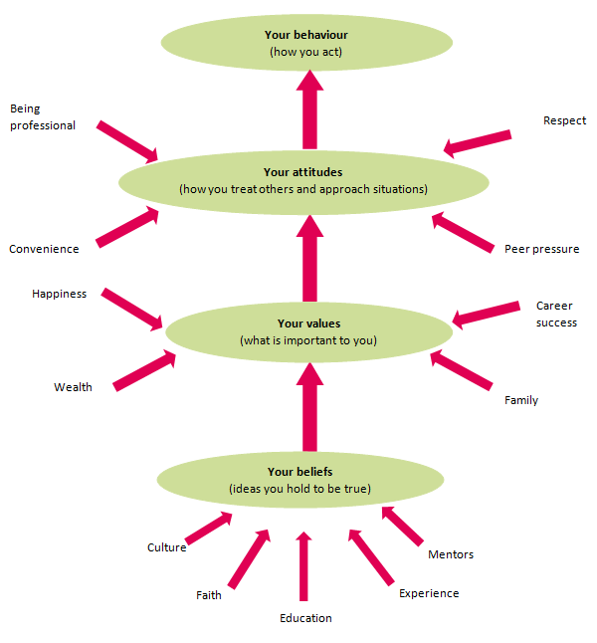

Image source: (Ministry of business. (2021).

The diagram below (diagram 2) shows us how the relationships from our personality, values, and our attitudes which all lead to the way that we behaviour.

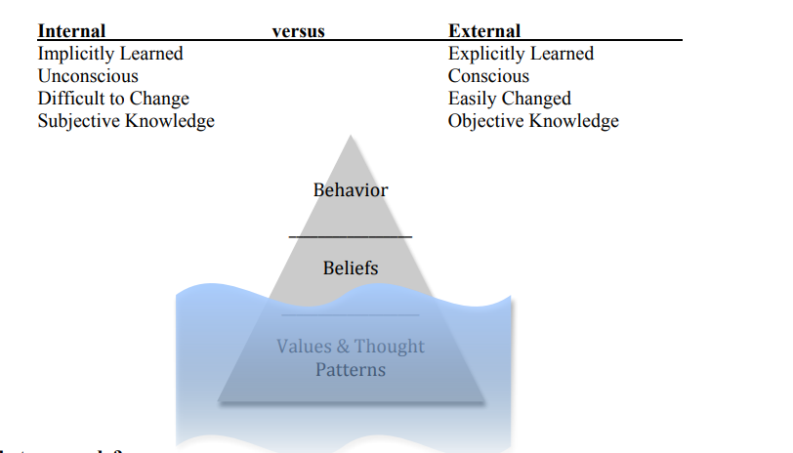
Diagram 2

Source: Beyond Culture (1976) by Edward T. Hall.
2.0
In my place of work, there are managers who are placing a negative vibes, what I mean by that is, they tell you they want out of this working environment, and that they have had enough, when we as employees hear this day in day out, it can start to bring you down to their level way of thinking, changing your prospective to the job you have taken and your performance of the work that you do can be impacted, it makes me de-value the position I have taken on because of the attitude and behaviour being past to me from them, but fortunately for me I have beliefs that I can change all the negativity which is being past to me, and my behaviour will shine through to accomplish the job I am enjoying, I feel they need to go and seek something else for their time here as a manager has past. Their values for the job they performed and once loved to have has come to an end, therefore their attitudes are to try and put people off enjoying the job they do, their beliefs are none anymore in the position they hold, so their behaviours change for the worse, they only stay in this position for the money and nothing else matters to them. The impact of this coming from management who supposed to be leading you through your role supposed to be leading you with example, on the employee side of things this would be confusing and disheartening, some employees have left after a short time of being here, they couldn’t except all the negativity from the management it was pulling them down day by day, this meant that once there was a strong workforce of good employees who valued their positions, dwindled down just to a few of us that’s left, now as far as the business growth, they have to either take on board to work out what the problem is with the management or they will continue to lose staff which will cause more expense to the company financially they will become at a loss due to their managers. Below I have put a SWOT graph to show how I have worked out the problem within the company I work for, firstly the managers have null shown strengths to perform for the company anymore to succeed, what they once showed in themselves has dwindled away, they don’t see any opportunities for themselves in their current job roll, no further climbing up the ladder ‘so to say, nothing else for them to achieved, they feel, they are week when it comes to decisions making so they just decide to put people off when they are new, employed by the company with their disheartening words, they seem to be threatened by the intake of new employees within the company. It’s a belief that they value the money side of the job and not their roll anymore, For these managers they need to identify when they last felt good with themselves in their job rolls, it is a lifelong exercise to be able to make the correct choices in life and to be confident in doing so, they may feel stress and conflict whilst in work and they don’t do their job correctly, so the impact of these managers to the employee is that the quick turnover of staff is costing the company financial stress, to which the employees are leaving frequently, this has a big impact on all those new employees, which were given the chance to become someone in this industry, doing something they would love to do, this job takes a certain person, it’s not everyone’s choice of employment. Below is explaining Fredrick Taylor on his own management theory.

2.1 Fredrick Taylor

Scientific Theory his own management theory. Taylor, (1911).

Taylor Management scientific theories were that he valued power and money over people, he worked his employees to the bone knowing he had all the control to say and do whatever he wished. His turnover of staff was high and very frequent, so his attitude was that he knew that he could get someone else to replace you, employees were just a number to him, and it was all about the profit that he was able to make. Taylor believed that if you were not fast enough to the job properly you would be out of the job, all of this reflected on his behaviour if he made money it didn’t matter about the employees that were working for him. Taylor's philosophy focused on the belief that making people work as hard as they could was not as efficient as optimizing the way the work was done. In 1909, Taylor published "The Principles of Scientific Management." In this, he proposed that by optimizing and simplifying jobs, productivity would increase. Taylor believed that all workers were motivated by money, so he promoted the idea of "a fair day's pay for a fair day's work." In other words, if a worker didn't achieve enough in a day, he didn't deserve to be paid as much as another worker who was highly productive. Ward,(2021).

Taylor's four principles are as follows:

- Replace working by "rule of thumb," or simple habit and common sense, and instead use the scientific method to study work and determine the most efficient way to perform specific tasks.
- Rather than simply assign workers to just any job, match workers to their jobs based on capability and motivation, and train them to work at maximum efficiency.
- Monitor worker performance and provide instructions and supervision to ensure that they're using the most efficient ways of working.
- Allocate the work between managers and workers so that the managers spend their time planning and training, allowing the workers to perform their tasks efficiently.

Frederick Taylor and Scientific Management
While Taylor's theory could make for more efficient workers, it is not without its flaws.
While Frederick Taylor's theory makes for more efficient workers, it is not without flaws. Frederick Taylor's scientific management theory, also called the classical management theory, emphasizes efficiency, much like Max Weber's. However, according to Taylor, rather than scolding employees for every minor mistake, employers should be rewarded for their workers to increase the productivity.
"The object of management should be to secure the maximum condition for the employer becoming successful, coupled with the maximum prosperity for each employee," said Taylor. "The words 'maximum prosperity' are used, in their broad sense, to mean not only large dividends for the company or owner, but the development of every branch of the business to its highest level of excellence, so that the success of the business may be permanent."
While the theory makes for more efficient workers, it is not without flaws. Many of these subtasks are menial, causing workers to feel like part of an assembly line, rather than creative additions to their team. Having said that, the quality of work is still a valuable result of this practice; and depending on the industry, the theory could be a great addition to businesses today. Here are four principles of Frederick Taylor's management theory. This was said by “Sammi Caramela,” (updated Feb 13,2018). 2022 business.com.

Break down assignments into subtasks
These subtasks are meant to make the process more organized and efficient, with multiple employees working on one assignment – each taking care of their own piece. By doing this the result should be completed correctly and organised and done more efficiently

Delegate responsibilities and train workers
Tasks are often delegated to employees with the proper skills and abilities to complete these tasks, those workers are then trained by the management. Some employees feel insignificant by doing the thing. But to Taylor, each employee will have a crucial role within the company and its success.

Monitor performance
supervisors ensure each worker below them is doing their job efficiently; and if a more productive practice is discovered, workers are re-trained to implement it in their work. Because employees must repeat the same tasks repeatedly, they can sometimes become boring, workers are motivated to deliver quality work because they are financially rewarded based on their performance. The more efficient the worker is, the higher their pay will be this will give then an incentive to work harder.

Allocate work between managers and employees
Most companies have various levels of workers, which can range from supervisors to part-time employees. Typically, the more experience and drive you have, the more likely you are to land an executive position. This is how much of the business world operates. Taylor believed in a similar hierarchy of three levels, with the most powerful workers on top. Each level is given exact responsibilities and detailed instructions specific to their role. They respect and adhere to those above them and do only what is assigned to them.
"Creative Commons Frederick Taylor" by Vikingstad / {{PD-1923}}

Maslow’s Hierarchy of Needs
This hierarchy of needs is also referred to Maslow’s theory to motivate us, there are five different levels with each level there are specific needs that allow us, as individuals to feel happy and satisfied these five stages are as follows.
1 Physiological need
These needs in this hierarchy refer to the basic needs of us as human beings, as employees we need to be able to access these services and get the opportunities while us as employees are at work. Employees need to have access to a rest room where employees can eat, drink, and enjoy their break and have a comfortable working environment. Also having a steady income will help to support yourself and keep a roof over their heads and help pay for the utility bills, food, and other essential needs.
2 Safety
Safety is a priority to have within the workplace, it is only natural to worry about your safety at work. For example, your safety is one of your priorities to have provided for a safe living space for your family, which is why everyone works hard for to be able to provide what they need. Another aspect of safety within the workplace is to have that feeling of support, especially if you’re worried about losing your job due to layoffs or budget cuts being made. This can be more challenging to yourselves motivated and to perform at your highest level, this is where the moral will go down in the workplace.

3. Love and Belonging
Maslow’s hierarchy of being loved and belonging within the workplace, if you don’t have that sense of belonging you don’t get the motivation to succeed. It’s not always easy for individuals to form some sort of relationship between colleges at work. Some companies may offer social gatherings to be able to build on their relationship with colleges, when you feel that you belong and most importantly fit in the workplace, you will find it easier to get motivated and work harder to achieve the results that are required.

4. Esteem
As well as receiving feedback and encouragement this means that you are more likely to succeed, esteem is that you as employee’s belief that you are contributing to reach the higher goal within the workplace, and the contributions that you have made don’t go unrecognised. As well as offering regular recognition and appreciation for the task’s that have been set for your employees, can have a positive impact esteem, even when some employees may be struggling.

5.Self-actualization
Maslow’s Hierarchy final level of needs is self-actualization, which maximises an individual’s potential at work. All employees want to feel that they are doing their best in the position that they are working, this then helps them to feel motivated and to be able to succeed within the company. Ways to make sure your employees can succeed is by giving them the opportunity to be able too, supervisors should also focus on the employee’s skills and abilities, by helping them to look for ways to be able to move forward, and not just push them into roles that are not suitable for them, be challenged at work but not to be overwhelmed or be overloaded with extra work.

While using Maslow’s Hierarchy of Needs within your professional life, you will also find that there will be areas that can be improved on. Employees will also need to be aware of how their needs will impact their overall success in certain roles, they must understand their own skills, abilities and be motivated to succeed within their workplace. It is important to assess whether you feel that your needs are being met in your employment. These are important and valuable; these must be kept high on your list of priorities. Also look for changes within your personal, this can then create a positive and engaging working atmosphere.
Indeed, Editorial Team, (2022).

Conclusion

With the research that’s been done in this assignment, I have begun to understand the management theories, which are included in this report. It has shown Taylors scientific theory, which has been compared to Maslow hierarchies’ theory’s, they both can be used internally and externally. FredrickTaylor’sTheory is based on efficiency by focusing on his employee’s productivity and rewarding employees monetarily based on their productivity. (Taylors scientific management theory – simplest explanation) as shown in the reference section of this assignment. (Fredrick Winslow Taylor (1856-1917). Compared to Maslow’s scientific management theory, Maslow’s workers were given different tasks to go alongside their knowledge of the job they could do, which meant that each worker had the same role day in day out. Born Abraham Maslow who had his first article in (1943). To critically assess the impact of beliefs, attitudes, and values, which then develops your behaviour the pearsons RED model 3 ways to critical thinking was used.

References

Webb Tina (27/02/2022)’own attitudes in workplace’
Webb Tina (27/02/2022)’own beliefs in workplace’
Webb Tina (27/02/2022)’own values in workplace’

Sweeney, D, (2022). Author Deborah sweeney. URL: https://thriveglobal.com/stories/keeping-a-positive-mindset-as-a-leader/ , Title: Keeping a Positive Mindset as a Leader. Purpose powers productivity. undated (2022). Accessed 16th March 2022.

Ward,(2021) , URL: https://nanoglobals.com/glossary/scientific-management-theory-of-frederick-taylor/ , Title : Frederick Taylor’s Principles of Scientific Management Theory , Published : October 3rd 2021. March 21st, 2021.

Ministry of business , (2021) , URL : https://www.iaa.govt.nz/for-advisers/adviser-tools/ethics-toolkit/personal-beliefs-values-attitudes-and-behaviour/ , title: Personal beliefs, values, attitudes and behaviour, Date : Undated ,2021. Accessed 16th March 2022.

Ministry of Business,(2022),URL: https://www.iaa.govt.nz/for-advisers/adviser-tools/ethics-toolkit/personal-beliefs-values-attitudes-and-behaviour/ IMMIGRATION ADVISORS ATHOUTHORITY title: person beliefs attitudes and behaviour, Date: Undated (2022). Accessed on 17th March 2022.

Edward. T (1976) https://www.spps.org/cms/lib/MN01910242/Centricity/Domain/125/iceberg_model_3.pdf , Title: Edward T. Hall’s Cultural Iceberg Model , Beyond culture, Accessed 24th march 2022.

Indeed editorial team (2022) , URL : https://www.indeed.com/career-advice/career-development/maslows-hierarchy-of-needs , Title : Applying Maslow's Hierarchy of Needs in the Workplace , Published : February 8th 2022. Accessed: 10th march 2022.

URL: https://www.mazzustick.com/12-values-and-beliefs-to-grid-your-life/ (accessed on 28/2/2022)

https://www.iaa.govt.nz/for-advisers/adviser-tools/ethics-toolkit/personal-beliefs-values-attitudes-and-behaviour/

Personal beliefs, values, attitudes and behaviour – Immigration. URL: https://www.iaa.govt.nz › adviser-tools › ethics-toolkit (Accessed on 2/3/2022).

Values, beliefs and attitudes - Future Learn URL: https://www.futurelearn.com › info › courses › steps (Accessed on 2/3/2022)

Beliefs, attitude, values, and behaviour
URL: https://www.ardigent.com/post/neuroscience-for-agile-leadership-behavior-belief-system-agile-mindset-and-how-they-relate Accessed on 09/03/2022

Collins (2022), URL:https://www.collinsdictionary.com/dictionary/english-thesaurus/behaviour, title: Collins Thesaurus of the English Language-Complete and Unabridged 2nd Edition.2002 HarperCollins Publishers 1995, 2002. Accessed 19th March 2022.

.
Taylor, F (2018) URL: https://www.youtube.com/watch?v=evtLzccDcUs title: Taylor’s Scientific Management Theory-Simplest Explanation 3rd Jun 2018. Accessed on 21st March 2022.

Maslow, A (2017) URL: https://www.youtube.com/watch?v=coVdSUtYDeM&t=144s title: The use of Maslow's Hierarchy of Needs in Business - Simplest explanation 30th March 2017. Accessed on 21st March 2022.

URL:https://www.smartsheet.com/14-free-swot-analysis-templates .accessed on 2022.

URL:https://www.mindtools.com/pages/article/newTMM_Taylor.htm#:~:text=Taylor's%20philosophy%20focused%20on%20the,simplifying%20jobs%2C%20productivity%20would%20increase.
(Accessed on 21/03/2022.

Taylor. F (1911) . URL:https://www.business.com/articles/management-theory-of-frederick-taylor/ , Accessed : 15th March 2022..

Patrick. W (2021). URL:https://nanoglobals.com/glossary/scientific-management-theory-of-frederick-taylor/ Accessed on 15th March 2022.

URL:https://nanoglobals.com/glossary/scientific-management-theory-of-frederick-taylor
(Accessed on 21/03/2022)

Pearson : URL:https://www.researchgate.net/figure/Pearsons-RED-Model-Adapted-from-Chartrand-et-al-2009_fig1_325951721 3 keys to critical thinking, uploaded by Author: Javier Julian Enriques Jan 2018. (Accessed on 24/03/2022)

URL:https://www.indeed.com/career-advice/career-development/maslows-hierarchy-of-needs (Accessed on 24/03/2022)

URL:https://profiletree.com/maslows-hierarchy-of-needs/ (Accessed on 24/03/2022)

https://www.youtube.com/watch?v=coVdSUtYDeM&t=144s

Appendix 1

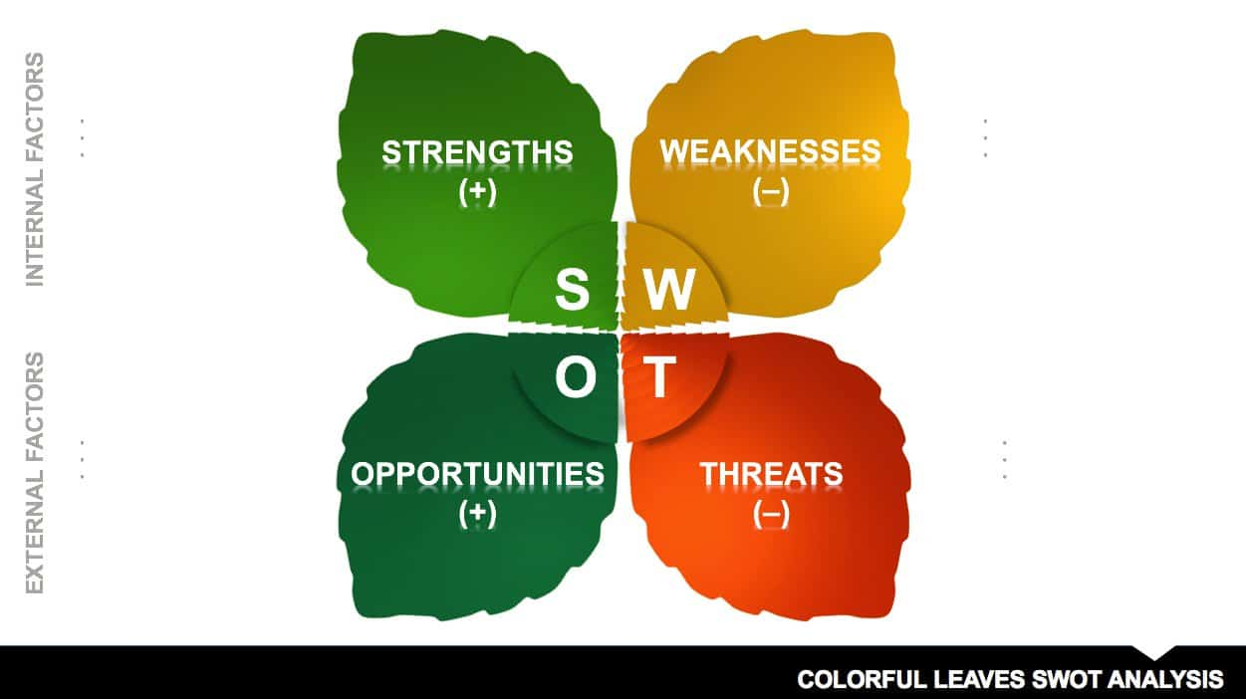
Smartsheet Contributor Joe Weller

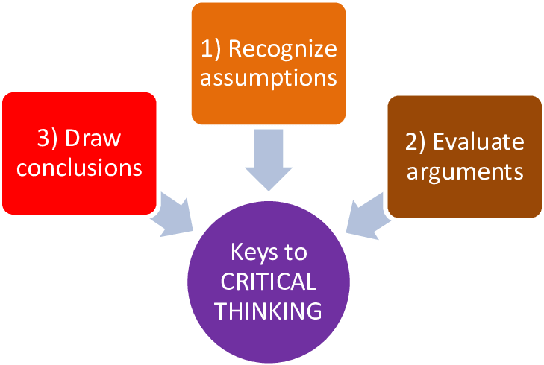

Pearson's RED Model (Adapted from Chartrand et al; 2009) (Jul 25, 2016).

