Report:

HTML & CSS

Web Development

Gareth John Williams (1910285)
DDA - Cloud Development
Introduction to Web Technologies
Tues 3rd May 2022

Table of Contents
Table of Contents 2
1 Introduction 3
2 Requirements 3
2.1 Web Site Purpose 3
2.2 Site Content 3
2.3 Initial Site Map & Navigation 3
2.4 Page Layout 4
2.4.1 Layout Principles 4
2.5 Graphic Design 6
2.6 Colour Scheme 6
2.7 Complementary Colours 6
2.8 Background Images and Themes 7
2.8.1 Page Marquee / Showcase 7
2.8.2 Site Images 8
2.8.3 Site Logo 8
2.8.4 Site Font 9
3 Implementation 11
3.1 Implementation - Web Site File Structure 11
3.2 Navigation Bar 11
3.3 Responsive Layout 12
3.4 HTML Validation 13
3.5 CSS Validation 14
3.6 Completed Site Overview 15
4 Evaluation 18
4.1 Usability 18
4.2 Content 19
4.3 Search Engine Optimization 19
4.3.1 SEO - Robot.txt 19
4.3.2 SEO – Example Google Recommendations 20
4.4 Accessibility 21
5 Report Summary 22
6 Bibliography 24
7 Appendices 25
7.1 Web Site Code 25

Introduction

This report describes the technologies, design principles and standards required to build a well-designed and accessible web site.

The technology scope for the report and web site is for HTML (HyperText Markup Language) and CSS (Cascading Stylesheets) only i.e., self-contained client-side pages. Other technologies such as JavaScript are out of scope but maybe used where necessary to support basic functionality.

There are three main sections within this report, they are requirements, implementation, and evaluation.

The appendices contain copies of the HTML and CSS files that make up the web site.

Requirements

This section outlines the requirements from content to initial web site design and styling.

Web Site Purpose

The website is to engage and build a growing community of model railway enthusiasts for both beginners and experts. It will also allow like-minded people with same interests to get in touch with each other and share skills and abilities.

Site Content
The website content will be for Model Railway enthusiasts, both beginner and Experts. The content will include and be grouped around News, Announcements, How to Articles and basic membership details.
As the site will be used by all ages and abilities, simplicity and clarity are key design principles for the site.

Initial Site Map & Navigation
One of the first part of the design steps is to use hand drawn site maps and page layouts to aid in elaborating requirements by visualising page layout and content format. Figure 1 shows an example hand drawn site map.
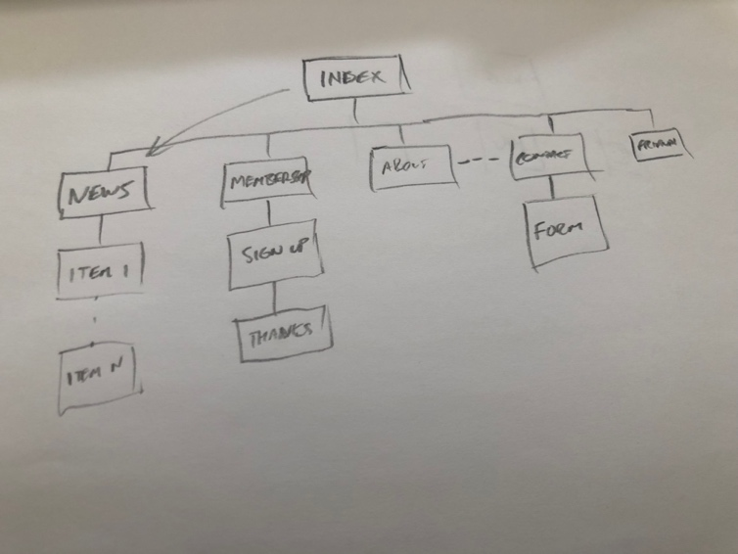

Figure 1 - Initial Site Map

The site purposefully has a flat structure in line with the simplicity requirement. As iterations of the development and design continue, additional pages may be added.

Page Layout

Layout Principles
In the video Introduction to Graphic Design by Tony Harmer, the author outlines 6 principles of layout design; “balance, alignment, proximity, contrast (not just colour), repetition and space” [2]. Where possible these design principles will be used throughout the web pages.
Initial site designs and layouts are tried out with simple pen and paper. These initial drawings can be done quickly and help elaborate requirements, Figure 2 – Page Layout is an example of this.
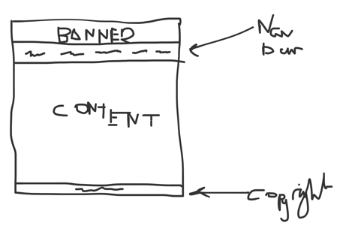
Key design principle is CRAP (citation), Figure 2 Page Layout shows the Banner, Navigation bar and footer, for consistency these will appear on every page.

This ensures the user can navigate to any other page without having to trawl by pressing the back button.

Figure 2 - Page Layout
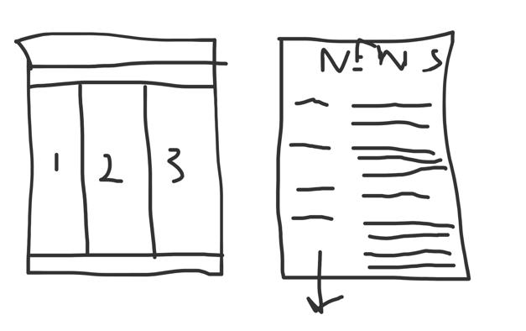
Alignment and balance are achieved in the content section of each web page by splitting the area into thirds, roughly based on the well-known design technique “rule of thirds”. This is described by Beaird, Jason, et al. The Principles of Beautiful Web Design [1], describes the rule of thirds as a technique for the composition of web pages. But the principle has been used for centuries for composition from photography to painting.

In the context of this web site – we’ll be splitting the content area into a 3-column grid. Note that the grid may contain 1 to many rows – this depends on the content of a given page.
Figure 3 - Rule of Thirds

Figure 4 and Figure 5 show the content element where columns 1 and 2 are used for content, and column 3 is used as for the side bar.

This principle is used throughout the site for the content area of the pages. Space is used to frame page content and paragraphs

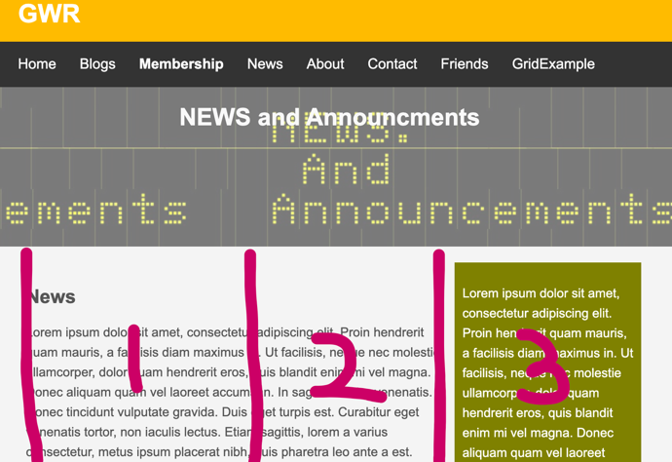
Figure 4 - 3 Column Layout

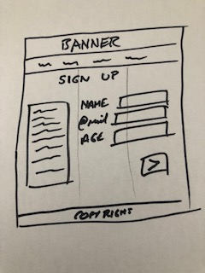

Figure 5 - 3 Columns

Graphic Design
This section describes some key principles and approaches to the way the web site colour scheme was created and developed. As well as consistency of layout, the consistent use of colour is also used in page design to provide a site style and theme.

Colour Scheme
As railways and trains is the main site content, the site will use a colour scheme users of the site would be familiar with. Inspiration was taken from classic railway rolling stock and to borrow colour from a real-life image.


Figure 6 shows a royalty free picture of locomotive from iStockphoto.com [1]. The image shows a HST locomotive in the classic British Rail corporate livery.
Figure 6 - Dwalish

The yellow against blue provides for a strong contrast. The tone and saturation may very slightly dependent on dates images were taken.

As CSS will use the hex RGB values. The RGB values were obtained by opening the image in the opensource graphics package GIMP [2] a well-known graphics package and using the “dropper tool” or “colour picker” as shown in Figure 7.
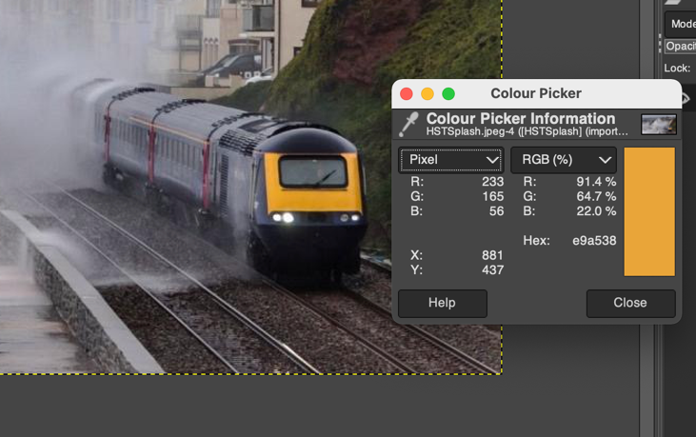
This allows the user to select the colour from an image and the tool provides the RGB or Hex colour value #E9a538 which can be used within the CSS.

The colour is then used repeatedly throughout the pages where contrast is required.

Figure 7 - Colour Picker

Complementary Colours
Now we have the inspirational colour #E9A538 we can use an online tool such as Adobe Color Wheel [4]which allows the entry of the hex number and calculates the complementary colours and their hex values.

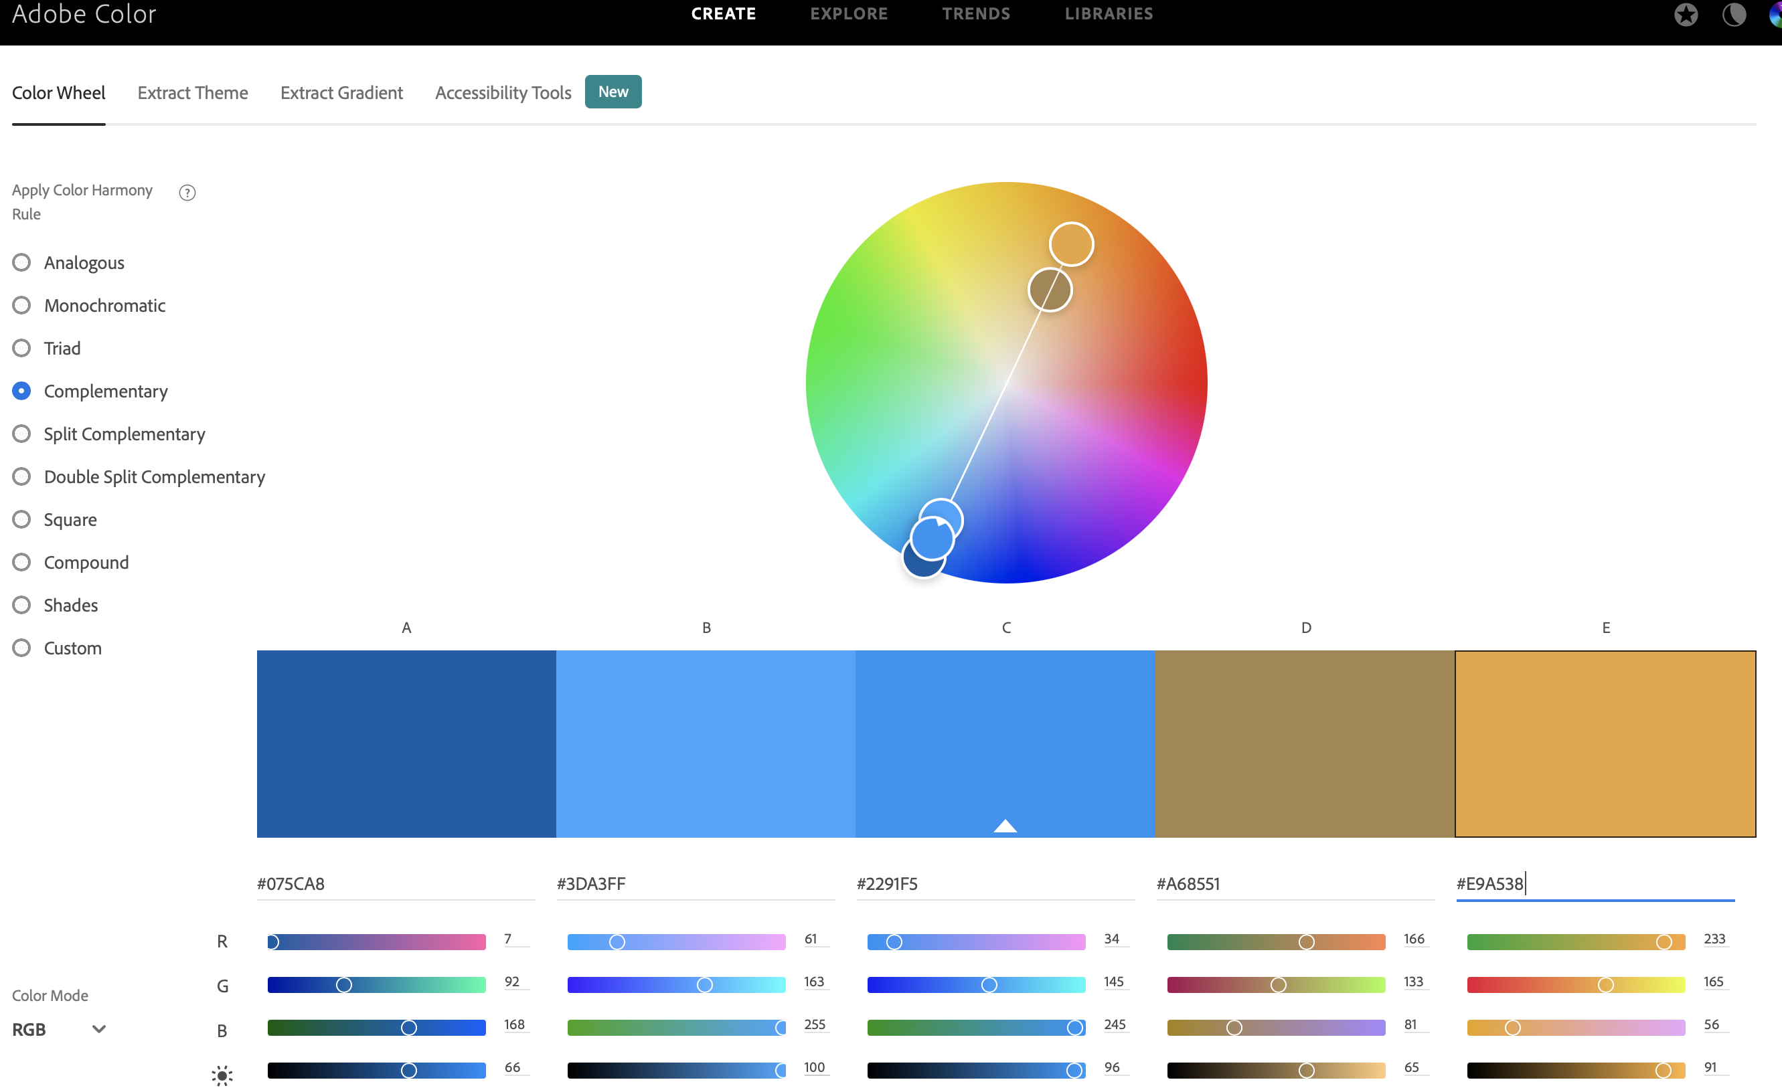
Figure 8 - Adobe Color Wheel

The colour wheel tool provides the complementary colours to use throughout the site. #075cab, #3da3ff, #2991f5, #a68551

Background Images and Themes

Page Marquee / Showcase
To continue the railway theme, inspiration came from the idea of a railway station information board.

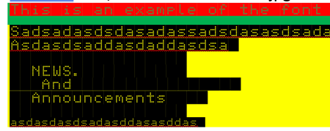
The font required to replicate the style is not part of the standard out of the box operating system fonts, so a custom font was downloaded and installed from fontspace.com [2]. Figure 9 shows the simple manipulation of the font foreground and background colours in Microsoft Word until the desired effect was achieved.
Figure 9 - Font Manipulation


As this is not a standard font, some applications and browsers will have trouble displaying, to get around this problem a screen grab is taken to create a jpeg file, it is this image that is used in the web site. An example is shown in Figure 10.
Figure 10 - Info Board Font Design

Further image control attributes, such as position opacity and size, will be set in the CSS file as the example shows in Figure 11.

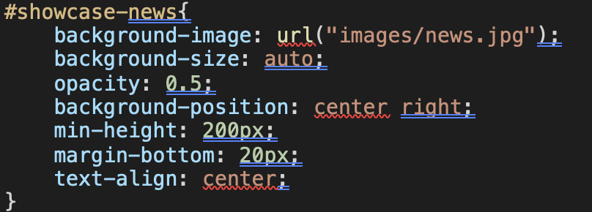
Figure 11 - Example CSS for News Banner

Site Images
There are several image types that browsers can display and examples of these can be seen in Figure 12 – W3 Schools Common Images Formats.

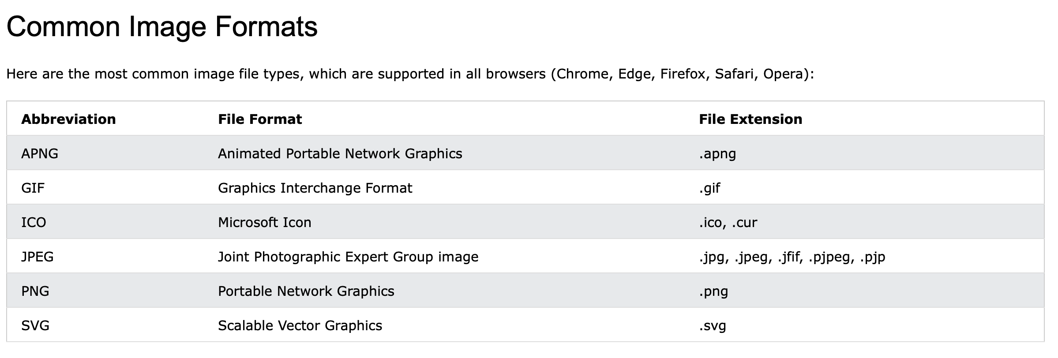
Figure 12 - W3 Schools Common Image Formats

A key consideration for web pages is content load times, therefore the site will use images that are of reasonable size.
The website uses 2 of these image file standards:

- SVG (Scalable Vector Graphics) – for the logo icon. The advantage of SVG is that it contains image attributes, such as start points, end points and size of shapes and interpreted by the browser and therefore is lossless even when zooming which helps meet accessibility requirements.
- JPEG (Joint Photographic Export Group) - All other images will use the jpeg bitmap format which allows for with a high compression rate. Any images loaded as part of the sites “blog” functionality will have pixel width and height limitations applied to ensure no large images files are uploaded.

No external links or references are used for graphics – all images are downloaded and saved locally in the images folder; this ensures greater control over the content.

Site Logo
For inspiration for the logo the web site WiX was used. The website allows generates an icon based on question/ answer responses, and any additional keywords entered.
For consistency, the styling options are altered the colour scheme by using the same colours as described in section 2. 1

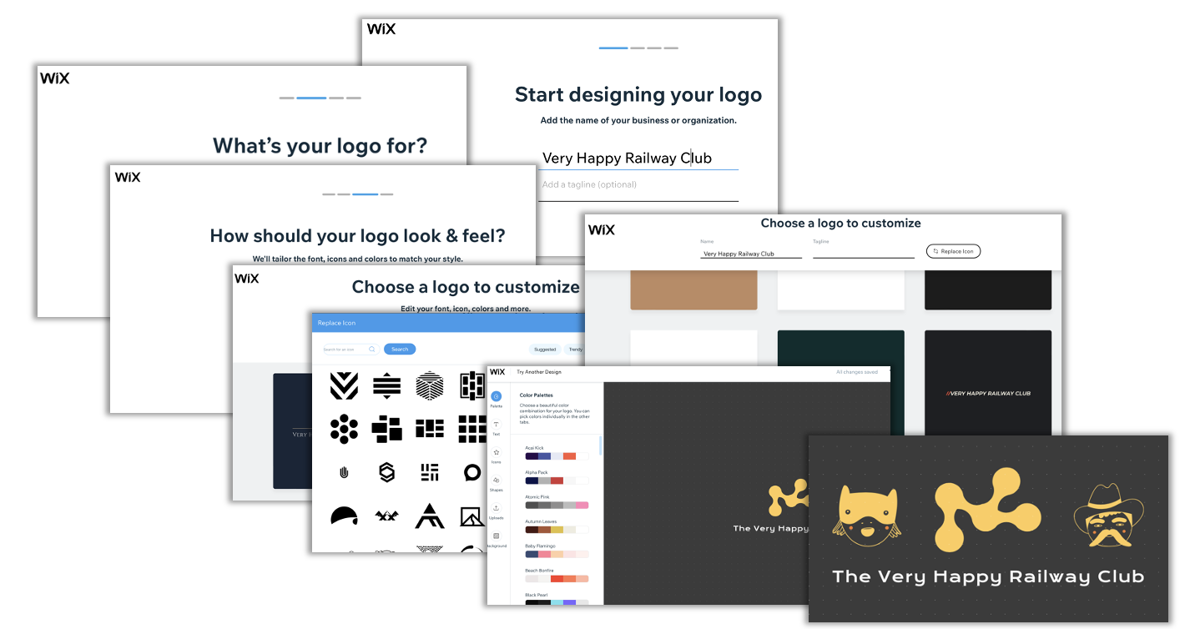
Figure 13 - Wix Icon Design Tools

Site Font
As a key requirement is clarity – Arial is a clear font that will be used by
W3 Schools use the term “websafe fonts” and describes them as “browsers and operating system are capable of displaying them correctly” [6]. Figure 14 shows the list of websafe fonts.
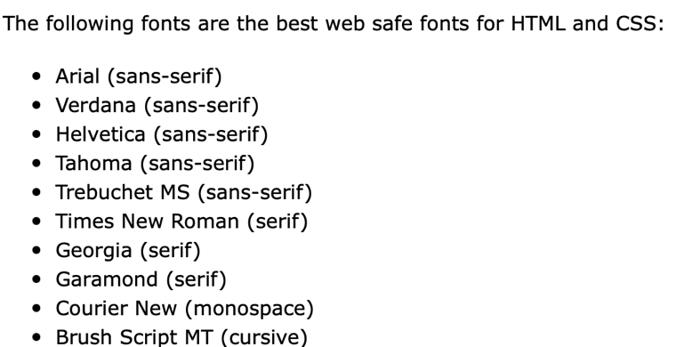

Figure 14 – W3 Schools - Web Safe fonts

W3 Schools also advise to that good practice before publishing a website to test with several browsers to check that any fonts used are displayed correctly.

If a browser has a problem loading a font from the operating system, it will attempt one of the fallback fonts that are specified in the stylesheet as shown in Figure 15.

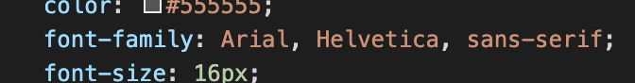
Figure 15 - Fallback Fonts

Implementation

This section describes the implementation of the first iteration of the web site. The site has been designed without the need for external CSS libraries such as Bootstrap or Materialize.

Web Site File Structure

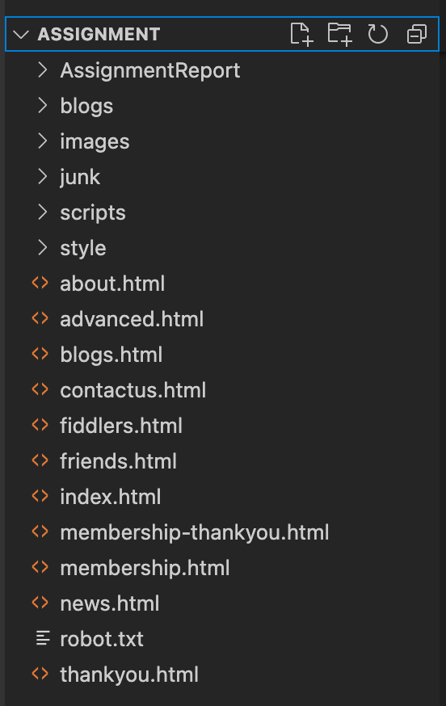
Figure 16 - File Structure
The web site is a self-contained client-side project.

The main files are in the root folder and broadly have the same name as the associated <link> in the navbar.

Following industry standard, index.html is the start page for the site.

Folders contain child items some as individual blog files or images.

The style folder contains examples of CSS files that are used throughout the site. However, some of the pages include their CSS styling in their <header><style> tag and some items on pages have their style attribute set.

It would be expected that in a production setting that the styling would be achieved using CSS files.

Navigation Bar
Normally repeated content such as the header and footer would be held and maintained in a single file and included into each page, as the aim was to construct the site with minimal use of JavaScript and to ensure each page is self-contained and viewable using client-side technology, the navigation bar, footer and logo elements are simply repeated in each HTML file.

The navigation bar within the site is a modification of example code provided on W3 Schools CSS Horizontal Navbar [6], that uses the CSS inline attribute to layout a unorder list <ul> of links.

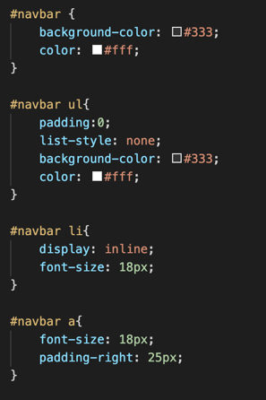
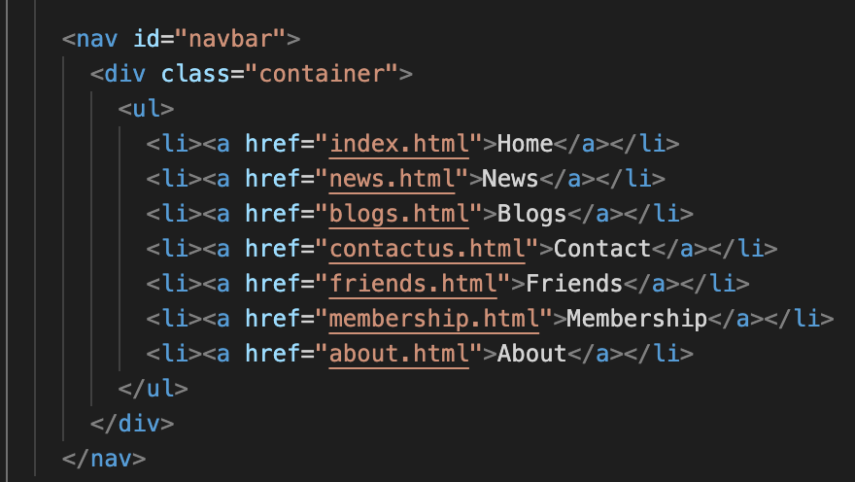
Figure 17 - Navbar List

Figure 18 - Navbar CSS

Responsive Layout
The book Responsive Web Design defines the term responsive web design as “… how the content is displayed across various screens and devices such as mobiles, tablets, phablets, or desktops.” [8]
The same book recommends making the web page responsive is driven by how the page is built for example viewport directives, flexible grids to control layout and using percentage values rather than fixed pixel sizes.

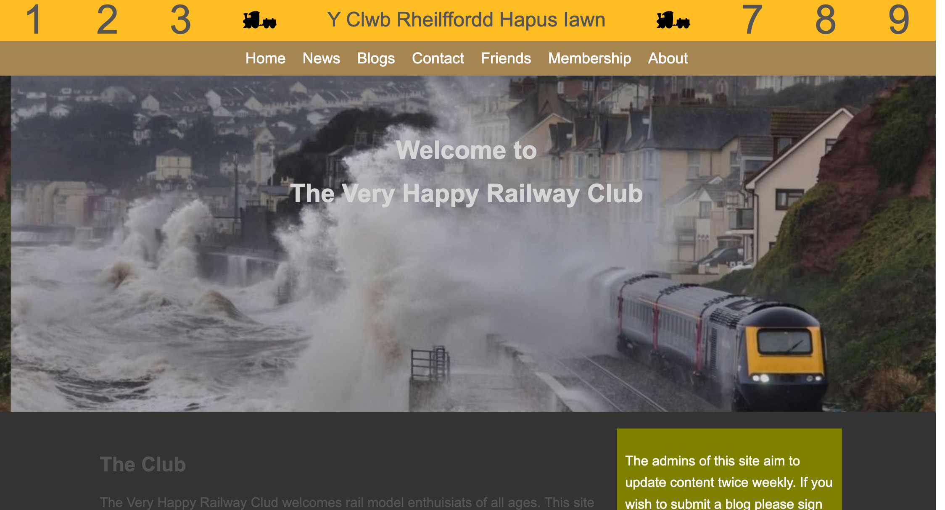
Figure 19 - Desktop Layout

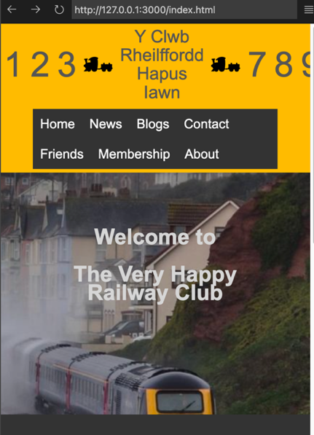
Figures 19 and 20 show the website viewed from a desktop browser and mobile device. The responsive design allows for the content to adjust automatically dependent on viewport size.

Note that the numbers in banner of the pictures are used to aid debugging and testing of the grid layout technique and are not included in the final published site.

Figure 20 - Mobile Layout

HTML Validation
Internet browsers can be forgiving when interpreting a HTML file and displaying HTML pages, so validation is a key aspect as soft errors in pages maybe fine during development but may present themselves in a production setting.

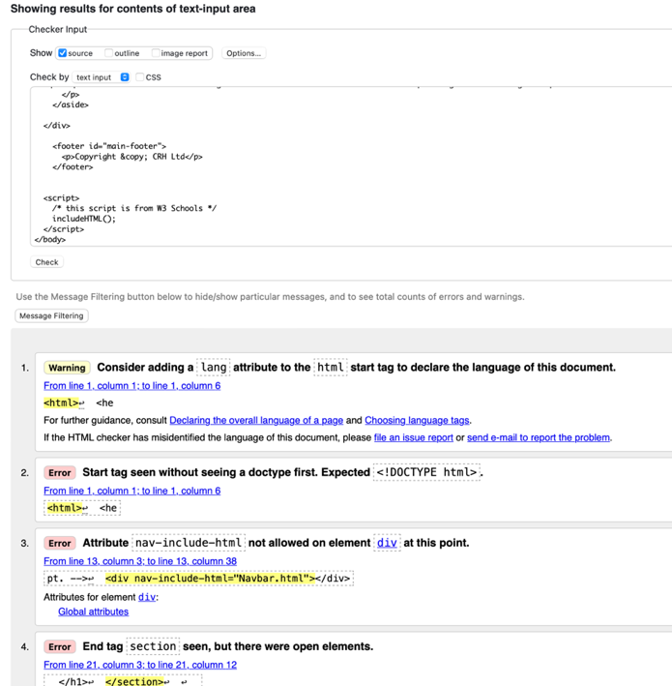
The screen grab in Figure 13 and Figure 14 shows results from the W3 Schools HTML validator. This tool allows a page developer to upload HTML code and execute the validation. The validation report shows HTML syntax warnings and errors and provides links to resources to help in resolution.

Figure 21 - W3 Schools HTML Validation

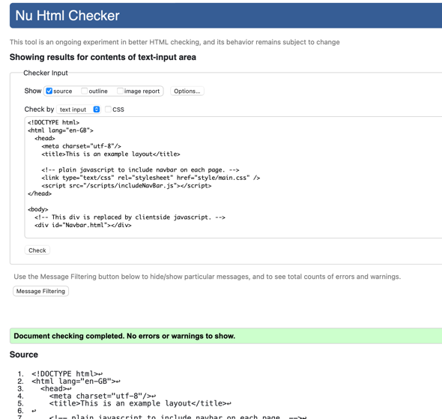

The findings of the initial Validation of the index.html file highlight:
- Missing lang attribute
- Missing <!DOCTYPE html>

Each error is resolved and the validation process repeated until no errors are reported.

Figure 22 - Successful Validation Report

CSS Validation
W3C also provide a CSS validation service [8], which allows a user option to provide a URL to be validated, upload CSS files or paste CSS code into the validation tools. As the web pages are offline, the CSS is copied to the tool. Figure 18 shows the outcome of the CSS validation.

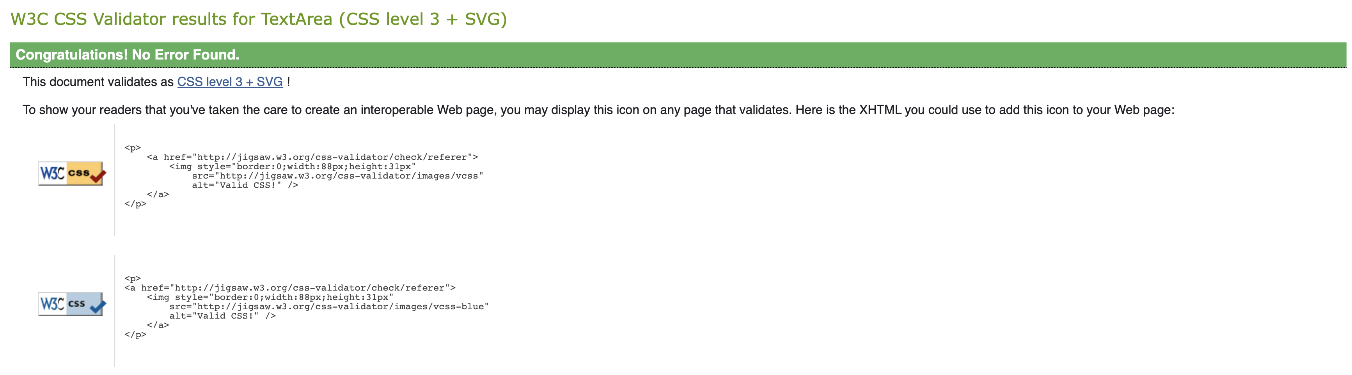
Figure 23 - CSS Validation Report

The two warnings provided are simply highlighting the fact that the validation can’t follow external “Imported” files.
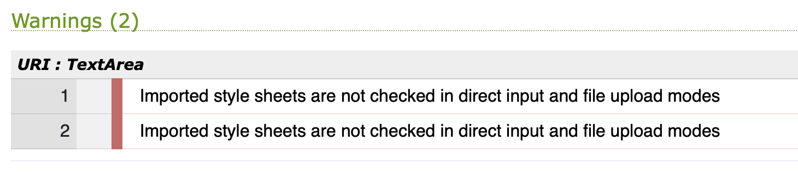
Figure 24 - CSS Validation Warnings

Completed Site Overview
The following list of screen grabs show each of the pages of the web site and a brief comment of the underlying HTML and CSS techniques used.
Page | Screen Grab
Home  The home page establishes the basic site page pattern of header, navbar, content and footer. The page also uses the semantic elements <header>, <nav>, <footer> and <section> tags to group information.  The CSS background-image attribute is used for images. The <section> and <aside> tags are used in conjunction with the float directive to layout the responsive text containers. | 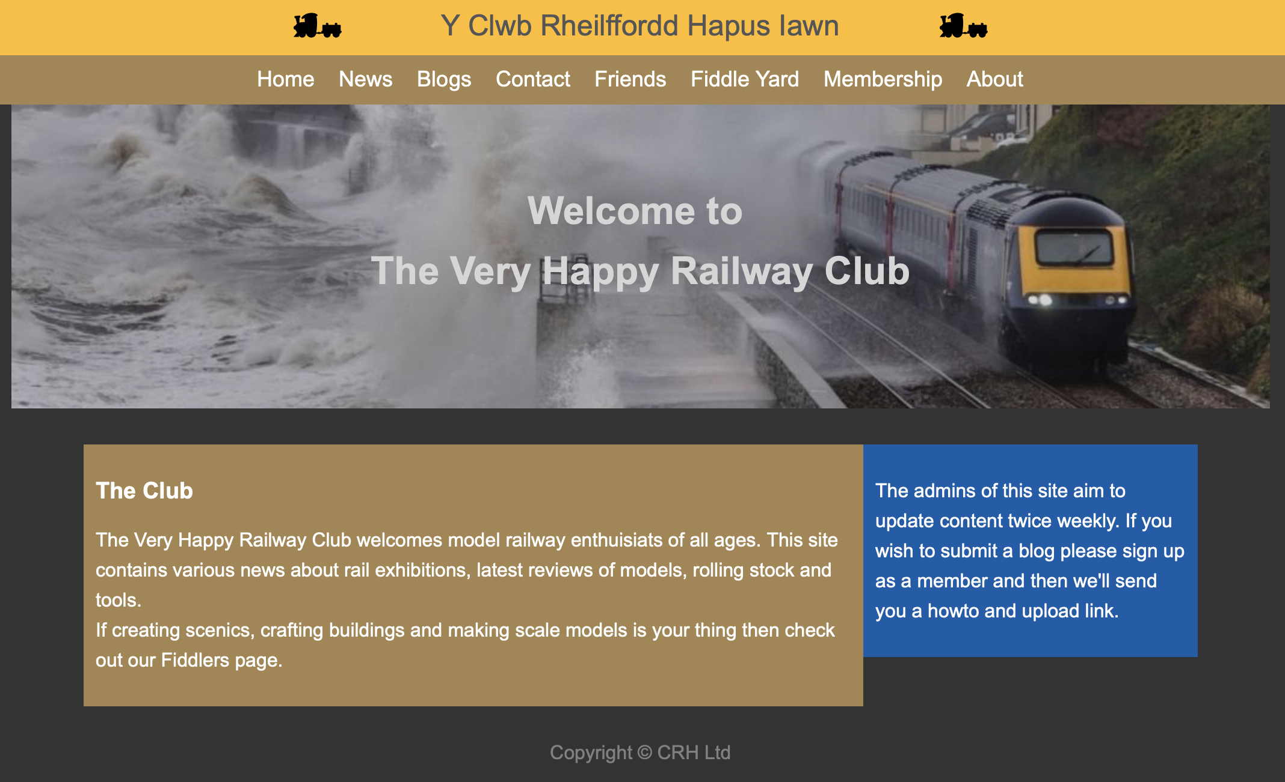
News  This page broadly follows the index.html.  The difference here is the custom banner as a JPEG image to avoid issues with web safe fonts. | 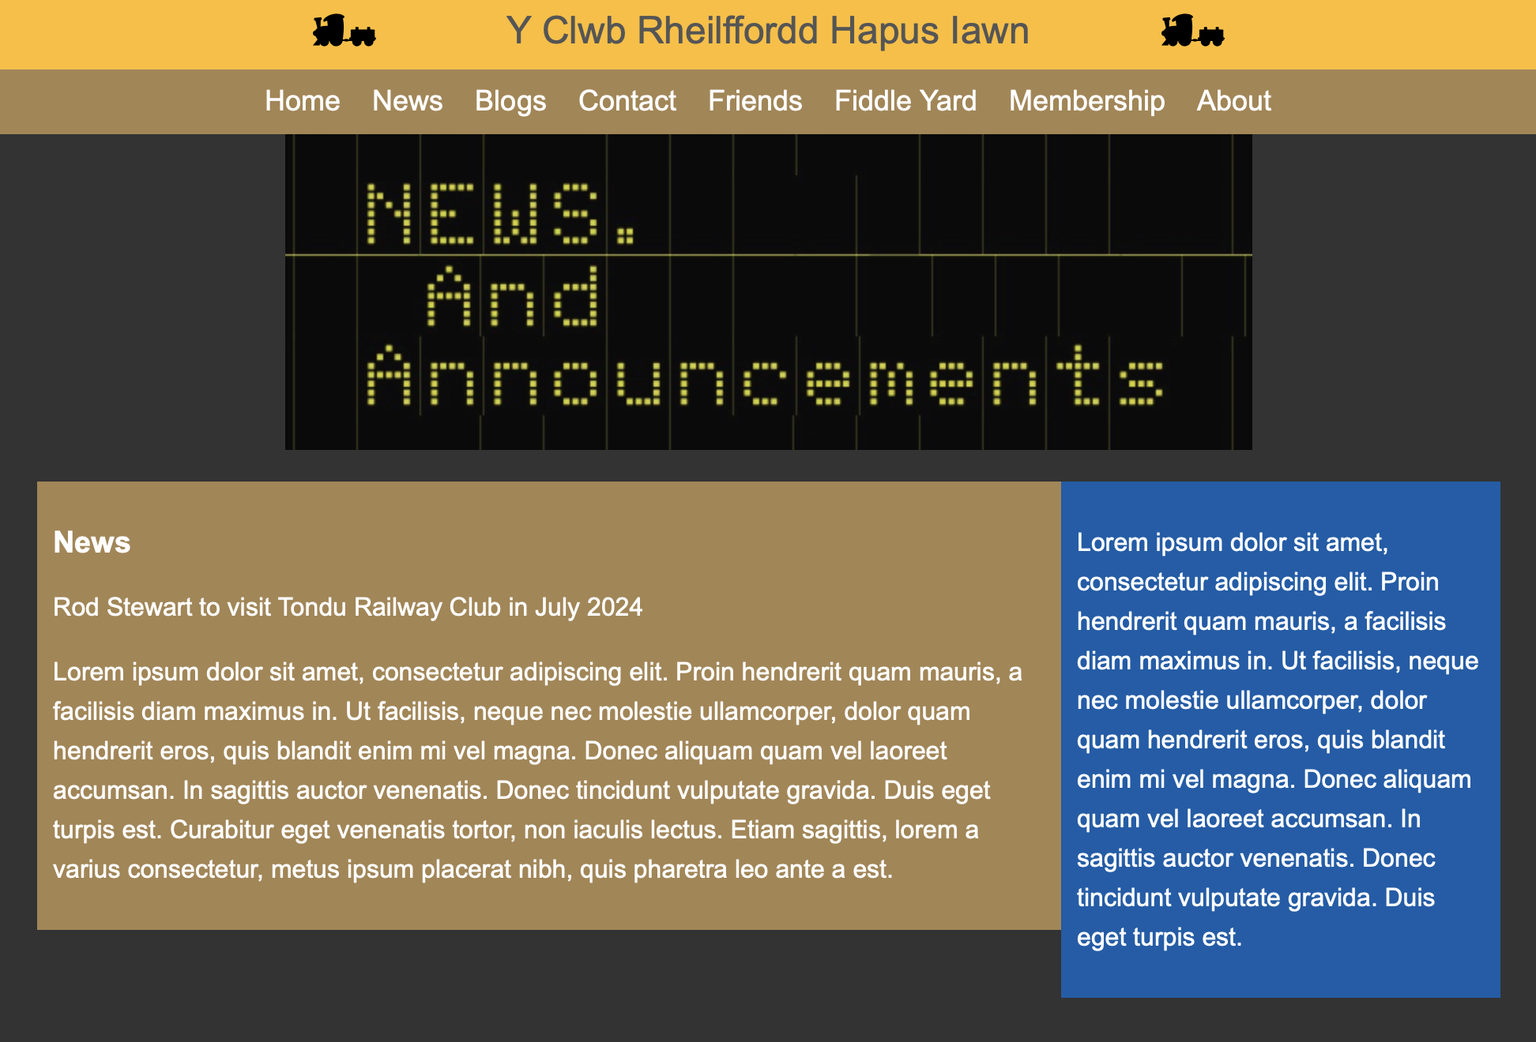
Blogs  The blog page introduces the use of the <grid> technique to allow pages to flex.  The “view blog” links takes the user to the individual page | 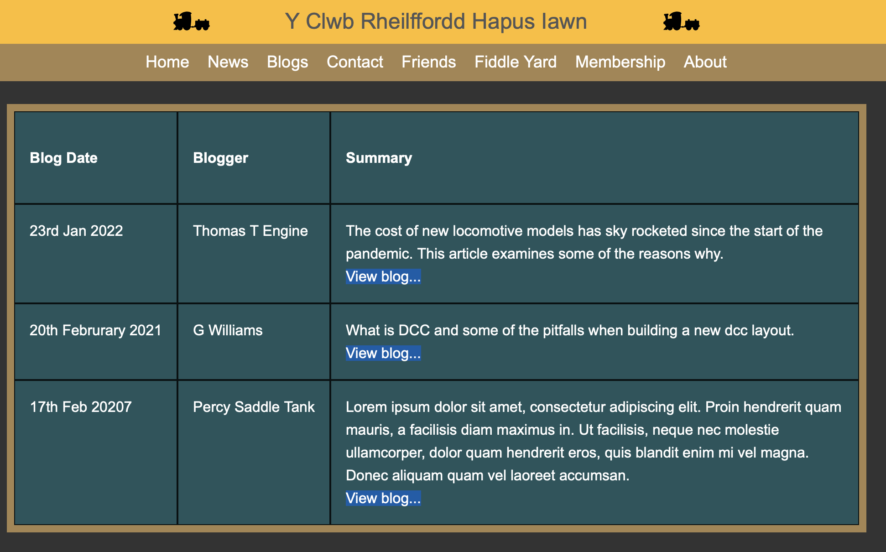
Blogs – example individual blog.  Note the use of Lorum Ipsum during development to mimic content to reflect how page content will look and feel | 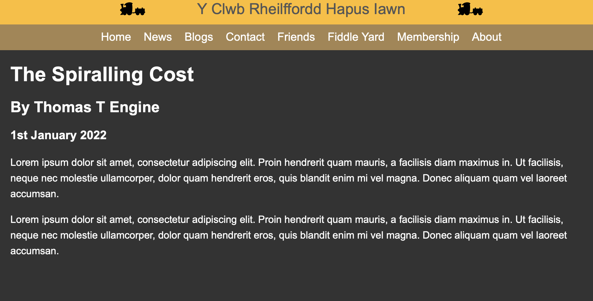
Contact  This page includes input elements and forms.  A grid is used to control layout. However, in this case | 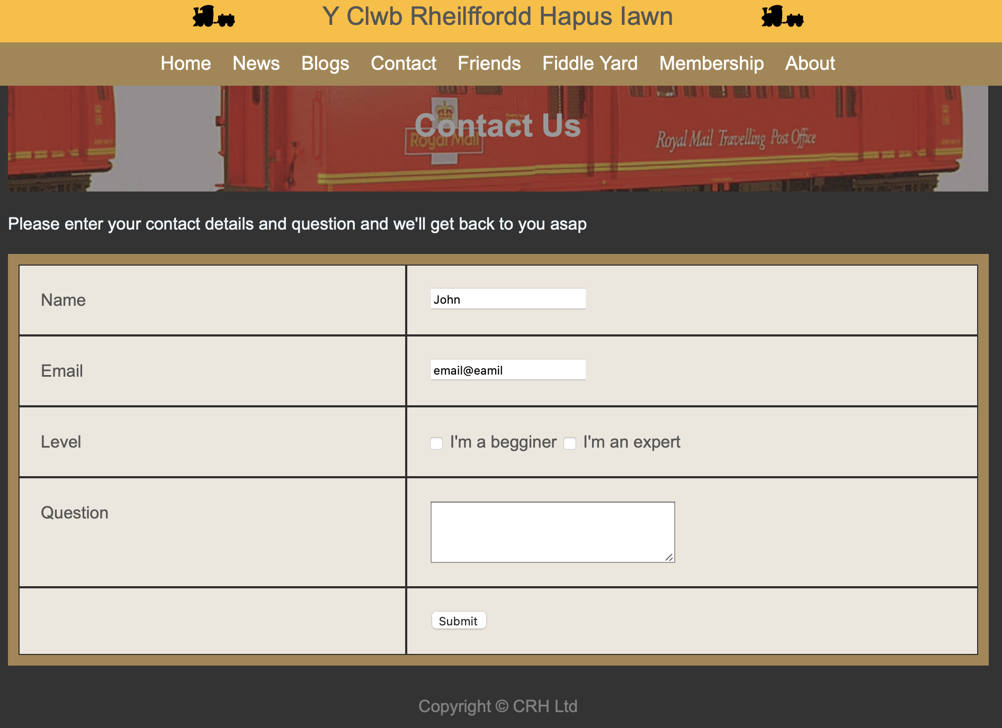
Friends  This page demonstrates the inclusion of images within grid items and maintaining the responsiveness of the page.  Note that there are external references to sites. | 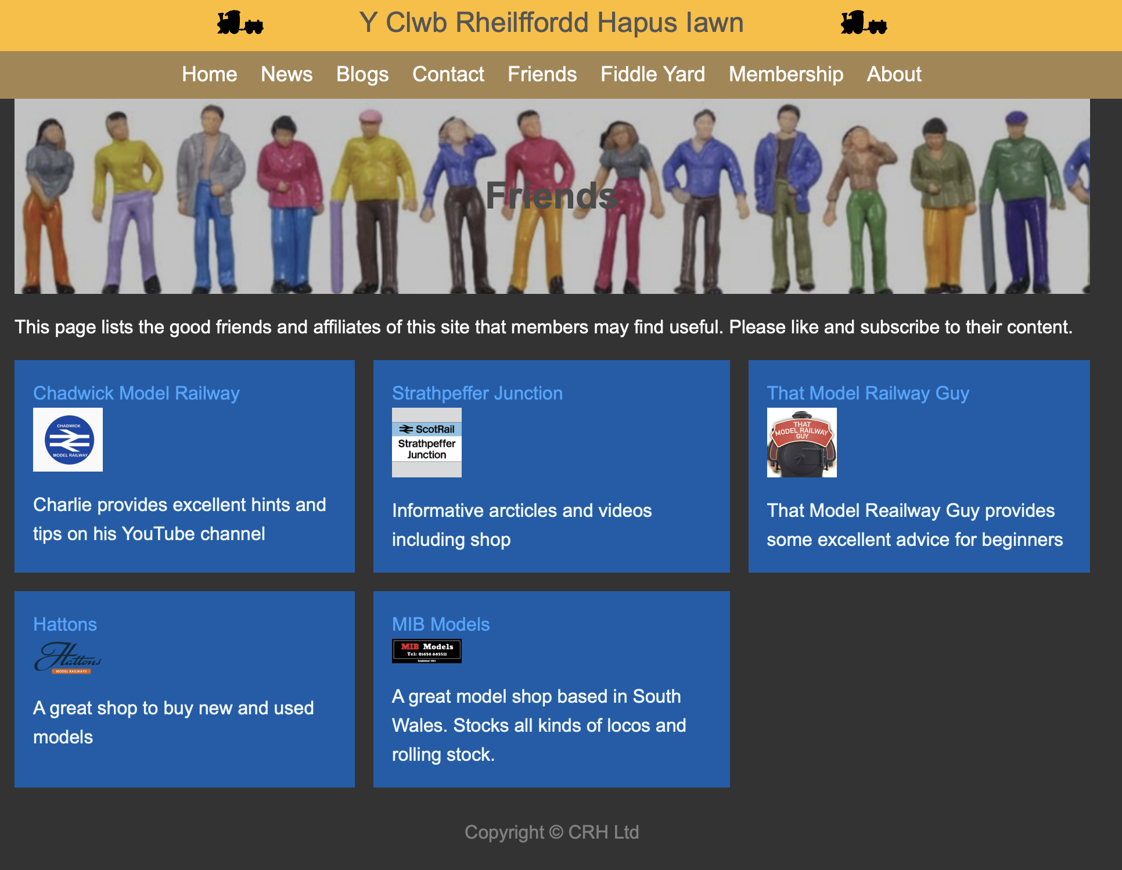
Fiddle Yard  This page uses a back ground image that will stretch to the width of the screen.  The text is automatically aligned with the icons as they are set to float | 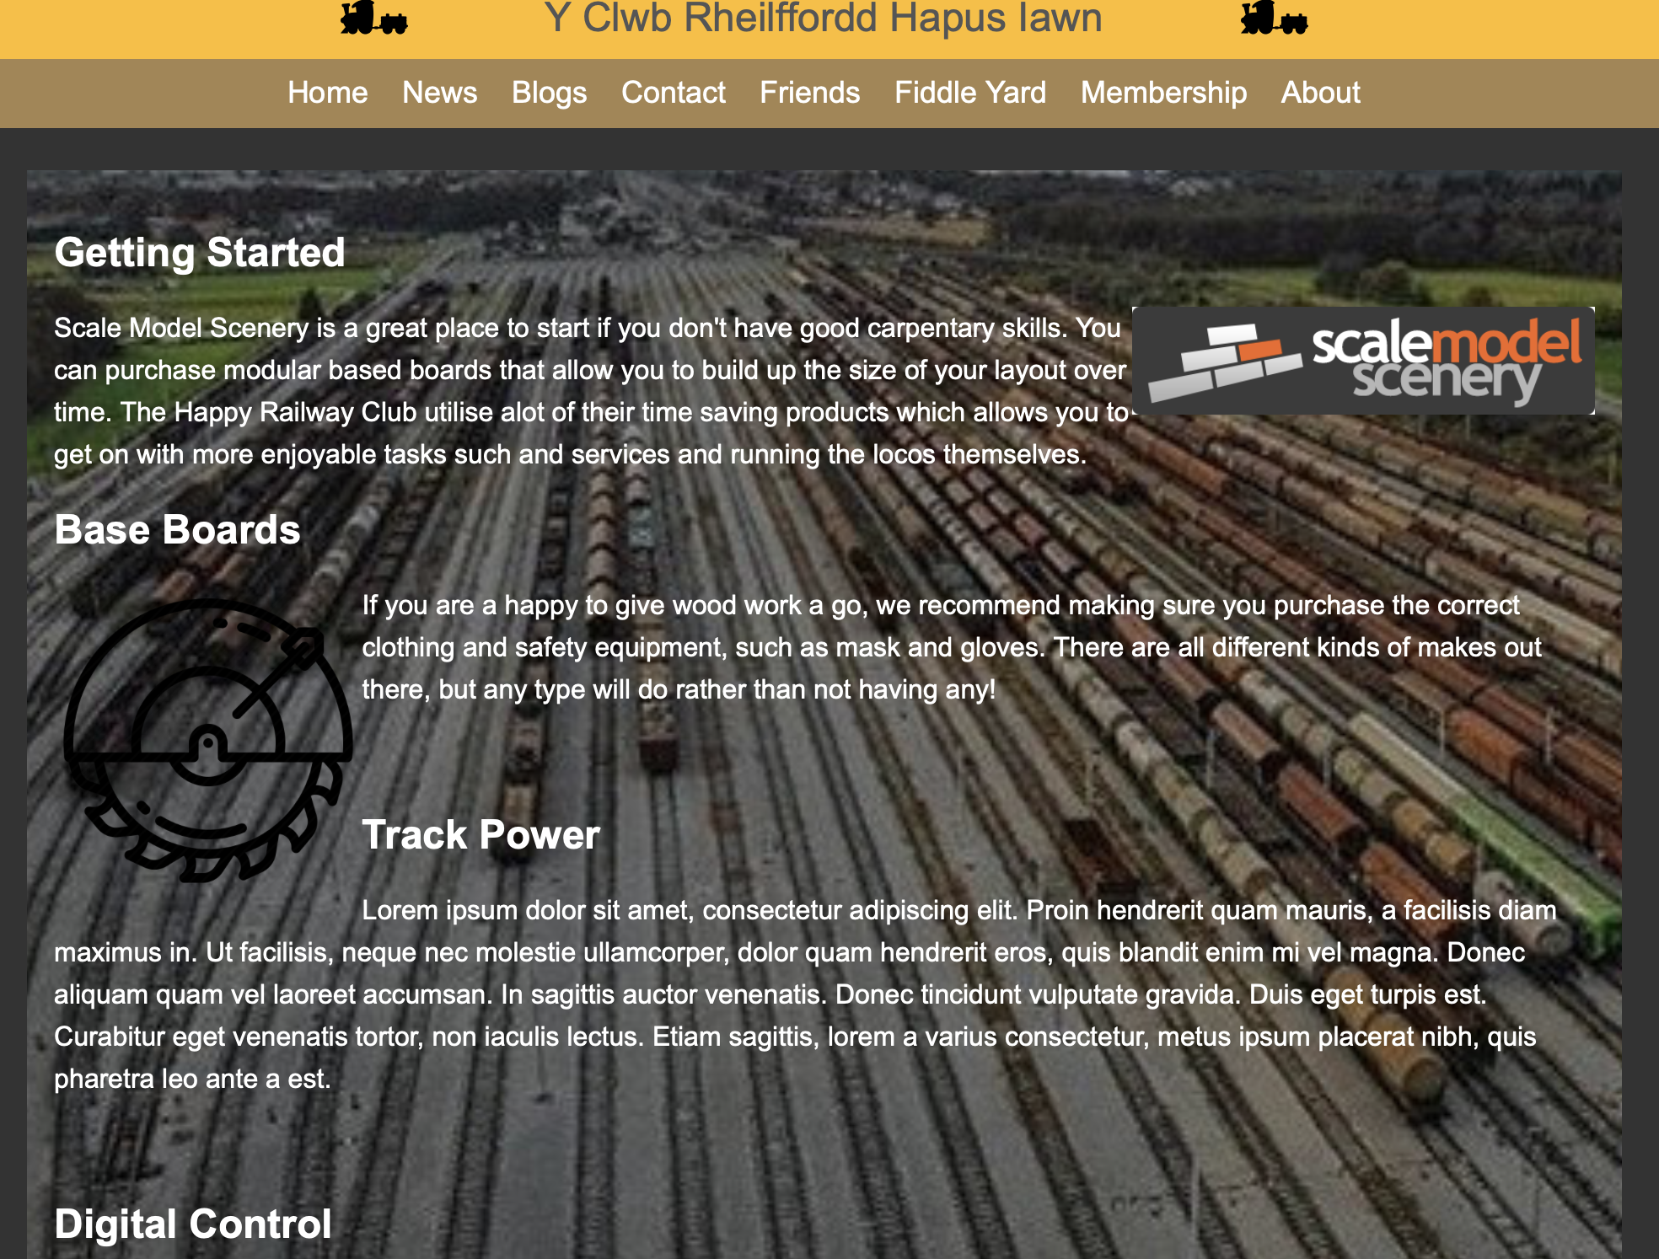
Membership  This page uses the @media directive in the CSS to switch the layout when the view port is reduced.  This is much cleaner that the “contact” screen.  Note the code here is modified from examples provided by W3 Schools [10] | 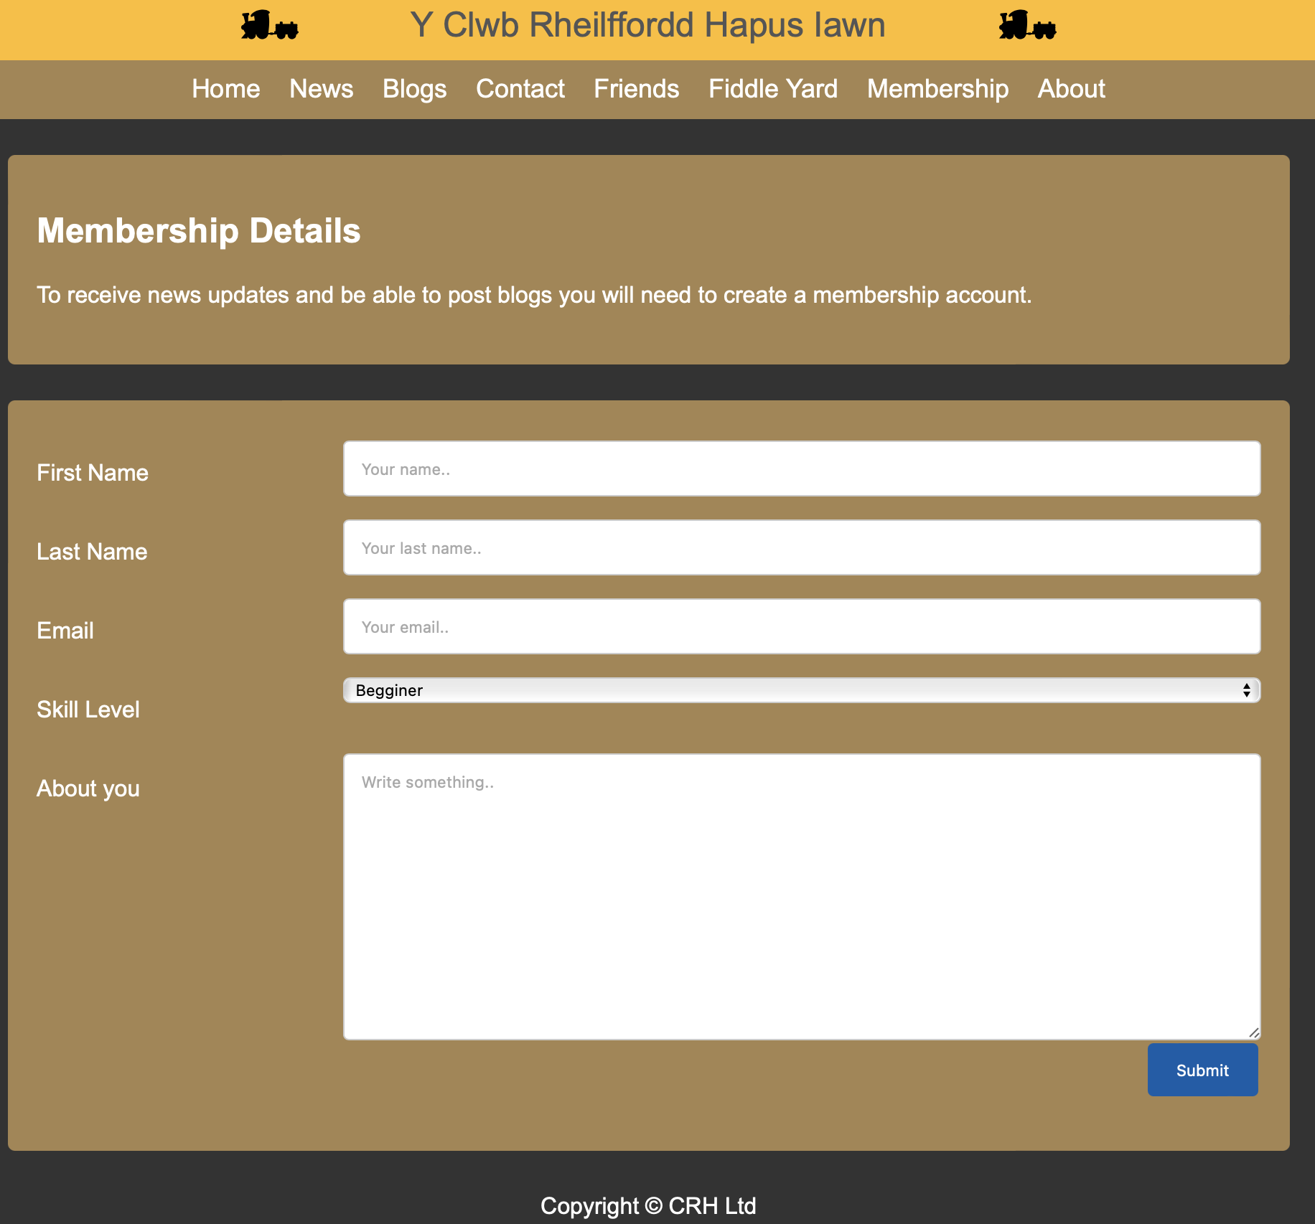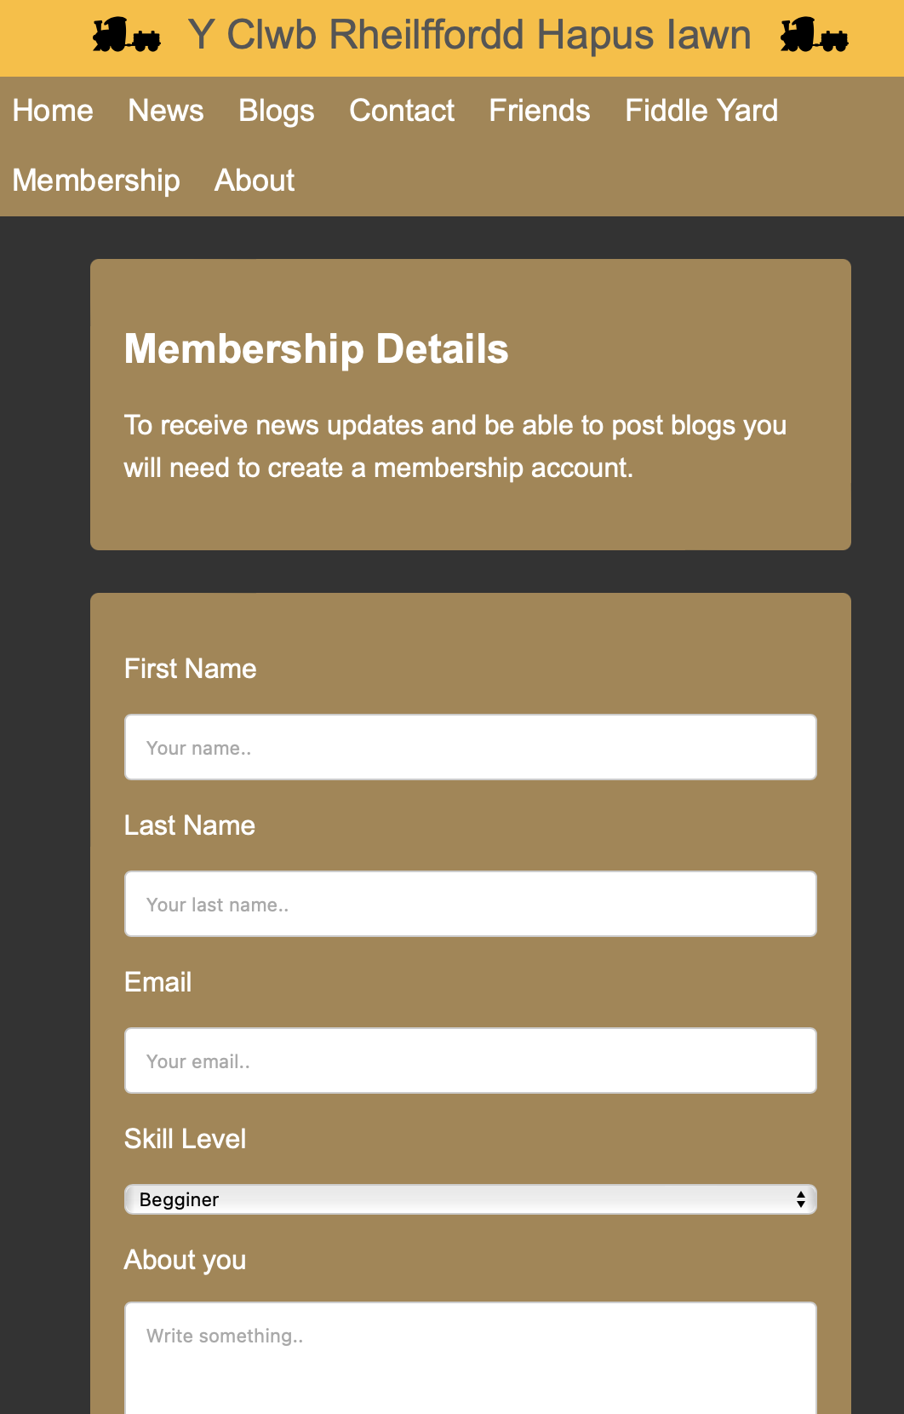
About  The about page simple uses the main container div and plain text  <span> | 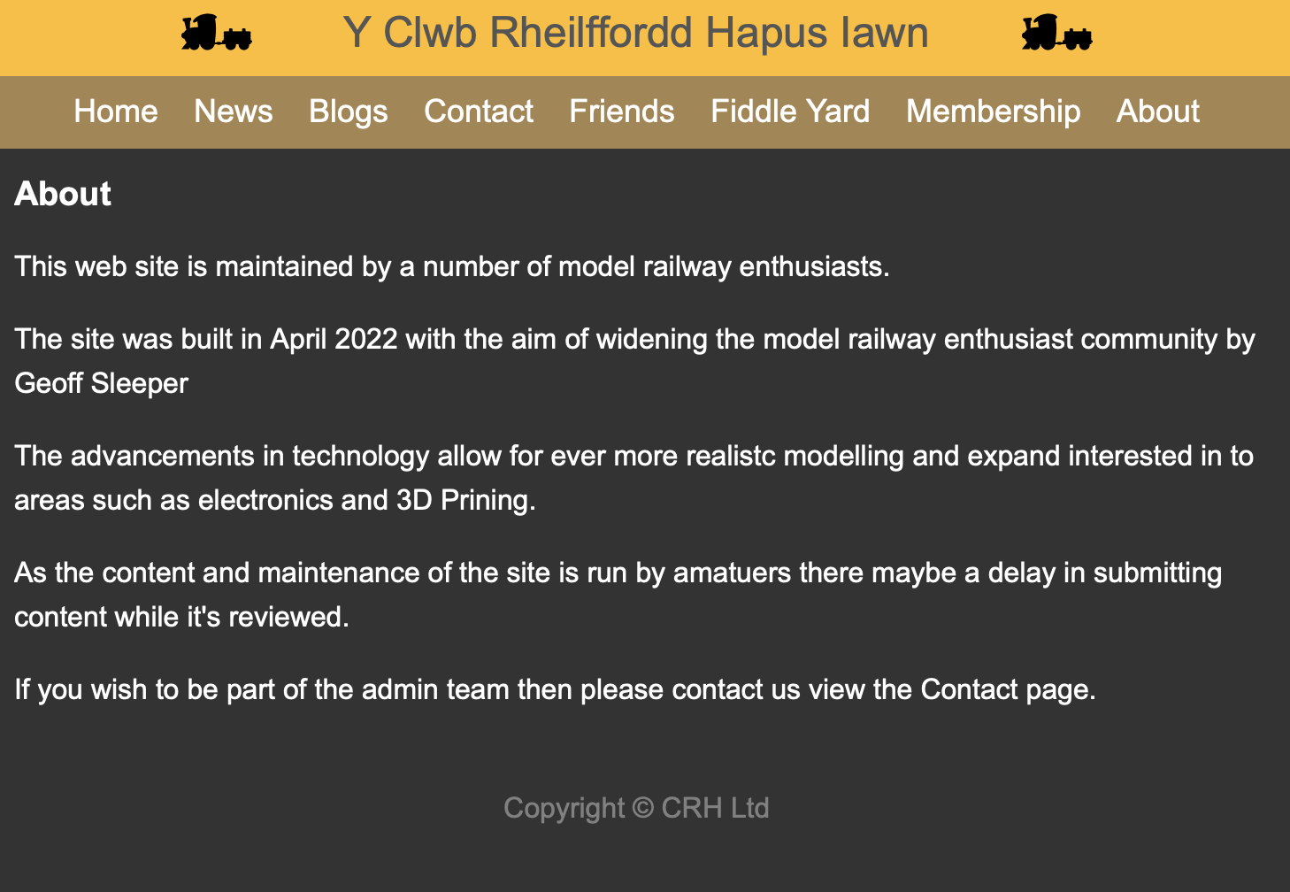

Evaluation
This section contains a brief evaluation of the website and provides findings and recommendations for improvement.

Usability
In the article by Belanche, Daniel ; Casaló, Luis V ; Guinalíu, Miguel

“Website usability can be defined considering the following aspects (Flavián et al., 2006): (a) the ease of understanding the structure of a website, its functions, interface and the contents that can be observed by the user; (b) simplicity of use of the website in its initial stages; (c) the speed with which the users can find what they are looking for; (d) the perceived ease of site navigation in terms of time required and action necessary in order to obtain the desired results; and (e) the ability of the user to control what they are doing, and where they are, at any given moment.” [10]

The following table in Figure 24 takes each of the usability aspects and examines how the website meets the principles.

Usability Measure | Evaluation
Structure, functions, interface and contents | - The web site structure is simple with obvious access to each category of content via the navigation bar.  - The consistent navbar satisfies is always the same - it’s not dynamic or context sensitive which could confuse a reader.  - Always available at the top of the screen and is always the same i.e., no dynamic changes to the website – the pages are in the same place on each visit.  - The website functionality is basic and user keyboard input is minimal, the only input being registration for membership, click content hyperlinks and use the navigation bar.
Simplicity of use | - The website utilises a simple single level menu to minimise mouse clicks. Navigating around the site is using standard mouse scrolling and using the main navbar menu.
Find what they are looking for | - As the navbar appears at the top of every page it makes it simple to browse to the appropriate section.  - One recommendation for improvement in functionality would be to have an internal site search page that would allow users to keyword search for specific site content rather than manually scan through pages.
Perceived ease of site navigation | - As the navbar is static the reader always knows to go to the top of the screen to then traverse down to the content they wish to access.  - The nav bar which is always on display it means it helps pages broadly follow the science of Z and F eye pattern track through of content e.g.,  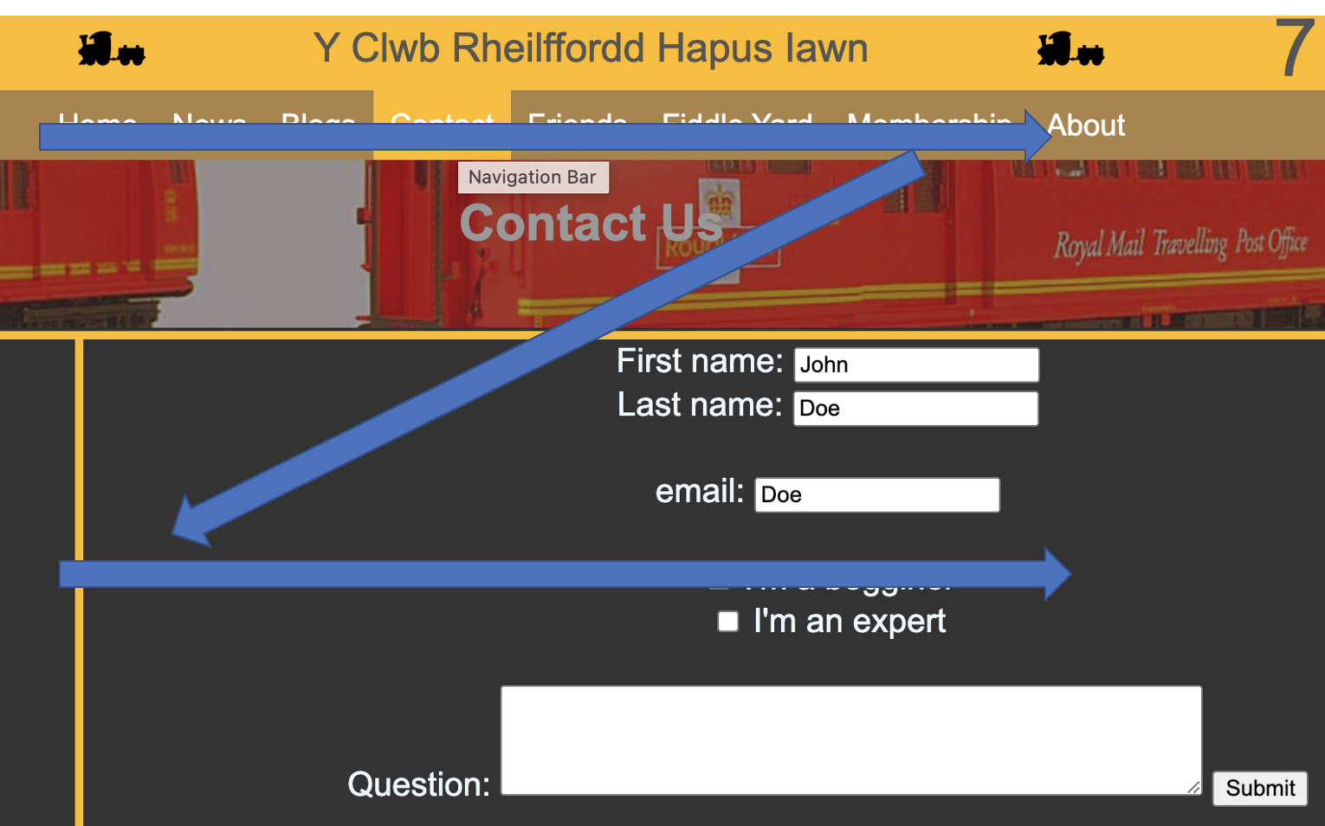  - The ability to sort, order and paginate lists such as summary lists as seen in the Blogs and News sections would help navigation.
Figure 25 - Usability Evaluation Table

Content
Due to the technical limitations of client-side technology, the content is static and requires manual intervention by a developer to update. For the next stage of the development the use of server-side technology to deliver dynamic pages would allow for richer functionality such as hiding certain pages behind logins, page content dynamically constructed and themed based on saved user preferences such as colour or specific content.

Search Engine Optimization
Good search engine optimisation is key to the success of a web site as described in the Art of SEO “Search has become integrated into the fabric of our society.” [8]
Search engine providers such as Ask, AOL, DuckDuckGo, Google, Yahoo! and Bing constantly crawl websites on the internet. For a site to be searchable it simply needs to be hosted on the world wide web. However, the web site needs to be designed in such a way to ensure that the search engines pick up the correct content and context of a page.
Google provides a developer guide [9] which describes how to fine tune a website to ensure the web page is correctly indexed by search engines.

SEO - Robot.txt
A website can implement Robot.txt to avoid certain content being crawled by an indexing bot or to point the crawler at specific content. The robot.txt file contains configuration to let the crawler know what will and won’t be useful to index, however, these are essentially hints, there is nothing restricting crawler traversing all public pages.
The following screen grab in Figure 22 shows the implementation on the website where the robot.txt is used to hint to the crawler that /AssignmentReport and /Images directory shouldn’t be indexed as the content isn’t relevant to search results.
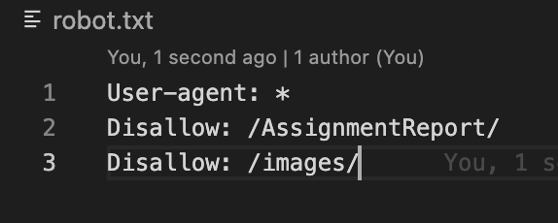
Figure 26 - Example Robot.txt

SEO – Example Google Recommendations
The following table shows examples of the website HTML code with the recommendations applied from the Google Developer Guide [9].

Google  Recommendation | Before | After
Unique and brief <title> tags for each page | <title>Home</title> | <title>Y Clwb Rheilffordd Hapus Iawn - Home</title>
Include a page description <meta> tag |  | <meta name="description" content="Y Clwb Rheilffordd Hapus Iawn provides a community web site for model railway enthusiasts."/>
Use the alt attribute for images | <img src="./images/happyloco.svg" /> | <img src="./images/happyloco.svg"  alt="Y Clwb Rheilffordd Hapus Iawn - The Very Happy Railway Club logo" />
Short but descriptive image filenames | Img_1245.jpg | Friends-background.jpg

Figure 27 - Google SEO Recommendations

In addition to advice, Search Engine providers provide tools for developers to see how well a crawler indexes a web site, both Google [9] and Bing [10] are just two examples. However, as the website is not hosted these are unable to be used in this development.

Accessibility
The initial web site design has focused on HTML and CSS technologies. This section examines how simple techniques can ensure the site meets the needs of users with additional communication needs.
As well as generally good practice to help ensure websites are of a good clear design there are also legal basis and requirements supporting access to information such as the Equality Act 2010 and based on that the Accessibility Requirement for Public Sector Websites and Apps [8].
In addition to legislation, The Web Content Accessibility Guidelines (WCAG) set out the four principles: perceivable, operable, understandable and robust [12].
To support designers with these aspects, W3C Web Accessibility initiative which provide advice and resources to web site developers on “Making the Web Accessible” [13], Figure 27 shows examples of these from the W3C site.

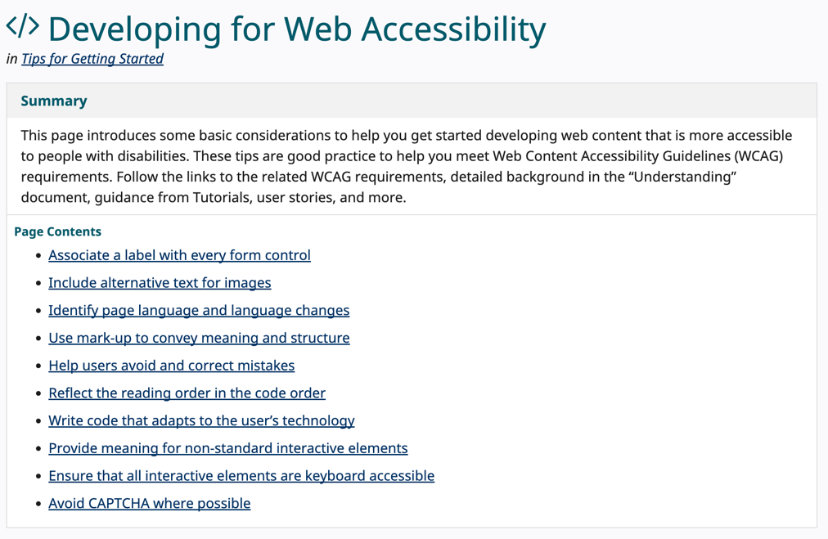
Figure 28 - Example W3C WAI Guidance

W3C organisation also provide a list of utilities that can be used that will check through web pages and highlight where improvements can be made, these can be found at https://www.w3.org/WAI/ER/tools/.

A simple example of good practice is using the “for” attribute of the <label> tag to ensure that screen readers link the label to the correct input.

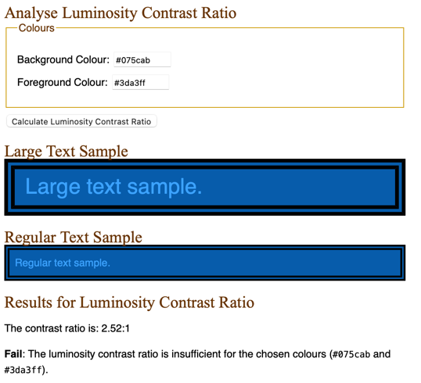

As part of the accessibility evaluation, the foreground and background colour hex values were input to to simple online tools. The tool then evaluates the colors and provides the contrast ratio.

As the screen shot shows in Figure 29, the tool provided by Juicy Studio [18], marks the contrast level as a “Fail”.

Figure 29 - Analyse Luminosity Contrast Ratio

In addition to checking for readability, for HTML authoring, tools can be installed to analyse code as you type and suggests changes that conform to good accessibility coding standards e.g. to ensure HTML tags and attributes are formatted for screen readers.


Figure 30 - VS Code Extension - Web Accessibility

This utility will check HTML as it’s being authored and highlight and suggest changes – this has the advantage of avoiding bad practice that may be picked up by testing later in the development cycle.

Here is an example highlighting the lack of “label for” in the code for the Contact Us page and highlight missing alternate text for images.
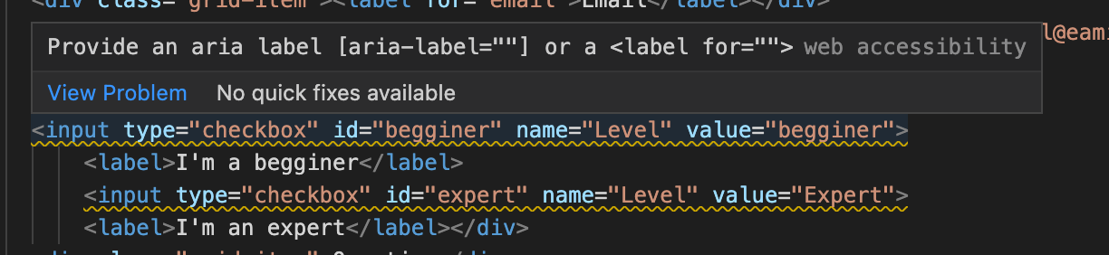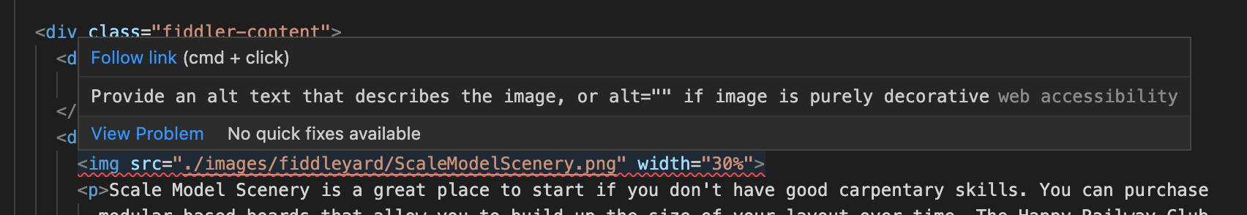
Figure 31 - Web Accessibility Good Practice

Report Summary
This report has described some example design techniques for developing responsive and themed web pages using HTML and CSS.

The next iteration of the website would be to utilise server-side technology such as PHP to allow a more interactive experience for a user and make the maintenance of the website an easier development task.

At each stage of the development lifecycle is will be important to ensure the principles regarding clear design, responsiveness, accessibility, and search engine optimisation are adhered to.

Bibliography

[1] | T. Harmer, “Introduction to Graphic Design,” Carpenteria, CA, 2018.
[2] | J. Beaird, The Principles of Beautiful Web Design, ProQuest Ebook Central, 2020.
[3] | istockphoto, “Dwalish,” [Online]. Available: https://www.istockphoto.com/photos/dawlish-train-storm-devon. [Accessed 28 03 2022].
[4] | Adobe, “Color Wheel,” 19 April 2022. [Online]. Available: https://color.adobe.com/create/color-wheel. [Accessed 19 April 2022].
[5] | fontspace.com, “Digital Scoreboard,” [Online]. Available: https://www.fontspace.com/category/digital,scoreboard. [Accessed 28 March 2022].
[6] | W. Schools, “Web Safe Fonts,” [Online]. Available: https://www.w3schools.com/cssref/css_websafe_fonts.asp. [Accessed 22 04 2022].
[7] | W. Schools, “CSS Navigation Bar,” [Online]. Available: https://www.w3schools.com/css/css_navbar.asp. [Accessed 19 April 2022].
[8] | T. a. o. S. 2. e. B. O. 2. E. Enge and E. Enge, The art of SEO, 2nd ed., Beijing : O’Reilly, 2012.
[9] | Google, “Search Engine Optimisation Starter Guide,” Google, [Online]. Available: https://developers.google.com/search/docs/beginner/seo-starter-guide. [Accessed 19 04 2022].
[10] | Microsoft, “Web Master,” [Online]. Available: https://www.bing.com/webmasters/about . [Accessed 28 03 2022].
[11] | U. Government, “Accessibility Requirements for Public Sector Websites and Apps,” [Online]. Available: https://www.gov.uk/guidance/accessibility-requirements-for-public-sector-websites-and-apps. [Accessed 18 04 2022].
[12] | W3C. [Online]. Available: https://www.w3.org/TR/WCAG20/. [Accessed 23 04 2022].
[13] | W3C. [Online]. Available: https://www.w3.org/WAI/fundamentals/accessibility-principles/. [Accessed 22 04 2022].
[14] | “svgsilh,” [Online]. Available: https://svgsilh.com/image/476375.html. [Accessed 29 March 2022].

Appendices

Web Site Code

<!DOCTYPE html>
<html lang="en-gb">

<head>
<meta charset="utf-8" />
<title>Home</title>
<title>Y Clwb Rheilffordd Hapus Iawn - Home</title>
<meta name="description" content="Y Clwb Rheilffordd Hapus Iawn provides a community web site for model railway enthusiates."/>

<link type="text/css" rel="stylesheet" href="style/main.css" />
<!-- <link type="text/css" rel="stylesheet" href="style/navbar.css" />
-->
</head>

<body>
<header id="main-header">
<div class="headergrid-container">
<div class="headergrid-item"></div>
<div class="headergrid-item"></div>
<div class="headergrid-item"></div>
<div class="headergrid-item"> <img src="./images/happyloco.svg"
alt="Y Clwb Rheilffordd Hapus Iawn - The Very Happy Railway Club logo" />
</div>
<div class="headergrid-item"><span>Y Clwb Rheilffordd Hapus Iawn</span></div>
<div class="headergrid-item"><img src="./images/happyloco.svg"
alt="Y Clwb Rheilffordd Hapus Iawn - The Very Happy Railway Club"></div>
<div class="headergrid-item"></div>
<div class="headergrid-item"></div>
<div class="headergrid-item"></div>

</div>
</header>

<nav id="navbar" title="Navigation Bar">
<div class="navgrid-container">
<div class="navbar-grid-item"></div>
<div class="navbar-grid-item"></div>
<div class="navbar-grid-item"></div>
<div class="navbar-grid-item"></div>
<div class="navbar-grid-item">
<ul>
<li><a href="index.html">Home</a></li>
<li><a href="news.html">News</a></li>
<li><a href="blogs.html">Blogs</a></li>
<li><a href="contactus.html">Contact</a></li>
<li><a href="friends.html">Friends</a></li>
<li><a href="fiddlers.html">Fiddle Yard</a></li>
<li><a href="membership.html">Membership</a></li>
<li><a href="about.html">About</a></li>
</ul>
</div>
<div class="navbar-grid-item"></div>
<div class="navbar-grid-item"></div>
<div class="navbar-grid-item"></div>
<div class="navbar-grid-item"></div>
</div>
</nav>

<section id="showcase">
<div class="container">
<h1><br /><br/>
Welcome to
<br />
<br />The Very Happy Railway Club
</h1>
<br/>
<br/>
<br/>
</h1>
</div>
</section>

<div class="container">

<section id="main">
<h1>The Club</h1>
<p>
The Very Happy Railway Club welcomes model railway enthuisiats of all ages.
This site contains various news about rail exhibitions, latest reviews of models, rolling stock and tools.
<br />
If creating scenics, crafting buildings and making scale models is your thing then check out our Fiddlers page.

</p>
</section>

<aside id="sidebar">
<p>
The admins of this site aim to update content twice weekly. If you wish to submit a blog
please sign up as a member and then we'll send you a howto and upload link.
</p>
</aside>

</div>

<footer id="main-footer">
<p>Copyright &copy; CRH Ltd</p>
</footer>

</body>

</html>

<!DOCTYPE html>
<html lang="en-gb">

<head>
<meta charset="utf-8"/>
<title>News</title>
<link type="text/css" rel="stylesheet" href="style/main.css" />

</head>

<body>
<header id="main-header">
<div class="headergrid-container">
<div class="headergrid-item"></div>
<div class="headergrid-item"></div>
<div class="headergrid-item"></div>
<div class="headergrid-item"> <img src="./images/happyloco.svg"
alt="Y Clwb Rheilffordd Hapus Iawn - The Very Happy Railway Club logo" />
</div>
<div class="headergrid-item"><span>Y Clwb Rheilffordd Hapus Iawn</span></div>
<div class="headergrid-item"><img src="./images/happyloco.svg"
alt="Y Clwb Rheilffordd Hapus Iawn - The Very Happy Railway Club"></div>
<div class="headergrid-item"></div>
<div class="headergrid-item"></div>
<div class="headergrid-item"></div>
</div>
</header>

<nav id="navbar" title="Navigation Bar">
<div class="navgrid-container">
<div class="navbar-grid-item"></div>
<div class="navbar-grid-item"></div>
<div class="navbar-grid-item"></div>
<div class="navbar-grid-item"></div>
<div class="navbar-grid-item">
<ul>
<li><a href="index.html">Home</a></li>
<li><a href="news.html">News</a></li>
<li><a href="blogs.html">Blogs</a></li>
<li><a href="contactus.html">Contact</a></li>
<li><a href="friends.html">Friends</a></li>
<li><a href="fiddlers.html">Fiddle Yard</a></li>
<li><a href="membership.html">Membership</a></li>
<li><a href="about.html">About</a></li>
</ul>
</div>
<div class="navbar-grid-item"></div>
<div class="navbar-grid-item"></div>
<div class="navbar-grid-item"></div>
<div class="navbar-grid-item"></div>
</div>
</nav>

<section id="showcase-news">
<div class="container">
</div>
</section>

<div class="container">

<section id="main">
<h1>News</h1>
<p><span style="font-weight:bold; background-color: #075cab">23 Feb 2002</span> - Rod Stewart to visit Tondu Railway Club in July 2024</p>
<p>Proin hendrerit quam mauris, a facilisis diam maximus in.</p>
<br>
<p>
<span style="font-weight:bold; background-color: #075cab">1st Jan 2022</span> - Hornby to release update to power controller
</p>
<p>
Lorem ipsum dolor sit amet, consectetur adipiscing elit. Proin hendrerit quam mauris, a facilisis diam maximus in. Ut facilisis, neque nec molestie ullamcorper, dolor quam hendrerit eros, quis blandit enim mi vel magna. Donec aliquam quam vel laoreet accumsan. In sagittis auctor venenatis. Donec tincidunt vulputate gravida. Duis eget turpis est. Curabitur eget venenatis tortor, non iaculis lectus. Etiam sagittis, lorem a varius consectetur, metus ipsum placerat nibh, quis pharetra leo ante a est.
</p>

</section>

<aside id="sidebar">
<p>
Lorem ipsum dolor sit amet, consectetur adipiscing elit. Proin hendrerit quam mauris, a facilisis diam maximus in. Ut facilisis, neque nec molestie ullamcorper, dolor quam hendrerit eros, quis blandit enim mi vel magna. Donec aliquam quam vel laoreet accumsan. In sagittis auctor venenatis. Donec tincidunt vulputate gravida. Duis eget turpis est.
</p>
</aside>

</div>

<footer id="main-footer">
<p>Copyright &copy; CRH Ltd</p>
</footer>

</body>
</html>

<!DOCTYPE html>
<html lang="en-gb">

<head>
<meta charset="utf-8" />
<title>Blogs</title>

<!-- plain javascript to include navbar on each page. -->
<link type="text/css" rel="stylesheet" href="../style/main.css" />

<!-- the use of css grid ensures responsive page -->
<style>
.grid-container {
display: grid;
grid-template-columns: auto auto auto;
background-color: #a68551;
padding: .5em;
margin: auto;
overflow: hidden;
width: 80%;
}

.grid-item h4 {
background-color: #25555C;
color: white;
text-align: centre;
}

.grid-item a {
background-color: #075cab;
}

.grid-item {
background-color: #25555C;
color: white;
border: 1px solid rgba(0, 0, 0, 0.8);
padding: 1em;
font-size: medium;
text-align: left;
}
</style>
</head>

<body>

<header id="main-header">
<div class="headergrid-container">
<div class="headergrid-item"></div>
<div class="headergrid-item"></div>
<div class="headergrid-item"></div>
<div class="headergrid-item"> <img src="./images/happyloco.svg"
alt="Y Clwb Rheilffordd Hapus Iawn - The Very Happy Railway Club logo" />
</div>
<div class="headergrid-item"><span>Y Clwb Rheilffordd Hapus Iawn</span></div>
<div class="headergrid-item"><img src="./images/happyloco.svg"
alt="Y Clwb Rheilffordd Hapus Iawn - The Very Happy Railway Club"></div>
<div class="headergrid-item"></div>
<div class="headergrid-item"></div>
<div class="headergrid-item"></div>

</div>
</header>

<nav id="navbar" title="Navigation Bar">
<div class="navgrid-container">
<div class="navbar-grid-item"></div>
<div class="navbar-grid-item"></div>
<div class="navbar-grid-item"></div>
<div class="navbar-grid-item"></div>
<div class="navbar-grid-item">
<ul>
<li><a href="index.html">Home</a></li>
<li><a href="news.html">News</a></li>
<li><a href="blogs.html">Blogs</a></li>
<li><a href="contactus.html">Contact</a></li>
<li><a href="friends.html">Friends</a></li>
<li><a href="fiddlers.html">Fiddle Yard</a></li>
<li><a href="membership.html">Membership</a></li>
<li><a href="about.html">About</a></li>
</ul>
</div>
<div class="navbar-grid-item"></div>
<div class="navbar-grid-item"></div>
<div class="navbar-grid-item"></div>
<div class="navbar-grid-item"></div>
</div>
</nav>

<br />
<div id="container">
<section>
<div class="grid-container">
<div class="grid-item">
<h4>Blog Date</h4>
</div>
<div class="grid-item">
<h4>Blogger</h4>
</div>
<div class="grid-item">
<h4>Summary</h4>
</div>

<div class="grid-item">23rd Jan 2022</div>
<div class="grid-item">Thomas T Engine</div>
<div class="grid-item">The cost of new locomotive models has sky rocketed since the start of the pandemic. This
article examines some of the reasons why.<br /><a href="./blogs/blog-2022-01-23.html" class="w3-button">View
blog...</a><br /></div>

<div class="grid-item">20th Februrary 2021</div>
<div class="grid-item">G Williams</div>
<div class="grid-item">What is DCC and some of the pitfalls when building a new dcc layout. <br /><a
href="./blogs/blog-2021-02-20.html" class="w3-button">View blog...</a><br /></div>

<div class="grid-item">17th Feb 20207</div>
<div class="grid-item">Percy Saddle Tank</div>
<div class="grid-item"> Lorem ipsum dolor sit amet, consectetur adipiscing elit. Proin hendrerit quam mauris, a
facilisis diam maximus in. Ut facilisis, neque nec molestie ullamcorper, dolor quam hendrerit eros, quis
blandit enim mi vel magna. Donec aliquam quam vel laoreet accumsan. <br /><a href="./blogs/blog-template.html"
class="w3-button">View blog...</a><br /></div>
</div>
</section>
</div>

</body>

</html>

<!DOCTYPE html>
<html lang="en-gb">

<head>
<meta charset="utf-8" />
<title>Contact Us</title>

<!-- plain javascript to include navbar on each page. -->
<link type="text/css" rel="stylesheet" href="style/main.css" />

<style>

.grid-container {
display: grid;
grid-template-columns: auto auto;
background-color: #a68551;
padding: 10px;
}
.grid-item {
background-color: rgba(255, 255, 255, 0.8);
border: 1px solid rgba(0, 0, 0, 0.8);
padding: 20px;
font-size: medium 30px;
text-align: left;

}

.grid-container2 {
display: grid;
grid-template-columns:
main input;
gap: 1px;
background-color: #a68551;
padding: 5px;

}
.col1 {
grid-area: main;
width: 50%;
}

.col2 {
grid-area: input;
width: 50%;
}

.grid-container2-item {
background-color: rgba(255, 255, 255, 0.8);
border: 1px solid rgba(0, 0, 0, 0.8);
padding: 20px;
font-size: medium;
text-align: left;
}

.grid-containerold {
display: grid;
grid-template-areas:
'menu main main main';
gap: 5px;
background-color: #FEBD23;
padding: 5px;
}

.grid-containerold div {
background-color: #333;
color: aliceblue;
text-align: center;
padding: 0;
font-size: 20px;
}
</style>
</head>

<body>
<header id="main-header">
<div class="headergrid-container">
<div class="headergrid-item"></div>
<div class="headergrid-item"></div>
<div class="headergrid-item"></div>
<div class="headergrid-item"> <img src="./images/happyloco.svg"
alt="Y Clwb Rheilffordd Hapus Iawn - The Very Happy Railway Club logo" />
</div>
<div class="headergrid-item"><span>Y Clwb Rheilffordd Hapus Iawn</span></div>
<div class="headergrid-item"><img src="./images/happyloco.svg"
alt="Y Clwb Rheilffordd Hapus Iawn - The Very Happy Railway Club"></div>
<div class="headergrid-item"></div>
<div class="headergrid-item"></div>
<div class="headergrid-item"></div>

</div>
</header>

<nav id="navbar" title="Navigation Bar">
<div class="navgrid-container">
<div class="navbar-grid-item"></div>
<div class="navbar-grid-item"></div>
<div class="navbar-grid-item"></div>
<div class="navbar-grid-item"></div>
<div class="navbar-grid-item">
<ul>
<li><a href="index.html">Home</a></li>
<li><a href="news.html">News</a></li>
<li><a href="blogs.html">Blogs</a></li>
<li><a href="contactus.html">Contact</a></li>
<li><a href="friends.html">Friends</a></li>
<li><a href="fiddlers.html">Fiddle Yard</a></li>
<li><a href="membership.html">Membership</a></li>
<li><a href="about.html">About</a></li>
</ul>
</div>
<div class="navbar-grid-item"></div>
<div class="navbar-grid-item"></div>
<div class="navbar-grid-item"></div>
<div class="navbar-grid-item"></div>
</div>
</nav>

<div class="container">

<section id="showcase-contactus">
<div class="container">
<h1>Contact Us</h1>
</section>
</div>

<div class="container">
<p style="color: aliceblue;">Please enter your contact details and question and we'll get back to you asap</p>
<div class="grid-container">
<div class="grid-item"><label for="fname">Name</label></div>
<div class="grid-item"><input type="text" id="fname" name="fname" value="John" /></div>
<div class="grid-item"><label for="email">Email</label></div>
<div class="grid-item"><input type="text" id="email" name="email" value="email@eamil"></div>
<div class="grid-item">Level</div>
<div class="grid-item">
<input type="checkbox" id="begginer" name="Level" value="begginer">
<label>I'm a begginer</label>
<input type="checkbox" id="expert" name="Level" value="Expert">
<label>I'm an expert</label></div>
<div class="grid-item">Question</div>
<div class="grid-item"><textarea id="w3review" name="w3review" rows="4" cols="30">
</textarea></div>
<div class="grid-item"></div>
<div class="grid-item"><input type="submit" value="Submit"></div>

</div>

</div>

<footer id="main-footer">
<p>Copyright &copy; CRH Ltd</p>
</footer>

</body>

</html>

<!DOCTYPE html>
<html lang="en-gb">

<head>
<meta charset="utf-8" />
<title>Friends</title>

<!-- plain javascript to include navbar on each page. -->
<link type="text/css" rel="stylesheet" href="style/main.css" />
<style>
.content-friends-grid{
display: grid;
grid-template-columns: auto auto auto;
grid-template-rows: auto auto;
grid-gap: 1rem;

}

.item2 {
color:aliceblue;
background-color: #075cab;
box-shadow: 1rem;
}

.item2 p {
margin: 1rem;
}
.content-friends-grid a {
color: #3da3ff ;
}

.banner-friends {
background-image: url('../images/friends.jpg');
opacity: 0.7;
z-index: 1;
width: 80%;
margin: auto;
overflow: hidden;
position: relative;
}

.banner-friends h1 {
color: #3da3ff, ;
font-size: xx-large;
text-align: center;
}

.content-friends {
width: 80%;
margin: auto;
overflow: hidden;

position: relative;
}

</style>
</head>

<body>
<header id="main-header">
<div class="headergrid-container">
<div class="headergrid-item"></div>
<div class="headergrid-item"></div>
<div class="headergrid-item"></div>
<div class="headergrid-item"> <img src="./images/happyloco.svg"
alt="Y Clwb Rheilffordd Hapus Iawn - The Very Happy Railway Club logo" />
</div>
<div class="headergrid-item"><span>Y Clwb Rheilffordd Hapus Iawn</span></div>
<div class="headergrid-item"><img src="./images/happyloco.svg"
alt="Y Clwb Rheilffordd Hapus Iawn - The Very Happy Railway Club"></div>
<div class="headergrid-item"></div>
<div class="headergrid-item"></div>
<div class="headergrid-item"></div>

</div>
</header>

<nav id="navbar" title="Navigation Bar">
<div class="navgrid-container">
<div class="navbar-grid-item"></div>
<div class="navbar-grid-item"></div>
<div class="navbar-grid-item"></div>
<div class="navbar-grid-item"></div>
<div class="navbar-grid-item">
<ul>
<li><a href="index.html">Home</a></li>
<li><a href="news.html">News</a></li>
<li><a href="blogs.html">Blogs</a></li>
<li><a href="contactus.html">Contact</a></li>
<li><a href="friends.html">Friends</a></li>
<li><a href="fiddlers.html">Fiddle Yard</a></li>
<li><a href="membership.html">Membership</a></li>
<li><a href="about.html">About</a></li>
</ul>
</div>
<div class="navbar-grid-item"></div>
<div class="navbar-grid-item"></div>
<div class="navbar-grid-item"></div>
<div class="navbar-grid-item"></div>
</div>
</nav>

<div class="banner-friends">
<div><br/><br/><h1>Friends</h1><br/><br/></div>

</div>

<div class="content-friends">
<p style="color: white;">This page lists the good friends and affiliates of this site that members may find useful. Please like and subscribe to their content.</p>

</div>

<section>
<div class="content-friends">

<div class="content-friends-grid">
<div class="item2"><p><a href="https://www.youtube.com/channel/UCMjSsrcmA4BNeAnh2NxYp0Q">Chadwick Model Railway</a><br>
<img src="./images/Friends/chadwick-logo.jpg" width="60" /><br></p>
<p>Charlie provides excellent hints and tips on his YouTube channel</p>
</div>
<div class="item2"><p><a href="https://www.youtube.com/channel/UCMjSsrcmA4BNeAnh2NxYp0Q">Strathpeffer Junction</a><br>
<img src="./images/Friends/strathpeffer-logo.jpg" width="60" /><br></p>
<p>Informative arcticles and videos including shop</p></div>
<div class="item2"><p><a href="https://www.youtube.com/channel/UCMjSsrcmA4BNeAnh2NxYp0Q">That Model Railway Guy</a><br>
<img src="./images/Friends/that-model-railway-guy.jpeg" width="60" /><br></p>
<p>That Model Reailway Guy provides some excellent advice for beginners</p>
</div>
<div class="item2"><p><a href="https://www.hattons.co.uk">Hattons</a><br>
<img src="./images/Friends/hattons.svg" width="60" /><br></p>
<p>A great shop to buy new and used models</p>
</div>
<div class="item2"><p><a href="https://www.mibmodels.co.uk">MIB Models</a><br>
<img src="./images/Friends/MIB-Models.jpeg" width="60" /><br></p>
<p>A great model shop based in South Wales. Stocks all kinds of locos and rolling stock.</p>
</div>
</div>
</div>

</section>

<footer id="main-footer">
<p>Copyright &copy; CRH Ltd</p>
</footer>

</body>

</html>

<!DOCTYPE html>
<html lang="en-gb">

<head>
<meta charset="utf-8" />
<title>Fiddle Yard</title>

<!-- plain javascript to include navbar on each page. -->
<link type="text/css" rel="stylesheet" href="style/main.css" />

<style>
.fiddler-container {
/* these are like defaults */
width: 80%;
margin: auto;
overflow: hidden;
padding: 1rem;
background-image: url('./images/fiddleyard2.jpg');
background-repeat: no-repeat;
background-attachment: fixed;
background-size: cover;
}

.fiddler-content {
color: white;
}

h2 {
color: white;

}

p {
color: white;

}

img {
float: right;
object-fit: fill;
}
</style>
</head>

<body>
<header id="main-header">
<div class="headergrid-container">
<div class="headergrid-item"></div>
<div class="headergrid-item"></div>
<div class="headergrid-item"></div>
<div class="headergrid-item"> <img src="./images/happyloco.svg"
alt="Y Clwb Rheilffordd Hapus Iawn - The Very Happy Railway Club logo" />
</div>
<div class="headergrid-item"><span>Y Clwb Rheilffordd Hapus Iawn</span></div>
<div class="headergrid-item"><img src="./images/happyloco.svg"
alt="Y Clwb Rheilffordd Hapus Iawn - The Very Happy Railway Club"></div>
<div class="headergrid-item"></div>
<div class="headergrid-item"></div>
<div class="headergrid-item"></div>

</div>
</header>

<nav id="navbar" title="Navigation Bar">
<div class="navgrid-container">
<div class="navbar-grid-item"></div>
<div class="navbar-grid-item"></div>
<div class="navbar-grid-item"></div>
<div class="navbar-grid-item"></div>
<div class="navbar-grid-item">
<ul>
<li><a href="index.html">Home</a></li>
<li><a href="news.html">News</a></li>
<li><a href="blogs.html">Blogs</a></li>
<li><a href="contactus.html">Contact</a></li>
<li><a href="friends.html">Friends</a></li>
<li><a href="fiddlers.html">Fiddle Yard</a></li>
<li><a href="membership.html">Membership</a></li>
<li><a href="about.html">About</a></li>
</ul>
</div>
<div class="navbar-grid-item"></div>
<div class="navbar-grid-item"></div>
<div class="navbar-grid-item"></div>
<div class="navbar-grid-item"></div>
</div>
</nav>

<br />
<div class="fiddler-container">

<div class="fiddler-content">
<div>
<h2>Getting Started</h2>
</div>
<div>
<img src="./images/fiddleyard/ScaleModelScenery.png" width="30%">
<p>Scale Model Scenery is a great place to start if you don't have good carpentary skills. You can purchase
modular based boards that allow you to build up the size of your layout over time. The Happy Railway Club
utilise alot of their time saving products which allows you to get on with more enjoyable tasks such and
services and running the locos themselves.</p>
</div>
<div>
<h2>Base Boards</h2>
<img style="float: left" src="./images/fiddleyard/woodwork.png" width="20%">
<p>If you are a happy to give wood work a go, we recommend making sure you purchase the correct clothing and
safety equipment, such as mask and gloves. There are all different kinds of makes out there, but any type will
do rather than not having any!</p>
</div>

<div>
<br>
<h2>Track Power</h2>
<p>Lorem ipsum dolor sit amet, consectetur adipiscing elit. Proin hendrerit quam mauris, a facilisis diam maximus in. Ut facilisis, neque nec molestie ullamcorper, dolor quam hendrerit eros, quis blandit enim mi vel magna. Donec aliquam quam vel laoreet accumsan. In sagittis auctor venenatis. Donec tincidunt vulputate gravida. Duis eget turpis est. Curabitur eget venenatis tortor, non iaculis lectus. Etiam sagittis, lorem a varius consectetur, metus ipsum placerat nibh, quis pharetra leo ante a est.
</p>
</div>

<br>

<div>
<h2>Digital Control</h2>
<p>Lorem ipsum dolor sit amet, consectetur adipiscing elit. Proin hendrerit quam mauris, a facilisis diam maximus in. Ut facilisis, neque nec molestie ullamcorper, dolor quam hendrerit eros, quis blandit enim mi vel magna. Donec aliquam quam vel laoreet accumsan. In sagittis auctor venenatis. Donec tincidunt vulputate gravida. Duis eget turpis est. Curabitur eget venenatis tortor, non iaculis lectus. Etiam sagittis, lorem a varius consectetur, metus ipsum placerat nibh, quis pharetra leo ante a est.
</p>
</div>
</div>
</div>

<footer id="main-footer">
<p>Copyright &copy; CRH Ltd</p>
</footer>

</body>

</html>

<!DOCTYPE html>
<html lang="en-gb">

<head>
<meta charset="utf-8" />
<title>Memberhship</title>

<!-- plain javascript to include navbar on each page. -->
<link type="text/css" rel="stylesheet" href="style/main.css" />

<style>
/*
This style and form was adapted from W3 Schools Responsive Forms example:
https://www.w3schools.com/howto/tryit.asp?filename=tryhow_css_responsive_form
*/

* {
box-sizing: border-box;
}

input[type=text],
select,
textarea {
width: 100%;
padding: 12px;
border: 1px solid #ccc;
border-radius: 4px;
resize: vertical;
}

label {
padding: 12px 12px 12px 0;
display: inline-block;
color: white;
}

input[type=submit] {
background-color: #075cab;
color: white;
padding: 12px 20px;
border: none;
border-radius: 4px;
cursor: pointer;
float: right;
}

input[type=submit]:hover {
background-color: #3da3ff;
}

.container {
border-radius: 5px;
background-color: #a68551;
padding: 20px;
}

.col-25 {
float: left;
width: 25%;
margin-top: 6px;
}

.col-75 {
float: left;
width: 75%;
margin-top: 6px;
}

/* Clear floats after the columns */
.row:after {
content: "";
display: table;
clear: both;
}

/* Responsive layout - when the screen is less than 600px wide, make the two columns stack on top of each other instead of next to each other */
@media screen and (max-width: 600px) {

.col-25,
.col-75,
input[type=submit] {
width: 100%;
margin-top: 0;
}
}

p {
color: white;
}

h2 {
color: white;
}
</style>
</head>

<body>
<header id="main-header">
<div class="headergrid-container">
<div class="headergrid-item"></div>
<div class="headergrid-item"></div>
<div class="headergrid-item"></div>
<div class="headergrid-item"> <img src="./images/happyloco.svg"
alt="Y Clwb Rheilffordd Hapus Iawn - The Very Happy Railway Club logo" />
</div>
<div class="headergrid-item"><span>Y Clwb Rheilffordd Hapus Iawn</span></div>
<div class="headergrid-item"><img src="./images/happyloco.svg"
alt="Y Clwb Rheilffordd Hapus Iawn - The Very Happy Railway Club"></div>
<div class="headergrid-item"></div>
<div class="headergrid-item"></div>
<div class="headergrid-item"></div>

</div>
</header>

<nav id="navbar" title="Navigation Bar">
<div class="navgrid-container">
<div class="navbar-grid-item"></div>
<div class="navbar-grid-item"></div>
<div class="navbar-grid-item"></div>
<div class="navbar-grid-item"></div>
<div class="navbar-grid-item">
<ul>
<li><a href="index.html">Home</a></li>
<li><a href="news.html">News</a></li>
<li><a href="blogs.html">Blogs</a></li>
<li><a href="contactus.html">Contact</a></li>
<li><a href="friends.html">Friends</a></li>
<li><a href="fiddlers.html">Fiddle Yard</a></li>
<li><a href="membership.html">Membership</a></li>
<li><a href="about.html">About</a></li>
</ul>
</div>
<div class="navbar-grid-item"></div>
<div class="navbar-grid-item"></div>
<div class="navbar-grid-item"></div>
<div class="navbar-grid-item"></div>
</div>
</nav>

<br>
<div class="container">
<h2>Membership Details</h2>
<p>To receive news updates and be able to post blogs you will need to create a membership account.</p>
</div>
<br>
<div class="container">
<form action="/membership-thankyou.html">
<div class="row">
<div class="col-25">
<label for="fname">First Name</label>
</div>
<div class="col-75">
<input type="text" id="fname" name="firstname" placeholder="Your name..">
</div>
</div>
<div class="row">
<div class="col-25">
<label for="lname">Last Name</label>
</div>
<div class="col-75">
<input type="text" id="lname" name="lastname" placeholder="Your last name..">
</div>
</div>

<div class="row">
<div class="col-25">
<label for="email">Email</label>
</div>
<div class="col-75">
<input type="text" id="email" name="email" placeholder="Your email..">
</div>
</div>
<div class="row">
<div class="col-25">
<label for="SkillLevel">Skill Level</label>
</div>
<div class="col-75">
<select id="skilllevel" name="skilllevel">
<option value="australia">Begginer</option>
<option value="canada">Intermediate</option>
<option value="usa">Expert</option>
</select>
</div>
</div>
<div class="row">
<div class="col-25">
<label for="aboutyou">About you</label>
</div>
<div class="col-75">
<textarea id="aboutyou" name="aboutyou" placeholder="Write something.." style="height:200px"></textarea>
</div>
</div>
<div class="row">
<input type="submit" value="Submit">
</div>
</form>
</div>

<footer id="main-footer">
<p>Copyright &copy; CRH Ltd</p>
</footer>
</body>

</html>
<html>

<head>
<meta charset="utf-8" />
<title>About</title>
<link type="text/css" rel="stylesheet" href="style/main.css" />
</head>

<body>
<header id="main-header">
<div class="headergrid-container">
<div class="headergrid-item"></div>
<div class="headergrid-item"></div>
<div class="headergrid-item"></div>
<div class="headergrid-item"> <img src="./images/happyloco.svg"
alt="Y Clwb Rheilffordd Hapus Iawn - The Very Happy Railway Club logo" />
</div>
<div class="headergrid-item"><span>Y Clwb Rheilffordd Hapus Iawn</span></div>
<div class="headergrid-item"><img src="./images/happyloco.svg"
alt="Y Clwb Rheilffordd Hapus Iawn - The Very Happy Railway Club"></div>
<div class="headergrid-item"></div>
<div class="headergrid-item"></div>
<div class="headergrid-item"></div>
</div>
</header>

<nav id="navbar" title="Navigation Bar">
<div class="navgrid-container">
<div class="navbar-grid-item"></div>
<div class="navbar-grid-item"></div>
<div class="navbar-grid-item"></div>
<div class="navbar-grid-item"></div>
<div class="navbar-grid-item">
<ul>
<li><a href="index.html">Home</a></li>
<li><a href="news.html">News</a></li>
<li><a href="blogs.html">Blogs</a></li>
<li><a href="contactus.html">Contact</a></li>
<li><a href="friends.html">Friends</a></li>
<li><a href="fiddlers.html">Fiddle Yard</a></li>
<li><a href="membership.html">Membership</a></li>
<li><a href="about.html">About</a></li>
</ul>
</div>
<div class="navbar-grid-item"></div>
<div class="navbar-grid-item"></div>
<div class="navbar-grid-item"></div>
<div class="navbar-grid-item"></div>
</div>
</nav>

<div class="container">
<h1 style="color: white;">About</h1>
<p style="color: white;">This web site is maintained by a number of model railway enthusiasts.</p>
<p style="color: white;">The site was built in April 2022 with the aim of widening the model railway enthusiast community by Geoff Sleeper</p>
<p style="color: white;">The advancements in technology allow for ever more realistc modelling and expand interested in to areas such as electronics and 3D Prining. </p>
<p style="color: white;">As the content and maintenance of the site is run by amatuers there maybe a delay in submitting content while it's reviewed. </p>
<p style="color: white;">If you wish to be part of the admin team then please contact us view the Contact page.</p>
</div>

<footer id="main-footer">
<p>Copyright &copy; CRH Ltd</p>
</footer>

</body>

</html>

<html>

<head>
<meta charset="utf-8" />
<title>Blogs - The Spiralling Cost</title>

<!-- plain javascript to include navbar on each page. -->
<link type="text/css" rel="stylesheet" href="../style/main.css" />

<!-- the use of css grid ensures responsive page -->
<style>
.grid-container {
display: inline-grid;
grid-template-columns: auto auto auto;
background-color: #FEBD23;
padding: 1em;
width: 80%;
margin: 5%;
overflow: hidden;

}
.grid-item h4{
background-color: #25555C;
color: white;
text-align: centre;
}

.grid-item {
background-color: #25555C;
color: white;
border: 1px solid rgba(0, 0, 0, 0.8);
padding: 1em;
font-size: medium;
text-align: left;
}

</style>
</head>

<body>

<header id="main-header">
<div class="headergrid-container">
<div class="headergrid-item"></div>
<div class="headergrid-item"></div>
<div class="headergrid-item"></div>
<div class="headergrid-item"> <img src="./images/happyloco.svg"
alt="Y Clwb Rheilffordd Hapus Iawn - The Very Happy Railway Club logo" />
</div>
<div class="headergrid-item"><span>Y Clwb Rheilffordd Hapus Iawn</span></div>
<div class="headergrid-item"><img src="./images/happyloco.svg"
alt="Y Clwb Rheilffordd Hapus Iawn - The Very Happy Railway Club"></div>
<div class="headergrid-item"></div>
<div class="headergrid-item"></div>
<div class="headergrid-item"></div>

</div>
</header>

<nav id="navbar" title="Navigation Bar">
<div class="navgrid-container">
<div class="navbar-grid-item"></div>
<div class="navbar-grid-item"></div>
<div class="navbar-grid-item"></div>
<div class="navbar-grid-item"></div>
<div class="navbar-grid-item">
<ul>
<li><a href="index.html">Home</a></li>
<li><a href="news.html">News</a></li>
<li><a href="blogs.html">Blogs</a></li>
<li><a href="contactus.html">Contact</a></li>
<li><a href="friends.html">Friends</a></li>
<li><a href="fiddlers.html">Fiddle Yard</a></li>
<li><a href="membership.html">Membership</a></li>
<li><a href="about.html">About</a></li>
</ul>
</div>
<div class="navbar-grid-item"></div>
<div class="navbar-grid-item"></div>
<div class="navbar-grid-item"></div>
<div class="navbar-grid-item"></div>
</div>
</nav>

<section>
<div id="container">
<div class="grid-container">
<div class="grid-item" style="color: #FEBD23">
<h4>Blog Date</h4>
</div>
<div class="grid-item" style="color: #FEBD23">
<h4>Blogger</h4>
</div>
<div class="grid-item" style="color: #FEBD23">
<h4>Summary</h4>
</div>

<div class="grid-item">23rd Jan 2021</div>
<div class="grid-item">Thomas T Engine</div>
<div class="grid-item">The cost of new locomodtive models has sky rocketed since the start of the pandemic. This is some text about stuff. Click Here to see full article</div>

<div class="grid-item">17th Feb 20207</div>
<div class="grid-item">Percy Saddle Tank</div>
<div class="grid-item">9</div>
</div>
</div>
</section>

</body>

</html>

