A Critical Reading of Desire and Gender in Ovid’s Metamorphoses

This essay will be exploring themes of desire and gender in Ovid’s Metamorphoses. Ovid, born around the middle of the first century AD, once a lawyer and a later poet, had a keen interest in the science and politics of love. Desire and love throughout Metamorphoses are often intertwined, with no obvious distinction between the two, with the moment one falls in love being determined by sight and aesthetical beauty. Though he was recognised and won awards for his poetry, at the time of writing Metamorphoses, he was banished by the Augustinian government, the cause of his banishment has oft been contemplated by scholars with no definitive conclusion. His epic elegiac poem Metamorphoses has been interpreted in many different theoretical lights, though for the purpose of this study feminist approaches will be adopted. Three stories in particular will be analysed, namely the tales of Pan and Syrinx, Hermaphroditus and Salmacis and Philomela, Procne and Thereus. The epic poem itself, has a self-proclaimed purpose to ‘tell of bodies which have been transformed into shapes of different kinds’ and punishment or redemption through a transformation is a prominent theme. By critically reading these stories it will be argued that Ovid was trying to experiment with gender roles and the meaning of lust and desire within Graeco-Roman society.

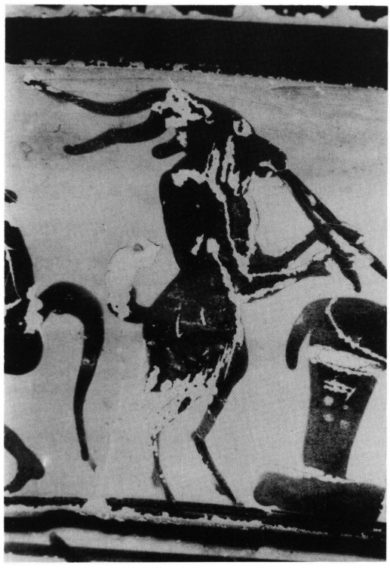
The myth of Pan and Syrinx (Ovid. Met. 1.689-1.712) is told by Mercury. It is of interest as it is the only story told with an ‘ulterior purpose,’ to assist Jupiter in re-abducting Io from his wife; essentially making it a myth about sexual assault with the purpose of helping a rapist and the cause of another transformee’s rescue. It is also the context which the story is placed which is intriguing, it is used as a soporific tale, and applauds non-violence in order to commit violence. There is no surviving contemporary art which focuses on this particular myth, though Pan and Syrinx in instrument form can sometimes be seen. Syrinx was a nymph and follower of the cult of Diana, which often penalised women who were raped or lost her virginity, making chastity more seemingly more repressive to female sexuality than non-chastity. Pan, who is known to be a lover of music, sees her and becomes enamoured, immediately giving chase. To escape his advances Syrinx prays to her sisters to help transform her, which they do by turning her into a reeve plant, essentially disappearing ‘in the process of her own rescue.’ That she wished to be transformed shows how powerless she felt in her ability to defend herself in her female form, the plant the preferable and only defence available to Syrinx in her desperation. After her transformation, whilst Pan is melancholy besides the plant, ‘the wind blew through the reeds, and produced a thin plaintive sound.’ Being interested in sound, he then cut some reeds to create the musical instrument of the syrinx, which was highly valued in antiquity. He steals her adapted body and adapts it once more with the words, ‘You and I shall always talk together so!’ It seems as though the acquisition of the instrument was a pyrrhic victory for Pan. He uses her body and forces her to speak and perform for him within his own hands, making the reader wonder to what extent the protection of her new form truly was worth, as he still benefits from her body, only now it is for eternity and he possesses and controls her voice too. The music of the syrinx is also noted to drive listeners into a state of frenzy, perhaps linking the noise of the instrument to the lust it was possessed by. Daphne and Syrinx’s transformed forms were both adapted by the Gods of art and music for their own inspiration and benefit. This signifies the male need to use women as muses for art, song, victory, and desire; it can also indicate unequal gender divides within all of these realms because the male benefits from the female form, even after it is transformed for protective purposes.
Figure 1. Depiction of Pan playing instrument
Fragment of a volute krater
https://books.openedition.org/pulg/204

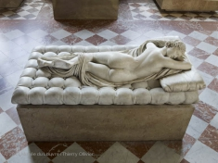
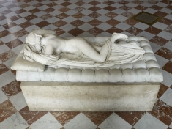
Figure 3. Statue of Hermaphroditus sleeping (front)
Louvre Museum
https://www.louvre.fr/en/oeuvre-notices/sleeping-hermaphroditos

Figure 2. Statue of Hermaphroditus sleeping (back)
Copy of 2nd Century BC original
Louvre Museum
https://www.louvre.fr/en/oeuvre-notices/sleeping-hermaphroditos
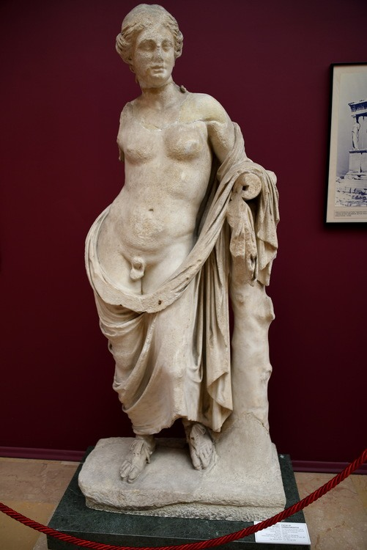
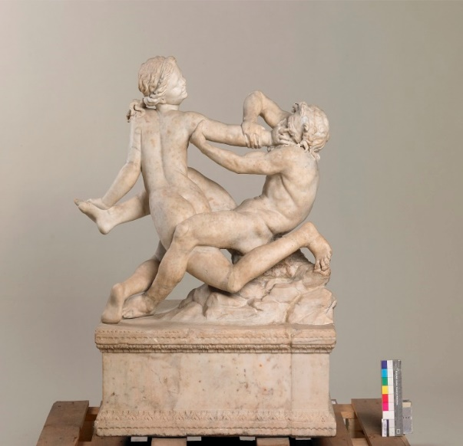
The myth of Hermaphroditus and Salmacis (Ovid. Met. 3.339-3.510) is another myth which focuses on gender roles, sexual abuse and lust, but uses a completely different narrative frame and theme to do so. In another ancient text which directly mentions Hermaphroditus, though not in conjunction with Salmacis, it seem as though he was born intersex, and that those who are born that way have special powers (Diod. Sic. 4.6.5). However, from an inscription on the spring of Salmacis, another versions of the tale, Salmacis is mentioned in a more innocent light where Hermaphroditus and Salmacis are linked to the creation of the ‘marriage bed’ and fertility. In this version, the creation of the marriage bed closely intertwined with ‘taming the savage mind of men.’ It could be argued that through the taming, the purpose of the spring is essentially the same, to make men more imbued with feminine qualities in order to calm their more base instincts. This also could have been the inspiration for Ovid’s alteration of the tale, the only recorded version where his inter-sex status has a cause. Salmacis is more masculine than the male and her sexual lust is an immediate need as is Zeus’s, Pan’s and most other male figures in the poem and is determined by the moment she sees Hermaphroditus. Thus the roles in Ovid’s version are warped from the start, with Salmacis being different to the ‘normal’ Diana-following nymphs therefore perhaps showing us her as unchaste, and themes of gender inversion are imbued throughout the whole text. She is exactly what many men at the time feared from their women as she defies the typical gender stereotypes; yet her activities are definitely more feminine pastimes, choosing to look beautiful instead of hunting. This may indicate that women who appreciate their own beauty are more dangerous and yet less likely to be abused as well as the possibility that women are similar to males but men are simply unaware or in denial. Hermaphroditus shuns female attentions as much as a nymph might commonly do, and therefore, though in a male form, may already be considered as more feminine, even before he is transformed. Because of the outcome of his rape, Ovid is signifying that men who are overpowered and raped by women are so effeminate that their gender itself is then pulled into question. However, despite the outcome, probably because of his status as male, even though he is shamed and transformed, his transformation is not that harsh as he still remains in control of his body, as Salmacis is the one who gets lost in him and therefore absorbed and he still owns the voice and consciousness of the new intersex form. The art which surrounds Hermaphroditus usually show him as extremely effeminate, though he still has male genitalia, and he is often depicted as an object of beauty and melancholy, and not so much as one of ridicule, with the exception of him being pursued by a Satyr. Most depictions of him come within the form of statues, and there are no known statues which have references to Ovid’s mention of him and Salmacis, therefore perhaps indicating that the other two variations may have been the more prominent versions of the tale.
Figure 4. Statue of Hermaphroditus
3rd Century BC
Museum of Archaeology, Turkey
https://www.ancient.eu/image/8684/statue-of-hermaphroditus-from-pergamon/
Figure 5. Statue of Hermaphroditus and Satyr
2nd Century AD
Museum of Liverpool
http://www.liverpoolmuseums.org.uk/wml/collections/antiquities/roman/ince-blundell/item-442116.aspx

The myth of Philomela, Procne and Tereus (Ovid. Met. 6.423-674) also includes the recurring theme of an initial violation of the female body, followed by a silencing or metamorphoses of voice through transformation, or in this case a literal abolishment of her ability to speak. From the wedding at the beginning of the tale to the end, furies are mentioned. Gildenhard and Zissos argue that these beings as well as the absence of the Gods is Ovid trying to represent ‘hell’ but this does not seem credible enough, as Ovid was in effect reiterating Greek myths, which do not agree with the concepts of a clear-cut heaven and hell. Therefore, the use of words such as ‘hell’ instead of Tartarus or Hades seems to invalidate the credibility of an otherwise realistic interpretation of the purpose of these valid issues within the tale.
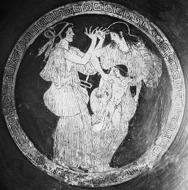
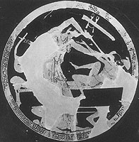
The Gods by name are not directly mentioned, and their lack of presence telling as they do not answer Philomena’s prayers. When Philomela is violated, the way she strikes back is through the power of ‘her words, which roused the fierce tyrant to anger, and to fear no less,’ instead of through the power of the Gods themselves as in the past tales. This scene is an obvious indication to the source of a female’s defence being the voice, and Tereus’ following action to draw his sword shows where the power of males lie too, within their strength. Therefore, invocation of the Gods, though powerful enough to rise Tereus to fear, were not powerful enough to defend her from his body or the weakness of her own, and so she and Procne have to carry out their own revenge by killing Itys and feeding him to his father. This could be seen as earth falling into scenes of disorder due to the lack of the presence of Gods, but this is also contradictory as in all the past tales, it has primarily been the Gods who have been at fault. However, even though she is denied her voice, and therefore censored, she finds a way around this to make herself heard; maybe indicating that censorship is never truly final and by trying to censor people, terrible things can happen as a consequence. To retake her sister, Procne dresses as male Bacchus, she receives the strength of the male disguise she dons which is interesting, as she strips herself of her gender in order to complete the task; and her sister is unknowing of this, making her more terrified for no apparent cause. As someone who is sympathetic to Philomena, she must have thought of the trauma her sister had endured, to dress as a man to ‘reclaim’ her shows no sympathy; and it also confuses gender within the tale more. In terms of depictions of them in art, there are not many and those which exist seem to primarily date to the 5th century BC. In those available, there seems to be little empathy for the actions taken by these sisters, and they are villainised though not for the vengeance, but for the unjust murder of Itys.
Figure 6. Procne & Philomela with Itys
5th century BC
Louvre Museum
https://antipodeanodyssey.wordpress.com/2017/05/01/philomelas-silence/
Figure 7. Procne & Itys
5th century BC
https://www.beazley.ox.ac.uk/dictionary/Dict/ASP/dictionarybody.asp?name=Prokne
Munich, Antikensammlungen

As we can see from the three myths analysed, love and desire in Ovid’s Metamorphoses are closely intertwined and often interchangeable with one another, with no differentiation to the meaning of the words. Desire, or love depending on which word is used, seems to be the undoing of all human norms and societal boundaries. In all these myths, love and desire are defined by the aesthetical beauty of the one being pursued and the longing to acquire that beauty by the pursuer. By using themes of gender inversion and transformation, Ovid introduces gender themes into the tales; this is especially noticeable in the tale of Hermaphroditus where it seems as though he has completely altered gender realities in order to fit in with the new gender narratives he was trying to implement. In general, it seems as though females were viewed as the victims, though in Hermaphroditus, he is the one who we need to take pity on; however this is precisely because of the gender inversion which makes her more masculine. And whenever women do have masculine traits (such as the ability to kill their own children and ignore maternal instincts) they are the villainised gender. However, when they do not act masculine, they still are punished and pursued just the same. The issue of possession and mutilation of the female form and voice is a prominent issues in all of these myths, and using voice as a powerful force in its own right.

Bibliography

Barker, Justin L. “Teaching Note The #MeToo Movement and Ovid’s Philomela” Radical Teacher. Volume 110 (2018): pp.65-67

Berger, Harry. “Orpheus, Pan, and the Poetics of Misogyny: Spenser's Critique of Pastoral Love and Art” ELH. Vol. 50.2 (1983): pp.27-60

Curran, Leo C. “Rape and Rape Victims in Ovid’s Metamorphoses” Arethusa. Vol. 11.1-2 (1978): pp.213-241

Enterline, Lynn. “You Speak a Language that I Understand Not": The Rhetoric of Animation in The Winter's Tale. Shakespeare Quarterly. Vol. 48.1 (1997): pp. 17-44 Berger

Fowler, Don. Roman Constructions: Readings in Postmodern Latin. (Oxford: Oxford University Press, 2000)
Fabre-Serris. Jacqueline “Desire and Rape in the Feminine: The Tales of Echo and Salmacis: An Ovidian Answer to Propertius 1.20?” Helios. Vol. 45.2 (2018): pp.127-144

Gildenhard Ingo & Andrew Zissos. “Barbarian variations: Tereus, Procne and Philomela in Ovid (Met. 6.412-674) and Beyond. Dictynna. Volume 4 (2007): pp.1-22

Groves, Robert. “From Statue to Story: Ovid’s Metamorphosis of Hermaphroditus” Classical World. Volume 109.3 (2016): pp.321-356

Hogue, Cynthia. Scheming Women: Poetry, Privilege, and the Politics of Subjectivity (New York: State University of New York Press, 1995)

Hubbard, Thomas K. The Pipes of Pan: Intertextuality and Literary Filiation the Pastoral Tradition from Theocritus to Milton (Michigan: The University of Michigan Press, 1998)

Murgatroyd P. “Ovid’s Syrinx” The Classical Quarterly. Vol. 51.2 (2001): pp.620-623

Ovid & Mary Innes. The Metamorphoses of Ovid. (Penguin Books Ltd, 1955)

Press, Gerald A. Plato’s Dialogues: New Studies and Interpretations, (Rowman & Littlefield Publications Inc, 1993)

Robinson, M. “Salmacis and Hermaphroditus: When Two Become One: (Ovid, Met. 4.285-388)” The Classical Quarterly. Vol. 49.1 (1999): pp.212-232

Romano, Allen J. “The Invention of Marriage: Hermaphroditus and Salmacis at Halicarnassus and in Ovid.” The Classical Quarterly. Vol. 59.2 (2009): pp543-561

Steele R. B. “Ovid” The Sewanee Review. Vol. 14.2 (1906): pp.184-185

Images

Figure 1.
https://books.openedition.org/pulg/204 (accessed 24/05/2019)
Allard Pierson Museum Amsterdam

Figure 2 & 3
https://www.louvre.fr/en/oeuvre-notices/sleeping-hermaphroditos (accessed 26/06/2019)
Louvre Museum

Figure 4.
https://www.ancient.eu/image/8684/statue-of-hermaphroditus-from-pergamon/ (accessed 28/05/2019)
Museum of Archaeology, Turkey

Figure 5.
http://www.liverpoolmuseums.org.uk/wml/collections/antiquities/roman/ince-blundell/item-442116.aspx (accessed 27/05/2019)
Museum of Liverpool

Figure 6.
https://antipodeanodyssey.wordpress.com/2017/05/01/philomelas-silence/ (accessed 28/05/2019)
Louvre Museum
Figure 7.
https://www.beazley.ox.ac.uk/dictionary/Dict/ASP/dictionarybody.asp?name=Prokne (accessed 28/05/2019)
Munich, Antikensammlungen

Ovid & Mary Innes (1955) The Metamorphoses of Ovid. Penguin Books Ltd: pp.10
Jacqueline Fabre-Serris (2018) Desire and Rape in the Feminine: The Tales of Echo and Salmacis: An Ovidian Answer to Propertius 1.20? Helios. Vol. 45.2: pp.139
Ovid & Mary Innes (1955) The Metamorphoses of Ovid. Penguin Books Ltd: pp.12
R. B. Steele (1906) Ovid, The Sewanee Review. Vol. 14.2: pp.184-185
Ovid & Mary Innes (1955) The Metamorphoses of Ovid. Penguin Books Ltd: pp.29
P. Murgatroyd (2001) Ovid’s Syrinx. The Classical Quarterly. Vol. 51.2: pp.621
Leo C. Curran (1978) Rape and Rape Victims in Ovid’s Metamorphoses. Arethusa. Vol. 11.1-2: pp.213
We can see the extent which the cult shuns those who are raped by the followers of Diana in the story of Jupiter and Callisto in (Ovid. Met. 2.401-2.507)
Harry Berger (1983) Orpheus, Pan, and the Poetics of Misogyny: Spenser's Critique of Pastoral Love and Art, ELH. Vol. 50.2: pp.34
Ovid & Mary Innes (1955) The Metamorphoses of Ovid. Penguin Books Ltd: pp.47
Cynthia Hogue (1995) Scheming Women: Poetry, Privilege, and the Politics of Subjectivity. State University of New York Press, pp.3
Ovid & Mary Innes (1955) The Metamorphoses of Ovid. Penguin Books Ltd: pp.48
Thomas K. Hubbard (1998) The Pipes of Pan: Intertextuality and Literary Filiation the Pastoral Tradition from Theocritus to Milton The University of Michigan Press, pp.63
Ovid & Mary Innes (1955) The Metamorphoses of Ovid. Penguin Books Ltd: pp.48
Gerald A. Press (1993) Plato’s Dialogues: New Studies and Interpretations, Rowman & Littlefield Publications Inc, pp.187
Cynthia Hogue (1995) Scheming Women: Poetry, Privilege, and the Politics of Subjectivity State University of New York Press, pp.3
Lynn Enterline (1997) “You Speak a Language that I Understand Not": The Rhetoric of Animation in The Winter's Tale. Shakespeare Quarterly. Vol. 48.1: pp.23
Allen J. Romano (2009) The Invention of Marriage: Hermaphroditus and Salmacis at Halicarnassus and in Ovid. The Classical Quarterly. Vol. 59.2: pp544, 546
Robert Groves (2016) From Statue to Story: Ovid’s Metamorphosis of Hermaphroditus, Classical World, 109.3 pp.323
Allen J. Romano (2009) The Invention of Marriage: Hermaphroditus and Salmacis at Halicarnassus and in Ovid. The Classical Quarterly. Vol. 59.2: pp549
Don Fowler (2000) Roman Constructions: Readings in Postmodern Latin. Oxford: pp.168
Jacqueline Fabre-Serris (2018) Desire and Rape in the Feminine: The Tales of Echo and Salmacis: An Ovidian Answer to Propertius 1.20? Helios. Vol. 45.2: pp.139
M. Robinson (1999) Salmacis and Hermaphroditus: When Two Become One: (Ovid, Met. 4.285-388), The Classical Quarterly. Vol. 49.1: pp.218
Jacqueline Fabre-Serris (2018) Desire and Rape in the Feminine: The Tales of Echo and Salmacis: An Ovidian Answer to Propertius 1.20? Helios. Vol. 45.2: pp.128
Jacqueline Fabre-Serris (2018) Desire and Rape in the Feminine: The Tales of Echo and Salmacis: An Ovidian Answer to Propertius 1.20? Helios. Vol. 45.2: pp.129
Jacqueline Fabre-Serris (2018) Desire and Rape in the Feminine: The Tales of Echo and Salmacis: An Ovidian Answer to Propertius 1.20? Helios. Vol. 45.2: pp.139
Ingo Gildenhard and Andrew Zissos (2007) Barbarian variations : Tereus, Procne and Philomela in Ovid (Met. 6.412-674) and Beyond. Dictynna. Volume 4: pp.4
Ovid & Mary Innes (1955) The Metamorphoses of Ovid. Penguin Books Ltd: pp.149
Justin L. Barker (2018) “Teaching Note The #MeToo Movement and Ovid’s Philomela” Radical Teacher. Volume 110: pp.66
Ingo Gildenhard and Andrew Zissos (2007) Barbarian variations : Tereus, Procne and Philomela in Ovid (Met. 6.412-674) and Beyond. Dictynna. Volume 4: pp.22
Jacqueline Fabre-Serris (2018) Desire and Rape in the Feminine: The Tales of Echo and Salmacis: An Ovidian Answer to Propertius 1.20? Helios. Vol. 45.2: pp.139

