
Audit of a Holiday Inn Hotel

Stilyana Mincheva (1816276) | Lecturer: Dr Olu Adegbite | Management and Organizational Behaviour

Executive Summary

In the report, the organization audit of Holiday Inn has been discussed to analyze the organizational performance and strategic direction. Holiday Inn is a global organization whose primary culture is based on creating a respectful and diverse workplace that can provide genuine hospitality and do business in a way that is fair and robust. However, COVID-19 created challenges for the overall market growth, which is the reason they had to bring visible changes in their market growth while maintaining the safety of the customers as well as the staff.

Table of Contents
Introduction 3
Organization Structure, Culture, and Values 3
Change Initiatives and Their Impact 4
Strategic Direction and Current Business Performance 6
Recommendations 8
Conclusion 8
Reference List 8
Appendix: Theory of E and O Combined 10

Introduction
The organizational audit can be defined as independent as well as consulting activity and objective assurance that has been designed so that value can be added, and operations of the organizations can be improved. In the report, the organization audit of Holiday Inn has been discussed to analyze the organizational performance and strategic direction.

Organization Structure, Culture, and Values
Organizational Structure
Holiday Inn is one of the most well-known five-star hotels whose headquarter established in Denham, Buckinghamshire, UK. In 2018 the company earned revenue of $4,627 million, and the net profit of the company was $630 million (IHG, 2020). The reason behind successful existence is the leadership of their board which oversees and reviews the activities of the group. They are responsible for setting the strategic direction and aim to deliver sustainable value for a long time (IHG, 2020). As per the opinion of Pawirosumarto, Sarjana and Gunawan (2017), the organizational structure is essential as it provides the teams and employees with tasks and procedures that are well-structured and help them to fulfil their job roles in respect of completing the objectives under their guidance as well as supervision. As far as Holiday Inn is concerned, the hotel chain has a very authentic functional organizational structure, where the head of the board is a non-executive chair under which chief executive officer operates (IHG, 2020). Moreover, there are chief executive officers and non-executive directors who look after the overall process of the organization. Furthermore, each hotel has its general managers under which various department works: among which HR, finance, food, and beverage directors, marketing, and sales managers along with residential managers are essential who is responsible for doing their jobs maintaining the rules and regulations.

Figure 1: Structure of Holiday Inn
(Source: Pawirosumarto, Sarjana and Gunawan, 2017)
Culture and Values
On the other hand, Camelia et al. (2019) mentioned that organizational culture is the starting point for the top management to establish ethical values within the organization which further influences the employees and staff to act appropriately so that they can enhance their performance and bring satisfaction in the work process. Holiday Inn is a global organization whose primary culture based on creating a respectful and diverse workplace that can provide genuine hospitality and do business in a way that is fair and robust (IHG, 2020). As suggested by Belias, Mantas and Tsiotas (2019), values are directly linked with culture, and they are necessary to support growth and value creation. That is the reason, IHG supports human rights policies and have where discriminations are not tolerated, and everyone has equal rights irrespective of class, race, and community. The company does not support child labour and maintain safety procedures (IHG, 2020).

Change Initiatives and Their Impact
Changes are one of the constant things that occur in the hotel industry, especially after the advent of COVID-19 in the UK. As per the view of Karim et al. (2020), after COVID-19 the world is going to witness a dramatic change in the hospitality sector as the industry will further focus on health security and customized experience so that they can come out of the loss they had to suffer for the pandemic. The company for further changes can maintain the Theory Of E and Theory of E integrate based on which they explicitly embraced the paradox between economic value and organizational capability while setting directly from the top and engage the people below [Refer to Appendix].
Giving Guest safety and flexibility
IHG is determined to bring changes in the hygiene standard as well as the safety standard to persuade the customers to return to the hotel in the UK. After the advent of the pandemic, the company took some drastic decisions regarding safety and flexibility of the guests. Hence, the hotel is developing daily monitoring and contacting the relevant authorities in the UK regularly (Hancock, 2020).
Booking and Loyalty
Since the hotel understands the current situation, they have launched a new Book Now Pay Later facility for the guests and also special hotel rates for the government workers and healthcare professionals. They created changes in IHG Reward Club loyalty programs to assist the members in protecting their status (Hancock, 2020). Moreover, hotels offered accommodation for homeless people initiated by the government and for which £236 million has allocated. However, before giving them space, they have been tested, and 300 beds were assigned to them so that they can maintain the isolation in the period of the pandemic (Townsend, 2020).
IHG Way of Cleaning
Moreover, they are changing their way of cleaning so that they can provide safety to the guests and their employees. According to Karim et al. (2020), massive changes are required to be brought to fight the situation, and that is the reason best policies are needed to be implemented. The company has reduced contacts in terms of check-ins and performed touchless transactions, sanitized keycards, and paperless checkouts (IHG, 2020).

Figure 2: Change Initiatives and Their impact
(Source: Karim et al. 2020)

Strategic Direction and Current Business Performance

Strategic direction is one of the essential factors in understanding the goals and objectives of the company, which further contributes to vision achievements. In compliance with Samsudin and Wahab (2018), through the strategic report, the companies try to develop the proposed model that can bring stability to the business and bring economic sustainability. While analyzing the strategic direction of the Holiday Inn, it can be said that they focused on unlocking ways that help in executing successful strategies at a faster pace while achieving accelerated growth (IHG, 2020). The company has created its IHG’s strategic model, which is based on five factors. Those are “Build and Leverage Scale, Strengthen Loyalty Program, Enhance Revenue Delivery, Evolve Owner Proposition and Optimize Preferred Portfolio of Brands for Owners & Guests” (IHG, 2020).

Figure 3: IHG’s Strategic Model
(Source: IHG, 2020)
Applying the model, the company managed to enhance its franchise hotel business and gain growth while creating the right offer for the guests as well as owners based on their needs. Not only that, but the company has created commercial as well as the technological organization that includes B2B sales, booking channels, and revenue management systems. Through this, the company wants to enhance its speed and efficiency while deploying new products. Moreover, the company has launched several loyalty programs while going into partnership with Amazon Kindle, OpenTable, and Grubhub (IHG, 2020).
As opined by Elbanna (2016), strategic direction helps the businesses to attain financial stability bring consistency as well as vital control in the industry, which further allows efficient decision-making. The company gained $4,337m in total revenue which is higher than the previous year by 6.4% (IHG, 2020). Moreover, the company managed $566m in operating profit and total gross revenue of $27.4bn (IHG, 2020). The current business performance shows that the company is one of the most successful hotels industry in the world and the UK. The growth has been achieved since the high-quality company principles while maintaining disciplines and committing resources while delivering sustainable growth for the stakeholders.

Recommendations
Therefore, to improve and maintain the overall performance, it is required to create a strategy that can connect the organizational culture with employee performance and the current performance of IHG.
- The company can include Performance management software to save time and improve the overall performance of the employees.
- The management should create a feedback process that includes the working performance of the employees so that in terms of cleaning and managing guests, better performance can be provided.
- The hotel management can be setting regular meetings with the management and employees to look after the COVID-19 situation and ensure the safety and care for the guests.

Conclusion

While concluding the report, it can be said that IHG has delivered significant growth in its market position and managed to create value and improve its performance in the process. However, COVID-19 created challenges for the overall market growth, which is the reason they had to bring visible changes in their market growth while maintaining the safety of the customers as well as the staff. It cannot be denied that structure is essential for the growth of the company and in IHG follows an authentic, functional organizational structure which gives the effective oversight and provides them with strategic direction. Moreover, the culture of the company ensures diversity as well as an inclusive culture. Additionally, their culture is to welcome and care about the guests and employees. Their goal is to create memorable guests’ experiences and to create thoughtful programs so that environment can be saved.

Reference List
Belias, D., Mantas, C. and Tsiotas, D. (2019). The impact of corporate culture in the performance of the front desk employees—The case of five-star hotels in Greece. Smart tourism as a driver for culture and sustainability (pp. 563-576). Springer, Cham.
Camelia, G., Ioana-Valentina-Alexandra, M. and Larisa-Andreea, N. (2019). Organizational Culture: A Case Study of The Impact of Ethical Organizational Culture On The Efficiency Of Accor Hotels. Romanian Economic and Business Review, 14(2), pp.86-96.
Elbanna, S. (2016). Managers’ autonomy, strategic control, organizational politics and strategic planning effectiveness: An empirical investigation into missing links in the hotel sector. Tourism Management, 52, pp.210-220.
Gössling, S., Scott, D. and Hall, C.M., (2020). Pandemics, tourism, and global change: a rapid assessment of COVID-19. Journal of Sustainable Tourism, pp.1-20.
Hancock, A. (2020). IHG warns coronavirus is hotels’ ‘most significant challenge. Accessed on: 10/7/2020. Available at: https://www.ft.com/content/2a470537-ab84-43b8-80b2-df088de2a72f
IHG (2020). Our Board. Accessed on: 10/7/2020. Available at: https://www.ihgplc.com/en/about-us/our-leadership/our-board
IHG (2020). Our culture. Accessed on: 10/7/2020. Available at: https://www.ihgplc.com/responsible-business/our-culture
IHG (2020). Strategic Report. Accessed on: 10/7/2020. Available at: https://www.ihgplc.com/-/media/DDE2897EEA6E47D99CF390B35B9B68FB.ashx
Karim, W., Haque, A., Anis, Z. and Ulfy, M.A., (2020). The movement control order (MCO) for COVID-19 crisis and its impact on the tourism and hospitality sector in Malaysia. International Tourism and Hospitality Journal, 3(2), pp.1-7.
Pawirosumarto, S., Sarjana, P.K. and Gunawan, R., (2017). The effect of the work environment, leadership style, and organizational culture towards job satisfaction and its implication towards employee performance in Parador Hotels and Resorts, Indonesia. International Journal of Law and Management.
Samsudin, F. and Wahab, S.A., (2018). Sustainable Development in Franchising: Measuring the Impacts of Strategic Direction in Franchise Organization.
Townsend, M. (2020). UK hotels to become homeless shelters under the coronavirus plan. Accessed on: 10/7/2020. Available at: https://www.theguardian.com/world/2020/mar/21/uk-hotels-homeless-shelters-coronavirus

Appendix: Theory of E and O Combined
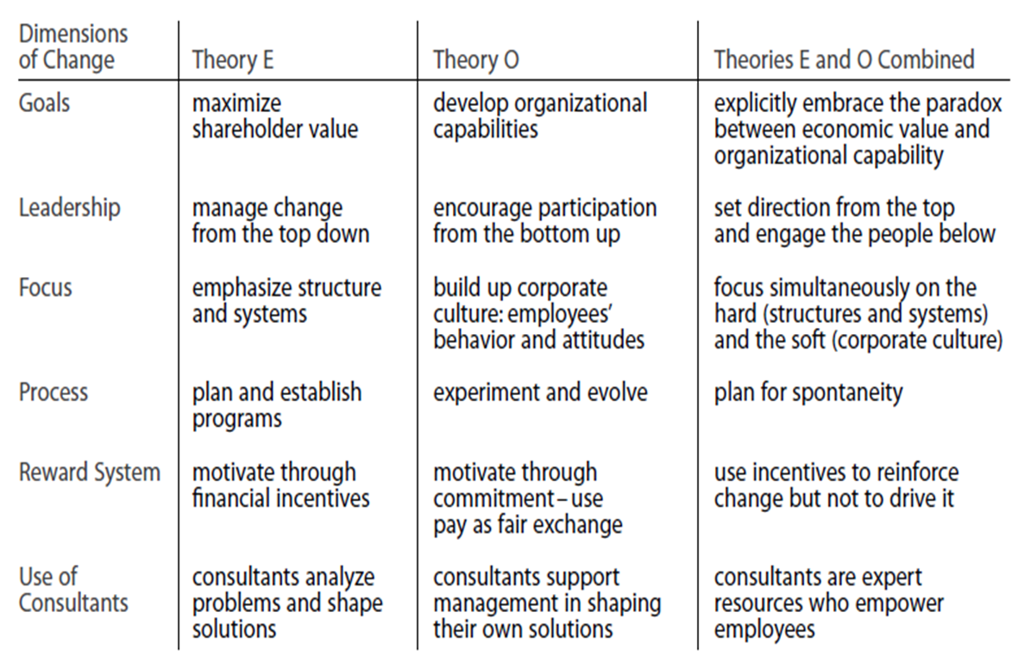
(Source: https://www.google.com/url?sa=i&url=https%3A%2F%2Faslamz2.wordpress.com%2F2014%2F06%2F25%2Findividual-and-organisational-resistance-to-change%2F&psig=AOvVaw2lOcu9FnjLcirxM6-q4TJC&ust=1594188393705000&source=images&cd=vfe&ved=0CAIQjRxqFwoTCJDY4u7HuuoCFQAAAAAdAAAAABAD)

