ANALYSIS OF THE HR INVOLVEMENT IN
DIFFERENT PHASES OF MERGER
AND ACQUISITIONS

Report by
Nargas Ahmadzai (2106756)
Module BMSW_5102BIRM
Developing Relationship
and Workplace Achievement
lectures by Dr Zahra Mohammadnazari

ABSTRACT

This report aims to analyse the HR department’s involvement in different phases of mergers and acquisitions between PJSC Lukoil corporation and Chevron oil and gas company in Russia and the United States origins. This contains the cultural analysis and understanding of its impacts on organisational behaviour and elaborates on the institutional approach to IHRM.

The second part of the report focuses on the M&A rationale and integration strategies to identify the reasons that provide the opportunity for agreement on the merger and acquisition. The HR challenges that arise before and after the cultural and institutional analysis of merger and acquisition agreements between the countries.

The final part will summarise some recommendations for the HR department to facilitate the smooth merger and acquisition transition.

Content list
- Introduction
The PJSC Lukoil company (Russia)
The Chevron Corporation (United States)

- Segment 1: The Cultural and institutional approach of IHRM

Part 1: Cultural analysis of Russia and America
Part 2: Institutional analysis of Russia and America

- Segment 2: Merger and Acquisition rationale and integration analysis

Part 1: Rational and integrational strategy
Part 2: Challenges of IHRM during pre- and post-stages of M & A

- Conclusion
- Recommendations
- References

Introduction

Oil and gas are natural resources, and they are distributed not equally, therefore, the interaction between companies and countries is very important to overcome challenges and shortages. Research shows that recent M&A agreements took more in oil and gas companies.
The two oil companies that this report is aiming to discuss and analyse the HR department’s involvement in the merger and acquisition phases and analyse their agreement on the merger or acquisition process are The PJSC Lukoil company and Chevron Corporation. Here is a brief introduction for both companies.

THE PJSC LUKOIL COMPANY

This is a private Russian worldwide oil company based in Moscow. The company specialises in the business of abstraction, manufacturing, transport, and sale of natural gas, petroleum and petroleum products and electricity. It was founded on 25 November 1991 by Vagit Alekperov in Russia (Chcom, 2022). This is also one of the most famous Russian brands in the United States. This is Russia's second-largest oil producer corporation (Craft, 2023).

locations | employees | competitors
5867 | 101,000 | Transnet, Gazprom Net, Rosneft, Tatnet

CHEVRON CORPORATION

Chevron Corporation is an American global oil and gas company. The second largest standard oil company in California. The headquarter is based in San Ramon, California (Chevron, 2022). It was founded on September 10, 1879, approximately 143 years ago as Pacific Oil Corporation by Charles N. Felton, Lloyd Tevis, George Loomis, and others (Staff, 2023).
locations | employees | competitors
More than 180 countries | 42,595 | Exxon Mobil, ConocoPhillips, BP total energies, Hess, Marathon Petroleum, Valero Energy, Phillips oil corporation

Segment 1
The cultural and institutional approach of IHRM

The comparison between cultures is important, according to Hofstede (1980) national culture is the combined programming of the mind that differentiate members of one group from another. So, this can have a huge impact on HRM practices in M&A agreements and affects employees’ values and attitudes in both countries (Cultural Foundation of IHRM-understanding culture, 2019).

Part 1:

Cultural analysis of Russia and America

As is already mentioned in the report that merger and acquisition is a very risky and challenging decision for companies and requires more analysis and decision-making process to achieve a successful outcome. The fact that every country has its own culture and perspectives and organisational systems, therefore, while mergers and acquisitions the companies must consider it before deciding to jointly form a new business entity and agree by mutual consent (Jenkins, 2022).
Hofstede’s cultural model is a framework introduced by Greet Hofstede in 1980 to acknowledge the cultural differences between countries (Hofstede,1980). As indicated in figure 1, there are six elements which run a framework including individualism-collectivism, power distance, uncertainty avoidance, masculinity-femininity, and short vs long-term orientation. Indulgence vs restraint was added later for extra cultural dimensions (Nickerson, 2022).

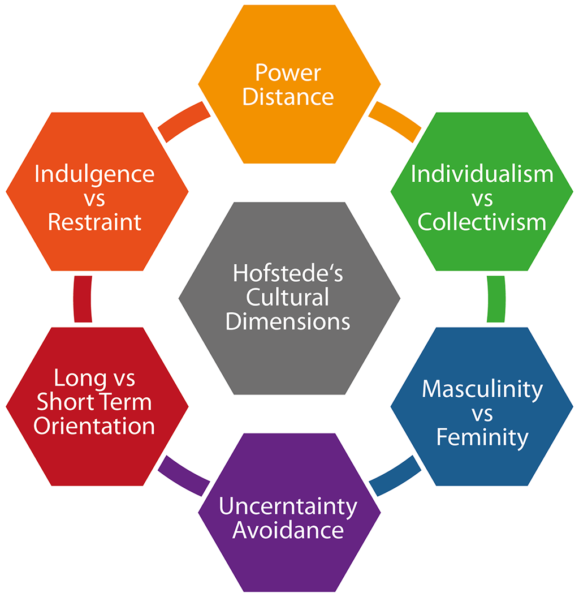

Figure 1 =Hofstede cultural dimension
Source (Hofstede insight,1980)

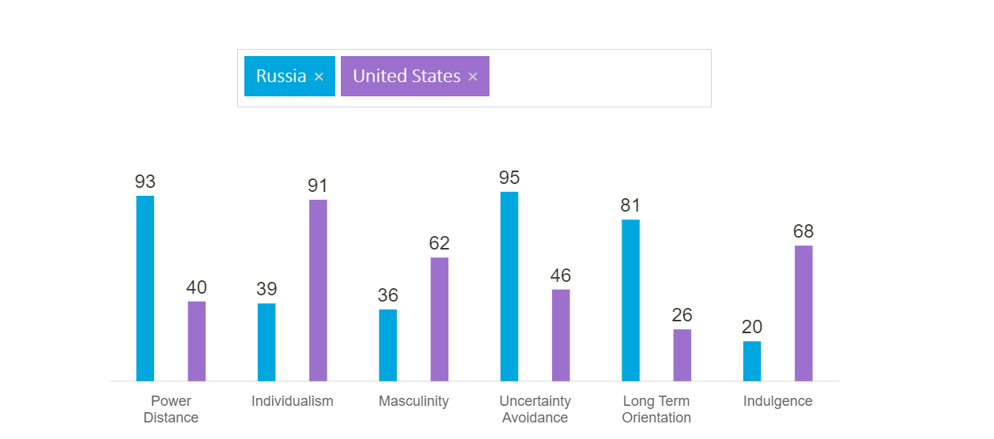

Figure 2= country comparison Hofstede insights
Source (Hofstede insights ,2023)

Power distance

Russia is a country that has a huge power distance dimension and people are not happy with the fact that power is not distributed equally. This is a large country with extremely rationalised behaviour, that 2/3 of the investors go to Moscow and developed 80%of all financial of the country. The top-down approach is mandatory in every organisation, and it leads to status consciousness and the difference between rich and poor (Hofstede Insights,2023)
On the other side, the US has less power distance because the people know where the power distance occurs. It is just a degree of power that one can influence the other for a better opinion and behaviour (Hofstede Insight,2023)

Individualism versus collectivism

Russia is a country that supports living in a group and prefers families and friends.
Relationships are very important for most organisational aspects such as negotiation, sharing information, ideas, and introduction (Hofstede Insight,2023).
Compared to Russia, the US is a more individualist country. In organisations the top managers are approachable, and they rely on their employees and can communicate directly. People prefer to live independently and not rely on families. The best thing is employees display their initiative and can be hired due to their merit evidence and achievements (Hofstede Insight, 2023).

Masculinity versus femininity

Russia is a masculine and feminine country, Russia can be forceful people in terms of business, however, they have a sexist attitude towards females meaning the women are likely to face challenges (Isik-Vanelli, 2004).
On the other side, the US has more scores in masculinity and is a masculine country meaning that masculinity is about responsibility, behaviours and features that are appropriate for men (The meaning of masculinities - National Democratic Institute 2022).

Uncertainty avoidance
Russia feels threatened by uncertain situations and must be prepared for the future. Detailed planning and briefing for negotiating and presentation are highly important to avoid uncertainty (Hofstede Insight, 2023).
While Americans are fairer to welcome new ideas and products and are willing to try and adapt changes in their technology or business. They have fewer rules and stress about the upcoming future (Hofstede Insight,2023).

Long-term orientation

Russia considers that honesty depends on the situation, factors, and time. Russians easily modify traditions to change any situation and have a strong liability to save and invest (Hofstede Insight,2023).
On the other side, Americans are very realistic and have strong intentions about goodness and horrible situations. They are mentally strong and flexible. American corporations estimate their production on a short-term basis, with profit and loss reports being published every quarter (Hofstede Insight,2023).

Indulgence versus restraint
Russia has a very restrained culture. They do not give importance to entertainment and vocation, they control the pleasure of their passions and follow social norms and rules and indulgence is believed the wrong action (Hofstede Insight, 2023).
The United States has a combined culture, which means people can be normative and indulgent. People believe balance in life is the best way to work hard and live a happy life (Hofstede Insight,2023).
This Hofstede insight has picturised the differences and similarities between Russia and America, and it shows that both countries have a huge difference in their cultures. According to Goehner, (2001), Russia and America both are nuclear power and have a variety of diverse groups both countries are energetic, inventive and appreciate big thinking. People are casual and direct, and these counties have heartfelt hospitality to visitors from other countries. The difference in cultures greatly impacts IHRM’s involvement in the M&A process.

Part 2
Institutional analysis of Russia and America
The second important element after the culture analysis is institutional analysis to compare both countries’ institutions and lay out the similarities and differences. It needs to consider the political, economic, social, technological, legal, and educational factors. The neo-institutional model focuses on the institutions of Russia and America to know about organizational behaviour as located in and influenced by other organisations and wider social traditions, actions, beliefs, and cultural rules, for better analysis. (Lounsbury & Zhao, 2013).
The three institutional pillars, Normative, Regulatory and Cultural-Cognitive Pillars together affect how Russian and American oil corporations are conducted through isomorphic pressures to process and develop the same structure. (Scott, 1995,2001,2007).

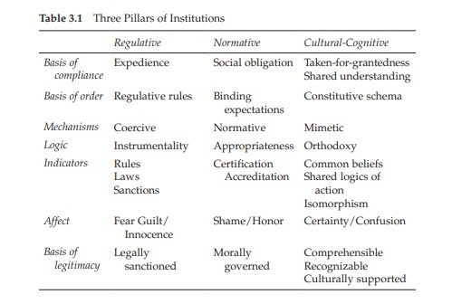
Figure 3. Three pillars of institution Scott
Source (Scott, 2007, p.60)

Regulatory pillar (political and economic institution)

Regulation, political and economic factors greatly impact organisations and the M & A process. The commencement of attacks from Russia on Ukraine resulted in the imposing sanctions on Russia by United Nations and the US on 24th February 2022. This has a huge impact on the oil corporations and the import and export of Russia and affects the economy of the country (Ukraine-/Russia-related sanctions 2022). The US imposed other sanctions on Russia on 12 September 2014 including Lukoil company.

Normative pillar and cultural-cognitive pillar (social institution)

The social institution and normative differences between Russia and other countries are not new, it creates a big clash over trade rules (Liik, 2018). Russian scholars have more trust in the church, their goals and values and less trust in political organisations (Kunchenkova, 2020).
According to lumen learning (2016), the United States of America’s social institute focused on the needs of the government, economy, education, family, healthcare, and religion.
IHRM may face more challenges in the M&A projects implementations in Russia and America because of the institutional differences. For example, HRM departments face difficulty in management in Russia according to the western textbook. However, in recent years HRM is practising successful implementations in Russia (Dixon et al., 2014).

Segment 2
Merger and acquisition rationale and integrational analysis

As the first segment of the report focuses on the cultural and institutional analysis, the second segment is the M&A rational and integrational analysis and IHRM responsibilities.
When businesses merge in a strategic process they introduce new entities (Skowronski & Girardin, 2023). While the acquisition is a transaction where an organisation acquires another company for some considerations (Patel, 2022).
Mergers and acquisitions provide opportunities for firms to grow and overcome the barriers to entry and create new economic values around the world. M &A is certainly a very risky decision because mostly of carrying out false objectives and incorrect evaluation processes and the outcome of the final decision can be a failure for the companies. (Dringoli, 2016).
However, the process can be successful if the companies accept that together they can be more powerful and run a smooth M&A process (L et al., 2022)

Part 1. Rational and integrational strategy

Some of the M&A, reasons across borders are to promote growth and manage technology. Reaction to political and economic situations or to reduce labour costs.
The M&A reasons can have rational motives and irrational motives. This report is focusing on the rational motives of M&A between Russian and American oil and gas corporations.

Furthermore, Lukoil North America is a subsidiary of PJSC Lukoil, and it is the second-largest oil producer in Russia, however, its franchises are not directly owned by Lukoil (Saigol,2022). The Ukraine war is affecting business in America as people are calling for boycotting Russia’s exports to show solidarity with Ukraine (Saigol,2022). However, Lukoil is not sanctioned internationally, and suppliers are dealing with a Russian entity (Parrinello, 2022).

As both companies have its strength and weaknesses for example Chevron is facing debt because of fewer technical and financial resources (Shastri, 2022). While Lukoil’s stable free cash flow provides opportunities to invest in the business. Lukoil has reliable suppliers because of its strong portfolio and the highly skilled workers and new technology provides opportunities to practice different strategies (Pro, 1962).

After cultural and institutional analysis of Russia and America, the rational decision for a deal between both corporations is to merge and introduce a new oil company that can successfully operate in both countries. The IHRM requires observing each phase of M&A and managing it successfully.

Haspeslagh and Jemison’s typology suggests 4 stages of M&A post-integration strategy in literature to support HR implementation.

Holding | No integration is required
Preservation | Target firm retains autonomy, little integration
Absorption | The acquired company is absorbed by acquiring company, with strong integration
Symbiotic | The balance between both companies acquired and acquiring, the most challenging

(Haspeslagh and Jemison,1991).

The table below outlines both integration stages of the M&A deal strategies.

Post-integration stage | Pre-integration stage
The post-integration stage of M&A between Lukoil and Chevron companies is in the HOLDING stage, so no integration is needed for both companies because of the current conflict between Russia and America which, has the biggest impact on the M&A process between Lukoil and Chevron oil corporations. | In the pre-integration stage, Lukoil and Chevron oil companies are negotiating, setting strategic objectives, and planning for eventual implementation.

Part 2: Challenges of IHRM during pre- and post-stages of M & A

HR has a crucial role during both pre-post stages of M&A. As the Lukoil and Chevron companies decided to merge despite the cultural and institutional differences and overcome their challenges now the HR departments have to play the best role to make this agreement to success.
The choice of strategies to implement the process, HR requires effective communication and recruiting trained expatriates and employees who understand the culture and environment of both countries very well (Cartwright, 2013).
HR must know the reason for M&A, make strategic decisions, and plan for process and implementation.
Russia and America have cultural and organisational differences and the most important being the current war in Ukraine is increasing challenges for HR in pre-and post-stages of M&A.
Maintaining the culture of both companies, considering the norms and values of cultures, and adapting and dealing with new changes in employees as the two companies merge the new company introduce new policies. Retention and recruitment of employees create issues and challenges for the HR department (Debara, 2021).

Conclusion

The report summarised the cultural and institutional differences between Russia and America using Hofstede’s insight and the results show huge cultural differences.
The Scott pillars have focused on the political, social, normative, and economic differences and analysed the institutes of both countries.
Russia is a country with a potential market that attracts investors from abroad however, the culture and institutional differences increase challenges for investors (Dixon, et al, 2014).
The involvement and responsibilities of the HR department in the merging process of Lukoil and Chevron oil companies are not very easy because Russia and America are both nuclear power countries and they both maintain a critical and strategic relationship and have huge differences in culture and institutes in the world.
The recent conflict and sanctions between countries may affect the M&A process and impact the IHRM decision-making and implementation process. HR needs to involve and observe that both cultures fit the agreement. The process requires a smooth transition between each phase of merger and acquisition.

Recommendations

Some of the recommendations for the HR department to process the M&A more effectively are.

- Safety and security of employees should be the priority because of the recent Ukraine war.
- Communication should be based on principles and according to their values.
- Strategic planning for each action and reacting quickly when necessary.
- Friendly response to employees’ concerns.
- The firm knowledge of the work culture of the organisations and policies of both countries.

References

Cartwright, S. (2013) International mergers and acquisitions: The issues and challenges, De Gruyter. De Gruyter. Available at: https://www.degruyter.com/document/doi/10.1515/9783110808797.5/html (Accessed: February 22, 2023).
Chcom (2022) Lukoil PJSC Oil Company (Lukoil Group), CompaniesHistory.com - The largest companies and brands in the world. Available at: https://www.companieshistory.com/lukoil-pjsc-oil-company/ (Accessed: February 7, 2023).
Chevron (2022) Chevron history, chevron.com. Chevron. Available at: https://www.chevron.com/about/history (Accessed: February 8, 2023).
Country comparison (2023) Hofstede Insights. Available at: https://www.hofstede-insights.com/country-comparison/ (Accessed: February 14, 2023).
Craft. co (edition.) (2023) Top Lukoil competitors and alternatives | Craft. co, top Lukoil competitors and alternatives /craft.co. LUKOIL. Available at: https://craft.co/lukoil-9a1a22e8cd/competitors (Accessed: February 7, 2023).
Cultural Foundation of IHRM-understanding culture (2019) theintactone. Available at: https://theintactone.com/2019/02/08/shrm-u3-topic-3-cultural-foundation-of-ihrm-understanding-culture/ (Accessed: February 14, 2023).
Debara, D. (2021) Top HR challenges during mergers and acquisitions - and how to handle them, Lattice. Lattice magazine. Available at: https://lattice.com/library/top-hr-challenges-during-mergers-and-acquisitions (Accessed: February 22, 2023).
Dixon, S., Day, M AND Brewster., (2014) changing HRM system in two Russian oil companies: western hegemony or Russia spetsifika? International journal of human resources management 25(22):3134-3156 (Accessed: February 14, 2023)
Dringoli, A. (2016) Merger and acquisition strategies: How to create value. Cheltenham, UK: Edward Elgar Publishing.
Goehner, D. (2001) Russian/American cultural contrasts, Russian / American cultural contrasts. Best of the Net Mining Co. Available at: https://goehner.com/russinfo.htm (Accessed: February 21, 2023).
Haspeslagh, P. and Jemison, D.B. (1991). Managing acquisitions: Creating value through corporate renewal. New York: The Free Press.
Hofstede, G. (1980) cultural consequences, Sage: London (Accessed: February 10, 2023).
Isik-Vanelli, M.B.A.H. (2004) Cultural dimensions of business in Russia, GRIN. Available at: https://www.grin.com/document/26493 (Accessed: February 10, 2023).
Jenkins, W. (2022) What is the difference between a merger and an acquisition? Wilson Browne. Wilson Browne solicitors. Available at: https://www.wilsonbrowne.co.uk/news/what-is-the-difference-between-a-merger-and-an-acquisition/ (Accessed: February 9, 2023).
Kunchenkova, A.V. (2020) The Russian Intelligentsia and Russia's social institutions: Trust or alienation, Taylor & Francis. Sociological research. Available at: https://www.tandfonline.com/doi/full/10.1080/10611428.2022.2135308 (Accessed: February 17, 2023).
L, E. et al. (2022) Mergers and acquisitions: A step-by-step legal and practical guide, Imaa. WILEY publishers. Available at: https://imaa-institute.org/mergers-acquisitions-legal-practical-guide/ (Accessed: February 8, 2023).
Learning, L. (2016) Introduction to sociology, Lumen. Available at: https://courses.lumenlearning.com/wm-introductiontosociology/chapter/reading-introduction-to-culture/ (Accessed: February 17, 2023).
Liik, K. (2018) Winning the normative war with Russia: An EU-Russia power audit, ECFR. Available at: https://ecfr.eu/publication/winning_the_normative_war_with_russia_an_eu_russia_power_audit/ (Accessed: February 17, 2023).
Lounsbury, M. and Zhao, E.Y. (2013) Neo-institutional theory, neo-institutional theory. Little, brown. Available at: https://www.oxfordbibliographies.com/abstract/document/obo-9780199846740/obo-9780199846740-0053.xml (Accessed: February 15, 2023).
Nickerson, charlotte (2022) Hofstede's cultural dimensions theory. Simply Psychology. Available at: https://www.simplypsychology.org/hofstedes-cultural-dimensions-theory.html (Accessed: February 9, 2023).
Parrinello, A. (2022) Russia's Lukoil rejects U.S. private equity firm's offer to buy its Sicily refinery - ft, Reuters. Thomson Reuters. Available at: https://www.reuters.com/markets/deals/russias-lukoil-rejects-private-equity-firms-offer-buy-its-sicily-refinery-ft-2022-11-04/ (Accessed: February 21, 2023).
Patel, K. (2022) 11 powerful acquisition examples (and what we learned from them), RSS. DealRoom. Available at: https://dealroom.net/blog/acquisition-examples (Accessed: February 17, 2023).
Pro, E.M.B.A. (1962) Lukoil (United Kingdom) SWOT analysis / SWOT matrix, embapro.com. Fern Fort University. Available at: https://embapro.com/frontpage/swotcoanalysis/19569-lukoil (Accessed: February 22, 2023).
Saigol, L. (2022) Americans are boycotting all things Russia, including Lukoil Gas Stations, Does Lukoil Use Russian Oil? Americans Are Boycotting Gas Stations. | Barron's. Barrons. Available at: https://www.barrons.com/articles/lukoil-gas-stations-russia-oil-boycott-51646391795 (Accessed: February 21, 2023).
Scott, W. R (2007) institutions and organisations (2nd edition) Thousand Oaks, CA: Sage (February 13, 2023)
Shastri, A. (2022) Detailed SWOT analysis of Chevron - 2023 study, IIDE. Available at: https://iide.co/case-studies/swot-analysis-of-chevron/ (Accessed: February 22, 2023).
Skowronski, J. and Girardin, M.K. (2023) What is a merger? definition, types, and examples, Forage. Available at: https://www.theforage.com/blog/skills/merger (Accessed: February 17, 2023).
Staff, M.B. (2023) CVX competitors 2023: CEMATRIX alternatives, Market Beat. Market Beat. Available at: https://www.marketbeat.com/stocks/CVE/CVX/competitors-and-alternatives/ (Accessed: February 8, 2023).
The meaning of masculinities - National Democratic Institute (no date) The meaning of masculinities. National Democratic Institute. Available at: https://www.ndi.org/sites/default/files/ACFrOgAZ9X_S2Bl-K9iPv3XhiQ140Fw6QWeUNSQwJwuNXzShO1b_Wv9-Vbsw1KX0rkmdxRZ-nlwzPhL-WIQLh1agPgzn5s70jFg-wYO0cIafAvyfqfNvFQQX_UYSZKGjzuPLlyl2J_UFqRjaCxNs.pdf (Accessed: February 14, 2023).
Ukraine-/Russia-related sanctions (2022) U.S. Department of the Treasury. Available at: https://home.treasury.gov/policy-issues/financial-sanctions/sanctions-programs-and-country-information/ukraine-russia-related-sanctions (Accessed: February 15, 2023).
Valle, S. and Khan, S. (2022) Chevron raises buybacks and says exposure to Russia is limited, Reuters. Thomson Reuters. Available at: https://www.reuters.com/business/energy/chevron-hikes-buybacks-raises-cash-flow-forecast-2022-03-01/ (Accessed: February 22, 2023).

