Christopher Hopkins

1911310@student.uwtsd.ac.uk
Database Design (The Book Store)
ACCB4012

Table of Contents
- Introduction 2
- Data Flow Diagrams (DFD) 2
2.1 Context Diagram 2
2.2 Level 0 DFD 3
- Entity Relationship Diagram (ERD) 4
- Microsoft Access 4
4.1 Test Data and Tables 4
4.2 Relationships 6
4.3 Forms 7
4.4 Reports 10
4.5 Queries 10
- SQL 11
5.1 Adding Records to a Table Using SQL 11
5.2 Creating Relationships Using SQL 11
- Use of Additional MS Access Functionality 12
6.1 Produce a Calculation in a Report 12
  - Producing Reports and Forms from a Macro Query 12
- User Guide Documentation 14
References 16

- Introduction

In the ‘Information Engineering – Database Design’ brief, students were tasked with creating database systems and models for a theoretical bookstore, ‘The City Book Store’.

It was outlined that the main working procedures of the bookstore were as follows:

- Staff would place orders with certain suppliers be it directly from publishers or collectable book dealers. They would use basic intuition and guessing for what books customers would be interested in.
- Customers would place orders for book, both rare and popular as some customers were outlined to being rare book collectors.
- As they have customers locally and further afield, they use a mail order service for orders to be made and delivered.
- They publish a newsletter once every 3 months outlining new and interesting stock.
- They had a basic computer network running throughout the store mainly used for word processing applications, housing a list of names and addresses of customers in a basic word form.

I was outlined that they had a loyal and growing customer base and had decided they need to update/create a new database system for their business in order to quickly retrieve and process information.
Additional aspects of the database include:
- Designing the database so it is menu driven
- Queries are possible for customers seeking availability information about specific books and in particular, rare first editions.
- They need the system to allow for flexibility and want to maintain their friendly reputation with customers.

- Data Flow Diagrams (DFD)
The author will begin by creating few very basic data flow diagrams for ‘The City Book Store’ to graphically outline the simpler processes and movement of data involved with ‘The City Book Store’. These diagrams will then be used as references and bases for developing a solution to the database systems that will be created for the brief scenario. By creating these diagrams, the author will hopefully comprehensively cover all aspects of the business and be able to visualise the transportation of data throughout the and will help to keep the system on track. [1] [2]

  - Context Diagram
Below is the context diagram:

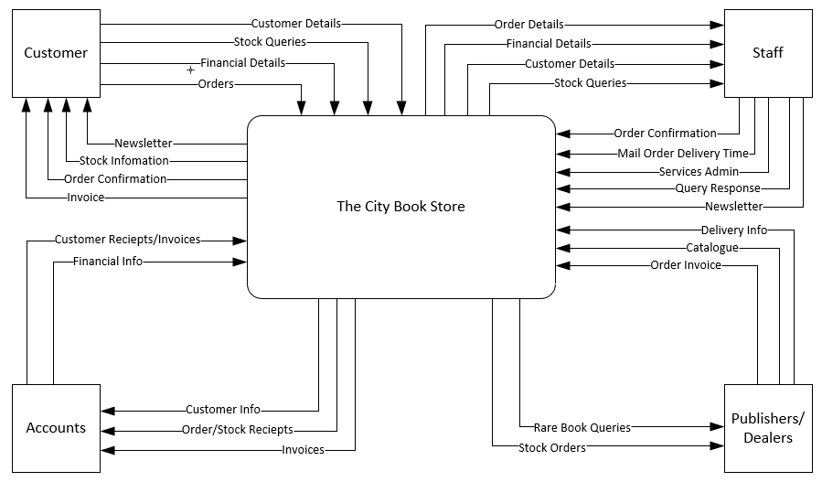

  - Level 0 DFD
Below is the Level 0 DFD:
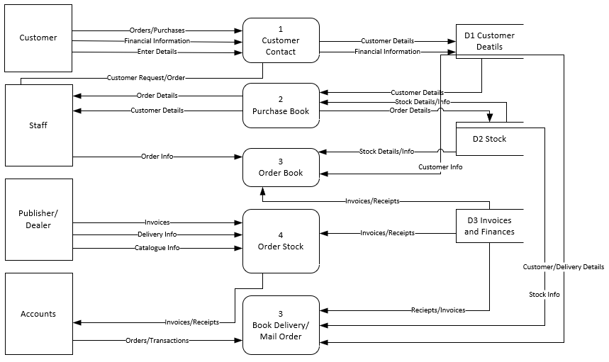

These diagrams can now be used as a base and reference for digitizing process and databases for ‘The City Book Store’.

- Entity Relationship Diagram (ERD)
The entity relationship diagram will allow the author/users to see the relationships between the processes and entities and better visualize the data flow.
Below is the entity relationship diagram:

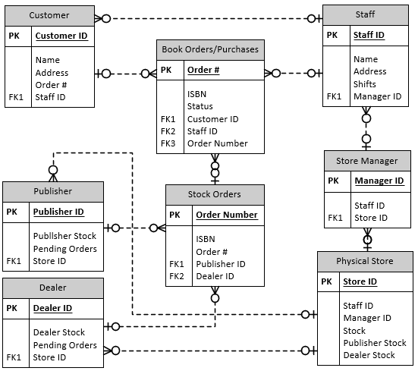

- Microsoft Access
Now that the initial ERD and DFD’s have been created for reference and ideas, digitization of the tables and systems can begin within Microsoft Access.
  - Test Data and Tables

Test data which has been generated by https://www.mockaroo.com/ can be imported from an excel file. The fields and data types were outlined on https://www.mockaroo.com’s website and exported as a .csv file. [3]
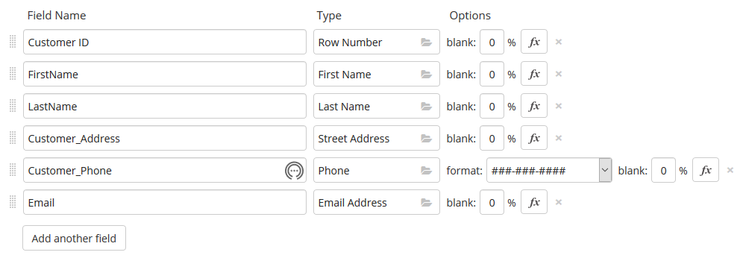
Below is an example of the csv file:
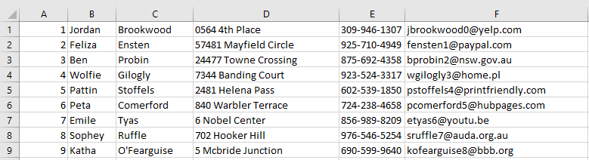
The field names were deleted so that the raw data could be imported into access where the fields can be set.
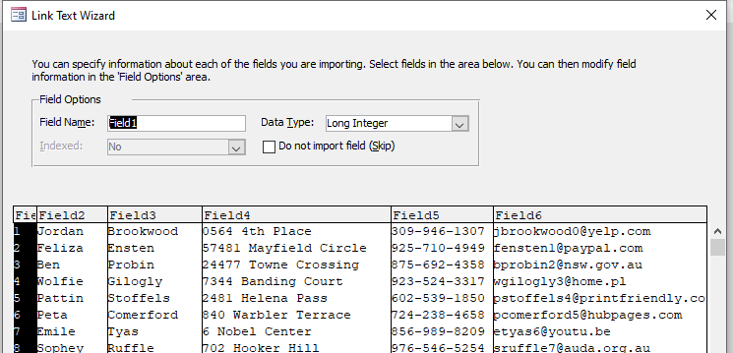

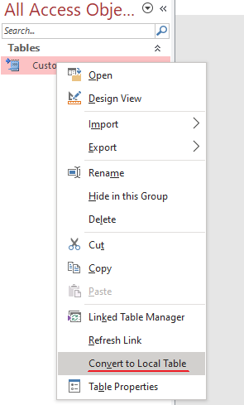
When the data has been imported the table is still not ready to be used. It is currently just a linked table and must be converted to a local table for use:

This process was repeated for certain tables along with manually created tables and manually inserted data.
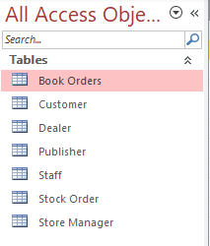

  - Relationships
Now that the tables have been created, the relationship diagram, menus and form can be created to allow more simple data entry. First the relationships were established to make sure the data flows between tables desired with one to many relationships also set up.
Below is the relationship table created in access:
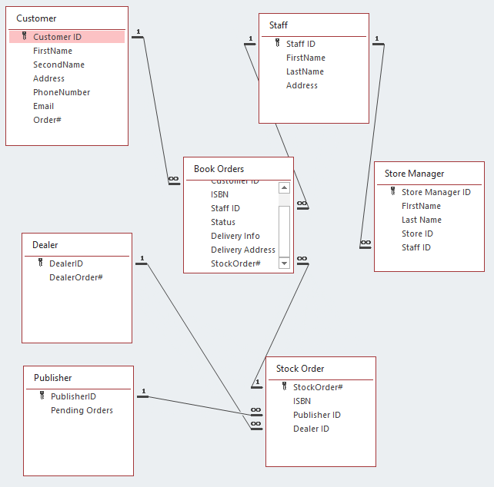
The ERD ended up being similar to the original reference ERB but other fields and tables have been added.

  - Forms
The next step was to create forms for data to be input to several different tables. The first to be created was the ‘Customer Form’. It was created using the form wizard. Buttons were added and after testing it was clear that the form was functioning as desired.
See below for a screenshot of the ‘Customer Form’ and then the other forms to follow. The two other forms that will be created are the ‘Book Order’ forms and ‘Stock Order’ forms. A main menu will also be included to allow users to navigate easily between forms.

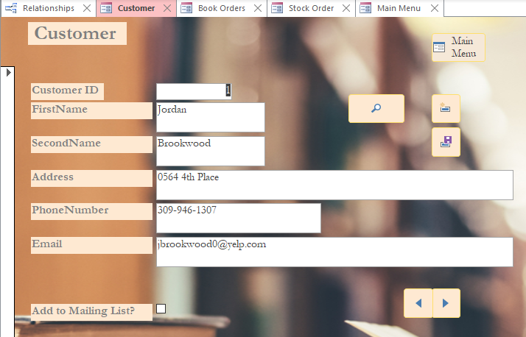
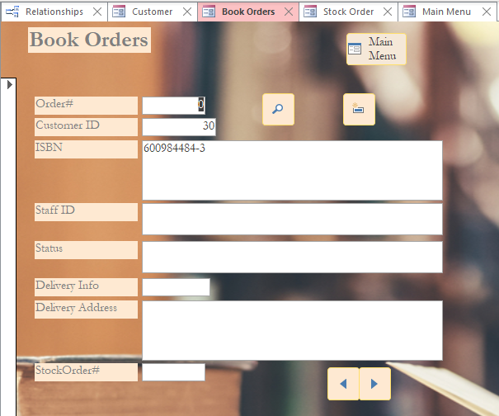

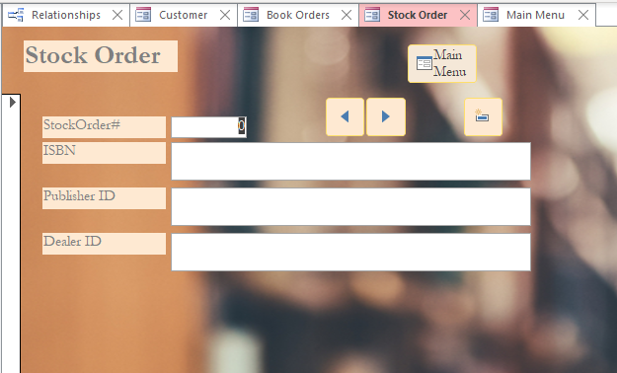
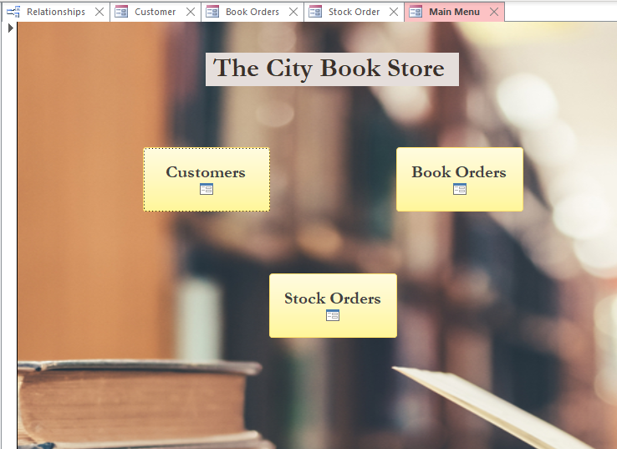
After testing it was noted that the menu navigation and data entry buttons work as intended.

  - Reports
Below are various generated reports using the report wizard and toolbars. If a user desired these reports could be printed out.
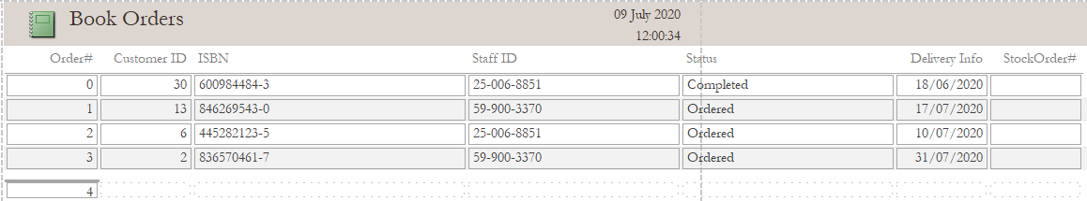
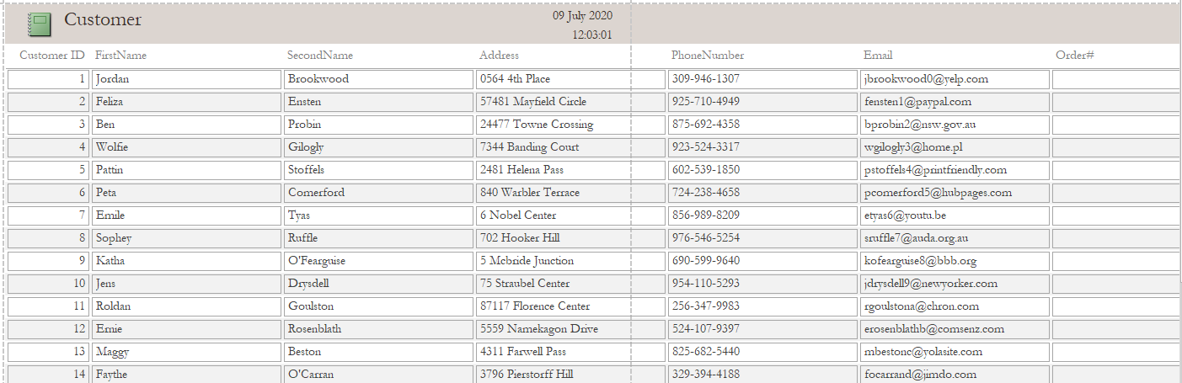
  - Queries
Below are various queries that the user can run. The first screenshot is the query relationship just for reference and below is the query after running.
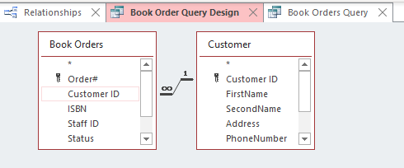
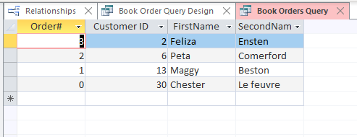
The relationships appear to be linked correctly as parts of separate tables calculate together correctly.

- SQL
Below are examples of use of SQL for access functions.
  - Adding records to a table Using SQL
Below is evidence of the expression used to insert information into a table.
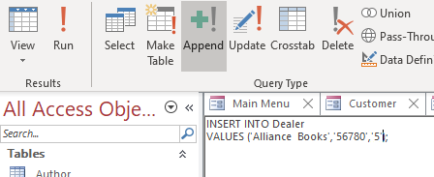
When this was run the values in the statement was entered into the table.
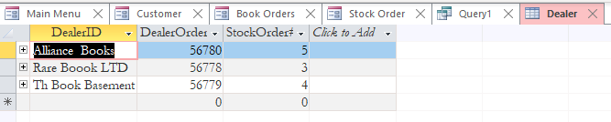

  - Creating Relationships Using SQL
The author had created most of the database before delving into SQL. A new formula was then created to add a new ‘rota’ table with certain FK and PK’s using SQL.
The query was as follows:
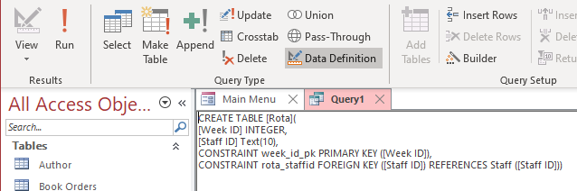

When run, the query seemed to successfully add the table into the project and upon checking the Relationships tab it was clear that the relationships had been successfully set. (See Below)
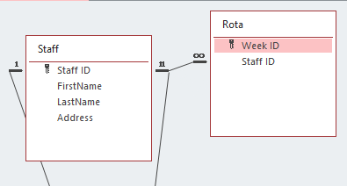

- Use of Additional MS Access Functionality
Below are various tasks and functions mentioned in the brief. The author will include screenshots of the tasks when successful.

  - Produce a Calculation in a Report
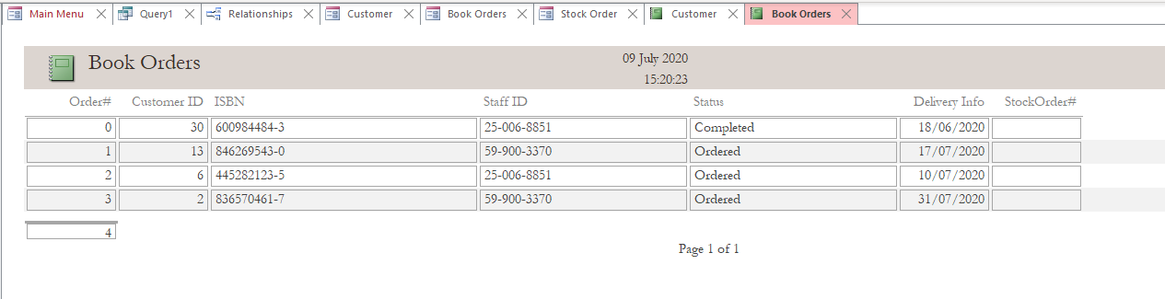
The total order records count populated underneath the Order# category. This was achieved by opening the report in design view, then using the totals and grouping toolbar, the ‘count records’ total could be calculated.

  - Producing Reports and Forms from a Macro Query
The author has decided to create a macro that can be embedded in a button so that from the Main Menu form (that opens when the project is loaded) the user will be able to create a new order.
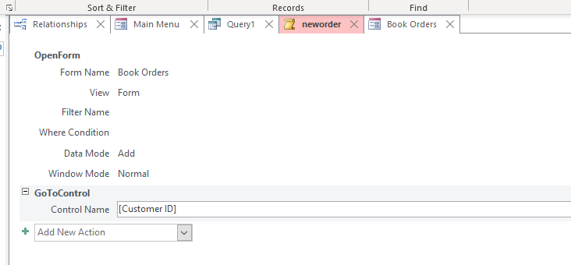
The macro builder was used to create the macro. The macro is designed to open a form and instantly go to the Customer ID field to begin data entry. This was achieved with the ‘GoToControl’ tool.
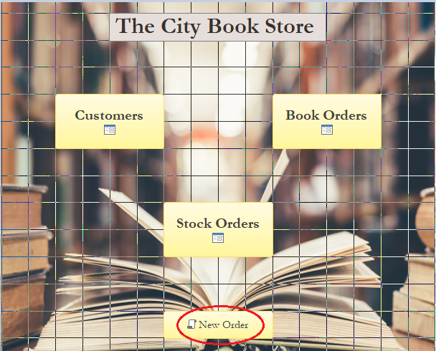
A button was then placed within the main menu form and related to the ‘neworder’ macro that was created. When this button is clicked the user is taken directly to the order from and the Customer ID filed is ready to be populated:
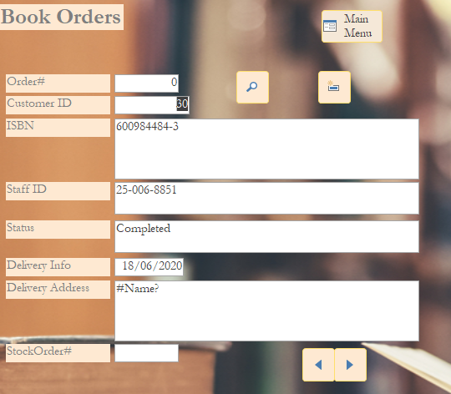

- User Guide Documentation
Most of the functions have already been covered within this document but some of the basics about navigating the from will be covered below.
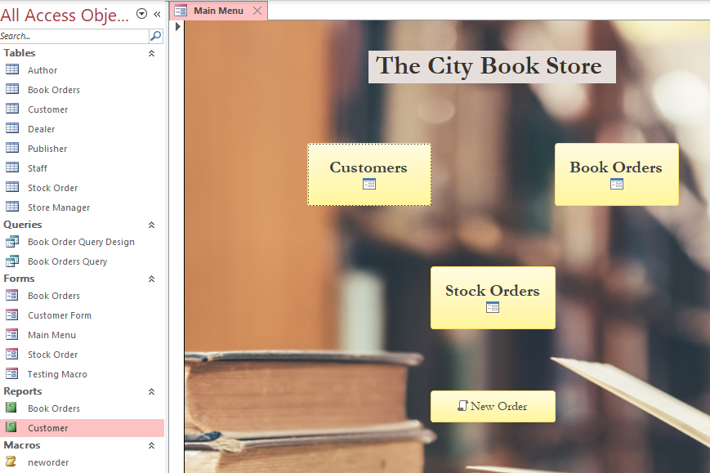
Upon opening the project, the main menu form will be shown.
From here users can navigate to any other form by simply selecting the form they need b clicking on it.

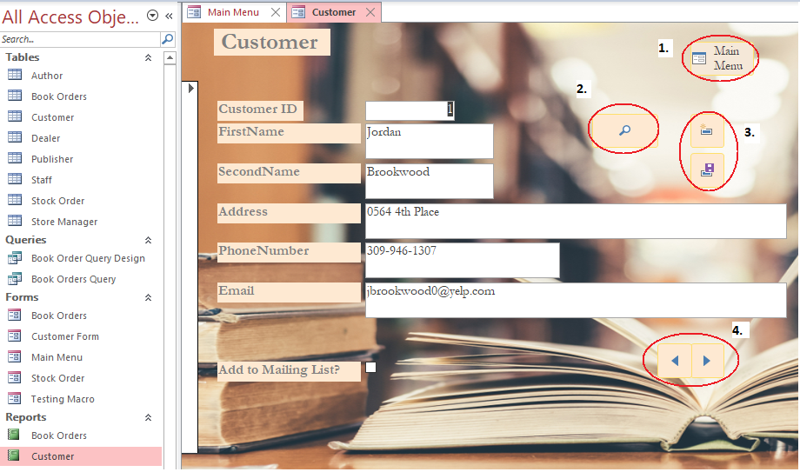
All forms are formatted with the same layout. The button will all work the same in each different form.
- This is the main menu button, pressing this will return the user to the main menu.
- This is the search button; users can find data simply with this function.
- These buttons are the ‘New’ and ‘Save’ commands for entering new data.
- These are navigation arrows used for scrolling through records and existing data.
This concludes the UI walkthrough.

References

[1] | J. Darrington, “Importance of Data Flow Diagrams,” Techwalla, [Online]. Available: https://www.techwalla.com/articles/importance-of-data-flow-diagrams. [Accessed June 2020].
[2] | B. Holland, “Strucured Systems Analysis (Powerpoint)”.
[3] | Mockaroo, “Mockaroo,” [Online]. Available: https://www.mockaroo.com/. [Accessed June 2020].

