

University of Wales Trinity Saint David
School of Engineering

Advance Vehicle Dynamic Behaviour
Transient Response Modelling of a Vehicle (ACEA7003)

Taylor Winter
Automotive Engineering
1901843

09/01/2023

Table of Contents
Abstract 3
1 Introduction 4
2 Methodology 5
2.1 One Degree of Freedom 5
2.1.1 Sprung Mass 5
2.1.2 Unsprung Mass 5
2.1.3 Equations 5
2.2 Two Degrees of Freedom 6
2.2.1 Pitch 6
2.2.2 Equations 6
2.3 Four Degrees of Freedom 7
2.3.1 Inertia 7
2.3.2 Equations 7
2.4 Seven Degrees of Freedom 8
2.4.1 Roll 9
2.4.2 Equations 9
3 Results 11
3.1 Two Degrees of Freedom 11
3.2 Four Degrees of Freedom 12
3.4 Seven Degrees of Freedom 14
3.4.1 Spring Investigation 17
3.4.2 Spring Investigation (Beyond Limits) 18
3.5 Seven Degrees of Freedom: Comparison 20
3.5.1 Setup One 20
3.5.2 Setup Two 21
3.5.3 Setup Three 22
4 Conclusion 23
Bibliography 24
Table of Figures 25
Table of Equations 25

Abstract
The results of the two DOF, four DOF and seven DOF models of the formula Ford race car's suspension and movements have been analysed and compared to real data. The results suggest that the underdamping of the vehicle is caused by its resistance to change and tendency to return to its original state. The 7DOF model provides the most accurate representation of the vehicle's movement and behaviour, as it accounts for movement on multiple axes. The results indicate that the stiffness of the spring and damper setups affect the pitch and roll response. With setups that have drastic differences in front and rear spring rates results in increased pitch response and a greater impact on the roll response. The results of the three SMD setups compared to the real data show that the SMD setups are generally stiffer than the real data, causing less movement under lateral and longitudinal accelerations.

1 Introduction
This paper entails a detailed study of the development and validation of an SMD (system identification for mechatronic systems) models for a vehicle system. This begins by discussing the fundamental principles and techniques used for system identification, and then proceed to describe the incremental steps taken to build the models for systems with increasing complexity, starting from 1 degree of freedom (DOF) and progressing up to 7 DOF. The 7 DOF model is then tested by comparing its dynamic response in pitch and roll to data obtained from a vehicle simulator session, where the vehicle is performing a standard lane change dynamic benchmarking manoeuvre. The simulation test is conducted to assess the impact of varying roll stiffness across the vehicle by altering spring rates front and rear. then providing a demonstration of how the longitudinal and lateral accelerations from the simulator session are imported and utilized as inputs in the SMD model in Simulink to recreate the test and produce overlaid graphs between the simulator data and the model's data for comparison.

Finally, critically evaluate the accuracy of the model compared to the simulator output data, paying particular attention to the limitations of the modelling methods used, and assess how well the model correlates and if it accurately models these changing variables in its prediction of dynamic response. Also, an investigation of the system response when additional parameters are altered and discuss the associated vehicle system response. The models that have been created are based on the Formula Ford Race Car which can be seen below in figure one, along with the parameters used in figure two.

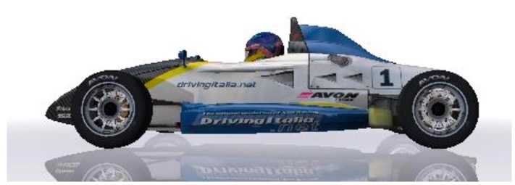
Figure 1: Formula Ford Race Car
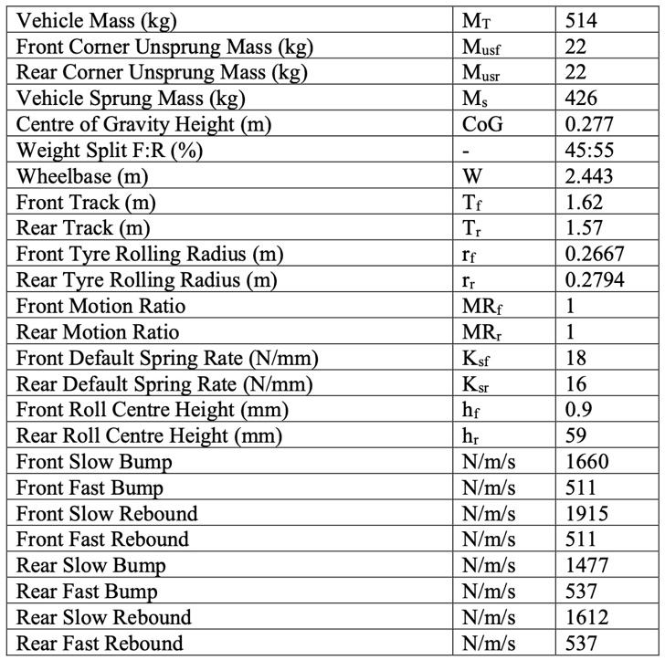
Figure 2: Formula Ford Race Car Parameters

2 Methodology

2.1 One Degree of Freedom
The concept of Degrees of Freedom (DoF) is an important one in mechanics and engineering and refers to the number of independent variables that are needed to describe the motion of a system or object. One Degree of Freedom (1DoF) systems are those that can only move in a single direction, and as a result, their motion can be described using a single variable. These systems are relatively simple and straightforward to analyse and are commonly found in everyday objects such as levers, pulleys, and gears.

2.1.1 Sprung Mass
Sprung mass refers to the part of a vehicle that is supported by the suspension system, such as the body and passenger compartment. This mass is "sprung" because it is separate from the unsprung mass which is in direct contact with the road surface. The sprung mass is connected to the unsprung mass via the suspension system, which helps to absorb and dampen the forces and vibrations from the road surface. The goal of the suspension system is to keep the sprung mass as stable and comfortable as possible for the passengers, while also maintaining good tire-to-road contact for optimal handling and traction. The weight of the vehicle is supported by the springs and dampers, which are connected to the body and frame of the vehicle (Kimberley, 2019).

2.1.2 Unsprung Mass
Unsprung mass refers to the parts of a vehicle that are not supported by the suspension system, such as the wheels, tires, axles, and some suspension components. These parts are in direct contact with the road surface and are not isolated from road inputs as the sprung mass is. Because unsprung mass is not supported by the suspension, it has a direct impact on the handling and ride comfort of a vehicle. It is important because it has a major effect on the dynamic behaviour of the vehicle, especially during braking and cornering. When unsprung mass is high, it can make the vehicle feel heavy and less responsive to steering inputs. It also increases the loads on the suspension and tires, which can lead to a harsher ride and increased tire wear. However, if the unsprung mass is low, the vehicle can feel responsive, and the suspension can do a better job of absorbing road imperfections (Formula1-Dictionary, 2022).

2.1.3 Equations
$$m\ddot{z}+F_{damper}+ F_{spring}=0$$
$$m\ddot{z}+c\left(\dot{z}-\dot{y}\right)+k\left(z-y\right)=0$$
$$-m\ddot{z}=c\left(\dot{z}-\dot{y}\right)+k\left(z-y\right)$$
$$\ddot{z}= -\frac{1}{m}\left[c\left(\dot{z}-\dot{y}\right)+k(z-y)\right]$$
Equation 1: OneDOF
Where:
$\ddot{z}$ = displacement of sprung mass
m = mass
$c\left(\dot{z}-\dot{y}\right)$ = damping velocity
$k\left(z-y\right)$ = spring extension

2.2 Two Degrees of Freedom
Two Degrees of Freedom (2DoF) systems are those that can move in two independent directions, and as a result, their motion can be described using two variables. These systems are relatively more complex than one degree of freedom systems and are commonly found in many areas of engineering.

2.2.1 Pitch
The pitch centre of a vehicle is the point around which the vehicle's body pitches (moves up and down) when going over bumps or other uneven surfaces (Aceable, n.d). It is typically located near the centre of gravity of the vehicle. To find the pitch centre of a vehicle, it is typically necessary to measure the suspension deflection at multiple points on the vehicle and use this data to calculate the location of the pitch centre. As the weight split is 45:55, the pitch centre was assumed to be behind the centre of gravity at 40:60. The calculations for this can be seen below:
$$a=0.6*wheelbase$$
$$a=1.4658m$$
Therefor;
$$b=wheelbase-a$$
$$b=0.9772m$$
This has also been used for 4DOF and 7DOF. Figure one below shows the movement or pitch.
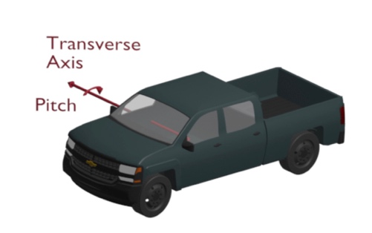
Figure 3: Pitch (Liske, 2020)
The pitch inertia of a car refers to the resistance of the car body to rotational motion about the pitch axis, which runs laterally (side to side) through the centre of gravity of the car. To calculate the pitch inertia of a car, you will need information about the mass and distribution of the car's components, including the body, engine, and suspension. A common method to calculate the pitch inertia is to use the equation:
$$I=\left(mfs* a^{2}\right)+(mrs* b^{2})$$
Equation 2: Pitch Inertia
Where:
mfs = front sprung mass
mrs = rear sprung mass

2.2.2 Equations
$$m\ddot{z}+F_{damper}+ F_{spring}=0$$
$$m\ddot{z}+ c_{s}\left(\dot{z}-{\dot{z}}_{u}\right)+ k_{s}\left(z-z_{u}\right)=0$$
$$-m\ddot{z}=c_{s}\left(\dot{z}-{\dot{z}}_{u}\right)+ k_{s}\left(z-z_{u}\right)$$
$$\ddot{z}= -\frac{1}{m}\left[c_{s}\left(\dot{z}-{\dot{z}}_{u}\right)+ k_{s}\left(z-z_{u}\right)\right]$$
Equation 3: 2DOF Sprung
$$m_{u}{\ddot{z}}_{u}+ F_{tyre spring}+ F_{trye damper}- F_{spring}- F_{damper}=0$$
$$m_{u}{\ddot{z}}_{u}+ k_{u}\left(z_{u}-y\right)+ c_{u}\left({\dot{z}}_{u}-\dot{y}\right)- k_{s}\left(z-z_{u}\right)- c_{s}\left(\dot{z}-{\dot{z}}_{u}\right)=0$$
$$m_{u}{\ddot{z}}_{u}= k_{u}\left(z_{u}-y\right)+ c_{u}\left({\dot{z}}_{u}-\dot{y}\right)- k_{s}\left(z-z_{u}\right)- c_{s}\left(\dot{z}-{\dot{z}}_{u}\right)$$
$${\ddot{z}}_{u}= -\frac{1}{m_{u}}\left[k_{u}\left(z_{u}-y\right)+ c_{u}\left({\dot{z}}_{u}-\dot{y}\right)- k_{s}\left(z-z_{u}\right)- c_{s}\left(\dot{z}-{\dot{z}}_{u}\right)\right]$$
Equation 4: 2DOF Unsprung
Where:
$c_{s}\left(\dot{z}-{\dot{z}}_{u}\right)$ = sprung damper velocity
$k_{s}\left(z-z_{u}\right)$ = sprung spring extension
$c_{u}\left({\dot{z}}_{u}-\dot{y}\right)$ = unsprung damper velocity
$k_{u}\left(z_{u}-y\right)$ = unsprung sprint extension

2.3 Four Degrees of Freedom
Four Degrees of Freedom (4DoF) systems are those that can move in four independent directions and, as a result, their motion can be described using four variables. These systems are relatively more complex than one or two degrees of freedom systems and are commonly found in many areas of engineering.

2.3.1 Inertia
Inertia is a measure of an object's resistance to change in its state of motion. In the context of a vehicle, it is often used to refer to the vehicle's resistance to acceleration or deceleration. To calculate the inertia of a vehicle, you would need to know the total mass of the vehicle and the distribution of that mass (Ritzel, 2016). Once you have that information, you can use the following formula to calculate the inertia:
$$I=\left(mfs* a^{2}\right)+(mrs*b^{2})$$
Equation 5: Inertia
It's important to note that this formula is assuming a rotating object around one axis, if the vehicle is moving in multiple axis or have complex geometry you will need to use the more general formula of Inertia Tensor for that.

This has also been used for 7DOF.

2.3.2 Equations
$$m\ddot{z}+ F_{spring front}+ F_{spring rear}+ F_{damper front}+ F_{damper rear}=0$$
$$m\ddot{z}+k_{sf}\left(z-z_{f}-aθ\right)+ k_{sr}\left(z-z_{r}+bθ\right)+ c_{sf}\left(\dot{z}-{\dot{z}}_{f}-a\dot{θ}\right)+ c_{sr}\left(\dot{z}-{\dot{z}}_{r}+b\dot{θ}\right)=0$$
$$-m\ddot{z}= k_{sf}\left(z-z_{f}-aθ\right)+ k_{sr}\left(z-z_{r}+bθ\right)+ c_{sf}\left(\dot{z}-{\dot{z}}_{f}-a\dot{θ}\right)+ c_{sr}\left(\dot{z}-{\dot{z}}_{r}+b\dot{θ}\right)$$
$$\ddot{z}= -\frac{1}{m}\left[k_{sf}\left(z-z_{f}-aθ\right)+ k_{sr}\left(z-z_{r}+bθ\right)+ c_{sf}\left(\dot{z}-{\dot{z}}_{f}-a\dot{θ}\right)+ c_{sr}\left(\dot{z}-{\dot{z}}_{r}+b\dot{θ}\right)\right]$$
Equation 6: 4DOF Sprung
$$m_{f}{\ddot{z}}_{f}+ F_{tyre spring front}- F_{spring front}+ F_{tyre damper front}- F_{damper front}=0$$
$$m_{f}{\ddot{z}}_{f}+ k_{uf}\left(z_{f}-y_{f}\right)- k_{sf}\left(z-z_{f}-aθ\right)+ c_{uf}\left({\dot{z}}_{f}-{\dot{y}}_{f}\right)- c_{sf}\left(\dot{z}-{\dot{z}}_{f}-a\dot{θ}\right)=0$$
$$-m_{f}{\ddot{z}}_{f}= k_{uf}\left(z_{f}-y_{f}\right)- k_{sf}\left(z-z_{f}-aθ\right)+ c_{uf}\left({\dot{z}}_{f}-{\dot{y}}_{f}\right)- c_{sf}\left(\dot{z}-{\dot{z}}_{f}-a\dot{θ}\right)$$
$${\ddot{z}}_{f}= -\frac{1}{m_{f}}\left[k_{uf}\left(z_{f}-y_{f}\right)- k_{sf}\left(z-z_{f}-aθ\right)+ c_{uf}\left({\dot{z}}_{f}-{\dot{y}}_{f}\right)- c_{sf}\left(\dot{z}-{\dot{z}}_{f}-a\dot{θ}\right)\right]$$
Equation 7: 4DOF Front Unsprung
$$m_{r}{\ddot{z}}_{r}+ F_{tyre spring rear}- F_{spring rear}+ F_{tyre damper rear}- F_{damper rear}=0$$
$$m_{r}{\ddot{z}}_{r}+ k_{ur}\left(z_{r}-y_{r}\right)- k_{sr}\left(z-z_{r}+bθ\right)+ c_{ur}\left({\dot{z}}_{r}-{\dot{y}}_{r}\right)- c_{sr}\left(\dot{z}-{\dot{z}}_{r}+b\dot{θ}\right)=0$$
$$-m_{r}{\ddot{z}}_{r}= k_{ur}\left(z_{r}-y_{r}\right)- k_{sr}\left(z-z_{r}+bθ\right)+ c_{ur}\left({\dot{z}}_{r}-{\dot{y}}_{r}\right)- c_{sr}\left(\dot{z}-{\dot{z}}_{r}+b\dot{θ}\right)$$
$${\ddot{z}}_{r}= -\frac{1}{m_{r}}\left[k_{ur}\left(z_{r}-y_{r}\right)- k_{sr}\left(z-z_{r}+bθ\right)+ c_{ur}\left({\dot{z}}_{r}-{\dot{y}}_{r}\right)- c_{sr}\left(\dot{z}-{\dot{z}}_{r}+b\dot{θ}\right)\right]$$
Equation 8: 4DOF Rear Unsprung
$$I\ddot{θ}+ bF_{spring rear}- aF_{spring front}+ bF_{damper rear}- aF_{damper front}=0$$
$$I\ddot{θ}+bk_{sr}\left(z-z_{r}+bθ\right)-ak_{sf}\left(z-z_{f}-aθ\right)+ bc_{sr}\left(\dot{z}-{\dot{z}}_{r}+b\dot{θ}\right)-ac_{sf}\left(\dot{z}-{\dot{z}}_{f}-a\dot{θ}\right)=0$$
$$-I\ddot{θ}= bk_{sr}\left(z-z_{r}+bθ\right)-ak_{sf}\left(z-z_{f}-aθ\right)+ bc_{sr}\left(\dot{z}-{\dot{z}}_{r}+b\dot{θ}\right)-ac_{sf}\left(\dot{z}-{\dot{z}}_{f}-a\dot{θ}\right)$$
$$\ddot{θ}= -\frac{1}{I}\left[bk_{sr}\left(z-z_{r}+bθ\right)-ak_{sf}\left(z-z_{f}-aθ\right)+ bc_{sr}\left(\dot{z}-{\dot{z}}_{r}+b\dot{θ}\right)-ac_{sf}\left(\dot{z}-{\dot{z}}_{f}-a\dot{θ}\right)\right]$$

Equation 9: 4DOF Pitch
Where:
$k_{sf}\left(z-z_{f}-aθ\right)$ = sprung spring extension front
$k_{sr}\left(z-z_{r}+bθ\right)$ = sprung spring extension rear
$c_{sf}\left(\dot{z}-{\dot{z}}_{f}-a\dot{θ}\right)$ = sprung damper velocity front
$c_{sr}\left(\dot{z}-{\dot{z}}_{r}+b\dot{θ}\right)$ = sprung damper velocity rear
$k_{uf}\left(z_{f}-y_{f}\right)$ = unsprung spring extension front
$k_{ur}\left(z_{r}-y_{r}\right)$ = unsprung spring extension rear
$c_{uf}\left({\dot{z}}_{f}-{\dot{y}}_{f}\right)$ = unsprung damper velocity front
$c_{ur}\left({\dot{z}}_{r}-{\dot{y}}_{r}\right)$ = unsprung damper velocity rear

2.4 Seven Degrees of Freedom
The Seven Degrees of Freedom (7DoF) is a term used to describe the six directions of movement in 3D space (pitch, roll, yaw, and the three linear translations) and an additional degree of freedom for the rotational movement around a specific axis. The ability to control and manipulate these degrees of freedom is essential for the design and operation of the suspension system to adjust the ride and handling of the vehicle (Bakar, et al., 2014).

The term degrees of freedom (DOF) refers to the number of independent variables that define the position and orientation of a body in space. A body with seven degrees of freedom (7DOF) can move in seven different ways without constraint. The seven degrees of freedom are:
- Translation in the X-axis (left and right)
- Translation in the Y-axis (up and down)
- Translation in the Z-axis (forward and backward)
- Rotation about the X-axis (pitch)
- Rotation about the Y-axis (yaw)
- Rotation about the Z-axis (roll)
- Rotation about an arbitrary axis (wrist rotation)

Each of these degrees of freedom corresponds to a different type of movement that the body can make. For example, translation in the X-axis corresponds to movement left and right, while rotation about the Z-axis corresponds to roll. In order to fully control the position and orientation of a body, all seven degrees of freedom must be taken into account.

2.4.1 Roll
Roll refers to the rotation of a vehicle around its longitudinal axis, also known as the side-to-side or transverse axis. This rotation causes the car to lean to one side or the other. Roll is often described in relation to the car's suspension, which is the system of springs, shock absorbers, and linkages that connect a car's wheels to its frame. The suspension helps to absorb shocks and vibrations from the road and helps to keep the car stable and level during turns. If a car is turning at high speeds and the suspension is not able to handle the forces, the car may experience rollover, which is when the car rolls over onto its side or roof. This can be dangerous, and it can cause a crash (Sebsadji, et al., 2008). Figure three below shows the movement of roll.
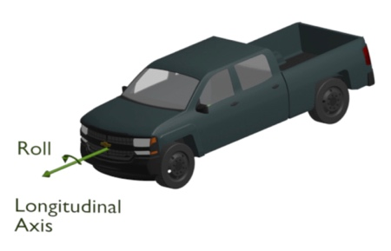
Figure 4: Roll (Liske, 2020)
The roll inertia of a car refers to the resistance of the car body to rotational motion about the roll axis, which runs vertically through the centre of gravity of the car. To calculate the roll inertia of a car, you will need information about the mass and distribution of the car's components, including the body, engine, and suspension. A common method to calculate the roll inertia is to use the equation:
$$Im=\left(mfs* αf^{2}\right)+(mrs* αr^{2})$$
Equation 10: Roll Inertia

2.4.2 Equations

2.4.2.1 Sprung Mass
$$\ddot{z}= -\frac{1}{m_{f}}\left\lceil k_{f1}\left(z-z_{f1}-aθ-β∅\right)+ c_{f1}\left(\dot{z}-{\dot{z}}_{f1}-a\dot{θ}-β\dot{∅}\right)\right\rceil +\left\lceil k_{f2}\left(z-z_{f2}-aθ+α∅\right)+ c_{f2}\left(\dot{z}-{\dot{z}}_{f2}-a\dot{θ}+α\dot{∅}\right)\right\rceil +\left\lceil k_{r1}\left(z-z_{r1}+bθ-β∅\right)+ c_{r1}\left(\dot{z}-{\dot{z}}_{r1}+b\dot{θ}-β\dot{∅}\right)\right\rceil +\left\lceil k_{r2}\left(z-z_{r2}+bθ+α∅\right)+ c_{r2}(\dot{z}-{\dot{z}}_{r2}+b\dot{θ}+α\dot{∅})\right\rceil$$
Equation 11: 7DOF Sprung

2.4.2.2 Unsprung Mass
$${\ddot{z}}_{f}= -\frac{1}{m_{f}}\left[k_{tf1}\left(z_{f1}-y_{f1}\right)- k_{f1}\left(z-z_{f1}-aθ-β∅\right)- c_{f1}\left(\dot{z}-{\dot{z}}_{f1}-a\dot{θ}-β\dot{∅}\right)+ c_{tf1}\left({\dot{z}}_{f1}-{\dot{y}}_{f1}\right)\right]$$
Equation 12: 7DOF Unsprung Front 1
$${\ddot{z}}_{f}= -\frac{1}{m_{f}}\left[k_{tf2}\left(z_{f2}-y_{f2}\right)- k_{f2}\left(z-z_{f2}-aθ+α∅\right)- c_{f2}\left(\dot{z}-{\dot{z}}_{f2}-a\dot{θ}+α\dot{∅}\right)+ c_{tf2}\left({\dot{z}}_{f2}-{\dot{y}}_{f2}\right)\right]$$
Equation 13: 7DOF Unsprung Front 2
$${\ddot{z}}_{r}= -\frac{1}{m_{r}}\left[k_{tr1}\left(z_{r1}-y_{r1}\right)- k_{r1}\left(z-z_{r1}+bθ-β∅\right)- c_{r1}\left(\dot{z}-{\dot{z}}_{r1}+b\dot{θ}-β\dot{∅}\right)+ c_{tr1}\left({\dot{z}}_{r1}-{\dot{y}}_{r1}\right)\right]$$
Equation 14: 7DOF Unsprung Rear 1
$${\ddot{z}}_{r}= -\frac{1}{m_{r}}\left[k_{tr2}\left(z_{r2}-y_{f2}\right)- k_{r2}\left(z-z_{r2}+bθ+α∅\right)- c_{r2}\left(\dot{z}-{\dot{z}}_{r2}+b\dot{θ}+α\dot{∅}\right)+ c_{tr2}\left({\dot{z}}_{r2}-{\dot{y}}_{r2}\right)\right]$$
Equation 15: 7DOF Unsprung Rear 2

2.4.2.3 Pitch
$$\ddot{θ}= -\frac{1}{I}-\left[-ak_{f1}\left(z-z_{f1}-aθ-β∅\right)-ac_{f1}\left(\dot{z}-{\dot{z}}_{f1}-a\dot{θ}-β\dot{∅}\right)\right]-\left[-ak_{f2}\left(z-z_{f2}-aθ+α∅\right)-ac_{f2}\left(\dot{z}-{\dot{z}}_{f2}-a\dot{θ}+α\dot{∅}\right)\right]+\left[bk_{r1}\left(z-z_{r1}+bθ-β∅\right)+bc_{r1}\left(\dot{z}-{\dot{z}}_{r1}+b\dot{θ}-β\dot{∅}\right)\right]+\left[bk_{r2}\left(z-z_{r2}+bθ+α∅\right)+bc_{r2}\left(\dot{z}-{\dot{z}}_{r2}+b\dot{θ}+α\dot{∅}\right)\right]$$
Equation 16: 7DOF Pitch

2.4.2.4 Roll
$$\ddot{∅}= -\frac{1}{I_{m}}-\left[-βk_{f1}\left(z-z_{f1}-aθ-β∅\right)-βc_{f1}\left(\dot{z}-{\dot{z}}_{f1}-a\dot{θ}-β\dot{∅}\right)\right]+\left[αk_{f2}\left(z-z_{f2}-aθ+α∅\right)+αc_{f2}\left(\dot{z}-{\dot{z}}_{f2}-a\dot{θ}+α\dot{∅}\right)\right]-\left[-βk_{r1}\left(z-z_{r1}+bθ-β∅\right)-βc_{r1}\left(\dot{z}-{\dot{z}}_{r1}+b\dot{θ}-β\dot{∅}\right)\right]+\left[αk_{r2}\left(z-z_{r2}+bθ+α∅\right)+αc_{r2}\left(\dot{z}-{\dot{z}}_{r2}+b\dot{θ}+α\dot{∅}\right)\right]$$
Equation 17: 7DOF Roll

3 Results
The results from one through seven DOF can be seen below. These include:
- Sprung mass
- Unsprung mass (with comparisons where needed)
- Pitch
- Roll

3.1 Two Degrees of Freedom
Figures 5 and 6 below show the results of the two DOF model. The sprung mass graph represents the behaviour of the vehicle. It displays the motion of the mass in response to changes in the springs and external loads characteristics (in this case there is no external load). The graph includes two axes, one for displacement and another for time, and plots the motion of the mass for different DOF.

The oscillation seen between 6.5 seconds and 10 seconds would suggest the system is underdamped. Underdamping refers to a situation in which a vehicle returns to its equilibrium position too slowly after being disturbed. In this case, the system continues to oscillate with a decaying amplitude, meaning that the oscillations gradually decrease in magnitude over time. Underdamping is a result of a system's resistance to change and its tendency to return to its original state. It is in contrast to overdamping, where the system returns to its equilibrium position too quickly and does not oscillate at all (Chegg, n.d).
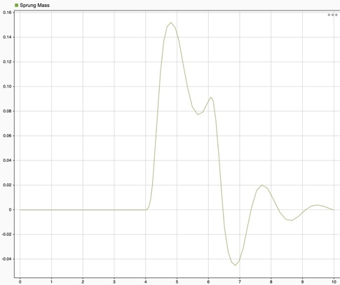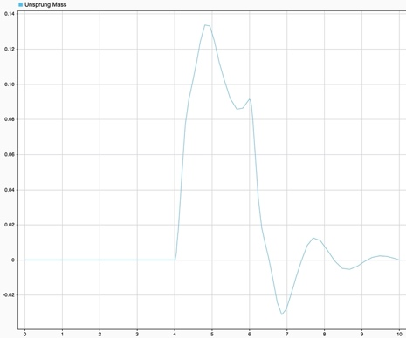
Figure 5: 2DOF: Sprung Mass. Figure 6: 2DOF: Unsprung Mass
The unsprung mass graph can be seen to follow the same trend at the sprung mass. This would suggest that the sprung and unsprung mass move in the same way. This can only be seen in the two DOF model because it doesn’t account for movement on any other axis, hence why a seven DOF model represents the vehicles movement much more accurately.

3.2 Four Degrees of Freedom
Figures 7, 8 ,9 and 10 show below the results from the four DOF model.

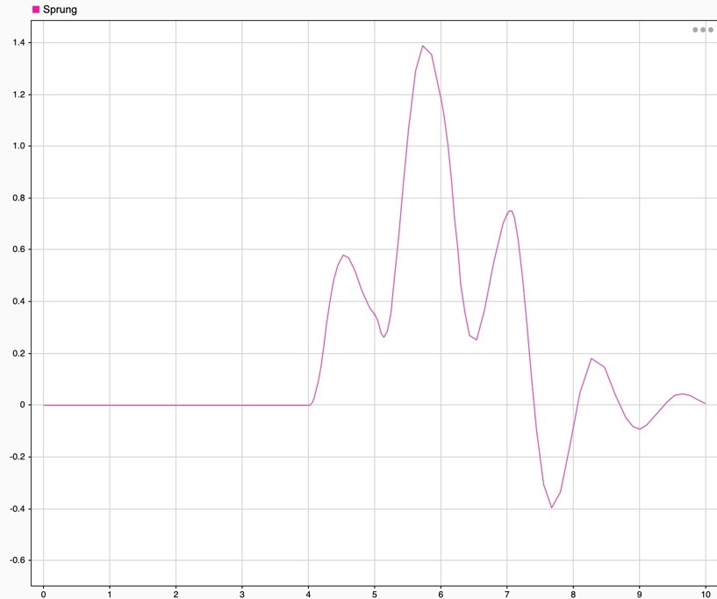
Figure 7: 4DOF: Sprung Mass
Figure 8 and 9 below shows the unsprung mass front and rear, respectively. There is a 1.25 second delay between the front and rear, which can be seen between 6.5 and 7.75 seconds. A delay in unsprung mass between the front and rear of a vehicle refers to a difference in the time it takes for the unsprung mass of the front and rear to respond to changes in road conditions. The delay in unsprung mass between the front and rear can be caused by a variety of factors, such as differences in the suspension system design, differences in the tire type and size, and differences in the brake system components, in this case the cause of the delay is the damping values. The rear dampers have a damping rate of 1477N/mm for bump and 1612N/mm for rebound; whereas the front has a damping rate of 1660N/mm for bump and 1915N/mm for rebound.

Both front and rear unsprung again show underdamping. This can be seen between 6.5 and 10 seconds for the front, and between 7.75 and 10 seconds for the rear.
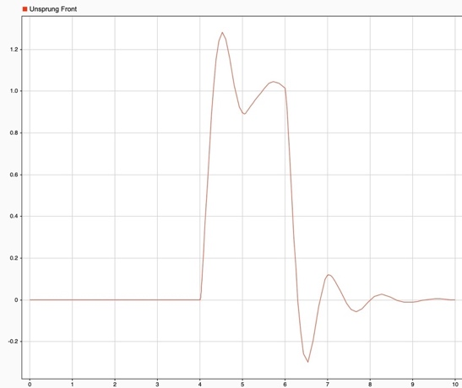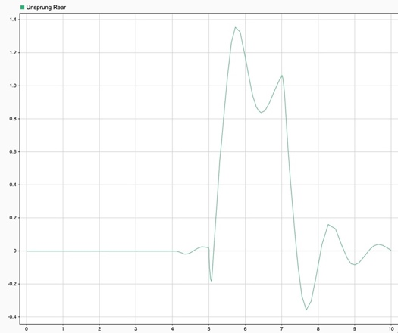
Figure 8: 4DOF: Unsprung Front Mass Figure 9: 4DOF: Unsprung Rear Mass
Figure 10 below shows the pitch angle of the four DOF system when a longitudinal acceleration has been applied (seen below in figure 21). Between 4 and 4.5 seconds braking occurs, resulting in a negative pitch angle. Negative pitch angle refers to the downward slope of the front of the vehicle relative to the rear. In other words, when the front end of the vehicle is lower than the rear end, it is said to have a negative pitch angle. A negative pitch angle can occur when a vehicle is decelerating or descending a hill. It can also be caused by factors such as a heavy load in the front of the vehicle or a malfunctioning suspension system, however, in this case it is caused by braking.

Having a negative pitch angle can affect the handling and stability of a vehicle, as it can lead to changes in the weight distribution and centre of gravity. This can result in decreased traction and increased tire wear, as well as decreased passenger comfort.

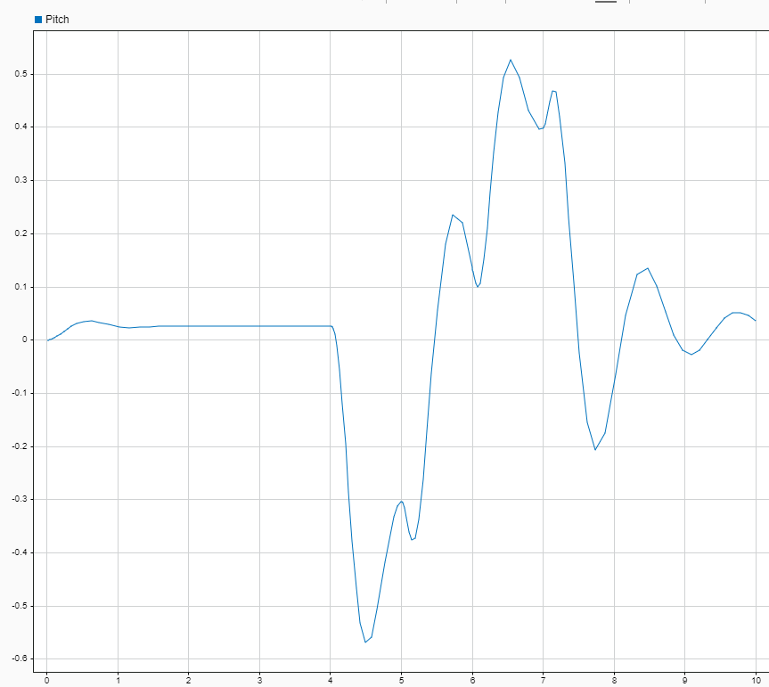
Figure 10: 4DOF: Pitch

3.4 Seven Degrees of Freedom
Figure 11 below shows the sprung mass. The graph shows the sprung mass movement from the pitch centre. Between 2 and 8 seconds underdamping can again be seen, however, due to the longitudinal acceleration, this looks much more drastic than usual.
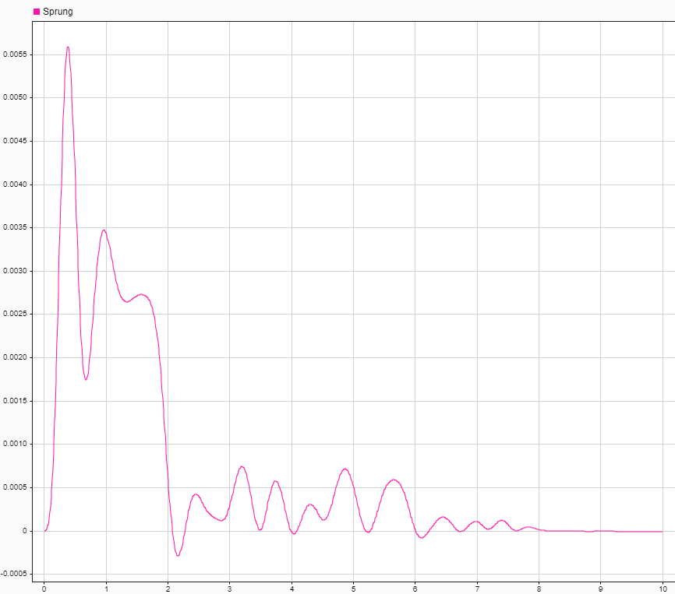
Figure 11: 7DOF: Sprung
Figures 12 and 13 show unsprung front left and right. They follow the same pattern in opposite directions, this is to be expected due to the roll response of the vehicle. When the left wheel goes up, the left wheel goes down and vice versa. Figure 14 below shows the same unsprung mass, the opposite directions can be seen more clearly here.
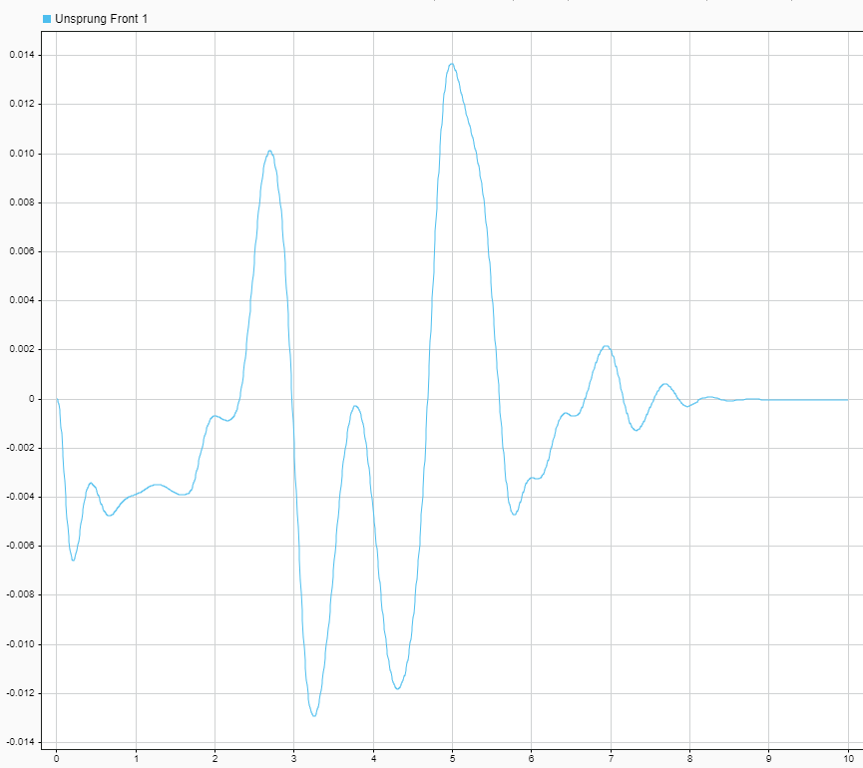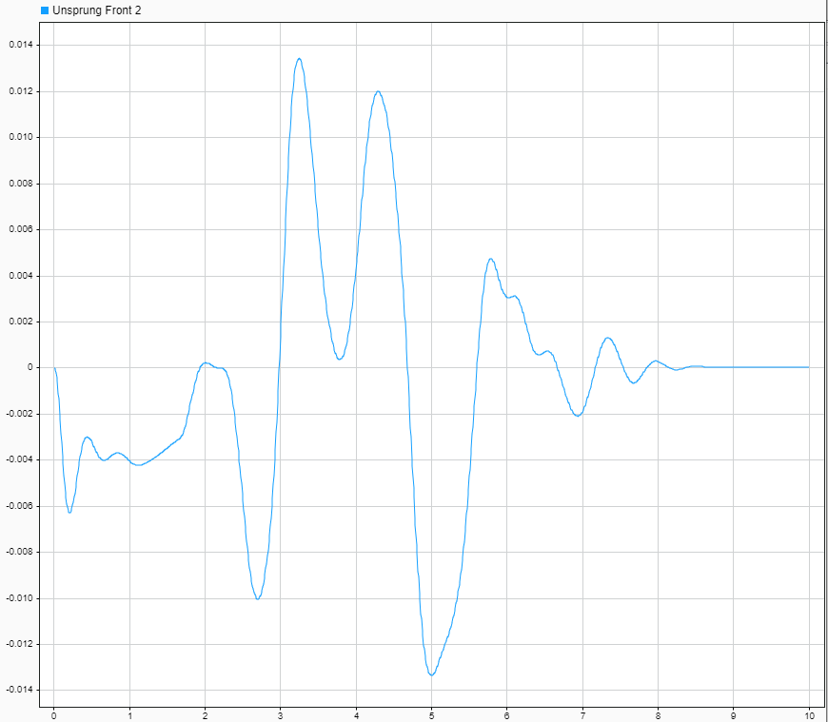
Figure 12: 7DOF: Unsprung Front 1 Figure 13: 7DOF: Unsprung Front 2
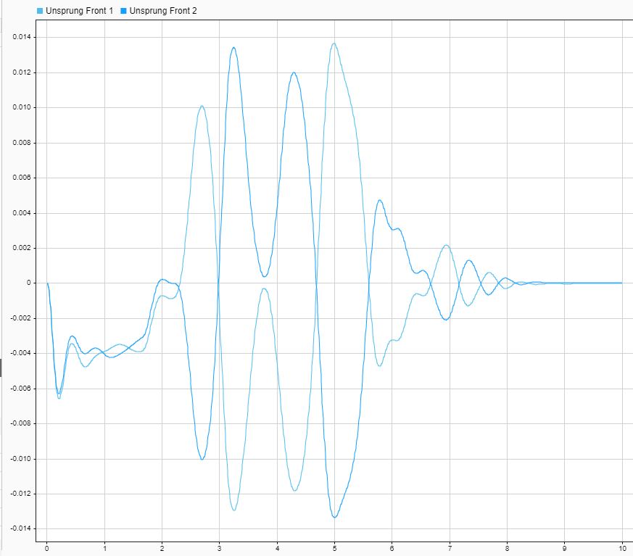
Figure 14: 7DOF: Unsprung Front

Figure 15 and 16 below shows the unsprung mass rear left and right. Again they can be seen to follow the same pattern in opposite directions which can be seen more clearly in figure 17 below.
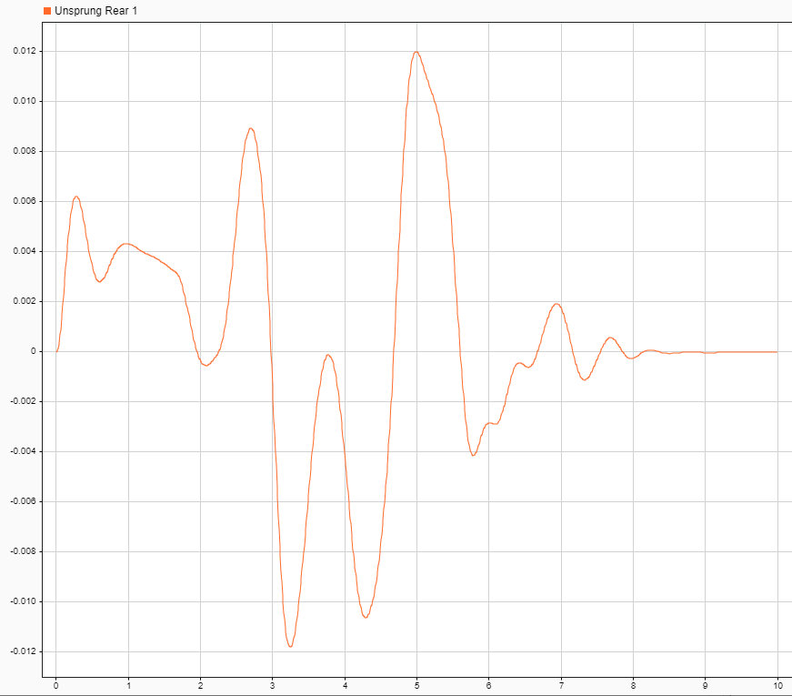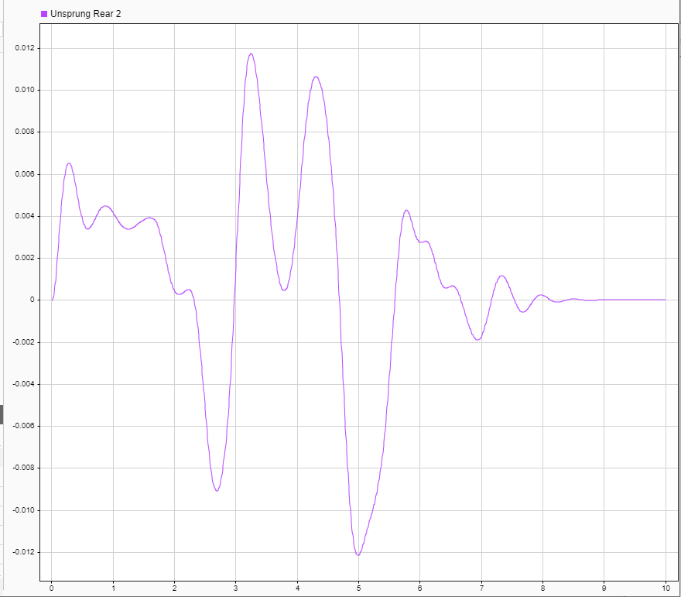
Figure 15: 7DOF: Unsprung Rear 1 Figure 16: 7DOF: Unsprung Rear 2
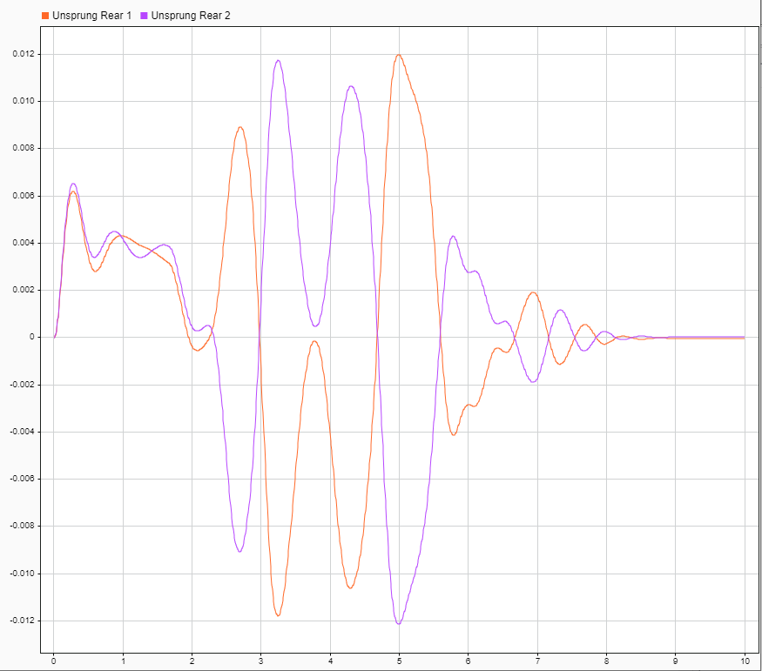
Figure 17: 7DOF: Unsprung Rear
Roll can be seen below in figure 18. As expected, this follows the pattern of the lateral acceleration input which can be seen below in figure 19.
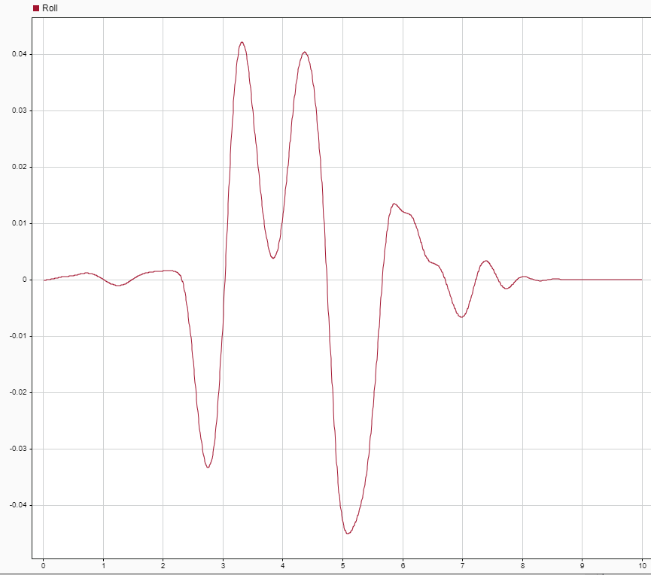
Figure 18: 7DOF: Roll
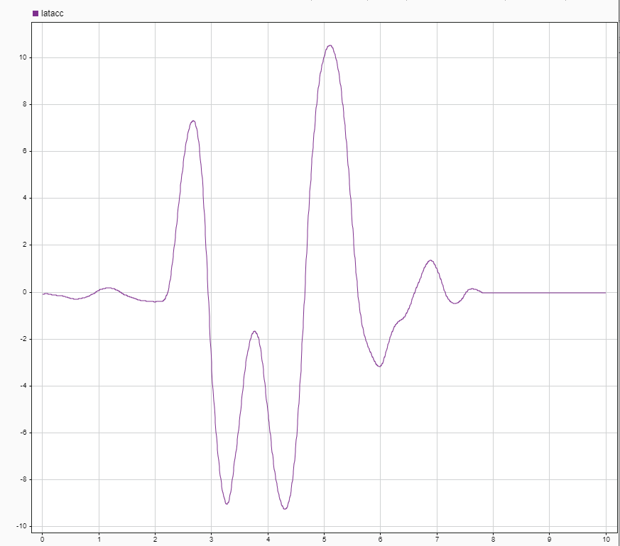
Figure 19: 7DOF: Lateral Acceleration
Figure 20 below shows the pitch angle of the vehicle, this follows the longitudinal acceleration which can be seen below in figure 21.
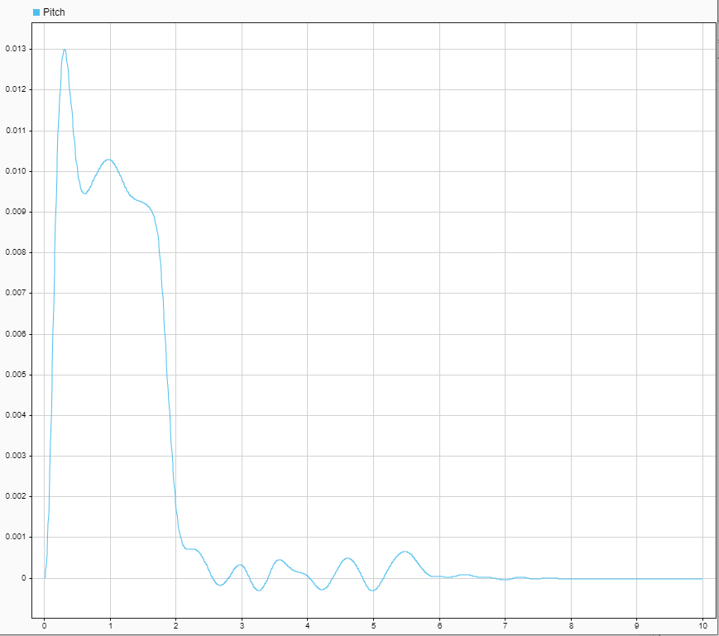
Figure 20: 7DOF: Pitch
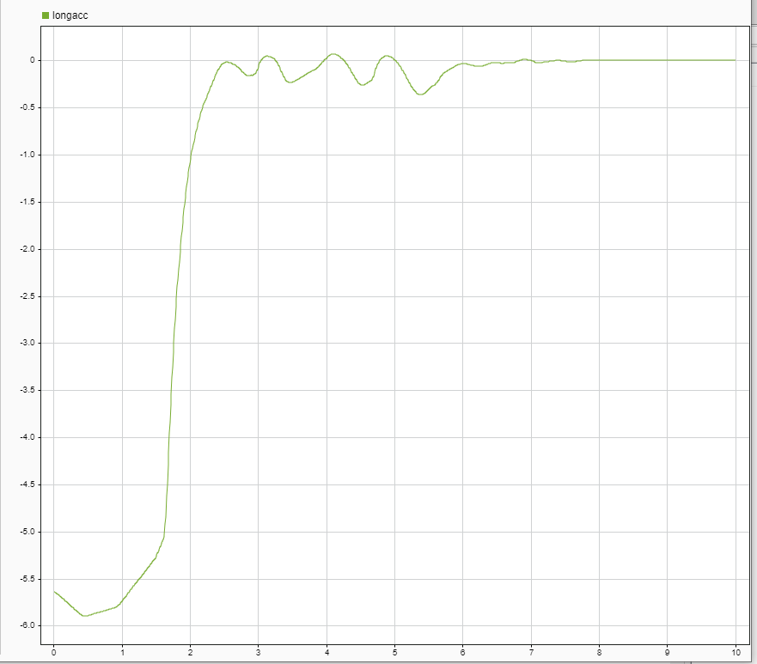
Figure 21: 7DOF: Longitudinal Acceleration

3.4.1 Spring Investigation
Figure 22 below shows the investigation used for this model.
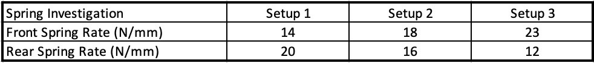
Figure 22: Spring Investigation
The pitch from setup 1, 2 and 3 can be seen in figure 23 below. The beginning of the graph shows a positive pitch meaning the vehicle is accelerating, followed by a decrease in pitch, suggesting braking. It can then be seen to accelerate again followed by a sudden brake. Setup three (seen in grey) can be seen to oscillate the least of the three setups. The spring setup affects the pitch response by controlling the amount of body roll and dive during acceleration and braking. The stiffness of the springs and dampers determine the firmness of the suspension, which affects the pitch response. A softer suspension will result in more body roll and dive, while a firmer suspension will reduce it. These changes to the spring setup can help to optimize the vehicle's handling characteristics and improve overall performance.

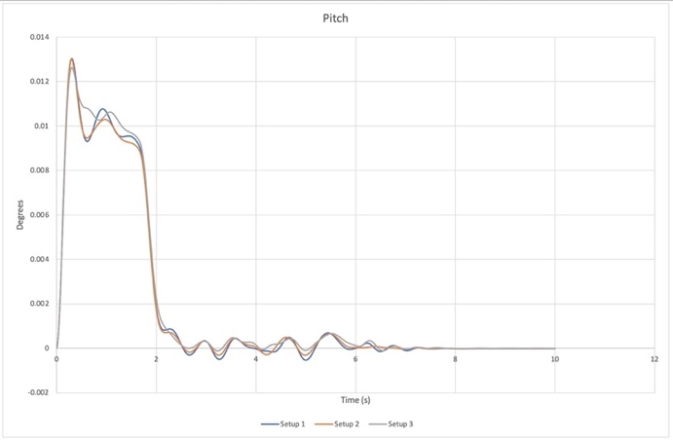
Figure 23: Spring Investigation: Pitch
The spring setup affects the roll response by controlling the amount of body lean during cornering. The stiffness of the springs and anti-roll bars determine the firmness of the suspension, which affects the roll response. A softer suspension will result in more body lean, while a firmer suspension will reduce it. These changes to the spring setup can help to optimize the vehicle's handling characteristics and improve overall performance. A proper spring setup can enhance stability and responsiveness during cornering, as well as reduce body roll for a more comfortable driving experience. Figure 24 below shows the roll encountered with the three spring setups. All setups result in the same roll angle through the whole cycle, this is because the spring rates are not drastic enough to see the changes in roll.
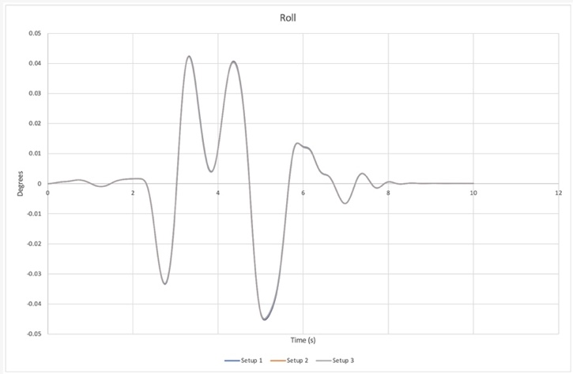
Figure 24: Spring Investigation: Roll

3.4.2 Spring Investigation (Beyond Limits)
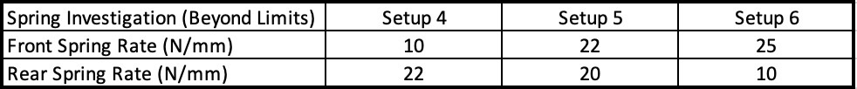
Figure 25: Spring Investigation (Beyond Limits)
Having different front and rear spring rates can affect the pitch of a vehicle. A higher spring rate in the front, such as 10N/mm (seen in setup 4), would make the front end of the vehicle stiffer and less prone to body roll. This can lead to improved handling and increased stability in high-speed corners. However, a stiffer front end can also result in a less comfortable ride over rough surfaces. A lower spring rate in the rear, such as 22N/mm (also seen in setup 4), would make the rear end of the vehicle softer and more prone to body roll. This can improve traction and comfort but can also reduce stability. The difference in spring rates between the front and rear can also affect the vehicle's overall handling balance and driving characteristics, as the front and rear suspension will respond differently to changes in the road surface.

Setup 5 has a higher front spring rate of 22N/mm, and a lower rear spring rate of 20N/mm would make the front of the vehicle stiffer and the rear softer compared to the other way around. A stiffer front end can lead to improved handling, increased stability in high-speed corners, and reduced body roll, but can also result in a less comfortable ride over rough surfaces. A softer rear end can improve traction and comfort but can also reduce stability. The difference in spring rates between the front and rear can affect the overall handling balance and driving characteristics of the vehicle, as the front and rear suspension will respond differently to changes in the road surface. Setup 6 also follows this with a front spring rate of 25N/mm and a lower rear spring rate of 10N/mm.
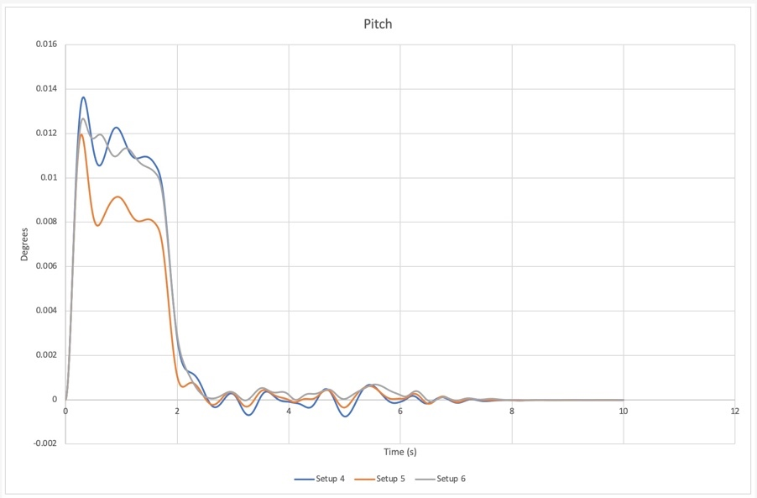
Figure 26: Spring Investigation (Beyond Limits): Pitch
Figure 27 shows the roll results with the spring rates beyond limits. Here a difference can be seen between each spring setup, this is because the setups are much more extreme. Setup 5 (in orange) shows a lower roll angle throughout the whole cycle due to the front and rear springs having a similar spring rate. When the spring rate are drastically different between front and rear, the vehicle pitch response is increased; this can be seen in setup 4 (in blue). This can also be seen for setup 6 (in grey).
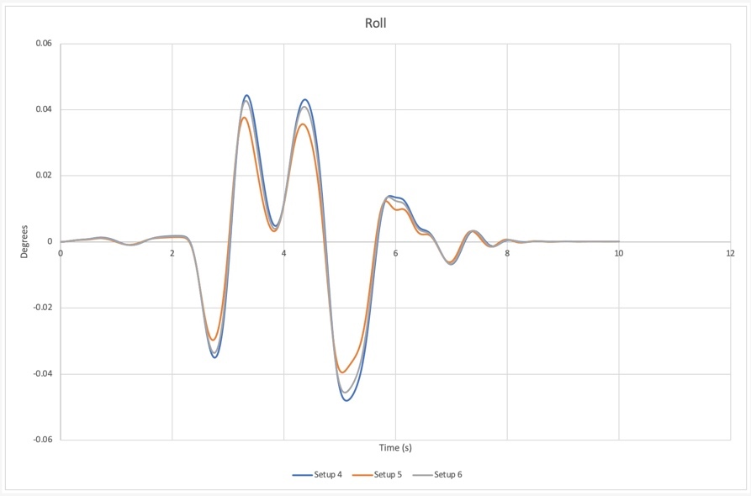
Figure 27: Spring Investigation (Beyond Limits): Roll

3.5 Seven Degrees of Freedom: Comparison

3.5.1 Setup One
Figure 28 and 29 below shows the results compared with the real data for the formula ford race car. This shows a comparison of the pitch response (figure 28) and the roll response (figure 29). As can be seen below the results (in blue) follow the same peaks between 2 and 6 seconds, however as they are much lower, this would suggest that the vehicle set up is much stiffer than that of the real data.
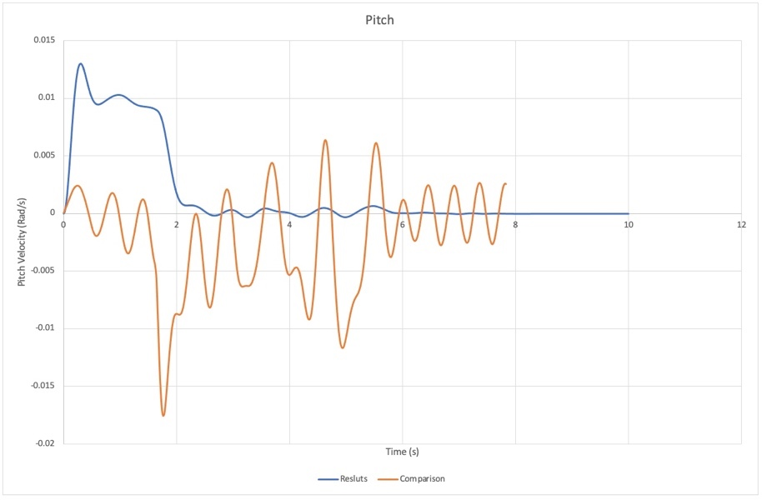
Figure 28: 7DOF Pitch Comparison: Setup 1
The roll follows a similar pattern; however, the real data points are much higher, again suggesting that the SMD setup is much stiffer, causing less movement under lateral acceleration.
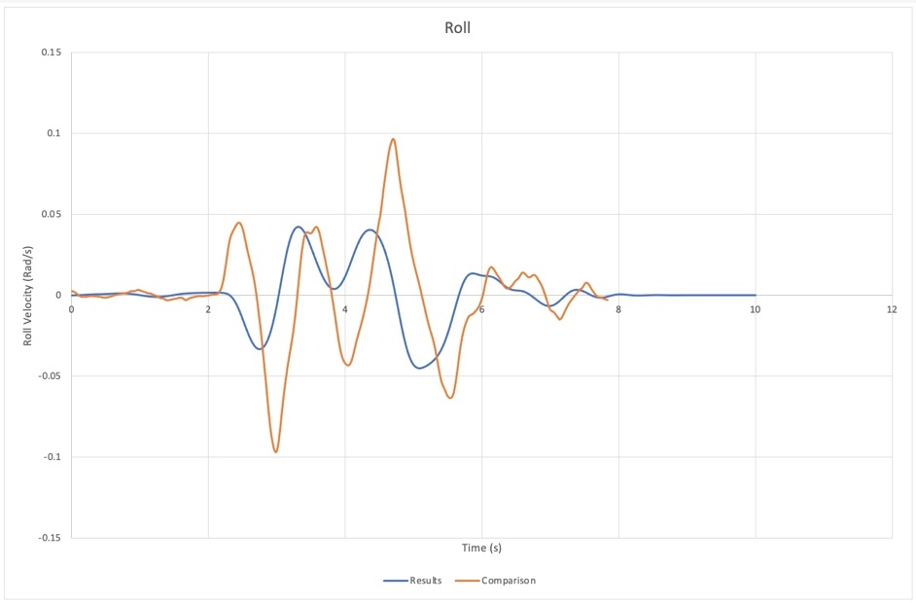
Figure 29: 7DOF Roll Comparison: Setup 1

3.5.2 Setup Two
Figure 30 and 31 below shows the results compared to the real data of set up two. The main focus is between 18 and 24 seconds, where it can be seen to follow the same peaks again at a lower value. It also seems to show a much slower response as after a peak or trough the real data returns back to 0 much quicker. This means that the vehicle is returning back to its original position much quicker. This suggests that the SMD system stiffness is higher than the real data in both bump and rebound.
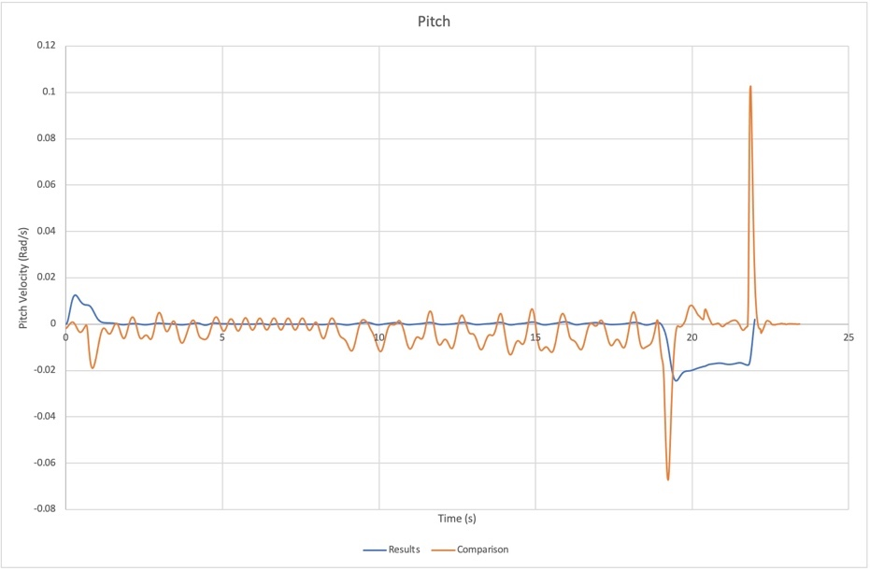
Figure 30: 7DOF Pitch Comparison: Setup 2
Figure 31 shows the roll response compared to the real data. Again, showing a delay in the graph suggesting the SMD system model is much stiffer.
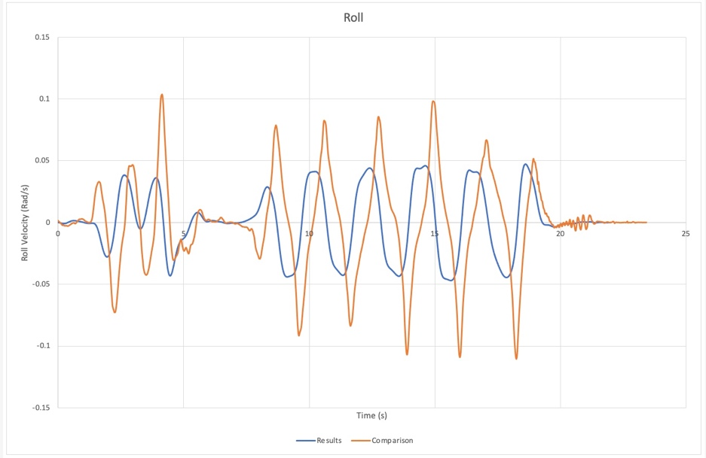
Figure 31: 7DOF Roll Comparison: Setup 2

3.5.3 Setup Three
Figure 32 and 33 below shows the results of setup three compared to the real data. Between 10 and 20 seconds, the model follows the peaks of the real data, again much lower suggesting the vehicle is stiffer. More pitch response can be seen in both sets of data suggesting a more aggressive longitudinal acceleration profile.
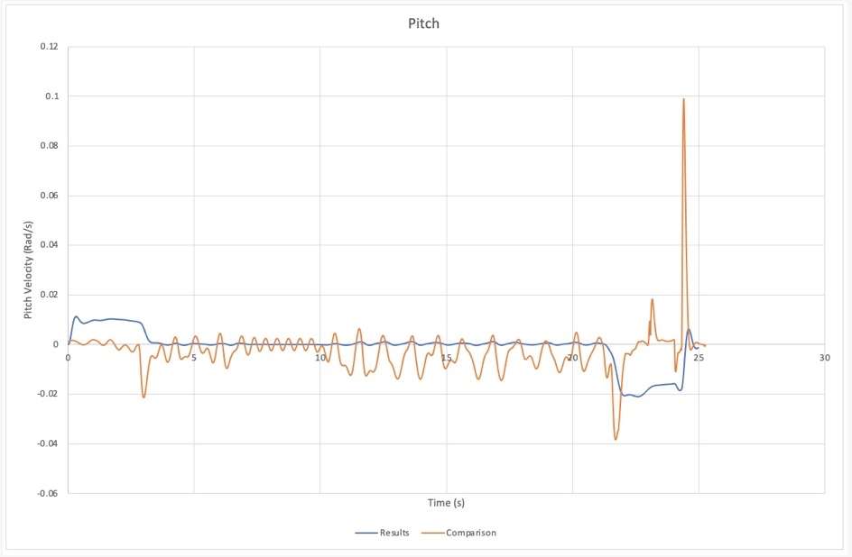
Figure 32: 7DOF Pitch Comparison: Setup 3
The roll follows a similar pattern; again, the real data points are much higher, suggesting that the SMD setup is much stiffer, causing less movement under lateral acceleration. However, in this setup there are more peaks and troughs, suggesting more aggressive lateral movements.

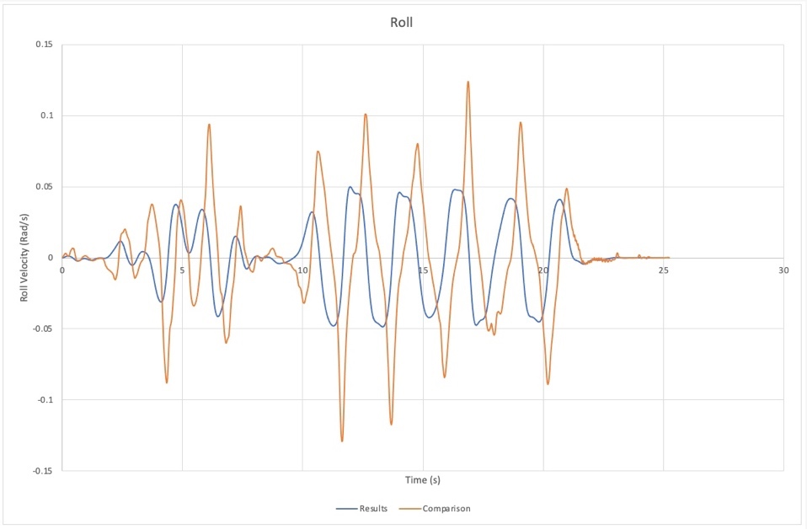
Figure 33: 7DOF Roll Comparison: Setup 3

4 Conclusion
In conclusion, the results of the two DOF model indicate that the vehicle behaves in an underdamped manner, meaning it returns to its equilibrium position too slowly after being disturbed. This underdamping is a result of the system's resistance to change and tendency to return to its original state. The unsprung mass graph follows the same trend as the sprung mass, suggesting that both masses move in the same way. However, a more accurate representation of the vehicle's movement can be obtained through a seven DOF model, as it accounts for movement on other axes as well.

For the 4DOF model, the unsprung mass of the front and rear of the vehicle shows a 1.25 second delay between them, caused by differences in the damping rates. Both front and rear unsprung masses display underdamping, and the pitch angle of the four DOF system shows a negative pitch angle caused by braking. The negative pitch angle can negatively impact the handling and stability of the vehicle, leading to decreased traction, increased tire wear, and decreased passenger comfort.

For the 7DOF model, the sprung mass of the vehicle displays underdamping, which is more drastic due to the longitudinal acceleration. The unsprung mass front left and right, as well as the unsprung mass rear left and right, follow the same pattern in opposite directions, which is expected due to the roll response of the vehicle. The roll of the vehicle follows the pattern of the lateral acceleration input, while the pitch angle of the vehicle follows the longitudinal acceleration. These patterns provide valuable information about the behaviour of the vehicle and its response to different inputs and external factors and can be used to improve vehicle performance and passenger safety.

The pitch and roll response of a vehicle can be greatly affected by the spring setup. The stiffness of the springs and dampers determine the firmness of the suspension, which affects the pitch and roll response. A softer suspension will result in more body roll and dive, while a firmer suspension will reduce it. The differences in spring rates between the front and rear can also affect the handling balance and driving characteristics of the vehicle. The results indicate that setups with drastic differences in front and rear spring rates can result in increased pitch response and have a greater impact on the roll response. A proper spring setup can enhance stability and responsiveness during cornering, as well as improve overall performance and comfort.

The results of the three SMD setups compared to the real data of the formula Ford race car indicate that the SMD setups are generally stiffer than the real data, causing less movement under lateral and longitudinal accelerations. This is shown through the lower peaks and slower responses in the pitch and roll responses compared to the real data. The results suggest that the vehicle set up is much stiffer in all three setups, with setup three showing a more aggressive longitudinal acceleration profile.

Bibliography
Aceable, n.d. Aceable. [Online]
Available at: https://www.aceable.com/safe-driving/how-does-pitch-affect-your-car/
[Accessed 21 January 2023].
Bakar, S. A. A., Mohd, P., Samin & Azhar, A. A., 2014. Research Gate. [Online]
Available at: https://www.researchgate.net/publication/269342602_Modelling_and_Validation_of_Vehicle_Ride_Comfort_Model
[Accessed 3 January 2023].
Formula1-Dictionary, 2022. Formula1-Dictionary. [Online]
Available at: https://www.formula1-dictionary.net/unsprung_weight.html
[Accessed 21 January 2023].
Kimberley, M., 2019. CarThrottle. [Online]
Available at: https://www.carthrottle.com/post/what-are-sprung-and-unsprung-mass-and-which-one-is-bad-news/
[Accessed 21 January 2023].
Liske, 2020. Liske Forecnsics. [Online]
Available at: https://www.liskeforensics.com/blog/title/vehicle-pitch-roll-and-yaw/id/249/
[Accessed 15 January 2023].
Ritzel, 2016. Ritzel. [Online]
Available at: https://ritzel.siu.edu/courses/302s/vehicle/vehicledynamics.htm
[Accessed 22 January 2023].
Sebsadji, Y., Glaser, S., Mammer, S. & Netto, M., 2008. ResearchGate. [Online]
Available at: https://www.researchgate.net/publication/228993977_Vehicle_Roll_and_Road_Bank_Angles_Estimation
[Accessed 17 January 2023].

Table of Figures
Figure 1: Formula Ford Race Car 4
Figure 2: Formula Ford Race Car Parameters 4
Figure 3: Pitch (Liske, 2020) 7
Figure 4: Roll (Liske, 2020) 10
Figure 5: 2DOF: Sprung Mass 12
Figure 6: 2DOF: Unsprung Mass 12
Figure 7: 4DOF: Sprung Mass 13
Figure 8: 4DOF: Unsprung Front Mass 13
Figure 9: 4DOF: Unsprung Rear Mass 14
Figure 10: 4DOF: Pitch 14
Figure 11: 7DOF: Sprung 15
Figure 12: 7DOF: Unsprung Front 1 15
Figure 13: 7DOF: Unsprung Front 2 15
Figure 14: 7DOF: Unsprung Front 16
Figure 15: 7DOF: Unsprung Rear 1 16
Figure 16: 7DOF: Unsprung Rear 2 16
Figure 17: 7DOF: Unsprung Rear 17
Figure 18: 7DOF: Roll 17
Figure 19: 7DOF: Lateral Acceleration 17
Figure 20: 7DOF: Pitch 18
Figure 21: 7DOF: Longitudinal Acceleration 18
Figure 22: Spring Investigation 18
Figure 23: Spring Investigation: Pitch 19
Figure 24: Spring Investigation: Roll 19
Figure 25: Spring Investigation (Beyond Limits) 19
Figure 26: Spring Investigation (Beyond Limits): Pitch 20
Figure 27: Spring Investigation (Beyond Limits): Roll 20
Figure 28: 7DOF Pitch Comparison: Setup 1 20
Figure 29: 7DOF Roll Comparison: Setup 1 21
Figure 30: 7DOF Pitch Comparison: Setup 2 21
Figure 31: 7DOF Roll Comparison: Setup 2 22
Figure 32: 7DOF Pitch Comparison: Setup 3 22
Figure 33: 7DOF Roll Comparison: Setup 3 22

Table of Equations
Equation 1: OneDOF 6
Equation 2: Pitch Inertia 7
Equation 3: 2DOF Sprung 7
Equation 4: 2DOF Unsprung 8
Equation 5: 4DOF Sprung 8
Equation 6: 4DOF Front Unsprung 8
Equation 7: 4DOF Rear Unsprung 9
Equation 8: 4DOF Pitch 9
Equation 9: Roll Inertia 10
Equation 10: 7DOF Sprung 11
Equation 11: 7DOF Unsprung Front 1 11
Equation 12: 7DOF Unsprung Front 2 11
Equation 13: 7DOF Unsprung Rear 1 11
Equation 14: 7DOF Unsprung Rear 2 11
Equation 15: 7DOF Pitch 11
Equation 16: 7DOF Roll 11

