Cofiwch Dryweryn - Territory by Tins of Paint
By Hannah Lee Chapman
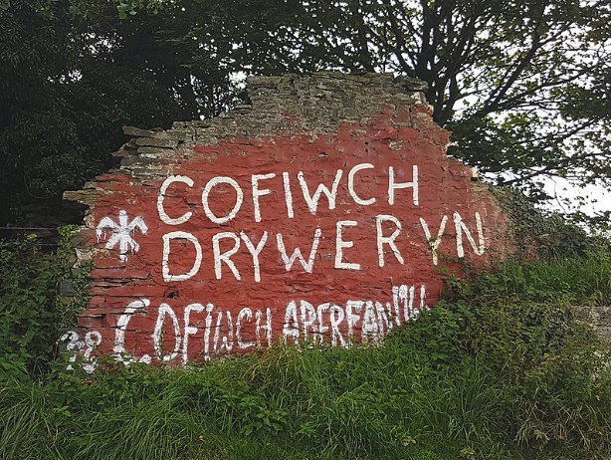
Cofiwch Dryweryn ac Aberfan (Tomos, 2017)
The saying 'Cofiwch Dryweryn' holds a massive significance to Welsh people, supporters of the Yes Cymru movement and Welsh-speaking communities. Most Welsh people are at least aware of the saying "Cofiwch Dryweryn", it is hard not to be mindful of it when there are hundreds of signs all around Wales. There are over 100 Cofiwch signs in the UK and Worldwide; there is even a mural in a pub located in Chicago, Illinois. Even though it is a widely known sign, not everyone would know what it was about. It is graffiti that is now being used as a mural that influenced unrest in Welsh communities. It still has even more relevance now as it did when the phrase started being used in the late 1960s. The wall was painted as of political statement for Welsh people as a reminder of what has happened to them at the hands of the English government and general political apathy when it comes to Welsh people throughout history. The saying "Cofiwch Dryweryn" has been at the centre of most if not all pro-Wales movements have happened. In more recent years there have been stickers, magnets, phone cases, t-shirts and even more recently with the pandemic, facemasks—all with the Cofiwch Dryweryn wall printed on them. There is nothing inherently wrong with this per se, but it can be argued that the mass production of related items almost trivialises the cause by capitalising off it.

Cofiwch Dryweryn translated into English means Remember Tryweryn (the T in Tryweryn mutates into a D in Welsh once used in a sentence). In the original sign made by Meic Stephans included the misconception that the word Tryweryn stays the same in the sentence, making it a grammatically incorrect statement (Howell, 2020). Later on, the wall got repainted to include the correct mutation. The wall it was painted by Stephans was on the side of an old cottage named Troed-y-Rhiw. It has no particular meaning to the message 'Cofiwch Dryweryn'. It is situated on the side of the main road going to and from Aberystwyth in the outskirts of Llanrhystud. The signs job is to be a reminder to Welsh people, and it does accomplish that by being very eye-catching on the side of the road.

There is another wall behind the main Cofiwch wall with another Welsh saying on it, and it reads "Fe godwn ni eto" meaning 'we will rise again' in English. It is the slogan of the Free Wales Army but it stating to be used by less radical pro-Welsh organisations. The Free Wales army setting fire to English owned holiday homes mostly in north Wales because it put a strain on the actual Welsh people who lived in the areas, the rents and house prices go up, and Welsh people from the area can no longer afford housing and get pushed out. This is a process called gentrification, and it is happening all over Wales. The drowning of the villages where a big factor is the free Wales army as it was another act of cruelty from the English to the Welsh.
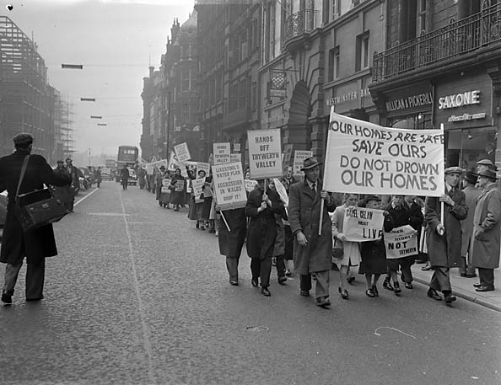
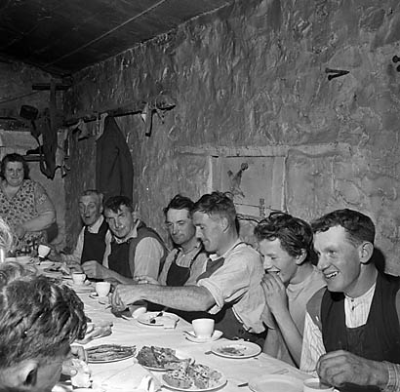
In the mid-1950s, the Liverpool council was starting to struggle to get the 65 million gallons of water that they needed to support the people who lived in the city (Crocket, 2019). Their solution to the problem was to build a dam in the Tryweryn valley. The problem with this is that there was a village in the valley called Capel Celyn and if the dam were going to be constructed, the village Capel Celyn would have to be drowned in the process. Their justifications the council gave for doing this was they needed water for the expanding population in Liverpool and to support the construction of infostructure (Griffiths, 2014). Unlike today where you need to have a consultation with the residents about this kind of thing, that did not happen. The residents of Capel Celyn travelled to Liverpool to try and meet with the council, but they were almost immediately shut down and thrown out of the building (Crocket, 2019). They also attempted to march through the city with signs saying, "Your homes are safe save ours do not drown our homes", "Liverpool's water plan is aggression in Wales drop it!", "Capel Celyn must live" among many more (Crocket, 2019). But the protesters ended up being spat on as well as having fruit thrown at them (Crocket, 2019). The Liverpool council still have no ideas to change after this. A bill went through to the UK parliament in London in 1957. Despite the fact that 35 of the 36 Welsh MP's voting against it, the bill still went through and the land that Capel Celyn stood now belonged in the hands of the Liverpool Council. Plaid Cymru's first major growth can be tributed to the fact that they were very much against the building of the Tryweryn dam (Harries, 2020). They were the first genuine political forces for Wales and for Welsh people which was something people needed at the time. Their involvement did not manage to change anything as the final decision was still down to the English governments. A sign went up in Tryweryn not long after the land was obtained, it read:
Protest held in Liverpool against the flooding of Capel Celyn (Tryweryn), 21 November 1956, (Charles, 1956)
Shearing for the last time at Capel Celyn, July 1961 (Charles, 1961)
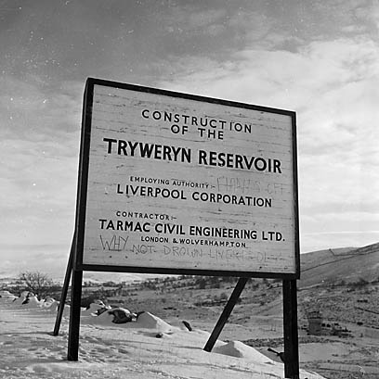
'Construction of the Tryweryn Reservoir.

Employing authority: Liverpool Council

Contractor: Tarmac Civil Engineering Ltd'

The sign did not stay as-is for very long as someone decided to draw over is saying "why not drown Liverpool instead" (Crocket, 2019).

After that, there was nothing people could do, the houses where deconstructed, the graves exhumed and placed elsewhere, and the people relocated to different areas. What once was called Capel Celyn (holly chapel) is now names Llyn Celyn (holly lake). Now just a memory of what it once was, its legacy inspired many.
Capel Celyn and Tryweryn (unknown, n.d.)

The following poem was written why a Welsh poet by the name of Ronald Stewart Thomas (R. S. Thomas):

"There are places in Wales I don't go:
Reservoirs that are the subconscious
Of a people, troubled far down
With gravestones, chapels, villages even;
The serenity of their expression
Revolts me, it is a pose
For strangers, a watercolour's appeal
To the mass, instead of the poem's
Harsher conditions. There are the hills,
Too; gardens gone under the scum
Of the forests; and the smashed faces
Of the farms with the stone trickle
Of their tears down the hills' side.

Where can I go, then, from the smell
Of decay, from the putrefying of a dead
Nation? I have walked the shore
For an hour and seen the English
Scavenging among the remains
Of our culture, covering the sand
Like the tide and, with the roughness
Of the tide, elbowing our language
Into the grave that we have dug for it."

Source: Abandoned communities

It was written in 1968 and published in a book called Not That he brought Flowers which was a collection of more of his works. It is assumed that the poem was written around the time that the Llyn Celyn Reservoir was being constructed. It is hard to believe that the deconstruction of Capel Celyn did not help provoke him into writing the poem.

Even though Capel Celyn may be the most well-known sight does not mean it is the only one. There are many villages that have been destroyed and drowned for the sake of the English getting water and supplies. There was Llanwddyn, Cwnmorthin, Nantgwyllt and Epynt village, to name a few. Epynt was not drowned, though, it was cleared for English military training (Howell, 2020). People are not just angry about the fact that it was small villages being targeted; it was also the fact it was a Welsh-speaking village. It seems like specifically Welsh speaking villages are being targeted for projects like this.

The theme of rising waters and the creation of lakes is something that often appears in Welsh mythology (Griffiths, 2014). The creation of them is penalty from the wrong doings of man. In the story of the creation of Lake Bala there was a wicked king names Tegid Foel who was warned vengeance will come his way if he was not careful. On the night of the celebration of his first-born grandson there was a massive party underway. Throughout the party he kept hearing a bird say, “Vengeance will come!”, Tegid followed this bird all the way to the top of the highest hill in town. It was then when the bird sang him to sleep. Once he awoke in the morning to find the town that he lived was completely flooded and no where to be seen. According to the myth the town is still at the bottom of Lake Bala today. Its eerie to think that the idea of drowned towns is so ingrained into our culture that it is even a part of the mythology; that the past can often be the best predictor of the future.

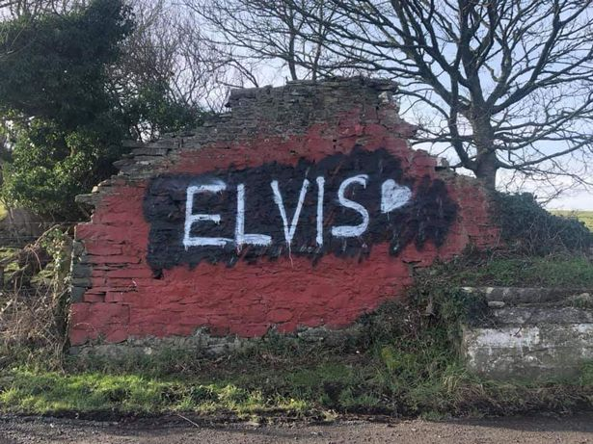
In 2020, the wall was first vandalised by someone painting the word "Elvis" over it that sparked aback a forth between people repairing it and people destroying and defacing it that lasted for months. The desecration of the wall was something many people took to heart and something that was seen as an attack on Welsh culture and 'Welsh Wales' (Howell, 2020). Below the writing 'Cofiwch Dryweryn' there is another piece of writing saying 'I'r gâd' meaning 'to battle' in English. A day after this was painted, half of the wall was completely knocked down (harries, 2020). After that incident, it was rebuilt but volunteers. CCTV was placed at the wall in the hopes to catch whoever was defacing it. In June of 2020, it was once again defaced but this time with a Nazi swastika and a white power symbol (Owen, 2020). it was restored by volunteers in the following days.
The Cofiwch Dryweryn wall is to be rebuilt and repainted to protect its legacy (Harries, 2020)

The wall has no official heritage status as well as no official listing as the wall as the wall of the cottage that it is painted on has no actual historical significance that needs to be protected (Howell, 2020). The wall is something that is mostly crowed conservative. It goes to back the fact that it is not protected legally by any one specific person or group of people. Previously it was owned by a collection of farmers in the area, but in August of 2012, a woman by the name of Dilys Davies purchased it for an unknown amount of money after just 10 minutes of deliberating with the farmers about the price (Harries, 2020). Davies said that the wall is going now going to be put into the hands of a charity that will be responsible for repairing the if it continues to get damaged (Addley, 2019).

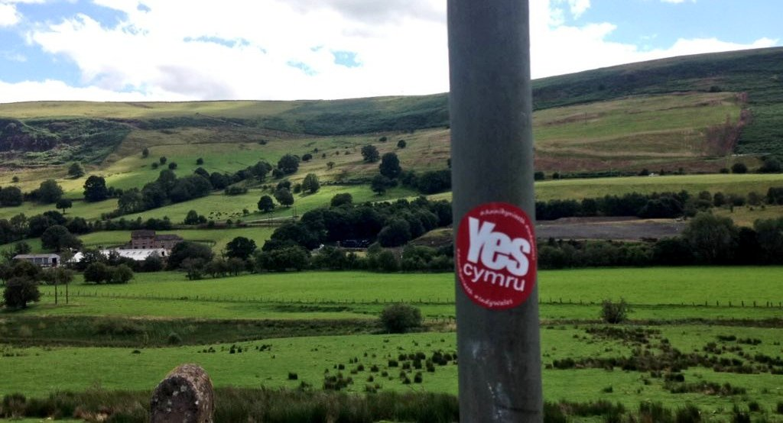
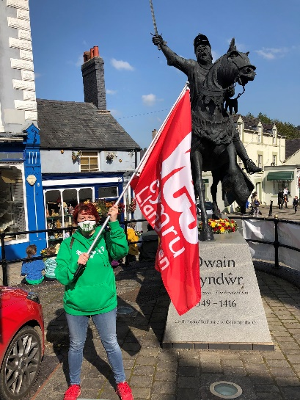
In the last few years, there has been a massive spike in interest and the support of independent Wales, especially in the younger (Hubbard, 2019). Evident by the Yes Cymru stickers are something that is also appearing on lampposts, walls, doors, buildings, chairs, everything. A YouGov poll now shows that there is more of a call for an independent Wales now more than ever with 32% of voters saying that they would vote yes if there was any kind of referendum (Evans, 2020) and 46% of those voters being between the ages of 16 and 24 (Evans, 2020). Even though younger people were not around when a lot of these things were happening when it comes to the free Wales army and the drowning of Welsh towns, but they have seen the way older people react to it as well as researching what the Welsh independence and pro-Wales stands for and agreeing with most of what is said. It stems from most of them wanting to reclaim something that has been lost in the last few generations. It was not too long ago when people were made to wear a Welsh not in school and to receive a beating at the end of the school day. Children no longer receive this kind of punishment, giving them more freedom to be open about their Welshness whilst embracing it and standing up for what they think is important.
(Winindymerch, 2020)
(YesLlangollen, 2020)

As for renegotiation of the wall? Arguably it is best just left as is. The main reason being it was something for the Welsh people, and it should be kept that way. If it belongs to the council or gets moved from its original place, it starts to become disconnected from the community who it was for in the first place. It is not a statue, nor a memorial it is graffiti no matter what kind of significance it holds. It is just a painted wall that stands as a constant reminder. Even though the original village is no longer there, Welsh people still have a connection because it is something that has happened over and over again. People show up to reaper it when it is damaged not because they have, or that they have an obligation to, but it is because of the significance that it holds for so many. A constant reminder that the community will come together during times of need. If it is moved, it also removes the original significance and context that the wall held in the first place. The wall will always belong to the people rather than any one person in the eyes of many Welsh people. The fact people came together to repair it shows that people have made clear how they like it, and that is just the way it is, unchanged and unmoved.

Reference List:
Abandoned communities. (n.d). Abandoned Communities ..... Reservoirs of Wales. Available at: http://www.abandonedcommunities.co.uk/page77.html [Accessed 30th January 2021]
Addley, E. (2019). Welsh graffiti wall to get charity protection following vandalism. Available at: https://www.theguardian.com/uk-news/2019/aug/07/welsh-graffiti-wall-cofiwch-dryweryn-charity-protection-vandalism [Accessed 30th January 2021]
Bowen, E. (2020). “Cofiwch Dryweryn”: A Welsh History of Oppression. Available at: https://cherwell.org/2020/07/19/cofiwch-dryweryn-a-welsh-history-of-oppression/ [accessed: 24th January 2021]
Charles, G. (1957). Protest held in Liverpool against the flooding of Capel Celyn (Tryweryn), 21 November 1956. [image] Available at: https://www.peoplescollection.wales/items/23 [Accessed 29th January 2021]
Charles, G. (1961). Shearing for the last time at Capel Celyn, July 1961. [image] available at: https://www.peoplescollection.wales/items/39 [Accessed 27th January 2021]
Crocket, J. (2019). The Drowning of Capel Celyn. Available at: https://medium.com/datadriveninvestor/the-drowning-of-capel-celyn-109496dc611e [accessed: 24th January 2021]
Evans, H. (2020). New YouGov poll shows highest ever support for Welsh independence. Available at: https://www.dailypost.co.uk/news/north-wales-news/new-yougov-poll-shows-highest-18832964 [Accessed 29th January 2021]
Garside, R. (2020). Epynt village clearance: Woman remembers, 80 years on. Available at: https://www.bbc.co.uk/news/uk-wales-politics-52941264 [Accessed 30th January 2021]
Gower, J. (2019). Review: Cofiwch Dryweryn: Cymru’n Deffro / Wales Awakening. Available at: https://nation.cymru/culture/cofiwch-dryweryn-cymrun-deffro-wales-awakening-capel-celyn-mari-emlyn/ [Accessed 29th January 2021]
Griffiths, H, M. (2014). ‘Water under the bridge? Nature, memory and hydropolitics’ Cultural Geographies. 21(3). pp. 449-474. Available at: https://www-jstor-org.ezproxy.uwtsd.ac.uk/stable/26168584?seq=1#metadata_info_tab_contents [accessed: 24th January 2021]
Harries, R. (2020). The Cofiwch Dryweryn wall is to be rebuilt and repainted to protect its legacy. [image] Available at: https://www.walesonline.co.uk/news/wales-news/cofiwch-dryweryn-wall-rebuilt-repainted-17888858 [Accessed 27th January 2021]
Harries, R. (2020). The Cofiwch Dryweryn wall is to be rebuilt and repainted to protect its legacy. Available at: https://www.walesonline.co.uk/news/wales-news/cofiwch-dryweryn-wall-rebuilt-repainted-17888858 [Accessed 27th January 2021]
Howell, D. (2020). ‘Cofiwch Dryweryn: The Frontiers of Contemporary Welsh Nationalism, as seen through the Creation of Contested Heritage Murals’ Public Archaeologies of Frontiers and Borderlands. Pp. 94-116. Available at: https://books.google.co.uk/books?hl=en&lr=&id=89kSEAAAQBAJ&oi=fnd&pg=PA94&dq=related:37bXeLRdowQJ:scholar.google.com/&ots=z3JqeZ1hIe&sig=Phegq0oD7nAfgH60UAsVa_Q7uq8 [Accessed 27th January 2021]
Hubbard, J. (2019) Welsh nationalism and the wider ramifications. Available at: https://www.theguardian.com/uk-news/2019/sep/30/welsh-nationalism-and-the-wider-ramifications [Accessed 27th January 2021]
James, A. (2011). ‘English(es) in post-devolution Wales: The sociolinguistic reconstruction of late modern Valleys Voice’ AAA: Arbeiten aus Anglistik und Amerikanistik. 36 (1), pp. 47-64. Available at: https://www-jstor-org.ezproxy.uwtsd.ac.uk/stable/26430940?seq=1#metadata_info_tab_contents [Accessed 27th January 2021]
Johnes, M. (2019). “God Bless the Prince of Wales” Available at: https://martinjohnes.com/tag/tryweryn/ [accessed: 24th January 2021]
Owen, C. (2020). Nazi swastika painted on Cofiwch Dryweryn wall in Ceredigion. Available at: https://www.walesonline.co.uk/news/wales-news/cofiwch-dryweryn-wall-swastika-sprayed-18514571 [Accessed 29th January 2021]
Tomos, D. (2017). Cofiwch Dryweryn ac Aberfan. [image] Available at: https://commons.wikimedia.org/wiki/File:Cofiwch_Dryweryn_ac_Aberfan,_Awst_2017.jpg [Accessed 27th January 2021]
Unknown, (n.d). Capel Celyn and Tryweryn. [image] Available at: https://www.peoplescollection.wales/items/29242 [Accessed 27th January 2021]
Wiliams, G. (1998/1999). ‘Liberating the Welsh Novel: Some Important Milestones’ Proceedings of the Harvard Celtic Colloquium. 18/19, pp. 434-444. Available at: https://www-jstor-org.ezproxy.uwtsd.ac.uk/stable/20557353?seq=1#metadata_info_tab_contents [Accessed 27th January 2021]
Winindymerch. (2020). Fancy winning a Owain Glyndŵr flag? Ble mae'r sticer hwn? Where's this sticker? Comment below & read the competition rules on the pinned tweet! Pob lwc/Good luck! (Competition closes September 12th) Please remember to comment and retweet to qualify! [image] Available at: https://twitter.com/winindymerch/status/1300725472771354625/photo/1 [Accessed 27th January 2021]
Williams, H, M, R. (2019). Cofiwch Dryweryn. Available at: https://howardwilliamsblog.wordpress.com/2019/08/18/cofiwch-dryweryn/ [Accessed 29th January 2021]
YesLlangollen. (2020). In Corwen today enjoying the sunshine and @Cambriaband celebrating Dydd Owain Glyndŵr Day! [image] Available at: https://twitter.com/YesLlangollen/status/1307373963409006592/photo/4 [Accessed 27th January 2021]

