Hywel Rhys Davies
1800664
BSc Product Design
Words : 1,635
Julia Lockheart

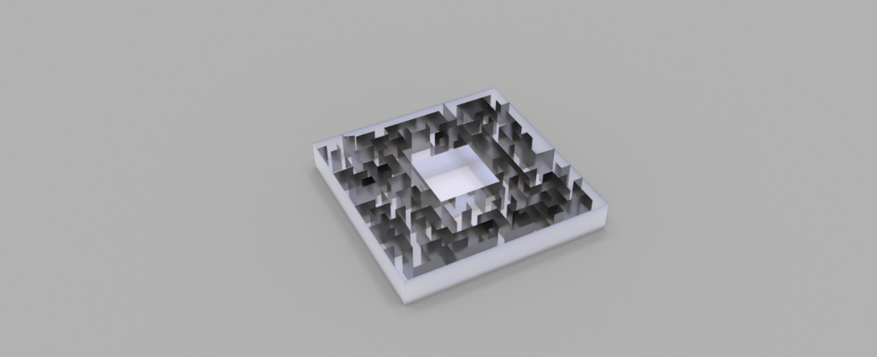
My gallery is a crossover of art and psychology. I have chosen these two fields of study as they crossover in every gallery whether you are aware of the effects or not. Art is well known for its power to move and create feeling in a person when they admire a beautiful work of art. Art can change a persons mood or feeling in an instant based on what they see, how they interact with the work and meaning they receive about the work. As with many forms of art, including music most notably, there are many meanings that arise from the views of different people.
(FIGURE 1)
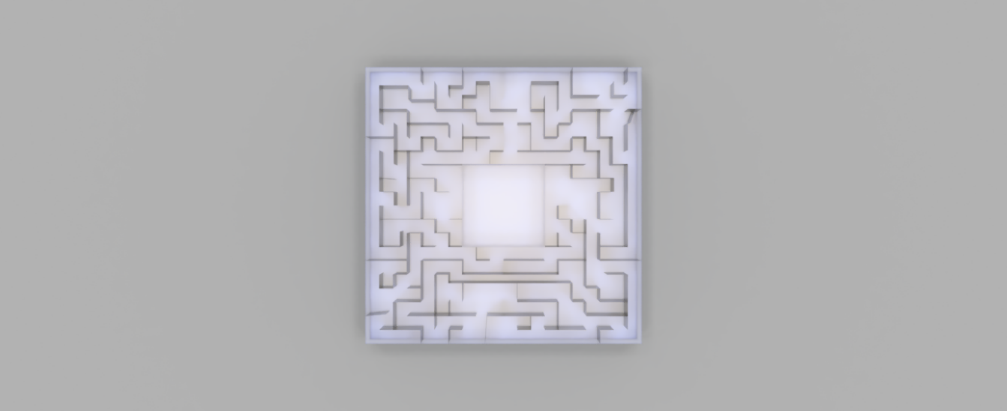
My research into this are began with the study of the interdisciplinary field of the psychology of art. The psychology of art Is an area of study that focuses on the view that art can be understood through perception, cognition and characteristics and not only the historical or face value of the work. As stated by Mark Jarzombek, taught and served within the History Theory Criticism Section of the Department of Architecture at MIT School of Architecture and Planning, the first psychologist to connect psychology and art together was Heinrich Wölfflin, a Swiss art historian, who attempted to show that architecture could be understood beyond a historical point of view and purely psychological. I believe this viewpoint of art being more then something that influenced it is important to my gallery as I believe that art can make a person feel in a way that is not always known to the viewer why they feel a such way. This point also solidifies my beliefs that art is influenced by past work but does not have to follow that path, and to become its own entity beyond the history of art.
(FIGURE 2)
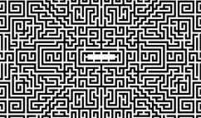
The gallery I have created is in a maze. As my earlier research implies there are many connections that can be made between psychology and art and therefore I researched into the solving of mazes. The Merriam-Webster dictionary defines maze as a confusing intricate network of passages and something that is confusingly elaborate or complicated, these definitions I believe are a good representation of what a maze is. Mazes can be as simple as a puzzle in a children’s book or as complex as the Cretan Labyrinth from Greek mythology with story of Theseus and the Minotaur. They can vary in size from being on the back of a news paper to being giant hedge mazes that span fields. All these variations yet they all have the same meaning and that is to help to develop the human mind and make us think. Mazes have always been a part of human history with references of them in Egyptian times from the 5th century BC, when a Greek traveller by the name of Herodotus visited the first known maze and was very impressed by the grandeur of the labyrinth and the expense and labour that had created it. He states that “yet all the works and buildings of the Greeks put together would certainly be inferior to this labyrinth as regards labour and expense.” And that even the great pyramids of Egyptian times were surpassed by the Egyptian labyrinth situated above lake Moeris (Krystek, 2001). As well as being a symbol of grandeur in ancient history there are still references of mazes in the modern pop culture. As seen in the popular books and subsequent movies ‘The Maze Runner’ is a book that is completely situated within a maze. This maze, like the labyrinth of Greek mythology, is filled with monsters and ways that the inhabitants of the maze can be trapped or killed within it. Another popular maze in modern times is the maze from ‘Harry Potter and the goblet of fire’. In this instalment of the popular book and film series, there is a maze in which the champions from each school is to venture into the maze in search of the Triwizard cup. When in the maze the champions encounter deadly creatures, hexes and threatening fogs. The last maze in pop culture I will discuss is the maze from ‘The Shining’. In this book released in 1977 by Stephan King and the movie directed by Stanley Kubrick three years later the maze plays an important role. The maze in this film is placed outside the hotel in which the film takes place. The maze plays an important role by being referenced several times in the classic film. The maze also throughout the film adds an unnerving sense to the film with several parts in the maze making the audience feel a sense of claustrophobia and nervousness surrounding the maze. The films thrilling climax comes to an end here as this is where Jack Nicholson’s character dies in the snow after the chase scene into the maze. This further solidifies the impact of the maze on the story. I feel that this is the most important maze in conjunction with my gallery as the layout of the maze in the movie is the inspiration for the layout I chose. As you can see by (figure 3), the maze has a central block in which the maze ultimately leads into. As seen in (figure 2) my gallery consists also of a central area in which the maze leads into and in this area is where my chosen artwork will be displayed. As with the use of the maze in ‘The Shining’ I also want to create a motion on uneasiness with the people that come to view my gallery, but I also want to create a space where my gallery will cause the spectators to want to work and think to see the artwork on display. That’s why in my gallery you must figure out the maze to find the artwork inside. As stated by James Olds, neuroscientist and director at George Mason University Virginia, “A maze is something that other humans have created that acts as a challenge to one of our most important skills: the ability to create an ecocentric cognitive map of our environment and to navigate through that cognitive map”.
(FIGURE 3)
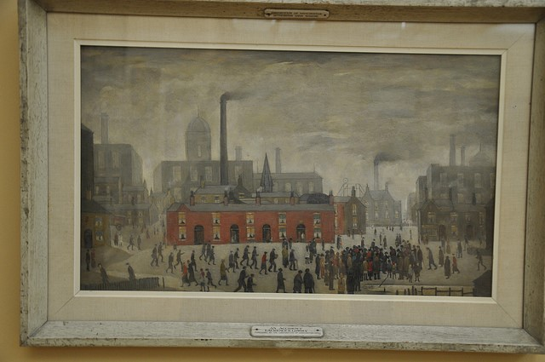
I have chosen four pieces of art to go into my gallery and one will be displayed on each side of the closed off centre block. The central block will have one-way glass on each side so that the viewers can see in but cannot see to the other side of the block. My chosen artworks are all chosen because of the hidden meaning they possess and therefore the viewers are required to further think of the art and their meaning to further understand them. My first artwork to be put in would be L. S Lowry’s ‘An Accident’ (Figure 4). In this L. S Lowry painting, there is a depiction of an everyday scene of an industrial England in the mid-20th century. It depicts a mundane image with little colour in the scene and many small figures in the foreground, but in a closer look at the painting there is a background of melancholy. In the bottom right of the foreground there is a crowd of people staring into the water. This may seem like a normal task but there is a melancholic true story behind this mundane act. This is based on a local suicide that happened in the area around the time when this painting was being made and the men looking into the water are looking at the body.
(FIGURE 4)
(FIGURE 5)
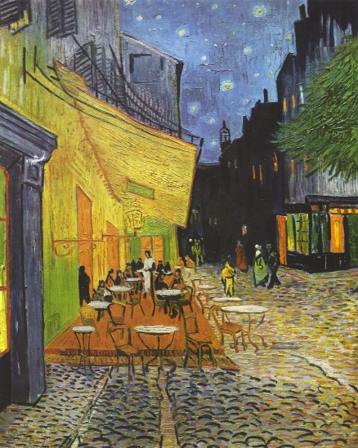
My second piece or art is Vincent van Gogh’s ‘Café Terrace at Night’ (Figure 5). In this painting its is shown as a simple summer’s night painted while observing a café with van Gogh’s trademark touch onto the painting. But this painting has a deeper, more religious, meaning to it. Many believe that this painting is a representation of the last supper from the bible. The evidence of this belief is said to the figures sat in the café are Jesus and his disciples. There are 12 figures sat at the café with a single figure standing over them in a white robe. This would signify as well as the other religious symbols such as several crosses set across the painting that this is a portrayal of the last supper.
(FIGURE 6)
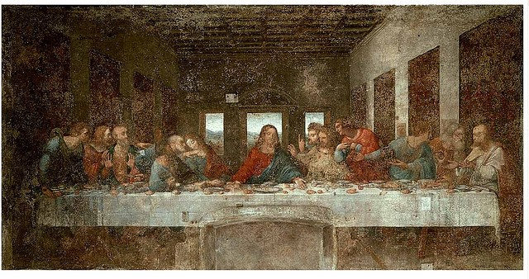
My third painting to be introduced into my gallery would be ‘The Last Supper’ by Leonardo Da Vinci (Figure 6). This artwork, unlike the one above is a certain painting of the last supper but this paintings hidden meaning shows more of the brilliance of Da Vinci. In this painting there is the famous portrayal of the last supper but as found by musician Giovanni Maria Pala by drawing five lines of musical staff across the painting the rolls of bread in connection with the Apostles’ hands it created a 40 second composition similar to a requiem when read from right to left as Da Vinci often would write. I would also play the 40 second composition over the artwork to show the deeper meaning to the artwork.
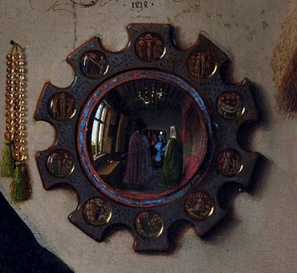
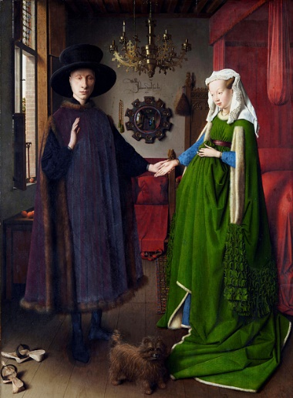
The last piece I would introduce into my gallery would be The Arnolfini Portrait by Jan van Eyck (Figure 7). In this painting there is an instant pull towards the two figures in the foreground, but the real details are in the background. In the background of this famous painting there is an elaborate Latins scribe written on the back wall. When translated it simply says, “Jan van Eyck was here 1434”. But there is another nod towards the artist when looking at the mirror behind the two figures the artist himself can be seen looking towards the viewer and raising his hand to greet the viewer (Figure 8).
(FIGURE 8)
(FIGURE 7)

Bibliography
Cluett, C., 2015. 5 Famous Paintings With Hidden Meanings. [Online]
Available at: https://www.artgallery.co.uk/blog/post/2015/11/02/5-famous-paintings-with-hidden-meanings
Davies, H., 2019. Maze Gallery. [Art].
Eyck, J. v., 1434. Arnolfini Portrait. [Art].
Gogh, V. v., 1888. Café Terrace at Night. [Art].
Krystek, L., 2001. Amazing Mazes. [Online]
Available at: http://www.unmuseum.org/maze.htm
Lowry, L., 1926. An Accident. [Art].
Milazzi, R., 2012. The Shining maze. [Art].
Tomas Chamorro-Premuzic, A. F. S. R., 2007. Personality and Art. [Online]
Available at: https://thepsychologist.bps.org.uk/volume-20/edition-2/personality-and-art
Vinci, L. D., 1495-1498. The Last Supper. [Art].
Weissmann, E., 2014. Amazing Maze: What Science Says About Solving Labyrinths. [Online]
Available at: https://news.nationalgeographic.com/news/2014/07/140730-science-mazes-labyrinth-brain-neuroscience/

