Judith Walton 2315393

The Evolution of Oral tradition To Modern Day Creative Writing

The humanities examine what it is to be human by using a group of academic areas of study. These are instrumental in exploring our global society and culture through the evaluation of disciplines including language, literature, history, philosophy, religion, and the visual arts. These disciplines intertwine and complement each other holistically, rather than being isolated studies. To look at what it means to be human, one must look at us in our wholeness. For example, the study of ancient history may also rely on principles taken from philosophic analysis to understand the physical evidence provided, the documentation of these discoveries is then transcribed in literary form. Therefore, a broad education of the humanities offers a stable foundation and a richer understanding of study within the specific chosen disciplines. Literature is deep rooted within the humanities and this essay will look to explore the origins of oral tradition and how this has evolved into modern day storytelling and creative writing.
A strong need to communicate has been a characteristic of human nature since the beginning of time. This can be evidenced by looking at one of the earliest surviving visual records of storytelling, the Cueva De Las Manos, Argentina, named as such due to the hundreds of stencilled handprints that date back to 9,500 and 13,000 years ago. The caves display many other images in addition to the stencilled hands, such as early images of humans and animals, hunting scenes, geometric patterns, and representations of the sun, created by using natural pigments or flint tools crafted specifically for use.

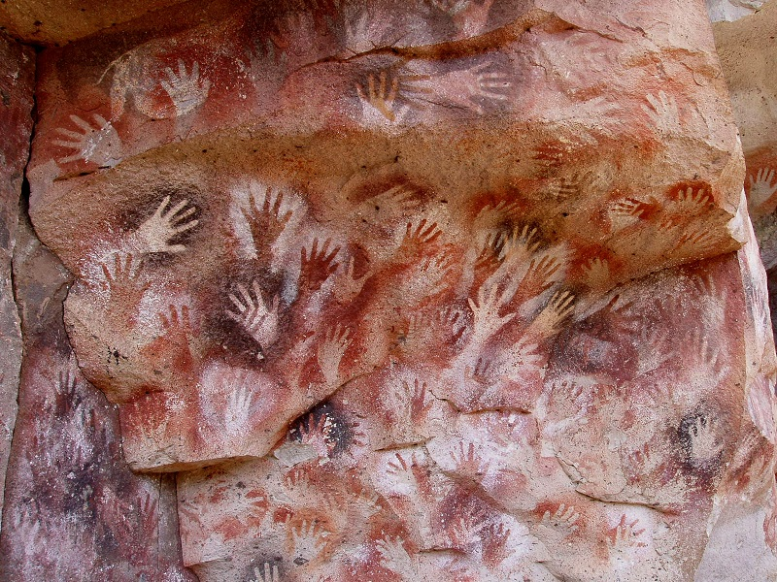
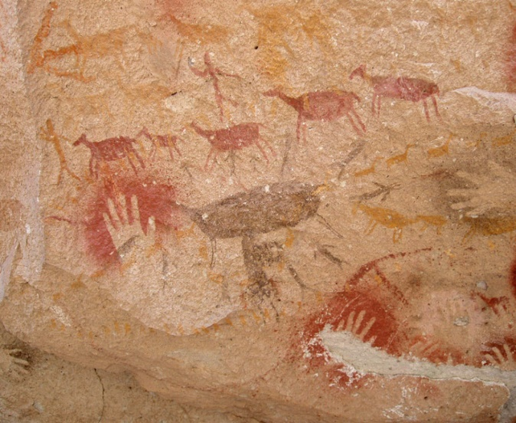
Cave art evokes a narrative without the use of written words and could be seen as the origins of language. It may be suggested that the images that are seen may have had a ceremonial purpose or have been part of a spiritual and/or early religious ritual or perhaps the artists merely wanted to make their mark and state their existence, a human desire to be remembered. With each generation contributing their additions to the walls, their shared knowledge, beliefs, and understandings of the world around them aided the continued advancement of their descendants.
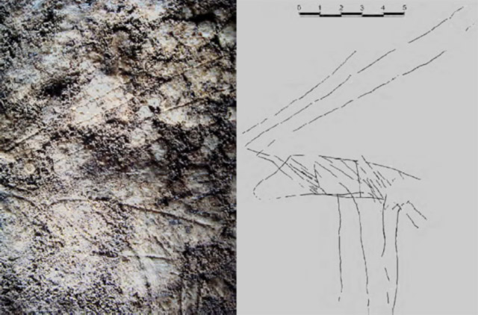
Archaeologist Dr George Nash made the discovery of the 14,000-year-old cave art in Cathole Cave on the Gower Peninsular in South Wales . The image of a speared reindeer is believed to have been created by the hunter gatherers during the Ice Age period. It cannot be assumed what the intentions were behind the cave art but with this example, along with the many other global discoveries evidenced, it does show us that the need to communicate has been long-established within human nature across the world.
Prior to the creation of writing, which is believed to have emerged over 5000 years ago, oral tradition had been the predominant means of communicating. Tales of myth, legend and superstition have been passed from generation to generation, being transformed through the ages. One such surviving legend from the Gower Peninsular, South Wales is that of King Arthur’s Stone, a neolithic tomb which has captivated the imaginations of the local community. So strong is the desire for creating stories that these myths and legends have arisen and endured generations, though there is no evidence of when this myth originated.
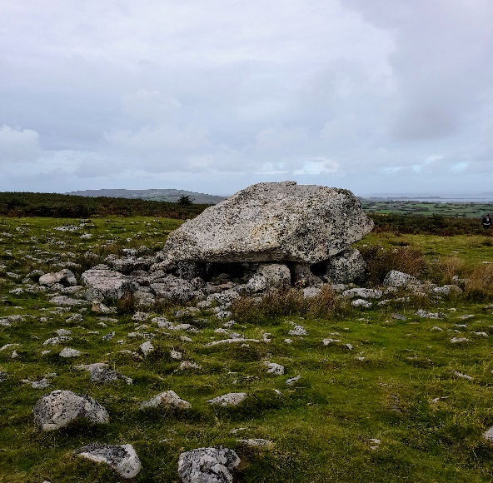
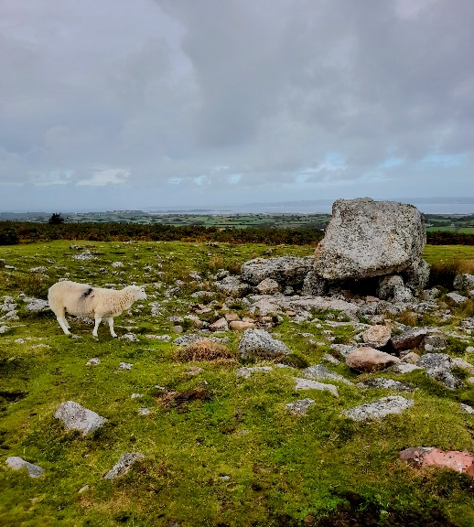
A well-known version of the legend of Arthur’s Stone is that while he was travelling in Carmarthenshire, King Arthur removed a stone from his shoe and threw it across the Loughor Estuary. Having been touched by his hand, when the stone eventually reached its final resting point at Cefn Bryn it had magically grown into an enormous boulder. Arthurian tales are plentiful in Wales, each cloaked in mystery. According to local lore, Merlin, Arthur’s wizard, and advisor, is said to have been born in a cave near to the town of Caerfyrddin, Carmarthenshire, South Wales. The town has since taken on a personal connection to his name and there is an abundance of tales associated with Merlin that have spanned the years. Merlin is said to have made a prophecy linked to an old oak tree that stood in Carmarthen, ‘When Merlin’s oak shall tumble down, then shall fall Carmarthen town.’ The stories of King Arthur have not been restricted solely to Wales and mythical references to him have been found in locations across England, Scotland, and Ireland as well as further afield such as in Brittany, France. There is something in these myths that have captivated writers, poets, and artists to create tales of this mythical ruler. These tales have been spoken across the land over the centuries, with adaptations having been made to reflect the location and historical associations. The popularity of regional myths and legends has more recently been used as a commodity to capitalise on travellers wanting to visit places of interest, for example, King Arthurs Seat, Edinburgh.
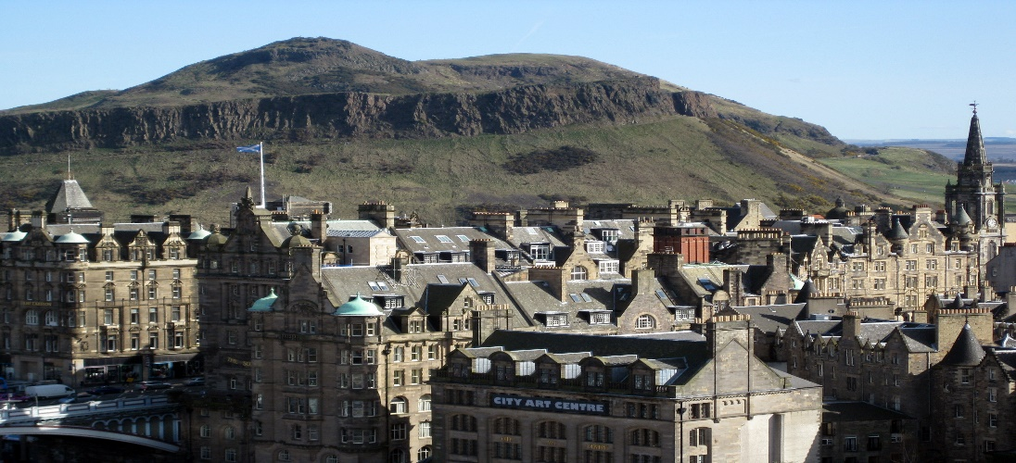
This could have been a comparable situation with the narration of Arthurian tales centuries ago as storytellers would have been trying to make money or have an exchange of sorts and so they would have adapted their stories to suit the needs of their audience. Unlike today, where we have multiple means of accessing information, for example, in books and the media, people during the Middle Ages would have relied on word of mouth for both news and entertainment. It is through the endurance of the spoken word that these myths and legends remain with us today, having been retold through the years. Only a small quantity of Welsh literature has survived from the medieval period as the original manuscripts have either been lost or destroyed. Taliesin was a renowned bard of the 6th century and thought to have sung at the courts of Celtic Kings. ‘The Black Book of Carmarthen’ dates from early 14th century and contains a collection of some of the oldest poems in Welsh, many attributed to Taliesin. These poems, having been preserved by the hand of a single scribe, allow us a glimpse into the literary style of the medieval period.
‘There Is A Graciously Disposed King’
There is a graciously disposed King, who is wonderful in the highest degree,
Who is chief above the children of Adam,
Who is a happy and most mighty defence [sic],
Who is generous, glorious, and most pure,
Whose claim is most strong and binding.

Praise poetry flourished during the Middle Ages. These poems would have been performed in flattery of Kings and religion, of places and heroes, much like the government whips of today. Dafydd Ap Gwilym was a prestigious poet during the 14th century whose poems consisted of praise of noble people, nature, religion and of love.
‘The Wind’
Sky-wind, unhindered course,
Mighty commotion passing yonder,
You are a harsh sounding minstrel,
World’s fool without foot or wing,
It’s amazing how wondrously you were sent,
From the pantry of the sky without any feet,
And how swiftly you run,
Now across the hilltop on high.
Reaching the 16th century, the style of literature being created in England was beginning to move away from the restrictive ideas that had been predominant during the Medieval period, the ideology having been focussed on the absolute power of God. William Shakespeare was a renowned poet, playwright, and actor during this period. His style of writing, characterised by his mastery of language, took on a deeper understanding of human nature which was reflected in his works.
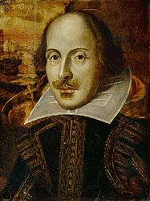
‘The artists and thinkers of the Renaissance did not necessarily reject the idea of God. In fact, Shakespeare himself may have been Catholic. The Renaissance cultural creators did, however, question humankind’s relationship to God.’
By the late 16th century, Shakespeare gradually developed his writing from a traditional style to a more self-expressive form, using metaphors and tropes to enhance the melodrama. The phrases he devised are still in use today, so engrained into modern language that they are used without realisation of their origins.
"O, beware, my lord, of jealousy! It is the green-eyed monster, which doth mock the meat it feeds on." — Iago
The colour green had commonly been associated with illness. Shakespeare applied the notion of being sick with jealousy into a metaphor that we still use today.
Despite being born in England, Shakespeare’s maternal grandmother, Alys Griffin is reported to have originated in Wales, and this may be the influence behind the Welsh characters and features often depicted within his works. Shakespeare’s play ‘Cymbeline’, a romantic play set chiefly in Wales with references made to Milford Haven and the Welsh mountains being one example. The works of Shakespeare have had a remarkable influence on modern day texts. From traditional literature and theatre productions to western philosophy and the English language. His influence can also be found in present day films, for example, ‘West Side Story’ being an adaption of Shakespeare’s ‘Romeo and Juliet’.
Creative writing has evolved immensely from the initial origins found within primitive cave art. A broadening perception of what it is that defines humanity, and the progression of cultural and societal awareness and acceptance has enabled the flow of evolution within the written word. Literature is no longer limited to the academics, scholars and wealthy as education and literacy are accessible to all. The Digital Age has revolutionised the way humanity communicates and the ability to access information instantly with the use of technology. Creative writing remains a fundamental foundation to many aspects of modern-day life, not only within all forms of literature, whether physical or digital publications, television, radio, and journalism, but also podcasts, marketing, theatre, and music. The modern-day creative writer continues to reach and influence a wide audience with their words and creativity, connecting humankind through shared human experiences and emotions.
Word Count: 2197 words.
Bibliography:
Wikipedia, ‘Cueva De Las Manos’, Wikipedia, 2 September 2023, <https://en.wikipedia.org/wiki/Cueva_de_las_Manos#Location> [accessed 18 October 2023].

Clottes, Jean, ‘Cave Art’, Brittanica, 13 October 2023, <https://www.britannica.com/art/cave-art> [accessed 19 October 2023].

Marianocecowski (photographer), ‘Cuevas De Las Manos’, Wikipedia, 2 June 2006, <https://commons.wikimedia.org /wiki/File:SantaCruz-CuevaManos-P2210651b.jpg> [accessed 17 October 2023].

Marianocecowski (photographer), ‘Cuevas De Las Manos’, Wikipedia, 12 August 2005, <https://en.wikipedia.org//wiki/File:SantaCruz-CuevaManos-P2210063b.jpg> [accessed 17 October 2023].

Bradshaw Foundation, ‘Cueva De Las Manos’, Bradshaw Foundation, n.d, <https://bradshawfoundation.com/south_america/cueva_de_los_manos/index.php> [accessed 17 October 2023].
Nash, Dr George (photographer), ‘The Engraving Of A Reindeer In Cathole Cave’, Science News, n.d, <https://www.sci.news/archaeology/article00452.html> [accessed 18 October 2023].

Nash, Dr George Nash, ‘Rock Art On The Gower Peninsula,’ Bradshaw Foundation, n.d, <https://bradshawfoundation.com/british_isles_prehistory_archive/gower_peninsula_south_wales/index.php> [accessed 18 October 2023].

Monforte, Pilar Fatas, ‘Rock Art Network,’ Bradshaw Foundation, n.d, <https://www.bradshawfoundation.com/rockartnetwork/unesco_world_heritage_sites_rock_art/index.php> [accessed 18 October 2023].

Clayton, Ewan, ‘Why Did Humans Start Writing,’ British Library, n.d, <https://www.bl.uk/history-of-writing/articles/why-did-humans-start-writing> [accessed 19 October 2023].

World History Edu, ‘The Legend Of King Arthur,’ World History Edu, 1 August 2021, <https://www.worldhistoryedu.com/the-legend-of-king-arthur/> [accessed 21 October 2023].
Swansea Bay, ‘The Legend Of Arthurs Stone’, Swansea Bay, 1 June 2017, <https://www.visitswanseabay.com/blog/2017/06/01/legend-arthurs-stone/> [accessed 19 October 2023].

King Arthur And The Knights Of The Round Table, ‘Merling The Magician’, King Arthur And The Knights Of The Round Table, n.d, <https://kingarthursknights.com/arthurian-characters/merlin/> [accessed 21 October 2023].

Merlin’s Hill Centre, ‘Merlin’s Hill Centre’, n.d, <https://merlinshill.com/merlins-hill-centre/> [accessed 21 October 2023].

Johnston, Mark, ‘The Old Oak, Carmarthen’, Street Trees in Britain: A History, (United Kingdom: Windgather Press, 2017).

Coffey, Sally, ‘King Arthur In Britain, Where To Fin The Truth Behind The Legend’, Lonely Planet, 7 February 2017, <https://www.lonelyplanet.com/articles/king-arthur-in-britain-where-to-find-the-truth-behind-the-legend> [accessed 19 October 2023].

Spence, Lewis, ‘Legends And Romances Of Brittany,’ 1st edn. (New York: Frederick A Stokes 1917), pp. 254-282.

O’Neil, Emma, ‘Seven facts You May Not Know About Arthur’s Seat,’ The Scotsman, 23 September 2015, <https://www.scotsman.com/arts-and-culture/seven-facts-you-may-not-know-about-arthurs-seat-1494785> [accessed 20 October 2023].

Ellard38 (photographer), ‘Arthur’s Seat In Edinburgh, Scotland’, 8 April 2019, https://commons.wikimedia.org/wiki/File:Arthurs_seat_edinburgh.jpg [accessed 20 October 2023].

Britannica, ‘Taliesin, Welsh Poet,’ Britannica, n.d, <https://www.britannica.com/biography/Taliesin-Welsh-poet> [accessed 21 October 2023].

PoemHunter.com, ‘Taliesin Biography,’ PoemHunter.com,n.d, <https://www.poemhunter.com/taliesin/> [accessed 20 October 2023].

The National Library Of Wales, ‘Black Book Of Carmarthen’, The National Library Of Wales, n.d, <https://www.library.wales/discover-learn/digital-exhibitions/manuscripts/the-middle-ages/the-black-book-of-carmarthen> [accessed 20 October 2023].

Jones, Mary, ‘Llyfr Du Caerfyrddin,’ Academy For Ancient Texts, n.d, <https://www.ancienttexts.org/library/celtic/ctexts/bbcindex.html> [accessed 20 October 2023].

Anonymous, ‘The Black Book Of Carmarthen’, (Great Britain: MythBank, 2020), p.28.

UK Parliament, ‘Whips’, UK Parliament, n.d, <https://www.parliament.uk/about/mps-and-lords/principal/whips/> [accessed 21 October 2023].

Johnston, Dafydd, ‘Dafydd Ap Gwilym,’ Dictionary Of Welsh Biography, 2018, <https://biography.wales/article/s12-DAFY-APG-1340> [accessed 20 October 2023].

Dafydd Ap Gwilym. Net, ‘The Wind – Dafydd Ap Gwilym’, DafyddApGwilym.net, n.d, <https://dafyddapgwilym.net/eng/3win.php> [accessed 21 October 2023].

Shakespeare Birthplace Trust, ‘William Shakespeare Biography,’ Shakespeare Birthplace Trust, n.d, <https://www.shakespeare.org.uk/exploreshakespeare/shakespedia/william-shakespeare/william-shakespeare-biography/> [accessed 21 October 2023].

Jamieson, Lee, ‘The Influence Of The Renaissance In Shakespear’s Work,’ ThoughtCo., 28 January 2020, < https://www.thoughtco.com/renaissance-shakespeares-time-2984986> [accessed 21 October 2023].

Paris 16, ‘The Flower Portrait Of William Shakespeare’, Wikipedia, 5 March 2009, <https://en.wikipedia.org/wiki/File:William_Shakespeare_1609.jpg> [accessed 21 October 2023].

Schwartz, Dana, ‘Green Eyed Monster, Othello, Act iii scene iii, Mental Floss, 22 April 2020, <https://www.mentalfloss.com/article/60264/21-phrases-you-use-without-realizing-youre-quoting-shakespeare> [accessed 21 October 2023].

Maley, Willy and Schwyzer, Phillip, ‘Shakespeare And Wales’, British Council Cymru, n.d, <https://wales.britishcouncil.org/en/shakespeare-and-wales> [accessed 21 October 2023].

Owen, Martha, Shakespeare And Wales, BBC Wales, 28 October 2011, <https://www.bbc.co.uk/blogs/wales/entries/f25f8321-d3a7-3699-9167-8d5c4c72a0f1> [accessed 21 October 2023].

The Editorial Unit, ‘How Shakespeare Changed Literature Around The World’, The Upcoming, 1 September 2020, <https://www.theupcoming.co.uk/2020/09/01/how-shakespeare-changed-literature-around-the-world/> [accessed 21 October 2023].

Dowd, Vincent, ‘The Story Of Westside Story’, BBC News – Culture, 25 September 2012, <https://www.bbc.co.uk/news/entertainment-arts-19702038> [accessed 21 October 2023].

Denning, Steve, ‘What Is The Digital Age And What Does It Mean?’ Forbes, 9 February 2022, <https://www.forbes.com/sites/stevedenning/2022/02/09/what-is-the-digital-age-and-what-does-it-mean/> [accessed 22 October 2023].

Wikipedia, ‘Cueva De Las Manos’, Wikipedia, 2 September 2023, <https://en.wikipedia.org/wiki/Cueva_de_las_Manos#Location> [accessed 18 October 2023].
Jean Clottes, ‘Cave Art’, Brittanica, 13 October 2023, <https://www.britannica.com/art/cave-art> [accessed 19 October 2023].
Marianocecowski (photographer), ‘Cuevas De Las Manos’, Wikipedia, 2 June 2006, <https://commons.wikimedia.org /wiki/File:SantaCruz-CuevaManos-P2210651b.jpg> [accessed 17 October 2023].
Marianocecowski (photographer), ‘Cuevas De Las Manos’, Wikipedia, 12 August 2005, <https://en.wikipedia.org//wiki/File:SantaCruz-CuevaManos-P2210063b.jpg> [accessed 17 October 2023].
Bradshaw Foundation, ‘Cueva De Las Manos’, Bradshaw Foundation, n.d, <https://bradshawfoundation.com/south_america/cueva_de_los_manos/index.php> [accessed 17 October 2023].
Dr George Nash (photographer), ‘The Engraving Of A Reindeer In Cathole Cave,’ Science News, n.d, <https://www.sci.news/archaeology/article00452.html> [accessed 18 October 2023].
Dr George Nash, ‘Rock Art On The Gower Peninsula’, Bradshaw Foundation, n.d, <https://bradshawfoundation.com/british_isles_prehistory_archive/gower_peninsula_south_wales/index.php> [accessed 18 October 2023].
Pilar Fatas Monforte, ‘Rock Art Network’, Bradshaw Foundation, n.d, <https://www.bradshawfoundation.com/rockartnetwork/unesco_world_heritage_sites_rock_art/index.php> [accessed 18 October 2023].
Ewan Clayton, ‘Why Did Humans Start Writing’, British Library, n.d, <https://www.bl.uk/history-of-writing/articles/why-did-humans-start-writing> [accessed 19 October 2023].
Authors own photo. 1 October 2022.
Authors own photo. 1 October 2022.
World History Edu, ‘The Legend Of King Arthur’, World History Edu, 1 August 2021, <https://www.worldhistoryedu.com/the-legend-of-king-arthur/> [accessed 21 October 2023].
Swansea Bay, ‘The Legend Of Arthurs Stone’, Swansea Bay, 1 June 2017, <https://www.visitswanseabay.com/blog/2017/06/01/legend-arthurs-stone/> [accessed 19 October 2023].
King Arthur And The Knights Of The Round Table, ‘Merling The Magician’, King Arthur And The Knights Of The Round Table, n.d, <https://kingarthursknights.com/arthurian-characters/merlin/> [accessed 21 October 2023].
Merlin’s Hill Centre, ‘Merlin’s Hill Centre’, n.d, <https://merlinshill.com/merlins-hill-centre/> [accessed 21 October 2023].
Mark Johnston, ‘The Old Oak, Carmarthen’, Street Trees in Britain: A History, (United Kingdom: Windgather Press, 2017).
Sally Coffey, ‘King Arthur In Britain, Where To Fin The Truth Behind The Legend’, Lonely Planet, 7 February 2017, <https://www.lonelyplanet.com/articles/king-arthur-in-britain-where-to-find-the-truth-behind-the-legend> [accessed 19 October 2023].
Lewis Spence, ‘Legends And Romances Of Brittany’, 1st edn. (New York: Frederick A Stokes 1917), pp. 254-282.
Emma O’Neil, ‘Seven facts You May Not Know About Arthur’s Seat’, The Scotsman, 23 September 2015, <https://www.scotsman.com/arts-and-culture/seven-facts-you-may-not-know-about-arthurs-seat-1494785> [accessed 20 October 2023].
Ellard38 (photographer), ‘Arthur’s Seat In Edinburgh, Scotland’, 8 April 2019, https://commons.wikimedia.org/wiki/File:Arthurs_seat_edinburgh.jpg [accessed 20 October 2023].
Britannica, ‘Taliesin, Welsh Poet’, Britannica, n.d, <https://www.britannica.com/biography/Taliesin-Welsh-poet> [accessed 21 October 2023].
PoemHunter.com, ‘Taliesin Biography,’ PoemHunter.com, n.d, <https://www.poemhunter.com/taliesin/> [accessed 20 October 2023].
The National Library Of Wales, ‘Black Book Of Carmarthen’, The National Library Of Wales, n.d, <https://www.library.wales/discover-learn/digital-exhibitions/manuscripts/the-middle-ages/the-black-book-of-carmarthen> [accessed 20 October 2023].
Mary Jones, ‘Llyfr Du Caerfyrddin’, Academy For Ancient Texts, ,n.d, <https://www.ancienttexts.org/library/celtic/ctexts/bbcindex.html> [accessed 20 October 2023].
Anonymous, ‘The Black Book Of Carmarthen’, (Great Britain: MythBank, 2020), p.28.
UK Parliament, ‘Whips’, UK Parliament, n.d, <https://www.parliament.uk/about/mps-and-lords/principal/whips/> [accessed 21 October 2023].
Dafydd Johnston, ‘Dafydd Ap Gwilym’, Dictionary Of Welsh Biography, 2018, <https://biography.wales/article/s12-DAFY-APG-1340> [accessed 20 October 2023].
Dafydd Ap Gwilym. Net, ‘The Wind – Dafydd Ap Gwilym’, DafyddApGwilym.net, n.d, <https://dafyddapgwilym.net/eng/3win.php> [accessed 21 October 2023].
Shakespeare Birthplace Trust, ‘William Shakespeare Biography,’ Shakespeare Birthplace Trust, n.d, <https://www.shakespeare.org.uk/exploreshakespeare/shakespedia/william-shakespeare/william-shakespeare-biography/> [accessed 21 October 2023].
Lee Jamieson, ‘The Influence Of The Renaissance In Shakespear’s Work,’ ThoughtCo., 28 January 2020, < https://www.thoughtco.com/renaissance-shakespeares-time-2984986> [accessed 21 October 2023].
Paris 16, ‘The Flower Portrait Of William Shakespeare’, Wikipedia, 5 March 2009, <https://en.wikipedia.org/wiki/File:William_Shakespeare_1609.jpg> [accessed 21 October 2023].
Dana Schwartz, ‘Green Eyed Monster, Othello, Act iii scene iii, Mental Floss, 22 April 2020, <https://www.mentalfloss.com/article/60264/21-phrases-you-use-without-realizing-youre-quoting-shakespeare> [accessed 21 October 2023].
Willy Maley and Phillip Schwyzer, ‘Shakespeare And Wales’, British Council Cymru, n.d, <https://wales.britishcouncil.org/en/shakespeare-and-wales> [accessed 21 October 2023].
Martha Owen, Shakespeare And Wales, BBC Wales, 28 October 2011, <https://www.bbc.co.uk/blogs/wales/entries/f25f8321-d3a7-3699-9167-8d5c4c72a0f1> [accessed 21 October 2023].
The Editorial Unit, ‘How Shakespeare Changed Literature Around The World’, The Upcoming, 1 September 2020, <https://www.theupcoming.co.uk/2020/09/01/how-shakespeare-changed-literature-around-the-world/> [accessed 21 October 2023].
Vincent Dowd, ‘The Story Of Westside Story’, BBC News – Culture, 25 September 2012, <https://www.bbc.co.uk/news/entertainment-arts-19702038> [accessed 21 October 2023].
Steve Denning, ‘What Is The Digital Age And What Does It Mean?’, Forbes, 9 February 2022, <https://www.forbes.com/sites/stevedenning/2022/02/09/what-is-the-digital-age-and-what-does-it-mean/> [accessed 22 October 2023].

