Abdul-Azeez Simiosla Obileye
2531449
LCLM4002_DIG_TASK2_FEB2026_WEEKEND

How to insert hyperlink in a PowerPoint


Step 1 : Select text to add hyperlink.
Step 2: 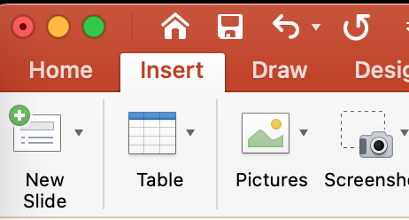 Select insert tab and Select 

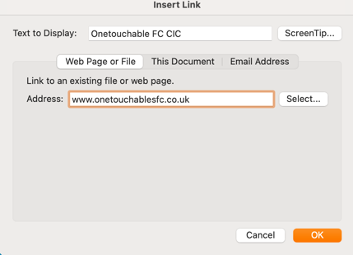
Step 3: Input text *www.onetouchablesfc.co.uk* into text box and click ok.


Step 4: Text has changed in colour as hyperlink is live, launch presentation and click text to open web browser.

Web browser launched and immediately opening website



