Name | Student Number | Date | Lecturer’s Name | Your score
Andrzej Kyrcz | 2419584 | 29.06.2025 | Akash P | To be filled by the marker  ___/40
You will have 90 minutes to complete this assessment. It is divided into three sections: note-taking, paraphrasing and writing a paragraph.
---------------------------------------------------------------------------------------------------------------------
1. Take diagrammatic notes from the passage below using the space provided:

The university experience is not just about subject knowledge, but also about developing skills that will equip you for your future life. For starters, it's impossible to graduate without a range of people skills under your belt. You'll meet new people from different backgrounds. You'll also interact with lecturers, tutors and university staff almost daily. Another life lesson that university teaches you is taking responsibility for yourself, your own schedule and learning. A lot of university study is self-directed - it's up to you to plan and organise your work, juggle multiple projects and manage deadlines – you will need to develop self-motivation if you want to succeed. Let’s not forget learning how to overcome obstacles; whether academic, work-related or personal, you'll face your fair share of hurdles as a student, but you will develop resourcefulness and resilience in the process. If you were a bit unorganised before you went to university, you won't be by the time you leave. To successfully navigate student life you'll need to handle a variety of study, work, social and personal commitments and the only way to do this is with organisation and time management. Finally, university provides plenty of opportunities to work on and boost your confidence: you'll work in groups, deliver presentations, complete assessments and maybe even become a class representative.
Adapted from: https://www.prospects.ac.uk/applying-for-university/university-life/7-life-skills-youll-learn-at-university

Space for your notes (max 12 marks):

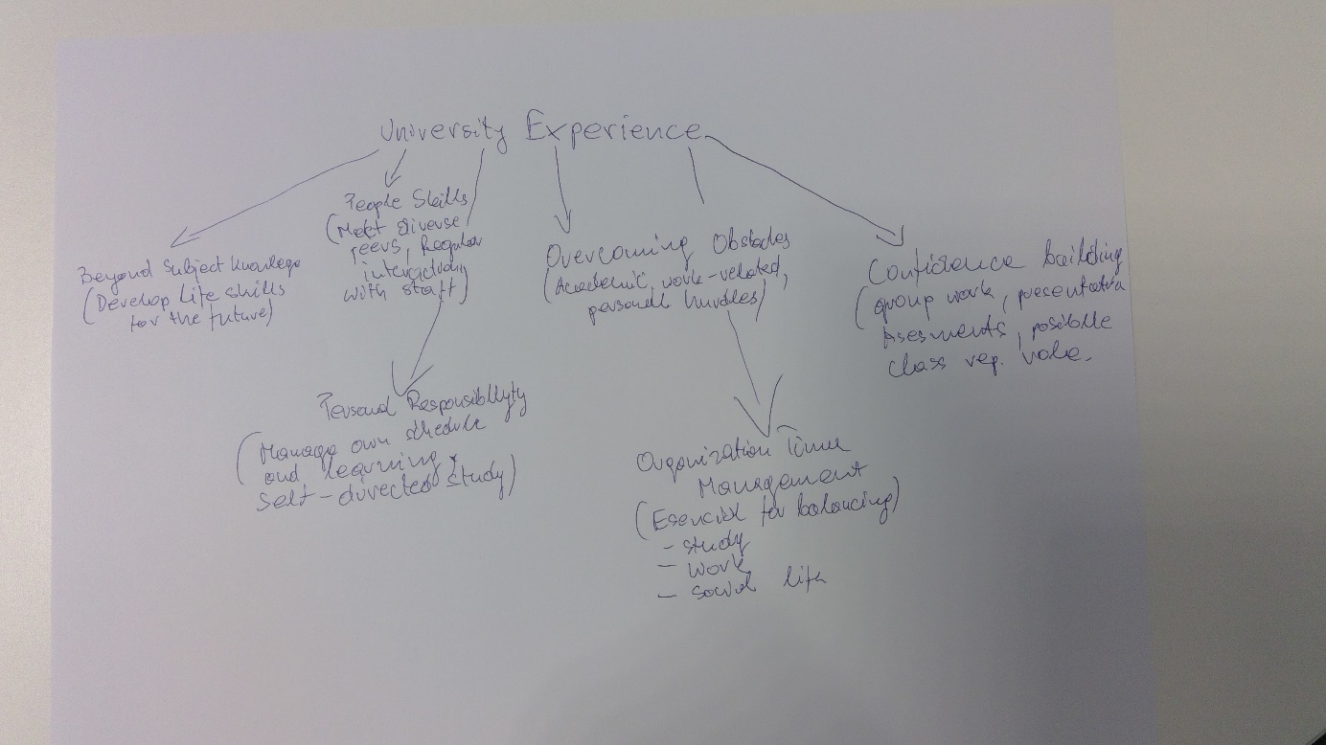

University Experience

1. Beyond Subject Knowledge
• Develop life skills for the future
2. People Skills
• Meet diverse peers
• Regular interaction with staff (lecturers, tutors)
3. Personal Responsibility
• Manage own schedule and learning
• Self-directed study
– Plan & organise work
– Manage deadlines
– Juggle multiple projects
• Need for self-motivation
4. Overcoming Obstacles
• Academic, work-related, personal hurdles
• Builds resilience and resourcefulness
5. Organisation & Time Management
• Essential for balancing:
– Study
– Work
– Social life
– Personal commitments
• Improves over time
6. Confidence Building
• Group work
• Presentations
• Assessments
• Possible class rep role

2. Paraphrase the following sentences (max 3 marks for each, max 12 marks in total):

a) To successfully navigate student life you will need to handle a variety commitments.
Managing different responsibilities is essential for thriving in student life.

b) You will need to develop self-motivation if you want to succeed at university.
To do well in university, it is important to cultivate your own drive to succeed.

c) Many students find it challenging to manage stress during assessment periods.
A large number of students struggle to copy with stress when exams and assignments are due.

d) Frequent reading can help you become a more effective communicator.

The more you read, the better you are likely to become at expressing yourself.

3. Write a well-structured paragraph (8 sentences) on the following topic:

Effective time management techniques for university students

Your paragraph must be written in full sentences (no bullet points) and in an academic style.

(max 16 marks in )

Effective time management is essential for university students to balance academic, social, and personal responsibilities. One key technique is creating a weekly schedule that outlines classes, study sessions, and other commitments. Prioritizing tasks using the Eisenhower Matrix—categorizing them by urgency and importance—helps students focus on what truly matters. Breaking larger tasks into smaller, manageable steps can also reduce procrastination and make goals more achievable. Additionally, using digital tools like calendars, reminders, and productivity apps can streamline planning and keep students organized. Setting specific, realistic goals for each day promotes a sense of accomplishment and keeps motivation high. It’s equally important to allocate time for breaks and self-care to avoid burnout. By consistently applying these strategies, students can improve productivity and reduce stress throughout their academic journey.

