UNIVERSITY OF WALES:  TRINITY SAINT DAVID |  |  | PRIFYSGOL CYMRU:  Y DRINDOD DEWI SANT
LOCATION: LAMPETER |  | LLEOLIAD: LLAMBED
LEVEL 6 |  | LEFEL 6
EXAMINATION PERIOD |  | CYFNOD ARHOLIADAU
may 2014 |  | mai 2014

MODULE CODE: AHAR6003
TOWNS, TOMBS AND TEMPLES: HOUSEHOLD PRACTICE AND RITUAL PERFORMANCE IN THE AEGEAN AND THE EAST

TIME: 2 HOURS
PLEASE ANSWER ONE QUESTION FROM EACH SECTION

Equipment or materials required – None
Adnoddau neu ddefnyddiau sydd eu hangen - Dim

A. Answer one of the following questions (50% of total).

1. Critically evaluate how archaeologists have applied models of ancestor cult to interpret funerary ritual in the Bronze Age Mediterranean, with specific reference to one of the following:
- Prehistoric Bronze Age Cyprus;
- Early Bronze Age Syria;
- Early Minoan Crete.

2. How might the study of figurative art allow archaeologists to explore embodied ritual practices in the ancient world? Use specific examples from the Aegean, Cyprus and Levant to support your answer.

3. “...space does not form a fixed entity but is continuously constituted and altered through social practice” (Maran 2009: 10). Discuss this observation with reference to a Bronze Age settlement of your choice from the Aegean, Cyprus or the Levant.

B. Answer the following questions (50% of total).
Choose one of the following archaeological assemblages. Outline the main characteristics and discuss its archaeological significance. Consider what you might infer about the human action which created the deposit, drawing specifically on some of the theoretical approaches covered in the module.

Assemblage A:

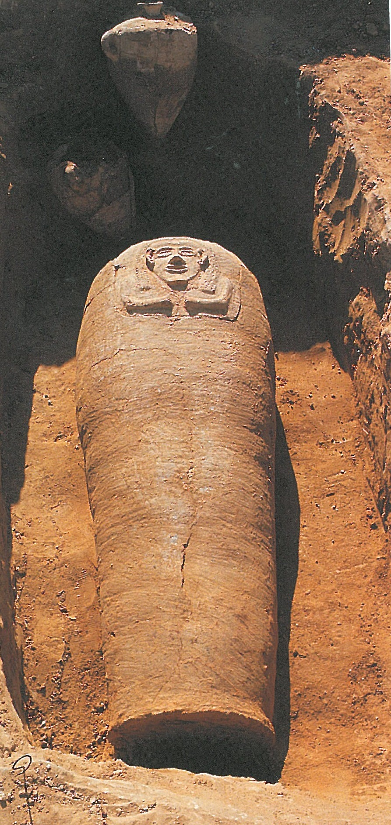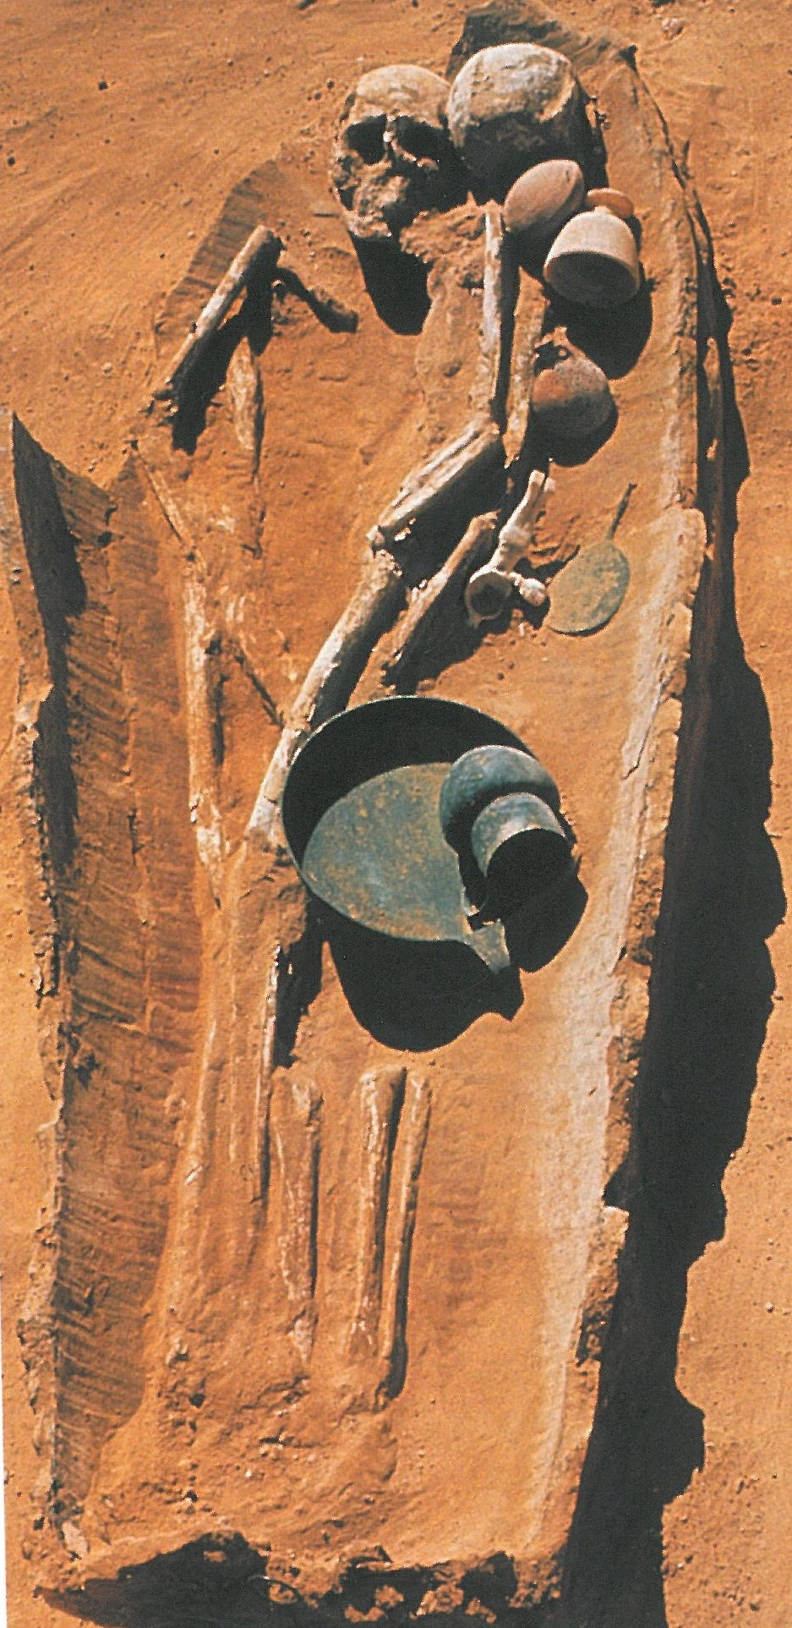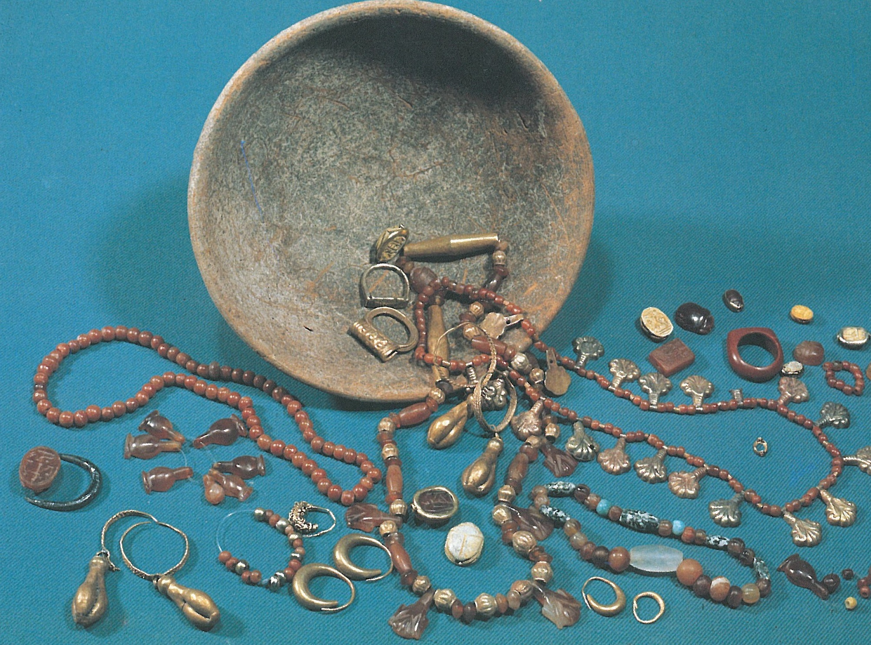

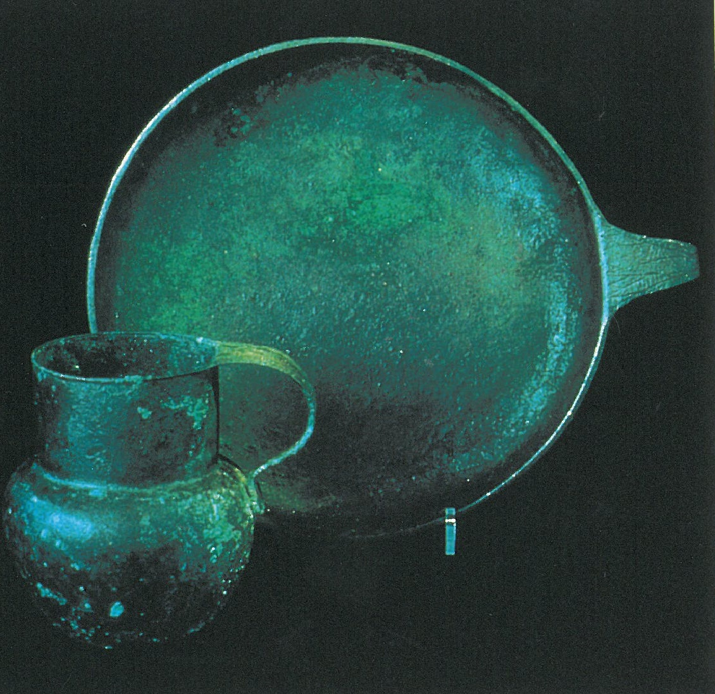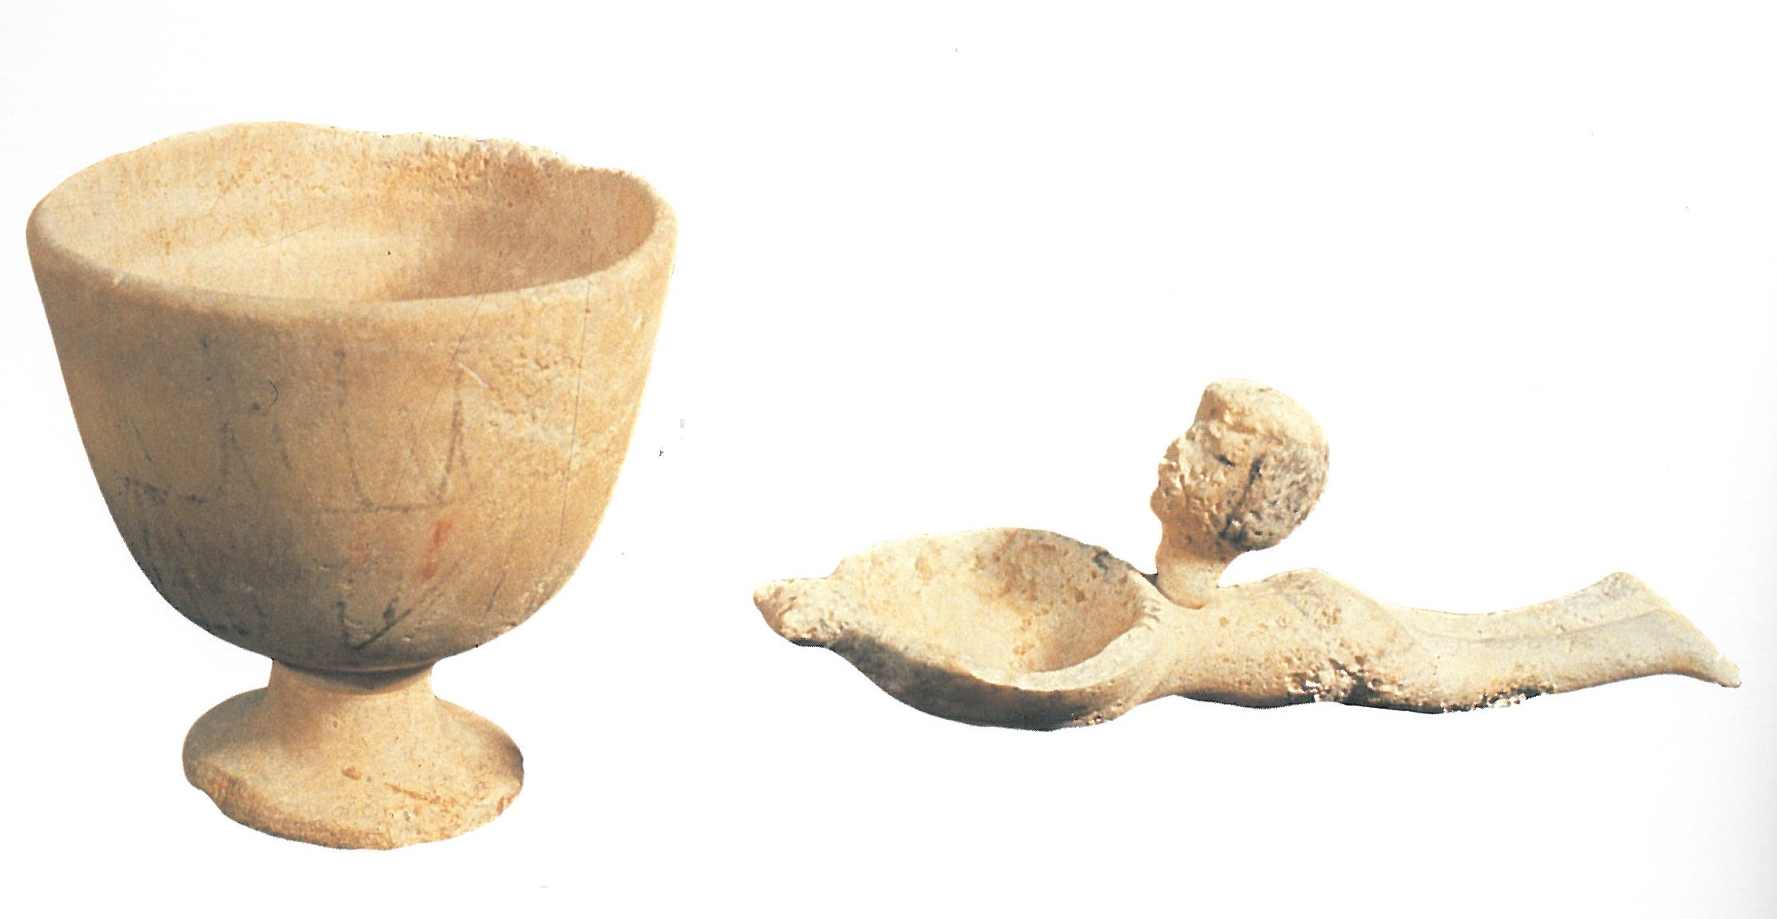

Assemblage B:


