

Methods and Search Strategy Academic Poster

Student name: Saira Arif
Student ID: 2220569

Module name: Independent Project
Module code: BMHP 6020

The impact of the COVID-19 pandemic on Mental Health coping strategies among Healthcare Workers.
Introduction and Research Aim:  - Structured secondary research design (Johnston, 2017)  - Explores stress, burnout, anxiety, depression in HCWs  - Evaluates coping strategies & organisational support  - Enables synthesis of global evidence (Aveyard, 2019) | Search Strategy:  - Systematic search principles applied (Booth et al., 2016)  - Keywords: healthcare workers, COVID-19, mental health  - Boolean operators: AND / OR / NOT  - Synonyms used to reduce publication bias (Hart, 2018)  - Search log maintained for transparency
Searching for Information  - PubMed (biomedical focus)  - Google Scholar (interdisciplinary coverage)  - UWTSD Library databases  - Filters: 2020–2025, peer-reviewed, English language  - Iterative screening process | 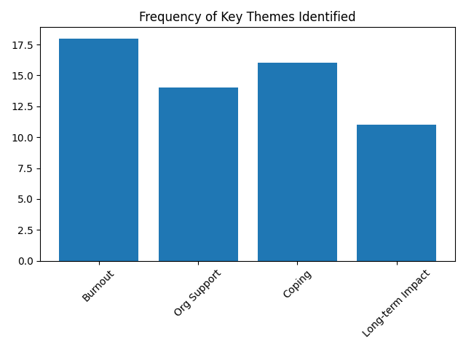
Research Validation and Analysis
- CRAAP test applied (Blakeslee, 2004)
- Currency & pandemic relevance checked
- Authority & institutional credibility verified
- Methodological rigour critically examined
- Enhances reliability & academic integrity (Aveyard, 2019).

Inclusion Criteria:  - Peer-reviewed journal articles  - Published 2020–2025  - Healthcare worker focus  - Mental health outcomes examined  - Coping or organisational strategies included | Exclusion Criteria:  - Non-peer reviewed source  - Non-healthcare populations  - Non-English publications  - Studies lacking methodological transparency
Ethical Considerations:
- Secondary data only – no participants involved
- Accurate Harvard referencing maintained
- Balanced reporting of findings
- Transparency in search & analysis process (Booth et al., 2016)

References:
Aveyard, H. (2019) Doing a literature review in health and social care. 4th edn. Maidenhead: Open University Press.
Blakeslee, S. (2004) The CRAAP test. California State University, Chico. Available at: https://www.csuchico.edu/lins/handouts/eval_websites.pdf (Accessed: 19 February 2026).
Booth, A., Sutton, A. and Papaioannou, D. (2016) Systematic approaches to a successful literature review. 2nd edn. London: SAGE.
Braun, V. and Clarke, V. (2006) ‘Using thematic analysis in psychology’, Qualitative Research in Psychology, 3(2), pp. 77–101. https://doi.org/10.1191/1478088706qp063oa
Hart, C. (2018) Doing a literature review: Releasing the research imagination. 2nd edn. London: SAGE.
Johnston, M.P. (2017) ‘Secondary data analysis: A method of which the time has come’, Qualitative and Quantitative Methods in Libraries, 3(3), pp. 619–626.

