Table of Contents
CV 2
Profile 2
Key skills and Achievements 2
Achievements. 2
Skills. 3
Employment History 3
Education 3
Qualifications and Training 4
Hobbies and Interests 4
References. 4
Covering Letter 5
Job Application 6
Reference 7

Kersha May Davies
Student number 1904976
8 Ael Y Bryn Penrhos
Ystradgynlais
SA1HY
07495800788

CV

Profile

Areas of expertise: Business manager, interpersonal communication skills, Supervision and Leadership, Self-promoted within catering/cleaning, Food and hygiene cert level 2, Health and safety cert, first aid certificate, Cert HE certificates Level 4.

Established a business within the cleaning and the catering industry, professionalised within a management profession. Developed a self-promoted business within the catering industry to create a personal franchise.
Achieved a CERT HE Certificate Skills for the workplace level 4 within a Professional career development.
Expanded expertise within the catering industry, completed a food and hygiene and health and safety certificate.
Practised first aid gaining an understanding on assisting appropriately in a life-endangering situation.

Key skills and Achievements

Achievements.
- Launched a cleaning business.
- Established a business within the catering industry.
- Cert HE Certificate (professional career development).
- Food and hygiene and Health and Safety Certificate.
- First Aid certificate.
- Management experience.

Skills.
- Communication: Communicate within face to face conversations building customer satisfaction and clientele. Apply reflective tools such as Swot, Smart, Gap and a personal development analysis to enhance a formal profile. Understand how to communicate with co-workers a in professional behaviour.

- Time management: Apply the Petro Principle theory to increase the time management skills to individuals within an industry. Utilize reflective tools to increase a self-awareness of how to apply time management within a professional career development.

- Emotional intelligence: Self-awareness within managing emotions professionally. Empathy: recognising other co-workers emotional attributes, managing individuals’ emotions within a professional performance. Self-management: control emotions before acting on them. Social skills: Developing Relationships, proficiency in managing relationships, generating trustworthy networks.

- Teamwork/Leadership skills, Management Experience within a self-promoted business: Manage finances, Delegation, Prioritisation, Basic Technology, Communication, Emotional intelligence, project management.

Employment History

- Sparkles cleaning industry - January to December 2015.
- Established business within cleaning CKC – January 2016 to December 2018.
- Employed part time as catering assistant in a restaurant March 2018 to November 2018.
- Food service assistant part time December 2018 to December 2019.
- Established a business within the catering industry attaining a self-promotion. (Miss-Mays Healthy cooked meals). December 2019 to December 2020.

Education

Bishop Vaughn Catholic School. Achieved English, maths and science with a C+ GCSE Certificate.
Accomplished the Duke of Edinburgh bronze award.
Beauty certificate awarded with Beauty & Guild.
Achieved a Higher education Cert HE certificate educated at Saint Trinity David university Swansea.
Completed a Food and Hygiene and a Health and Safety Certificate at the High-Speed Training Academy online.
Practised First Aid training within the Red cross first aid training course.

Qualifications and Training

- Established a catering business.
- Established a cleaning business.
- Self-management/self-promotion.
- Cert HE Skills for the workplace/ Business studies Level 4.
- Food and hygiene certificate level 2.
- Health and safety certificate.
- First aid certificate.

Hobbies and Interests
Enjoy bike riding, swimming, tennis and attending the gym. I enjoy visiting animal centres and museums. I am interested in exotic cuisines and enjoy experiencing different flavours of food and wine.

References.
Available upon Request.

Covering Letter

Turtle Bay
10 Castle Street Swansea SA1 1JF
Tel: 01792 467060
Job ID: 91348149 Reference: Caterer/ 4989
(Bay, 2020).

Kersha May Davies
Student number 1904976

To Whom it may concern I attain the qualities you require for the head chef position at your restaurant,
I am experienced and attain the expertise within establishing a catering business. I attain the passion you require for a professional head chef to create and produce high quality dishes and provide an excellent customer service satisfaction rate.
I perform flawlessly as a professional individual and within a team, creating a friendly atmosphere, encouraging pleasant relationships while providing an excellent team ethic.
Inspiring the team to preform to their best abilities, forming a professional team dynamic throughout the workplace.
Implementing the education, I have received within communication and team dynamics, this participated towards self-awareness. This enhanced my skills to create a professional team dynamic strategy that will enable my co-workers to preform efficiently within their responsibilities.
The skills I attain are communication, time management, emotional intelligence and leadership skills, these skills are what turtle bay require for a professional candidate for the position of head chef. I attain experience within all these skills and practised them to a professional standard.
I attain the leadership skills you require for this position as I have experience within establishing a business, employing staff and creating networks.
My reputation of producing high standard meals and a quality customer satisfaction rate, is exemplified through social media via Facebook on my professional business page Miss-Mays Healthy Meals. Inspiring to launch a personal franchise.
Turtle Bay has an astonishing reputation for producing high quality food, I believe I am the employee for this position as a head chef and will exceed all your expectations, I strive towards gaining the experience of working within your company as this will significantly increase my professional catering skills and gain a creditable reputation within the catering industry.
Kind Regards Miss Kersha May Davies.

Job Application

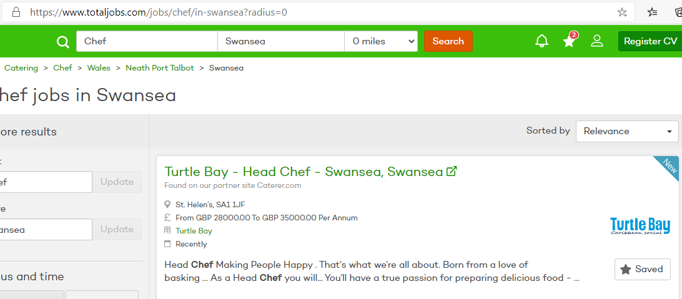

(Bay, 2020).

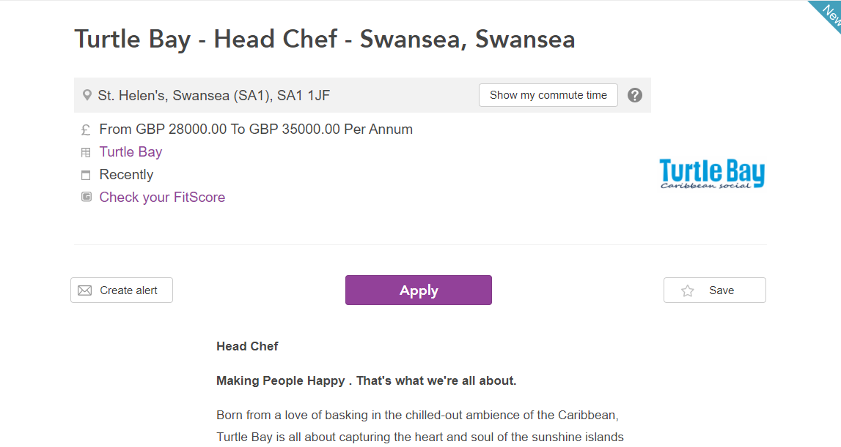

(Bay, 2020).

Reference

Bay, T., 2020. Chef Jobs In Swansea In December 2020 | Chef Job Vacancies Swansea - Totaljobs. [online] totaljobs.com. Available at: <https://www.totaljobs.com/jobs/chef/in-swansea?radius=0> [Accessed 2 December 2020].

