Student name: Miriam Naomi Otelas
Student number: 2321531
Module Code: LCLM 4001- Reflective report- Academic skills (Feb 2024)
Lecturer: Tim Hopkins

Content
- Introduction
- Paraphrasing skills
- Summarising skills
- Note taking
- Conclusion
- References
- Appendices.

Reflective Report

The purpose of this report is to reflect on my learning experience on this module. I will be focusing on three academic skills that caught my attention namely, paraphrasing skills, summarizing skills and note taking. I will be using Driscoll’s model of reflection as it has helped me reflect on myself. It has 3 stages: What, so what, now what. Reflecting on my academic skills has been an amazing journey for me. I have encountered challenges, and this report will delve into my experiences. My goals are to enhance my academic skills and examine my strengths and weaknesses.
What is Driscoll’s model?
It consists of analyzing and reflecting on one's own experiences.
“What?” stage, here we describe the situation/ what happened a brief description.
“So what?” stage here we evaluate the experience, understanding the impact that had on the learning journey
“Now what?” The last stage is to determine the changes to take for the future, what improvements to make and setting goals.

Paraphrasing skills/ Driscoll’s model
“What” This skill is particularly important in day-to-day life, because it helps with more knowledge and better communication. I heard about this skill before, but I was not confident on it, as English is not my first language. I have learned that paraphrasing means using synonyms, changing word order, and changing word class, for example from adjective to adverb. One strategy that I use is highlighting the main words and trying to find similar words and changing the order of a sentence.

“so what "Paraphrasing is important because it shows that I have understood the source and the knowledge of changing it into another words. The transformation of the ideas of other authors into my words, changing order or finding other adverbs and adjectives avoids plagiarism. It helps me with my creativity, engages my ability to learn more, writing skills and communicate. I can share the same idea but with different words.
“Now what” In the future, I am going to focus more on learning how to paraphrase better, to improve my vocabulary, I will read more books that will help me improve these skills. One book I read is Gulliver’s travelers, and it has a variety of different words I am learning, and a dictionary that is useful to find the meanings or more synonyms. I always read two or three times to understand the source and after I put it in my words. I must seek other colleagues' feedback to review my paraphrasing. This will help me identify where to improve and refine my skills.

Summarising skills

“ What” Learning about summarising helps me identify the most important parts of a text and writing it shorter than it was before, using my words. I have learned that summarising is useful when I have to analyze and understand a text. This skill is important as it helps with my memory, and I can catch things easily. When I started learning about these skills, I was confused with paraphrasing and summarising but now I am more confident, and I understand the differences. I learnt that to summarise I must read the text carefully, find the main points and make a note and after that write briefly about those main points.

“So what” Learning how to summarising has develop my memory and understanding. When I must study for an assignment, I always use this skill as it helps me understand and saves time. It enhances my comprehension and information retention. One mistake that I tend to make when using this skill is that sometimes I add too much detail in everything, and it loses its effectiveness. It helps organize my thoughts and communicate effectively with others.

“Now what” In the future, to develop this skill, I will read diverse types of books, Journals, articles, and practice summarising. Trying to identify main points and key ideas and put them in my own words, I will get to learn more vocabulary by reading. This skill is important in a professional setting as I will show my communication and understanding skills. It will help my critical thinking abilities by identifying important aspects of the text. Learning how to use my own words, avoiding copying the same source, making the summary more concise.

Note taking skills.

“What” This skill means the ability to effectively catch and organize information during reading, lectures, and other events. For this skill, we must be an active listener. It is necessary to identify the main ideas and write them in an organized manner. When I studied about this academic skill, I learnt about three types of notes taking called: Spider, tabular and linear. Cornell notes helped me with diving more to get information and to retain that information. This method consists of dividing into cues that is extra ideas, any statements, comments, and thoughts. Notes, this part is to write Gist (the main point)
Spider: It consists of mapping ideas and brainstorming ideas.
Linear: This is the most used in lectures when I take notes and I tend to summaries as well.
Tabular: A table comparing various sources that says about a topic

“So, what” Learning this different method has helped me gain more knowledge and understanding when trying to understand a topic. It helps me retain information. I sometimes use bullet points when taking notes or highlighting ideas. This skill is especially useful when remembering information. It quickly refreshes my memory and allows me to reinforce information. Lastly it encourages my critical thinking by drawing conclusions and deeper understanding of a subject.

“Now what” In the future, I will consider some strategies such as: Developing my note taking system, for example using headings or categorize information. I am trying to learn how to do diagrams, charts and other visuals that can help me understand better. Lastly regularly review my notes as part of my routine.

Conclusion
In my point of view, this academic skill has helped me through this journey. Paraphrasing has improved my knowledge of how to restate information in my own words while having the same meaning. It helps me avoid plagiarism. Summarising it consists in condensing a bigger text into a shorter text using my own words for better understanding, capturing the main points and key ideas. Lastly note taking, it develops my comprehension, organization, and retention of information. This is my favorite academic skill as i can be creative while taking notes and learning faster and better. These skills are essential for understanding, Its facilities my learning and ideas.

References:
Uwtsd (2024): Academic skills Note taking LCLM4001. London campus
Uwtsd (2024): Academic skills summarising and paraphrasing LCLM4001. London campus
University of Cambridge (2021). Reflective Practice toolkit: Models of Reflection. University of Cambridge. Available at: https://libguides.cam.ac.uk/reflectivepracticetoolkit/models.

‌

Appendix
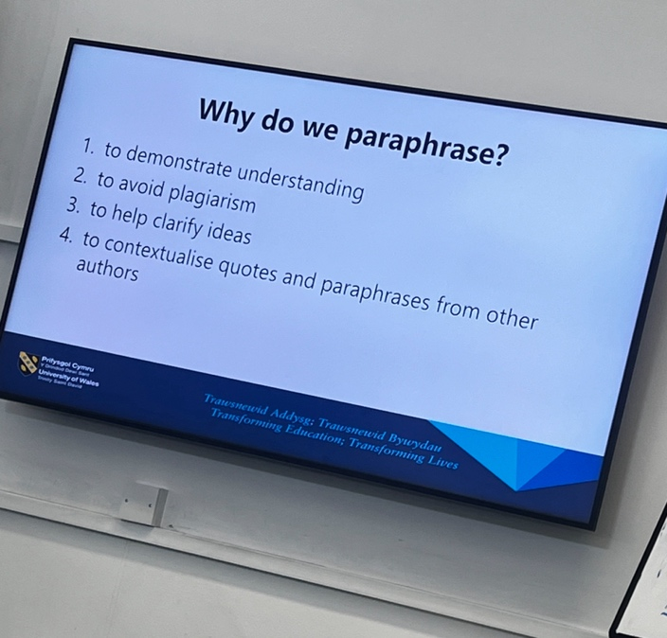
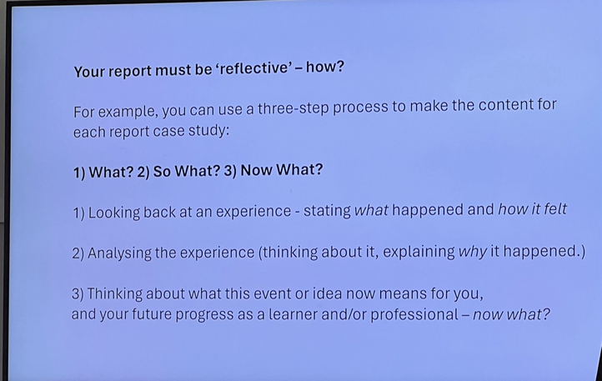
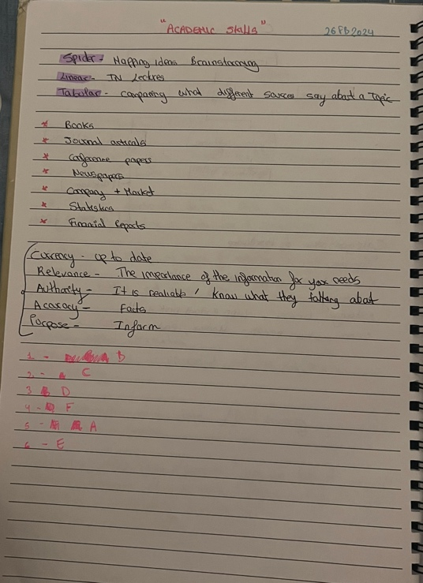
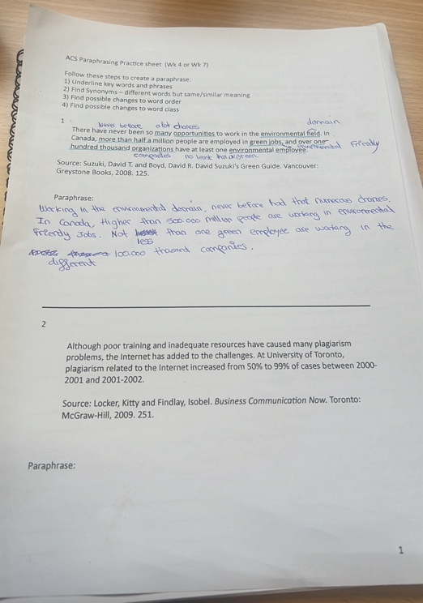
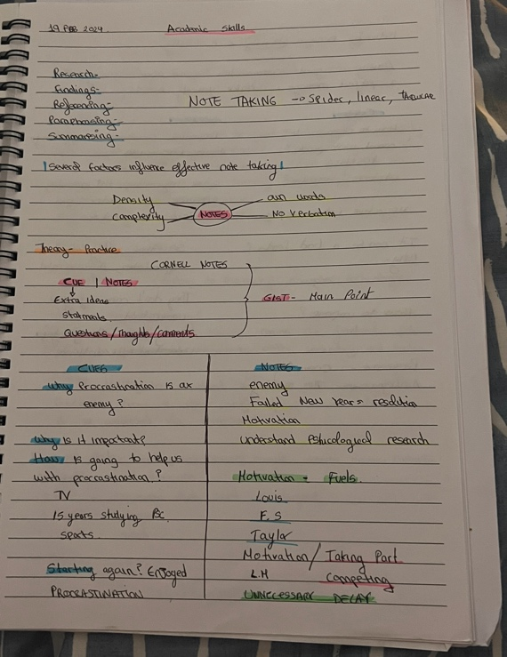
In this section, I will be providing all my supplementary information such as note taking, pictures that had helped me through my journey. It provides evidence that may be helpful.

