University of Wales Trinity Saint David

OME level 6 degree apprenticeship



Design Process of a New Cratering Charge
Group Project (ACDA5022)

Max Fisher

2113637

April 2024

Lecturers: David Holley & Jenni Steen

Contents

Contents 2
1. List of Figures 4
2. List of tables 5
3. Introduction 5
1.1. Aims and Objectives 5
1.2. Customer Requirements 5
1.3. Team structure 6
4. Background Information 6
5. Initial design 9
6. Modelling and it effects 9
7. Manufacturing 11
7.1. Introduction 11
7.2. Systems approach 12
7.3. Shaped charge Case 14
7.4. Shaped charge liner 15
7.5. Filling charge 16
7.5.1. Method 1 17
7.5.2. Method 2 18
7.6. Boosters 19
7.6.1. Shaped Charge Booster 19
7.6.2. Main Charge Booster 19
7.7. Main Charge 19
8. Packaging 20
9. Interactions with other stages 21
10. Presentation Questions and Answers 22
11. Conclusion 23
12. References 24
References 24
Annex 25

List of Figures
Figure 1 blast hole drilling (mining) 7
Figure 2 Rapid Crater Kit effects. 8
Figure 3 Rapid Crater Kit mk2. 8
Figure 4 Modelling ‘Comp B’ fill. 10
Figure 5 Modelling SWANS-EX fill. 11
Figure 6 Process importances. 12
Figure 7 Means Importance 13
Figure 8 Key controls. 13
Figure 9 key noises. 14
Figure 10 Metal hemming [9] 16
Figure 11 Resodyn RAM mixer range [9] 17
Figure 12 Manufacturing flowchart. 20
Figure 13 Wooden transport crate. 21
Figure 14 Collaboration overview. 22

List of tables
Table 1 NR 50 performance 6
Table 2 NR50 performance 6

Introduction

Aims and Objectives
This Portfolio aims to discuss the methods and processes followed through the design of a new cratering charge kit. Specifically, this pertains to the manufacturing methods chosen and how this both affects and is affected by the design, test, and proof processes. This portfolio is one of 5 produced as part of this project by the following authors:
- Stephen McAngus
- Max Fisher
- Luke Malcolm
- Silas Blevins
- Natalie Coplin.
These portfolios are interlinked, and a summary presentation is available on request.

Customer Requirements
In order to understand what the team was to design; it was necessary to collate and understand the customer requirements. This was not a novel concept or idea in fact, versions of what would be required has been in service for many years: Charge, Demolition Rapid Crater kits have been used for decades in one of two versions to entrench defensive positions rapidly and safely. However, these charges do not meet the modern ‘Insensitive munition’ or ‘IM’ requirements, as such the customer wants a device that has similar capabilities but enhanced safety characteristics.
The full list of requirements was presented as follows:
- Provide the armed forces with an ability to rapidly and safely ‘dig in’ or entrench.
- The munition must be ‘IM compliant’ in accordance with AOP39.
- The system should be safe and effective in desert or hot environments although it is desirable to have all climate capability.
- The system should be transportable in all transport aircraft both rotary and fixed wing.
- The system should be transportable in both wheeled and tracked vehicles.

Team structure
In order to effectively produce a design, the team decided to divide the workload between the individuals’ specialisms. This was to allow a greater individual focus on each area of the design and reduce the likelihood of design oversights. The work was divided as such:
- Stephen McAngus: Modelling and simulations
- Max Fisher: Manufacturing and packaging
- Luke Malcolm: Sequential environmental testing
- Silas Blevins: Lab analysis
- Natalie Coplin: Non-sequential safety testing

Background Information
The current in-service Crater Charge kit is the Charge, Demolition Rapid Crater kit mk2. This consists of an 11kg shaped charge (sometimes listed as charge number. NR50 [1]). Some sources list the penetration data of this charge however, these disagree.
STV group provides the following data table:
Armor plate (mm) | 500
Mild steel (mm) | 1 000
Reinforced concrete (mm) | 1 500
Ground/soil (mm) | 3 000
Penetration performance
Table 1 NR 50 performance
While Mondial Defence [2] provides this:
Arable soil | ~3.5m
Gravely soil | ~3m
Clay | ~3m
Concrete | ~2m
Steel | ~1m
Table 2 NR50 performance
The shaped charge is used to provide a pilot hole for a later blasting charge. This allows a greater effect for a given mass of explosive; containing much of the force of the explosion and causing ground heave similar to that used in explosive mining applications [3]. When used in a mine setting the precursor holes are often drilled, however this is a relatively lengthy process and requires specialist knowledge and equipment such as those seen in Figure 1.
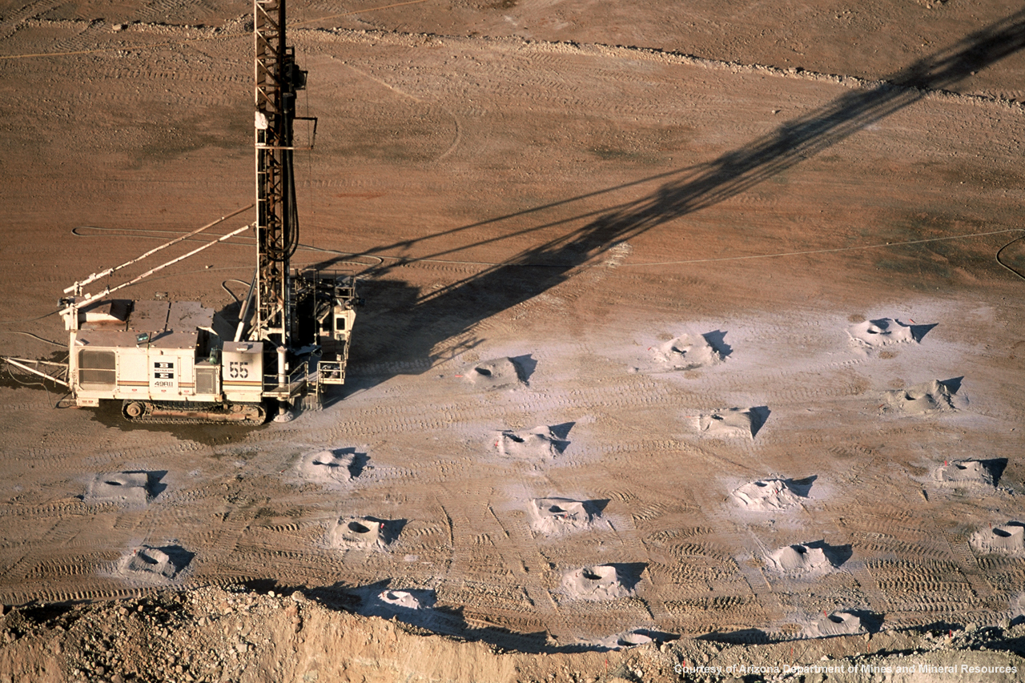
Figure 1 blast hole drilling (mining)
The effect given by the current charges is illustrated in a diagram produced by Mondial defence (Figure 2). The orange zone represents the pilot hole left by the shaped charge, while the wider white region represents the final crater. The main charge has been produced in several variations. A total charge mass of 19.6kg or 30kg (NR51 [4])have been used along with both granulated and solid form bulk explosive. These large charges are normally broken down into two bags for user convenience and portability, normally being 9.8kg or 15kg respectively. These are detonated by a standard detonator (either electric or non-electric) placed into the charge. The ignition kit is a standard piece of equipment, and is beyond the scope of this portfolio, but will normally contain detonators, safety fuze, black and tan cabling, and several other components [5]. An example of the kit can be seen in Figure 3. It is important to note at this stage that the previous charges both the main and shaped charge are not IM compliant as such present and increased vulnerability and risk throughout their lifecycle when compared to IM munitions.
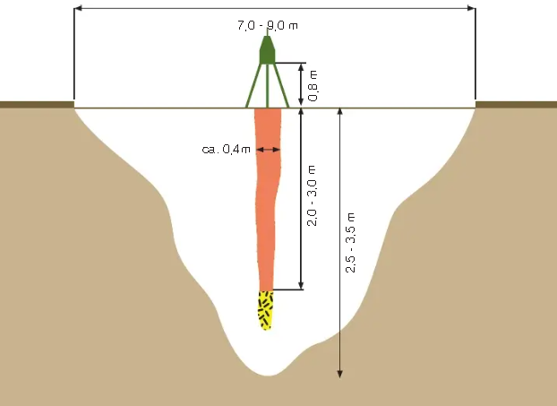
Figure 2 Rapid Crater Kit effects.
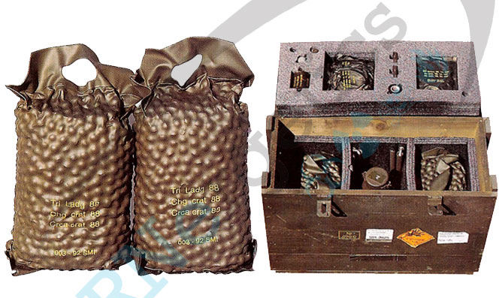
Figure 3 Rapid Crater Kit mk2.

Initial design
The group approached this task with the following core features in mind. To keep unit cost down, to maintain or improve the munition performance, to allow rapid mass production, to enable easy transport by man or vehicle over land or by air. It was initially intended to keep much or the architecture of the kit similar to its current form; keeping the setup of a shaped charge followed by a main blasting charge. It was also intended to retain the production lines for manufacture of the shaped charge casing and liner. The core changes were to replace the existing carry straps with longer or adjustable straps both on the shaped charge and the main charge bags. This would allow much easier transportation on foot, as the carrying strap could then be looped over a shoulder, freeing up both hands to hold other equipment such as a soldier’s rifle. It was also planned to replace the current bulky foam standoff legs for the shaped charge with 3 aluminium legs, these were to be foldable to reduce storage size, while retaining the standoff required for optimal jet formation. Finally, the most critical design change was to replace the fill of both munitions. This was to be the novel explosive SWANS-EX-2024. This is a polymer-bonded explosive, which was to be Resonant Acoustic Mixed (RAM) and is detailed as having a higher detonation velocity that its RDX/wax predecessor. SWANS-EX contains a 60:40 mix of RDX: HMX and procured in its constituent ingredients; the reason for this will become apparent in the manufacturing section.

It is important to note for a future reader that SWANS-EX-2024 is a fictional explosive composition selected for its hypothetical safety and performance data. Any allegories to existing compositions are by coincidence. This portfolio aims to present a realistic ad practical method for a design process without creating a genuine article.

Modelling and it effects
Before progressing further through the design stages into manufacturing and testing, it was essential to model the shaped charge. Shaped charges are relatively sensitive systems, and minor changes can significantly affect the formation of the jet. While it was intended to keep the geometry of the liner and casing the same, along with all the materials and thicknesses used, by replacing the fill with that of a higher detonation velocity, it was possible that the cone may collapse in an unpredictable way, not forming a penetrative jet. Mr McAngus decided to use Dassault System’s ABAQUS software package to simulate both the previous RDX: TNT (60:40)/ Comp B fill and the new SWANS-EX fill. Setting charge diameter to 170mm with a cone angle of 60⁰, both options were simulated. Figure 4 shows the Comp B fill, this clearly shows the deformation of the cone and the appearance of a Jet. This jet feature is the mechanism through which the pilot hole is created and this essential for the performance of the charge. Figure 5 shows the SWANS-EX simulation, this appears visually fine, however when understating the S mises strain (demonstrated by the colours) it is many times that of the Comp B simulation. To reduce compounding errors element deletion was deactivate but this gives a false impression that this jet would function. The red areas in relative would fragment and the jet would fail to form. For this cone diameter the explosive fill ‘overpowers’ the cone, causing it to fragment instead of forming a jet. Mr McAngus later re-ran simulations with element deletion on, and it did become clear this would be an issue.
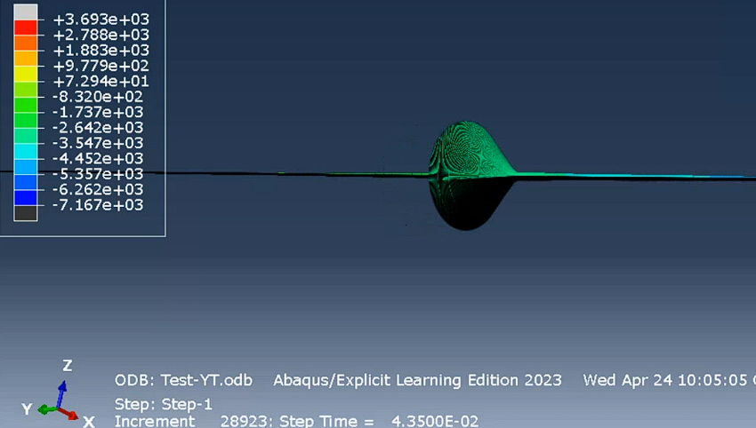
Figure 4 Modelling ‘Comp B’ fill.
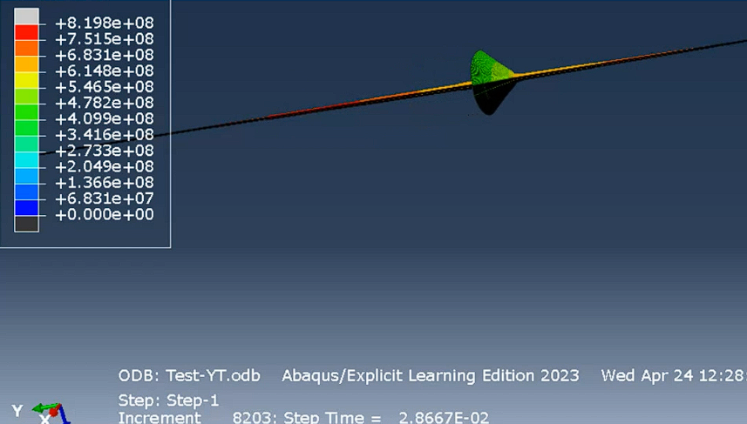
Figure 5 Modelling SWANS-EX fill.
This meant that the design would have to be revisited. It was understood that this overstressing of the cone was due to the increased force from SWANS-EX. This could be mitigated somewhat through reducing the quantity of the fill; however, this would also affect the forming the jet in other negative ways. Another suggestion was to use an inert ‘wave-shaper’ which would reduce the likelihood of cone collapse. This would however increase the complexity of the device and as such manufacture cost. It was also suggested that is issue could also be solved by reducing the cone diameter. This would mean less fill would be required to generate a similar effect, while remaining a ‘simple solution’. This was further investigated by Mr McAngus, and it was found that this new smaller charge diameter solved the issues faced. Full details of the simulation and its settings can be found within the Mr McAngus’ portfolio.

Manufacturing

Introduction
At present in the UK there is only one site with the capability to manufacture significant quantities of large calibre munitions. This site is BAE Glascoed in South Wales, a former Royal ordinance factory established in 1938, where primary production includes 155mm and 105mm artillery shells, 40mm ‘CT’ ammunition and many others, with BAE claiming to supply up to 80% of the Armed Force’s general munitions [5]. The site has extensive history and expertise in the filling of munitions, including the production of the previous iterations of the rapid crater kits, using the waste material from the shell filling. [6] However, due to the changing of the fill from the RDX:TNT to the new SWANS-EX fill, this cannot continue and a new production line must be established.

RAM mixing is a relatively new technology in the manufacturing environment and as such has a relatively low number of adopters. Current uses include the BAE and the Falcon project, who use RAM mixing to produce novel propellants. It is important to note that when producing compositions in RAM mixers, the scale must be gradually increased: this will reduce the risk of emergent failures and the associated safety hazards.

Systems approach

Before Beginning the design of the production line, it was decided to utilise a ‘systems’ approach to identify the critical stages of manufacturing; where the greatest risks were and how these could be mitigated. The first stage of this was to perform a ‘Quality function deployment or ‘QFD’, which compares the manufacturing functionality to manufacturing requirements. These are compared with importances and given either a ‘1’, ‘3’ or’ 9’depending on the strength of their relationship. This then provides a ranked process importance charge which can be seen in Figure 6. This clearly shows that filling the casing is the most important process followed by the formation of the liner.
Figure 6 Process importances.

These are then taken forwards into a QFD 2 where solutions from a ‘Process function means analysis’ (Process FMA) are compared and identified for their importance. This follows a similar process where the ‘1’,’3’ and ‘9’ are again used. The results of this can be seen in Figure 7 and again shows the methods of filling the case is critical to the function of the shaped charge.

Figure 7 Means Importance
Finally for this tasking, a ‘p diagram’ was created for the filling process. This compares likely noise factors with control factors, again highlighting the key ‘bits’ or in this case the worst noises and the best controls. The results can be seen in Figure 8 and Figure 9.

Figure 8 Key controls.

Figure 9 key noises.
A full analysis of a systems approach to manufacturing can be seen in the authors report into systems engineering this can be provided additionally on request.

Shaped charge Case
The case for the previous shaped charges were made of aluminium, this material is relatively cheap, lightweight, and readily available. It also retains the important property of being ductile, allowing it to be easily worked and formed. As discussed, it was intended to continue to use the existing design of case however the modelling showed the cone was overpowered, leading to a redesign. This new munition is 10% smaller, now having to accommodate a 9.9kg fill in place of the 11kg.
There are several methods to manufacturing simple geometries out of aluminium sheets, two of which are optimal for large scale manufacturing:
Stamping/ pressing.
Metal spinning

Stamping is an extremely common process and involves large presses forming an aluminium sheet or ‘blanks’ against a from, forcing the material to take the shape of a mould. This method is ideal for making large quantities of a part but can introduce stresses to the material which may have adverse effects [7] later in the munition’s lifecycle.
Metal spinning is when a disk of material is placed into a lathe and spun against a form. This is then ‘massaged’ or drawn across the blank creating a uniform thickness of material across the part. Metal spinning can also be performed at high volume but is a more expensive process that alternatives. Metal spinning is also adept at getting ‘deep’ cylindrical features, which pressing sometimes struggles to achieve given the volume of material required. As such it is often used to manufacture items such as pots and pans. [8]

It was decided to use the metal spinning process in the munition, this would likely make it of a slightly higher cost but would reduce the likelihood of failures of the munition especially when dropped, this will later be explored through the munition tests both environmental and safety.
While the fill is the main concern of the case, it is also important to leave sufficient space for a booster and a detonator well. This will be done by creating a ‘neck’ for the munition during the spinning process.
Stamping will still be used for some elements of production, in this case toggles for the carrying strap and the standoff legs will be pressed out of large sheets of aluminium before being riveted to the side of the casing. There will be 3 standoff legs to form a tripod style standoff, and 2 toggles to attach a carry strap.

Shaped charge liner
The liner will also be formed using a metal spinning process. This time a 2.5mm copper blank will be drawn against the form to generate the cone. This will be a similar geometry to the original munition, retaining a 60⁰ cone, again as discussed this will be around 10% smaller in area than the previous munition due to the increased detonation velocity of SWANS-EX. It is extremely important at this stage that the liner is as symmetrical as possible, as even minute differences in material thickness will cause the jet to particulate or ‘keyhole’, which will significantly reduce the penetration of the jet.
At this stage the liner must be protected against corrosion this will be done by the use of a lacquer, this protects the copper against moisture and erosive materials that it may come into contact with, especially in extreme environments.
Once this has been done the liner will be attached to the case by rolling the edge of the aluminium over the liner. This is known as metal hemming and will prevent the liner from slipping.
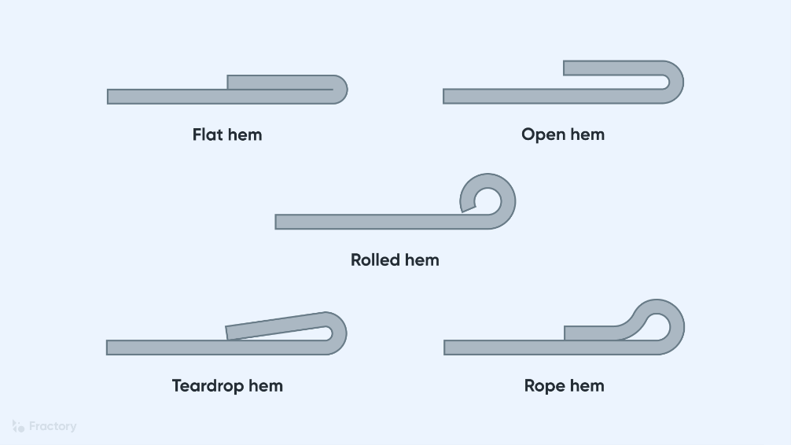
Figure 10 Metal hemming [9]

Filling charge
As identified during the systems phase, filling the charge is likely the most important single step in the manufacturing process. It is especially critical as SWANS-EX is PBX type explosive; once the energetics are mixed the clock begins to tick down until the material is permanently unworkable. There are multiple reasons that two methods are presented here, first and foremost is the QFD, which showed that there is likely to have more failures than at any other stage here. The second is the availability of RAM mixing equipment, Resodyn the primary manufacturer of RAM mixers produces two main models: the RAM 5 and the RAM55 with a 36kg and 420kg [9]payload capacity respectively. Both models are in high demand, however the RAM 55 has significant lad times which has only increased with a recent uptick in orders. As this is the primary limitation of the manufacturing process this must be taken into account. Thirdly, the scale of the orders must be accounted for; if it is only required to make small batches of these kits then a lower volume system is tolerable, however if surge capacity or a high baseline production rate is required then a larger volume system is required. By presenting both options to a customer the response can be tailored to suit. For both options, several controls must be in place, including but not limited to humidity, temperature, material tolerances, a dust free environment and regular cleaning of pipework. After the completion of filling process each shaped charge will be x-rayed to ensure the fill is of a good quality, further information of x-ray analysis can be found in the safety and environmental test reports.
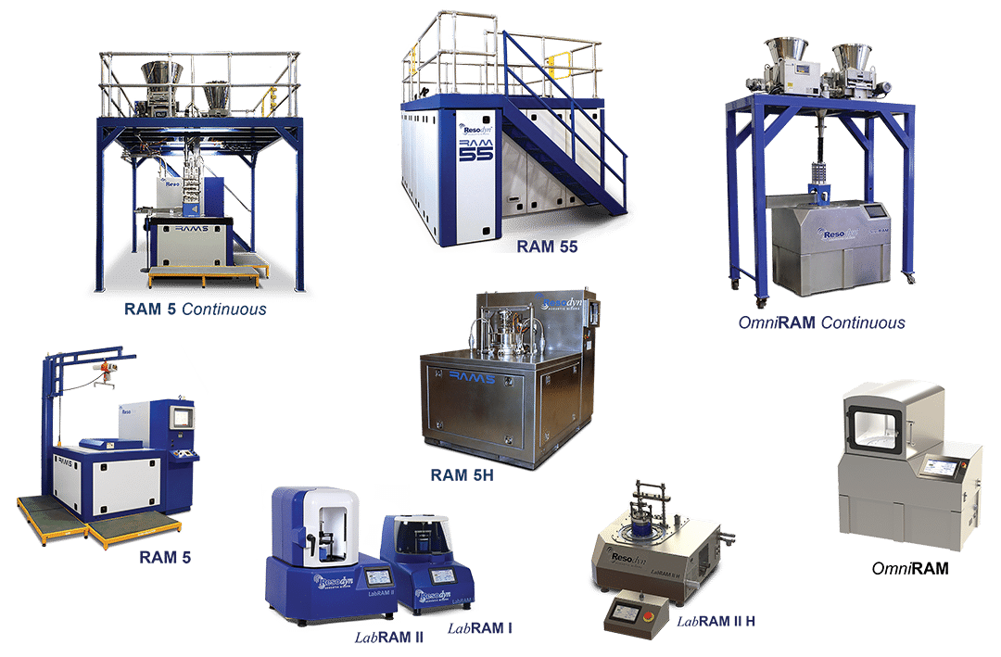
Figure 11 Resodyn RAM mixer range [9]

Method 1
Method 1 is the higher production throughput method and relies upon the RAM 55 system. This means that it would have a higher initial startup cost, and longer lead times but a higher overall production throughput once that the line is up and running.
This method is very similar to melt casting from the pouring stage, but as SWANS-EX is a PBX the mixing and preparation is very different. SWANS-EX is to be added to a RAM55 mixer in its constituent parts, only once there are casing ready to be filled. Once the mixing begins, the clock is started, from the point of initial mixing the explosive will begin to set and harden. When the mixing is complete, the material will be pumper through pipes into a dispenser head, where the mix is released into the casing. This will be a measured through weight of fill and through a flowmeter. During the pouring, the munition will be placed under vacuum and on a shaker table, this will reduce the likelihood of trapped air bubbles forming within the fill, which would negatively affect the formation of the jet as well as the safety of the full munition. When munition is filled, the blanking plug will be added, and the munition left to set. The blanking plug has a double job of ensuring that dust and particulates do not enter the munition, while also forming a ‘well’ for the booster charge and for the detonator. At all stages of the mixing the viscosity of the fill will be monitored and a cut-off time observed. If SWANS-EX cures within pipework a flushing regime must be undertake, with the pipes inspected for any residual material. It is critical that regular maintenance be undertaken to prevent blockages or contamination of the fill. When the curing has been completed, the blanking plug will be removed, and the threads inspected and cleaned. The munition will then be ready for the booster and transport cap.

Method 2
Method 2 is the production method that would be the cheapest to set up and likely provide the highest quality of fill. This method utilises the RAM5 mixer, and the entire munition would be placed inside. Immediately before mixing, the constituent parts of the SWANS-EX would be added to the casing, with each ingredient measured through a volumetric dispenser. The total mass of the munition will also be measured through this process to ensure that the correct ratios of binder, RDX and HMX are used. When all the components are inside the munition, the blanking plug will be added to the top of the munition to seal the casing, and to ensure that there remains room for the booster and detonator. Next the whole article will be placed into the mixer, where the fill will be mixed in case. This has the added benefit of reduced chances of voids as all munitions will have a fill of the same initial low viscosity and no air to be trapped available in the first instance. The shaped charge would then be left to cure, and once the fill has solidified, the blanking cap removed, and the threads cleaned. This would then be ready for the installation of the booster and transport cap.
Method 2 would likely present a higher quality of product, with a lower setup cost than that of method 1. However, the unit-to-unit cost would make it prohibitively expensive for large scale production and leave little surge capacity. It does however allow a user to get production moving much faster due to the shorter lead times of the RAM5 mixer. Depending on customer feedback and budget, a combination of these two methods could be used with method 2 acting as an interim measure while full, large-scale production is ramped up.

Boosters

Shaped Charge Booster
The shaped charge booster is 25g and is pressed from a sheet of PE8 plastic explosive. This is a commonly used explosive and is readily available. It is easily initiated by a detonator, while still retaining IM compliancy [10]. PE8 is most commonly supplied in 2kg ‘slab packs’ and can be easily worked. To form the booster pellet, the slab pack will be pressed, with a ‘cookie cutter’ style tool. An indentation will then also be made in the top of the pressed pellet, to allow good contact with the detonator. This will be installed into the top of the shaped charge and pressed against the fill to ensure good contact. When this is done the transport cap will be fitted, and the shaped charge will be ready for service.

Main Charge Booster
The main charge booster will also be made of PE8 and again pressed from the 2kg slab packs. The main charge booster will be 100g and will have 4 ‘cut’ lines and 4 detonator wells stamped into it. This will allow a user to split the main charge and booster into several smaller sections and allow several smaller craters to be generated.

Main Charge
The main charge will be made by RAM mixing the constituent parts of SWANS-EX either in a RAM 5 or 55. This will then be poured into rectangular moulds with a target weight of 2kg. 5 of these two-kilogram blocks will comprise one charge bag of 10kg. Two charge bags will be supplied with the kit, giving a total main charge mass of 20kg. As described in the booster section, the main charge will be used with a booster to ensure reliable detonation. The main charge can also be broken down and used in smaller quantities e.g. two craters each generated by 10kg or 4 craters each of 5kg (this would involve cutting two charge blocks in half). This will allow a modular approach to crater generation.
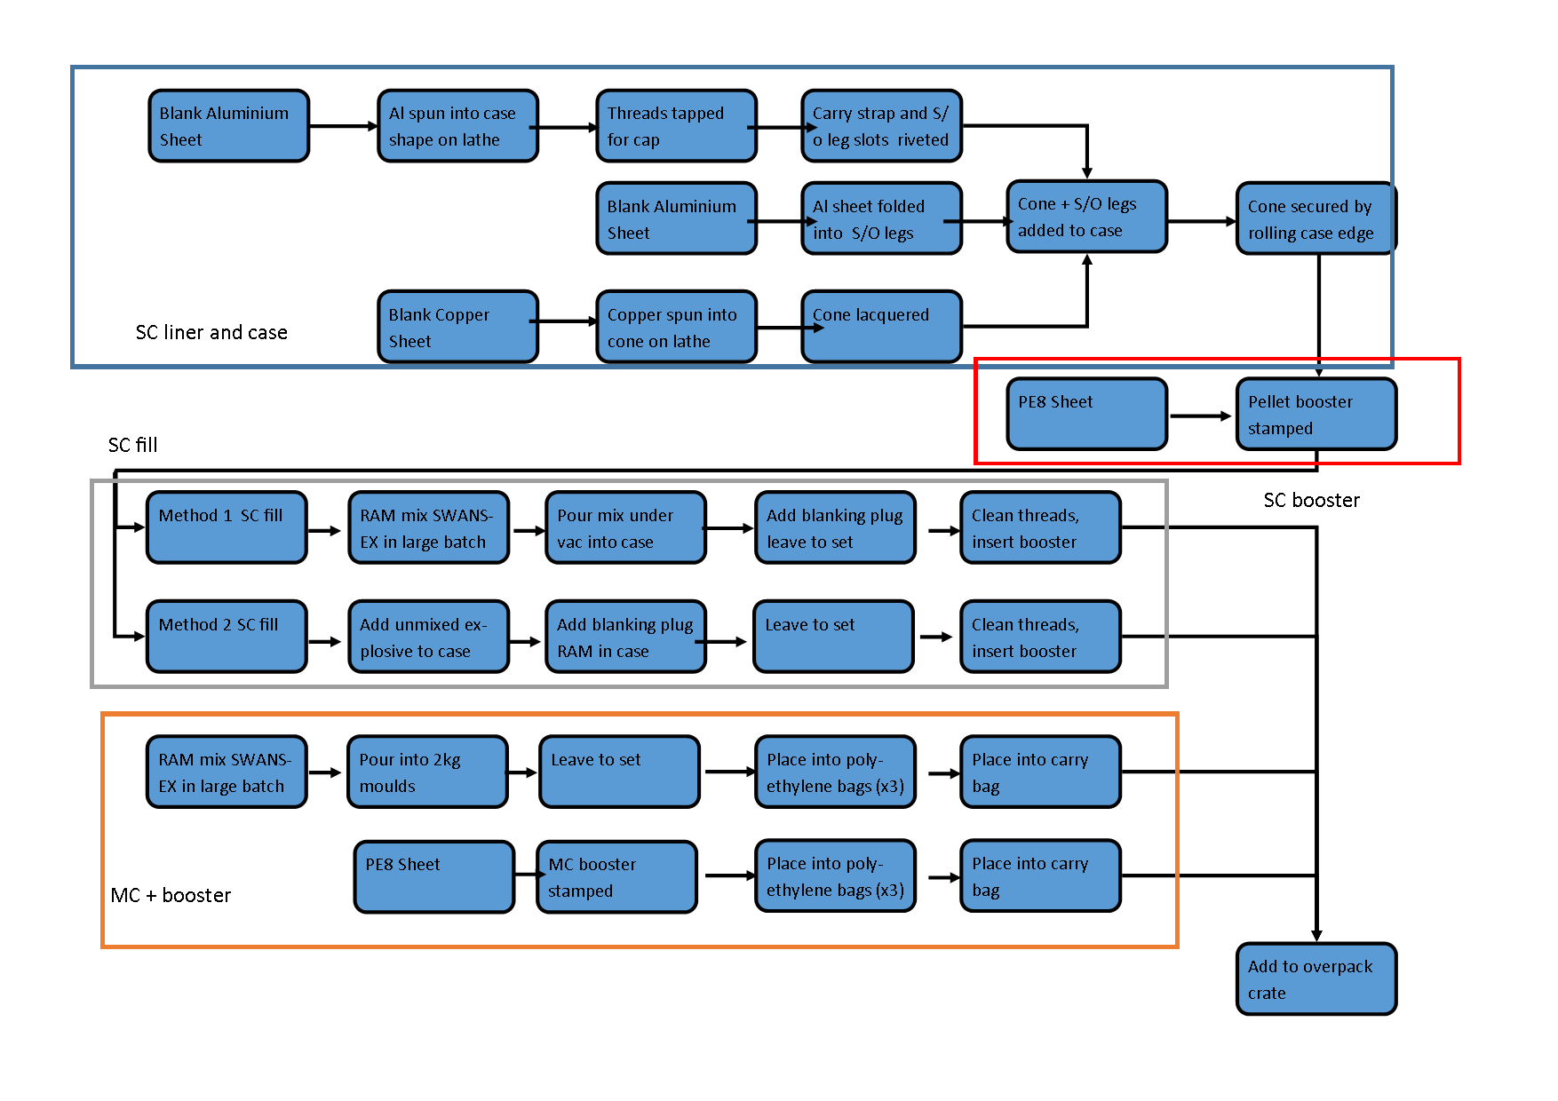
Figure 12 Manufacturing flowchart.

Packaging
Packaging is essential to the long-term viability of the munition kit. This is especially important for the main charge and main charge booster as they are exposed raw explosive material. To protect these, each charge will be placed into 3 layers of polyethylene bags. These will provide a moister barrier to the explosive as well as reducing the likelihood of electro-static discharge. Using multiple layers allow additional protection in the event the first layer fails through abrasion or mechanisms. These polyethylene bags will then be placed into an outer carrying bag, this will have a carrying strap, allowing a user to carry the charge bag over their shoulder or attach it to a bergen.
For long term storage and logistic transport, the kit will be packaged together into a wood overpack crate similar to that of Figure 13 Wooden transport . This will contain the shaped charge, the two main charge bags and the main charge booster. As previously discussed, the detonators will not be provided with the kit, as such they will not be stored with them. Using the wooden box was a deliberate choice, the project team discussed the options, and it was understood that SWANS-EX would likely still be somewhat vulnerable to sympathetic detonation, this was to later be tested by Ms Coplin. It was suggested that while a wooden case would fragment, it would contain any explosion less and the resulting fragmentation would carry less energy than a metal or plastic alternative. This would reduce the chances of injury to those in the surrounding areas while still protecting the kit from moisture, ESD and temperature extremes during storage.
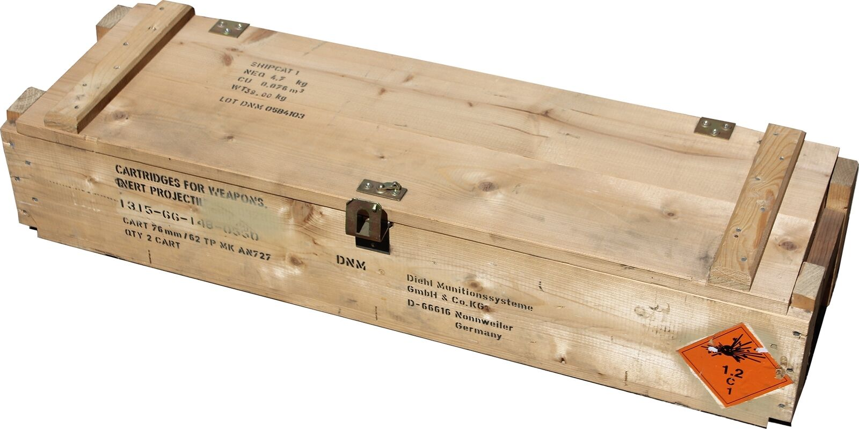
Figure 13 Wooden transport crate.

Interactions with other stages
Throughout this design task it was essential that all group member remained in constant communication. This was achieved by weekly team meetings, where progress was discussed, and design issues identified. Meeting Minutes are available on request.

Key areas where collaboration was required were as follows:
- Explosive type - all group members were involved in the selection of the energetic as this effected each and every part of the munition kit.
- Booster - again all group members were involved in the selection of the booster and its size for both the main charge and booster.
- Charge diameter, this was selected after extensive modelling, discussion between the author of this report and Mr McAngus.
- Test regimes – feedback from both Mr Malcolm and Ms Coplin revealed that a significant quantity of kits would be required for both the safety and environmental tests (more than 89 munitions)
- Packaging – discussions with Mr Malcom and Ms Coplin as to the impact of packaging materials.
- X-ray inspection – again discussions with Mr Malcom and Ms Coplin
Figure 14 shows these interactions in flowchart form. It is clear to the author that there would be significant issues had this collaboration not taken place. By communicating with one another, redesigns have been prevented and all have gained a better understanding of the processes and requirements for getting a munition into production and service.
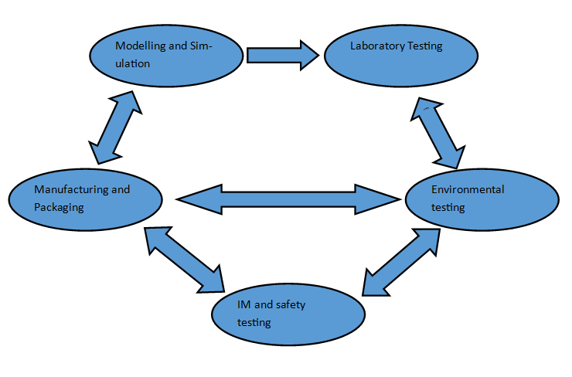
Figure 14 Collaboration overview.

Presentation Questions and Answers
Initiators separate (Why?)

The initiator kit is separate from the main kit for two main reasons. The first one is safety related. By storing the detonators separately from the main charge and boosters, it significantly reduces the chances of accidental ignition. Detonators when stored in appropriate packaging often carry a 1.4S hazard classification, by not including them in the kit, this does not have to be factored in during the later safety tests. Secondly the shaped charge has been designed to take a detonator with a diameter/length of 6.4/59mm this is the standard shape for the L1A2 non-electric detonator and the L2A2 electric detonator. These are already in service and in production and have been for many years at this point. This reduces the total cost of the system by utilising of the shelf components, which the armed forced already have in great numbers.

Flow forming of copper (Work hardening / annealing copper on spinning?

Work hardening of copper is a concern, it would be disadvantageous for the copper to become brittle, as it would significantly reduce the effectiveness of the jet. In This case it is believed that due to the relatively small size of the munition and the small thickness of the starting copper sheet, this would not be an issue. However, before full scale production would commence a small test batch would be made. If this was identified as a concern, this could be mitigated using an annealing oven, heating the copper to ‘relax’ the material, making it significantly more malleable and less likely to fracture.

IM boosters from shell? More accurate? More reliable (Proven?)

The original shaped charge did not appear to contain a formalised booster, but rather a ‘primer pellet’ as the fill has been changed to a less sensitive composition, the group decided to introduce the booster, to increase the likelihood of initiation. At this stage no comparative trials have been undertaken to test this; however, several shaped charges could be pulled from the line before the booster is fitted. This would allow a comparative trial on the ignition reliability of the munitions. If I was found to have a limited effect, the booster can be omitted from the kit. This were to happen; it would reduce costs and the sensitivity of the kit.

Conclusion
This report illustrates first and foremost the process through which a replacement for the rapid cratering kit mk2 was designed, manufactured, and tested. It highlights the importance of communication across disciplines and the improvements that can be made in each step. This report and accompanying presentation showcase a variable IM replacement for the rapid cratering charge kit, meeting all customer requirements and providing options for the manufacturing process. It is clear to the author that good design involves lots of communication and planning before any part is taken to testing or manufacture stages.

References

References

[1] | STV group, “Shaped Charge NR-50,” STV group, [Online]. Available: https://www.stvgroup.cz/en/product/shaped-charge-nr-50#:~:text=The%20shaped%20charge%20NR%2D50,performance%20of%20the%20shaped%20charge.. [Accessed 26 4 24].
[2] | Mondial Defence, “NR50 11kg Shaped Charge,” [Online]. Available: https://www.scribd.com/document/678134928/NR50-11kg-Shaped-Charge. [Accessed 26 4 24].
[3] | RPM drilling, “Blast hole drilling The basics,” RPM drilling, 2017 8 24. [Online]. Available: https://www.rpmdrilling.co.za/blast-hole-drilling-process/#:~:text=Blast%20hole%20Drilling%20is%20a,drilling%20and%20associated%20mining%20activity.. [Accessed 26 4 24].
[4] | CBRNergetics, “Shaped Charges,” 23. [Online]. Available: https://www.cbrnergeticsltd.com/SubCategories.aspx?iCategoryID=29&iSubCategoryID=57. [Accessed 26 4 24].
[5] | MOD, “Munition technical publication RAPID CRATERING CHARGE mk2,” MOD.
[6] | BAE Systmes, “Our contribution,” BAE systems, [Online]. Available: https://www.baesystems.com/en-uk/our-contribution-to-the-uk-and-its-regions. [Accessed 26 4 24].
[7] | D. Holley, Interviewee, lecture anecdotes. [Interview]. April 2024.
[8] | 1. P. M. A.-Z. a. J. M. A. Isidoro Iván Cuesta, “Mechanical Behaviour of Stamped Aluminium Alloy Components by Means of Response Surfaces,” Multidisciplinary Digital Publishing Institute (MDPI), 2019.
[9] | Industrias Puigjaner S.A. - DENN, “Metal Spinning machine - Kitchenware - Aluminium Pots and Pans - ZENN 100 CNC,” 11 2 2016. [Online]. Available: https://www.youtube.com/watch?v=m8jmYc6Esjg. [Accessed 26 4 24].
[10] | Resodyn, “Resodyn,” Resodyn mixers, [Online]. Available: https://resodynmixers.com/. [Accessed 26 4 24].
[11] | CHEMRING, “PE8 plastic explosive,” [Online]. Available: https://www.chemring.com/~/media/Files/C/Chemring-V3/documents/energetics/PE8%20Plastic%20Explosive%20Iss%2013%20Nov%2020.pdf. [Accessed 4 28 24].
[12] | Fractory, “Sheet metal hemming,” Fractory, [Online]. Available: https://fractory.com/sheet-metal-hemming/. [Accessed 26 4 24].

Annex
The following is available on request from the author:
- Meeting minutes,
- Full presentation,
- Systems engineering analysis.
Please contact the author of the report if there are any further questions using the following email: 2113637@student.uwtsd.ac.uk

