The Changing status of Screen print & Letterpress

INTRO
Why have I chosen this?
Chapter 1 - Screen-printing

Stencil printing was a widely utilized artistic and commercial practice in China and Japan, going back to 500 AD. During the Sung dynasty, Japanese stencil printing, familiar as Kappazuri-e; employed complex paper stencils in that small, confined stencil pieces were attached to the rest of a complex stencil with fine silk threads or human hair. Those stencil structures were used to print starch-resists onto fabrics that were later then dyed, as the start of a pattern. Stencils were also occasionally used in conjunction with woodblock prints as a technique for printing colour layers. Stencil printing finally found its way to Europe along trade routes. In the late nineteenth century and in the early twentieth, intricate paper stencil printing called pochoir, which was basically stencil printing, was broadly used in Europe and in the US for commercial reasons, specifically for book illustration and textile printing. The use of stronger stencils capable of printing hundreds of copies led to the practice of paper stencils fastened to frames, which were stretched with a fine-weave silk. The first patent for the silkscreen operation was taken out in 1887 by Charles Nelson Jones in Michigan.
(Fick et al: 2015)

Originally, inks were practiced through silkscreen stencils with hard brushes. The meaning of the squeegee to push ink through the screen further advanced the potential of production printing. Screen printing was essentially used for commercial applications. In the early twentieth century, the European textile business. In the 1930’s screen-printing was used for fine art printing on paper. In 1936, artist Anthony Velonis picked up the commercial screen-printing process for printing posters for the Works Progress Administration (WPA), the biggest of the US New Deal plan during the Great Depression. Alongside support from the WPA, Velonis set up a screen-printing studio that enabled artists to work collaboratively with fellow designers and makers. These transactions spawned a wide interest in screen-printing as a fine art process, gaining respect as a genuine print process for fine artists in the US and Europe. Beside the 1960’s Pop Art movement, screen-printing gained popularity as many artists including America’s Andy Warhol and Robert Rauschenberg, and Eduardo Paolozzi and Joe Tilson in the United Kingdom – all engaged in screen-printing as part of their artistic production. The artists, Eduardo Paolozzi and Richard Hamilton utilized screen-printing to employ a collage strategy, combining photographic elements with hand-drawn autographic stencils.
(Fick et al: 2015)

Andy Warhol was born in 1928 on the 6th of August and passed away in 1987 on the 22nd of February. Warhol was an American artist, producer and director who was a leading figure in the visual art movement known as Pop Art. His work explored the bond between artistic expression, celebrity culture, and advertising that bloomed by the 1960’s and span a mix of media, including painting, silk-screening, sculpture, photography and film. Some of his best-known work consist of his silkscreen paintings Campbell’s Soup Cans (1962), insert image the Marilyn Diptych(1962) insert image. Warhol initially saw a successful career as a commercial illustrator. After exhibiting his work in many galleries in the late 1950’s he started to gain recognition as an influential and controversial artist. His studio in New York, The Factory, became a well know meeting place that brought distinguished intellectuals, drag queens, playwrights, Bohemian street people, Hollywood celebrities and wealthy patrons. Warhol promoted a selection of personalities known as Warhol superstars, and is accepted with coining the broadened used expression “15 minutes of fame.” In the late 60’s, Warhol managed and produced the experimental rock band The Velvet Underground and founded Interview magazine. He wrote numerous books, including The Philosphy of Andy Warhol and Popism: The Warhol Sixties.
Andy Warhol http://www.tate.org.uk/art/artists/andy-warhol-2121 (no date)

The money, Coke, airmail and S&H stamps, glass label and Campbell’s Soup can paintings enforce the issue of multiplicity of the image itself, which as a motif is endlessly repeated. Two important formal innovations edge into these paintings. First, the actual as against the simulated use of an anonymous and mechanical technique, and second, the use of serial forms. (page 296)

Several of the money paintings were silk-screened, as were the modulated rows of images imprinted on the surface of the Whitney Museum’s Green Coca-Cola Bottles. However, Warhol much later never entirely stopped hand touch ups from his paintings, it was not until he used the blown-up photographic picture captured from newspapers or alternative sources that he became urgently crucially involved in photomechanical and silk-screen printing processes. Warhol’s Campbell’s Soup cans were the last of his hand painted images, he then shifted decisively into the use of serial forms. It is hard to ascertain exactly what combination of circumstances led Warhol to switch his imagery and technique so rapidly, thoroughly and simultaneously toward the end of 1962 and in early 1963. Warhol’s first New York exhibition in late 1962 included a very varied selection of paintings – Campbell’s soup cans, Coca-Cola match overs, repetitive row of Coke bottles, repetitive Martinson Coffee tins, one of the newspaper images (129 die) and various portraits, such as the repetitive heads of Troy Donahue, Elvis Presley and Marilyn Monroe. In this exhibition containing one painting of rows of Coke bottles, all the portraits engage the silk-screen technique. The impersonal process of hand-painting the images up to now, is subjected to an effective transformation. Rauschenberg and Warhol appeared to develop curiosity in the silk-screen technique at near enough the same time. Rauschenberg’s intension was to find a means to change scale of the photographic material which he had formerly stuck to his paintings as elements of collage. Silk-screen let him to adhere the blown-up picture as an integral element of the canvas surface. Warhol, having said that, used the technique as a device to have charge of the overall surface of the painting. He first lays down a flat but frequently an intense ground colour and then unifies the surface and image by repetition of the module of the screen. The final picture, nevertheless, is very arbitrary and completely unlike the impersonal care of the serial Campbell’s soup cans, from which all trace of paint care had been suppressed. Engaging the silk-screen technique, which is used in commercial art to give evenness of surface and crispness of outline, Warhol does an opposite effect. In his hands the technique evolves as arbitrary, unpredictable and aimless as the paint surface appears to be un and Abstract Expressionist painting.
Warhol’s paintings show’s images in an encircling space that is felt or perceived as a continuum. This is improved by the fact that his portraits are without a literal background. His heads of figures are positioned on a flat-painted surface.

WARHOL - COMBING COMMERCIAL ASPECTS WITH THE ART (1960)

Chapter 2 - Letterpress

Letterpress is a technique used to define the relief printing of text/images using a press with a high-type bed. The idea of relief printing from carved wooden blocks is thought to go far back as AD c. 200 in China. Although, it is German Johannes Gutenberg who is mostly regarded as the pioneer of printing with reusable, moveable type. In the mid fifteenth century, he created the use of individually cast, movable letters, that replaced handwritten calligraphy. The popular Gutenberg Bible was published in c. 1455 begun Gutenberg’s movable type machine as a superior means of printing. As well as movable type, Gutenberg adapted the screw mechanism, highly commonly used in wine making, to increase his first wooden hand-press. It worked by inking the type surface, placing the paper on top by hand, and then sliding it under the padded surface, before using the threaded mechanism to apply pressure and to make an impression on the paper. As time went by, presses that used a knuckle and lever mechanism were designed, and ink rollers came in to the picture for use. The paper on these platen presses was still placed by hand but the rollers did the inking. As the ink had already been applied to the rollers, they would swing back and forth onto the inking plate to collect extra ink. While the platen was pressed onto the paper to create the print, the printed paper would then be removed from the press and replaced with a fresh sheet of paper, and the action would be repeated. The twentieth century came, and presses such as the Kluge and Heidelberg Windmill featured automated feed and delivery. Gutenberg’s press process remained constant for over three hundred years. The floor-standing hand-operated platen presses were direct offspring of the Gutenberg. Mid Nineteenth century the industrial revolution and improvements in engineering saw the creation of a huge number of hand-presses. These new presses tried to improve on the weighting and leverage needed to make an imprint, and are still extensively used by hobby printers and small stationary businesses today. Popular models involve the Chandler & Price and the Adana 8 x 5, the latter of which was created in England until 1999.

Coming to the end of the nineteenth century, full-sized platen presses, including the Chandler & Price and Golding Jobber, were further being manufactured and were usually for commercial printing up until the end of the twentieth century. Throughout the years, the presses were modified and automatic feeds were added, the best common being the Heidelberg Windmill press, which is still a popular automated press used by commercial letterpress printers today. By the 1930’s motorized flatbed cylinder presses such as the Heidelberg KSBA were more becoming popular among commercial printers owing to their capability to handle big print runs.
(Rivers et al: 2010)

Alan Kitching is a British artist born in Darlington in the year of 1940. He had strong love for printing, painting and drawing while he was in school, but he had to leave school at the age of 14 due to unforeseeable circumstances and got employed as an apprentice compositor in the Experimental Printing Workshop at the School of Art at the Watford College of Technology, under supervision of the local printer Anthony Froshaug. Intrigued by the job he was seeing daily, Kitching decided to find a career in design. He has experimented with graphic design, letters, animation and software development over the years of his career.
Alan Kitching is first in rank of one of the world’s best of letterpress typography design and printmaking. Kitching is famous for his artistic use of wood and metal letterforms in creating visuals as his task and his own limited edition prints. Kitching has had solo shows in Barcelona and London, and donated to various group exhibitions including the Pompidou Centre Paris, the British Library and the Barbican Art Gallery London. In 1994 Kitching was selected Royal Designer for Industry.

Kitching established his own design practice in London, during the year of 1973, partnering up with Derek Birdsall. It was in here that Alan started to seriously dabble with letterpress printing, partially as a hobby but also working for numerous commissions. Soon, Kitching started to teach typography as a visiting lecturer at the Royal College of Art in London, continuing to do so till the end of 2006. Sticking rigorously to wood and metal as a material of his choice, Alan produced highly evocative graphic images and had a masterful control of letters inside his work – something he never truly lost over the course of the years. https://www.widewalls.ch/artist/alan-kitching/

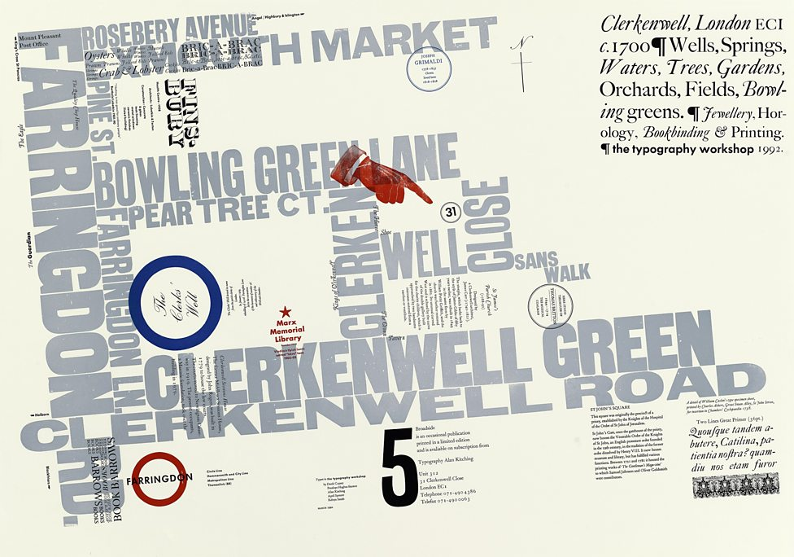 Broadside No. 5 (1992) Letterpress. Alan Kitching

This is one of my earliest typographic maps. The Broadside Series, an ad hoc publication devoted to typographic arts, signified my return to the letterpress in the late 1980s and was when I began to explore the use of colour. Although I later used this map of Clerkenwell to advertise the existence and whereabouts of The Typography Workshop, the important features of my typographic maps are dictated by specific criteria relevant to the area. http://www.bbc.co.uk/programmes/articles/LKH84ry7v5zJWJHk3QDNyZ/typecast-alan-kitching-on-the-art-of-letterpress

In the late 80’s, the surroundings around print didn’t really exist, but Birdshall had begun as a professor of graphics at the Royal College of Art and persuaded Kitching to educate students in the letterpress studio once a week.
“I didn’t want to do it, but eventually I gave in so we went. In a way it was great, because they had all the printing gear. It soon came under threat from the rector though, who wanted to get rid of it all – take the college into the 21st century. But the students saved it.”
Beside technician Mike Perry, Kitching had begun a series of workshops: “I didn’t tell anybody about it, just printed the posters and went round all the departments. Come the following Thursday I go in and there are students waiting and that’s how it started. It got talked about, we kept it high profile, got a piece in Baseline and Creative Review. If the students hadn’t turned up and kept it going, it would have died. Now we can see that letterpress and computers can sit well together.” Though the workshops were achieving some spotlight, Kitching’s name and that of the letterpress process spread, “other people got interested and now it’s the buzz word,” he said. Kitching preserved a relationship with the college up to 2006, and whilst he was there, he was also operating a workshop, The Typographic Workshop in Clerkenwell. “And I was never interested in printing, the first thing I’d say when I came into the studio in the morning was ‘I’m not interested in letterpress printing, I’m interested in what you can do with this stuff.’ All this obsolete technology, what can we do new with it now.” https://www.itsnicethat.com/features/alan-kitching-life-in-letterpress-typography-300316
(the highlighted section I am not sure whether I should indent or leave it as how it is?)
Chapter 3 - Psychedelic Posters?

Day-Glo and anti-naturalistic in colour, psychedelic art often contained swirling patterns, erotic imagery and hidden messages. The works referenced the changing states of consciousness while under the influence of the drug. Much of the art grew out of the hippy community in San Francisco. http://www.tate.org.uk/art/art-terms/p/psychedelic-art

Victor Moscoso, a Spanish-American artist did not create the psychedelic poster trend. When Moscoso arrived in San Francisco, with the underground scene in the 1960’s, rock and roll music was already hooked onto psychedelic visuals like lipstick on a special cigarette. But, Moscoso had a little something that the other Bay Artists have, and that is skilled training and a mind for money. Moscoso studied photographic collage and art at Cooper Union, Yale and the San Francisco Art Institute, and then became an instructor. Moscoso first started designing his soon-to-be emblematic poster for the Avalon Ballroom in 1966, and later then for the Matrix, a famous San Francisco nightclub. He began making under his imprint, Neon Rose, to huge success. In 1966 Moscoso started his own company called Neon Rose. After the Summer of Love hit in 1967, Moscoso benefitted an international reputation for his visual intensity and crucial use of optical illusions in his work. His training in photographic collage and colour theory comes over in vibrantly contrasting and overlapping pictures.
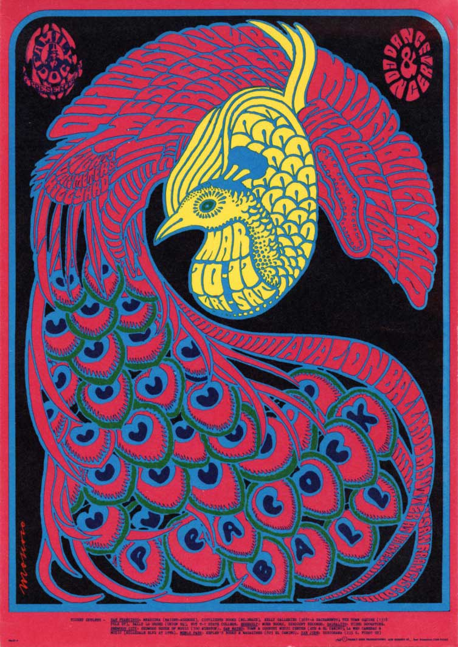
Victor Moscoso (1967) Peacock Ball. Lithograph Poster

Chapter 4 - Has technology affected print?

For much of their history fine art prints have been an independent art form, created for connoisseurs and collectors, published in limited editions and hidden away in portfolios. The twentieth century saw the progress of a more public role for these prints, with the adoption of cheap processes such as linocut, and editioned lithographs made for public display, such as those commissioned by J. Lyons & Co. for their restaurants, and great love for the ‘school prints’ in the 1940’s and 50’s. This changed in the 60’s and 70’s with the growth of print studios such as Gemini GEL and ULAE in the USA, and Kelpra studio in the UK. This improvement encouraged artists to seek the potential of printmaking and use it to produce work which expressed major breakthroughs as visionary statements, placing print, arguably for the first time, next to sculpture and painting as a primary means of expression. Printmaking, silk-screen distinctly, was appropriated by artists such as Rauschenberg and Warhol for unique pieces of work on canvas, and ‘combined’ with painting and installation pieces.

The boundaries that once defined printmaking began to blur. From the cutting-edge experiments of the 1960s printmaking has developed in many new directions, and over the last 20 years, prints have become more visible, accessible and affordable than ever before. No longer merely secondary, supplementary or reproductive, print is now a central part of many artists' activity, the equal of their output in other media, and conceived as integral or complementary to it. New technologies have been swiftly co-opted for fine art printmaking, and traditional techniques have been supplanted, modified (and sometimes facilitated), by the photocopier, the fax, and the inkjet printer attached to a PC.

However, some artists have carried on exploring the untapped probable of more common techniques, whether it be by printing on surfaces other than paper or by working on a new scale or clearly by working in a way which broadens the definitions of ‘print’. The increase of new media, seen by some as a threat to the future of printmaking, has plainly extended the options ready for use. As well as the invention of lithography did not contribute woodcut and engraving redundant, and photography did not spell the end of traditional graphic media, therefore digital technologies have not replaced other techniques but moderately broadened choice and capacity.

Between 1989 and the early 90’s, had taken historical meaning for all kinds of reasons. Connections were altering, with the effect on fax machines, and later in the 1990’s came the email. In the industry of design, printing, publishing, new computer-based technology was carrying out ripples of difference, impactful work practices and the bond between designers and clients. The idea of desktop publishing, equal with the thought of samizdat publishing after the fraying Iron Curtain, was challenging the functions of standard printers, publishers and typesetting houses: a start-up zine might use Letraset or original computer typesetting, even though established, profitable labels still sent their job to typesetters. Nevertheless, for a small design business, a computer was still high-priced, and for a printer, choosing what a large-scale kit-scanners, laser-setters, to invest in or improve to was an equally fraught business. Still everyone knew, after ten years of rhetoric about the mighty micro, ensued by talk of the imminent computer world, that big changes were approaching soon.

It will seem strange in an era of pushing buttons on a machine, screen-printing was completely exclusive by hand just before the middle of this century. Whilst the turning presses of other graphic arts where spinning ahead at speeds of upwards of 10,000 impressions an hour, the screen-printer continually done 250 or more impressions an hour with a helper watching. Electrical screen presses had been working all the way since 1925 which was able to hit speeds of 1200 impressions an hour. The flaw was mostly in the fact that the paints free at that time were not made to dry fast enough to hold up with the quick pace of the press. It would take several hours for the paint to dry, and at times overnight to dry. Each individual print was placed on a rack, on its own shelf to be air dried. The request for quicker drying paints was requested by paint chemists, who were working firmly with press and drying experts, developed paints which were created to dry with minutes, plus with the time could be more cut down into seconds by using drying ovens. It has been said somewhere else, it is doubtfully that automatic presses will ever totally replace hand printing processing. Though the popularity in mechanization is meant to continue, mainly in those areas of screen-printing where calibration is doable. Improvements have been made, in the progress of automatic screen-printing processes. Machines on the market to meet needs of the mixed requests in terms of thickness and nature of stock, size of printing surface, open floor space, and degree of mechanization. The value of printing is higher to manual printing, with precision of register under endless mechanical control. Pressure is continued over the entire length of the squeegee. Larger models, holding these same features, are in stock.
(insert image of press)
A different line of General machines is the Decorator Presses. They are strongly built presses designed for screen process printing of any stiff materials, for instance, metal signs, heavy boards, wood, wall board and many more awkward materials. The three simple components are a reciprocating open bed rails that upholds and carries the material to be printed, a reciprocating stencil frame and a squeegee under the moving stencil frame.
The cycle is as follows: the materials to be printed is front and side registered automatically and is picked up by the bed.
When it is about to do its print, there are holes on the bottom of the bed that will have suction to keep the paper still in its position while it goes under then stencil, for the media to then seep through by using the squeegee. The press will then continue with its cycle at a very fast pace. The print itself will travel through the machine in a straight line, starting at the feed-board, to then printing and then through to delivery at the end of the press. It will do up too 1800 impressions an hour. The general Model 34, was created to print sheets up to the size of 24’ x 34’, doing 3500 impressions an hour, is generated for precision printing on small complex work, like greeting cards, decals, plastic sheet printing, foil printing and many more. Preparing is moderately easy and process accurate and automatic.
The large General press unit is General’s Model 76, fitted with automatic feeder and take off. (insert image) It was magnificent for very big sheet sizes in posters, folding cartons and 24-sheets. It would take 52’ x 76’ sheet, and it would do 1500 impressions an hour and it was fully automatic. This machine was specifically designed for very big print runs. The Lawson “Genie” range comes in models which are automatic only in the genuine squeegee process. The feeding on the machine is done by hand. The worker controls the run of the press to fit the needs of the material that they are printing.
This press here, (insert image) is showing an easy screen press with automatic transport device. Only the feeding on this machine is done by hand. The action of the ejection of the print and the squeegee movement is done by the machine. That press is marketed as the Filbar Press, it has a changeable pace doing up to 900 impressions an hour. It has a foot-operated brake to end any action that is happening to a halt. There is presses created for an industrial making where silk-screen printing is a linked phase of manufacturing. A similar press such as the Precision Industrial Screen Printer, (insert image) it would print on any material with a flat surface. The printing supply may be stiff, floppy, square or irregular-shaped – anything from thin paper to material one inch or more in thickness. There is a business of presses that are created to be semi-automatic a sense that feeding take-off are done by hand. The action of the squeegee is mechanical. Specific presses sometimes offer just one advantage over the completely mechanized units because they allow the worker to control his own pace. These presses are in main less expensive and more versatile. Being mostly easy in construction, they can be made economically and in a big as well as small sizes. One maker gives a 48’ x 112’ model, which he calls a Powered Squeegee. This non-mechanical unit can print on any material that the traditional hand-operated printing unit can manage. The printer can handle many materials to be printed on such as paper, glass, masonite, wood, vinyl and many others with easy adjustments for the process. The standard every day screen shop might not be tooled for complete automation for many reasons. The various work it does may be too mixed for mechanical equipment. In addition, too, installation of big equipment usually involves a cost beyond the means of the humble financed processor. Other than that, the semi-automatic tools said previously may show to be worth thinking about. With different printing tools, even less expensive is a range of squeegee units distinctly called “one-man squeegee” and “Easy squeegee”. Kenn Equipment Company and the Cincinnati Screen Process Supply Company, have done greatly to grow this type of working equipment. Generally, these units make up a big squeegee bar which travels smoothly forth a back rail.

Chapter 5 - Contemporary Print
In this next chapter, I will be discussing several screen-printing and letterpress artist’s work. Ben Rider is a London based illustrator, printmaker and teacher. Who creates vibrant, edgy artwork with a punk look and feel to it. His work is layered up from a dense hybrid of sketches, collaged imagery and multi-layered colours. He has previously worked for many big names/companies such as the Victoria & Albert museum, University of the Arts London, O2Ireland, Samsung and Brew Dog. All his work is vibrant with bold black line work. (Smith & Cooke et al: 2015)

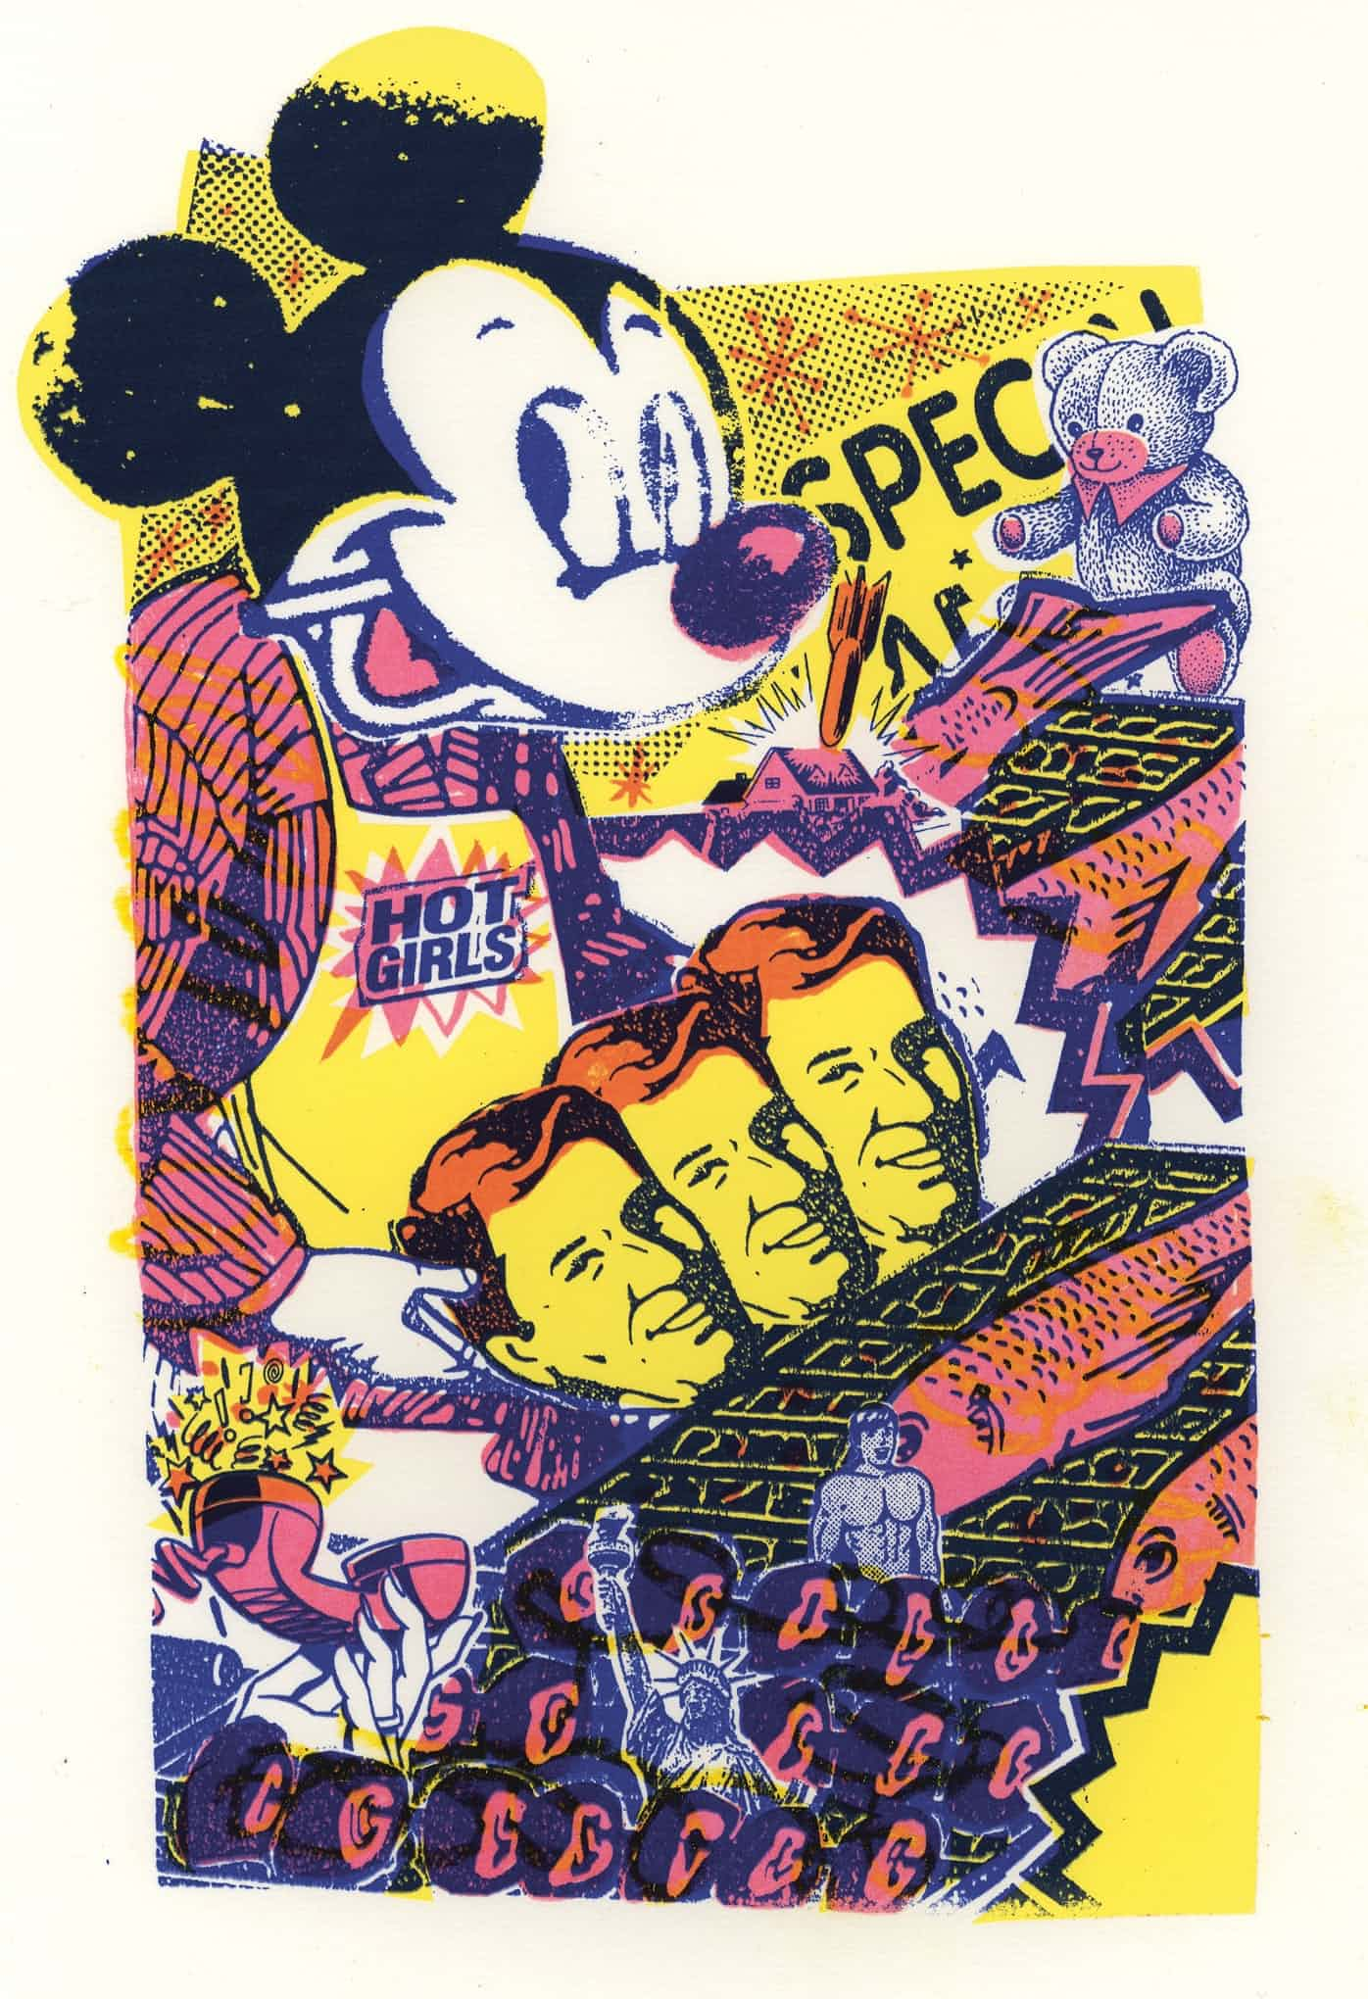Hot Girls. (2014) Hand Screen-print. Ben Rider.
Rider’s work is colourful and eye-catching it inspires me to create something similar not by imagery but by the influence of his colour palette he uses. Throughout his work the colours are never dull, he always uses bright vibrant colours. Another piece of his work that has also influenced me to experiment to this length, is his piece called Blisters: Sound Sessions.
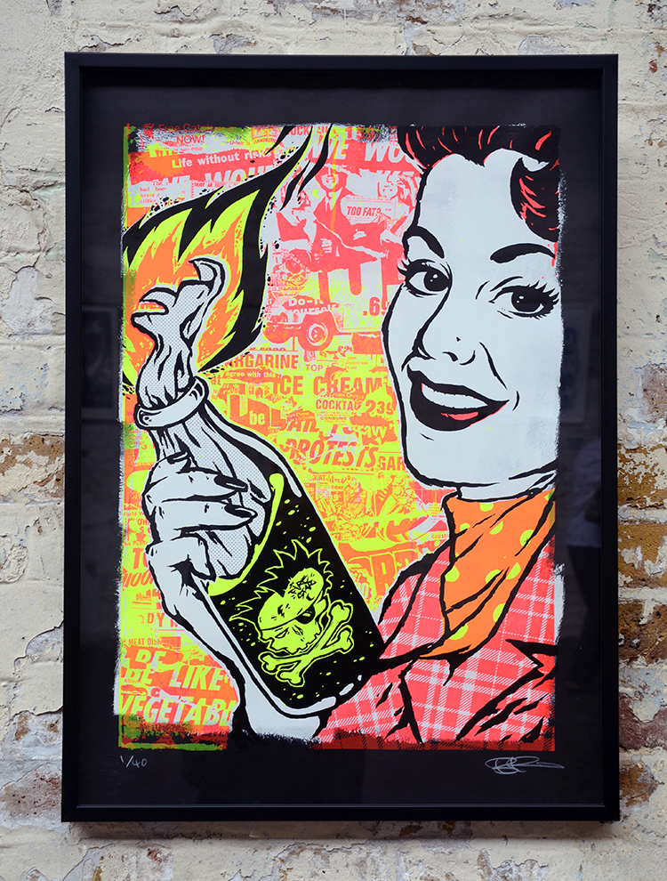 Blisters: Sound Sessions. (2014) Hand Screen-printed. Ben Rider.
Rider had got black paper, and painted each one with a dirty roller with white paint. That gives it a rough edgy look when he applies the ink on top. He wanted to mix petrol with his mediums so during the exhibition he could set it alight and it would be scorched into the paper stock, but knew it would be a bad idea so he didn’t in the end. He set up a 3-layer print process, the red on the bottom so when the yellow would be printed over top it would make an orange, then finally a glossy black for the finishing touch.

Printmaking has had an impact on me and my work, the unlimited creative potential and finish it gives, is really exciting. Years on there’s still just an inexhaustible supply of ideas and potential I have. I’ve always been up for being a bit experimental with printmaking, I feel it can really bring artwork alive. It is amazing what can be done with it and what it can do to your work, it’s like cooking with a microwave all your life then suddenly someone shows you a BBQ and loads of great marinades. http://www.hungertv.com/feature/blisters-sound-sessions-ben-rider/

http://typegeek.com/p_contemporary-letterpress.html

Commercial printing

References

Books
Biegeleisen, J.I., 1963. The complete book of silk screen printing production. New York: Dover Publications
Faerna, J.M. 1997. Warhol. London: Harry N. Abrams
Fick, B. 2015. Printmaking, a complete guide to materials & processes. London: Laurence King.
Madoff, S.H. 1977. Pop Art a Critical History. London: Berkley C.A.
Rivers, C. 2010. Reinventing letterpress: inspirational pieces by contemporary practitioners
Switzerland: RotoVision.
Smith, M. & Cooke, A. 2015. People of Print. London: Thames & Hudson.
Williamson, C. 2011. The Little Book of Screen-printing. United States: Chronicle Books.

Websites
Anon. 2014. Blisters: Sound sessions – Ben Rider. [Online] Available at: http://www.hungertv.com/feature/blisters-sound-sessions-ben-rider/ [Accessed 17 November 17]

BBC. 2016. Typecast: Alan Kitching on the art of letterpress. [Online] Available at: http://www.bbc.co.uk/programmes/articles/LKH84ry7v5zJWJHk3QDNyZ/typecast-alan-kitching-on-the-art-of-letterpress [Accessed 25 November 2017]

Bellis, M. 2017. History of Computer Printers. [Online] Available at: https://www.thoughtco.com/history-of-computer-printers-4071175 [Accessed 10 December 2017].

Debut Art. n.d. Alan Kitching. [Online] Available at: http://www.debutart.com/artist/alan-kitching [Accessed 25 November 2017]

Faber, G., 2010. Gerard Malanga’s Beautiful Soul [Online] Available at: http://www.dazeddigital.com/artsandculture/article/8186/1/gerard-malangas-beautiful-soul [Accessed 7 December 17]

Fleishman. G, 2017. How letterpress printing came back from the dead [Online] Available at: https://www.wired.com/story/how-letterpress-printing-came-back-from-the-dead/ [Accessed 10 December 2017].

Gallery of Works, 2007. Robert Rauschenberg
1967–1978 [Online] Available at: https://nga.gov.au/Rauschenberg/ [Accessed 9 December 2017].

Levy. D & Scott-Clark. C, 2010. When is a Warhol not a Warhol? The $2 million self-portrait turning the art world on its head [Online] Available at:
http://www.dailymail.co.uk/home/moslive/article-1242915/When-Warhol-Warhol-The-2-million-self-portrait-turning-art-world-head.html [Accessed 7 December 2017]

Marcroy. 2014. Best print in house, Ben Rider. [Online] Available at: http://www.peopleofprint.com/best-of/blisters-2014-best-print-in-house-ben-rider/ [Accessed 17 November 2017]

Muraben, B., 2016. It’s Nice That. [Online] Available at:
https://www.itsnicethat.com/features/alan-kitching-life-in-letterpress-typography-300316 [Accessed 25 November 2017]

National Print Museum, Dublin, 2017. [Online] Available at:
http://www.heritagecouncil.ie/news/events/from-craft-to-technology-and-back-again-prints-progress-in-the-twentieth-century-conference-hosted-by-the-national-print-museum-30-31-march-2017 [Accessed 10 December 2017]

MoMA, n.d. [Online] Available at:
https://www.moma.org/learn/moma_learning/andy-warhol-campbells-soup-cans-1962 [Accessed 13 November 2017]

Ryan, T.R, n.d. [Online] Available at:
https://www.khanacademy.org/humanities/ap-art-history/later-europe-and-americas/modernity-ap/a/warhol-marilyn-diptych [Accessed 13 November 2017]

Tate. n.d. Andy Warhol [Online] Available at: http://www.tate.org.uk/art/artists/andy-warhol-2121 [Accessed 30 October 2017]

Tate, 2004. Robert Rauschenberg [Online] Available at: http://www.tate.org.uk/art/artworks/rauschenberg-almanac-t01135 [Accessed 9 December 2017]

The Guardian, 2002. [Online] Available at: https://www.theguardian.com/culture/2002/feb/06/artsfeatures.warhol [Accessed13 November 17]

VAM. n.d. Printmaking in the 21st Century. [Online] Available at: http://www.vam.ac.uk/content/articles/p/prints-21st-century/ [Accessed 30 October 17]

Walker, T. 2008. The Evolution of Printer Technology: Then and Now. [Online] Available at: https://www.cartridgesave.co.uk/news/the-evolution-of-printer-technology-then-and-now/ [Accessed 10 December 2017].

Walters. J.L, 2016. Extract from Alan Kitching: A Life in Letterpress. [Online] Available at: https://www.creativereview.co.uk/extract-from-alan-kitching-a-life-in-letterpress-by-john-l-walters/ [Accessed 25 November 2017]

Weathers, C. 2010. Gerard Malanga’s Journey From Andy Warhol’s Stage Dancer To Factory Poet. [Online] Available at: https://www.huffingtonpost.com/2010/08/04/gerard-malangas-journey-f_n_670629.html [Accessed 7 December 2017]

Widewalls. n.d. Alan Kitching. [Online] Available at:
https://www.widewalls.ch/artist/alan-kitching/ [Accessed 25 November 2017]

