

Assessment 2 – Reflective Report

Student Name | Bianca Ioana Terza
Student Number | 2009067
Module Number | BMHP4003_LON
Module Title | Psychology for Health and Social Care
Lecturer Name | Diya Ganguly
Date on submission | 27th of August 2021

Table of Contents:

- Introduction page 3
- Analysis of Piaget’s theory of cognitive development page 3
- Understanding the role of a practitioner in healthcare page 6
- Reflection page 7
- Conclusion page 8
- Reference page 8

1. Introduction

In 1879, the German psychologist Wilhelm Wundt opened the first experimental psychology lab, offering the possibility to learn about the complex relationship between mind and behaviour. (Bbc.co.uk, 2014)
In the early 1900s, however, psychologists re-defined their research as the study of human behaviour since they determined that the mind is unobservable, and the mental activity is something not tangible yet a process that naturally flows and characterizes the individuals. (Kalat, 2017)
Nowadays, psychology is considered a scientific study that understands how thoughts, emotions, communication, memory, and many other different aspects influence a person’s demeanor in a social environment. (The British Psychological Society, 2019)
In this report, I will offer a reflection on the impact of the psychological theories learned throughout the module on the numerous roles in the health and social care setting and evaluate their applicability and possible repercussions on the workplace's performance, starting with an analysis of Piaget's theory of cognitive development, applied in the previous group assignment.

2. Analysis of Piaget’s theory of cognitive development

In view of the exams, the class was encouraged to form groups that would analyze a psychological theory applied to a specific life stage. My teammates and I were enthusiasts to research about Piaget’s theory of cognitive development in relation to infancy.
This stage, which includes the first 3 years of life, is described by Armstrong, in 2017, as a vibrant stage where the infant dynamically explores the surrounding world and learns important concepts like family and bonding.
The child’s plastic mind able to absorb rapidly information and external stimuli encouraged the psychologist Jean Piaget, to articulate various theories on how humans acquire knowledge, stating that children’s learning and thinking processes were different from the adult’s ones. His thesis got largely rejected by the contemporary philosophers and cognitive developmentalists as they perceived the younger’s mind able to grow only through an accumulation of information, considering the quantity of knowledge gathered more important than the advancement of the quality of the process which leads to acquiring it. (Sutherland, 1997, pp 7 – 29)
Piaget’s revolutionary idea of human development was refusing to limit the person’s intellectual progress to the genetics’ passivity and described it via a series of stages that show how the capacity of understanding the world’s complex aspects increases with age. (Carpendale, Lewis, and Müller, 2020)
The theory of cognitive development includes four stages, sensorimotor activity, where the child learns about the environment through senses and actions, preoperational stage, where the kids have an egocentric approach to the world, the concrete operational stage, where the child starts to logically understands concrete events, and formal operational stage, where abstract scenarios and hypothetical problems are easily solved by the young adults’ mind. (Mcleod, 2020)
Once these ideas got distributed, multiple psychologists expressed their opinion in regards, including Lev S. Vygotsky, one of the major figures who criticized Piaget’s conclusions, outlining a different thesis considered by many, a valid alternative to Piaget.
In his writings, Vygotsky defines intelligence as the ability to learn following instructions and describes the children as active learners, who, guided by educators, can reach constructive goals. The teacher’s role is to guide pupils from the current potential (x) to their potential level (x+1) throughout a zone of proximal development, to attain a successful learning process. Vygotsky also emphasized the importance of language as a child can develop awareness by talking with others, this brings current psychologists as Doise, Mugny, and Schaffer to see the kid as an individual able to build personal concepts. (Moll and Lev Semenovič Vygotskij, 1990)

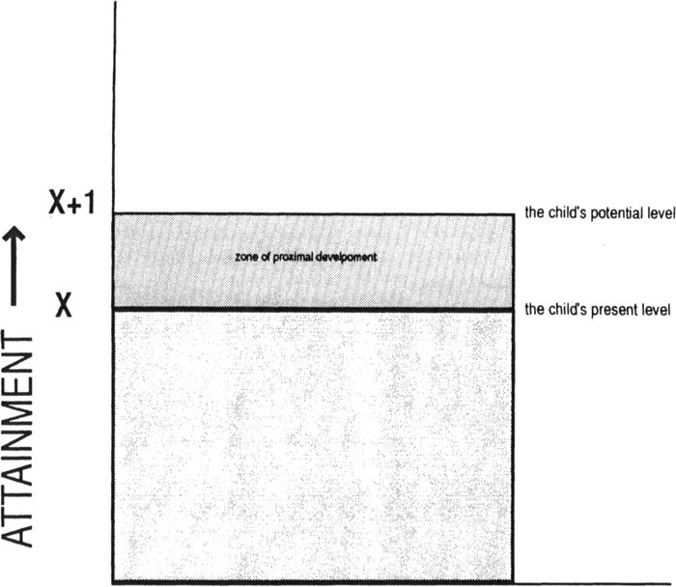
(Sutherland, 1997)

Highly inspired by Vygotsky, Jerome Bruner, agrees on the positive influence that instructors and language have on the child’s development, introducing a spiral model where the verbal expression is influenced by experience, demonstrating how the same concept develops in time.
Burrhus F. Skinner, instead puts the instructor on a dominant level, introducing a model called “operational conditioning”, where the child receives rewards and moves forward in class only if he offers the “right” answer to the teacher, creating a linear learning program. (Sutherland, 1997, pp 55 – 61)

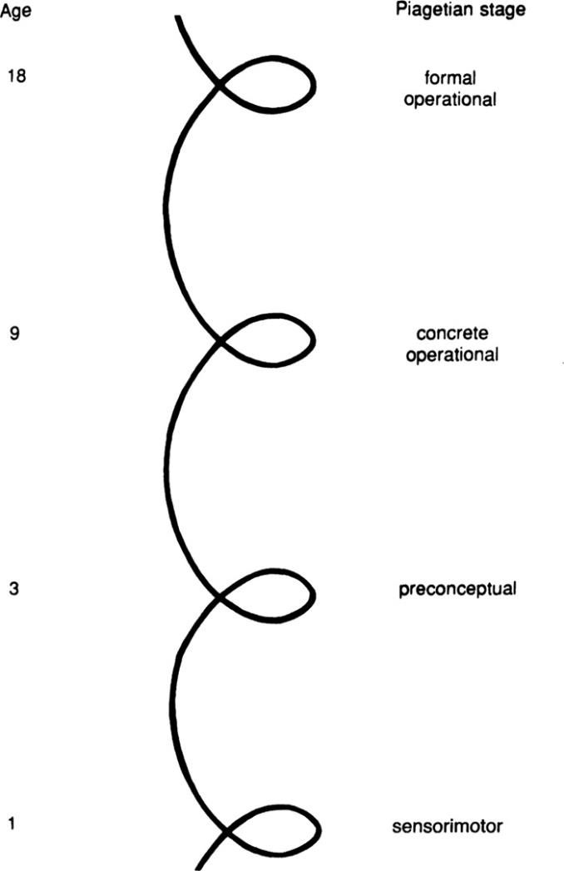
(Sutherland, 1997)

After understanding different critiques that Piaget’s theory received, I had the opportunity to recognize the stativity in his studies. I feel that his research, despite being revolutionary, can’t be considered finalized as the sample studied was limited and didn’t consider different aspects such as culture, ethnicity, and the social interaction kids may have during their growth. I believe that, even if incomplete, his theory served as a foundation for the creation of the current institutional teaching system, agreeing with Beilin, 1992, who considered the influence of Piaget’s work on developmental psychology similar to the one Shakespeare’s had on English.

3. Understanding the role of a practitioner in healthcare

In the healthcare environment, maintaining the patient’s well-being is the main objective of a practitioner and in order to do so, the medical assistants should be able to express empathy and compassion towards those who feel unwell.
Empathy is considered an essential skill for health professionals, as it helps to understand somebody’s experience, worries, and mindset, developing a relationship based on trust which can contribute to a better performance of the patient in the medical setting. (Haque, 2019) Empathy requires emotional, moral, cognitive, and behavioral ability to understand and offer an appropriate response to the person’s misfortune. This intellectual skill, together with compassion, triggers the human mind to act on behalf of those in need. (Riess, 2017)
Compassion, on the other hand, has been included in the six core values, (care, compassion, competence, communication, courage, and commitment) of the NHS in 2012. (Tierney, Bivins and Seers, 2018) In 2013, Gilbert states that compassion includes empathy, sympathy (ability to “feel” for others), distress tolerance (accepting emotive reactions), sensitivity to distress (capacity to notice needs), non-judgemental attitude, and care for well-being.
The assistant’s thoughtful conduct was already largely requested in environments where the patient’s individualism was prioritized, from 1969, in fact, Edith Balint presented a patient-centred care program, emphasizing the individualism of the patients. The World Health Organization (WHO) developed then a policy framework, stressing on the person-centredness as a core component in medical institutions. The personalized care plan includes different races and ethnicity, gender and sexual identity, religion, status and economical background, and disabilities, promoting human dignity for patients and practitioners. (Santana et al., 2017)
In case this personal dignity is at risk, the healthcare practitioner should be able to notice the issue and discuss the situation with colleagues and executives, brainstorming ideas and proposing a solution. After setting an achievable goal that impacts on the problem, the community would share the common interest to implement changes and maintain the patient’s security within the clinic. (Woodward, 2009)

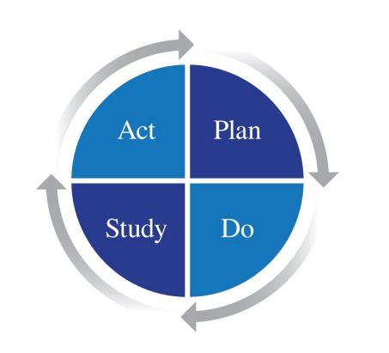
(9P Online, n.d.)

4. Reflection

At the current time, I am working as a catering assistant in a medical setting, taking care of the patient’s nutritional needs during the stay-in. Even if I enjoy my role, I aspire to become a psychologist and offer them more personalized support.
During this term I learned about how each individual has a unique personality, described by the psychologist Carl Jung as the relation between the conscious and unconscious. (Kapustin, 2016) Later on, Jung developed a personality typology that begins with the distinction between introversion and extroversion. Introverts people focus their ego on their persona, while the extrovert’s one concentrate more on the outer reality. The personal interaction with the world impacts personality as well and Jung identified four ways, which everyone has in different proportions, sensing (information are collected by senses), thinking (ideas get rationalized and evaluated), intuiting (when perception follows an unusual process), and feeling (where calculations and plans prevail on the emotional response). (Boeree, 1875)
I believe that understanding different traits of personality can bring to the formation of strong teams able to efficiently collaborate and deliver outstanding results. I also think that, for a psychologist, recognizing the main features in a person’s behaviour helps them to interpret actions and needs, and promptly respond to their anxieties.
Another important theory learned throughout the module involves defense methods, defined by Freud in his writings as psychical mechanisms of defense that repress distressing ideas for the patient’s ego (1962). Nowadays psychologists identify multiple defense methods the individual may adopt to protect themselves.
Denial is a common mechanism in which reality is rejected, while displacement involves the redirection of negative emotions on someone considered more vulnerable. Identification is a process where the patient adopts other’s attitudes through an imaginative procedure, isolation enables the exclusion of negative feelings while projection involves the relocation of responsibility on substitutes. Rationalism is frequently adopted as the individual justifies improper behavior, reaction formation consists in expressing the opposite of what is felt, and repression is the construction of mental barriers that help to isolate the torment. (Clark, 1998)
People protect themselves from pain and suffering twisting their personality and altering reality, to prevent that I consider crucial the role of the psychologist, whose role consists in liberating the patients from the self-imposed limitations and protect their natural psychological development.
Due to the overwhelming impact on their own mental health, a psychologist must remember to practice self-empathy to ensure an appropriate end emphatic performance toward others, (Riess, 2017), and self-care. In 2007, Norcross and Guy define self-care, not as a luxurious whim but a clinical imperative that helps improve wellbeing and performance.

5. Conclusion

This report presented a reflection on different theories learned throughout the duration of the module “Psychology for Health and Social Care” and their importance for the psychologist’s figure. This paper brought to my attention the complexity of the role and reminded me of the challenging path that leads to achieving this fascinating career. Despite my inexperience, this study encouraged me to maintain a positive attitude in order to reach my goal.

6. References

- Alahmad, M. (2020). Strengths and Weaknesses of Cognitive Theory. Budapest International Research and Critics Institute (BIRCI-Journal): Humanities and Social Sciences, 3(3), pp.1584–1593.
- Armstrong, T. (2017). The 12 Stages of Life | Thomas Armstrong, Ph.D. [online] Institute4learning.com. Available at: https://www.institute4learning.com/resources/articles/the-12-stages-of-life/ [Accessed on 21st of August 2021]
- Bbc.co.uk. (2014). BBC Science | Human Body & Mind | What is Psychology? [online] Available at: https://www.bbc.co.uk/science/humanbody/mind/articles/psychology/what_is_psychology.shtml [Accessed on 21st of August 2021]
- Boeree, C. (1875).. [online]. Available at: http://webspace.ship.edu/cgboer/Jung.pdf [Accessed on 24st of August 2021]
- Carpendale, J.I.M., Lewis, C. and Müller, U. (2020). Piaget’s Theory. The Encyclopedia of Child and Adolescent Development, pp.1–11
- Clark, A.J. (1998). Defense mechanisms in the counseling process. Thousand Oaks: Sage Publ., Cop.
- Hanfstingl, B., Benke, G. and Zhang, Y. (2019). Comparing variation theory with Piaget’s theory of cognitive development: more similarities than differences? Educational Action Research, 27(4), pp.1–16.
- Haque, M. (2019). Importance of empathy among medical doctors to ensure high-quality healthcare level. Advances in Human Biology, 9(2), p.104.
- Heinze, K., Suwanabol, P.A., Vitous, C.A., Abrahamse, P., Gibson, K., Lansing, B. and Mody, L. (2020). A Survey of Patient Perspectives on Approach to Health Care: Focus on Physician Competency and Compassion. Journal of Patient Experience, [online]. Available at: https://journals.sagepub.com/doi/full/10.1177/2374373520968447 [Accessed on 22nd of August 2021]
- Jung, C.G. (2014). Collected Works of C.G. Jung, Volume 8: Structure & Dynamics of the Psyche. Princeton University Press.
- Jung, C.G. and R F C Hull (2014). Collected Works of C.G. Jung, Volume 17: Development of Personality. Princeton University Press.
- Kalat, J.W. (2017). Introduction to psychology. Boston, Ma: Cengage Learning.
- Kapustin, S.A. (2016). An existential criterion of normal and abnormal personality in the works of Carl Jung and Carl Rogers. Psychology in Russia: State of the Art, 9(2), pp.54–68
- Mcleod, S. (2020). Jean Piaget’s Theory of Cognitive Development. [online] Simplypsychology.org. Available at: https://www.simplypsychology.org/piaget.html [Accessed on 23rd of August 2021]
- Moll, L.C. and Lev Semenovič Vygotskij (1990). Vygotsky (Lev Semenovič Vygotskij) and education. Instructional implications and applications of sociohistorical psychology. Cambridge Cambridge U.P
- Nice.org.uk. (2012). Patient experience in adult NHS services: improving the experience of care for people using adult NHS services | Guidance and guidelines | NICE. [online] Available at: https://www.nice.org.uk/guidance/cg138/chapter/1-Guidance#essential-requirements-of-care [Accessed on 22nd of August 2021]
- Posluns, K. and Gall, T.L. (2019). Dear Mental Health Practitioners, Take Care of Yourselves: a Literature Review on Self-Care. International Journal for the Advancement of Counselling, 42(1), pp.1–20.
- Riess, H. (2017). The Science of Empathy. Journal of Patient Experience, [online] 4(2), pp.74–77. Available at: https://www.ncbi.nlm.nih.gov/pmc/articles/PMC5513638/ [Accessed on 22nd of August 2021]
- Santana, M.J., Manalili, K., Jolley, R.J., Zelinsky, S., Quan, H. and Lu, M. (2017). How to practice person-centred care: A conceptual framework. Health Expectations, [online] 21(2), pp.429–440. Available at: https://onlinelibrary.wiley.com/doi/full/10.1111/hex.12640 [Accessed on 22nd of August 2021]
- Shayer, M. (2003). Not just Piaget; not just Vygotsky, and certainly not Vygotsky as alternative to Piaget. Learning and Instruction, 13(5), pp.465–485.
- Sutherland, P. (1997). Cognitive development today: Piaget and his critics. London: Pcp/Paul Chapman Publishing
- The British Psychological Society (2019). What is Psychology? | BPS. [online] Bps.org.uk. Available at: https://www.bps.org.uk/public/what-is-psychology [Accessed on 21st of August 2021]
- Tierney, S., Bivins, R. and Seers, K. (2018). Compassion in nursing: Solution or stereotype? Nursing Inquiry, 26(1), p.e12271
- Woodward, S. (2009). All nurses need to make one change to improve patient safety. [online] Nursing Times. Available at: https://www.nursingtimes.net/archive/all-nurses-need-to-make-one-change-to-improve-patient-safety-14-08-2009/ [Accessed on 23rd of August 2021]
- 9P Online. (n.d.). Plan Do Study Act (PDSA). [online] Available at: https://9principles.com/learning/pdsa-model/ [Accessed on 23rd of August 2021]

