Hannah Williams 2101320
BA Illustration
Gwenllian Beynon
Alphonse Mucha and the Art Nouveau Movement
Between the years of 1890 and 1910, the Art Nouveau Movement started to spread across Europe. It can be originally seen to stem from the Arts and Crafts Movement in England that started during the latter half of the 19th century. It is often described as “a response to growing industrialisation in Europe” (Maher, 2011). The Art Nouveau Movements main purpose was to modernise design and to move away from historical styles, that prior to the Art Nouveau Movement, had been popular. It was seen to unite the fine and applied arts, which was called a Gesamtkunstwerk (total work of art). It was popular primarily throughout France where it was given many names Style Jules Verne, Le Style Métro, Art belle époque, and Art fin de siècle. People often describe art nouveau as looking organic, natural, or sinuous. This style of art has intertwined itself into our architecture, with these tall delicate pillars and detailed stained glass. But on paper it is most recognisable for its focus on the form of flower stalks, flower buds, vine tendrils and insect wings. Other art styles such as Post Impressionism and Symbolism share similar trait to that of the Art Nouveau Movement, but soon branched off to develop into their own style due to these practitioners adapting to architecture, furnishings, applied arts and interior design. “Art Nouveau was a short-lived movement whose brief incandescence was a precursor of modernism, which emphasized function over form and the elimination of superfluous ornament” (Gontar, 2006).
Some notable artists to mention during the movement are René Lalique a glass maker, considered a master at his craft and had a huge influence on the movement. Antoni Gaudí the infamous designer who was commissioned to build the Sagrada Família in Barcelona. And finally, there is Alphonse Mucha, and extremely talented illustrator, where his work is to be regarded as the very foundation of the Art Nouveau movement.

For my semiotic analysis I will be using the following structure method, created by Gillian Rose, author of Visual Methodologies.
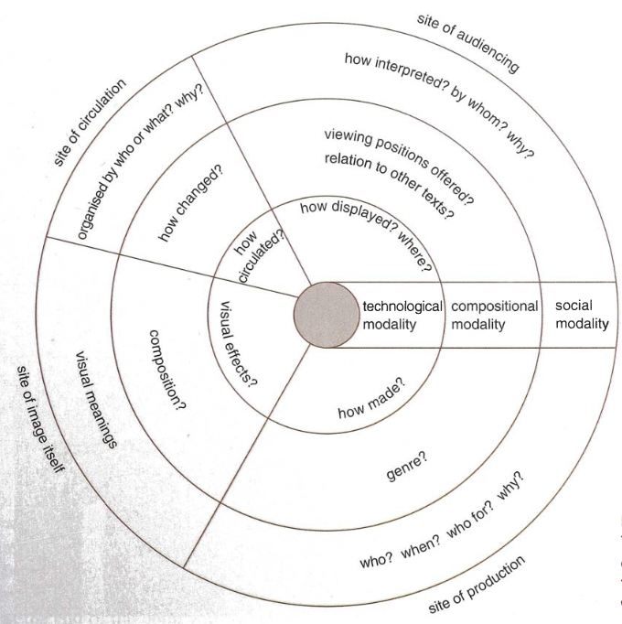

Rose, Visual Methodologies
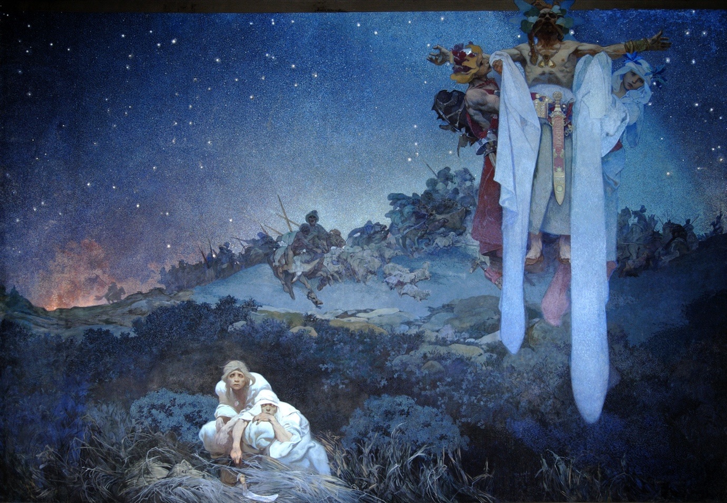
Alphonse Mucha was a Czech illustrator, painter, and graphic artist. He lived in Paris during the peak of the Art Nouveau Movement. During his lifetime Mucha accomplished many great things. He produced a large range of work, this included paintings, posters, advertisements, and book illustrations. Mucha drew inspiration from artists such as the Pre-Raphaelites, Hans Makart, and Japanese wood cuts. Drawing inspiration from these artists led him to develop his unique style, adopting certain organic traits into his work. This can be seen in his ‘The Seasons’ series where there is this constant flora and fauna theme, which also incorporates itself into the Byzantine style border her creates around these pieces. Towards the beginning of his career, he mainly did lithography and used his amateur photography skills to take photographs to use as foundations for these prints he made. However later on in his career he distanced himself from the print making technique to promote the media that he was using at the time and then continued to use, oil paint. Some of his greatest works are still widely recognisable today, some of which being the Jobs Cigarette Papers (1896), The Seasons (1896), Slavia (1908) and The Slavs in Their Original Homeland (1912). The piece ‘The Slavs in
Alphonse (1912) The Slavs in Their Original Homeland
Their Original Homeland’ is just one of twenty 6x8 meter canvas that make up his lifelong project called ‘The Epic Slav’ (otherwise known as ‘Slovanská epopej’ 1911-1926). In 1910 he moved his family to Prague where he started to work on ‘The Epic Slav’ painting series. During this time, it was the start of World War One, where he continued working on the series. By the time of the end of the Great War he had completed the first 11 canvases, where they were then put up on display in Prague. Mucha used oil paint and tempura to create these pieces on a large scale canvas, as later in his career that is the medium he wanted to promote. The main influence to create these series of paintings was to unite the much-persecuted Slavic people and bring them together with spiritual virtue.

The origin of the Slavs homeland can be traced back to swampy land starting from the Baltic Sea to the Black Sea, where both many small and large clans coexisted with one another. They sustained themselves through hunting and farming the land they lived off. However, living settling where they did mean that they were constantly targeted and attacked by Nomadic tribes from the south and east, these tribes were the Turanians and the Sarmatians. Additionally, they were also attacked from the west by the Goths.
This painting is a symbolism piece which depicts exactly that, a Slavic clan settlement under attack by a neighbouring hostile tribe. The painting is said to be based off of any time between the 3rd to the 6th century. The piece shows a somewhat clear stary night, where the sky has been tainted by the smoke coming from a nearby attack by a horde of Nomads. Towards the centre of the piece, you can see that the Nomads have killed the old and sickly and are now stealing their cattle and young people who will be most likely of been sold into slavery. During this period a town called Kherson near the Black Sea was where these people were taken to then be sold on as slaves. In the foreground of this piece, you can see a couple whom we can only assume are the sole survivors of this attack, Mucha has shown this by the pure look of terror and trauma in their eyes. By the nature of their positioning there are two main emotions felt here: pure hatred towards the Nomads, but also the want to live a life of peace. These feelings shown here manifest in the form of an ancient Slavic Priest who can be seen lifting the stars up in the sky and asking the gods to help. The armoured young man dressed in red is holding up his right hand, and by looking at the colours he is dressed in we can assume he is seen as a symbol of war. In contrast, on his left there is a young woman dressed in white symbolising peace. Mucha use of colour is embedded with meaning, this isn’t just done without purpose. This manifestation of emotions conveys the crucial message that “fight is necessary for protection but that it is only possible to flourish and thrive in peace” (Červinková, 2022). His use of colour in the piece allows for both meaning and hues to contrast each other. He uses a potent blue colour represents the spiritual realm. This then combined with the whites seen on the young woman, contrast greatly with the warmer red and orange tones coming from the fiery embers of the Slavic village in the background.
Since Mucha’s whole aim was to unite the Slavic people through his works. “These paintings are considered to be a continuations of Slavic folk art” (Heather, 2019). After completing the first eleven canvases, they were put up on exhibition in 1919 in Prague, where they were well received by the public, however critics were unimpressed by the overtly nationalist subject matter. When Mucha completed the final canvases The Apotheosis of the Slavs in 1926, which symbolises the Slav independence, he gave his series to the city of Prague, Czech Republic.
Mucha was a well accomplished artist for his era, and massively contributed to the Art Nouveau movement. His work has a huge impact on the Slavic people and brought unity among people too, especially when at a time like after the first world war when unity and bringing people was crucial. An example of this can be seen in the Art Deco furniture that we still see being designed and produced today. We can also see that in Post Modernism design that there is a slight revival in the Art Nouveau movement, proving that even though it may have been a short lived movement it served as a major impact of the artistic world.
Word Count 1362
References

Alphonse, M. (1912) The Slavs in Their Original Homeland [Oil and Tempura on Canvas]. Prague

Červinková, P. (2022) Slavs in Their Original Homeland. Available at: https://artsandculture.google.com/story/-wUx3DYdeSDxgg (Accessed: 3 December 2022).

Gontar, C. (2006) Art Nouveau. Available at: https://www.metmuseum.org/toah/hd/artn/hd_artn.htm (Accessed: 10 December 2022).

Heather, (2019) “The Slavs in their Original Homeland” by Alphonse Mucha. Available at: https://www.myddoa.com/the-slavs-in-their-original-homeland-alphonse-mucha/ (Accessed: 3 December 2022).

Maher, A. (2011) Origins of Art Nouveau. Available at: https://www.europeana.eu/en/exhibitions/art-nouveau-a-universal-style/origins-of-art-nouveau (Accessed: 3 December 2022).

Rose, G. (2001) ‘Visual Methodologies’, Material Culture, 36(1), pp.78-80. Available at: https://www.jstor.org/stable/29764218 (Accessed 8 December 2022).

