PROBLEM SOLVING AND DECISION MAKING
BMSW4004

UNIVERSITY OF WALES TRINITY SAINT DAVID

STUDENT: MIHAITA GHEORGHE (2120440)
LECTURER: LAILA MAAZOUZ


TABLE OF CONTENT
- INTRODUCTION
- THE WORKPLACE PROBLEM
- ANALYSING INFORMATION
- ROOT CAUSE ANALYSIS (RCA)
- APPLYING SITUATIONAL ANALYSIS MODELS
- RANGE OF ALTERNATIVE SOLUTIONS
- EVALUATION OF ALTERNATIVE SOLUTIONS
- IMPLEMENTING THE SOLUTION
- COMMUNICATION PLAN WITH STAKEHOLDERS
- MONITORING AND REVIEW TECHNIQUES
- CONCLUSION
- REFERENCES
- APPENDIX

INTRODUCTION
Importance of problem-solving skills:
"Problem-solving skills allow you to find candidates who are cognitively equipped to handle anything their jobs throw at them." (“Does the use of the properties helpful in solving the problems?”)
"Problem solvers can observe, judge, and act quickly when difficulties arise when they inevitably do." (“Pro... - Glocal After School - Academy of Employability Skills”) Moreover, they are not afraid of the unknown, which is invaluable to employers who rely on their employees to identify and solve problems.
"There are several important benefits of critical thinking skills in the workplace." (“Importance of problem-solving skills - advance.umich.edu”) Below, we’ll go through five of the most significant traits that all problem solvers can bring to their roles and workplaces.
1. Ability to organize their time intelligently
Time management skills can often be under looked as one of the benefits of problem-solving skills in the workplace. People with problem-solving abilities also have time-management skills. The ability to manage their time wisely and focus on what is important to the business will lead to better decision-making and business impact.
2. Ability to prioritize, plan, and execute strategies
Problem solvers have no issue with carefully assessing customer and client needs and how to prioritize, plan, and execute strategies for how to meet them. They can manage all moving parts since they can strategize how best to meet target and demands.
3. Ability to think outside the box
Problem solvers can often identify opportunities in problems. Thinking outside of the box is an important problem-solving skill in the workplace since it can often lead to better outcomes than had been expected originally.
4. Ability to work under pressure
"This is often one of the most important benefits of problem-solving skills in the workplace." (“The importance of problem-solving skills in the workplace”) Problem solvers often have characters that respond well under pressure, including accelerated deadlines and changing project parameters.
Depending on your workplace culture, you might prefer someone who can deliver quick solutions or someone who takes their time to identify the next steps -- both are valid problem-solving qualities.
5. Ability to address risk
Planning is an important problem-solving skill. Problem solvers are not just equipped to deal with the problem at hand but are also able to anticipate problems that will arise in the future based on trends, patterns, experience, and current events. | About Us
How Good Is Your Problem Solving?
"Good problem-solving skills are fundamentally important if you're going to be successful in your career." (“Good problem-solving skills are fundamentally important”)
But problems are something that we don't really like.
They're time-consuming.
They make their way into already packed schedules.
They force us to think about an uncertain future.
And they never seem to go away.
That's why, when faced with problems, most of us try to eliminate them as quickly as possible. But have you ever chosen the easiest or most obvious solution – and then realized that you have entirely missed a much better solution. Or have you found yourself fixing just the symptoms of a problem, only for the situation to get worse.
To be an effective problem-solver, you need to be systematic and logical in your approach.

My employer is METALWORK LTD, a well-known company established 30 years ago in Kent,
and they are leaders in welding industry for more than a decade. Of course, they are focused on production every day, but in same time problems start to take their toe and productivity begin to suffer by touching a low level.
THE WORKPLACE PROBLEM
No way forward: This is a problem that is cutting production and delay objectives.
Every human wants to be better than he was yesterday. We all can learn and be better. While most of the employees come to earn and settle in one position, others don’t want to settle. They want to improve, master more skills, and learn more. Most of the companies don’t give such an environment to the employees which lead to work-related stress.
Welcoming creativity and development not only is good for the employees but also favors the company. Organize more training, personal development programs, and career programs for the employees so that they can know you care for them.
Having issues at work is a common thing. A workplace teaches us patience, honesty, loyalty, and many more lessons. Learn them and be better for your future. As for the companies, they must create a welcoming environment for the employees if they want to progress.
“(The psychology clinic/the 10 most common problems people have at work and how to solve them)”.

ANALYSING INFORMATION
ROOT CAUSE ANALYSIS (RCA):
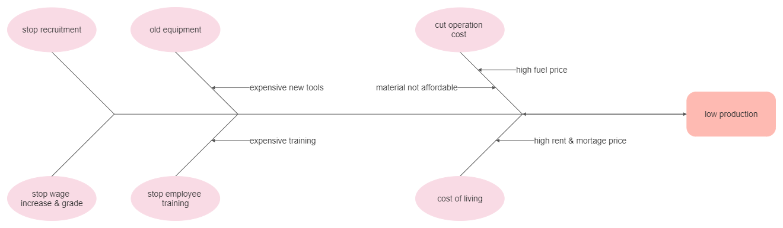

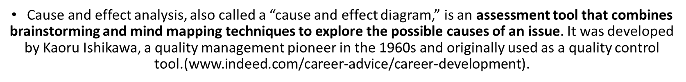
APPLYING SITUATIONAL ANALYSIS MODELS
PESTLE ANALYSIS:
POLITICAL
  - Availability of government grants or assistance in the form of cash or other asset.
  - Stable or dynamic political environment. If the government changes frequently resulting in changing policies being implemented by every new government.
  - Barriers to entry and exit. Example by imposing licensing requirements.
  - New training to workers.
  - Provide infra-structure includes sewerage, transportation, and energy.
ECONOMICAL
  - Access to resources, finance at reasonable cost, workers pay at reasonable rates.
  - Customers & suppliers, their availability and bargain power should be assessed.
  - Inflation, interest, and exchange rates.
  - National income can also influence demand for the firm's product.
  - Level of unemployment in the country, high unemployment may suggest that employer has dominant position and can negotiate low wage rate with workers
SOCIAL
  - Stakeholders demand and behaviour in markets.
  - Demographic: Increasing or decrease in population.
  - Attitude to work. Are people committed to their work or they just comply with standards.
  - Cultural change, identifying type of societies leisure activities, changes in customs.
TECHNOLOGICAL
  - Automation/cyber security/ technology infrastructure(5G)
  - New product developments may permit doing business more efficiently, cost-effectively.
  - Innovation leads to break-through in economy and it may affect society as well. Example Facebook, YouTube are the products which affecting youths’ behaviour.
ENVIRONMENTAL
  - Greenhouse effect has affected the way business trades. There are increasing demands of environment friendly products. (by using hybrid cars and paper bags instead of plastic bags).
Climate change impact (increase of extreme weather).
  - Carbon footprint and sustainability.
  - There are legislations being related to environment. The business is forced to change its policies and disposal costs.
LEGAL
  - Competition law imposes restriction. (Industry regulation).
  - Employment legislation protects rights of workers by setting minimum wage requirements, anti-discrimination, and anti-harassment legislation. (Protection of IP)
  - Health and safety legislation to protect workers.
Trade unions to protect employees.
SWOT ANALYSIS
STRENGTH:
The strength of the company is their experience over the years.
In same time they attracted very talented people in company technical team.
They are in top 10 wealthy employers in the country.
WEAKNESS:
In last year they lost 20% of the employees do to pandemic and cost of living.
They failed to improve the grade system.
The management team failed to understand the people needs, do to lack of facilities.
OPPORTUNITIES:
Do to government deals with different country all over the world,
The company have the chance to expand and reach new markets.
With a little investment they can bring on the market a new product.
THREATS:
Other company can exploit their weakness and attract best employees, offering better
Conditions and pay.
By not solving internal problems, productivity decrease, and their best customers will be lost.
Risk of closing some departments.
Risk of insolvency.
RANGE OF ALTERNATIVE SOLUTION
The solutions found are:
(1)Introduce a new evaluation grade system for skills.
(2)Give permission to all employee to qualify outside the company.
(3)Recognition of qualifications and asses everyone fair regardless nationality.

EVALUATION OF ALTERNATIVE SOLUTIONS
PMI Solution (1)

P | M | I
A new system will benefit workers. | If system is not changed, production will decrease. | By changing the system they will create a fair work environment, securing future.
A new system will grow productivity. | Increase the risk of tensions between employees.
Will attract new talent in company. | Becoming hard to recruit new people.

PMI Solution (2)
P | M | I
The company will benefit by cutting cost of training. | IS A RISK THAT AFTER WORKER IS QUALIFIED, WANT TO LEAVE JOB | WHEN COMPANY IS OPEN TO EMPLOYEES ABOUT HOW TO DEVELOP THEIR CAREER, MOTIVATION GROW IN TEAMS.
Company will not have lost time and continue focus on production.

PMI Solution (3)
P | M | I
Recognition will bring motivation to all workers. | The refuse of recognition will become factor number one for leaving the company. | Recognition attract talent and talent bring success.
Prospect of a long career bring stability.

IMPLEMENTING THE SOLUTION

IMPLEMENTATION PLAN
A | D | K | A | R
Awareness | Desire | Knowledge | Ability | Reinforcement
The change of grade system will come to effect from 1st January 2023. | If any employee have concerns how this new system works, we are planning a meeting to explain all. | The company is providing new training to all employees interested. | In first month from announcement of new grade system, we noticed motivation within our teams. | Introduced new rules and regulations.  Update existing rules.  Delegate new manager.
We are doing this change to enable our employees to grow their career. |  | The company is offering qualification  Courses. | We are working towards new production target. | We are offering a holiday bonus to all employees according to their time in company.
 |  | All information will be printed and make it available.

COMMUNICATION PLAN WITH STAKEHOLDERS
List of stakeholders:
Costumers
Services
Kent council
Government
Suppliers
Environmental agency
Other company
Employees

EMPLOYEES  SERVICES  Meet their needs | COSTUMERS  SUPPLIERS  Key player
OTHER COMPANY  KENT COUNCIL  Low priority | ENVIRONMENTAL AGENCY  GOVERNMENT  Keep informed

STAKEHOLDER ENGAGEMENT PLAN

STAKEHOLDER COMMUNICATION PLAN
STAKEHOLDER | POWER/  INTEREST | KEY INTEREST&  ISSUES | COMMUNICATION  VEHICLE | FREQUENCY | COMMENTS
Employees | High power/  High interest | Career & Pay  Growth | Memo | Yearly | Urgent from 1st January
Government | High power/  Low interest |  | Email | Monthly
Environmental  agency | High power/  Low interest |  | Email | YEARLY
Costumers | Low power/  Low interest | New  Offers | Social media/  posters | Weekly
Suppliers | Low power/  High interest | New  Contracts | Email | Daily

MONITORING AND REVIEW TECHNIQUES
The introducing of new grade system become a success with real impact on employees and production target.

Awareness: Employees accepted the change.
Desire: Employees agreed and support change.
Knowledge: All employees start new training.
Ability: First 10 employees are qualified and progress with their career.
Reinforcement: The new grade system become part of company policy.

CONCLUSION
As humans we are happy when solving problems for others, when we know that did the
Right thing. A problem solver is not having a easy life but is full of satisfaction and reward.
A change like this will benefit so many employees and in same time will bring new talent in the company. Also, will motivate people and increase productivity over the years.
THANK YOU!

REFERENCES
- www.indeed.com/career-advice/career-development.uk
- The international psychology clinic/The 10 most common problems people have at work and how to solve them.
- Good problem-solving skills are fundamentally important.
- Does the use of the properties helpful in solving the problems?
- Pro..-Glocal After School-Academy of Employability Skills.
- Importance of problem-solving skills -advance.umich.edu
- The importance of problem-solving skills in the workplace.

APPENDIX

