Application Development (Web)
  - Lecture 5 Lab

Visual Studio Update Requirements

Update Visual Studio (VS)
- On your computer, locate the Visual Studio Installer application and launch it.
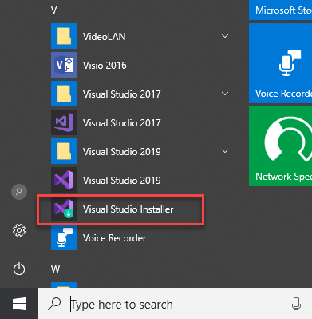
- Click the Modify button (you may need to click the “More” button to show this option).
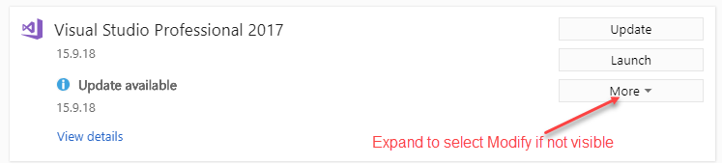
- Make sure the following options are selected (leave the others already selected).
  - ASP.NET and web development
  - Data storage and processing
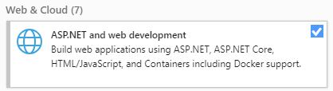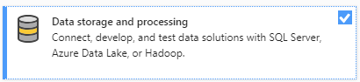
- Click the Modify button to install the updates.
- If the options were already selected, you can close that window and check if there is an Update available and if yes, click the Update button. It takes a while to update, so this is a good time for a coffee/tea break.
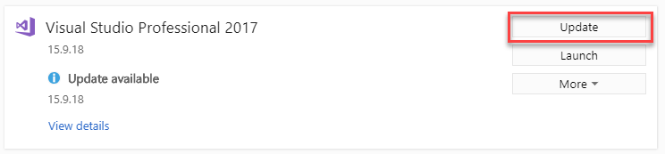

Install .NET Core 2.2.
You also need to install .NET Core 2.2. There is a new version out, but this is not supported in VS 2017 and as I mentioned above I need to support both platforms.
- Please go to https://dotnet.microsoft.com/download/visual-studio-sdks.
- Download the appropriate .NET Core 2.2 SDK for your VS version.
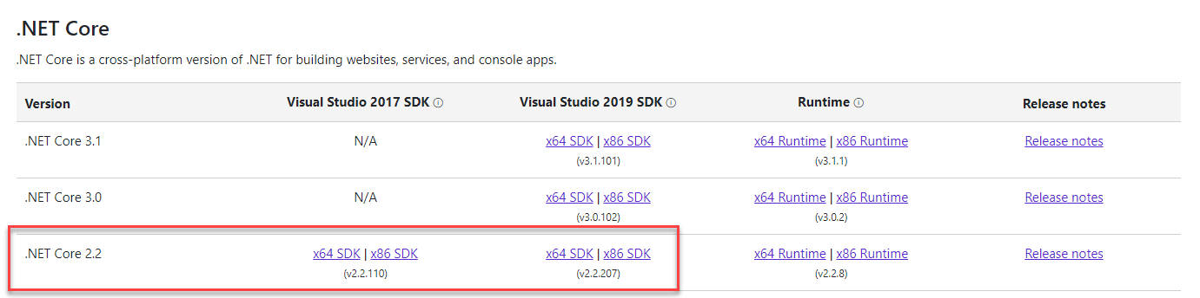
- Install the SDK.

