
Professional Career Development Reflection and Application.



Valentin Halici 1918830
Name of host Organisation (UWTSD)
Date of report publication 12/6/2020

Executive Summary

In this report I've recorded a complex set of personal development related theories and technique. Within this article you will find self-awareness techniques such as SWOT analysis, defining targets approaches such as SMART objectives. Explained coping patterns, positive strategies and self-reflection techniques, ways to track and evaluate success and reach goals, all backed up with Harvard style references and personal experience.

Table of contents
CONTENT PAGE NUMBER
EXECUTIVE SUMMARY………………………………………………………………1
CONTENTS PAGE ………………………………………………………………………2
TERMS OF REFFERENCE…………………………………………………………….3
PROCEDURE………………………………………………………………………………4
INTRODUCTION ………………………………………………………………………..5
FINDINGS…………………………………………………………..………………………6-13
CONCLUSION…………………………………………………………………………….15
RECOMMENDATIONS……………………………………………………………….16
REFERENCE LIST…………………………………………….………………………….17-18

Terms of Reference
This assessment is completed by Valentin Halici student number 1918830 on the 9/6/2020on request by Laura James on 12/6/2020

Procedure
Use the accessibility of books and website’s information.

Introduction
The learning journey is a complex process and requires time, research and investment to improve and acquire skills for all life needs, specific to this essay, academic / employability skills and business start-up, skills needed to develop proactivity and productivity.
"There are no secrets to success. It is the result of preparation, hard work, and learning from failure." – Collin Powel
The learning journey will begin with selfawareness to better understand the needs for implementation and to check the actual level. Using the tools necessary to address suitable learning styles and motivational theories a person can generate a meaningful work, selfreflection to generate growth plans for learning journey beginning from self-awareness.

Findings

Professional career development is the lifelong learning and educate myself true the college, university, studying, doing courses to progress in workplace or to achieve workplace goals by being determinate to achieve them in future. Professional career development is important for everyone to progress in workplace and to get better at the job you are doing, every day is a development even without studying, only by getting and growing in experience slowly, but by studying you develop quickly and probably in high standards. Without development everyone get stuck in one place.
I think employability skills is the most important thing that a person can have and can always progress. Employability skills is something what always a manager or an owner look for when they employee someone. As myself I can speak about my experience in customer service and about my skills what I have and what I will like to have after this course in Skills for the work place. True the years I did achieve some skills in customer service such as time management, dealing with customers’ needs and complains.

REFLECTION in past few weeks I can say I learn lots of new things such as smart, swot, personal development plan and skills, we learn about different types of learning style and where I find myself as a learning style. I can say the most difficult part for me is online schooling, personally I can say this affect me as I like to be in a classroom and pay attention and take notes which I find more interactive. I found this course very important for my career in management as everything we learn so far is very new for me. Internet was my main and probably only one I use for my research as I find it easier to access it and to use it.

Swot analysis
Strengths | weaknesses
Hard working, good customers service skills, intrinsic motivation, work committed, very professional , very pleasant, | Lack of team leading qualification, lack of tolerates, distracted, writing English skills, lack of knowledge in other departments, rota making in work place
Opportunity | Treats
Finish the course of The Certificate in Higher Education Skills for the Workplace programme.  Move into Uk. | Lack of opportunity to grow in work place.  Brexit and anything associated with Brexit.

Strengths: being a foreigner in the UK create a complicated situation where the only chance to integrate into the system is by working hard for my finances and evolution of career. I consider every job I do focus of my commitment and because the job I had to take, I had to enjoy doing it to my maxim potential. Working in hospitality sector comes with challenges although having customers service and pleasant and professional come with the territory of the job.
Weakness: academic skills are weakness as the importance of finances for survival was more essential than the learning of any academic skill. Lack of team leading qualification and skills create lack of tolerances, poor English skills and lack of knowledge in other departments create a perfect situation where the progression in job career is stopped.
Opportunity: Making the decision to come to UK was a difficult one but with hard work I consider that it was a good idea. With poor English but with hard work and motivation I succeeded to have a job in Hospitality that I find fulfilment. The course I am attending in Skills for the Workplace will create few more occasions for me to develop my academic skills in a way that will not impend my family commitment.
Threats: The political situation behind the BREXIT create risk of incertitude for me as an European citizen as there are no clear plans for me as a European citizen in UK. Having a family in Swansea create another feeling of downfall due the incertitude of BREXIT. Having low academic skill, the opportunities in my current job are minimal and create a threat of work diminished in long term because of lack of qualification in management structure.
Criticism: SWOT analyses offer a way of understanding the individual or the company although will not create a solution ad-hoc to find the response of personal question, is important to find appropriate way to tackle any situation exposed in the analyses.

Personal SMART Goals
Setting goals and measuring progress is the most significant step towards achieving success. Not all goals are worth the effort, SMART goal increases your chance of achieving goals successfully. SMART stands for Specific, Measurable, Achievement, Time-bond and Relevance. My SMART goal to achieve its Academic skills can be broken down to a paragraph of self-acknowledgement like:
I will like to say since I was 15 years of age I’m working in Customers service like restaurants and hotels and gain a lot of experience true working in different countries and I think is time for me to progress in my career. In 2 years from now I want to be a manager but being a manager required study and personal development which I’m doing now true university. By the 20/ July / 2021 after I will finish the first year of university I will be ready to become a manager as my knowledge in management will grow.
Having the skills accumulated in the last 6 weeks, personal SMART can be enounced:

Specific: having a clear, concise goal
I want to have Higher Education Diploma in Business in the next 12 months.
Measurable: tracking the progress and sett milestones
The progress is delimited by the marks for each assignment and the final mark will showcase the whole progress.
Achievement: challenging yet achievable goals.
Full achievement of my goal is defined by full attendance on my classes and my marks for work. All the research and practice will give me information to help my progression.
Relevant: be sure your goal it is worth your time and it’s beneficial and relevant to your overall life plans.
Achieving Academic Skills it is helpful for my life time career and comparative for my other plans, progress in my job or overcame to a career variation necessity.
Time-bound: goals need to have an aim time devoted to them
I should be a diligent working student in the next 12 months to achieve the school assignments, help the knowledge with individual study and realistic experience to sustain my learning process and inspire me before I complete all 12 months.
Criticism: Often it's not practical about the target or the time-bound, so a new goal will take place, disappointment causes dissatisfaction and poor motivation to start again.
Personal Development Plan to Improve Performance has to be a task to be consider when complacence kick in. Job title gain is has the fulfilment necessary and the skill and knowledge required by the actual job role.
Job Title: Supervisor conference and events and food and beverage
Skills and knowledge required by your job role:
- Good communication skills
- Personal alcohol licence
- Good team leading skills
- Good organization skills
- Product knowledge
Achievements, qualification and experience I have over 15 years’ experience working in customer service, been a bar and cellar assistant manager and 4 years food and beverages supervisor as well as Conference and events coordinator with a lot of knowledge in food and beverages UK standards. In last 2 years I manage to get the qualification and the diploma in LVL2 Team leading, LVL1 in Matt’s qualification as well as lvl2 digital literacy qualification, passed the English communication skills.
How do I apply this skill is a question answered by working every day with customers, by leading with professionalism my team and most important thing by teaching and training the new staff everything about the role either is bar, waiting or supervising.
As everyone I do have some skills shortage which identifies immediate development by the company and as my own goal such as Personal Alcohol licence and need a qualification in Business management my team leading qualification not cover but by the end of 2020 I will manage to get it.
As part of my existing skills such as language skills (in my case is English), management skills always need improvements to be up to date , bar tender skills is a skill I do have it but the market always bring something new out and maybe weekly or monthly need studying the new product and develop as a own skill.
The theory of learning style is that we all have a way we’d rather learn. Many people tend to sit down and read about a subject, for example, whereas others like to get on with it and have a ride. Generally it's not as clear-cut as that, though, because priorities can evolve over time and when you are expected to do different things at work and more broadly in life.
I chose to apply VARK and Honey and Mumford on myself as you will see below.
VARK is an acronym described by 4 modalities of learning and learning styles. “V “it come from the visual learner style here the students will internalize and synthesise information when viewed in a graphic representation of realistic symbols they are identified as visual learners. They can respond to arrows, charts, diagrams and other information hierarchy visualisations but not necessarily to photographs or videos
“A” comes from the abbreviation of auditory learners and are more effective when they are granted the ability to hear vocal details because often students with this learning style may choose not to take notes during class to maintain their unbroken auditory attention, educators may mistakenly conclude that they are less engaged than their classmates. Some students, however, may have actually concluded that note-taking is a diversion and that their unbroken concentration is a more important form of studying.
“R” stand for the reading/ writing learners. Students who work better in the way they read / write show a strong learning preference for the written word. This involves all written material shared in class in the form of hand-outs and PowerPoint slide shows, as well as the ability to synthesise course content as written assignments complete. This approach is also ideal for performing online analysis, as many sources of knowledge on the internet are largely text-rich.
“K” stands for kinaesthetic learner. Kinaesthetic learners are hands-on, participatory learners who tend to assume a socially involved role in the learning environment to achieve their optimal educational results. These are often referred to as "tactile learners," although that could be a bit of a misnomer; kinaesthetic learners prefer to use all their senses similarly in the learning phase rather than merely use contact. In conventional classroom settings, kinaesthetic learners often have the most difficult time to succeed because of their active nature. Some educators have seen progress in motivating kinaesthetic learners to use flashcards to turn rote memorization into an immersive activity for subjects like math and English.
After the VARK test undertaken the result is show me that I am a visual learner. When visual learners tend to see the whole scene until they can make meaning out of a particular point, we need to give them a holistic perspective about what they are studying. They must see how every detail fits into the whole, and see the relationship between all the parts. Any information not within the chart (not connected to other data) would become a significant diversion. Visual learners can come to an abrupt, stuttering halt when provided with specifics they don't know how to cope with. They may seem unable to grasp what their concurrent colleagues think is obvious and simple. Thinking in entire pictures is indeed a wonderful ability it simply isn't appreciated.
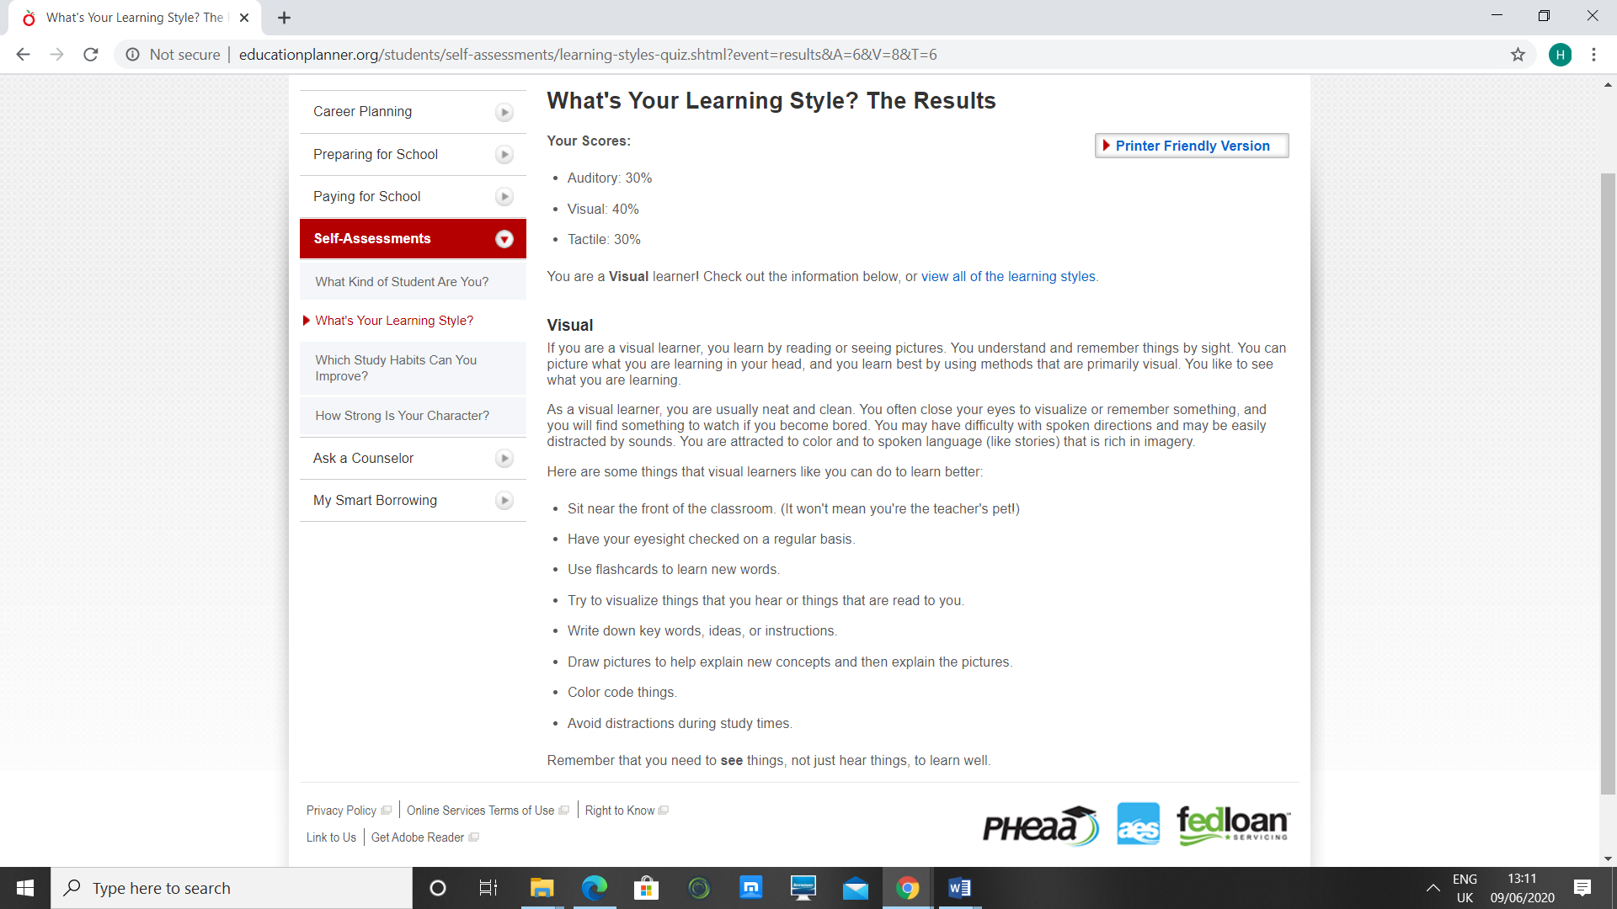
In the learning questionnaire Honey and Mumford I found out I’m an activist learning which I like to learn by been active in classroom, in workplace, always like to try once and support the consequences later. I like to have all the attention on me and constantly involve myself in others conversation.
Activists are such individuals practising by performing. Activists tend to get their hands dirty, then immerse themselves in with both feet. Have an open-minded approach to learning that fully and without prejudice involves itself in new opportunities.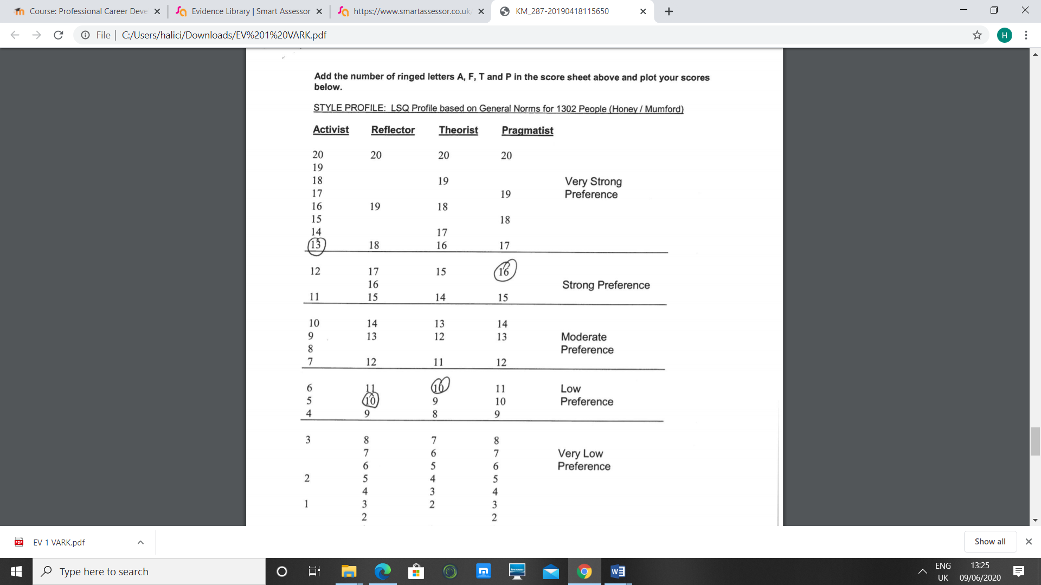

Conclusion

Every day we become a stronger version of ourselves, using the right resources to determine the stage we continue and the best approaches to develop abilities and quality of life, to meet the objectives we set and track success. Starting with self-awareness will continue with a specific SWOT analysis to test your degree in this moment. Having the right coping method, utilising questionnaires, analysing facts and producing response and inference is simpler. Real assessment during the research completed can add more insight about the experience and a new knowledge to be conscious of in order to perform better next time or in a particular way.

Recommendations

After questionnaire in VARK learning style and Honey and Munford it result that to develop myself the academic skills in an activist way and use visual acumen. To do that are few activities to help:
- Brainstorming
- problem solving
- group discussion
- puzzles
- competitions role-play

References/Bibliography

Cameron D Herzberg – still a key to understanding motivation. Training Officer, 32(6), Jul-Aug 1996, pp 184 – 186

Educationonline.ku.edu. 2020. 4 Different Learning Styles You Should Know: The VARK Model. [online] Available at: https://educationonline.ku.edu/community/4-different-learning-styles-to-know [Accessed 11 June 2020].

Hansen, B., 2018. YOUR GUIDE TO UNDERSTANDING AND ADAPTING TO DIFFERENT LEARNING STYLES. [Blog] Lifelong Learning Matters, Available at: https://www.cornerstone.edu/blogs/lifelong-learning-matters/post/your-guide-to-understanding-and-adapting-to-different-learning-styles [Accessed 11 June 2020].

Www2.le.ac.uk. 2020. Honey And Mumford — University Of Leicester. [online] Available at: https://www2.le.ac.uk/departments/doctoralcollege/training/eresources/teaching/theories/honey-mumford#:~:text=Activists%20are%20those%20people%20who,without%20bias%20in%20new%20experiences.&text=These%20learners%20like%20to%20understand%20the%20theory%20behind%20the%20actions. [Accessed 11 June 2020].

Teach.com. 2018. Learning Styles. [online] Available at: https://teach.com/what/teachers-know/learning-styles/ [Accessed 11 June 2020].

Skillsyouneed.com. 2020. Learning Styles | Skillsyouneed. [online] Available at: https://www.skillsyouneed.com/learn/learning-styles.html [Accessed 11 June 2020].

Martin, M., 2019. [online] Business News Daily. Available at: https://www.businessnewsdaily.com/5543-personal-swot-analysis.html [Accessed 11 June 2020].

Hr.duke.edu. 2020. Professional Development Plan | Human Resources. [online] Available at: https://hr.duke.edu/managers/performance-management/professional-development-plan [Accessed 11 June 2020].

Corporate Finance Institute. 2019. SMART Goal - Definition, Guide, And Importance Of Goal Setting. [online] Available at: https://corporatefinanceinstitute.com/resources/knowledge/other/smart-goal [Accessed 11 June 2020].

Child1st Publications. 2020. Visual Learners And How They Learn. [online] Available at: https://child1st.com/blogs/resources/visual-learners-and-how-they-learn [Accessed 11 June 2020]

Wingston, s., 2018. How to taylor workplace training to all types of learning styles. [Blog] Eagle's Flight, Available at: https://www.eaglesflight.com/blog/how-to-tailor-workplace-training-to-all-types-of-learning-styles [Accessed 11 June 2020].

