DEVELOPING RELATIONSHIPS AND WORKPLACE ACHIEVEMENT
2018

By Louise Westcott
Student I.D 1705358

Host – Brynach Heffernan
Organisation - UWTSD

Publication Date 14/12/2018

EXECUTIVE SUMMARY

The purpose of this assignment aims to critically evaluate some of the development vehicles available to an organisation which are both appropriate to the purpose, the role, and to the development needs of the individual.
Examining models and theory’s such as Maslow, KPI’s, AMO’s and Honey & Mumford, we can begin to build a catalogue of development tools and examine their reliability and potential benefits to both the organisation and the individual when some time and money is spent on implementing these strategies.
This will include some examples of companies and how their success and reputation is built on good individual development strategies.
The assignment will conclude with a personal development plan, which aims to meet the identified needs and expectations of the individual. It explores how to identify these needs, what information is needed and how to gather it as well as exploring how the plan implemented and monitored and how the effectiveness is evaluated.
All material used within the report will be referenced using Harvard style referencing.

Page 1
CONTENTS

Executive Summary ………………………………………………………………………… 1
Introduction …………………………………………..………………………………………. 3
Part 1
Motivation……………………………………………………….....……………………… 4 - 6
Production Management………………………………………………………………… 7 - 8
Training………………………………….……………….…………………………….…... 9
Part 2
Benefits to the organization and the individual………………………………………... 10 - 11
Sir Richard Branson ……………………………………………………………………… 12
Estee Lauder ……………………………………………………………………………… 13
Conclusion ……. ………………………………………………………………………….. 14
Personal Development Plan…….…………………………………………………….… 15 - 16
References …………………………………………………………………………………17 - 18
Bibliography ……………………………………………………………………………….. 18

Page 2
INTRODUCTION

When we hear the term “development vehicles” we are referring to tried and tested development strategies created by theorists, which help an employee within an organisation to grow, both professionally within the workplace, and as an individual. These strategies can be to boost motivation, performance, or to improve the skills of the individual with training, to name but a few.
By examining what these vehicles are and how these development vehicles can be implemented in the workplace, we can see which models are working best.
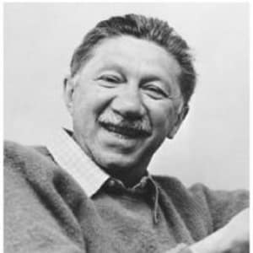

- Motivation

- Performance Management

- Training

Abraham Maslow

Focusing on both excellent training for the individual to carry out his or her role to the best of their ability, and with strategies in place which motivates and uplifts the individual enhances individual performance – which leads to good manager-employee relations and employee - peer relations.
Ensuring the individual is happy in his or her role leads to better productivity which in ultimately leads to better profits and success. Getting things right at this fundamental level can decide the fate of the company as a whole.
By examining two highly successful organisations, I will examine which development strategies they use for their employees and how these strategies affect their ability to;
- Gain and Retain Employees (employee contentment within the workplace)
- Performance of Employees (relating to vehicles used)
- Company Profits (which factors have led to organisation successes/failures)
- Improve (suggestions based on the evidence)

Examining these factors within successful organisations can provide evidence on which development vehicles work best, as well as providing helpful insight into how to better ourselves in our current and future workplaces.
Developing a plan to meet the identified development needs and expectations of an individual help the organisation to structure the employee’s role and ensure that he/she is amply equipped to carry out the role within the organisation, and provides job satisfaction for the employee because he/she can do their job well.
Page 3
PART ONE - IDENTIFYING DEVELOPMENT VEHICLES AVAILABLE TO ORGANISATIONS

MOTIVATIONAL VEHICLES
Motivation is of paramount importance to all of us, both in the workplace and in our personal lives. Therefore to have motivated employees is imperative to any organisation. When we think about how to motivate individuals in the workplace, we need to establish what it is that drives a person, what gets them out of bed and into work in the mornings, what keeps them performing well and makes them want to remain with the organisation for a reasonable amount of time. The difficulty with this is that people are individual and as individuals, they are all different in what motivates them. However, there are some basic motivators that all good organisations should adhere to, these include;
- Competitive rates of pay
- Performance-based progression and rewards
- Work/Life balance
- Good working conditions (environment)
- Good work relationships
- Progression opportunity’s
- A feeling of worth and appreciation
- Job satisfaction
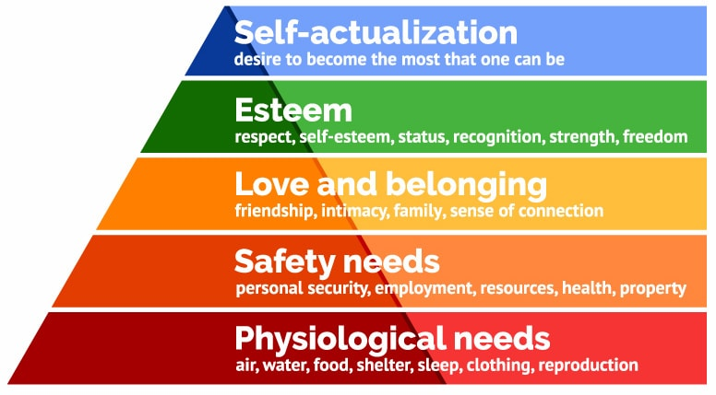
MASLOW’S HIERARCHY OF NEEDS

Maslow’s Needs Hierarchy Model, (Maslow 1943)

Page 4
Abraham Maslow came up with a model in 1943 he termed, The Theory of Human Motivation - or Maslow’s Hierarchy of Needs. Revolutionary in its day, in a time where employees were typically treated as machines by hard driving, profit maximising employers, the model provided an insight into what workers need and deserve.
According to Maslow, “individuals are motivated by unsatisfied needs. As each of these needs is significantly satisfied, it drives and forces the next need to emerge. Maslow grouped the five needs into two categories - Higher-order needs and Lower-order needs.” (Juneja, 2008)
- Physiological needs - These are the essentials to sustain our lives -
Air, water, food, clothing and shelter.
- Safety needs – This includes our physical, emotional and environmental needs – a need for job, financial, family and health security, protected from danger, etc.
- Social needs - Includes the need for love, care, affection, appreciation, a sense of belonging and friendship.
- Esteem needs - This includes both internal esteem needs such as, self-respect, confidence, competence, pride, achievement, freedom, and external esteem needs such as recognition, power, status, and admiration etc.
- Self-actualisation needs - This includes the urge to reach your full potential, the need for growth and self-contentment, for creativity and gaining more knowledge,

Note - Self - actualisation needs are never fully satisfied because as an individual grows psychologically, the bar is set ever higher.

In Maslow’s book, he notes that there have been a number of exceptions, which is to be expected due to human diversity. For example, one person’s desire for self-respect and
Page 5
Power may be far greater than their need for love, or a starving artist’s need for recognition and achievement, greater than their need for job security or even food. (Maslow 1946)
This creates some limitations, and the Maslow model is certainly not ‘one size fits all’ however, I believe Maslow’s model to be a good one because it creates a basic, generic rule of thumb which is favourable to the majority of individuals.
Bruce (2006) provides a more detailed model, in her book “How to motivate employee” She states that “a managers main goal in the workplace is to help create a truly motivating organization, one that inspires each employee to do his or her best every day – particularly when the manager isn’t looking”
Knowledge of what drives people is therefore of great importance. Bruce suggests some ideas which have proven successful in many organisations today -
- Make employees feel like partners
- Show employees how business operates
- Inspire creative and innovate thinking
- Help workers achieve greater performance
- Rewards and recognition
- Incentives and morale boosters
- Build trust
- Encourage mutual accountability
- Create a fun and comfortable work environment
- Make employees feel important

I believe Bruce’s model to be an excellent one because it is centred on the individual. Her model is certainly evident in Sir Richard Branson’s and Estee Lauder’s business ethics as demonstrated in part two.

Page 6
PERFORMANCE MANAGEMENT DEVELOPMENT VEHICLES

Aims of Performance management methods are to;
- To correct poor performance (individual and organisational)
- To sustain good performance
- To improve performance
- To improve organisational performance, e.g. Individual.
- To encourage and initiate development e.g. of teams
- To manage the behaviour of the workforce to aid improved individual, team and organisation performance.
(Lee, 2005)
One of the ways in which performance can be measured, is in KPI’s, (key performance indicators) for example, a company may ask the following questions to measure if individuals are performing well;
- Are Sales targets being met?
- What is the rate of Absenteeism? Are there any particular individuals missing more work than others and if so, why?
- Employee turnover – the ability to attract and retain workers
- Footfall

KPI’s are a good way of keeping a check on important information and detecting areas that need attention or improvement quickly. KPI’s can be used in a number of ways as described by Mills, C. (2017) In his book “Performance management a practical guide” However as Mill’s states, KPI’s are not a black and white strategy and managers must be aware of other factors which can affect KPI charts such as dry spells in the market, time of year, economic climate etc.

THE AMO THEORY
ABILITY, MOTIVATION, AND OPPORTUNITY

There seems to be some confusion over who created the AMO theory. However, it is most commonly “credited to Olander and Thogersen in the Journal of Economics around 1995. However, other behavioural scientists have put forth similar theories or parts of theories that are related to AMO theory.” (Study.com 2014).
“The AMO theory suggests that three independent work system components shape employee characteristics and contribute to the success of the organisation. According to the theory, organisational interests are best served by a system that attends to the employee's Ability, Motivation, and Opportunity.” (bayt.com).

Page 7
The three components of the AMO theory, suggests that employees perform better when they have;
- Ability - the appropriate skills, training and knowledge to perform their job well.
- Motivation - which is achieved by firstly giving them the ability, and by receiving appropriate rewards and recognition, progression etc.
- Opportunities - to demonstrate their skills, knowledge, expertise and ideas and ability to progress up the career ladder.

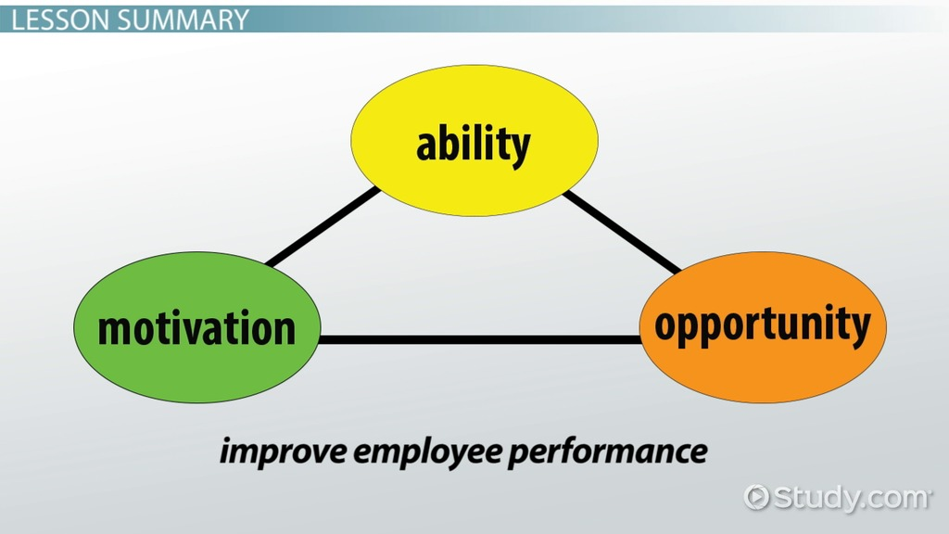

As a result of the implementation of good AMO procedures, employees should know and understand what is expected of them. They should have;
- The required skills and training to be able to deliver what is expected of them.
- Support from the organisation to develop to meet expectations.
- Feedback on their performance.
- The opportunity to discuss and contribute to individual, team and organisation aims and objectives.
(Armstrong and Baron, 2004)

The AMO model is a reliable one, which has been widely used over the last two decades. It is a common sense approach to understanding what employees need. By providing good incentives which encourage motivation, providing the ability to do the job well with good training methods and giving career progression opportunity’s, is a key component to a happy, thriving workplace and in turn successful organisation.

Page 8
TRAINING AND DEVELOPMENT VEHICLES

There are many training techniques organisations can use to create an effective, happy workforce. A definition of what training is “is an organised activity aimed at imparting information and instruction to improve a person’s performance or to help them to acquired level knowledge or skill” (businessdictionary.com).
Training is a vital part of individual development because an organisation can only ever be as good as its employees.
SOME EXAMPLES OF TRAINING METHODS TYPICALLY USED TODAY ARE;
- Shadowing – where an individual will watch, partake and learn from a senior team member whose role is appropriate to the one they will be needed to perform.
- Coaching – is to be taught, driven and motivated by a professional coach who is experienced in aspects of the organisation relevant to the individual’s role.
- Mentoring – is to be led by someone who is already performing the role.
- Lectures – usually by a senior team member, where the individual has the opportunity to take notes, ask questions and be given information on the topics they are learning about.
- Induction sessions/orientation, these are typically at the beginning of your employment with an organisation. However, they can also be used when an individual is progressing into a new role or a higher level. These can involve lots of activities including role play and learning about what is expected of the individual, and also about the organisation's policies, ethics, etc.
Also, these types of training can be, mandatory, voluntary or requested by a manager or individual, in or out of house, and can be on a whole host of topics or skills needed for the individual to carry out his/her role. (Uscreen.tv 2018).
There are implications of using the correct training techniques, concerning the individual his/herself and how best he/she learns, for example, one individual may learn best by shadowing another team member, whereas another individual may learn best in a classroom style setting with an experienced teacher or coach. This is where management discretion plays a part, and managers who know their employees well is essential in achieving this. This is one reason why the numbers of individuals they manage are better kept relatively small.
In recent years organisations increasingly use models such as the HONEY AND MUMFORD LEARNING STYLES QUESTIONNAIRE, which identities which of the four learning styles the individual is. This is a useful tool in deciding which type of training an individual is best suited to. (Bearwell & Claydon 2010).
The questionnaire divides individuals into four distinct category’s which are;
- Activists - who learn best when they are actively involved in tasks
- Reflectors - who learn best through reviewing and reflecting on what has happened previously and what they have done.
- Theorists – who learn the best information, concepts, ideas or theory.
- Pragmatists – who learn best when they can relate the information to real-life issues or problems. (Honey & Mumford 1986).
PART TWO
BENEFITS TO THE ORGANISATION AND THE INDIVIDUAL OF PERSONALLY DEVELOPING INDIVIDUALS IN THE WORKPLACE

There are many benefits to both the organisation and the individual from personally developing individuals in the workplace.
As mentioned in section one, motivation among employees is essential for everything, because a motivated employee comes to work on time and rarely calls in sick, works eagerly to the best of his/her ability, behaves well and provides the best service to the customer that they can. However “you cannot motivate an employee, you can only motivate what inspires them” (Bruce 2006)
The topic of motivation ties in with the other development vehicles because many of them, in turn, inspire motivation.
Good Performance management systems such as KPI’s are essential for the organisation to;
- Improve and track Individual performance
- To develop and encourage the development of teams
- To manage and control the behaviour of individual workers

Models such as KPI’s are performance management tools which set targets for individuals and allow managers to track progress which is vital to any successful organisation. It also gives structure to the employee, giving clear guidelines of what is expected.
Regular appraisals are also a helpful tool in particular when the appraisals are a “two-way appraisal” where the individual can also provide feedback to the manager. This can help both parties to improve themselves and form good manager-employee relationships.
Good training methods can contribute to the organization's objectives by;
- Reducing costs / enhancing profitability
- Provision of services, customer retention, technical innovation, added value
- Survival or growth of the business – sustainability
- Increased employee loyalty
- Succession planning
- Enhanced corporate image
- Flexibility and adaptability to change
- Coping with critical incidents, problems, opportunities

In addition to this, training helps the individual by;
- Improved skills – multi-skilling / greater flexibility
- Enhanced performance and efficiency
- Increased profitability
- Fewer mistakes – better quality of output
- Fewer complaints - happier customers who return and spend more
- Enhanced reputation
Page 10
- Fewer accidents – health and safety improves
- Improved morale – less absence and labour turnover
- Everyone benefits – the organisation, the employees and the customers
(Moodle 2018)

It is important however that the methods of training used are appropriate to the individual, the role and the organisation's requirements because when training methods used are incorrectly this can cost and essentially, waste money.
There are certainly be pro’s and con’s to all development vehicles, so by using models such as the Honey and Mumford questionnaire employers can route out the best method of training for the individual.
There are many ways to develop an individual in the workplace, but in my opinion, the way an organisation treats their employees is arguably the most important of all.
From the evidence I have explored, the most successful organisations are the ones who focus much of their efforts on making individuals feel good about themselves. This inspires the greatest motivation.
Creating a sense of belonging to the individual, making them feel appreciated and valued, while showing kindness and patience, creates an individual who values their job and wants to perform well and remain with the organisation. (Branson 2018).
Providing an opportunity to learn, progress and to give good rewards also provides the individual with motivation and an eagerness to succeed.
There are some organisations which are world class, not just because of their products and services, but because of their ethics on how they treat their employees.
By examining the way they operate, we can learn valuable lessons on how we manage employees, run our businesses or even to understand what we deserve and should expect as employees as well as building a profile of which methods and models are working best in today’s economic and social climate.

Page 11
LEARNING FROM THE PROFESSIONALS
THE RICHARD BRANSON EMPIRE – THE EMPLOYEE FIRST APPROACH

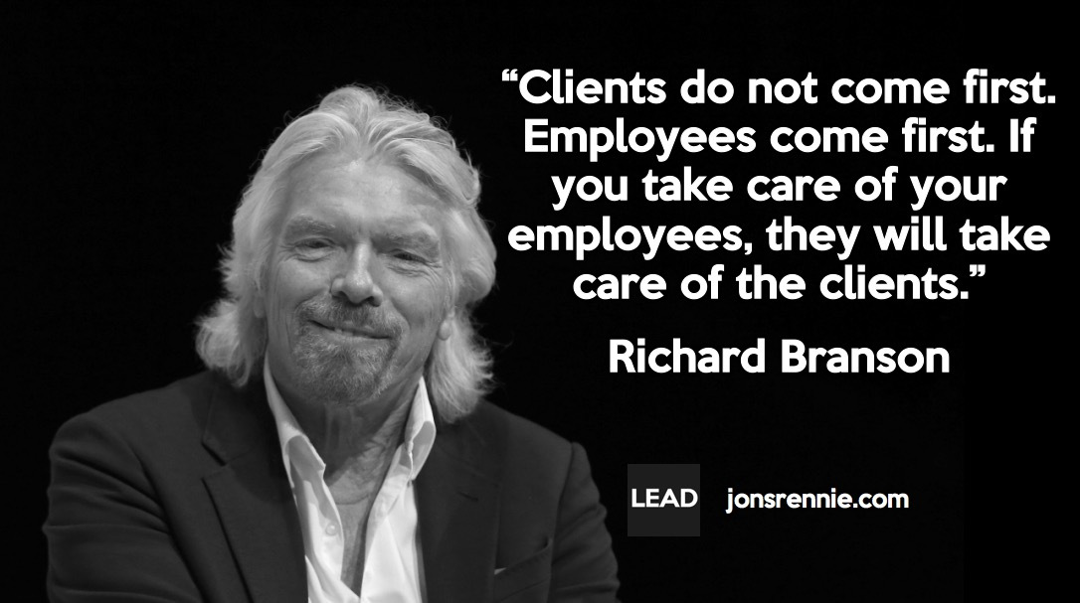
Richard Branson is one of the most famous Entrepreneurs in the world. He is a world-class leader and the founder of many successful businesses including the Virgin group and others.
Branson “prioritises his employees first, customers second and shareholders third. He explains that happy employees take care of customers and happy customers purchase more goods and services which keep the shareholders happy.” (Inc.com 2018).
Branson achieves this in many ways. He invests a lot of time speaking to employees in their workplaces, checking that they are doing okay. In addition to this, he only employs managers who have excellent track records, both in business and at maintaining happy workers.
He invests heavily on training which includes shadowing, coaching and both in and out of house training activities. He also insists that employees have regular two-way appraisals. (Elliot and Corey 2018)
He “attends as many orientations for new staff as possible to set the tone and send the message, “Get out there and have a good time. Enjoy yourself, because most of your life is spent working, and you ought to have a great time doing it." (Branson, R. 2018).
He backs this up with career progression opportunities, excellent rates of pay, and rewards. One such reward is Branson’s annual party in his home outside London which all employees and their families are invited to attend. There they are lavished with good food and wine in an event which has been known to go on for several days. (Strategy-Business 1998).
The result has been that his employees feel truly valued, respected and appreciated. They have a true sense of belonging, value their jobs and have pride in working for Branson. And because of his ethics, Branson has been in business for over five decades and is one of the most successful businessmen in the world today.
ESTEE LAUDER – MAKING EMPLOYEES FAMILY AND EXPERTS IN TRAINING



Another organisation which has been highly successful for decades in the Estee Lauder Family. Company president and CEO Fabrizio Freda stated that “the company operates like a family.” And that "Families are, both, the most caring and demanding of environments. Our culture is a unique combination of nurturing and challenging, respectful of our roots and inspired to envision the future.”
Estee Lauder's ethics she instilled into her dynasty is often described as a rare mix of family values with a high-performing public company. From an employee’s perspective, who doesn’t want to be made to feel like family when they go to work? Doesn’t everyone want the best they can for their family? I believe this to be a key ingredient to the job satisfaction felt by her employees and to the success of the organisation as a whole.
Lauder describes her organisation as “a caring, collaborative and compassionate workplace with a competitive spirit being a powerful source of motivation. Above all else, there is a focus on long-term, sustainable growth which engenders loyalty and commitment from internal and external stakeholders.” (Estee Lauder Company 2018)
The fun doesn’t end there for employees of Estee Lauder, as the organization regularly sends management-level employees from all over the world on week-long retreats, working with the Macquarie graduate school of management on a programme they refer to as “the whole person” - working on body, mind and spirit, in addition to excellent in-house training available for employees at all levels. (Elliot & Corey 2018)

Page 13
CONCLUSION

I have determined that there are several key components to running a successful organisation. Drawing on the evidence I have seen from the models along with investigating highly successful organisations such as Richard Branson and Estee Lauder’s empires I believe that;
The foremost important component in an organisation is simple – BE NICE!
When you treat your employees with kindness, it goes a long way. This does not mean that you cannot also be firm when needed, however when you treat your employees as family, as a stakeholder it gives them a sense of belonging and of value, rewarding and complimenting where deserved encourages motivation like nothing else.
Having a comfortable, flexible work environment with good salaries and incentives where individual’s needs are recognised and met by following models such as Maslow and AMO is a basic necessity in any work environment today. Adding a personal touch where you as the manager are accessible and approachable to all employees also adds to the individual’s happiness in the workplace.
Offering excellent training for employees, which fit the individual based upon the results of questionnaires such as the Honey and Mumford and which are relevant to the role and the organization's requirements and giving regular two-way appraisals is in my view the recipe to a happy and successful organisation.

Page 14
PART THREE
A PERSONAL DEVELOPMENT PLAN FOR JANE DOE

Jane Doe has been working for our organisation for the past five years. During this time she has proven herself to have excellent managerial skills, regularly helping our current store manager and covering in her absence.
Her ability’s to problem solve and her excellent customer service skills backed up by her knowledge of the store, staff and our store's procedures gives me confidence that she is the right person for the position.
Her previous employer references and her academic record are also excellent. For these reasons I have decided to promote her to store manager at our Llanelli New Look Store, to replace our current manager, Susan Wilson who retires on the 31st January 2019.
There are however some areas needing improvement and further training; we completed a Honey and Mumford questionnaire which showed that Jane is an activist. I have prepared a PDP chart for Jane based upon this and in line with our store’s procedures.
AREAS TO IMPROVE OR FOR FURTHER TRAINING | METHOD | PROGRESSION TRACKING METHOD | END GOAL
MANAGEMENT TRAINING | JANE WILL SHADOW SUSAN IN HER DAY TO DAY MANAGERIAL DUTIES. SUSAN WILL TRAIN JANE AND ENSURE JANE IS FAMILIAR WITH ALL ASPECTS OF THE ROLE | JANE AND SUSAN WILL REPORT TO ME WEEKLY TO ADVISE ON ANY ISSUES AND IF JANE NEEDS ANY FURTHER TRAINING ACTIVITY’S.  WE WILL COMMENCE 2-WAY APPRAISALS 3 MONTHLY FOR THE REMAINDER OF THE YEAR BEFORE MOVING TO OUR USUAL 6 – MONTHLY APPRAISALS IN 2020 | JANE WILL FEEL CONFIDENT AND ADEQUATE IN HER NEW ROLE BY 31/01/2019
IMPROVE I.T SKILLS TO BETTER HELP CUSTOMERS WITH ONLINE ORDERING | JANE WILL BE TAUGHT BY SIMON OUR AREA COMPUTER SPECIALIST – A TOTAL OF TWO, TWO HOUR SESSIONS | SIMON WILL ASSESS JANES PROGRESS AND ADVISE BOTH JANE AND ME IF FURTHER SESSIONS ARE NEEDED | JANE WILL BE CONFIDENT IN USING THE STORE TABLETS TO CHECK STOCK AVAILABILITY AND ORDER FOR THE CUSTOMER
BECOME ACCUSTOMISED WITH WIDER COMPANY POLICY’S SUCH AS STAFF HIRING, APPRAISALS, STAFF DISCIPLINARY PROCEDURES | JANE WILL ATTEND A THREE DAY SENIOR MANAGEMENT LEVEL COURSE TO BE CONDUCTED IN SWANSEA, JANUARY 3RD - 5TH | JANE WILL SHADOW ME AND PARTAKE WHEN I AM INTERVIEWING NEW EMPLOYEE’S UNTIL WE ARE MUTUALLY CONFIDENT | JANE WILL BE ABLE TO PROPERLY MANAGE ALL ASPECTS OF HER MANAGERIAL ROLE WITHIN SIX MONTHS

Page 16
REFERENCES

BOOKS;
Armstrong, M. & Baron, A. (2004). Managing performance: performance management in action. London: Chartered Institute of Personnel & Development.
Beardwell, J. & Claydon, T. (2010). Human resource management, a contemporary approach. (6th ED). Great Britain: Pearson Education Limited.
Branson, R. (2018). Finding My Virginity: The New Autobiography. London: Virgin Books.
Bruce, A. (2006). How to motivate every employee. United States of America: McGraw-Hill Education LLC.
Elliot, G. & Corey, D. (2018). Build it! The rebel playbook for world-class employee engagement. Great Britain: Wiley publications.
Maslow, A.H. (1943). A theory of human motivation. (1st ED). Floyd, Virginia: Wilder Publications, Inc.
JOURNAL;
Maslow, A.H. (1943). Conflict, frustration, and the theory of threat. J. abnorm. (soc.) Psychol., 1943, 38, 81-86.

WEBSITES;
Bayt.com (2014). What is the AMO theory. [Online]. Available; https://www.bayt.com/en/specialties/q/285381/what-is-the-amo-theory/ [Accessed 2018, November 21st].
Biography.com (2014). Abraham Maslow Biography. [Online]. Available: https://www.biography.com/people/abraham-maslow-9401669 [Accessed 2018, November 16th].
Biography.com (2015). Estee Lauder Biography. [Online]. Available; (https://www.biography.com/people/est%C3%A9e-lauder-9374625 [Accessed 2018, December 9th].
Businessdictionary.com (2018). Training definitions. [Online]. Available: http://www.businessdictionary.com [Accessed 2018, December 4th].
Estee Lauder companies (2018). Culture & Values. [Online]. Available; https://www.elcompanies.com/who-we-are/culture-and-values [Accessed 2018, December 9th].

Page 17
Inc.com (2018). Richard Branson: Companies Should Put Employees First. [Online]. Available; https://www.inc.com/oscar-raymundo/richard-branson-companies-should-put-employees-first.html [Accessed 2018, December 1st].
Jonsrennie.com (2017). Putting Employees Ahead of Customers. [Online]. Available; https://jonsrennie.com/2017/10/05/putting-employees-ahead-of-customers/ [Accessed 2018, December 1st].
Juneja, P. (2016). Maslow’s Hierarchy of Needs Theory. [Online]. Available: https://www.managementstudyguide.com/maslows-hierarchy-needs-theory.htm [Accessed 2018, November 20th].
McLeod, S. (2018). Maslow’s Hierarchy of needs. [Online]. Available: https://www.simplypsychology.org/maslow.html [Accessed 2018, November 16th].
Statery-Business.com (1998). How Richard Branson works magic. [Online]. Available; https://www.strategy-business.com/article/13416?gko=19354 [Accessed 2018, December 6th].
Study.com (2014). The AMO Theory. [Online]. Available: https://study.com/academy/answer/when-was-the-amo-theory-born-who-was-the-creator-of-amo-theory-which-paper-article-journal-used-amo-theory.html [Accessed 2018, December 1st].
The E-learning network (2017). Honey and Mumford learning styles. [Online]. Available; http://resources.eln.io/honey-and-mumford-learning-styles/ [Accessed 2018, November 28th].
Uscreen.tv (2018). 6 Types of Online Employee Training Programs. [Online]. Available; https://www.uscreen.tv/blog/6-types-online-employee-training-programs/ [Accessed 2018, December 8th].

BIBLIOGRAPHY

WEBSITES;
Edge point learning (2017). Top 10 Types of Employee Training. [Online]. Available; https://www.edgepointlearning.com/blog/top-10-types-of-employee-training/ [Accessed 2018, December 4th].
YouTube.com (2009). The Performance Appraisal. [Online]. Available; https://www.youtube.com/watch?v=unmKnS5jPOc [Accessed 2018, December 2nd].

Page 18

