

Programme: BA (Hons) Leadership and Management Skills in the Workplace
Module: Managing Projects in the Organisation
Module code: BMSW5104
Student name: ANA COJAN
Student ID: 2109647

Executive Summary
The report has discussed a project plan for Magan Restaurant's staff. It has described the project with its scope. This has been followed by carrying out a stakeholder analysis and risk assessment. Furthermore, the report has discussed the necessary resources using which the project activity will be continued effectively.

Table of Contents
Introduction 4
Project outline or description…………………………………………………………………………….4
Project Scope…………………………………………………………………………………………….4
Project Life Cycle Model…………………………………………………………………………………5
Stakeholder Analysis…………………………………………………………………………………….6
Work Breakdown Structure (WBS)………………………………………………………………………7
Cost and Resources use…………………………………………………………………………………8
Consideration of Resources ……………………………………………………………………………10
Project Schedule and Gantt Chart …………………………………………………………………….10
A Risk Assessment 12
Conclusion……………………………………………………………………………………………….14
References……………………………………………………………………………………………….15
Appendix…………………………………………………………………………………………………16

Introduction
The report will discuss the project on "Happy Life Better Work" at Magan Restaurant situated in the UK. The restaurant will incorporate the project with the help of its HR team and project manager to ensure a healthier life for its staff. The report will discuss the scope of the project followed by presenting a discussion on the project lifecycle model. This will be followed by stakeholder analysis, WBS, cost and resource use, consideration of resources, project schedule and risk assessment.

Project outline or description
The project "Happy Life Better Work" is a six-month initiative designed to inspire and empower the staff of the restaurant to lead a better and healthier lifestyle at the Magan Restaurant, UK. The project also aims to provide them with the opportunity to foster a positive workplace environment (Kerzner, 2019). The focus of the project is to offer nutritional advice, create a positive and supportive work environment, conduct workshops based on mindset improvements and so on. Here, the main objectives are cultivating a positive workplace atmosphere, promoting a healthier lifestyle choice, offering nutritional advice, and conducting workshops based on mindset improvement. Along with that, the six-month implementation plan includes events such as health assessments or screening, project kick-off, activities for team building, fitness workshops, workshops on improving one's mindset, skill development sessions and employee feedback (Kivits and Sawang, 2021). The project's effects on motivation, job satisfaction and well-being will be assessed through routine evaluations and input from staff members.

Project Scope
The "Happy Life Better Work" project's scope is to motivate and empower restaurant workers to live healthier lives and foster a better work environment. By offering dietary guidance and holding workshops on mind improvement, the project seeks to address both mental and physical well-being (Lang, 2021). It consists of exercises like fitness workshops, health assessments, mindset improvement workshops, ongoing support, skill development workshops and team-building exercises. The scope moreover encompasses evaluating the efficacy of the project with the help of regular feedback and assessments from all staff members of Magan Restaurant.

Project Life Cycle Model
Magan Restaurant in the UK would implement this project that will follow a structured project lifecycle model in order to improve the well-being of its staff and create a positive working environment. An overview of the phases of the project lifecycle is as follows:
1. Initiation: The project's initiation phase recognises the need to improve employee well-being and the workplace environment. Goals and objectives are clearly stated, with a particular emphasis on encouraging healthy lifestyle choices, creating a good work environment, offering dietary guidance, and running workshops on improving one's mindset or thinking (maganrestaurant, 2023). During this phase, a project team would be established to organise and carry out the initiative after securing the backing of management. Magan Restaurant must consider improving the well-being and working environment during this phase. At this stage, Magan must make sure to identify the factors such as high turnover, low motivation and thereby the desire in creating more positive and healthier lifestyle choices.
2. Planning: Magan prepared a thorough implementation plan during the planning stage. The six-month period is covered by the milestones and timeline. The demands of Magan' staff are taken into consideration while choosing the workshops and activities for them. There may be a need to consult external experts like psychologists and nutritionists (Rowe, 2020). For that, a communications plan is developed with a focus on the initiative's advantages in order to inform and motivate the staff. Here, a feedback system is set up to monitor the project's impact and progress.
3. Execution: At this phase, the plan for Magan is put into action. During this phase, a kick-off event is introduced to highlight the initiative as well as generate enthusiasm. At Magan, individual health assessments would be conducted to recognise areas that need further improvement. The execution phase will also include nutritional advice sessions to offer personalised dietary plans whereas the fitness workshops at Magan would promote physical wellbeing (Willumsen et al., 2019). With that, Magan has also shown interest in team-building exercises and this step can strengthen relationships. Moreover, the mindset improvement workshops will provide strategies to manage stress. This will be followed by collecting daily feedback from all the staff working at Orwells and who are a part of the programme.
4. Closure: This phase marks the end of the project. Here, Magan will consider the final assessments to compare the final and initial health assessments. There shall be a separate report summarising the feedback, recommendations, and outcomes. Magan at this stage must also consider allowing the staff to share their achievements with other staff and management, identifying their contributions. Moreover, the closure phase will also demand plans to sustain the changes like providing ongoing training, integrating more wellbeing programs and so on (Willumsen et al., 2019).

Stakeholder Analysis
Stakeholder | Power | Interest
Magan Management | High | High
Project Team Members | Medium | Medium
HR Department of Magan | Medium | High
External experts such as Psychologists and nutritionists | Medium | Medium
Table 1: Stakeholder Analysis applying the power-grid matrix
Stakeholder Analysis- Project Planning phase (using the power grid matrix)
1. Magan management: For the management of the restaurant, both power and interest are high in the planning phase. The management of Magan has significant powers since they possess the authority to make key decisions, allocate resources and impact the direction of the project (Bourne, 2016). The management moreover has high interest specifically in the planning phase since it will set the foundation for the success of the project.
2. Project team members: The members of the project team are skilled in planning and carrying things out. Even though they may not take the ultimate decision, their contributions and involvement are crucial at the planning stage. They have medium interest at this stage since the planning stage directly affects their responsibilities and work (Hoory and Bottorff, 2022).
3. HR Department of Magan: When it comes to ensuring compliance and coordinating employee engagement, the HR department at Magan play an important role. They hold the authority to affect choices and regulations pertaining to employees. They show high interest during the planning phase as it has an impact on the working environment and employee wellbeing.
4. External experts: External experts that have specialised knowledge and advice are brought in during the planning phase such as psychologists and nutritionists. Despite the fact that they may not directly influence decisions, their knowledge affects the effectiveness and design of the sessions and workshops (Rowe, 2020). They have a moderate level of interest because the success of contributions is based on the results of the planning stage.

Work Breakdown Structure (WBS)
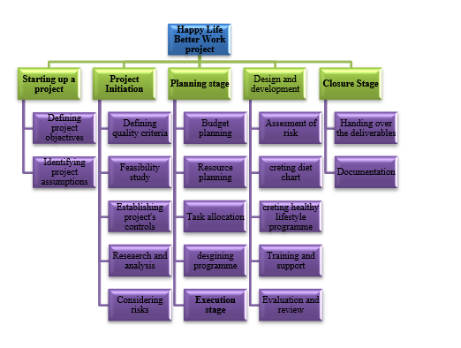
Figure 1: work break down structure
The work breakdown structure is a very effective tool for any kind of project management as it describes the work which the project needs to be implemented in order to be successful. Work breakdown structure in project management describes as a method to execute complex tasks through multi-steps (Aljamee and Naeem, 2020). In the present multistep project, the work breakdown structure initially consists of five different stages. While structuring up the project the activities include defining the project's objectives, finding out project-related assumptions, identifying the masterminds, and more. After this phase, the stage of project initiation occurs. In the project initiation phase, the tasks consist- of defining the quality criteria of the project, feasibility study, establishing proper project controls, research and analysis, and risk consideration. Right after the initiation stage, the planning stage appears. In the planning stage, the required works are broken down into four stages to be successfully implemented. In the planning stage, the tasks consist of budget planning, resource planning, and allocating jobs and resources to the project team. The fourth stage of project management is execution in this stage the works are broken down into six different categories which include- development and design, Risk assessment, creating diet charts, creating healthy lifestyle-related programs, prided training and support to the workers, and finally evaluation and review. The last step of the project development is the closure stage. In this stage, tube activities include handing over the deliverables to the project owners and documentation.

Cost and Resource use
Cost management and resource utilization are important in the project planning process to improve the development strategy of the project. Cost allocation can help the management to make the proper decision in the project development process effectively. There are three different resources that can be seen in the project management process such as human resources, physical resources, and financial resources. The estimated total cost of the project planning phase will be over £9000. The use of the resources has been stated below-
Resource | Description | Usage | Cost
Nutritional advisor  Team empowerment  Team building workshop | Staff costs and managerial costs are the human resources required in the planning phase of the project. | The project planner and project manager are used to develop the initial plan for the project and identify the cost related to the project management operation. | £3200
Materials and Handouts | Physical resources, computers, ERP software, and stationary are required in the planning phase. | ERP software can be used to allocate the resources in the project management process whereas the computer can be used for the data management. | £2500
Financial resources | The financial budget and financial report are the financial resources required for the planning stage. | A financial budget can help to predict the potential financial requirement in the business operation which can help the project management in resource planning. | £3500

Consideration of Resources
Resources are seen to be one of the most important aspects, which ensure the smooth completion of project activity. The presence of effective resources enables members of a particular organisation to finish the project effectively as well as efficiently. In order to carry out the project The Happy Life Better Work there would be used primarily two types of resources namely, “Human Resources” and “Financial Resources”. Under “human resources”, it would be the project planner under whose instructions project activity would be continued systematically. The individual who would be working as a project planner would have to be very careful in making a proper plan in the form of a strategy using which the project activity can be contained in a systematic manner (Kulik and Perry, 2023). Financial resources would also be vital for carrying out the activity in the project-planning phase. It would determine the task of formulating a budget for making smart decisions related to the project activity. At the same time, financial resources such as “capital funding”, “liquid assets”, “retained earnings” and others would prove to be helpful for the person in charge of the project to formulate strategic decisions to carry on the activity in a systematic manner. Apart from these two physical resources could also be taken into consideration for this project activity in planning the same. It would include the usage of “raw materials” and “machinery”, which would be monitored under the guardianship of the project manager in a systematic manner (Snell and Morris, 2022).

Project Schedule and Gantt Chart
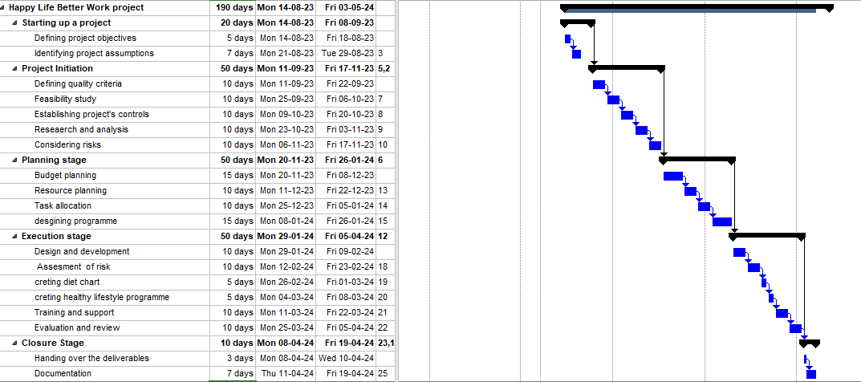
The Gantt chart in project management illustrates the works which are going to be completed within a particular period. The Gantt chart typically includes two main parts outlines and task lists (Li et al. 2022). The project needs a total of 180 days to be completed. Project activity defining requires a total of 5 days to be fully executed. The provided timeline for the project describes that in the initiation phase. The project initiation stage consists of some steps which include- defining project activities, defining feasibility, establishing proper control over the project, considering risks, research, and analysis. The initiation stage of the project needs 50 days in total to be fully executed. In the planning stage of the project, the tasks consist of resource allocation, task allocation., budget planning, and resource planning. This project management needs a total of 50 days to execute the tasks in the planning stage. The timeline showcases that the project needs a total of 70 days in the tube execution stage. Finally, in the project closure stage 3 days are allocated to handing over the deliverables to the project owner and 7 days for documentation.

A Risk Assessment
Possible risk | Risk Description | Likelihood (high, medium, low) | Responsible Person | Mitigation Strategies
Insufficient funds were allocated for planning the project. | Inadequate project planning resources like money, time or staff may result in a lack of information or insufficiently effective planning. | Medium. | Project Manager. | 1. There must be a clear flow of communication. All the management must be informed in detail about the resources needed for effective planning (Kerzner, 2019).  2. To support the allocation, there must be a thorough strategy or detailed plan with predicted resource requirements.  3. Another strategy would be to work together with stakeholders to quickly identify any potential resource limitations and look for workarounds.
Improperly conducted stakeholder analysis. | Failure to recognise and comprehend the relevant stakeholders' requirements and expectations led to a lack of involvement and support from stakeholders throughout the planning phase. | High. | Project Manager. | 1. The most effective mitigation strategy would be to carry out an in-depth stakeholder analysis by involving subject matter experts and relevant departments.  2. To identify important stakeholders, their levels of influence, and their areas of interest, it is suggested to use stakeholder mapping approaches (Kivits and Sawang, 2021).  3. Communicate with stakeholders frequently to get their opinions, handle any issues and guarantee their participation in the planning process.
Inadequate verbal or written communication | Stakeholders, management and project team members should all communicate effectively about mismatched expectations, delays and misunderstandings. | High. | Project Manager | 1. Create a thorough communication strategy that includes the channels which will be used and stakeholders.  2. Encourage honest and open dialogue among project team members and stakeholders.  3. Another mitigating strategy is to incorporate different communication techniques and tools to make sure of the accurate and timely delivery of information (Lang, 2021).
Inadequate risk analysis and emergency planning | Failure to sufficiently identify and evaluate potential risks at the planning place might result in unforeseen problems that can interfere with project goals and timelines. | Medium. | Risk Management Team and Project Manager. | 1. The first mitigating strategy might be to find prospective hazards and their potential effects on the planning phase. For this, a thorough risk assessment is required.  2. Another important motivation strategy is to create a risk management strategy that includes mitigation tactics, backup plans as well as escalation procedures (Bourne, 2016).  3. Throughout the planning phase, it is important to update and review the risk register frequently to handle any new risks that might appear.
Table 2: Risk Assessment for Magan Project- for the planning phase
Magan and the project manager need to consider the risks that are likely to appear during the planning phase. They need to address them and incorporate the mitigation strategy wherever required. This way, the project's manager can apply the project successfully at Magan and proactively mitigate the effects on the success of the project (Rowe, 2020). Risk assessment, effective communication, stakeholder analysis and so on are essential for a well-planned project that lays the groundwork for the succeeding phases.

Conclusion
From the report, it can be found that the project can be a successful one. It is also seen that there might be risks during the planning phase however the restaurant's HR department and project manager need to mitigate those. The report has provided a well-structured project plan focusing on the planning phase for Magan' staff to have the happiest and healthiest life ahead.

References
Bourne, L. (2016). Stakeholder Relationship Management: A Maturity Model for Organisational Implementation. [online] Google Books. CRC Press. Available at: https://www.google.co.in/books/edition/Stakeholder_Relationship_Management/vGPeCwAAQBAJ?hl=en&gbpv=1&dq=Stakeholder+Analysis&printsec=frontcover [Accessed 18 Jul. 2023].
Hoory, L. and Bottorff, C. (2022). What is a stakeholder analysis? Everything you need to know. [online] Forbes Advisor. Available at: https://www.forbes.com/advisor/business/what-is-stakeholder-analysis/ [Accessed 18 Jul. 2023].
Kerzner, H. (2019). Using the Project Management Maturity Model: Strategic Planning for Project Management. [online] Google Books. John Wiley & Sons. Available at: https://books.google.com/books?hl=en&lr=&id=4vyGDwAAQBAJ&oi=fnd&pg=PR11&dq=planning+a+project+in+project+management&ots=UbEoG1e0hX&sig=QUHoiP3ru4u177L6vBxzE2qA-F8 [Accessed 18 Jul. 2023].
Kivits, R. and Sawang, S. (2021). The Dynamism of Stakeholder Engagement: A Case Study of the Aviation Industry. [online] Google Books. Springer Nature. Available at: https://www.google.co.in/books/edition/The_Dynamism_of_Stakeholder_Engagement/ROEmEAAAQBAJ?hl=en&gbpv=1&dq=Stakeholder+Analysis&printsec=frontcover [Accessed 18 Jul. 2023].
Kulik, C. T., and Perry, E. L. (2023). Human resources for the non-HR manager. Routledge.
Lang, C. (2021). Stakeholder Analysis in the Context of Project Management. [online] Google Books. GRIN Verlag. Available at: https://www.google.co.in/books/edition/Stakeholder_Analysis_in_the_Context_of_P/gfFLEAAAQBAJ?hl=en&gbpv=1&dq=Stakeholder+Analysis&printsec=frontcover [Accessed 18 Jul. 2023].
maganrestaurant (2023). Magan Restaurant. [online] Magan Restaurant. Available at: https://maganrestaurant.com/ [Accessed 18 Jul. 2023].
Rowe, S.F. (2020). Project Management for Small Projects, Third Edition. [online] Google Books. Berrett-Koehler Publishers. Available at: https://books.google.co.in/books?hl=en&lr=&id=BSzJDwAAQBAJ&oi=fnd&pg=PP1&dq=planning+a+project+in+project+management&ots=qnQ2z-yq1m&sig=BXd249-OMnlg8ixkAmyGi3sQZC0&redir_esc=y [Accessed 18 Jul. 2023].
Snell, S., and Morris, S. (2022). Managing human resources. Cengage Learning.
Willumsen, P., Oehmen, J., Stingl, V. and Geraldi, J. (2019). Value creation through project risk management. International Journal of Project Management, [online] 37(5), pp.731–749. Available at: https://www.sciencedirect.com/science/article/pii/S0263786318304848 [Accessed 18 Jul. 2023].
Aljamee, H.K. and Naeem, S.M., 2020, March. The benefits of applying project management methodology on project delay: A study in construction projects in Iraq. In IOP Conference Series: Materials Science and Engineering (Vol. 745, No. 1, p. 012155). IOP Publishing.
Li, D., Han, D., Xia, B., Weng, T.H., Castiglione, A. and Li, K.C., 2022. Fabric-GC: a blockchain-based Gantt chart system for cross-organizational project management. arXiv preprint arXiv:2207.09249.

APPENDIX

