Report on Data Handling Kwikimart


Name: William Spencer
Student number: 1704386
Module: Digital Intelligence & Analytics (BMBM5006)

Table of Contents

Executive Summary Page 3
Introduction Page 4
Microsoft Excel Page 4
Strength and Weakness Page 7
Weka Page 7
Conclusion Page 8

Table of Figures
Figure 1 Page 4
Figure 2 Page 5
Figure 3 Page 5
Figure 4 Page 6
Figure 5 Page 6
Executive Summary
This report analysis Kwikimart set of data using different data mining tools to determine which will be more affective for the data. Excel is looked at first, which is a spreadsheet with pre-processing capabilities, the report analyses IF statements, VLOOKUP, Pivot Tables and Charts and Graphs. Excel is found to be easy to use and very visual when trying to look deeper at the data.
Weka is a much more comprehensive data mining program, the report explains the three different types of datamining used, Prediction – the way of looking at past events to forecast. Association – the way of finding products that wouldn’t normally be associated and grouping them together. Lastly is clustering – the process of finding natural groupings or clusters and using these to understand and recognise customer segmentation.

Introduction
This report will analyse a large set of data from Kwikimart.csv using and compering Microsoft Excel and WEKA. The report will look at the capabilities of both sets of data mining software processes and highlight some strengths and weaknesses they might have and highlight any areas of the business where profitability is low or negative.
Microsoft Excel
Microsoft Excel has many functions available to accurately mine data. This report will look at IF statements, VLOOKUP, Pivot table, Charts and Graphs. An IF statement can test for a specific situation, IF statements would be created using the formula =IF(the selected cell >0,”PROFIT”,”LOSS”) in Kwikimart.csv the If statement was used to determine whether a specific sale was a profit or a loss to the company. Using the If statement speeds up the process making it easier to see if a sale is a profit or loss.
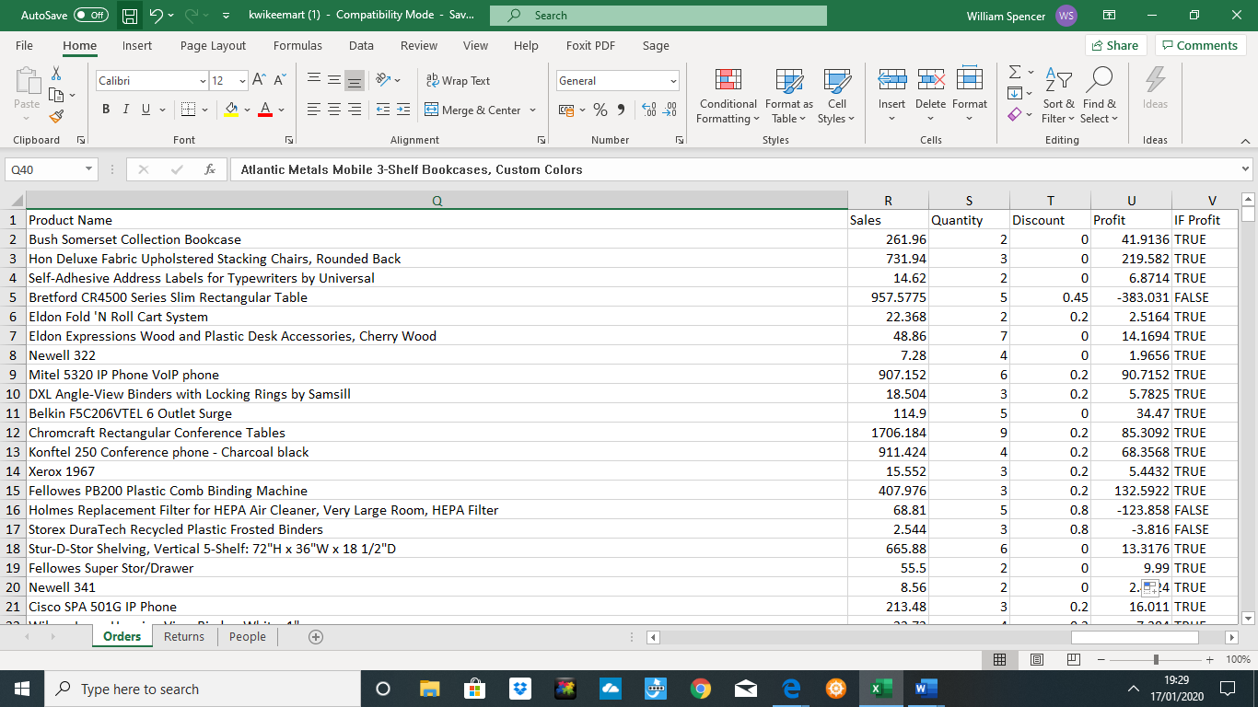

Figure 1

The next function is VLOOKUP, this is a way of being able to find specifics in the data instead of trying to look through the whole spreadsheet. Using Kwikimart.csv VLOOKUP is used to look up any customer and see if they have a profit or a loss for the company. The formula is as follows =VLOOKUP(E4,A4:C797,3,FALSE) in this situation E4 is the customer’s name and the formula is cross referencing the customers sales against profit. This is useful to see what customers are valued within the business.

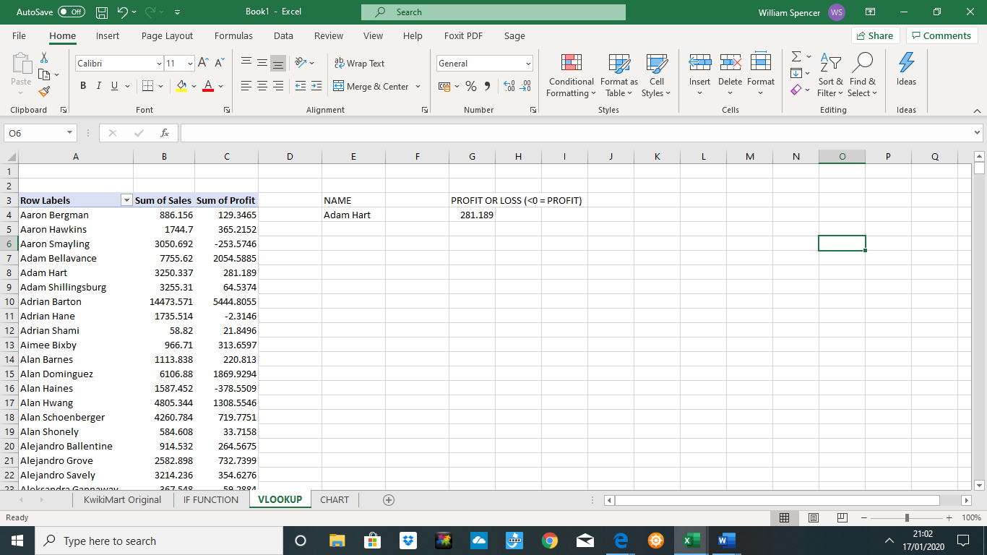

Figure 2
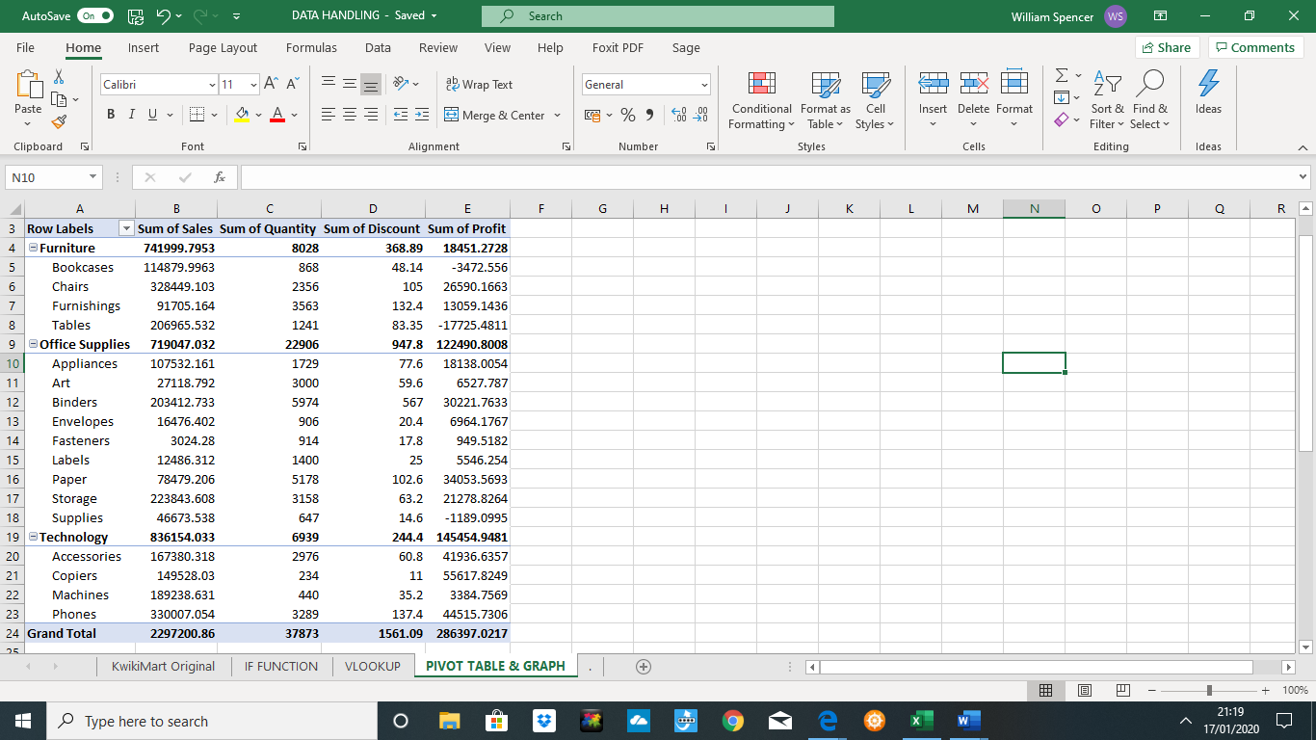
Pivot tables are the third function used in data mining in excel, Pivot tables are useful for a breakdown of the data. As the data can be quite difficult to read a Pivot table is much easier to look at large amounts of data and is simple to use with a drag option to design the table with any fields required. This report for Kwikimart.csv looked at how many of each item were getting sold. A pivot table can also make subcategories, for example instead of listing all products the table listed them as furniture, office supplies and technology.

Figure 3
Charts and Graphs are a useful tool to use to be able to read the data quickly and accurately, a bar chart was created for Kwikimart.csv showing was the most popular items were. This is a great tool to use to accurately see which items are selling more, in contrast to a pie chart that is a lot more difficult to read.
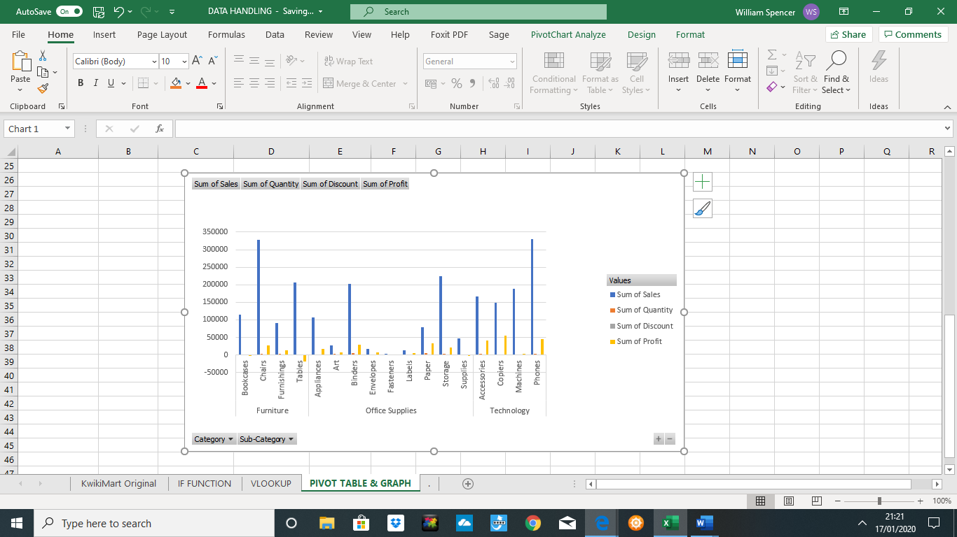

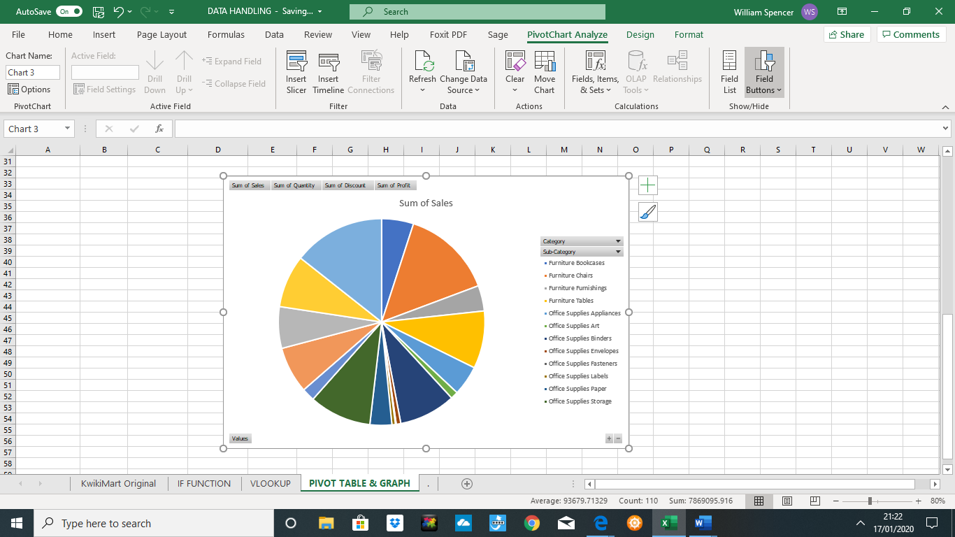
Figure 4

Figure 5
Strengths and Weaknesses to Microsoft Excel
Excel is a great data mining tool for a smaller business as it is affordable compared to other types of data mining software. It is also fairly simple to use with many online tutorials and videos to help the user understand using the program. Another benefit to using excel for mining data is how using pre processing can help visualise the data. With using VLOOKUP the data can be read much easier and it is then easier to see what items sell and what trends there are in the business.

Weka
Weka is a data mining program set to mine large sets of data, there are three main parts to Weka that this report will look at, Prediction, Association and Clustering. The report couldn’t upload images from Weka as the user couldn’t input the data, which is the main major issue with Weka. The program isn’t as user friendly as Excel, for a novice on data mining Weka could be considered off putting to use.
Prediction looks at past experiences to predict future outcomes. There are two sides to prediction, Classification and Regression. Classification will look at one variable of the data where regression would look at loads of different variables. Kwikimart could use this to predict future selling trends with the customers.
Association is the next way of mining data using Weka, this looks at the different items that pair together unexpectedly. This could determine what products should be shelved together creating ease for the customer. Kwikimart could use association to know where to stock their products.
Lastly is clustering, this is the process of groups naturally clustering together. This is useful for the business as they can then segment different things, Kwikimart would use clustering to group the customers together, based on certain purchasing characteristics to send them different marking material relevant to them.

Conclusion
In Conclusion, it is recommended that Kwikimart use Excel for data mining over Weka, as Excel is much simpler to use and the data that needs to be used can be completed perfectly using excel. Also, the visualisation excel is much easier to read and use to under profitability for Kwikimart.

