A critical analysis of the relationship between teacher subject knowledge and effective learning and teaching in the primary school.
Word Count: 4223.

Introduction

This assignment will discuss the connection between the subject knowledge of the teacher and the impact it has on teaching and learning of the children. It will look at the different theories behind subject knowledge, the experience that I had during my Professional Teaching Experience (PTE) placement and the way I used my specific subject knowledge with the class. It will look at the effect it had on the pupils learning as well.

School X is a rural school situated in West Wales where 3-11 year olds attend (My Local School, 2018). The school is made up of 236 pupils in an English medium school. The school is situated in a deprived area where 27.5% of the pupils are on free school meals. I was placed in a class of 22 pupils in Year 5 and 6 (9-11 year olds). The class was made up of 11 Year 5 (4 male, 7 females) and 11 Year 6 (6 males, 5 females). The class was mixed ability group, where 5 (year 5’s) were lower ability and 2 from year 5 and 5 from year 6 were more able and talented pupils. The class had a Learning Support Assistant for a pupil with hearing impairment, but they also helped to support the lower ability groups when doing group work.

Literacy based research:
Teachers have a responsibility to educate students in a professional and effective way so that students can reach their optimum attainment (Jarvis, 2006). There are many areas and strategies in which a teacher can do this and Hattie (2012) discusses what effects the learning of the pupils most, which will be looked at further on in the assignment. One of the qualities that a teacher should have is Subject Knowledge. Subject Knowledge is a complex matter and can be defined differently by different theorist / theories such as Lee Shulman’s theory (Shulman, 1986) and the Knowledge Quartet (Rowland, Huckstep, and Thwaites, 2003). These theories will also be discussed further on in the assignment.
Graham Donaldson mentions that “… subject knowledge has stood the test of time and remains the best path to a sound and relevant education.” (Donaldson, 2015: 5;4.) In ‘Successful Futures’ where he believes that over a course of time, it is clear that subject knowledge has been one of the fundamental aspects for pupils to achieve the best that they can. For the curriculum and education in Wales to develop and improve, teacher subject knowledge needs to be inspired within the teacher. Therefore, to enhance this level of attainment in education across Wales, subject knowledge should still be in place within the teacher when the new curriculum comes out (Donaldson, 2015).

Most theories behind Subject Knowledge can be split into further categories such as Shulmans theory (Shulman, 1986; Shulman, 1987) within subject knowledge. His belief is that for the pupils to have the best possible outcome, teachers need to have a sound Pedagogical Content Knowledge. This is then split into two sections; Subject Content Knowledge and General Pedagogical Knowledge.

Subject Content Knowledge is the subject matter in which the teachers are educating the students and the outcomes of what they are expected to learn within a specific topic area (Shulman, 1986; Shulman 1987). Hence, it is well known that teachers in a secondary setting should have excellent subject content knowledge as they are teaching in a specific subject role (Grigg, 2010). It can be argued then, is it important for teachers in a primary position to have excellent Subject Knowledge in all subject areas? Buchmann (1984) argues that it is important for teachers to have Subject Content Knowledge as you need a deep understanding of a topic, allowing teachers to be able to respond to the pupils needs. By having this the teacher will be able to explain certain or specific subjects and will be able to respond to pupils who may have some misconceptions in the particular subject area. However, Hattie (Hattie, 2012; The Australian Society for Evidence Based Teaching, 2018) disagrees with this, which will be looked at later in the assignment.

Ofstead (2009) reports, that when their review of schools which had “good’ teaching skills and but not excellent, the teachers particularly did not have such a grasp on the Subject Content Knowledge and it was shown in their lesson objectives being focused on a literacy or mathematical target instead of the specific subject taught. There would be reports on the effect that pupils have misconceptions and errors in their work due to the lack of knowledge that the teacher has (Harding, 2018). Therefore, if teachers had a better understanding of the Subject Knowledge, they would have an opportunity to correct the pupils work there and then, which in turn helps the understanding of the topic for the pupils. This could even improve the feedback to pupils when they have questions about that subject area. Because without the subject content knowledge the teacher does not feel confident to answer, but when their subject content knowledge is effective, they will be able to answer the pupil’s questions (Shulman, 1986; Shulman, 1987).

However, if a teacher only had subject content knowledge without the help of Pedagogical Knowledge, they will find it difficult to transfer this knowledge to the pupils. This is where Shulman (1986; 1987) other section for Subject Knowledge comes in. He says that teachers need Pedagogical Knowledge to be able to transfer knowledge to the pupils. Several features make up pedagogical knowledge, from assessing and tracking, different theories which surround teaching, knowing the curriculum, knowing the learners and their characteristics etc. (Shulman, 1986; Shulman, 1987). Without pedagogical knowledge, children may become confused as a teacher is not able to simplify their knowledge base, suitable for them to understand the subject or even use the best strategies that the children can learn in, in order for them to reach their full potential. As Even (1993) states, experts in a subject area are very knowledgeable about their subject matter but they are not able to address the subject to the pupils. This is because it is too complicated for them to understand, therefore pupils will not learn as they will get disheartened by the thought of not being able to do the task. This results in the pupils putting minimum effort into the task, which effects the outcome of their understanding.

As Shulman (1986; 1987) stated, Pedagogical Content Knowledge is the combination between Pedagogical Knowledge and Content Knowledge and he believes this is the best opportunity for pupils to learn. Without Pedagogical Content Knowledge, teachers will not be able to deliver a deep and rich subject content or be able to respond to pupils inquisitive questions. Further the teacher may not be able to identify if a pupil has made an error, or be able to simplify their knowledge suitable for the learner to use or adopt the best strategies children can use in order for them to learn to their full potential. (Shulman, 1986; Shulman, 1987).

With this in mind, some theorist such as Montessori (Montessori, George and Holmes, 2016) for example, believe that children should investigate matter for themselves and should come up with different ideas and strategies on how to overcome obstacles on their own. Therefore, it is questioned whether teachers Subject Matter Knowledge should be as important as Shulman states that it is. This is especially important in subject matters such as Mathematics and Scientific experiments. This links to the teacher Subject Content knowledge, by allowing the children to find their own way to identify the answer instead of the teacher telling them the reply to their questions. This is more prominent in the foundation phase, as children are all hands-on in their learning, with Donaldson (2015) stating that children of all ages should do more active learning and learning through play. Alternatively, theorist such as Vygotsky, needs Subject Knowledge to allow the teacher to help scaffold pupils. A teacher will need the subject content, as they will not be able to provide the support for the pupils and without the knowledge of the subject itself, it will be very difficult (McLeod, 2018).

Similarly to Shulman, the Knowledge Quartet discusses the four areas for a successful subject knowledge (Rowland, Huckstep, and Thwaites, 2003). The four areas include; Foundation, Transformation, Connection and Contingency. The Foundation is the basic starting point, this is the teacher’s knowledge (Rowlands, 2012e). It’s where the teacher understands the content of what is being taught and the pedagogy behind how children learn. Linking back to Shulmans theory, this is the Content Knowledge and the theory behind the pedagogical knowledge on how children learn.

Transformation includes being able to use their pedagogical knowledge in a classroom by being able to model and use appropriate examples for pupils to use, therefore they have to have a sound understanding of the content and how to deliver and transfer this knowledge to the pupils (Rowland, Huckstep, and Thwaites, 2003), again linking in with the Pedagogical knowledge with Shulman. Without this, teachers will find it difficult to address their subject to their pupils. It could be as simple as making a connection between division and multiplication (Rowlands, 2012d). Without this knowledge children may find this concept hard to understand.

The third area is Connection, this links the pupil’s prior knowledge and to make connections to their future learning, whether this is the instructions given to the pupils or the lesson ordering (Rowland, Huckstep, and Thwaites, 2003). Linking back again to a division (Rowlands, 2012c), the teacher can find a connection between this lesson and a previous lesson on multiplication which will be able to get the pupils to think about their work.

The final area is contingency, this is where it provides an opportunity for the teacher to reply to any of the questions asked by the pupils (Rowlands, 2012a). This offers opportunities to maximise the pupils learning, where the teacher can provide another alternative solution of a better understanding for the pupils if needed or even noticing a spark that interests the learners where they can then create another chance for learning (Rowland, Huckstep, and Thwaites, 2003). This is more difficult, as the teacher should have a sound knowledge of the content and be able to answer the pupils question in a way that the pupil understands. It could even be identifying when a pupil is struggling and offering alternatives, such as different ways to find the answers to a division question.

However, Hattie (2012), believes that although Subject Matter Knowledge is important in teaching, it is not as important as other factors that can influence and affect the learning of the pupils. According to The Australian Society for Evidence Based Teaching (2018) Hattie conducted a meta-analysis of factors that affect and influence the pupil’s achievement. He identified 138 factors that have influenced and effected the learning of the child. Teacher’s Subject Matter Knowledge is fairly low in comparison to others with an effect size of only 0.09. Comparing this to other factors such as family life and structures where “fathers” come under as an effect size of 0.2 or classroom influences where “classroom behaviour” comes under 0.62 of an effect.
However, teaching strategies have some of the highest effects on pupil’s achievement. These include; the learning intentions and feedback which both have an effect size of 1.29. Thus meaning, Hattie puts a great deal more emphasis on how to teach the children by using different strategies and the awareness of pupils themselves as this will have the greater impact on the outcome and achievement of pupils. This can be linked to Shulmans Pedagogical content knowledge and the Knowledge Quartet (Rowland, Huckstep, and Thwaites, 2003). As they have highlighted the importance of the teaching structures which is identified in the transformation and connection model in the Knowledge Quartet where it is important for the teacher to understand the different strategies available for the pupils in order for them to have their optimum learning.

Having said this, Hattie later revisited the topic matter and said the more experienced teachers would be able to use their Subject Knowledge to their advantage. This is achieved by teachers being able to organise their lesson in order for the pupils to learn, and these expert teachers will be able to recognise when their students are finding a particular topic difficult (Heggart, 2016). With their knowledge on the subject they are able to simplify it, in order for others to understand. Others have criticised Hattie with some saying that they believe that a teacher should not just focus on one factor that could affect the child’s attainment (Heggart, 2016). They believe that to become an excellent teacher you must consider all factors that can affect a child learning and include it into their teaching.

Coe, et al, (2014) believes that Pedagogical Content knowledge is a fundamental part in a teacher. They say that if teacher does not have this quality there is strong evidence that this will have an impact on the pupils attainment and outcomes. They believe that, not only should a teacher be aware of what they’re teaching but also the pedagogical side, linking this with Hattie, teachers should have an idea on how to overcome students misconceptions (Coe, et al, 2014).

Analysis and Evaluation on my subject knowledge

I have had many opportunities to reflect and evaluate my own subject knowledge in class.

Workhouse:

One of the lessons where I thought that my pedagogical content knowledge was evident was in the imaginary recount lesson (Appendix 1). On teaching practice, the class topic was the revolution era. To begin I felt that my knowledge on this topic was very slim, so I decided to research further into the topic before teaching it to the class. After researching, I found that I have some prior knowledge on the subject, but I researched further as I felt I needed wider knowledge on the subject to be able to teach it to the class. From this, it gave me a better content knowledge linking to Shulmans theory of content knowledge and the foundation part of the knowledge quartet.

I was confident in my pedagogical knowledge as I have an undergraduate degree in Primary education and I had undertaken a wide range of research in to different theories. The aim of this is to help children learn again linking in with the foundation part of the Knowledge quartet and Shulmans theory of pedagogical knowledge. From having this knowledge, I adapted my lesson, so it was child friendly. I asked them to build on their own prior knowledge in order to gauge their understanding of the topic so far. It was evidenced that they understood what they needed to do; to write an imaginary recount, however they had little information about the revolution era. This linked to the connection model of the knowledge quartet.

I was confident in the class to explain and instruct the pupils the knowledge on how to write an imaginary recount and the content of living in a workhouse. This was proved effective as one pupil enjoyed the lesson so much, they went on to write a diary of living in a workhouse in their free time. I used open ended questions with the pupils, to get them to think about what they were learning and think about different answers. When the pupil’s curiosity peaked, I was able to answer questions correctly from them. I was also able to correct pupils from their misconceptions from not only about the information about workhouse but also misconceptions about how to write an imaginary recount. This links in with the transformation section of the knowledge quartet. Instead of telling them the correct answer, I asked the class whether they agree, and what they thought the correct answer was and to explain why. This then gave me an understanding of how well the other pupils understood the task.

I used my pedagogical knowledge when I used a hook (a diary entry from a workhouse) for a lesson, which engaged and increased the interest of the pupils in the lesson. This was then used as a model to help pupils in their writing. This links in with Shulmans pedagogical content knowledge and with the quartet knowledge by transformation, where it helped the pupils to write an imaginary recount.

I used the connection section in the knowledge quartet as I had a previous lesson on how to write and imaginary recount information regarding the content of the life in a workhouse (appendix 2). I had these lessons, so I was able to build the pupils knowledge on imaginary recounts and the workhouse. However, in the previous lesson one of the downsides was that my model example of a recount had errors in it – for example, the sentences had been mixed up. This did confuse the pupils when they read it, however it did not affect what the pupils needed to include in a recount. I overcame this by asking the pupils to problem solve by asking what they thought the sentence should have said.

It is proved that the lesson was successful, by the tracking of the lesson shown in appendix 3. It shows that most of the pupils understood what was needed in the task as they were able to as most hit green.

Maths: Bar graphs.

One lesson where my pedagogical knowledge was not apparent was in one of the maths lessons. I believed I would be confident in teaching maths as I enjoyed maths in school and it was a subject I was most comfortable in. The maths group I taught in school X, was the lower ability group of 17 pupils from Year 5 and Year 6 (from the other classes as well as my own class). The first lesson that I taught was a lesson on bar graphs (see appendix 4). As this topic can be done in year 2, I thought I could ask more complicated questions from reading a bar graph, but as this was a lower ability group it was apparent that they were not able to follow the questions.

The lesson planned was too difficult for them to understand. The pupils did not understand the questions asked during the presentation. Instead of adapting the questions I decided to carry on and try to help scaffold the pupils to give them bridging steps in order to understand the questions. Looking back, I should have made the introduction more engaging, to hook the pupils attention but instead the pupils got disinterested as they felt they could not answer the questions put on the board.

During the task, they had to read their own graph, this time the questions were adapted, and the pupils were separated into groups where a staff member were able to help scaffold them. Linking back to earlier, where it’s difficult to scaffold pupils when your content knowledge is not there.

Linking this with Shulmans theory, I did not have the pedagogical knowledge to address this to the pupils for them to answer. I believed the questions asked, would be easy enough for the pupils to understand, however, they still found it difficult, especially the questions such as “the difference between __ and ___” or “how many more does __ have than ___”. It is possible that I should have known the pupils and what they would have found difficult, however it was my first lesson therefore I was unsure of what they were capable of. Reflecting on this, I should have helped them and use a mental warm up to try and help them to find the difference between 2 numbers. From this, they could have made a connection between the warm-up and the questions, which would have linked to the connection section in the knowledge quartet theory. This would have been an easier link to make than figuring out on the spot questions. I reflected on this and adapted my future lessons by planning for other mathematical lessons, I have tried to link a mental maths warm-up with the lesson planned. This is shown in appendix 5 where I used the difference in two numbers warm up for finding the range lesson. From the contingency part of the knowledge quartet, I failed to be able to offer alternatives to pupils on how to overcome their difficulties in finding the answer in the presentation, however when the pupils were on task, questions were adapted and put into groups to help scaffold the pupils which can be linked to the transformation section of the knowledge quartet.

Having said this, I did use a model on how to answer a question by using the power point in front of the class. This also links to the transformation model in the knowledge quartet. This I thought would help the children answer the questions when it was their turn to answer questions by themselves, but as they couldn’t figure out how to answer it.

Biography.

On 12.12.18 I decided that it would be nice for the pupils to create a biography on a famous person in the revolution era, it was decided that Charles Dickens would have been a good idea (see appendix 6). During the previous lesson we learned all about biographies and the life of Charles Dickens. I believed that my knowledge on Charles Dickens was limited, which resulted in me feeling less confident in teaching during these lessons. I felt this was seen in my lesson delivery to the class. Thus meaning, my content knowledge for this topic was poor which had a knock-on effect in my teaching. Although I had placed strategies into my teaching, I felt that I did not put all of my teaching strategies to use. I used Think Pair Share, which helped some individuals to scaffold the lower ability group, but I should have used more open-ended questions to challenge the higher pupils and get them thinking outside of the box. I didn’t feel confident to ask these questions as I had little content knowledge and was afraid to correct pupils as I was not sure myself.

I built up to this lesson by having planned 2 other lessons to give the information to the pupils. I had one specific for Charles Dickens then the next one specific for features of a biography. However, it is not fair to put all blame on my content knowledge as two of the planned lessons had to be placed into one lesson as there was no time to finish because pupils had practice sessions ready for the Christmas concert. This resulted in the lesson being rushed and possibly the delivery of the topic not being transferred to the pupils. Which could be linked to the pedagogical knowledge with Shulman or the transformation section of the knowledge quartet. This would have affected the pupils as they may not have been able to remember all of the necessary information needed, however it was seen that they remember most of the information on a biography from another prior lesson. This then linked in with the knowledge quartet with the connections section, as I built on the prior knowledge of the pupil. They were able to recall the features of a biography and link this information up with the knowledge learnt about Charles Dickens.

One incident where it really showed that my content knowledge was lacking was after the session on Charles Dickens, one of the pupils enjoyed learning about Charles Dickens so much that they decided to create a quiz when they got home, for the pupils in the class for the next day. When it came to answer the questions, they had gathered more information than I had about Dickens. However, I used this to my advantage and role reversal the situation, where I got the pupil to “be the teacher” and help the class out with the questions on the board. By taking this step back, I was able to see each pupil and see how well they gained the knowledge of Charles Dickens and areas they found difficult to understand. However, I had to be careful as to how much information was given as the content might not have been correct and I would not have been able to identify any misconception or misunderstandings therefore would have failed to correct the pupil.

Conclusion:

In conclusion, I believe that it is important for teachers to have a sound pedagogical content knowledge. Without so, it is very difficult for pupils to learn what is needed. If a teacher is only able to be a master in one of these areas, then the learning of the pupils will be affected. A great scientist may be an expert in his field, but without the help of pedagogical knowledge they may not be able to convey their knowledge to others resulting lack of understanding from the pupil. When a teacher then has pedagogical knowledge but no content knowledge, it is difficult to help progress the pupils further, as the teacher will have misconceptions as well as the pupil. It is important for a teacher to have both these qualities in order for the best possible attainment from pupils. Having said this, subject knowledge is important in the classroom, but there are other qualities needed in a teacher for the best possible outcome for the pupil, as explained by Hattie.

Reference:

Buchmann, M. (1984). The priority of knowledge and understanding in teaching. In L. Katz and J. Raths (Eds.), Advances in Teacher Education (pp. 2950)
Coe, R., Aloisi, C., Higgins, S. and Elliot Major, L. (2014) What makes great teaching: Review of underpinning research, available at: http://www.suttontrust.com/researcharchive/great-teaching/ (Accessed on: 29Th of December 2018).
Donaldson, G. (2015) Successful Futures: Independent Review of Curriculum and Assessment Arrangements in Wales Crown Copyright, available at: http://gov.wales/topics/educationandskills/schoolshome/curriculum-for-wales- curriculum-for-life/why-we-are-changing/successful-futures/?lang=en (Accessed on 1st January 2019).
Even, R., (1993) Subject-Matter Knowledge and Pedagogical Content Knowledge: Prospective Secondary Teachers and the Function Concept. Journal for Research in Mathematics Education. Vol. 24, No. 2 (Mar., 1993), pp. 94-116.
Grigg,R. (2010) Becoming an Outstanding Primary School Teacher, Harlow: Pearson.

Harding, E., (2018) Hundreds of teachers still struggle with spelling, maths and knowledge of the curriculum, 'confusing children by inserting errors into their work' Available at: https://www.msn.com/en-gb/news/uknews/hundreds-of-teachers-still-struggle-with-spelling-maths-and-knowledge-of-the-curriculum-confusing-children-by-inserting-errors-into-their-work/ar-BBQJy5e Accessed on: 31st December 2018.

Hattie, J. (2012). Visible learning for teachers : Maximizing impact on learning. London: Routledge.

Heggart, K., (2016) How important is Subject Matter Knowledge for a teacher? Edutopia. Available at: https://www.edutopia.org/discussion/how-important-subject-matter-knowledge-teacher accessed on: 2nd of January 2019.

Jarvis, P. (2006). The theory and practice of teaching. London: Routledge.

Mcleod, S., (2018) Lev Vygotsky Available at: https://www.simplypsychology.org/vygotsky.html Accessed on: 31st December 2018.
Montessori, M., George, A., Holmes, H. (2016) Montessori Method. 2nd edn. Frederick A. Stokes Company: New York.
My Local school (2018) My Local school. Ysgol Y Castell http://mylocalschool.wales.gov.uk/School/6692192?lang=en accessed on 2nd of January 2019
OFSTEAD (2009) Improving primary teachers’ subject knowledge across the curriculum https://dera.ioe.ac.uk/305/1/Improving%20primary%20teachers%20subject%20knowledge%20across%20the%20curriculum.pdf Accessed on: 20th of December.
Rowland, T., (2012a) The Knowledge Quartet. Contingency. Available at: http://www.knowledgequartet.org/category/contingency/ Accessed on 30th December 2018.
Rowland, T., (2012b) The knowledge quartet. Making connections between procedures. http://www.knowledgequartet.org/272/mcp-scenario-2/
Rowland, T., (2012c) The knowledge quartet. Connection. Available at: http://www.knowledgequartet.org/category/connection/ Accessed on 30th December 2018.

Rowland, T., (2012d) The Knowledge Quartet. DT Scenario 1. Available at: http://www.knowledgequartet.org/category/transformation/ accessed on: 29th of December 2018.

Rowland, T., (2012e) The Knowledge quartet. Foundation. Available at: http://www.knowledgequartet.org/category/foundation/ accessed on: 29th of December 2018.
Rowland, T., Huckstep, P. And Thwaites, A. (2003) The Knowledge Quartet. Williams, J. (Ed) Proceedings of the British Society for Research into Learning
Shulman, L. (1986) Those who understand: Knowledge growth in teaching, Educational Researcher Vol.15. No. 2: pp. 4-14.
Shulman, L. S. (1987) Knowledge and teaching: Foundations of the new reform, Harvard Educational Review, 57(1): pp. 1-22.

The Australian Society for Evidence Based Teaching (2018) Hattie’s 2017 Updated List of Factors Influencing Student Achievement http://www.evidencebasedteaching.org.au/hatties-2017-updated-list/ Accessed on: 18th of December.

Appendix:
Appendix 1:
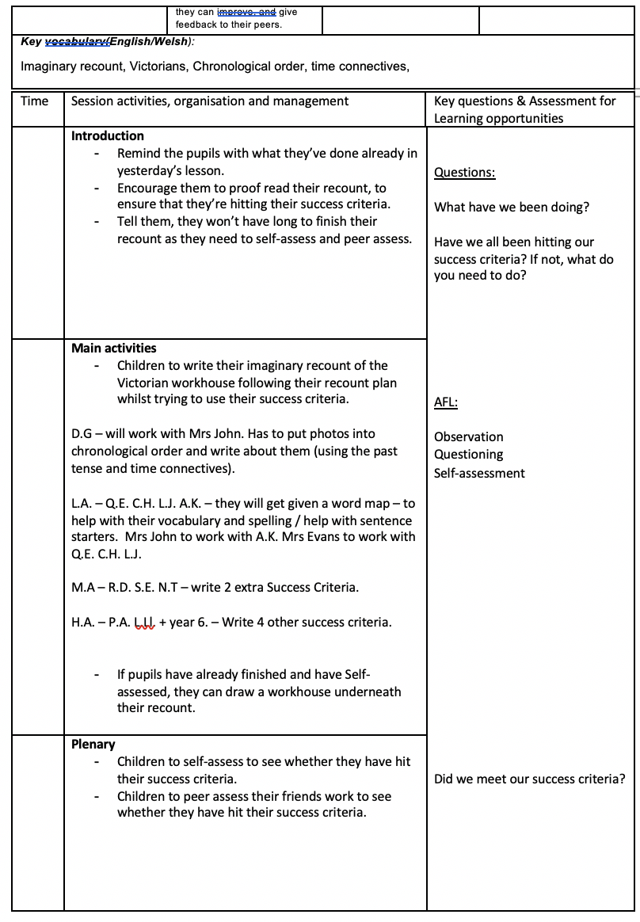



Appendix 2:
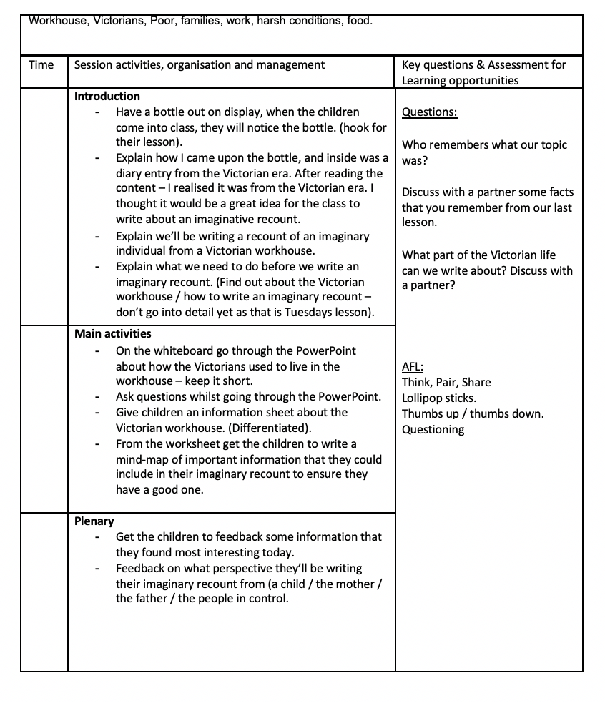

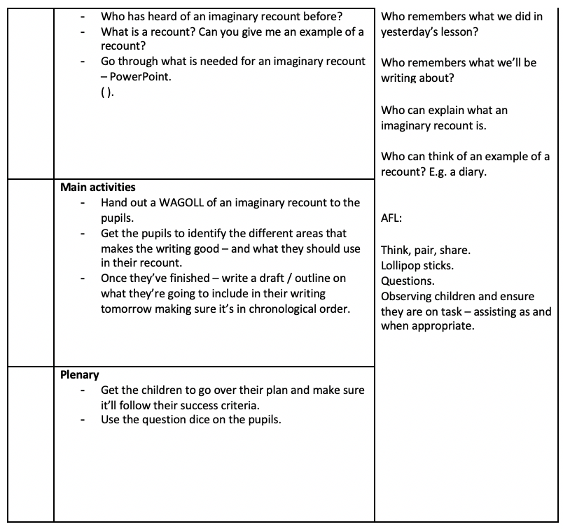


Appendix 3:
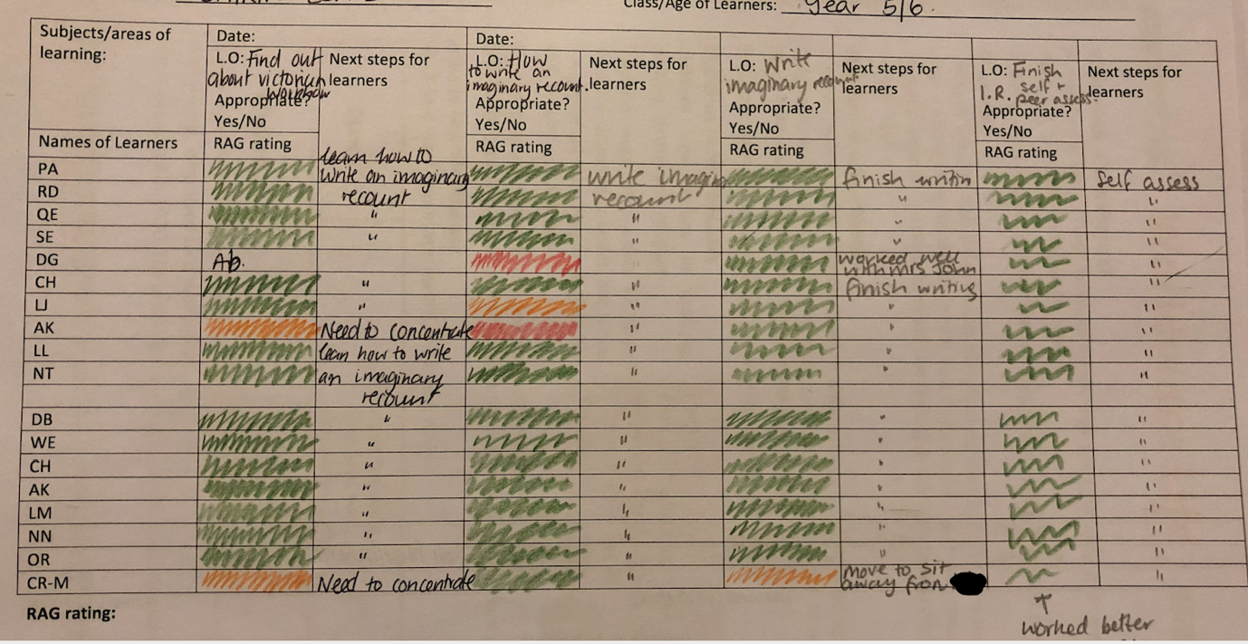




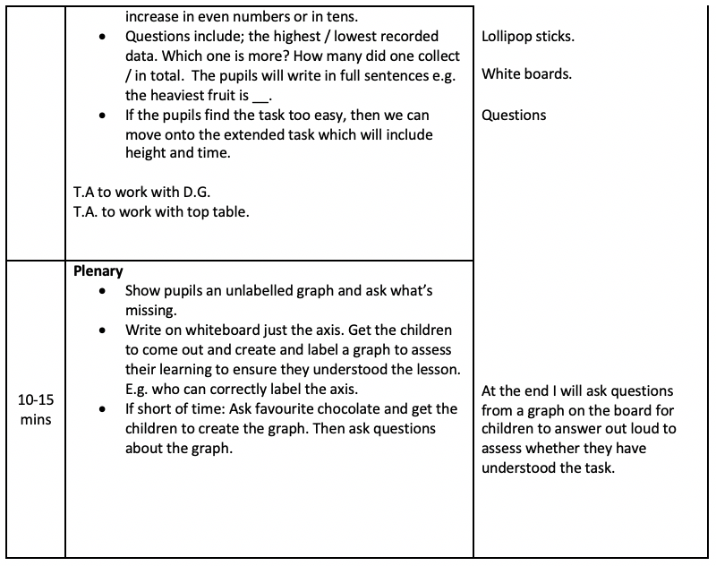
Appendix 4:


Appendix 5:
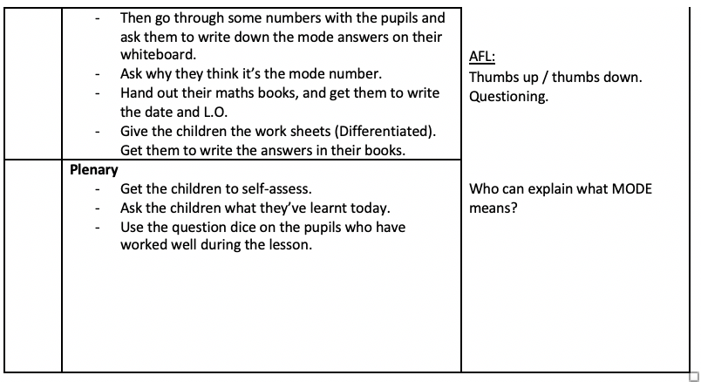

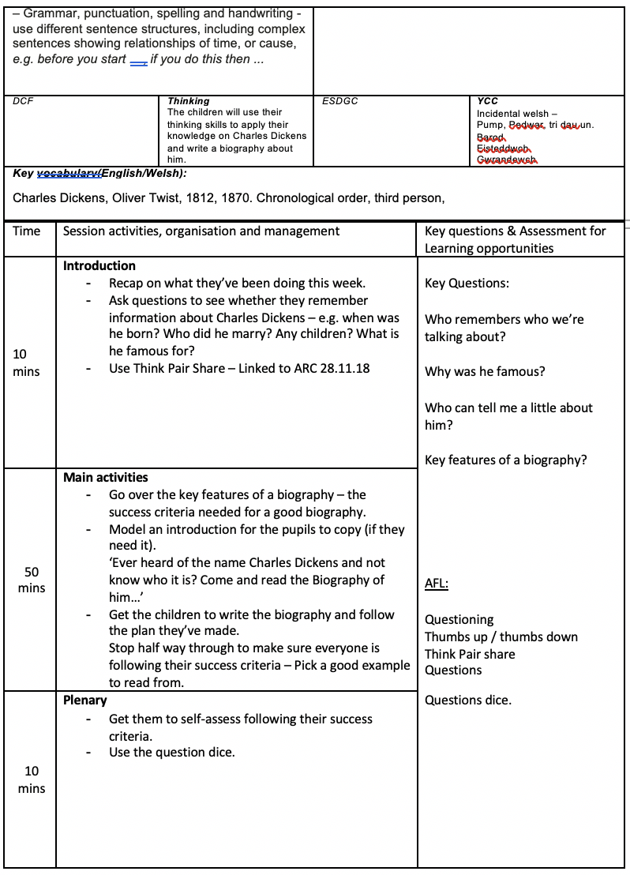
Appendix 6:


