  Component One: Student Journal (learning log) 750 words +/- 10%  Contribution to Overall Module Assessment: 25% | Student No: | Ionut-Gabriel Gheorghe  2222508
 | Module Title: | Hotel Placement – Operating Hotel Facilities.
 | Module Code: | BMIH4006
 | Lecturer: | Giulia Chifari
Description:
My placement within the housekeeping department tasked me with a variety of responsibilities that were foundational to the guest experience in the hotel. On a daily basis, I was involved in the detailed cleaning of guest rooms, ensuring that every corner of the space met the hotel’s high standards of cleanliness and comfort. This extended to meticulous bed making, replenishment of guest supplies, and the maintenance of public areas within the hotel. A significant part of my role also included adhering to the Health & Safety at Work Act (1974), which underscores the importance of a safe system of work for both employees and guests. (Augustine, 2024)

Feelings:
The experience was an emotional journey, starting with feeling overwhelmed by the exacting nature of the work and the pace required. However, as time progressed, this gave way to a profound sense of accomplishment when guests would leave positive feedback, highlighting the cleanliness and orderliness of their accommodations. The team dynamics were also a source of emotional learning; camaraderie was essential in getting through the busiest and most demanding days. Yet, the intensity of the workload, particularly during peak seasons or events, often led to fatigue and stress. Balancing the physical demands of the job with the need to maintain an unwavering attention to detail was a continuous challenge. (Serban, 2017)

Evaluation:
Upon reflection, my ability to follow detailed protocols and procedures with precision was a strong point in my performance. I demonstrated an understanding of the intricate balance between efficiency and thoroughness, which is essential in housekeeping operations. However, managing time effectively under pressure and maintaining high energy levels throughout the day were areas that required further development. The pace of the environment sometimes led to rushed decisions or actions that, while not compromising on safety or standards, could have been executed with greater finesse. Collaborating with team members was a strength, but I also recognized the need to improve in delegating tasks and communicating expectations more clearly. (Richardson, 2023)

Analysis:
My time in the housekeeping department revealed the intricate choreography behind the scenes of a well-maintained hotel. Each task, from refreshing rooms to managing laundry logistics, was a cog in the larger machinery of hospitality operations. The housekeeping department's impact on guest satisfaction was profound; a spotless room or a timely fulfilled request often translated into a glowing review or a repeat guest. I learned that housekeeping is as much about perception management as it is about actual cleaning—every fluffed pillow or neatly folded towel contributed to the narrative of care and attention the hotel prides itself on. (Barten, 2023)

Conclusion:
Reflecting on the culmination of experiences during my placement, the key lessons crystalize around the central role of meticulous attention to detail, the importance of cohesive teamwork, and the art of balancing efficiency with thoroughness. The experience has reshaped my perception of the hospitality industry, highlighting the often unseen yet critical contributions of the housekeeping department. I've developed a newfound respect for the individuals who orchestrate behind the scenes to deliver flawless guest experiences and the systems that support their efforts. (Insights, 2023)

My initial trepidation gave way to confidence as the weeks passed. I understood that the role of a housekeeper is not merely a job but a testament to the ethos of hospitality. The transformation from a novice to a competent member of the housekeeping team has been a significant personal and professional journey, underpinned by the realization that the work is a relentless pursuit of excellence. (Hunter-Jones, 2023)

Action Plan:
To further my development and prepare for future challenges in the hospitality sector, my action plan includes the following steps:

1. Time Management Enhancement: Enrol in workshops and seek mentorship to improve efficiency and learn advanced strategies for managing high volumes of work within tight time constraints.

2. Physical Well-being: Adopt a regular fitness routine to build stamina and incorporate ergonomic techniques into my work to prevent injury and fatigue.

3. Stress Management: Pursue training in mindfulness and stress reduction techniques to remain calm and focused during peak operational times.

4. Continued Learning: Commit to ongoing education in the hospitality field, including attending industry conferences, participating in webinars, and staying abreast of the latest trends and best practices in housekeeping.

5. Feedback and Reflection: Establish a structured process for receiving and reflecting on feedback from supervisors and peers to continuously refine my skills and approach to work.

6. Networking: Engage with professionals in the field through online forums and local hospitality associations to learn from their experiences and gain insights into career advancement opportunities.

By committing to these action steps, I aim to solidify my skills in the housekeeping department and position myself for future opportunities within the hospitality industry. (School, 2024)

(Words 774)

Component Two: Health and Safety Guide
Contribution to Overall Module Assessment: 25%
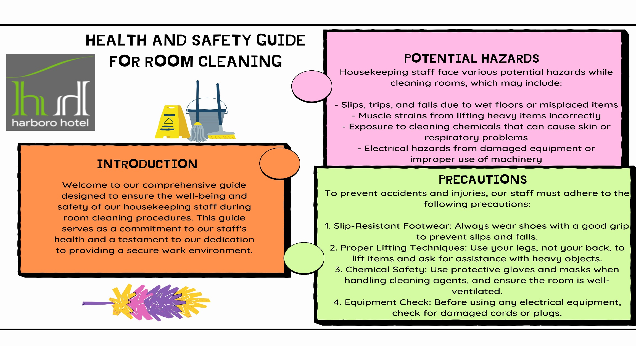
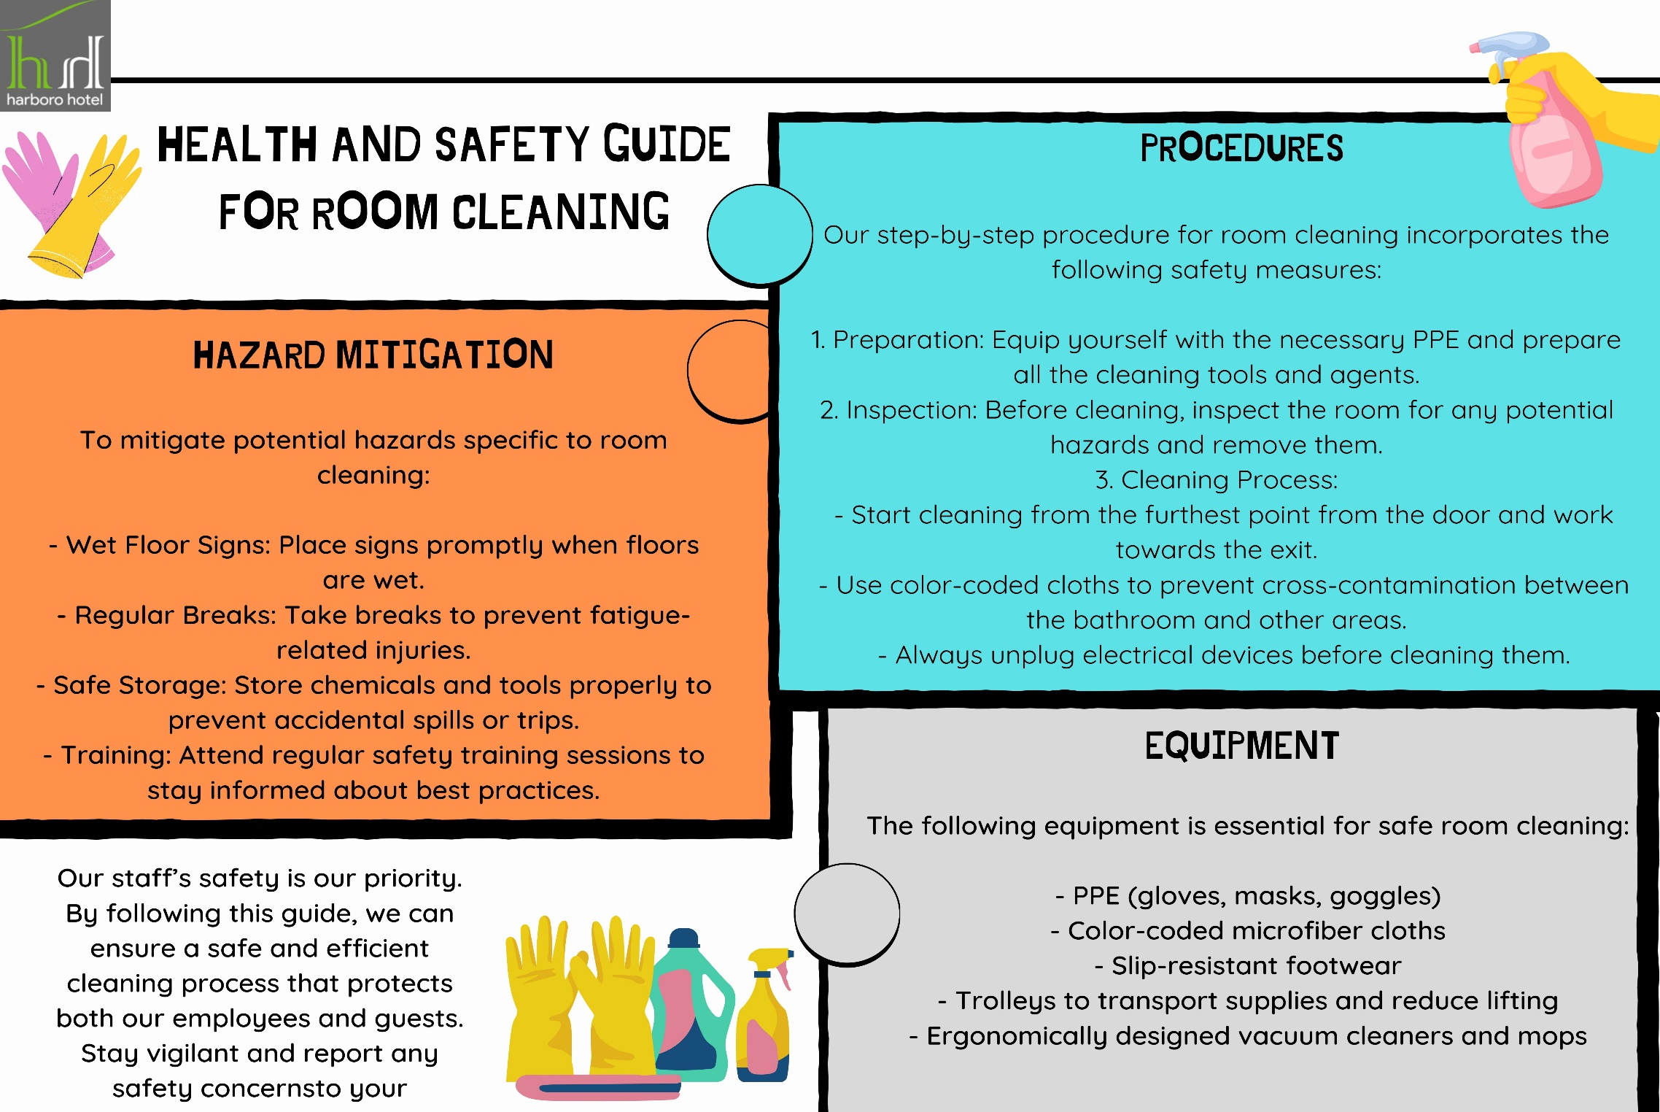

Reference List

Component one
Augustine. (2024, January 4). https://setupmyhotel.com. Retrieved from Housekeeping – Introduction, Definition, Role, Responsibilities and Layout: https://setupmyhotel.com/hotel-staff-training/housekeeping-training/housekeeping-introduction-definition-role-responsibilities-and-layout/
Barten, M. (2023, December 24). https://www.revfine.com. Retrieved from Housekeeping Department in Hotel Businesses: https://www.revfine.com/housekeeping-department-in-hotel/
Hunter-Jones, P. (2023, January 9). https://www.sciencedirect.com. Retrieved from The contribution of hospitality services to person-centred care: https://www.sciencedirect.com/science/article/pii/S0278431922002900
Insights, E. (2023, August 31). https://hospitalityinsights.ehl.edu. Retrieved from Why Hospitality is important as a skill and not only as an industry: https://hospitalityinsights.ehl.edu/why-hospitality-is-important
Richardson, T. (2023, May 21). https://www.linkedin.com. Retrieved from Balance Quality and Speed in Hotel Housekeeping: https://www.linkedin.com/pulse/balance-quality-speed-hotel-housekeeping-tayran-richardson-ceh/
School, E. G. (2024, FEBRUARY 2). https://hospitalityinsights.ehl.edu. Retrieved from How to foster continuous improvement in the hospitality industry: https://hospitalityinsights.ehl.edu/culture-of-continuous-improvement-hospitality-industry
Selander, F. (2024, January 30). https://www.lingio.com. Retrieved from Health and Safety Training: https://www.lingio.com/blog/how-to-train-housekeeping-staff
Serban, R. (2017, August 15). https://www.hubgets.com. Retrieved from Team Dynamics Is About Playing Team Roles to Your Advantage: https://www.hubgets.com/blog/team-dynamics-belbin-team-roles/
Abbas, T. (2023, October 16). Key Performance Indicators for Housekeeping – Explained with Examples. Retrieved from changemanagementinsight.com: https://changemanagementinsight.com/key-performance-indicators-for-housekeeping/

Component two

Trotto, S. (2015, December 19). Keeping hotel housekeepers safe. Safety+Health. Retrieved from https://www.safetyandhealthmagazine.com/articles/keeping-hotel-housekeepers-safe-2
Little Hotelier. (n.d.). Hotel Housekeeping: Tips, Tricks & Checklist. Retrieved from https://www.littlehotelier.com/resources/blog/hotel-housekeeping-tips-tricks-checklist/
ALICE. (2020, June 24). Post COVID-19 Hotel Housekeeping Protocols: 7 Ways They’ll Change. Retrieved from https://www.actabl.com/blog/hotel-housekeeping-protocols-post-covid19/
Unilever Professional India. (n.d.). Hotel Housekeeping Standard Operating Procedures. Retrieved from https://www.unilever-professional.com/india/hotel-housekeeping-standard-operating-procedures/
Duvigneau, A. (2022, September 6). How the New Housekeeping Policies Impact Hotel Safety. Beekeeper. Retrieved from https://www.beekeeper.io/blog/housekeeping-policies-

