

MANAGEMENT ACCOUNTING

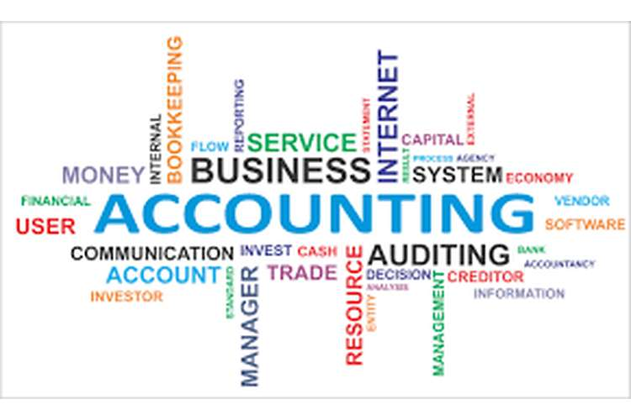

STUDENT NAME : MIRCEA PROCA
STUDENT NUMBER: 1811226
LECTURER NAME: DR. ISAIAH OINO
MODULE TITLE: MANAGEMENT ACCOUNTING
MODULE CODE: LCBB5002

Table of Contents
Part A 3
1. Absorption costing 3
2. Activity Based Costing 4
3. Costing Methods 4
Part B Evaluation of Break-even Analysis 6
Reference List 12
Appendices 14

Part A

Task:

ABSORPTION COSTING
 |  | LW | MR
UNITS |  | 4500 | 500
DIRECT MATERIAL COST | LW (4500 ×3)  MR (500×10) | 13500 | 5000
DIRECT LABOUR COST | LW (6.30÷9) × 4500 =0.70 × 4500  MR ((6.30×7) ×500 =0.90 × 500 | 3150 | 450
Overhead Cost | LW ( 67500 × 0.50)  MR (7500 × 0.5) | 33750 | 3750
TOTAL COST |  | 50400 | 9200
UNITS |  | 4500 | 500
PER UNIT COST |  | 11.20 | 18.40
 | LWs | MRs
Direct Material | 3.00 | 10.00
Direct Labor | 0.70 | 0.90
Overhead | 7.50 | 7.50
Absorption Cost | 11.20 | 18.40

ACTIVITY BASED COSTING

Activity Based Cost |  | LW | MR
DM LW- (4500 × 3)  MR- (500×10) |  | 13500 | 5000
DL LW (6.3×4500) ÷9  MR (6.3 ×500) ÷7 |  | 3150 | 450
Purchasing | LW (20000÷400) ×360  MR (20000 ÷400) ×40 | 18000 | 2000
Training | LW (1000÷50)×20  MR (1000÷50) ×30 | 400 | 600
Set up | LW (2250 ÷90)×60  MR (2250÷90) ×30 | 1500 | 750
Running machine | LW ( 2250÷90) ×60  MR (2250 ÷90) ×30 | 12825 | 1425
 | Total | 49375 | 10225

- COSTING METHODS
The costing methods are the main attempts of understanding and estimating the cost allocation of the company and eventually understanding the requirements of the cost allocation process by every department of the company. Here, the company is based on the production of different stoves (Martinović, 2019). The main variations are the LW stoves and the MR stoves. The difference between these options is mainly created through the difference within the costing system and the demand and production of the two types of stoves. The differences are helping the cost accountant to get a better and improved view of the company's management. Here, the company is mainly following the cost accounting or the management accounting technique of Absorption Costing system as this system provides a better estimation of the company's products and their costing system. This helps in getting an appropriation method for the company's production process in total and eventually identify the individual product based cost and expense. One product has the capacity of absorbing a wide range of variables and costs such as fixed costs and variable costs. These are not the expenses that are counted within the product but are often justified as one only when the entity pays for it. The main components of the Absorption costing method mainly justify the main requirements of the production process of each product. Here, the main components are the direct materials such as the raw materials with the help of which the product will be finished (Rahmann et al. 2017). The direct labours are the costs that are necessary for the construction of the product with the factory costs. The factory costs are helpful and necessary to the production process because it is the fund and the main cost or expenses by which the company can finish the product. The variable manufacturing overhead costs are the main expenses required for the construction and smooth processing of the production and manufacturing department. Through the utilization of the manufacturing department, the company will be able to mortify each of the methods that are required for the efficient maintenance of the production volume, and the efficient earning of the profitability and increase the productivity of the manufacturing department. In the case of setting up the equipment and machinery is one of the main points that are required for the company's management functions. The fixed manufacturing costs are the main thing which is necessary to operate the manufacturing activity and facilities that are not variables but fixed. The fixed costs and expenses do not vary according to the changes in the production volume of the company. With the appropriate understanding of the absorption costing system, the company is successful in maintaining the standard and yet becomes successful in the cost-optimization system. This is one of the most important costing systems of the company as it helps in the better assignment of individual product cost and helps to get a better and improved idea from the costing and management accounting system. Although there are several problems such as the constraints created by the direct costing systems and the fixed overhead costs of the company that does not help, stops the company from estimating and earning extra profits from the produced but unsold goods (Zambrzhitskaia et al. 2017). (toppr.com, 2020) [Referred to appendix 1]
The Activity-Based Costing system is mainly derived through the process of allocating the right costs and overheads to the right and suitable products that helps to assess the potential cost incurrence and relationship between the production costs and overheads of the products. This utilizes the nature and the responsibility of the products that recognizes the potential relationship between the individual costs and the available overheads. The existing relationship between the costs, overheads, manufacturing activities and the assignment of the indirect costs are identified and understood most reasonably. The Activity-based costing system is considered in this company as this company is producing large amounts of products that are segmented into two different types. Nature which is why the company can not allocate its costs and funds in a total amount due to the different portions of requirements. So, the company and the operations manager is subletting the ABC method that will help in the inadequate and specific product based cost. This will eventually find out the better version of the production costs derived through the individual products of utilities, tasks and goals that would help in estimating the cost drivers (Otley, 2016). The steps of Activity costs might be lengthy, time taking and costly. Still, the assessment and identification of the individual product are easier and adequate in comparison to the other costing system. The main steps are,
The company and the supervisor of the accounting sector identify the main costs of the company and production process that requires to be allocated in the right manner among the channels and department. Through the identification, the sorting is done. In the next step,
The company has to identify the primary and secondary cost pools, and after that, the costs are allocated appropriately around the activity cost pools of the company. Through this, the company will be successful in understanding the requirements of the products and determinants. The activity drivers are another main thing that is considered mainly to understand the details of nature and the requirements of each of the costs. The costs are allocated in the cost pools based on the information provided in the activity drivers and primary-secondary cost pools. The changeability of the cost to the cost objects is another main function that helps in creating the appropriate report of the cost allocations that eventually helps in the better management of the costing system of the products. Through the report, the company and the operations manager will be able to make the decisions and help in the assessment of the risks and instabilities that need improvements and changes in it (Cooper et al. 2017). The Activity-Based Costing technique mainly helps in the projection of the method that creates the overhead costs and the allocation of such costs as per the requirements of the company's production process and the individual products. (yourarticlelibrary.com, 2020) [Referred to appendix 2]

Part B

EVALUATION OF BREAK-EVEN ANALYSIS

The Break-even points analysis is required within a company as it helps to assess the point of company's sales and profits where the company will be able to construct the idea that the cost or expense and the total sales revenue are equal. The planning of the company helps in the understanding of the company's strength and the potential costing system potential of the company too. The business profitability and stability is judged based on the BEP analysis. Often the BEP was done by not only producing one single product but in the 21st century, it was done by implementing it in the multiple products and the production process at the same time. When a company conducts its business through multiple products and their production purposes the company may use the best process to assess the "cost-volume-profit analysis" that helps to get the idea of the efficiency in the planning and cost volume analysis process. The BEP analysis requires some main and basic components that help in the better assessment of the company's management of costs and sales process (Weetman, 2019). Here, the variable and fixed cost are required to be determined in the first go as it will help in the basic maintenance of the cost of the product and identify the adequate and correct sales revenue and the point where both of them will be equal. The BEP analysis might be very common and frequently used, but in the case of multi-product BEP analysis, the formulas and the requirements change thoroughly. In case of Multi-product BEP, the BEP in units is mainly determined through dividing the total fixed costs by Weighted Average Contribution margin per unit and in case of determination of BEP in dollars the formula stands for "total fixed Costs divided by weighted average Contribution Margin ratio". Under the changing business situation and the generation along with the changes in the business environments, styles and techniques. Through the most companies that conduct business with multiple products environments, they have to consider different products that they can sell and eventually they have to make their budgetary and costing plans minutely as the different products' requirements are different and the cost allocations are equally different for each one of the individual products. The sales mix decision is a vital decision that helps the company to take the BEP analysis correctly. The concept of the company's sales mix is a vital analysis and determination that the company requires. Through the sales mix, the company determines the sales and profitability from the mix of the selling activities of the Products such as A, B, C and so on (Ax and Greve, 2017). Through the clear concept of the sales mix, the company is able to find out a better way to maximize the profitability of the company by determining the current sales mix and improvising it according to the profitability records from the previous sales mix. The company manager and owner must always be well informed as the determination of the company's ways to maximization of profitability are judged and gathered. The company will be able to understand and observe the possible changes that the managers can make to the sales mix and to the production process of individual products. The CVP analysis method has a great requirement among the companies that mainly conducts its business through the reflection of the nature of the products and its costing system. The variable costs, fixed costs, selling prices and all the other components of the analysis method to extract the contribution margin are the main attraction of the company. (economicsdiscussion.net, 2020)

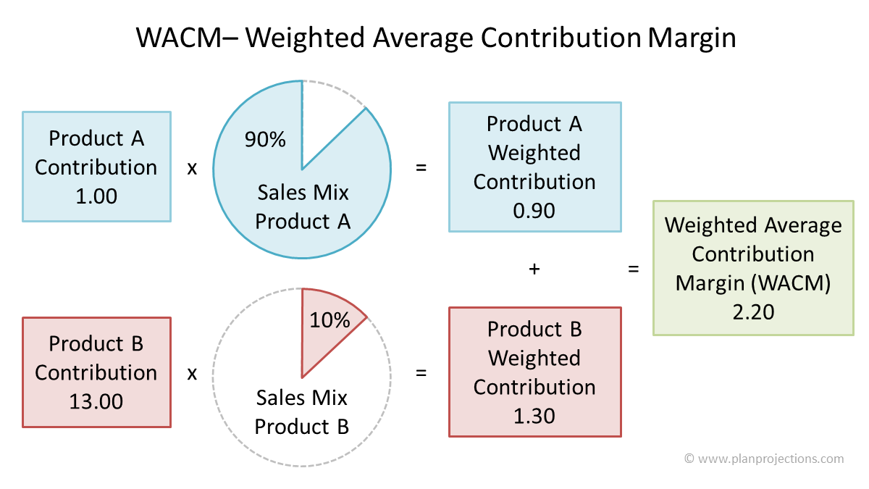

(Source: https://www.planprojections.com/wp-content/uploads/break-even-analysis-for-multiple-products.png)
The company-wide costs are one of the main focus for the 21st-century companies as it helps in including all the changes and analysis of the company. The determination of the variable and fixed costs are the main and most important considerations in case of determining the correct result of the BEP analysis. The utilization of these factors is important as the company conducts its business through different products. It has the potential risk of going wrong in the BEP analysis section. As different products can have different selling prices and moreover different costs allocated to them, the BEP analysis can get more complex than in the case of single product BEP analysis (Nitzl, 2016). With the appropriate analysis and determination, the BEP analysis might show adequate results and all over the same. But due to the difference in the variable and fixed costs as well as different prices the analysis will help in the better but complex assessment of the sales revenue and difference in the company's cost and expenses parallel to the sales mix and sales revenue. The sold products to the customers is another factor that the company chooses to put in the contribution margin as it equalizes the requirements and the contribution of the individual products in the sales revenue of the company at the end of the period. With appropriate composition in the company's sales mix, the company has to agree to the individualism over the overall sales revenue and costs and expenses. The prediction of the sales mix might seem like a good idea to the companies at first, but the assumptions are the main reason behind the failure of the multiple product BEP analysis as it does not help in the assessment of the company's associations and proper methods of conducting the namesake sales revenue and cost analysis as a parallel factor Malkin, 2017). The business-level considerations there are specific tax laws that help in getting a better idea and overview of the company's management system in the sales revenue and the cost allocation. The different products are based on different purposes, and due to that, the requirements of the different products are different in each sample that creates thorough participation of the company's management system. (casrilanka.com, 2020)[Referred to appendix 3]
The companies nowadays not only conduct the BEP analysis among the multiple products, but they also get attached to the Intra-Group trading transactions with other companies that is another complex principle that the companies follow mainly. Intra trading mainly refers to the maximization of the trading process among the separate other companies and subsidiaries. The homogeneous companies conduct their trading businesses through the utilization of the products and the nature requirements by the companies. Here, most of the companies are authorized to do transactions with stocks, investments, bonds and the repayments. The intra-trading process and business activity show the strength of the companies to trade with their brand value and standardized products that they have manufactured. The main process of the intragroup trading is to determine the potential strong company who can handle the subsidiaries and affiliations from the host company without incurring losses. This is a trading deal that benefits both the companies and helps in gaining better anticipations from both the companies (Shea et al. 2018). With the correct form of manufacturing and production process of the host company the understanding and identifying the strengths, sales, costs and expenses of the company before the contract is a great job that the financial and operational managers of the company are assigned to. Through the intragroup trading, the transactions of the companies become interesting as it values the revenue and expenses of the company and simultaneously also maintains the balance of the company. In case of a hosting company who is selling the products or bonds will increase the value of the assets in the consolidated balance sheet and in case of the purchasing company the balance sheet will show a reduced amount of assets. The changes in the income statement are a great factor within the company as it justifies for the moves that the company will be able to make in the next turn (Ringelstein, 2018). Through the BEP analysis, the company is able to identify the potential strength of individual products and the risk factors of losses are also judged in case of managing the expenses and the income statement. The differences created through the BEP analysis is a major consideration for any company as through this, the trading business activities are depending on the profitability and eventually maintaining the substantive systems of the purchaser's interest. With all the possible consideration of the transactions of the BEP analysis and the Intra-Group Trading the strength of the company lies within the number of people involved, a number of companies involved and the debt in the banks that the company needs in managing. (cafr.ro, 2020)
The unrealized profits of the group members through group transactions are the main causes behind the frequent failure of this process. The companies mainly conduct Intra-Group Trading as it helps the company in expanding and maximizing its strength and profitability due to the diligence and the getting attached to the company's profitability and management team. Although the Break even points analysis has a great impact over the profitability, risk assessment and proper methodology of conducting and rectifying the problems, yet the company manages to identify the potential companies and the different products that might have the potential to earn profit from the company, and it's trading and sales activity. The selling activity helps in the management of the report preparation and the costing system. The company gets benefited with the preparation of the cost volume analysis report as in that way the company can easily in a simpler way judge the elements of the company and the profitability ratio of the company that can be signified by the company's management of costing system and the financial and operational manager can easily eliminate the possible risks from the individual products manufactured and finished by the company (Rahimniya et al. 2020). The multiple product BEP analysis is a complex method, but at the same time, it has the strength of maintaining safety and cost optimization properly. The company's trading businesses primarily focus on the motive of increasing the profitability of the companies and expanding the business activities of the company in the retained earnings sector that increase the cost optimization and efficient work in progress and stops the company from wasting the resources and funds by allocating excess funds and costs to the cost centres and the different cost drivers. The different products require different shades and sizes of costs and the prices of such products are determined equally based on the proper cost optimization functions that would help in the proper assessment of the price of the individual products. The profitability of the company through the BEP analysis and the Intra-Group Trading is mainly determined through the proper activities and the efficiency levels of such activity. The companies are judged on the basis of better profitability. The company can only gain profitability when it has the potential strength of determining each of the steps and the determinations of the variable, fixed costs, the cost drivers and the cost allocation system in the right manner. No matter how good is the idea of Intra-Group Trading, with the help of the BEP analysis the company will always make sure that the selling prices of the multiple products and the cost allocation system of the company were done effectively and properly. (newhorizonindia.ed, 2020)

Reference List
Journal
Martinović, D., 2019. Advantages and limitations of linear and nonlinear break-even models. Ekonomski horizonti, 21(3), pp.221-238.
Rahmann, C., Mac-Clure, B., Vittal, V. and Valencia, F., 2017. Break-even points of battery energy storage systems for peak shaving applications. Energies, 10(7), p.833.
Zambrzhitskaia, E., Kozlova, T. and Mamaeva, A., 2017. Specifics of formation the portfolio of orders on the basis of break even analysis for Iron and Steel Works. In SHS Web of Conferences (Vol. 35, p. 01017). EDP Sciences.
Otley, D., 2016. The contingency theory of management accounting and control: 1980–2014. Management accounting research, 31, pp.45-62.
Cooper, D.J., Ezzamel, M. and Qu, S.Q., 2017. Popularizing a management accounting idea: The case of the balanced scorecard. Contemporary Accounting Research, 34(2), pp.991-1025.
Weetman, P., 2019. Financial and management accounting. Pearson UK.
Ax, C. and Greve, J., 2017. Adoption of management accounting innovations: Organizational culture compatibility and perceived outcomes. Management Accounting Research, 34, pp.59-74.
Nitzl, C., 2016. The use of partial least squares structural equation modelling (PLS-SEM) in management accounting research: Directions for future theory development. Journal of Accounting Literature, 37, pp.19-35.
Malkin, W., International Business Machines Corp, 2017. Process analysis, simulation, and optimization based on activity-based cost information. U.S. Patent 9,697,480.
Shea, V.J., Waldrup, B.E., Xu, H. and Williamson, S., 2018. ERROR RATE IMPACTS ON DECISION EFFICACY: ACTIVITY-BASED COSTING SYSTEMS IN SMALL BUSINESS. QRBD, p.59.
Ringelstein, D., 2018. Time-driven activity-based cost accounting: A Critical Review. The Journal of New Business Ideas & Trends, 16(3), pp.20-27.
Rahimniya, R., Ram, M., Siavashi, E., Ghasempour, S., Baruni, M., KHakian, M. and Fakhrzad, N., 2020. Calculating the cost of student services through activity based costing method (ABC) at the department of student and cultural affairs of Tehran university of medical sciences in 2011. Interdisciplinary Journal of Virtual Learning in Medical Sciences, 5(2), pp.8-15.
Online Article
newhorizonindia.ed, (2020) costing methods Available at:https://newhorizonindia.edu/nhc_kasturinagar/wp-content/uploads/2018/09/costing-methods.pdf [Accessed on 20.04.2020]
cafr.ro, (2020) costing methods Available at: http://revista.cafr.ro/temp/Article_9514.pdf[Accessed on 20.04.2020]
casrilanka.com, (2020) costing methods Available at:https://www.casrilanka.com/casl/images/stories/EDBA/chapter%203-%20specific%20areas%20of%20costing.pdf [Accessed on 20.04.2020]

Website
economicsdiscussion.net, (2020) costing methods Available at: http://www.economicsdiscussion.net/cost-accounting/costing-methods/31688[Accessed on 20.04.2020]
yourarticlelibrary.com, (2020) costing methods Available at: http://www.yourarticlelibrary.com/cost-accounting/methods-and-techniques-of-costing/55231[Accessed on 20.04.2020]
toppr.com, (2020) costing methods Available at: https://www.toppr.com/guides/fundamentals-of-accounting/fundamentals-of-cost-accounting/methods-of-costing/[Accessed on 20.04.2020]

APPENDICES
Appendix 1: Absorption Costing
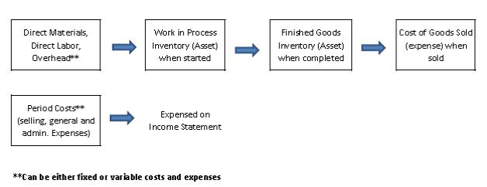
(Source:https://s3-us-west-2.amazonaws.com/courses-images-archive-read-only/wp-content/uploads/sites/1430/2015/10/04031434/absorp.jpg)

Appendix 2: Activity Based Costing technique
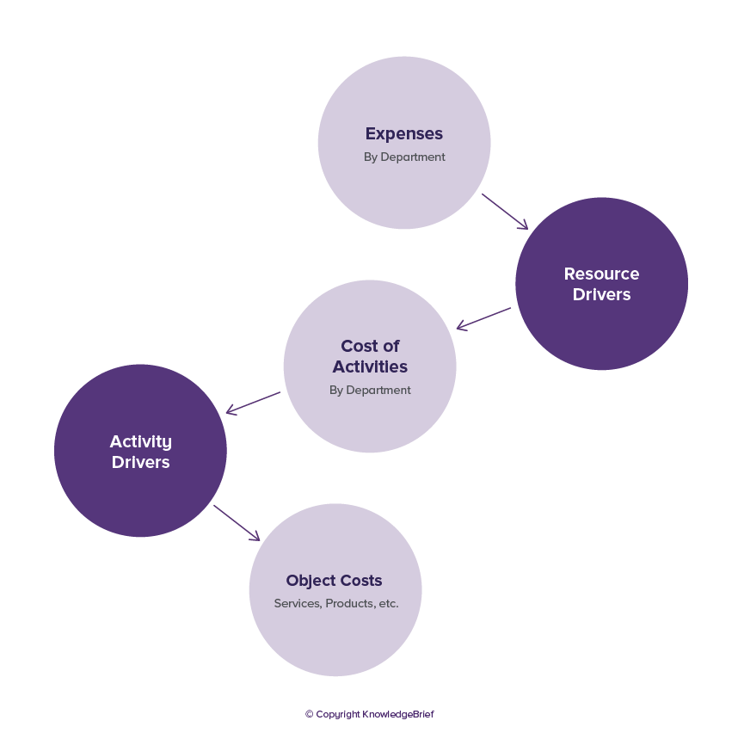
(Source: https://www.kbresearch.com/concept-files/activity-based-costing-v3.png)

Appendix 3: Break even Analysis with Multiple Products
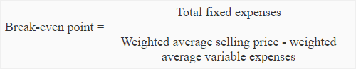
(Source: https://www.accountingformanagement.org/wp-content/uploads/2012/07/break-even-analysis-with-multiple-products-img1.png)

