Celtic Art Assignment 2: Describe and analyse the work of an artist that has made use of the visual characteristics of Celtic Art or focussed on any kind of Celtic theme as the subject matter for their work

I confirm that I have not used AI tools in research and creation of this assignment. I confirm that I have not presented any AI generated materials as my own work. I confirm that have copies of my drafts, notes, and other resources I used, which I may be asked to provide as evidence.

The Celtic revival movement that rose to prominence throughout the Victorian Age and still persists to this day has opened up many new fields of study. In regard to the field of Celtic art, many influential scholars, artists, archaeologists and historians have contributed to the field significantly. It is, however, the Scottish artist John Duncan who notably stands out from his fellows for blending elements of ancient Celtic artworks, Brythonic folklore and Christian/ Italian Renaissance imagery together to form unique and visually stunning pieces of what is known as symbolist art. Duncan was not simply a painter who occasionally borrowed the decorative motifs from the traditional Celts. Rather, he devoted most of his artistic career to recovering, reinterpreting, and visually transforming their myths, symbols, spirituality, and visual language associated with their culture for a modern audience. By merging these elements into his works, Duncan brought back aspects of obscure Celtic/Gaelic art and reintroduced them into more familiar forms for the cultural zeitgeist of the time and in a way showed the Scottish people how neatly all differing aspects of their history and cultural values still fit together across time. This essay examines some of Duncan’s works to see the characteristics of traditional Celtic art present and how he has used Celtic/Gaelic themes to influence others.
John Duncan was born in Dundee, Scotland in 1866. In 1877, at the age of eleven he supposedly would have enrolled at the Dundee School of Art and would remain there for the next three years before leaving to start his early career as an illustrator and etcher. However, Morrison raises doubts on this claim due to the school not opening its doors until 1888. His early works during this time saw use of mythological elements, it would not be until 1890 that Duncan would pursue his interests and would travel across the European mainland, to study at various art schools as a painter. Duncan had a particular interest in the fifteenth-century Renaissance movement artworks and would later adopt many of their distinct visual styles into his own works as enthusiasts can see in his paintings after he returned to Scotland in 1890.
John Duncan created his artistic style through the influence of the artistic environment in Dundee at that time. During his early life Duncan would become an acquaintance of Patrick Geddes, a sociologist, city planner and part time professor, who would become somewhat of a mentor to Duncan. Geddes may have been the key influence who introduced Duncan to the Celtic revival movement that was taking root across Britian and mainland Europe at the time and possibly inspired Duncan’s adoption of Celtic motifs. Geddes was a prominent voice in Scotland during the revival and wrote several collections of poems with their intention meant as an attempt to 'arrest the tremendous centralising power of the metropolis of London' and to 'restore to Scotland something of its old pre-eminence in the world of thought.' Throughout the height of the Celtic revival period many writers and artists look the past for new sources of inspiration, however, many Scottish artists during this time used both Celtic and Highlander themes in their work in order to shape a more distinct Scottish identity outside of the growing British nationalism. Morrison suggests that could Duncan have been inspired to paint Celtic inspired works out of a nationalist view like some of his fellows at the time. However, ultimately based on Duncan’s use of painting non-Scottish elements like in the Arthurian tales or his portrait of the Irish figure Cuchulain reflects that Duncan was embracing a wider scope of the Celtic past, not exclusively the parts that only highlight Scotland. Morrison writes:
Duncan’s appropriation of an Irish tale rather than a source more immediately identifiable as Scottish, can be attributed to his work with Geddes in the 1890s. The painter’s association with the Celtic Revival in Scotland was not a focus or an exemplar for narrow nationalism. It did not simplistically parade Scotland’s supposed Celtic heritage as a mark of difference and therefore singularity. Frequently Scottish artists were concerned to promote their ‘ancient heritage’ as a conduit for a United Kingdom nationalism, to which Scotland contributed. Duncan can, on occasion, be understood in this way but more commonly his work consciously embraced a pan-European internationalism. Scottish autonomy was not the focus, and even Scottish distinctiveness within a British polity, so often the subject of earlier nineteenth century Highlandist art, was frequently subsumed into a celebration and promotion of this European identity.
Duncan’s embrace of the wider Celtic world adds to his appeal, by not exclusively limiting himself to trying to boost Scotland’s heritage, Duncan instead elevates the Celtic world as a whole.
Duncan’s travels across the European mainland further inspired him to develop his style using elements of Renaissance visual cues. In some of the portrait paintings Duncan had created, there are visual similarities to the style made recognisable by artists such as Botticelli, who is famous several paintings but most notably the Primavera and the Birth of Venus. A group of similarity styled artists would also be active around the time of Duncan’s life known as the Pre-Raphaelites. They were primarily a group of English artists and writers who sought to emulate and bring back into relevance the art styles of the Quattrocento period of Italy. It is uncertain to say if Duncan had any direct experiences with this group or not. However, Duncan and the group shared an appreciation for the same art styles of the Renaissance period and were both active at the same time.
Most of his work follows the unique style Duncan created across his career but two particular paintings really emphasise this synthesis of Celtic/Gaelic, Arthurian and Renaissance style of imagery. The Taking of Excalibur and The Riders of the Sidhe are examined here. Both of these paintings Duncan had created as oil paintings, which was a very common style of painting across Europe during the Renaissance period, but its origins are thought to be earlier originating from the Middle East. The means in which Duncan had created these two particular paintings involved the method known as tempura, the most common of which and the one Duncan used for these paintings was the egg tempura method. This method requires only the yolk of an egg, and it is diluted with water, or sometimes vinegar and paint pigments to create tones seen in Duncan’s paintings.
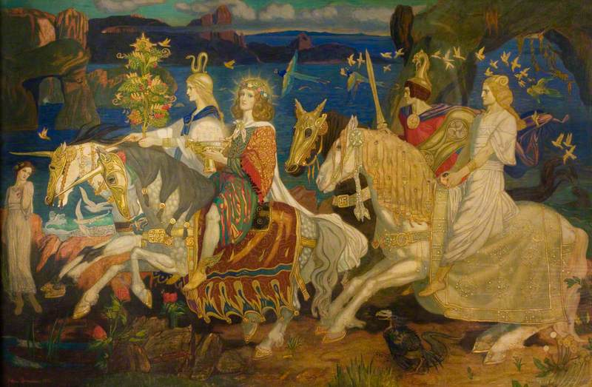

Figure 1The Riders of the Sidhe: (Image source: Wordpress.com)
The Riders of the Sidhe is the painting depicting the faerie type of folk known as Sidhe in Scotland and Aos Sí in Ireland riding in a procession. Each of the riders is notable for holding a unique item relevant to Celtic iconography. The first is a woman wearing a head garment with a snake atop it and holding a tree. In the Celtic world the snake symbolizes the cycle of death and rebirth through its act of shedding its skin. It is notable that Duncan chose to give the snake headdress to the woman holding what is considered to be the Tree of Life. While some cultures use trees exclusively as symbols of live and rebirth, the Celts saw trees as scared due to the religious connotations as most druids operated out of scared groves One of the more well-known Druidic groves in Wales was burnt down by the Romans during the siege of Mona.

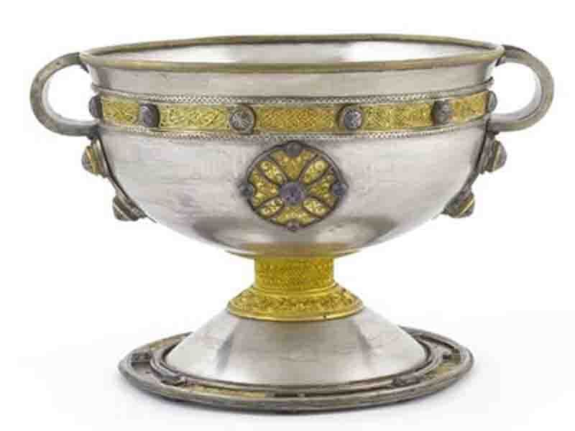
Figure 2 The Ardagh Chalice: (Image Source: National Museum of Ireland)

The second rider is holding a type of chalice or grail which hold significant meaning in the Arthurian myths for granting boons of eternal youth, providing infinite abundance and even having healing powers due to its association with Christ. While its inclusion can be thought of as artistic flare to link in the Celts and the Gaelic myth together. Upon closer exanimation it appears the chalice Duncan has painted bares a striking resemblance to the Ardagh Chalice, if at a slightly bigger scale in the painting. The Ardagh Chalice that was discovered in Ireland in 1868 and could have possibly remained in the cultural memory enough for Duncan to use as a point of reference.

The third rider is a warrior welding a sword and shield. The sword is a symbol of strength and bravery across many cultures, but it is notable that Duncan has depicted both the sword and the shield as the type that were commonly used by the Celts in the Bronze Age. The shield especially bares a very striking resemblance to The Battersea Shield that was recovered from the Thames in London in 1857. Robertson comments that Duncan had a keen interest in the illustrations of various museum collections, which may have provided him with the to use the Battersea Shield as a point of reference. The fourth rider is described as carrying the only what is known as the ‘stone of quietness’.

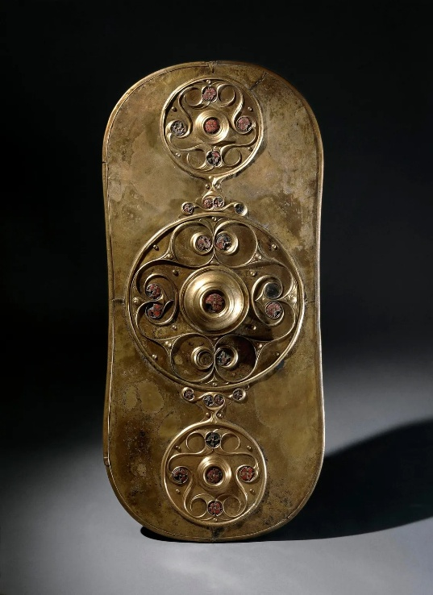
Figure 3 Battersea Shield: (Image Source London Museum)

The objects held or worn by the Sidhe riders are not the only Celtic iconography that Duncan has incorporated for this painting, several examples of Celtic styled knotwork is subtlety added in on the clasps and other objects used to hold the horse’s caparison in place. Celtic knotworks are various in design but tend to follow a similar pattern of a twisting and connecting knot. While thought to be originally Roman in practice, the knotwork has become synonymous with the Celts and has appear all over several ancient monuments and early manuscripts such as the Book of Kells for example.
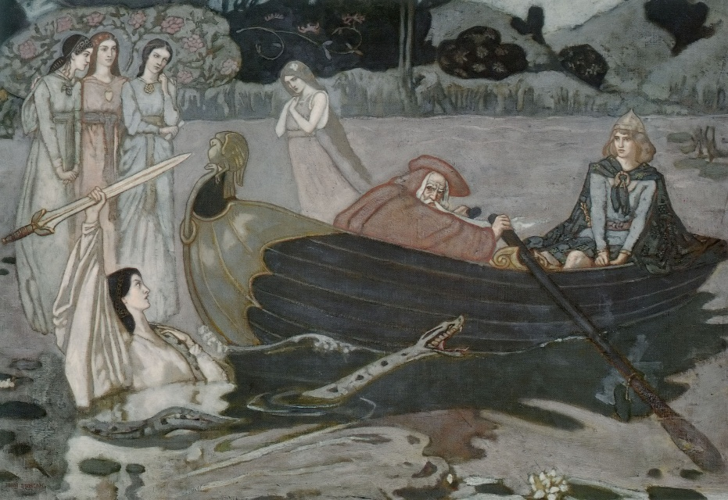
Figure 4 The Taking of Excalibur (Image Source: Artuk.org)

The Taking of Excalibur depicts a scene from the Arthurian legends where Arthur is gifted the legendary sword by the Lady of the Lake. The Arthurian legends can be trace across the British Isle in various forms before many of the tales were reinterpreted by Geoffrey of Monmouth in the 11th century. The additions added by Geoffrey of Monmouth and later authors have shaped how we consider the Arthurian mythos today. In Duncan’s interpretation, he pays homage to both the original versions of the tale in the style of the visual iconography. In the painting Duncan has depicted several of the characters wearing adornments bearing a Celtic knotwork style and the appearance of the snake but be in relation to one of the legends or possibly another Celtic inclusion given the importance snake iconography was to the Celtic people.
The artwork that John Duncan created throughout his life details the unique blend of cultural themes. By mixing visual, mythological, symbolic and historical iconographies together Duncan has constructed a uniquely modern vision of the Celtic past. The paintings created by Duncan have transformed folklore and legend into allegories of cultural identity and transcendence, positioning Celtic myths as a source of aesthetic and spiritual renewal in modern Scotland. This sense of redefining what modern Celtic art means is why Duncan’s creations remain essential for understanding the relationship between mythology, nationalism, and modern art in the late nineteenth and early twentieth centuries.

Image Source:

The Riders of the Sidhe: https://astrofella.wordpress.com/wp-content/uploads/2015/10/riders-of-sidhe.jpg

The Battersea Shield: https://www.londonmuseum.org.uk/blog/battersea-shield-river-thames/

The Ardagh Chalice: https://www.museum.ie/en-IE/Collections-Research/Collection/The-Treasury/Artefact/The-Ardagh-Chalice/ac53e68e-76a4-4560-a624-c87647c57a00

The Taking of Excalibur: https://artuk.org/discover/artworks/the-taking-of-excalibur-93240

Bibliography

Bain, George, Celtic Art: The Methods of Construction (Courier Corporation, 1973)
Berthelot, Anne, ‘Merlin and the Ladies of the Lake’, Arthuriana, 10.1 (2000), pp. 55–81
‘Botticelli, Sandro’, Grove Art Online, n.d. <https://www.oxfordartonline.com/groveart/display/10.1093/gao/9781884446054.001.0001/oao-9781884446054-e-7000010385> [accessed 21 May 2026]
Bowman, Marion, ‘Contempary Celtic Spirituality’, in New Directions in Celtic Studies, ed. by Amy Hale and Philip Payton (University of Exeter Press, 2000)
‘Cornelius Tacitus, The Life of Cnæus Julius Agricola, Chapter 18’, n.d. <https://www.perseus.tufts.edu/hopper/text?doc=Perseus:text:1999.02.0081:chapter=18> [accessed 21 May 2026]
Curley, Thomas M., Samuel Johnson, the Ossian Fraud, and the Celtic Revival in Great Britain and Ireland (Cambridge University Press, 2009)
‘Definition of HOLY GRAIL’, 29 April 2026 <https://www.merriam-webster.com/dictionary/Holy+Grail> [accessed 21 May 2026]
Evans, John, The Ancient Bronze Implements, Weapons, and Ornaments of Great Britain and Ireland (Library of Alexandria, 2020)
Facos, Michelle, Symbolist Art in Context (Univ of California Press, 2009)
Geoffrey of Monmouth and Lewis Thorpe (introduction and translation)., with Internet Archive, Geoffrey of Monmouth The History of the KIngs of Britain (Penguin Books Ltd., 1968) <http://archive.org/details/geoffreyofmonmou0000geof> [accessed 20 May 2026]
Green, Miranda, Symbol and Image in Celtic Religous Art (Routledge, 1989)
Mayer, Ralph, Artists Handbook Of Materials And Techniques (Online, 1930) <http://archive.org/details/in.ernet.dli.2015.70073> [accessed 21 May 2026]
Morrison, John, John Duncan, Patrick Geddes and the Celtic Revival, (Aberdeen), 5.1 (2012), pp. 27–39
National Galleries of Scotland, ‘John Duncan | National Galleries of Scotland’, Museum Archive, National Galleries of Scotland, n.d. <https://www.nationalgalleries.org/art-and-artists/artists/john-duncan> [accessed 15 May 2026]
National Museum of Ireland, ‘The Ardagh Chalice’, Museum Archive, National Museum of Ireland, n.d. <https://www.museum.ie/en-IE/Collections-Research/Collection/The-Treasury/Artefact/The-Ardagh-Chalice/ac53e68e-76a4-4560-a624-c87647c57a00> [accessed 21 May 2026]
Robertson, Anna, ‘John Duncan’s “The Riders of the Sidhe”’, Archive, Art UK, 1 December 2022 <https://artuk.org/discover/stories/john-duncans-the-riders-of-the-sidhe> [accessed 18 May 2026]
Ruggiero, Guido, A Companion to the Worlds of the Renaissance - Google Books (2008; John Wiley & Sons, Ltd, 2019) <https://web.archive.org/web/20190815223158/https://books.google.com/books?dq=Timurid+renaissance&hl=en&id=fx0Dlwb18WYC&lpg=PA59&ots=oRBca6Ril-&pg=PA59&sa=X&sig=91TIV5mBBnYFwGah_7x6b0NP-jA&source=bl&ved=0ahUKEwijusmUk5fQAhVHKsAKHeqdDn8Q6AEITTAI#v=onepage&q=Timurid%20renaissance&f=false> [accessed 21 May 2026]
Shaw, Michael, Fin-de-Siecle Scottish Revival: Romance, Decadence and Celtic Identity (Edinburgh University Press, 2019)
‘The Battersea Shield Found in the River Thames’, London Museum, n.d. <https://www.londonmuseum.org.uk/blog/battersea-shield-river-thames/> [accessed 21 May 2026]
‘The Girlhood of Mary Virgin’, 23 March 2023 <https://web.archive.org/web/20230323172857/https://www.rossettiarchive.org/docs/s40.rap.html> [accessed 21 May 2026]
Young, Clara, ‘Duncan, John (1866–1945), Painter and Illustrator’, Biographies, Oxford Dictionary of National Biography, Oxford Dictionary of National Biography, 2010, doi:10.1093/ref:odnb/94434

Marion Bowman, ‘Contempary Celtic Spirituality’, in New Directions in Celtic Studies, ed. by Amy Hale and Philip Payton (University of Exeter Press, 2000), p. 69.
Michelle Facos, Symbolist Art in Context (Univ of California Press, 2009), pp. 1–2.
John Morrison, John Duncan, Patrick Geddes and the Celtic Revival, (Aberdeen), 5.1 (2012), pp. 27–39 (p. 27).
National Galleries of Scotland, ‘John Duncan | National Galleries of Scotland’, Museum Archive, National Galleries of Scotland, n.d. <https://www.nationalgalleries.org/art-and-artists/artists/john-duncan> [accessed 15 May 2026].
Clara Young, ‘Duncan, John (1866–1945), Painter and Illustrator’, Biographies, Oxford Dictionary of National Biography, Oxford Dictionary of National Biography, 2010, doi:10.1093/ref:odnb/94434.
Morrison, John Duncan, Patrick Geddes and the Celtic Revival, p. p.27.
Young, ‘Duncan, John (1866–1945), Painter and Illustrator’.
Young, ‘Duncan, John (1866–1945), Painter and Illustrator’.
Thomas M. Curley, Samuel Johnson, the Ossian Fraud, and the Celtic Revival in Great Britain and Ireland (Cambridge University Press, 2009), p. 124.
Michael Shaw, Fin-de-Siecle Scottish Revival: Romance, Decadence and Celtic Identity (Edinburgh University Press, 2019), p. 3.
Morrison, John Duncan, Patrick Geddes and the Celtic Revival, p. 28.
‘Botticelli, Sandro’, Grove Art Online, n.d. <https://www.oxfordartonline.com/groveart/display/10.1093/gao/9781884446054.001.0001/oao-9781884446054-e-7000010385> [accessed 21 May 2026].
‘The Girlhood of Mary Virgin’, 23 March 2023 <https://web.archive.org/web/20230323172857/https://www.rossettiarchive.org/docs/s40.rap.html> [accessed 21 May 2026].
Guido Ruggiero, A Companion to the Worlds of the Renaissance - Google Books (2008; John Wiley & Sons, Ltd, 2019), p. 59 <https://web.archive.org/web/20190815223158/https://books.google.com/books?dq=Timurid+renaissance&hl=en&id=fx0Dlwb18WYC&lpg=PA59&ots=oRBca6Ril-&pg=PA59&sa=X&sig=91TIV5mBBnYFwGah_7x6b0NP-jA&source=bl&ved=0ahUKEwijusmUk5fQAhVHKsAKHeqdDn8Q6AEITTAI#v=onepage&q=Timurid%20renaissance&f=false> [accessed 21 May 2026].
Ralph Mayer, Artists Handbook Of Materials And Techniques (Online, 1930), p. 228 <http://archive.org/details/in.ernet.dli.2015.70073> [accessed 21 May 2026].
Miranda Green, Symbol and Image in Celtic Religous Art (Routledge, 1989), pp. 24–25.
‘Cornelius Tacitus, The Life of Cnæus Julius Agricola, Chapter 18’, n.d. <https://www.perseus.tufts.edu/hopper/text?doc=Perseus:text:1999.02.0081:chapter=18> [accessed 21 May 2026].
‘Definition of HOLY GRAIL’, 29 April 2026 <https://www.merriam-webster.com/dictionary/Holy+Grail> [accessed 21 May 2026].
National Museum of Ireland, ‘The Ardagh Chalice’, Museum Archive, National Museum of Ireland, n.d. <https://www.museum.ie/en-IE/Collections-Research/Collection/The-Treasury/Artefact/The-Ardagh-Chalice/ac53e68e-76a4-4560-a624-c87647c57a00> [accessed 21 May 2026].
John Evans, The Ancient Bronze Implements, Weapons, and Ornaments of Great Britain and Ireland (Library of Alexandria, 2020), p. 344.
‘The Battersea Shield Found in the River Thames’, London Museum, n.d. <https://www.londonmuseum.org.uk/blog/battersea-shield-river-thames/> [accessed 21 May 2026].
Anna Robertson, ‘John Duncan’s “The Riders of the Sidhe”’, Archive, Art UK, 1 December 2022 <https://artuk.org/discover/stories/john-duncans-the-riders-of-the-sidhe> [accessed 18 May 2026].
George Bain, Celtic Art: The Methods of Construction (Courier Corporation, 1973), p. 16.
Anne Berthelot, ‘Merlin and the Ladies of the Lake’, Arthuriana, 10.1 (2000), pp. 55–81 (p. 57).
Geoffrey of Monmouth and Lewis Thorpe (introduction and translation)., with Internet Archive, Geoffrey of Monmouth The History of the KIngs of Britain (Penguin Books Ltd., 1968), p. 20 <http://archive.org/details/geoffreyofmonmou0000geof> [accessed 20 May 2026].

