

Developing Innovation and Creativity for Business Advantage
BMSW6102
Jannat Firdausi Rahman
Student ID: 1817067
Lecturer: Dr Charles Vincent

Contents

Introduction 3
1 Innovative proposition 3
1.1 The service 4
1.2 Target market 4
1.3 Competitive advantage 5
1.4 Sustaining the business 5
1.5 Toys go Round SWOT analysis 6
2 E- commerce 7
2.1 Website 7
2.2 Payments 8
2.3 Finance and supplies 8
2.4 Health and safety 9
3 Marketing 9
3.1 Promoting the service 9
3.2 Customer journey 10
Conclusion 11
References 12

Introduction

Tohidi and Jabbari (2011) noted innovation played a vital role in all human areas from the development of products to innovative methods of working. Innovation can be defined as the process of changing and enhancing a product or service in a way that it can be presented as a new innovation. The purpose of this report is to demonstrate a new innovation service proposition covering all necessary areas, including the emerging need of such an innovation, what the service offers, the platform through which it will be offered and the marketing strategies to reach out to customers and involves the key stages of understanding the problem you are trying to solve and how you intend to do it through your service.

1 Innovative proposition

Toys play a vital role in the shaping of a child’s behaviour, imagination and experience and has a major impact on their early development. Today’s busy lives has limited the interaction between parent and child and therefore parents compensate for this time by expressing their love by gifting toys to their children (Klemenović, 2014). The 2005-2020 consumers expenditure statistics revealed that in 2020 approximately £23.22 million GBP worth of toys and games were consumed by UK households bringing the toy industry to a market worth £7.1 billion GBP (Statista, 2022).
The innovation created is a subscription service for rotating toys. The proposed service is named as Toys go Round. The service enables the customer to subscribe for up to as many children according to age 0-8 years, select gender and from a range of toy categories for a box of toys that are sent on a monthly basis, which are then returned and replaced with another box. To make the service as easy as possible and hassle free, a pre-paid box will be sent each time for returns with only one additional charge of £3.99 each month for postage and packaging no matter how many subscriptions per household.

1.1 The service
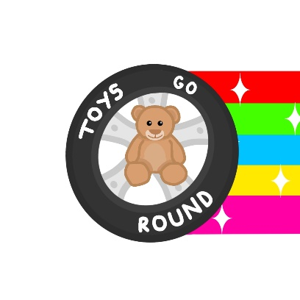

Business name- Toys go Round
Slogan- moments of fun, over and over again
Mission- working together with you to develop your child’s imagination
Vision- Creating a pathway to ensure the best for our planet.

The degree of the new service innovation is incremental. This entails the process of bringing small changes and improvements to existing products and services. This benefits the proposition as the process involves a lower degree of creativity, less risk and low cost compared to radical innovations (Souto, 2015). The business proposition can also be classed as an open innovation. This is the free flow of an organizations internal information that is shared and received with knowledge from the organizations external boundaries to create innovative solutions (West et al., 2014).

1.2 Target market

This innovative service fulfils the emerging wants of those customers who are conscious about the well-being of this planet. 90% of toys are made from plastic of which majority is obtained from fossil fuels that bring out greenhouse gas emissions during the process that contributes hugely towards environmental pollution (Green Journal, 2020). This service offers them eco- friendly customers a chance to play a vital role in helping the environment reduce plastic waste that is harmful for humans and the planet just by simply minimising the buying of plastic toys. The innovation is also to target the average families who want to save money. Since the economy reopened after being struck by the pandemic, inflation rate has risen to its highest in 30 years, affecting millions across the country (Partington and kirk, 2022). With living costs rising it becomes necessary for the average families to manage the essentials and discard the luxuries. Therefore, this service allows a great way to save money on popular brands and new trends in the toy market. As online YouTube videos are continuously promoting toys and influencing high sales, this is a great way for families with high expenditure to give children a chance to experience the ever- changing toy trends.

1.3 Competitive advantage

For an organization, competitive advantage is the ability to discover customer needs and preferences from a business and then to create customer satisfaction on that need profitably (Razak and Vattikoti, 2018.) Businesses today face huge competition and continuously under threat in the global marketplace, therefore it has become vital for businesses to create sustainability and strengthen its competitive advantage by meeting and even exceeding customer expectations (Razak and Vattikoti, 2018). As with every product and service, competition is always looking for a way in. The most similar service to Toys go round is, The little loop company. They are an online business who sell a subscription service to swap clothes. The service specialises in ethical brands of clothing allowing you to choose from a plan that best suits you. Each plan comes with a number of credits which are redeemed for items of your choice. The plan gives you the freedom to keep the clothes for up to how long you want with unlimited swaps. The similarity between this service and Toys go round is the type of service being offered and the need it is aiming to fulfill but the competitive advantage lies in many areas. The little loop offers subscription plans from as little as £18 p/m to £36p/m or quarterly plans from £50 to £100. Toys go round provides differentiation and low-cost through its unique selling point, offering 2 months free subscription and then £10.99 per child with the offer of adding another child for an extra £3 for up to as many children they want with no long-term contracts. You are free to leave if we cannot fulfil your needs. The low subscription with 2 months free introductory offer will keep competition very low against rivals and will attract new customers to give the service a try as they have nothing to lose.

1.4 Sustaining the business

Sustainability in business can be defined as “the ability to meet the needs of present customers while taking into account the needs of future generations” (wales, 2013). With every business, it is important to keep on finding new ways to sustain that business for the future. This proposition revolves with sustainability at its core. A business that will look to make profit with minimal negative and a high positive impact on the environment. The initial stages of the business may not see profit instantly but as subscribers increase so will profit margins. Initially the business will start with subscribers but further will go on to developing strategies to work together with private nurseries, play groups and schools who could benefit from this service. Pairing up with paid partnership schemes with large retailers such as Smyths toys to promote new lines of products. As the business starts to grow, it can further look into adding lines of products such as clothing and hobby related products to become more competitive in the market. The future of this service can also look into operating through mobile apps to create convenience at a click.

1.5 SWOT analysis

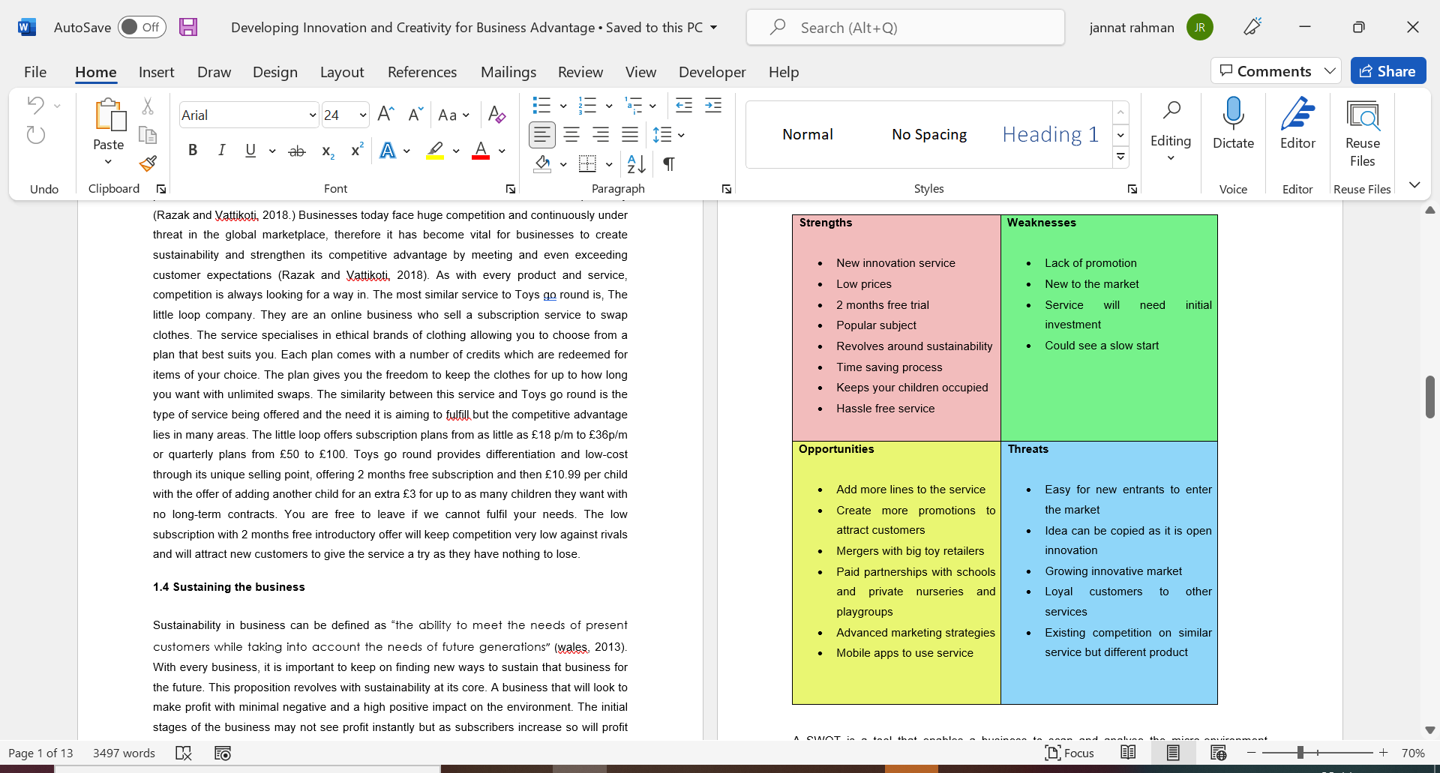

Table 1. Toys go round SWOT analysis

A SWOT is a tool that enables a business to scan and analyse the micro-environment surrounding its boundaries. The scanning brings to attention the strengths and weaknesses of the business that can be dealt with to protect the business from potential threats allowing to take advantage of any opportunities that can prove to be beneficial (GURL, 2017). The strengths within the new service innovation can be described as the unique selling points that will stand out against competition and the weaknesses are areas of improvement such as the lack of promotion. This area can be improved by taking up the opportunity to invest in advanced marketing strategies and creating attractive promotions and offers. Threats allow the company to create mitigation strategies that can limit or even eliminate the negative impacts of potential issues.

2 E- commerce

E-commerce is the electronic method of buying and selling goods and services and making transactions via the internet. This process has become the most flexible and convenient method for discovering and purchasing through online markets and retailers. E- commerce invites the business and buyers into the global economy where competition, price comparisons and substitute services are available just a click away (JAIN et al., 2021). This creates a stronger competition in the market as well as findings ways to discover new opportunities and has become the most popular way of shopping (Taher, 2021).

2.1 Website

The innovation service proposition will be available and offered to customers via e-commerce platform. The service will be visible through a website. This platform was selected above the brick and mortar because the service is not selling items on a daily basis, but however will need storage facilities to store supplies. Overall, there are many advantages to e-commerce platforms. It is fast, convenient and flexible, low costs and resources involved, affordable marketing, easy to create a good customer base by reaching out to more customers via internet access and multiple payment methods are available too (Taher, 2021).
Websites are a great way to keep track of and respond to how effectively it is reaching out to customers and what features are being used allowing you opportunities to improve. The website will be created through WIX.com. This website allows you to customise your site, add on features that best suit your business, then build and upgrade as you move along. The best suited to the business will be their most popular package, Business unlimited that covers all essentials to grow your business at a cost of £17pcm. Website will include all necessary material for a customer to understand the business and its products and services. This will include:
- Business name with logo and slogan
- About Us page including business overview, what we do and the business mission and vision statement
- Detailed description of service and how it works
- Prices
- Photographs and videos
- Reviews and feedbacks- will be added along the way
- FAQs
- Customer service number
- Web chat
- Terms and conditions
- Delivery and returns policy
- Health and safety
- Privacy policy

2.2 Payments

The package is integrated with an online booking platform where customers will be directed from the web page to buy subscriptions through direct debit payments as this is the most flexible, reliable and cost-effective way to handle transactions in between banks. Direct debits are ideal payment options for subscriptions and memberships that require taking regular recurring payments from customers. This method must ensure the technical and operational requirements of the payment card industry data security standards (PCI DSS) to protect cardholder data and reduce chances of fraud.

2.3 Finance and supplies

The business will need an initial investment of £30,000. This will be a business loan taken out with minimum interest rate. This will include the cost of building the website and maintenance, cost of professional photography and videos displaying products and service for advertisement purpose, marketing strategies such as leaflets, ads in local magazines and notice boards costing around £2500. Packaging material and equipment will also be eco- friendly and used from recycled material as this is what the company envisions for the future, therefore, can be purchased cheaper along with the cost of all necessary insurance covers around £1500p/y.
For toy supplies, initial investment will be around £8-9k. First approach will be the big toy retailers and independent toy companies and attempt to strike deals on the stock that they are not selling or want to get rid of or put on sale/reduction. Visits to local charity shops and toy banks can be beneficial because as we are recycling toys there will be no harm in attaining goods that are in good condition. Wholesalers such as Kids Stuff For Less where we can bulk buy for the initial start and increase on products on popular demand. An area will be needed to store supplies and goods, therefore companies like Self-storage prove to be ideal as it gives you the option to select appropriate size of room needed. For the initial start, a self-storage with average space for the approximate goods will cost around £1000 annually. The need for permanent employees is not necessary as the required tasks can be completed by freelancers when needed or staff kept on part-time flexible contracts. Aim is to target about 200 subscriber’s a month with an additional 150 extra children generating a profit of around £17,500 annually.

2.4 Health and safety

As the business involves the use of recycled toys that are being shared amongst children, wear and tear of products will be inevitable and therefore to reduce the consequences of any mishappen it is extremely vital that the business is covered by public liability insurance. All products returned will go through safety checks and quality control to meet all UK and EU safety standards and sterilised before re-used as hygiene and safety is utmost important.

3 Marketing

One of the largest impacts on human life over the recent years has been the rapid growth of online social networks. This also contributes significantly to the change in human activities and interaction. Due to this change, businesses have been compelled to take a step forward to digital marketing, to be able to connect and reach out to a targeted audience at low cost and in a measurable way (Tiago and Veríssimo, 2013).

3.1 Promoting the service

A strong online presence and brand awareness is the key to promoting the business so therefor, the service will be largely promoted through social media platforms. Social media has immense power when it comes to reaching out to potential buyers and creates ways to interact with customers on a personal level and be able to relate to them by sharing personal experiences and stories. Social media is the least expensive method of marketing digitally and doesn’t require the need for advertisement tools but rather a consistent flow of posting interesting material about your service to intrigue your audience (Henderson, 2020). A Facebook and Instagram page with necessary contents about the business, including photographs and videos, blogs and reviews and continuous updates, progress and developments will be added. Blogging will also attract future prospects and create opportunities. The service will also be communicated online through networking groups such as Mumsnet, Mummy social and Emma’s diary where majority of the targeted mothers and audience will be reached. Purpose is to aim for the ethical and green social networking sites where the service can be put on notice. These ways of promoting generate word of mouth communication amongst customers swiftly and increases communication flows, helps improve knowledge and build brand loyalty. Social media platforms can improve the overall business performance by improving on services and products through customer feedback and reviews. However, it is important to also understand that failure to respond to customers online effectively can bring negative feedback and complaints resulting in visible criticisms which can damage brand reputation.
Emailing marketing will be used to reach out to customers and keep them up to date with promotional offers. Physical techniques will be utilized , such as brochures, neighbourhood notice boards, door to door leaflets and ads in local newspapers, and magazines that are free to public in stores, GP surgeries, hospitals, libraries, church, mosques, schools, playgroups and nurseries.

3.2 Customer journey

Customer journey can be explained as the viewpoint and experience of a customer’s journey through specific touchpoints, from the moment they hear about you and till they make the decision to become a continuous part of your business. This journey has significant concerns in the design and management of services (Folstad et al., 2014). The customers journey will begin through awareness of such a problem in their homes. Costs of living rising, high utility bills, clutter of unnecessary items and children’s demands. The use of websites analytics can enable you to understand customer activities such as searching google for “how to save money” or “how to reduce clutter around the home” and how much time spent with you, is the first stage of the journey where customer behaviours are analysed.
Second stage involves considering the results of the search. Comparing your prices with competitor’s. Searching for your business on Facebook and Instagram, reading reviews and reports and collect opinions from other users. Take advantage of the company’s 2 months free trial and give the service a go. Enjoy a hassle-free service and see whether there is a change around your home and whether your children are keeping busy with something they are happy with. Third and final stage involves making the decision of whether you want to continue with the service and become a subscriber. Clarify all details with salesperson over the phone or on our web chat facility about prices, delivery and returns policies and about contracts. Customer will take up subscription service, we will serve their needs and customer will leave positive reviews and feedback on our touchpoints, promote service and experience through word-of-mouth communication to friends and families, persuading them to give the service a try with our 2 months free trial offer and eventually becoming a permanent subscriber. So therefore, as the market grows, profit will rise.

Conclusion

The overall report has demonstrated a new innovation service proposition with a description of all appropriate and best suited methods chosen to deliver the service and reach out to the targeted audience. Digital marketing strategies today has proven to be the most cost effective and popular approach to promoting and reaching out to a larger audience and whereas e-commerce has become the way forward for any business as it allows you to spread your business on a global scale and improves knowledge and services through comparison.

References

Følstad, A., Kvale, K. and Halvorsrud, R., 2014, June. Customer journeys: Involving customers and internal resources in the design and management of services. In ServDes. 2014 Service Future; Proceedings of the fourth Service Design and Service Innovation Conference; Lancaster University; United Kingdom; 9-11 April 2014 (No. 099, pp. 412-417). Linköping University Electronic Press.
Green Journal | News about green energy. 2020. Plastic toys: The effect on humans and the environment | Green Journal. [online] Available at: https://www.greenjournal.co.uk/2020/06/plastic-toys-the-effect-on-humans-and-the-environment/ [Accessed 3 March 2022].
GURL, E., 2017. SWOT analysis: A theoretical review.
Henderson, G., 2020. The Importance Of Social Media Marketing. [online] Digitalmarketing.org. Available at: https://www.digitalmarketing.org/blog/the-importance-of-social-media-marketing#:~:text=Social%20media%20networks%20are%20open,strategy%20to%20attract%20such%20customers. [Accessed 23 March 2022].
JAIN, V., MALVIYA, B. and ARYA, S., 2021. An Overview of Electronic Commerce (e-Commerce). Journal of Contemporary Issues in Business and Government| Vol, 27(3), p.666.
Klemenović, J., 2014. How do today’s children play and with which toys?. Croatian Journal of Education: Hrvatski časopis za odgoj i obrazovanje, 16(Sp. Ed. 1), pp.181-200.
Partington, R. and kirk, A., 2022. In numbers: what is fuelling Britain’s cost of living crisis?. [online] the Guardian. Available at: <https://www.theguardian.com/business/2022/feb/03/in-numbers-britains-cost-of-living-crisis> [Accessed 29 March 2022].
Razak, A. and Vattikoti, K., 2018. Critical evaluation of value chain analysis for assessing competitive advantage-a study on select companies of e-tailing industry. Academy of Strategic Management Journal, 17(6), pp.1-14.
Souto, J.E., 2015. Business model innovation and business concept innovation as the context of incremental innovation and radical innovation. Tourism management, 51, pp.142-155
Statista. 2022. Games, toys, hobbies expenditure (volume) 2005-2020 | Statista. [online] Available at: https://www.statista.com/statistics/374947/annual-expenditure-games-toy-hobbires-in-the-united-kingdom-uk/ [Accessed 4 March 2022].
Taher, G., 2021. E-Commerce: advantages and limitations. International Journal of Academic Research in Accounting Finance and Management Sciences, 11(1), pp.153-165.
Tiago, T. and Veríssimo, J., 2013. Marketing and Social Media: Benefits and Ways Forward. In Proceedings of the 3rd Conference of the International Network of Business and Management Journals.
Tohidi, H. and Jabbari, M.M., 2012. The important of innovation and its crucial role in growth, survival and success of organizations. Procedia Technology, 1, pp.535-538.
Wales, T., 2013. Organizational sustainability: What is it, and why does it matter. Review of enterprise and management studies, 1(1), pp.38-49.
West, J., Salter, A., Vanhaverbeke, W. and Chesbrough, H., 2014. Open innovation: The next decade. Research policy, 43(5), pp.805-811.

