University of Wales Trinity Saint David Birmingham
BA (Hons) Business Management
LCBB4004 Marketing fundamentals

Individual Report

Marketing mix analysis for Vodafone Group PLC

Author: Elena Turcanu, Student nr 2127547
Lecturer: Dr Yousuf Kamal

Table of Contents

Introduction……………………………….……………………………………………….….….3
- Company overview…………………………………………. ………………………………..3
- Marketing mix concept for Vodafone Group PLC…………………………….…….………4
- Product element: Vodafone Product strategy……..……………………..………..5
- Price element: Vodafone Price strategy…………………………………………....7
- Place element: Vodafone distribution strategy………………………………..…..8
- Promotion element: Vodafone promotion strategy…………………………..…...9
3. Suggestions for improving Vodafone marketing strategies ……….…….…. ….11
Conclusion …………………………………………………………….………..…......13
References…………………………………………………………………………..………..….14

Introduction
Globalization progress in the 21st century have considerably impacted every organizational climate. Businesses must adapt their standard procedures. Commercial businesses today should consider innovative dated methods to deliver their services if they want to satisfy their clients' expectations.
Because consumers are becoming more discerning, traditional marketing tactics are no longer effective.Due to the fierce competition, businesses must expand their product portfolio, supply high-quality goods, to considerthe customer's requirements, reduce costs and increase profit.
To achieve effectiveness, it's also crucial to coordinate and utilise the components of the marketing mix and their associated actions. Good marketing mix management enables marketers to put together a set of components that will enable prudent budget management for the business to accomplish the intended goals. Businesses that work hard to run efficiently and accomplish their objectives must spend well to have complete control over the marketing mix. It is not sufficient to use just one or a few elements in order to get the finest result. In order for the components of the marketing mix to be aligned, it is necessary to take into account each component's qualities. The company's difficulties may be caused by the above-mentioned factors of interaction being out of alignment.
Considering the context exposed above, I proposed in this paper to analyse the Marketing Mix elements from a theoretical point of view and their practical application within the Vodafone company! Thus, we will be able to understand the importance of the effective use of the Marketing mix by marketers, combining different market tools, to obtain the best financial result for the company! At the end of the paper, I will come up with suggestions for Vodafone to improve its marketing strategy, ending with a conclusion on the whole analysis.
- Company Overview
Vodafone Group Plc is a British multinational telecommunications company, is headquartered in Newbury. Vodafone offers telecommunications and IT services to corporate clients in 150 countries across the world through its own networks in 21 countries and partner networks in an additional 47 countries. The business picked the name Vodafone to "represent the offering of voice and data services over mobile phones," which is where the word "voice data fone" originates from (Vodafone Group, 2012).
Their purpose is “to connect for a better future”! They aspire to create an equitable and environmentally friendly digital society and believe that Vodafone has a key role to play in improving the communities in which they operate.
Vodafone strategy, is focused on generating investment returns through progress, which is implemented through their client engagements and supporting strategies.
They collaborate to realize their shared vision of becoming a next-generation network and digital solutions operator for Europe and Africa that promotes an equitable and environmentally friendly connected world. (Vodafone, 2022)
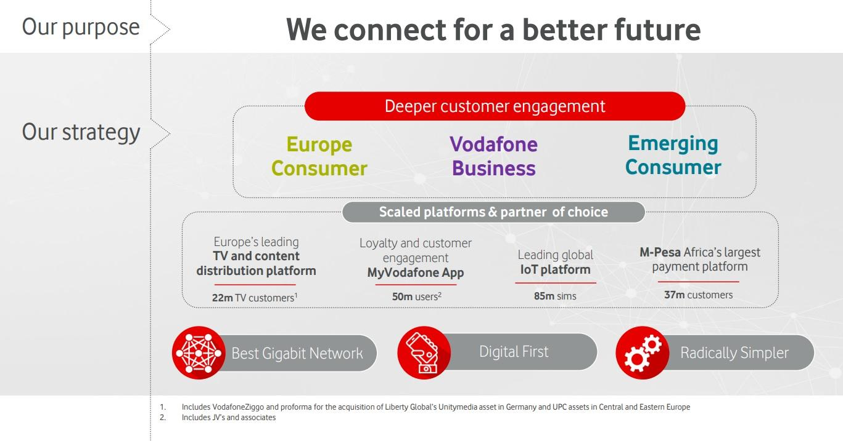Fig. 1 Vodafone strategy. Source: Vodafone 2019 annual presentation
- Marketing mix concept
McCarthy (1964) defined the "marketing mix", which referred to the "4Ps", as a method of putting marketing strategy into action.
Nowadays, Marketing Mix represents the 7Ps: Product, Price, Place and Promotion (McCarthy, 1960) and three more components that help us overcome the difficulties of business services: People, Process and Physical Evidence (Booms & Bitner, 1982).
The term "marketing mix" refers to a conceptual framework, that identifies the main considerations that marketers must make to tailor their offers to the buyers' requirements, and to create strategic plans for both the long run and the short term (Palmer, 2004).
The idea behind the marketing mix is comparable to blending ingredients for a cake. The amounts of the ingredients in the cake will vary depending on the type of cake we wish to make. Similar to how the ratios of the marketing mix can be altered depending on the good or service and the company's final objective.
The marketing mix is an effective marketing tool due to its functionalities, the attribution of flexibility and manoeuvrability to the field of marketing, the outlining of marketing as a separate element in the company's operational system, and the advantages offered to the company in front of its competitors. (Grönroos, 1994).

- Product element: Vodafone Product strategy
Product is defined as a tangible item or service that the client is prepared to pay for. It contains both tangible things such as clothes, food, technology, as well as services, such as electricity, internet, insurance, banking etc. (Singh,2016).
The product, according to Kotler and Armstrong, "is what can be supplied to the market, to acquire attention, to be the acquisition of utilised or used, and to satisfy the desires or requirements." The concept of a product is therefore quite broad and encompasses not just natural goods and services but also experiences, people, locations, property rights, firms or organisations, information, and concepts.
The field of Technology is expanding confidently, and the telecommunications industry is also changing rapidly. The introduction of 5G will herald the beginning of a future era in the telecommunications industry. Around 90% of the cities in the United Kingdom have 4G service. In addition, 5G services have been introduced, which have significantly improved data speed when compared to Wi-Fi services offered in households. In such a situation, the demand for integrated solutions, high-speed internet and mobile data is also growing faster.
Worldwide, Vodafone has introduced a wide range of goods and services aimed at private consumers, businesses and public sector (Fig. 1, Fig. 2, Fig.3.). Both innovations and globalization are the main concerns of the company. Residential customers also want a faster and more efficient network for downloading and viewing Internet resources, so the need for telecommunications and digital technologies extends beyond just the business sector.
The image below (Fig.1) is a screenshot from Vodafone's official website. From it we can notice that Vodafone's activity extends to a diverse complex of technological products (mobile phones, tablets, laptops and other accessories) and digital services (SIM, broadband), which highlights a strategy of selling complementary products and services in a package.
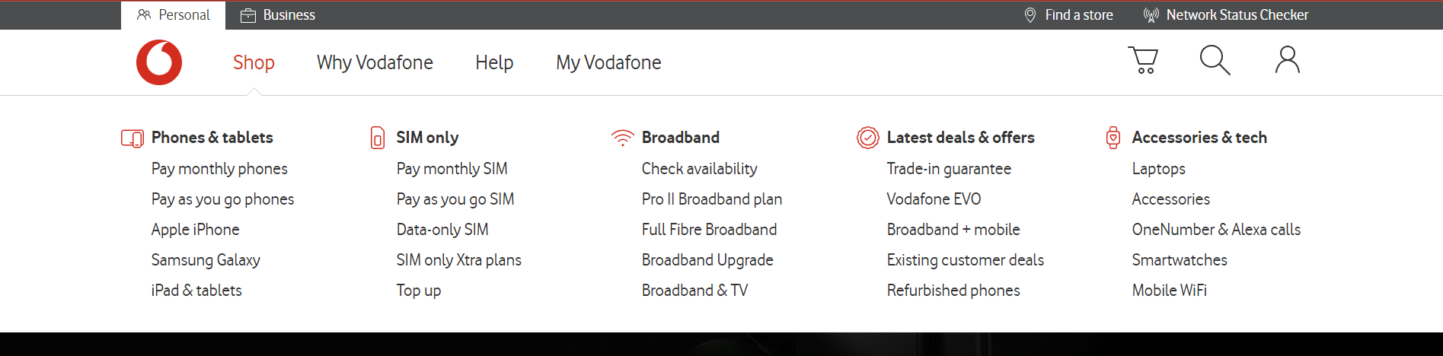
Fig. 2. Vodafone Product and service offers for individuals. www.vodafone.co.uk/. 2023
Customers are given the choice of a variety of services, which include call, text, and data packages with unlimited usage, and the products can be purchased with full payment or in instalments. This strategy denotes the company's tendency to influence their customers' purchasing power and preferences. In addition, initiatives, promotions, and awards are made to increase client loyalty and satisfaction levels.
In support of what is said above comes figure 2, where we can notice the diversity of services and digital solutions proposed by Vodafone to the business. So that the company that procures laptops or phones, for example, from Vodafone, has the option to buy a SIM package with phone calls and SMS, broadband, security software and other solutions for running their business.
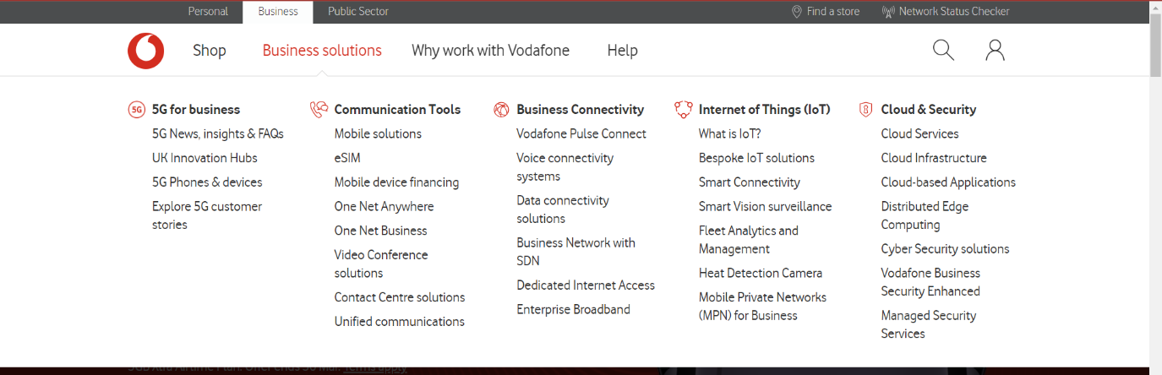
Fig. 3. Vodafone Business solutions for companies. www.vodafone.co.uk/. 2023
Vodafone's digital solutions do not stop at individuals and businesses, but it also extends to the public sector.
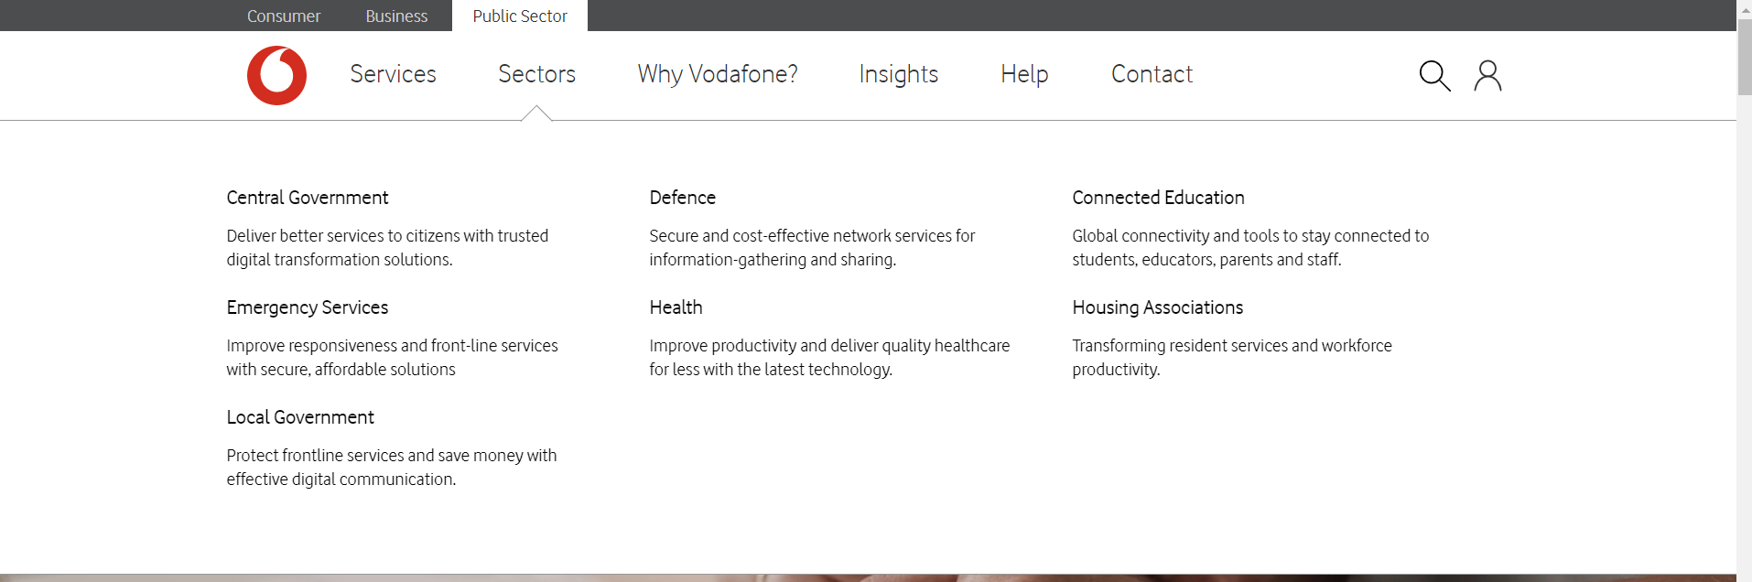 Fig. 4. Vodafone Digital solutions for Public Sector. www.vodafone.co.uk/. 2023
An example of Vodafone's involvement in the public sector is Connected Education (Fig.4).
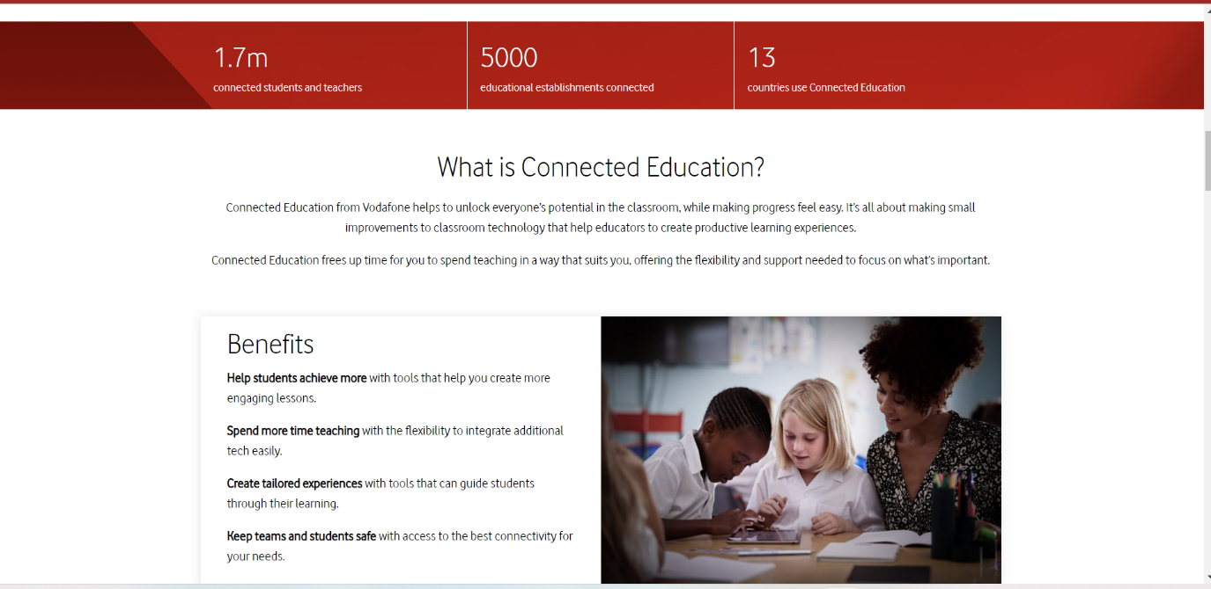
Fig. 5. Vodafone Connected Education. www.vodafone.co.uk/. 2023

Examples of Vodafone digital solutions for school, college, and universities, are:
- Campus Wi-Fi. To maintain a strong signal when students move between buildings, the system uses Vodafone internet and is enhanced by Cisco Meraki Wi-Fi access points that are positioned around the campus.
- Security. Vodafone, supported by Trend Micro, provides a cloud-based, set-and-forget solution with thorough protection for the endpoints and portable devices of the students, teachers and administrative personal.

- Price element: Vodafone Price strategy
According to Chong (2003), the concept of the Marketing Mix started from a single element P (price) of microeconomic theory.
Kotler and Armstrong define pricing as the amount of money required to purchase a good or service or as the value of the trade that enables customers to do so for a given amount of money.
Many scientists believe that price is one of the most crucial market factors that affects both profitability and competitiveness. Price is not only one of the most important variables in a competitive marketplace that directly affects the company's revenue and efficiency metrics; it is also one of the most elastic marketing mix components that can swiftly react to market fluctuations, and the most important customer satisfaction and loyalty factor.
Vodafone has adopted differentiated price plans, for individuals and businesses, for services within the UK, or international services. For calls made and received from abroad, Vodafone prices are influenced by different roaming zones (Europe Zone 1, Europe Zone 2, Asia Pacific, USA & Canada, Rest of World Zone 1, Rest of World Zone 2). (Vodafone Price Plan Guide. 2022)
According to Vodafone website, the offers for business are designed depending on the number of employees of the company and its needs. For instance,
- businesses with 1-9 employees may choose “Vodafone 5G Unlimited mobile plans” or “Red Plans”;
- companies with 10-49 employees might consider previous two plans plus “Business Evolve plan”;
- for big companies with 50 -249 employees, Vodafone offer following plans: Vodafone Business Advance; Business Evolve, Vodafone Business Optimiser and Business Freedom plans;
- and for corporations, with more than 250 employees may suit Vodafone Business Advance, Vodafone Business Optimiser and Business Freedom plans.
Individuals also has a range of options, but regardless of the price plan chosen by the buyers, they has two payment options: monthly payments, or “pay as you go” (Fig. 5).

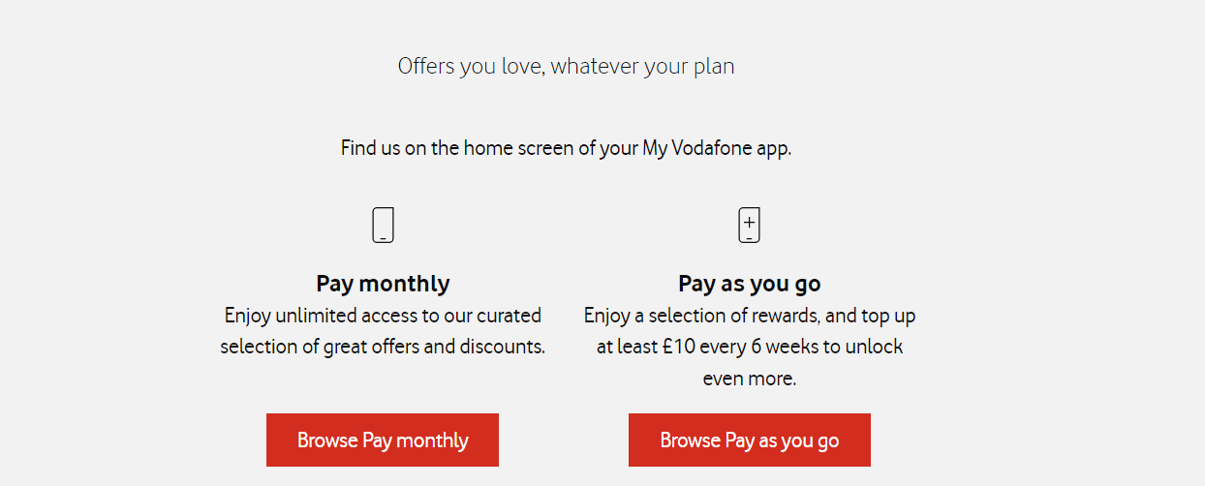
Fig. 6. Vodafone payment options. www.vodafone.co.uk/. 2023

- Place element: Vodafone distribution strategy
The place is another crucial component of marketing. Place element is also known as distribution and is defined as the procedure and techniques by which goods or services are delivered to clients (Martin, 2014).
The review of the academic resources found that there are various channels through which businesses can decide to provide their clients goods and services. Two common distribution routes, direct and indirect marketing channels, are typically allocated to them (Dang 2015). The direct distribution channels of a company's products and services can be: through subsidiaries and own sales employees, or through independent brokers who operate in accordance with the indications of the production company (through dealers, brokers and commission agents).
On the other hand, the indirect distribution channel includes brokers, who act independently. Brokers or traders buy the product from the manufacturer or service provider and resell it to the consumer at the price set or negotiated by the broker. Thus, the path of the product from the producer to the consumer is longer and the price paid by the consumer is more expensive, considering that each intermediary seeks to obtain a profit margin.
Vodafone provides its telephone services in 20 countries, and internet connection in 150 countries. The company's distribution network is mostly based on online sales, but they are also available in assistance centres and their own sales stores. The store network is quite complex and includes all the countries where the company operates.
According to ScrapeHero, at the beginning of 2023, there were 410 Vodafone sales stores in the UK, 84%of them being in England.
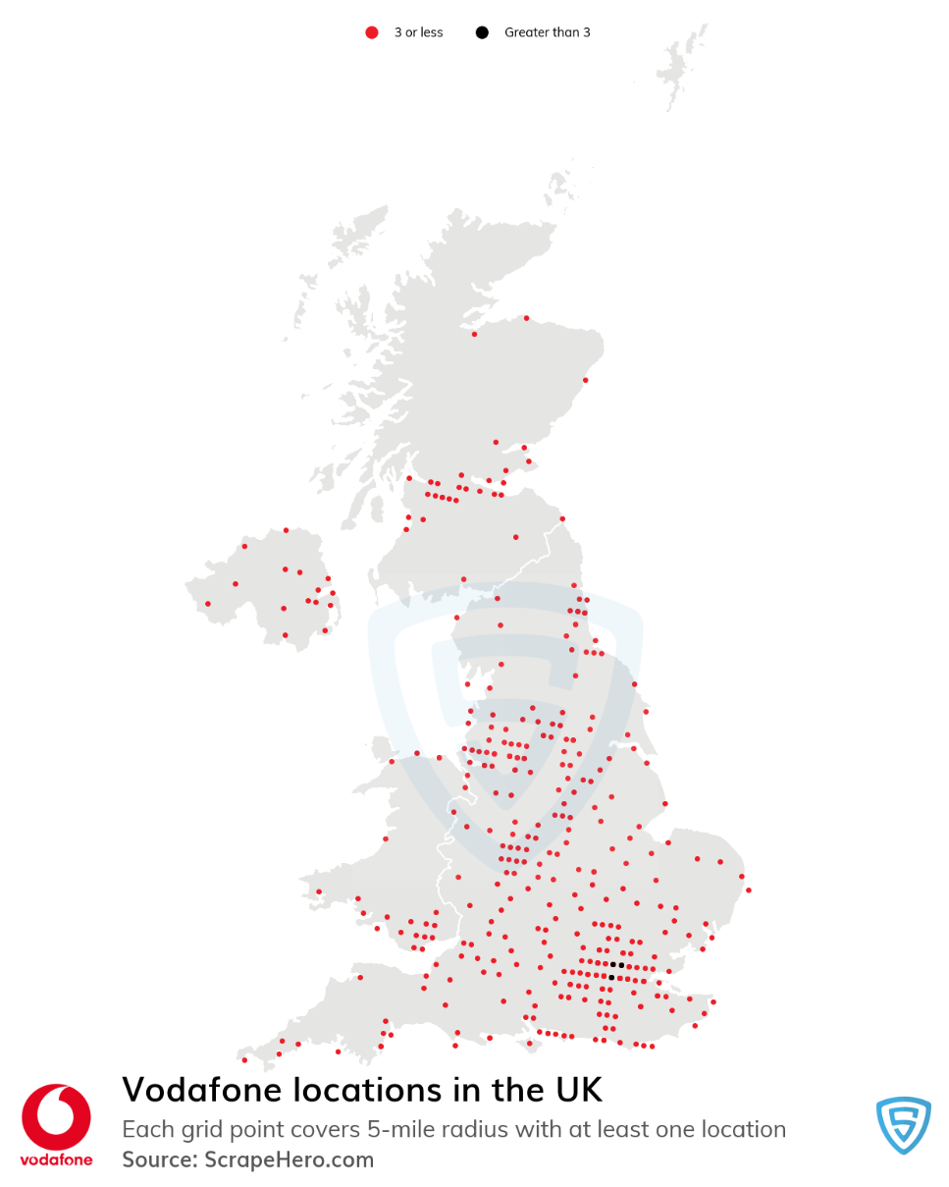
Fig. 7. Vodafone location in the UK. Source: ScrapeHero.com (2023)

- Promotion element: Vodafone promotion strategy
Promotion is the last part of the 4P marketing complex, and it serves to increase customer awareness of the items, which increases sales and develops brand loyalty.
Promotion serves as an instrument that facilitates the distribution of information, stimulates buying process, and influences the customer decision.
The most crucial technique for consumer sales promotion is sponsorship, which also includes discounts, promotions, coupons, samples, refunds, bonuses, rewards, competitions, product demos, and statements about what drives customers to make purchases.
According to Kotler, and other authors, sponsorship is an action that informs potential customers about a product or service, highlights its benefits, and persuades them to purchase it.
Promotion is a complex element of the marketing mix, which can be achieved through various techniques, such as advertising, sales promotion, personal selling, public relations, and direct marketing. Along with globalization and technology, the number of these techniques is constantly increasing.
Vodafone promotion strategy is a complex one, which includes Indirect Channels, Exclusive Retail, Direct Channels, Modern Trade, and B2B Business (fig.8).
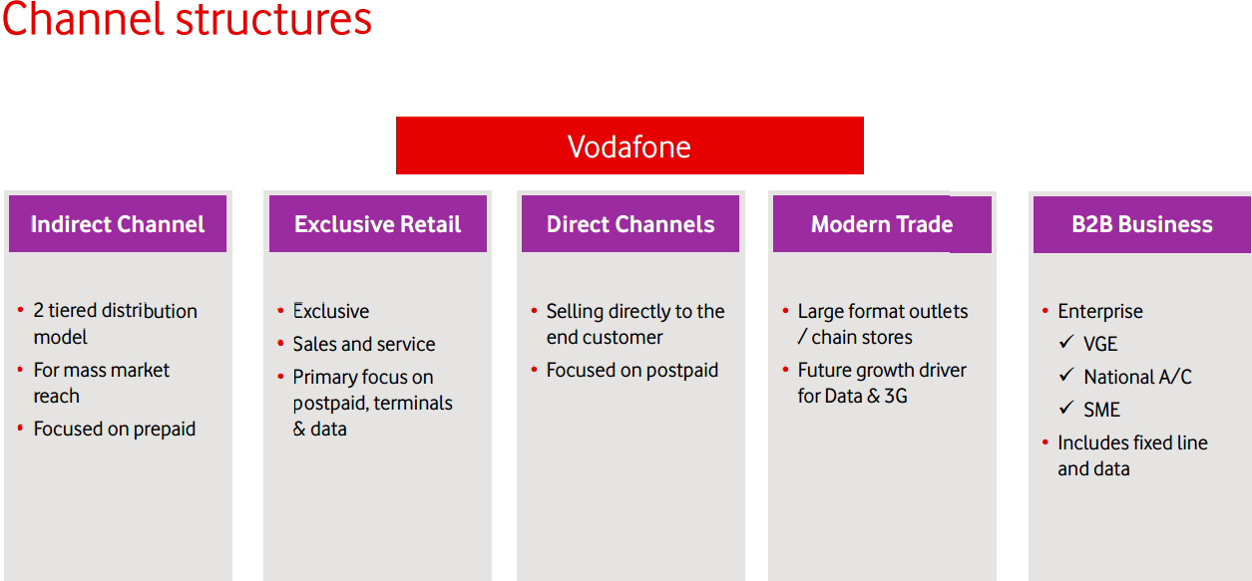
Fig. 8. Vodafone's Promotion Channels. Source: http://jdforvodafone.blogspot.com/

For example, exclusive retail refers to sales that take place directly from Vodafone stores, which are strategically located in urban, semi-urban and rural areas, each of this category fulfilling roles corresponding to the contingent of consumers in the respective area:
- With a good selection of smart phones that can be utilised with the Vodafone service and a customised package, Vodafone stepped into urban areas to give improved service quality.
- The Vodafone mini stores are more practical. It was established through a partnership with individuals that offer service in semi-urban locations.
- Customers in rural areas are given additional in-depth service at the Vodafone micro store.
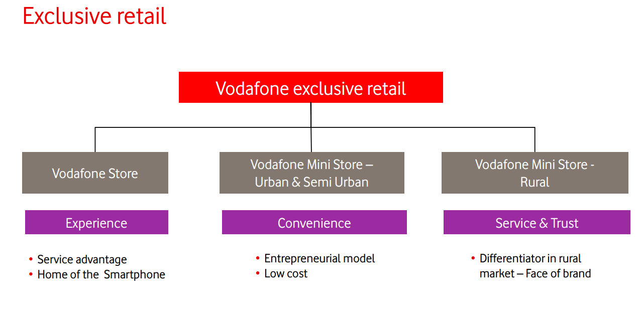
Fig. 9. Vodafone Exclusive retail. Source: http://jdforvodafone.blogspot.com/
Another Vodafone promotion strategy is thought Direct channels, which refers to selling products or services to customers directly through personal interactions outside of fixed retail locations:
- Direct sales representatives market their products by walking the streets and making cold calls.
- By using an outgoing telephoning setup and a "foot on the street" delivery method
- Telephoning is employed using analytics-based data that is provided before and after operator changing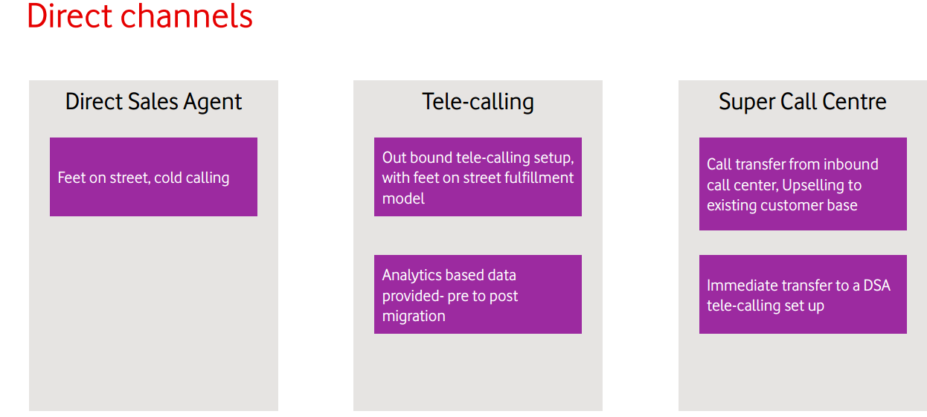
Fig. 10. Vodafone Direct channels. Source: http://jdforvodafone.blogspot.com/

- Suggestions for improving Vodafone marketing strategies
If a business wants to stand out from the digital noise and be seen in today's crowded market, it is imperative to implement successful methods for marketing on the telecom market given the growing number of consumers and businesses that rely on telecoms.
There are a number of marketing strategies that broadband companies can use to attract and retain customers.
- One strategy is to offer promotional discounts or incentives to new customers. By giving new customers a special deal, you can show them that you appreciate their business and that you want them to come back again. There are a few things to keep in mind when offering promotional discounts. First, make sure that the deal is attractive enough that people will want to take advantage of it. Second, make sure that the deal is easy to understand and that the terms are clear. Finally, make sure that you can afford to offer the discount without losing money on the deal. If you can follow these guidelines, then promotional discounts can be an effective way to attract new customers.
- Another strategy is to offer bundle deals that include broadband, cable TV, and/or phone service. Bundle deals are a marketing strategy that is often used by broadband providers. Combining related goods at a discount could increase sales and maintain customer engagement. If a customer is already planning to purchase one item, a bundle can increase their entire purchase while introducing them to additional goods or services they might find interesting. Vodafone bundles, for instance, can comprise broadband, phone, and/or television service. Each listing for a single item then includes a featured link to the bundle, with headlines pushing buyers to make additional savings by purchasing more.
- Broadband companies can also use targeted advertising to reach specific demographics or target markets. By targeting ads to specific individuals, companies can ensure that they are reaching the people who are most likely to be interested in their products. As a result, they can save money on advertising and increase their sales. There are a few things to keep in mind when targeting ads. First, make sure that you have accurate information about your target audience. Second, make sure that your ads are relevant to your target audience. Third, make sure that your ads are visually appealing and easy to understand. Fourth, make sure that you track the results of your ads so that you can measure their effectiveness. If you can follow these guidelines, then targeted advertising can be a powerful tool for increasing sales and profits.
- They can also sponsor events or concerts. Sponsorship as a marketing strategy can be extremely beneficial to a company. It allows a business to associate its name with a particular event, activity, or cause, which can create positive associations in the minds of consumers. In addition, sponsorship can help a company to reach new audiences, connect with customers in a more meaningful way, and create brand awareness. There are a few things to consider before embarking on a sponsorship program, however. First, it's important to make sure that the cause or event aligns with the company's values and messaging. Additionally, sponsorship can be expensive, so a business needs to make sure that the investment is worth it. There are also some potential disadvantages to sponsorship, such as the risk of negative associations if the event or cause goes awry. Overall, sponsorship is a powerful marketing tool that can have a positive impact on a company's bottom line. When done correctly, it can help a business to build a strong brand identity and connect with consumers in a meaningful way.
- They can provide free Wi-Fi in public places. There are a few benefits for both customers and Vodafone when the company provides free Wi-Fi in public places. For customers, free Wi-Fi can be a great way to save money on data usage, and it can also be a convenient way to stay connected when travelling. For Vodafone, providing free Wi-Fi can help to increase customer loyalty, attract new customers, and boost brand awareness. Additionally, free Wi-Fi can help to improve customer engagement and create opportunities for digital marketing.

CONCLUSIONS
The marketing mix's two primary goals are to satisfy the customer's demands and the firm's goals. Today's corporate climate is one that is dynamic. For a firm to be successfully established and to maintain its profitability, it is essential to provide services that may meet consumer requirements.
To accomplish this, marketing experts must continuously monitor the industry and its changes in order to react and adapt effectively. Customers depend on businesses because they need to meet their demands. Quality is taken into consideration when making decisions and carrying out actions related to the 4p complex features. This mixture is made up of the firm's characteristic.
A marketing element known as a "product" encompasses decisions and actions pertaining to the acquisition, enhancement, or modification of offered goods or services. The marketing mix's price component includes choices and activities relating to retail prices and diversity. Distribution is a part of the marketing mix that deals with the decision-making processes involved in getting products from provider to client. Sponsorship is the term for efforts and initiatives performed to enhance the connection between the provider and the final consumer.
Coming back to Vodafone, we can conclude from the content above, that they have a vast marketing strategy, every element of the marketing mix being exploited to the maximum. I noticed that they emphasize the quality, diversity and customization of services and products, offering them at a fair price for the buyer. Vodafone's distribution system includes both online services and physical sales in the network of stores it owns throughout the UK and in all the countries where it operates! And the promotion channels include indirect sales, exclusive retails through company stores, direct channels through the direct approach to the customer, modern trade and B2B businesses.

References
- Booms, B. H., & Bitner, M. J. (1982). Marketing Services by Managing the Environment. Cornell Hotel and Restaurant Administration Quarterly, 23(1), 35-40.
- Chong, K. W. (2003). The Role of Pricing in Relationship Marketing. A Study of the Singapore Heavy Equipment Spare Parts Industry, PhD Dissertation, International Graduate School of Management, University of South Australia.
- Dang, Y., Jia, G., Choi, J. et al. (2015). Optimizing SGRNA structure to improve CRISPR-Case knockout efficiency. Genome Biol 16, 280
- GLOBAL DATA (2023) Company-profile. Vodafone Group PLC. twww.globaldata.com/
- Goi, C.L. (2009) A Review of Marketing Mix: 4Ps or More? Department of Marketing & Management, School of Business, Curtin University of Technology CDT 250, 98009 Miri, Sarawak, Malaysia
- Grönroos, C. (1994). From Marketing Mix to Relationship Marketing: Towards A Paradigm Shift in Marketing. Management Decision, 32(2), 4-20.
- Išoraitė, M. (2016) Marketing mix theoretical aspects. International Journal of Research – Granthaalayah, Vol. 4, No. 6, 25-37.
- Jdforvodafone (2014). Vodafone's Promotion Channels. The Vodafone Story
- Kotler, P.T., Armstrong, G. (2018) Principles of Marketing, 17th Global Edition, Pearson
- Martin, B. (2014) Business, Marketing Mix. https://www.cleverism.com/placefour-ps-marketing-mix
- MBA Skool Team. (2021) Vodafone Marketing Strategy & Marketing Mix (4Ps). www.mbaskool.com
- McCarthy, E.J. (1960) Basic Marketing: A Managerial Approach. McGraw-Hill Inc., US.
- McCharty, E.J. (1964) Basic Marketing: A Managerial Approach. 2nd Edition, Irwin, New York.
- Palmer, A. (2004). Introduction to Marketing - Theory and Practice. UK. Oxford University Press.
- ScrapeHero (2023) Number of Vodafone retail stores in the United Kingdom in 2023. www.scrapehero.com
- Singh, M. (2012) Marketing Mix of 4P’S for Competitive Advantage. IOSR Journal of Business and Management (IOSRJBM). Volume 3, Issue 6 (Sep,-Oct.).
- Sutradhar, T. (2015) An analysis of the distribution channel of Vodafone. Marketing. GUIM.
- Vodafone Group Plc. (2022) Annual Report 2022 . Retrieved 16 January 2023
- Vodafone Group Plc. (2022) Vodafone Price Plan Guide. www.vodafone.co.uk
- Vodafone Group Plc. (2023) About us. www.vodafone.co.uk
- Vodafone Group. (2012) Origin of Vodafone. theoriginof.com. Archived from the original on 6 January 2016. Retrieved 13 July 2012.
- Vodafone Group. (2012) About Us- History 1982 . Vodafone Group. Archived from the original on 20 July 2012.
- Wikipedia. (2023). Vodafone UK. wikipedia.org/

