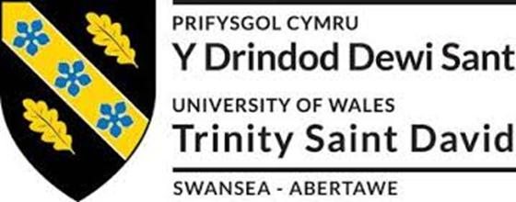

2014507 - Cameron Dickson
Plant and Asset Engineering
Evaluating the Effectiveness of Chosen Maintenance Strategies for Dedicated Equipment
Andrew Thorn
03/04/2023

Table of Contents
Introduction 3
Review of Current Maintenance Practices 3
How Maintenance approaches could be improved 5
Consideration of Costs and Resources 6
Conclusion 7
References 7

Introduction

Renishaw is a global, high precision metrology and healthcare technology group. Renishaw design, develop and deliver solutions and systems that provide unparalleled precision, control and reliability. Renishaw are also a world leader in the field of additive manufacturing, where we design and produce industrial machines which ‘print' parts from metal powder. From transport to agriculture, electronics to healthcare, our breakthrough technology transforms product performance. As a maintenance engineer within Renishaw it is our job to maintain repair and keep all machines in Renishaw running and running efficiently too.
The machine that I will be reviewing is a Yamazaki FJV 250 which is a 3 axis CNC milling machine. The FJV 250 uses “MAZATROL SmoothC CNC system, designed for unsurpassed ease of operation, is standard equipment” (Ref 1). Below is a image of a FJV 250. (Fig.1)
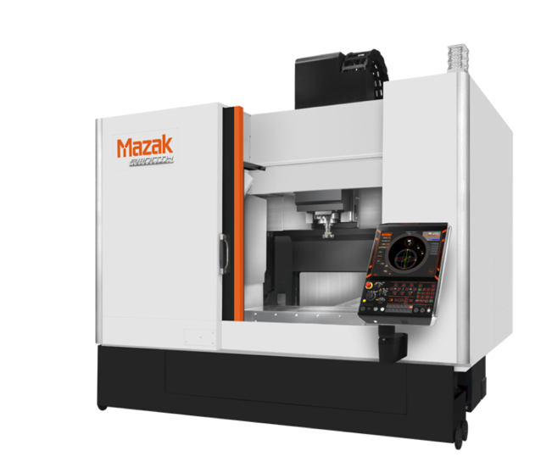 Fig.1

The FJV 250 is a very ridged machine in construction meaning which ensures you are getting high precision and high accuracy when machining. Within Renishaw we use the FJV 250 to machine most of the products that are used for precision systems and even medical systems.

Review of Current Maintenance Practices

Within Renishaw maintenance on the machines is key so that we can prevent down time. On all of the machines in Renishaw and especially the FJV 250 we use a certain maintenance procedure that should prevent down time loss. This procedure uses a monthly PPM (Preventative Planned Maintenance) maintenance check, a six monthly PPM check and an annual maintenance check.

The monthly maintenance check takes around 4 hours to conduct and consist of the following steps.

- Clean slide way and spindle lube tank filler port filters.
- Lubricate the spindle sparingly with Mazak Metalube spray located on stock YAM/FJV/155/S.
- Clean CNC and chiller air filters.
- Check condition of drum filter mesh, report any problems to Senior Engineer for further action.
- Clear any accumulation of swarf as necessary.
- Check in line filter to drum wash jets, clean as necessary.
- Check and clean weir mesh grill in ‘clean’ coolant tank return to drum wash section.
- Carry out a swarf level check in the working compartment coolant tank, if excessive amount is noted, discuss removal and cleaning with a Senior Engineer.
- Check operation of E-Stops.
- Check the operation and condition of the work light and replace if damaged.
- Carry out a spindle vibration check.
- Check the condition of tool grippers and replace any damaged units
- Check the drawbar pressure and record in the Coswin notes. Coswin is our system where all notes of PPM and any maintenance on the machines are held. It is also used to check and book out stock
- Clean mesh weir plate in conveyor.
- Check the level of hydraulic oil in core clamping system and top if necessary.
- Check and clean swarf drum line filter(s).
- Check the condition of swarf drum mesh, report any holes and notify Senior Engineer for immediate further action. (Clear if any blockages present).
- Check the operation of the coolant overflow ultrasonic switch.
- Check ski alignment using spider, adjust if necessary.
- Check condition of guide rollers on bridgework, replace if worn.
- Visually check the carousel for missing ‘bullets’ replace as necessary.
- Check the security of the carousel foot locking nuts, tighten as required.
- Check the condition and air gap setting of the wing detection proximity switch, adjust if necessary.
- Check nut runner torque and record the status, adjust if required.(22Nm)
- Back up machine parameters to a flash disk, follow back up and data storage instructions.
- Check the condition and security of the ski guide rollers.
- Check the spindle coolant jets and ensure they are not blocked and are directed at the tool correctly.
- Remove the transfer arm cylinder dampers and clean out any sludge.
- Clean the window to the coolant drum mesh area.
- Remove the cover to the ATC (Automatic Tool Change) area and wash out any swarf from the area including the ATC top door runners and Cylinder.
- Clean the top of the Main coolant tank and conveyor.
- Visual check on the condition of the Gull Wing door panels. Advise your supervisor of any issues.
- Clean and check the condition of all machine viewing windows for cracks and oil/coolant damage. Report and issues to a member of the supervision team.
As you can see in the monthly a lot of the steps that are taken are more simple checks like visual checks and quick checks like ensuring the safety circuit is working. A lot of the checks are mainly swarf due to machining swarf getting into a lot of places that can cause the machine issues. A big issue that we get is that the conveyors get overloaded with swarf and will trip. When they trip the machine is stopped and booked with maintenance. A thermotrip can take up to an hour of downtime as you have to clean and remove swarf from the conveyor and then run it for 20-30 minutes to ensure its working correctly before handing it back to production. However, keeping on top of this with the monthly checks should minimise the amount of down time from the conveyor tripping.
A six monthly check is very similar to a monthly check with cleaning and ensuring swarf is affecting anything however there are some different steps that are taken. These different steps are stated below
- Change hydraulic oil and clean the filler port filter.
- Remove main swarf and coolant system and clean tanks.
- Remove drum filter spray bar and check nozzles, replace as necessary.
- Apply grease to all ATC and Z axis grease fittings (Pump until grease is visibly coming out to fill the shoe.
- Change the oil in the ATC unit.
- Clean the dried up coolant residue from the top of the machine to reduce the possibility of slipping.
- Steam clean the ATC area and grease the shifter rails.
A yearly check also consists of the very basic checks but will have different steps that are not needed until a year has passed. These different steps are stated below
- Check the condition of the electrical wiring.
- Replace the hydraulic unit line filter on the oil pickup inside the tank.
- Clean the linear guide lube oil tank and refill.
- Visually check all hydraulic/air/lube oil hoses for wear or damage.
- Check the Z axis brake operation.
- Change the air unit element.
- Replace core clamping springs and seals.
- Inspect the core clamping system for leaks and correct operation.
- Check the machine is level, if not then it must be re levelled with the coolant sump removed and then a Ballbar ran on each Axis.
- Replace both turret lock and unlock relays.
The most important step on that yearly check is the Ballbar test. The Ballbar is a measurement device made by Renishaw that will accurately collect data on all axis when moving in a circular motion. The Ballbar test can accurately measure to + or – 1um. This shows if our machines are not levelled or running correctly which can affect the accuracy when machining our parts. Below in Fig.2 is an image of a Ballbar test on our FJV 250 machine.
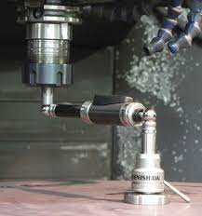
Fig.2

How Maintenance approaches could be improved

Considering that our maintenance checks are already very thorough already and the machines are already well looked after there could still be some major improvements done on these machines. On every machine in Renishaw there is an extraction system fitted to the machine that will remove and filter all fumes from coolant and oils that could be harmful to workers in Renishaw. These systems are not checked only tested by an external insurance company to see if they are working or not. Recently Renishaw has had an issue where at least 10 of these extraction units were deemed not working and we could not run these machines until the extraction units were repaired. Some of the issues found on these extraction units were that they were actually blowing the fumes and mist back into the machine due to the wiring of the motor being wrong. This could be caused by someone from maintenance when changing a motor if it was faulty and wiring back up incorrectly. Also the filters in the extraction systems can get very clogged up or damaged by loose swarf and will stop working meaning until the insurance company comes back out we will not know if these units are working correctly or not. Using an anemometer we can test if these are working correctly or not. The insurance company states these systems should be around 0.5 m/s any less and it might not be working correctly. I propose that Renishaw add an extraction check to the PPM that will be carried out monthly as if not working correctly it could be harmful to workers.

These checks that I would implement would be as follows
- Check the condition of all ducting for damage and blockages.
- Check ducting intakes are clear.
- Check that the filters are within the specified values on the pressure gauges and make a note of the values on a Coswin ticket.
- Where required replace or clean the filters to gain the correct gauge readings.
- Check the equipment is within the 6 monthly LEV inspection period carried out by an external assessor.
- Check that any relevant loss or pressure switches are operational and set to the correct values
- Check the filter access panel seals.
- Check filter mechanism is free and not corroded.
- Check the Face Velocity, Door open 100mm with Anemometer. Minimum reading should be 0.5m/s if this is less report to supervision
- Check arrow next to motor to ensure fan is rotating the correct way.

Consideration of Costs and Resources

In regards to the costs it could save the company a lot. When a FJV 250 goes down it loses the company around £65 an hour. This is quite low for a big company however due to the amount of FJV 250s we have the product if urgent can always be put on another machine that has less of a priority job on it. Although this is not ideal. By adding an extra 30 minutes for these extraction checks we could drastically change the down time to these extraction units. In the last month there was a total of 12 extraction units that had gone down and were not safe to use. It took a full week to get these back running and working safely. So losing these 12 machines over the space of the week roughly cost Renishaw £65 x (5x24) = £7800 for 1 machine. As these machines should run 24 hours a day 5 days a week. £7800 x 12 = £93,600.
So adding these checks will minimise these massive amounts. This is only calculated on the FJV there are a lot of other machines that use an extraction system.

Adding these checks will flag any issues and will stop Renishaw from losing days of down time to these extraction units. Instead the down time might only be an hour or two for small changes. The resources for these checks are not a massive issue as we have scheduled time for PPM and adding an extra 30 minutes to the schedule will not drastically affect us or put any strain on the maintenance team.

Conclusion

To conclude I believe that all companies should ensure PPM is kept up to date and the machines are maintained properly. Although Renishaw already had a very good PPM schedule in place there is always room for improvement as we can see from the extraction checks that will be implemented. By implementing these the machines will run more efficiently increasing production time and hopefully lowering massive down time on these machines an saving the company a lot of money. These improvements I believe will be very helpful to Renishaw and this PPM schedule will be monitored monthly. Checks will be put in place to see if the down time of faults on extraction will decrease over time. If they do show a decrease we could maybe change the plan to a six monthly check. Also long term the PPM schedule should be implemented to the other machines we have in the company that have a extraction unit system in place.

References

Ref 1 - www.mazakeu.co.uk. (n.d.). FJV-250. [online] Available at: https://www.mazakeu.co.uk/machines/fjv-250/ [Accessed 2 Apr. 2023].

Fig.1 - https://www.mazakeu.co.uk/machines/fjv-250/
Fig.2 - https://www.mmsonline.com/articles/raising-the-bar-with-ballbar-testing

