- Student Name: Pinky Begum
- ID:2521850
- Module: Entrepreneurial innovation
- Module code: BMBM4011
- Assignment title: Developing a venture plan for sustainable delivery and longevity
- Project title: Eco refill hub (own venture idea)
- Executive summary: A major global sustainability challenges is one use plastic waste. It has created huge pollution which led to environmental crisis worldwide. Eco Refill hub is a circular economy venture set up to address the worldwide plastic threat. This venture’s goal is reducing one use plastic waste by enabling consumers to refill products such as, detergent and cleaning liquids and reusable containers. With 400 litres monthly sales at UWTSD campus. We aim to launch starts and aim to break even by 12 months. And this actively promotes the idea of a circular economy concept advocated by (Ellen MacArthur Foundation, 2013). With packaging accounting for 36% all plastics created (UNEP, 2024) and with over 400 million tonnes of plastic produced annually and only 9% recycled efficiently. Sustainability here does not just refer to environmental impact but also viability and the longevity of the future of our environment. Delivering 20% cost savings over traditional packaged products eased through repeat consumer business strategy. Eco refill hub shows how entrepreneurial innovation can address plastic waste problems while ensuring long term business viability beyond 24 months
- Project overview and context. Eco refill hub is a social venture it is located in Swansea. Its challenges the £2.1bn UK domestic hygiene market (Mintel, 2024). In SA1 Swansea waterfront campus, we will begin with refill stations so That 3,500 students and staff can easily access and refill their shampoos, detergents, and cleaning liquids. By not investing in plastic bottles and applying porters five Forces (Porter, 1980). Threats of newcomer's are at medium risk, as the machine cost is about £8,000 with low operational constraints. Buying power is high as students prioritise price, by being 20% cheaper than normal branded bottles and ensuring consumer loyalty and long-term viability. Bargaining power of suppliers is low due to several UK wholesale suppliers including Bio-D, Miniml Refills, Delphis eco, made kind, and Ecoffee cup are available, so we won’t be stuck with one company if needed. But primary competitive threat is people are just buying normal bottles and to prevent this by being the only refill option on campus and ensuring long term financial sustainability we will offer exclusive deals on campus, we will run a loyalty scheme. Four stamps = one free refill which will help driving repeat sales.
Currently, in Swansea there are few zero waste shop so competitive intensity in Swansea is low. The venture will register as an asset locked limited company to secure commercial longevity and reduce stakeholder risk. (Audit, Investigation, and community enterprise) Act 2004. Cardiff was rejected due to higher rent with more then £1000 month whereas in Swansea rent is less then that. Cardiff furthermore has multiple established competitors which makes it slightly a bit more of a challenging task. To run and operate this business The lead founding team will be 2 members to do the full operations day in day out and plus one part time technician. First one will do all day to day operations of the business and talk to UWTSD, second member will deal with the financial aspect and apply for the relevant grants etc. Also, A part time Technician staff for machines maintenance which will be at £12.71 per hour which covers £15 hours weekly.
Startup venture cost is £8,240. The first £8,000 for two refill units and £240 for the first 200 litres of stock. The site fee subject to student union commercial agreement, project led at £250 monthly for break even model. actual fee to be confirmed with SA1 Swansea waterfront campus. There will be one part time staff at £12.71 hourly and do 15 hours weekly which monthly £762. And funding £5,000 will be funded via UWTSD Green fund and rest from founder savings.
- Strategy for longevity: Eco refill hub plays significant roles in students life.it mitigated the main two problem for the students at SA1 Swansea Waterfront campus (bay campus). First expenditure pressure and second one is plastic waste. The enterprise prices for laundry liquids at £3 per litre which is 20% price advantage over supermarket which price is at £3.75. And every one refill saves one plastic bottle. currently UK eco refill worth at £42m and each year it is expanding to 12% because day by day consumers preference changing to eco friendly packaging (WRAP, 2023). It shows that this business commercial longevity continues beyond 24 months
- Students will use this method because it quite comfortable to fit in their daily routine and solve their problems easily. The service is amazingly simple, you bring a bottle you got to you designated tap. You pull the tap and pay by card that’s it easy and simple. It is affordable and that also help students Throughout cost-of-living crisis when it is affected on student expenditures. also many students' preference for low packaging waste format and this will help them to make feel guilt free. And by PESTLE analysis proven this how supportive environment working.as a consequence supermarket bottles are more expensive because for politics plastic packaging Tax with £228.82 per tonne and that has less than 30% recycled (HMRC, 2026).so day by day supermarkets price is increasing and refill price will remain same which means over time venture value will be stronger.
For turning one time purchase into routine, business will offer an exclusive offer 4 refill earn one litre free refill bottle which will attract more customers. The venture service will be always change with times for match with changing demands. moreover every 3 months the sales data will be reviewed. By examining from sales if this detects that student demanding something else like shampoo body wash, we will swap the taps if needed. if opening time in the morning but peak demand window in the evening we will change the timing with requirements. With This technique refill station will be part of students weekly shopping routine Instead of one-time trial. we will adapt any innovative ideas and change business strategies for the venture beneficiary.
- The development strategy is measured and safe.the venture launch with SA1 Swansea Waterfront campus. With 1,200 daily walks through people also 3,500 students (UWTSD Estates, 2023). For the first few months only, target will be reaching on the break and after that we can grow our business more like we can add more products and if the student ask for anything else like body wash or something we will add one more tap too. The goal is expanding our business in two years as we are a community interest company, so we need our profits to come into our business so we can budget so in future we don’t have to depend on or ask any grants again.
- The primary threat is similar venture entering in the same business field.new rivals are risk.but entry possibilities are limited because two machine cost is £8,000 which is stopping most people to going forward in market and which is one positive things for us. Also, UWTSD Green fund support us with the cost (UWTSD Green Fund, 2024).and second one is we have two years deal with the student's union which means we are the only one who allowed to do refills at campus. And third after few months of reviewing our business we will know which products most demanding here while A new company won’t have this data.and there are few refills shop in Swansea, and they put their price higher compared to ours, so our one is more reasonable than theirs.in the uk over 30 companies sell refill products so if one put their prices up we have more options we can switch to another one.
- The launching cost is £8,240 where £8,000 for two machine and £240 for first 200 litre of refill stock at £1.20 per litre..for running this venture each month cost is £1, 012.and that including £250 rent for the space SA1 UWTSD waterfront campus.and £762 for one staff member who working 15 hours a week at £12.71 per hour.we keeping our cost low and keeping the student union deals are most important things for us because in each litre sale our profit £1.80 so our target is sale 562 litre to break even.other campus schemes use more compare to ours (student Reuse Network, 2023). this analysis shows the target achieving is doable so this reveals this strategy will keep the venture more then 2 years.

- The canvas below presents figures of the eco refill hub. This model targets the 3,500 SA1 Swansea waterfront campus students. To help them with easy access ability for there day to day essentials and helping them save money which they can budget and spend on others important necessities they may need. As student are limited with there income, we here at eco refill are here on this venture to make a difference with our price at £3.00 per litre which is far cheaper than supermarkets. We aim to help student and the environment for a brighter future. At eco refill we break even at £562 litre monthly. £1,012 fixed cost that covers site fee £250 To be confirmed. We make a £1.80 gross profit per litre after buying product per litre at £1.20 from supplier (Bio-D wholesale pricing,2024). This shows here at eco refill we are passionate and determined and we have a 20% price advantage which is viability. Not only it will and can last 24 months. It can go further and expand to a global change for a brighter and pollution free future. This venture will help the future generations to understand the importance of recycling and keeping the environment as clean as possible for our future students who can have a good life. Is it not fair a generation to make a mess and another generation focus and fixes all the problem. If we put a good system in place everyone can receive help from it.
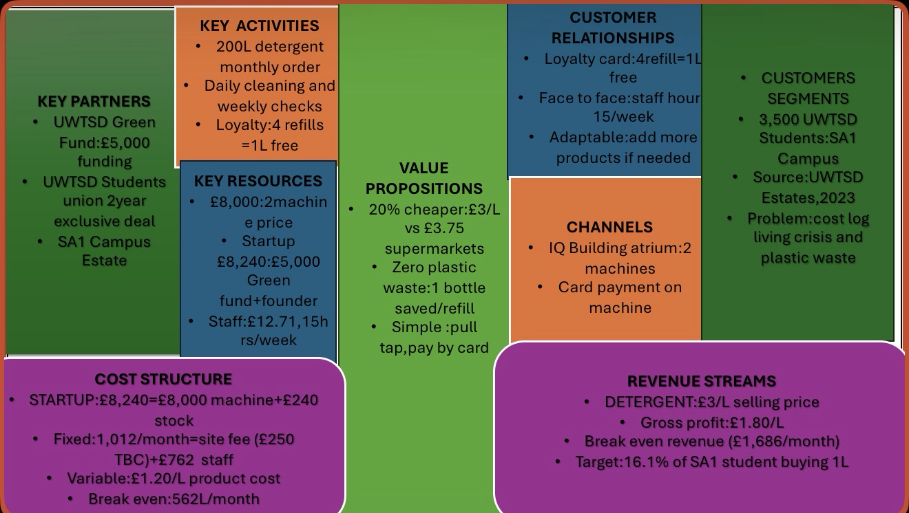
- This is the business model canvas about the venture Eco Refill hub, SA1 Swansea waterfront campus.
- As showed in figure 2 the break even is at £562 litres monthly and £1,686 total revenue cost and each litre sale making £1.80 gross profit and which indicates that we will be able to pay back the launching cost £8,240 in 8 months times. furthermore, for reducing risk we will push the site fee for the 3 months during startup, and it will come down to £762.

- Figure 2: This table shows Break even Analysis about Eco Refill Hub
- This venture break even once the venture covers £1,012 monthly fixed cost. It will cost £762 for part the time staff paying them at national rate of £12.71, plus an additional £250 for the site fee. Additional charge of £250 is still to be confirmed with UWTSD Estates. The venture product cost £1.20 per litre from Bio-D wholesale.
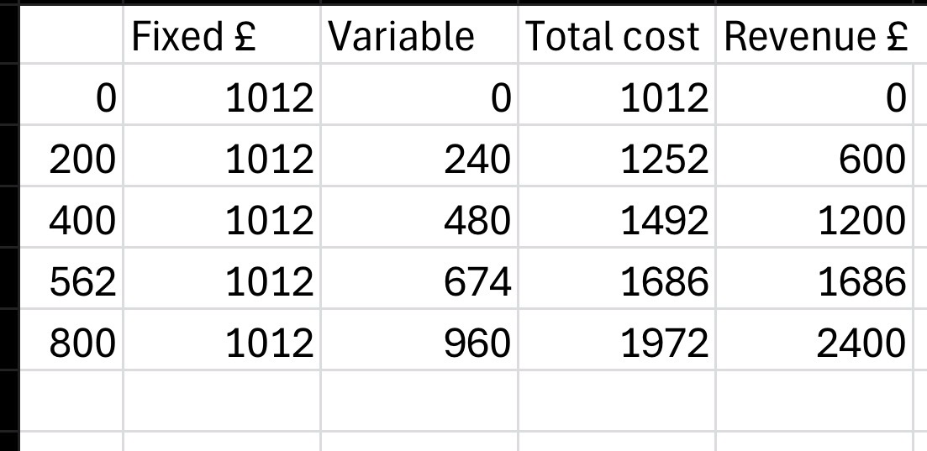
- SA1 Swansea waterfront campus students currently facing shortage of refill facilities. When campus students want detergent powder for their day to day washing, they have two choices walk to Tesco Marina and pay £5.62 for a 1.65 litre plastic bottle or second option would be to catch a bus to the uplands for another zero-waste shop as there is no other zero waste refill option on campus.
- As presented below in figure 3 Eco refill hub is a far better choices for students who are looking for lower price and at the same time help protect environment for zero waste plastic. Currently in supermarkets the price is £3.75. We are charging it more affordable £3.00. That is 75p saved in every litre sale. Which will help student to save a little more and also at the same time help environment which inevitably helps us at eco refill to provide the operations of saving the environment on the long run. The small saving might not seem a lot but saving matters for students and matter for us. Together we can make the difference that is much needed.
- Down bellow is showing figure 3: competitor price comparison-SA1 Swansea waterfront campus Area
Competitor: Tesco Marina, Lidl, Ripple Living, Eco Refill Hub
Location.Tesco location Quay parade, Lidl location is Fabian way, ripples Living location is Uplands and ours Eco Refill hub location is SA1 Swansea waterfront campus
Price per: Tesco price pert litre £3.75, Lidl price per litre £3.60. Ripple Living price per litre £4.20 and our price per litre is £3.00.
Container type: Tesco 1.5L plastic bottle. Lidl 1.5L plastic bottle. Ripple living own container and Eco Refill hub Own container
Distance: distance from target customer is Tesco 0.3 miles. Lidl 0.8 miles. Ripple Living 2.1 miles and Eco Refill hub 0 miles.
Viability, Finance, and/or Resources
- Is this really gonna work? Let’s analysis this, so first setup cost is £8.240 for startup and that will be covered by £5,000 funding from UWTSD and the rest £3,240 is from the founders.and this covers the vendapin mini pro refill machine £5,500 and first Bio-D stock 500 litre £600,installation and signaga cost £1.140 and & £1,000 working spare float and emergencies.
- Monthly fixed cost is £1,012. One part time staff per hours at 12.71 (April national minimum wage ,2026) weekly 15 ours which monthly wages is £762.And the other £250 is for the site fee, but still, it is to be confirmed (TBC) pending discussions with UWTSD Estates.product cost is £1.20 (2024) per litre from Bio-D wholesale price including delivery to SA1 Campus.
- As analysis from figures 2 it shows that break even is attain at 562 litre monthly that mean £1,686 in and out. venture selling price is £3.00 per litre and variable rate is £1.20 so per every litre profit is £1.80 that mean after even break 562 Litre sales every litre sold will help payback the £8,240 startup cost.From target consumers if 16% of them buy monthly 1 litre it will easily break even and that will seems achievable.
- The main problem is that £250 site fee if with discussions with Estatesand it’s gives first 3 month rent free which will reducing the break-even target selling litre which will saves money. And even the wholesale supplier increases the price up to 10% still it’s profit for us.and also in uk over 30 wholesales if needed we can choice another company with affordable price.
- The venture not taking any loans, so the business has no debt.and the grant covers the two machines and card payments which means cash directly coming so this analysis prove that it’s viable beyond 24 months and helps SA1 Swansea waterfront campus UWTSD achieved it’s goal by 2030 by cutting plastic .
- Implementation and Learning Loop
•Months 1-2: setup: Initially main job is do arrangements for machines and get them in as soon as possible. order vendapin mini pro week 1 and discussion with UWTSD Estate rent free for first 3 month. while waiting for machin delivery 6-8 weeks that time work on other important things like sort out the card reader, vala gg design signage.and do some online marketing such as instagram. Facebook, TikTok about the startup which will expand demand.
•Shoft launch: to get people easily to the the door we all give students a exclusive offer which is first 50 students get 10% off which will attract more students. i will check sales every day to find out how much do we need for our break even by 562 litrer.and if we can’t fulfil our target monthly break even I’m not gonna sit down I will do live demo at lunchtime and give students free sample for free trial and by this student will be u introduced with the detergent easily.
•Analyse and change: This is where we can find out what is working and what is not working. every Monday I will checking and look at three things, how many litre we sold, what students are preferring and if we are running low on stock.if students asking for fabric cleaner or any other product then I will order more vendapin machine for month 5.And if we achieve our target easily we will offer another exclusive offer for our regular customers.For regulars per litre will be £2.80.this is with using sales data not guessing.
Backup plan: successful business strategy is always having plan B ready. if we still not even break in month numbers 5 then I will go back to Estates and ask for another three months for free or will drop staff weekly hours 15 hours to 10 hours.
• To keep it sustainable: we will display in counter monthly plastic bottles how many numbers saved. it is making net zero things real for student.
- Conclusion and Recommendations: Eco Refill hub will work if 16% of SA1 students refill 1 litre a month. And Recommendations UWTSD to give startup first three months rent free launch with £5,000 grants. will watch the sales data weekly and add more products if demand increases by 20+ monthly
- Down bellow about this analysis references is given
- White, K., Hardisty, D.J. and Habib, R., 2019. The elusive green consumer. Harvard business review, 11(1), pp.124-133.

Lofthouse, V. and Bhamra, T., 2006. An investigation into consumer perceptions of refills and refillable packaging. Deliverable for DEFRA Waste and Resources Research Programme, June, pp.1-33.

- Lübker, M. and Schulten, T., 2026. WSI Minimum Wage Report 2026: Consolidation of the New European Minimum Wage Policy (No. 111e). WSI Report.
- Hayles, C.S., 2019. INSPIRE sustainability internships: Promoting campus greening initiatives through student participation. International Journal of Sustainability in Higher Education, 20(3), pp.452-469.
- Burgess, M., Holmes, H., Sharmina, M. and Shaver, M.P., 2021. The future of UK plastics recycling: one bin to rule them all. Resources, Conservation and Recycling, 164, p.105191.
- Ertz, M., Durif, F. and Arcand, M., 2016. Business in the hands of consumers: A scale for measuring online resale motivations. Expert Journal of Marketing, 4(2), pp.60-76.
- Edbring, E.G., Lehner, M. and Mont, O., 2016. Exploring consumer attitudes to alternative models of consumption: motivations and barriers. Journal of cleaner production, 123, pp.5-15.
- https://www.gov.uk/government/publications/the-national-minimum-wage-in-2026/the-national-minimum-wage-in-2026
- Hamari, J., Sjöklint, M. and Ukkonen, A., 2016. The sharing economy: Why people participate in collaborative consumption. Journal of the association for information science and technology, 67(9), pp.2047-2059
- Bartek, C. and Rumbolt, A., 2022. Household product refills as a solution to single-use packaging: Developing The Theory of Retailer Care.

