Student Name: Elza Soares
Student Number: 1815430

Programme: BA International Hotel Management
Modulo: Personal Resourcing and Development
Module code: M5X01921
Lecturer: Abdi Rahman

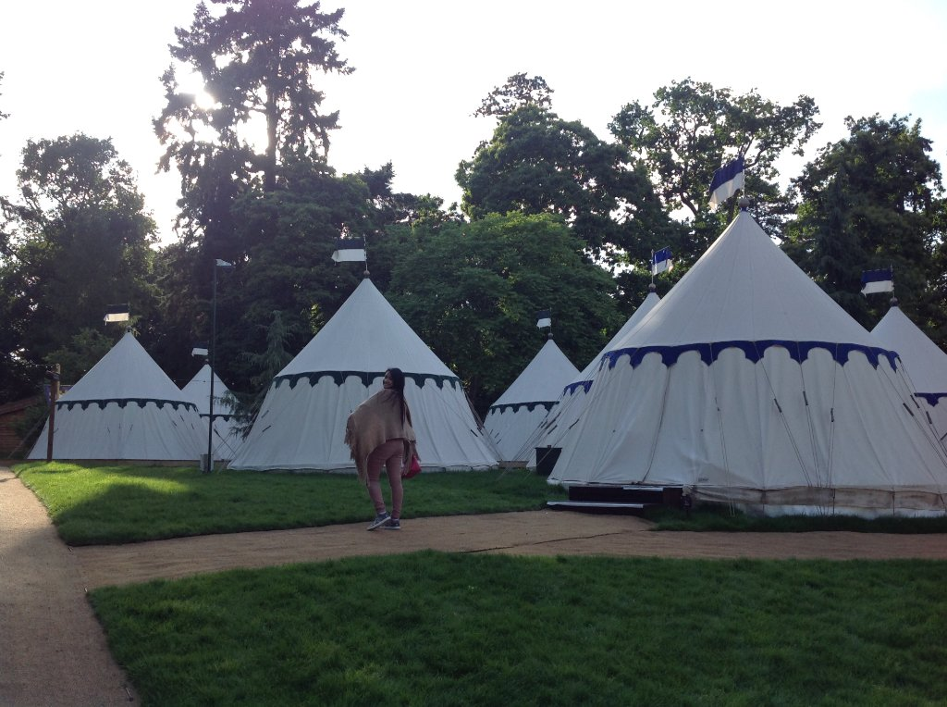

Content:
1 Hotel Knight's Village at Warwick Castle
2 The practice for Hotel
3 Development workforces
4 Primary and secondary resource

Introduction:
The new attributes of the new society are the globalization, free time, “intellectualization”, creativity, aesthetics, subjectivity, dynamism and interactivity between people through the internet, the quality, “emotionality” and femininity, the disruption of time and space, with the search for a better quality of life. (Masi 2000)
Hotel developments are examples of these management changes,
as they constitute a true hospitality industry whose final product is the
“Welcome and welcome” and the provision of services, increasingly qualified due to these changes, which is essential for these ventures.
If you need to change a hotel with history for the whole family and have fun, come and meet Knight’s Village Hotel. (Amanda Figueredo Werneck)
Close to the River Avon, on the grounds of the 11th century Warwick Castle, this relaxed resort with a medieval atmosphere is 6.5 km from Victorian Jephson Gardens 7-minute walk from Warwick train station. (Google)
This Hotel is full of attractive mediaeval stories of daily representations tell the secular history, huts and tents have the decor of that time, and they are all prepared to receive families of 5 or more people.

2 The practice for Hotel
Now I will compare 2 Hotels the Knight's Village that I had the pleasure to visit and make a short interview and the Forest of Arden Marriott Hotel & Country Club that I had the pleasure of interning for 3 months.

Hotel the Knight's Village
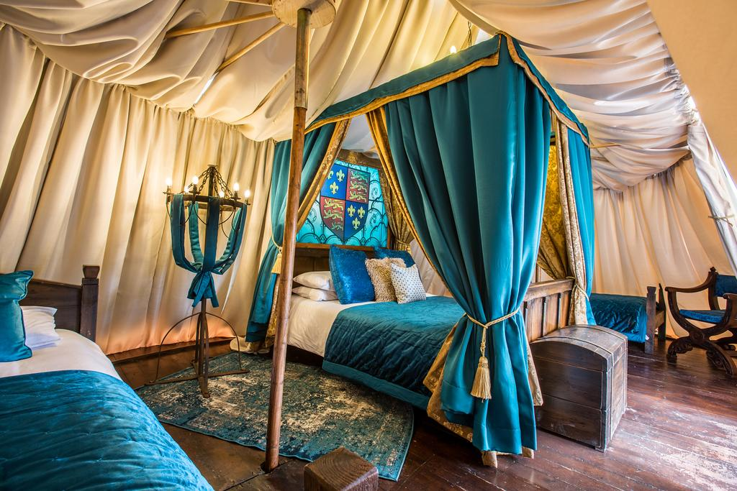

The Knight's Village Hotel I had the pleasure of visiting and doing an interview; in this remote hotel in time, the rooms are shaped like wooden huts and tents with period decor, but with all the necessary modernism.
The family is more focused on total relaxation, with the various activities represented daily and the very atmosphere that makes you travel through time. Warwick Castle is a truly unique setting for a short break, you can experience an exclusive family sleepover like no other, set in a picturesque woodland grove on the riverbank within.

Throughout the interview I noticed the enthusiasm of the employees, they have constant training and are motivated with discounts for the family in all activities in the hotel and in the castle, discounts in supermarkets and cinemas.

It would be nice if the reception staff could offer suggestions on how to get to Warwick Castle. We didn't ask, because we didn't know that this would be a problem. The priority gate for the access of the occupants of the knights' village was locked. As tourists, we didn't know that the walk to the castle is a 30-minute walk with the child, the stroller, etc. They could suggest that we park closer to the castle, as we didn't know there was an option. We were tired before we even started the adventure. (TripAdvisor)

Brilliant 2 day visit to Castle and Knight's Village. Lodge extremely comfortable and immaculately clean. Great value with breakfast and 2 days entry into castle. Good fun for kids after dinner. You can spend as much as you want in the Castle grounds, but this was a birthday treat for our 2 grandchildren and we all had a great time. The dungeon is a must. Yes, things are pricey but only what you would expect. (TripAdvisor).
The morning wakeup call by the elf was the highlight of the stay! The acting cast were excellent during the evening performance too. (TripAdvisor)
We didn't wish to eat at the main restaurant and decide to find something in town. Walking back from the town the main road entrance to the barriers it was unlit and very dark, there was no pathway and mark to identify road and grass curb.
It was unique with the themed room which made it ideal for our special occasion as it was our 25th Wedding Anniversary and we also got a free complimentary drink to celebrated it. Staff were lovely and helpful. (Booking.com)

Forest of Arden Marriott Hotel & Country Club

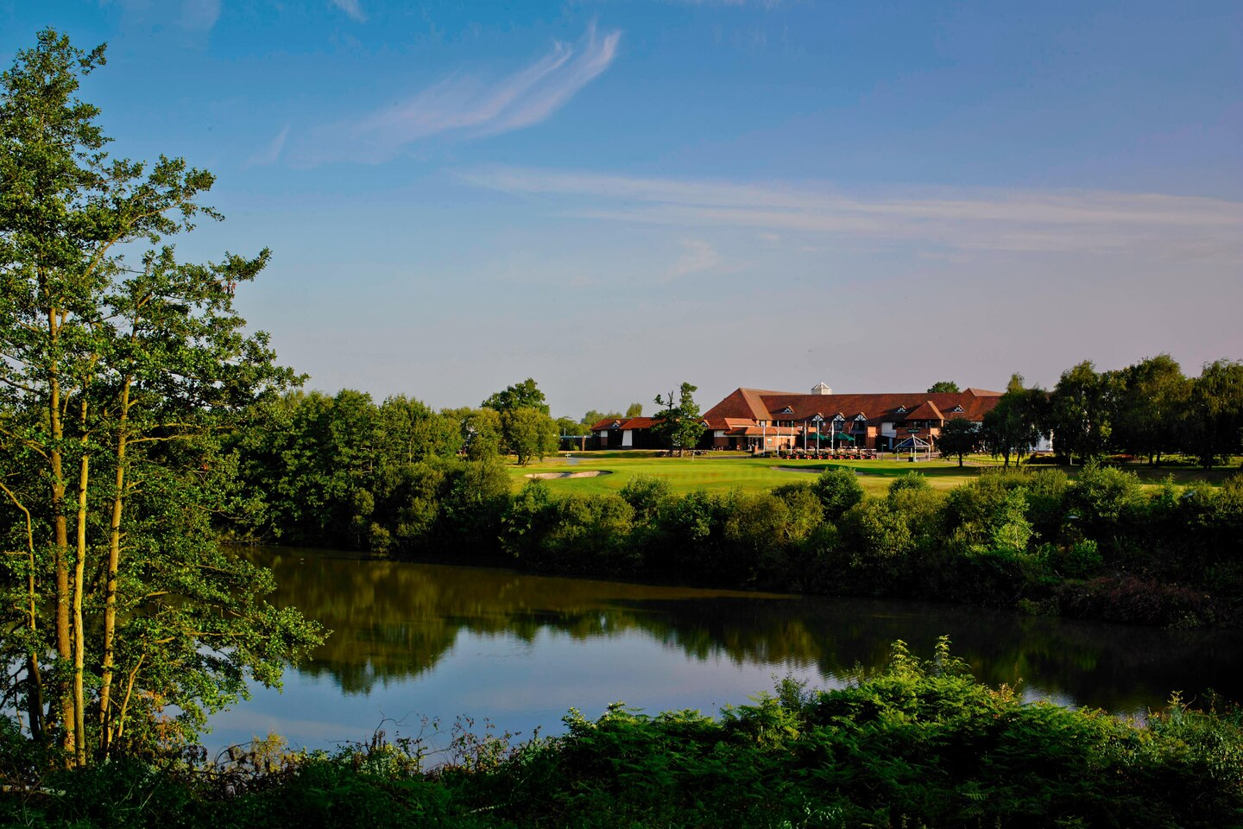
It was in this hotel that I did my placement for three months and had the opportunity to see up close its qualities and the mistakes made daily.
Is a Hotel aimed more at golf lovers has many courses where many competitions take place, including restaurants, bars, swimming pool, and Spa
this hotel is difficult to access for those who do not have their own transport.
Marriott has a points system every time he stays, he earns points that can be exchanged for states and other Marriott Bonvo products.
This hotel and one of the most important in the sport of golf is located 5 km from Birmingham airport, with extensive facilities to be able to receive large golf tournaments with gymnasiums, indoor swimming pool and leisure has spacious rooms. it has free internet for guests inside the grounds as well as in the public areas of the hotel also a Spa for leisure moments, a tennis court, It has 18 meeting rooms and a restaurant that has already been awarded AA Rosette, Cast Iron Bar & Grill.
It has a terrace where guests can enjoy a good meal in one of the restaurants.
there is 24-hour room service and taxi service.
The Marriott group has member fees, with rates they offer a discount of two percent on weekdays and up to five percent on weekends at any of its hotels worldwide.
Rates must be booked by Marriott Bonvoy member using the appropriate rate category not applicable to groups of more than 10 people or more rooms
but can be combined with other promotions, existing offers.
The hotel should improve its equipment, the recycling mode has a lot of daily waste

It has many meeting rooms with difficult access for transporting food and drinks, it only has a kitchen that provides all the meeting rooms. in case of urgency to pick up a certain order in the kitchen at the customer's request, you will have to wait at least 15 minutes, which is a long time for those who are on a break.
they do not bet on their employees; the managers are in constant change which makes the sectors in permanent disrepair.
there is a shuttle from the train station to the Hotel at certain times which means if you have an emergency it can only be a taxi, in case you are late or leave early which is an inconvenience for the employees.

Marriott offers one meal each shift
I booked this last night to spend a romantic night with my girlfriend! As it was last minute, I hadn’t really planned anything romantic, I’d bought some flowers which were the best of a bad bunch! Hearing my sad story, the staff was amazing, they organized rose petals sprinkled on the bed, towels shaped like swans and a complimentary bottle of Prosecco!! Absolutely blown away by the kindness at this hotel!!! Ordered room service and the food was prompt and delicious!! I will stay here again!! Lobby smelt incredible. (Booking.com)
Lovely place the views are to die for. The whole team is brilliant. Loads of internal activities. But some things to improve with your website and reservation system. We booked a room and meal package. We had to ask a lot of questions to understand what was included and what was not. The website implies that you can book meals and other activities, but we are unable to find out how. Systems are so disconnected that they need an IT systems specialist. Correct this and my score could easily have been 5 stars. (Trivago.com)

3 Development workforces
there is a need to effectively serve the public and clients, career professionals need to be equipped and prepared with the most functional and modern theories and models in the field. Constant updating is a necessary process for an ethical career practice with knowledge of the theory. The aim of this book was to provide professionals with a solid and practical basis, a tangible resource that they can use to develop theory-based interventions. (Nancy Arthur, Roberta Neault, Mary McMahon)
Employers need to be aware of encouraging their employees to keep them loyal and longer. Training, special discounts, and a fair salary guarantee everyone's satisfaction.
It is necessary to know how to plan a good we must effectively think about good planning on how to recruit, train and mobilize people with qualifications to carry out a certain job.
It is important for managers to intervene to take effective measures so that everything works perfectly. (CIPD)

4 Primary and secondary resource
The primary features of the offering and although present everywhere, they can be considered as when exploited for this purpose. Before that, they integrate the offer potential. Accordingly, you agree with (CAZES, LANQUAR &
OUARD 1980: 35) when he states that there are no tourism resources by itself ", but only" exploitable "and usable resources that, for reach a tourist offer, needs of economic conditions and technological features. (GUNN (1988: 37) goes further by stating that as attractions are available, in the first place, in natural resources today, they are produced and do not exist, are used, until they are
facility suggestions. This is the first step to better understand
Secondary sources
interpret, discuss, comment, and can accurately describe a particular episode discuss, interpret, comment, make an analysis, evaluate, summarizing the processes of the primary sources. some examples may be articles in popular newspapers or magazines, books or films or articles found in academic magazines that discuss or evaluate the original research. (Library.ithaca.edu)

There is a great concern in the last decades, there has been a significant increase in patients with allergic diseases, especially in the pediatric population. new drugs have emerged with much greater efficacy compared to those available at the time, which reduced the morbidity and mortality of these diseases. However, the incidence and prevalence of these diseases is increasing. Over the course of 20 years, allergic reactions to food, which result in atopic dermatitis, asthma and anaphylaxis, have increased by three to four times compared to previous decades.
According to many authors, the explanation for this has to do with genetic susceptibility, associated with new environmental allergens and respiratory viruses. In this sense, the lactation period and the preschool period are particularly important, because at these times in life the immune system is in the process of maturation and contact with these factors interferes with immunomodulation. For this reason, it is essential to understand how the fetus' immune system changes during pregnancy and how it changes with the advancement of childhood. (Aderbal Sabra)
The existence of an information book on food ingredients is very important in all establishments that cook food, but unfortunately there are still many restaurants without this information and cooks who are unable to act in certain situations.
This information is very important and can save many lives.

I will mention some examples of primary source archived material, manuscript
photographs, audio recordings, video recordings, films magazines, letters and diaries newspapers and magazine clippings published at the time government publications oral stories organization records autobiographies and memories
ephemera printed artifacts, for example, clothes, costumes, furniture search for data. (UCI Libraries)

Examples of secondary resources can be found in Bibliographies Biographical works Reference books, including dictionaries, encyclopedias and atlases Magazine, periodical and newspaper articles after the event Literature reviews and review articles, History books and other popular or academic books Critical and interpretation works Comments and treaties didactic books Indexes and summaries

Conclusion:
With the proposal to conceptualize and observe intellectual management in
hotel development, the management theory of the study carried out in two hotels located in Warwickshire was presented in this work.
where systematic observation was developed by the researcher, during
visit and internship periods.
A study of the hotel was carried out with the observation of routines and
The work environment in the reception sector, throughout the period of the visit, and the location characterize its management from a managerial point of view.
Due to the size of the hotels analyzed, I noticed the team's enthusiasm in answering all questions and the availability of services and measures that
Through questionnaires and interviews, I was able to conclude that the hotel is in constant training to improve the qualification of its employees and assist in management.
It is important to note that although there are two totally different Hotels, there are many improvements to make the level of satisfaction of its employees, in IT the details, there are many improvements to be considered.

Reference:
(Aderbal Sabra)
(Amanda Figueredo Werneck)
(Booking.com)
(CIPD)
(CAZES, LANQUAR & OUARD 1980: 35)
(GUNN (1988: 37)
(Google)
(Library.ithaca.edu)
(Masi 2000)
(Nancy Arthur, Roberta Neault, Mary McMahon)
(Trivago.com)
(UCI Libraries)

