Digital Signals and Communications
Comparison of Digital Modulation Methods
Professor Ian Wells
Edward Russell
12-30-2017

Contents
Introduction 2
Modulation and Demodulation 2
Amplitude Shift Keying 2
Frequency Shift Keying 3
Phase Shift Keying 5
Addition of Additive White Gaussian Noise. 6
Comparison 6
Forward Error Correction 7
Conclusion 7
Bibliography 9
Appendix 10

Introduction

Digital modulation is a necessity for the transmission of smaller signals, or any signal over longer distances. This is because modulation brings with it several advantages such as, a reduction in the height of the antenna required to receive the signal, an increase in range, improved quality of reception, and removes the risk of signals mixing [1]. Digital modulation also allows for the addition of error control codes to detect and/or correct errors in the transmission [2]. There are three main types of digital modulation, Amplitude Shift Keying (ASK), Frequency Shift Keying (FSK), and Phase Shift Keying (PSK). In this report the different techniques will be outlined and compared, both with and without the addition of Additive White Gaussian Noise and Forward Error Correction. To determine the most effective method and error rate calculation block will be used to measure the number of errors received.

Modulation and Demodulation

Digital modulation has two stages, Modulation and Demodulation. The basic principle of modulation is taking a given binary signal, combining it with a carrier signal (sinusoidal in shape) whereby converting it into an analogue signal. This can be done in one of three ways; Amplitude shift keying, Frequency shift keying, and Phase shift keying. Demodulation is the reverse of this, it takes the modulated signal, combines it with a sinewave identical to the first and puts it through a low pass filter which smooths out the signal. The final stage is combining it with a comparator or decision circuit to output the original binary signal. For this assignment however, mathematical functions were used in the place of a comparator and decision circuit.
The differences between the three modulation techniques come in the form of the different carrier signals. The ASK is different from the other two in this respect, it is only combined with one carrier signal during modulation, whereas FSK and PSK both get combined with two.

Amplitude Shift Keying

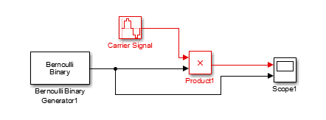
During ASK the amplitude of the carrier wave is alternated from high to low according to the received binary signal. If the binary signal is high (1) then the carrier is present at a constant amplitude, however if the binary signal is low (0) then there is an absence of the carrier signal. The ASK used in this comparison had an amplitude of 1, a frequency of 2*pi*100 and a sample time of 1/1000.
Figure 1 An ASK modulator created in Simulink
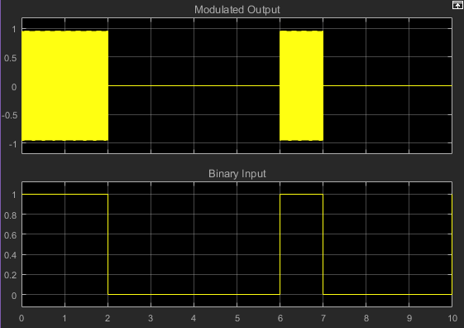
Figure 1 shows how the ASK modulator was created within Simulink.
Figure 2 Scope view of ASK modulation
Figure 2 shows the difference between in the binary input to the modulator and the sinusoidal analogue output.
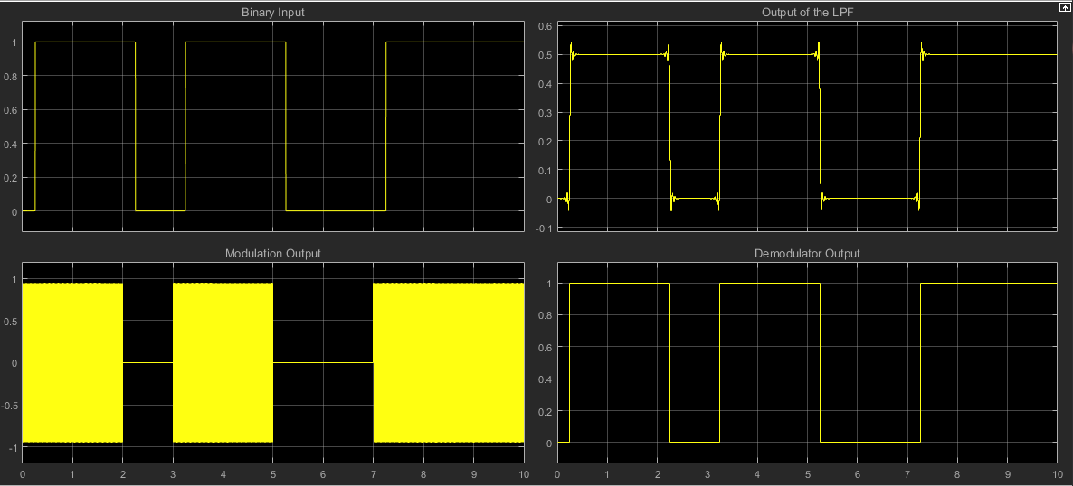
The demodulation for ASK is as described above, combining the modulated output with a carrier signal identical to that in the modulator and putting the result through a Low Pass Filter followed by some mathematical functions to smooth out the demodulated signal to return it to its premodulated state.
Figure 4 Scope view of both modulation and demodulation
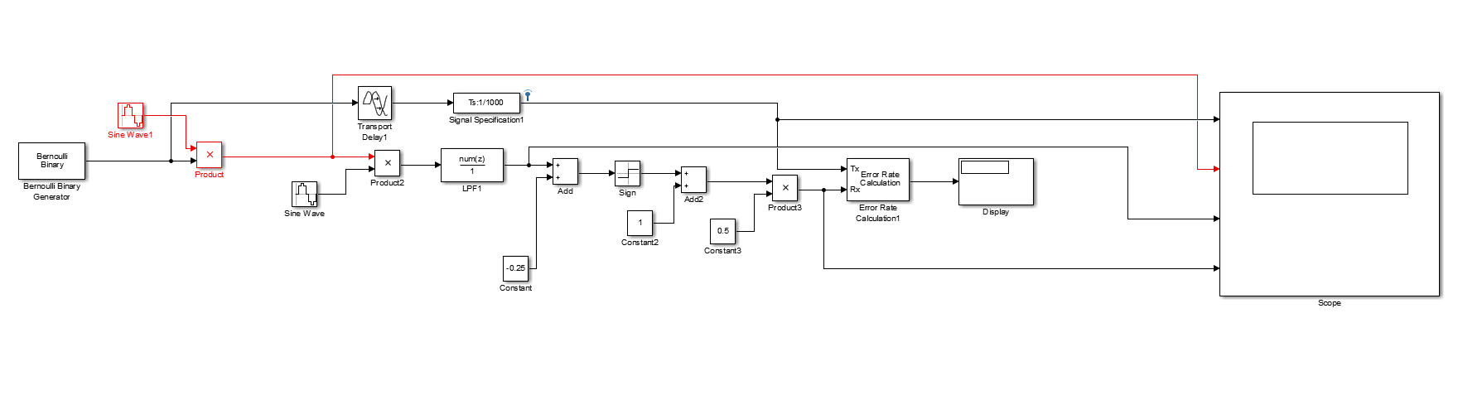
Figure 3 shows both stages of the modulation of the input signal in Simulink.
Figure 3 ASK Modulation and Demodulation
Figure 4 shows four different stages of the process. First the input, followed by the output from the modulator showing the binary against the analogue signals. The top right is the analogue signal that has been taken and put through the Low pass filter, smoothing it out and bringing it much closer to the original signal. Finally the output after the demodulation stage is complete.

Frequency Shift Keying

In FSK, unlike ASK where there is only one carrier wave, there is two carrier waves, identical in all regards except frequency. For this assignment the carrier waves had an amplitude of 1 and a sample time of 1/1000, with the first carrier wave having a frequency of 2*pi*100 and the second a frequency of 2*pi*50. These are both connected to a three-way switch with the third option being the binary signal. When the binary signal is high (1) it switches to the high frequency carrier wave, and similarly when the binary signal is low (0) it switches to the low frequency carrier wave. This is shown in figure 5.
Figure 6 shows the scope view of the FSK modulation, displaying the different output signal frequencies at binary high and low input.
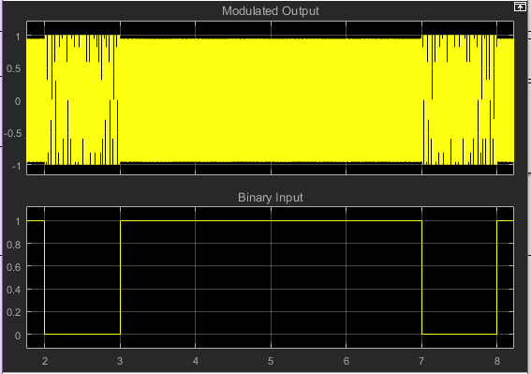
Demodulation of FSK is different to ASK as eluded to above. FSK has two carrier signals in the modulation stage, during demodulation it is combined with an identical copy of both carrier signals and splits into two paths which both get put through separate but identical low pass filters. Both paths are then subjected to some mathematical functions to smooth it and are then combined before being put through some more mathematic functions to output the final demodulated signal. The Simulink stages for this are shown in figure 7.
Figure 6 Scope view of FSK Modulation

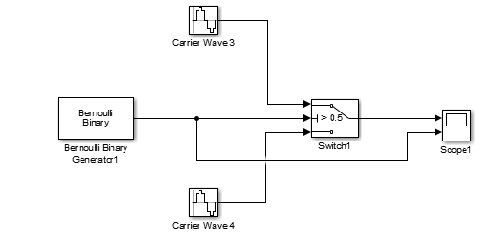
Figure 8 shows the scope view of both stages, starting with the input signal followed by the modulated output, post LPF signal and final demodulated output.
Figure 5 The FSK modulator in Simulink.

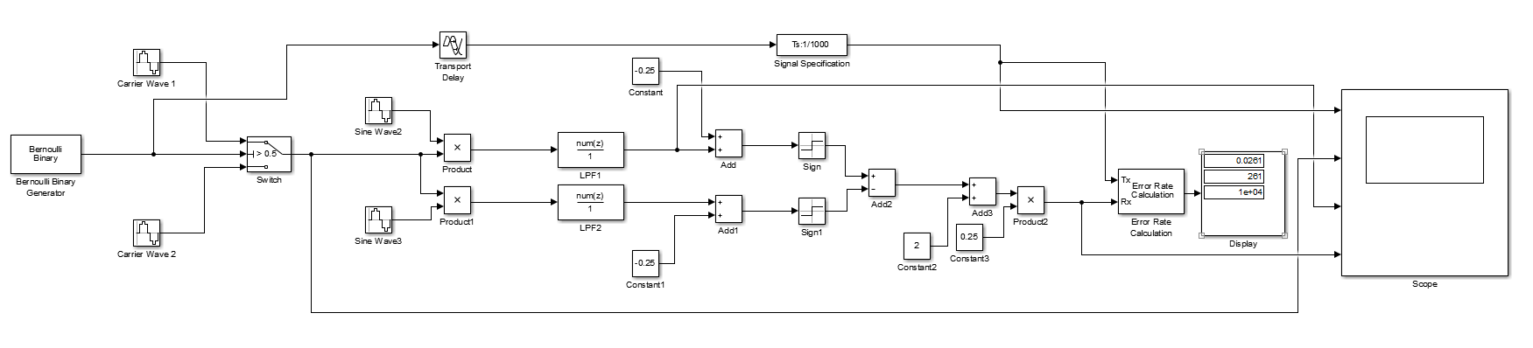
Figure 7 FSK Modulation and Demodulation
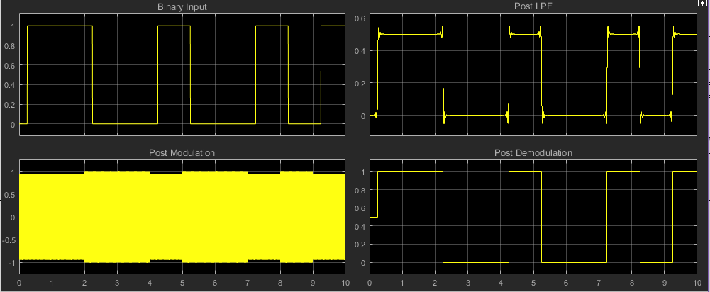
Figure 8 Scope view of FSK Modulation and Demodulation

Phase Shift Keying

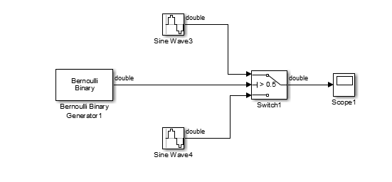
PSK, like FSK, is combined with two carrier signals during modulation, however instead of a difference in frequency, they have a difference in phase. Both signals have an amplitude of 1 a frequency of 2*pi*100 and a sample time of 1/1000 but one of the signals has a phase of -pi. Connected to a three-way switch with the binary input signal. When the binary signal changes from high to low or vice versa the phase changes.
Figure 9 A PSK Modulator
Figure 9 shows the PSK modulator in Simulink.
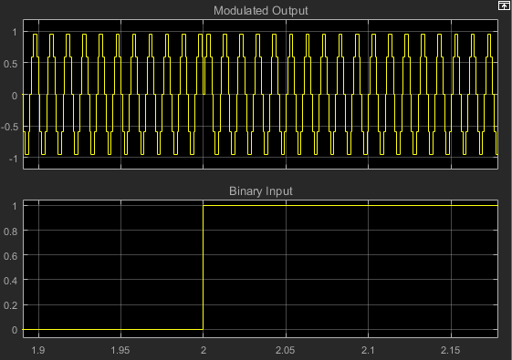
Figure 10 shows a section of the scope view from the PSK modulator, the section shows the change of phase when the binary input changes from 0 to 1.
Figure 10 A section of the scope view of the PSK modulator.
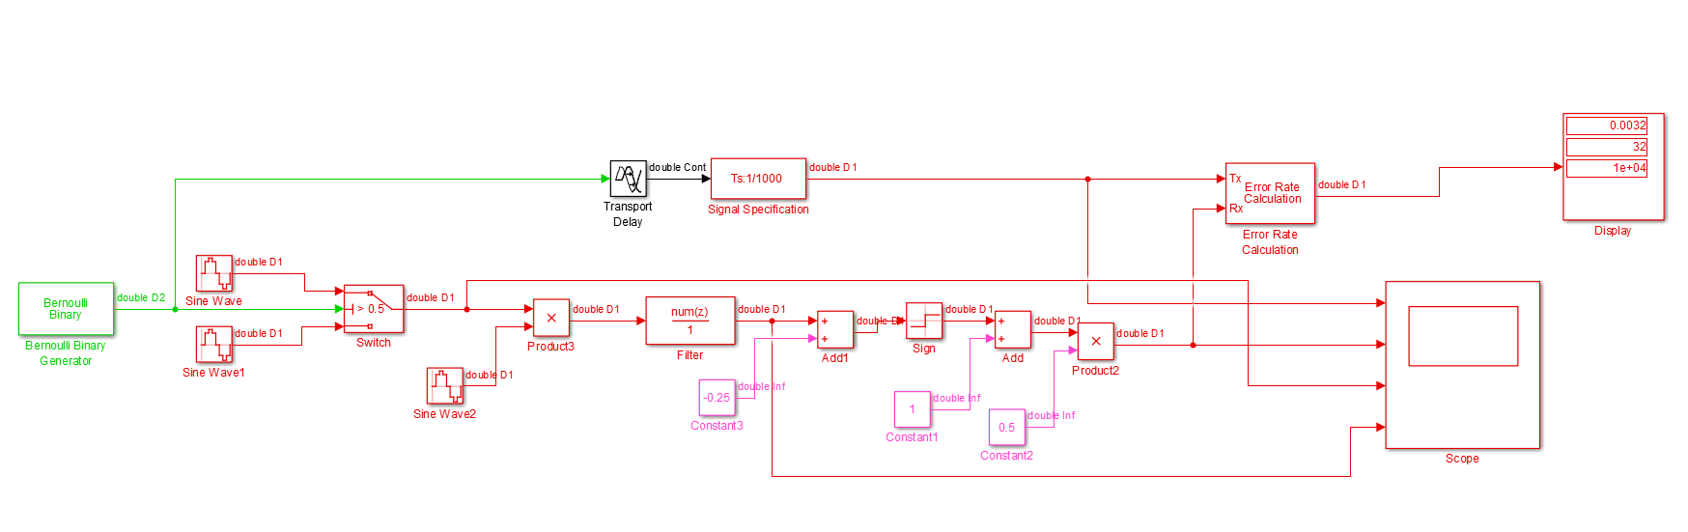
Demodulation is much closer to ASK than it is to FSK because it is only combined with one carrier signal during the demodulation stage, again identical to one of the carrier signals from the modulation, in this case the signal has a phase of 0. It is then followed by a Low Pass Filter and mathematical functions to smooth it and return a signal identical to the original binary signal. The Simulink model of this is shown below in figure 11.
Figure 11 PSK Modulator and Demodulator

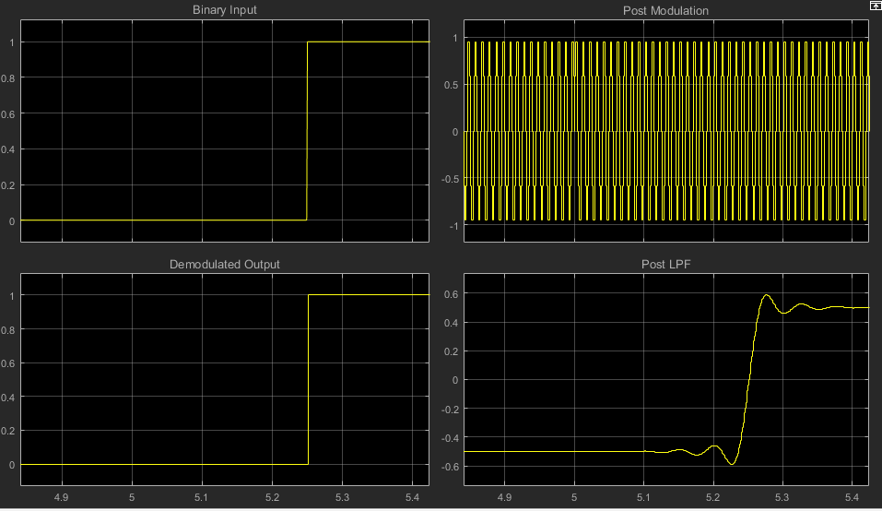
Figure 12 shows the scope view of a section of the PSK modulation and demodulation.
Figure 12 Scope view of PSK Modulation and Demodulation

Addition of Additive White Gaussian Noise.

During the communication and transmission of signals an issue that arises is that of thermal noise, with respect to this “The performance of a digital communication system is quantified by the probability of bit detection errors in the presence of thermal noise.” [3]. In Simulink it is possible to simulate the addition of this noise using a AWGN (Additive White Gaussian Noise) block. This allows us to measure the difference between the different modulation techniques under the effect of different levels of noise.
So, to show the effect of thermal noise, the AWGN block was placed directly before the Low Pass Filter. For all three the signal to noise ratio (SNR) was first set to 128 (dB), this simulates a negligible amount of noise as there is a large difference between the signal and unwanted noise [4]. To simulate a large amount of noise the SNR was set to -10 (dB) on all three. A table displaying all the results is shown below. For all results the simulation was run three times, and the results from the Error Rate Calculation block were taken and averaged across those three runs. All are displayed as percentage of error.
Table 1 A table showing the average result of three runs for different levels of noise across all three modulation techniques
Technique | No Noise | Low noise 128(dB) | High noise  -10(dB)
ASK | 0.0008 | 0.0006 | 0.3305
FSK | 0.0257 | 0.0260 | 0.6750
PSK | 0.0032 | 0.0040 | 0.2226

Comparison

As can be seen in table 1, all three modulation techniques are highly effective without the addition of noise, with ASK and PSK both having less than 1% error rate. FSK is the outlier with 2.6% error rate however outside of applications where exceptional precision is required this is still perfectly acceptable. When the addition of low noise (128dB) is considered it is apparent that there was little to no effect upon the outcome for any of the techniques, with the results all being within the margin for error of the results for no noise. Once high noise (-10dB) was introduced this changes drastically. Here it is evident that there is a significant difference in how effectively the different modulation techniques handle the noise and the outcome as a result. What was previously the most efficient technique (albeit by a small margin) ASK has had an error rate increase of 413% from 0.0008 to 0.3305. PSK was in the middle for efficiency originally but has proved itself more efficient with the addition of high noise, it only has an error rate increase of just 69.5% from 0.0032 to 0.2226. FSK has once also shown greater efficiency with the addition of high noise, with an error rate increase of 26.2% from 0.0257 to 0.6750. As is shown in the results whilst all three techniques are capable of dealing with the addition of noise to an extent, none are capable of doing so with enough proficiency to produce a sufficiently accurate outcome.

Forward Error Correction
With the addition of factors such as additive noise, distance and bandwidth requirements, it quickly becomes apparent that these techniques are insufficient by themselves. One solution to this issue is the addition of Forward Error Correction (FEC). On a basic level FEC adds redundant information known as parity bits to a data stream [5] without changing the data. It works by encoding the original binary data before modulation, and after the demodulation has occurred the data is decoded, during which it effectively detects and corrects errors [6].
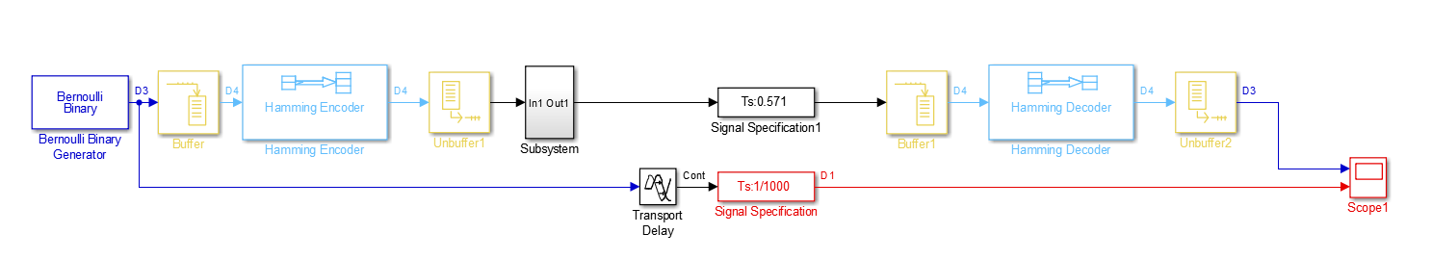
One such type of FEC is Hamming code. The simplest form of Hamming Code is (7,4) which indicates the codewords of 7 bits in length, 4 of which are the original binary signal and the other 3 are the parity bits added for the detection and correction of errors [7]. For example, given the following (7,4) code, 1110101 it is possible to identify that the original data is the first 4 bits, 1110, and the parity bits are the following 101. This was implemented within Simulink in an attempt to reduce the error rate for all of the modulation techniques, however due to an issue within the Simulink software we were unable to get it working successfully. Nonetheless Figure 13 shows how the hamming code would be constructed within Simulink. The subsystem showing in the figure is representative of the ASK simulation shown in figure 14 in the appendix.
Figure 13 An implementation of Hamming code FEC in Simulink

Conclusion

All three techniques, ASK, FSK, and PSK are highly effective without the addition of thermal noise, once a large amount of noise is introduced however they all suffer from a strong reduction in effectiveness. The results showed that during our testing ASK was the most effective when noise was not a factor with an error rate of just 0.0008 however once high levels of noise were implemented this changed and PSK became the most effective with an error rate of just 0.2226. FSK had the highest error rate both with and without the addition of noise so in both it was the least effective. With the addition of FEC this could be accounted for and some of the errors could be detected and corrected however we were unable to test this in theory due to some issues with the Simulink software itself. Figure 20 is a chart depicting these results.

Bibliography
[1] Sasmita, “Explain the need for modulation in a communication system – Electronics Post.” [Online]. Available: https://electronicspost.com/explain-the-need-for-modulation-in-a-communication-system/. [Accessed: 30-Dec-2017].
[2] M. Torlak, “EE4367 Telecom. Switching &amp; Transmission Introduction to Digital Modulation Introduction to Digital Modulation.”
[3] Qasim Chaudhari, “Additive White Gaussian Noise (AWGN) | Wireless Pi,” 2010. [Online]. Available: http://wirelesspi.com/additive-white-gaussian-noise-awgn/. [Accessed: 04-Jan-2018].
[4] I. Poole, “Signal to Noise Ratio | Radio Receiver SNR | Radio-Electronics.com.” [Online]. Available: http://www.radio-electronics.com/info/rf-technology-design/rf-noise-sensitivity/receiver-signal-to-noise-ratio.php. [Accessed: 04-Jan-2018].
[5] K. Azadet and M. Yu, “Forward Error Correction ( FEC ) techniques for optical communications,” Group, no. July, pp. 1–31, 1999.
[6] “Use Forward error Correction To Improve Data Communication,” Electronic Design, 2000. [Online]. Available: http://www.electronicdesign.com/communications/use-forward-error-correction-improve-data-communications. [Accessed: 04-Jan-2018].
[7] M. Viswanathan, “Hamming Codes – How it works – GaussianWaves,” Hamming Codes - How it Works, 2008. [Online]. Available: https://www.gaussianwaves.com/2008/05/hamming-codes-how-it-works/. [Accessed: 04-Jan-2018].

Appendix
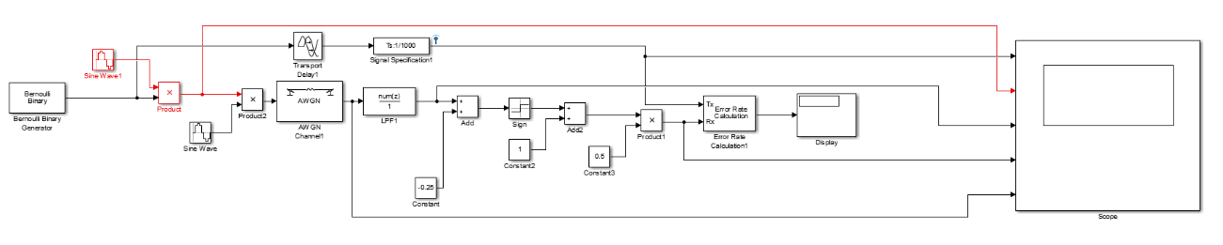
Figure 14 ASK Modulation and Demodulation with AWGN
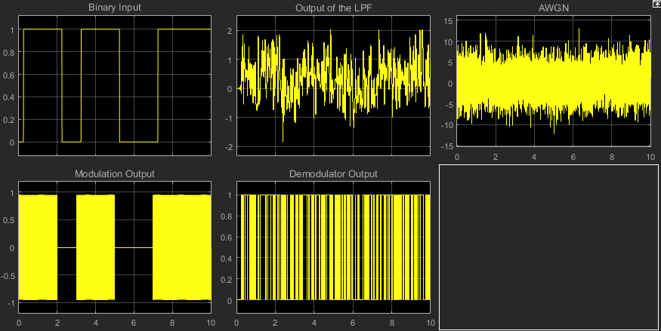
Figure 15 Scope view of ASK with high levels of noise

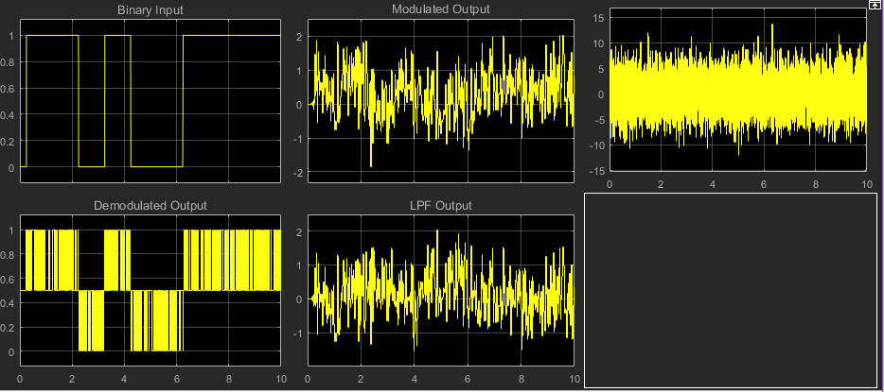
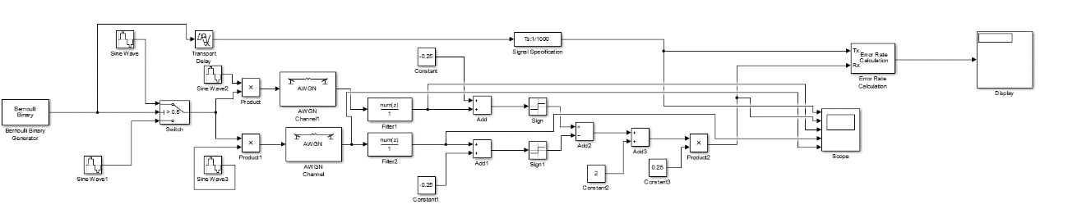
Figure 17 Scope view of FSK with high levels of noise
Figure 16 FSK Modulation and Demodulation with the addition of AWGN

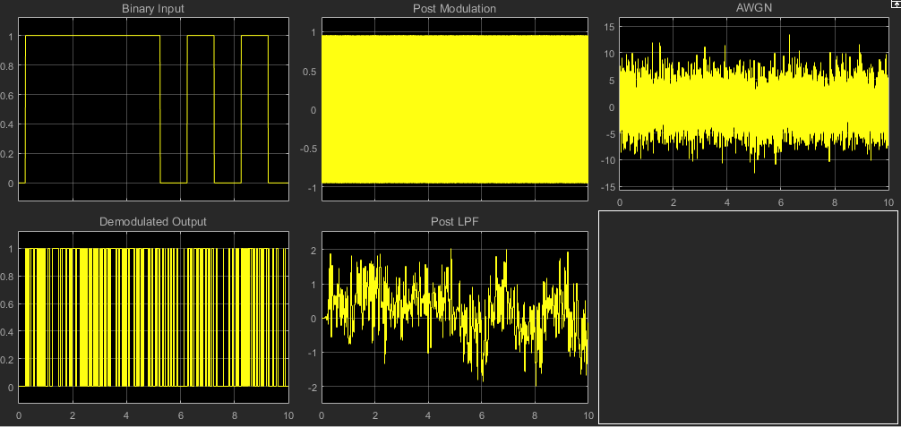
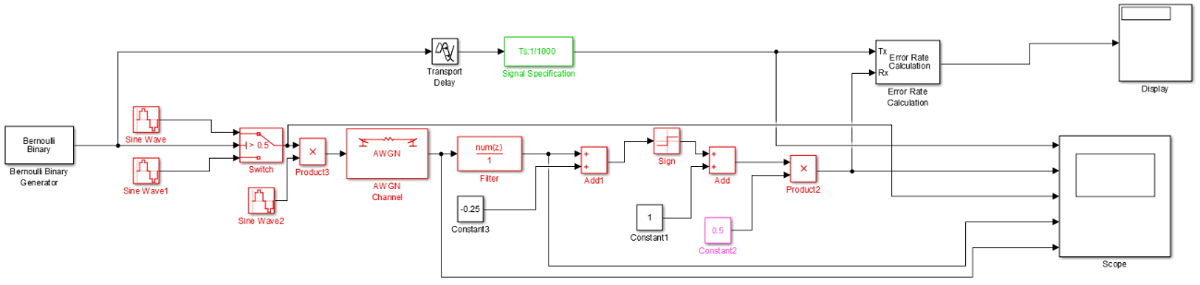
Figure 19 Scope view of PSK with high levels of noise
Figure 18 PSK Modulation and Demodulation with the addition of AWGN

Figure 20 A chart showing the effect of noise on modulation techniques

