

BMIH5003
Foreign Languages and Cultural Awareness
Student ID: 2246646

Portfolio

Table of Contents
Introduction 2
Component 1 - Professional Reflection 3
Component 2 - Training Plan 4
Component 3 - Students self-reflection 6
Component 4 - presentation 7
Conclusion 10
References 11

Introduction
The importance of language in today's globally integrated hotel industry cannot be overstated, claims (Ordonez de Pablos, 2020). The study provides more evidence that multilingual employees are an asset to the hospitality industry, particularly at upscale establishments like the Novotel Hotel. Of the four parts that make up the study, language and cultural awareness are the two most crucial. Customer satisfaction, communication, and cultural understanding can increase when hotels encourage and facilitate staff members' pursuit of multilingualism and language proficiency.

Component 1 - Professional Reflection
Scenario
I had a cultural misunderstanding with a customer whilst serving breakfast at the Novotel Hotel in the UK during my Level 4 placement in the food and beverage service sector. Some Japanese tourists wanted their coffee "weak". I misunderstood their request and served them regular-strength coffee, thinking they preferred it slowly brewed, which resulted in the customer being unsatisfied and delicately mentioning that the coffee had too much caffeine.
Explanation
Since people from different nations use different words, gestures, and communication styles, misunderstandings are common (Lizunova, 2017). Due to these nuances, the term "weak" carries diverse connotations across nations. Some cultures use the word "weak" to describe a weakly made cup of coffee, while others use it to describe a desire for a weaker beverage. This kind of misunderstanding is more likely to occur if we are unaware of the visitors' cultural background or individual preferences. According to Mendy (2018), the hotel business should promote cultural awareness and understanding to guarantee effective communication. When interacting with guests, it is essential to be sensitive to their ethnic backgrounds, regardless of whether we speak the same language. As our experience has demonstrated, providing first-rate service that is customised to the preferences of people from many cultural backgrounds necessitates continuous learning and adaptation.
Reflection
The need to acquire new knowledge and adjust my behaviour to prevent future cultural blunders is something I fully grasp and intend to continue developing by:
- Cultural Sensitivity: I need to educate myself more on the many ways that people from other cultures prepare and consume food. For example, I need to be familiar with the various coffee tastes from around the world to anticipate my customers' preferences.
- Effective Communication: I should try to be clear and ensure they understand, especially when I try to figure out what they want that might involve cultural nuances. I can ask the customer to repeat or ask for more information to make sure I correctly understand their asks and requirements. Asking the customer to repeat themselves or ask for more information is one way to make sure everything is clear (Lie and Shrikant, 2019).
- Active Listening: Paying closer consideration to my customers' needs and signals, like body language or tone of voice, will help me understand their tastes better and avoid misunderstandings.
- Adaptability: In the hospitality industry, it is crucial to be able to understand and help guests from a wide range of ethnic backgrounds (Jackson, 2014). My method needs to be able to change based on the tastes and cultural backgrounds of each guest.
- Continuous Learning: Through ongoing education and training, I commit to discovering more about cultural diversity and improving my ability to give great service to people from all walks of life.
My goal is to make this place a better place for guests to feel welcome and included by learning and further developing these skills and improve how I act so that everyone can feel at ease and understood.

Component 2 - Training Plan
Helping others understand different cultures is a big part of being a respected employee at the Novotel Hotel, especially those who work in Food and Beverage service (Hofstede and Minkov, 2010). A recent cultural misunderstanding that a customer experienced while buying coffee shows how essential it is to understand different cultures to provide excellent service. Therefore, I have created a thorough training plan to help our F&B workers become more culturally aware and better at communicating.
Smart Goals Plan for Cultural Competence Training in F&B Service at Novotel Hotel:
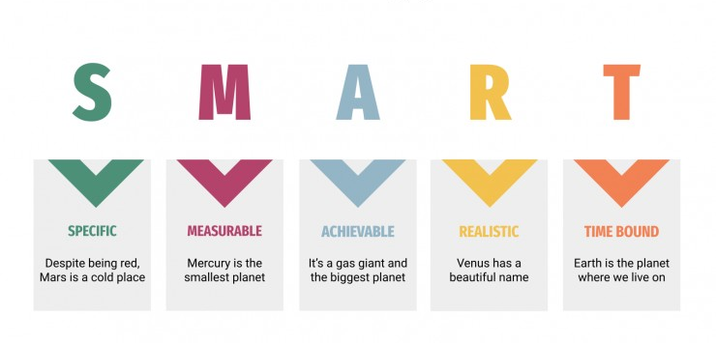
Fig 1. Smart Goals Plan (Ghaye, 2021)

Specific Goals | Measurable Objectives | Achievable Strategies | Relevant Activities | Time-Bound
Raising the cultural understanding of the F&B staff to make sure they understand and value people from different backgrounds. | Ensure that all F&B workers have been trained in the principles and practices of cultural competence. Evidence of achievement will be needed. | Set up regular training sessions run by knowledgeable staff or external trainers to ensure that all workers get thorough training in cultural competence (Murswieck, 2021). | Engaging in activities like group discussions, role-playing, and case studies can help train workers to better understand cultural diversity and set up the first training classes for F&B workers.  There should be sessions on cultural competence. These sessions should cover things like cultural awareness, effective interaction, and meeting the needs of guests with different needs. | Months 1- 4
Enhance communication skills among staff members to accurately understand and meet the culturally sensitive needs of guests. | Develop the staff's communication skills so they can comprehend and meet the cultural needs of guests (Hofstede Insights, 2024). Raise the level of satisfaction with cultural competence training by 20% as decided by regular staff polls. | Make tools like cultural sensitivity guidelines, online classes, and customer demographic information available that can help people learn and understand. | Offer ongoing learning opportunities, like classes on cultural competence, investigating customer feedback, and access to new training materials.  Using staff feedback, I need to implement any changes to the training materials that are needed and keep tabs on how satisfied staff are with the cultural competence training.  I should keep teaching and helping people achieve cultural competence. Employees should talk about how they overcame problems and applied what they had learned in real life during team meetings. | Months 5-9
Foster a welcoming environment in the F&B service that sees and values the different cultural backgrounds of its customers. | I intend to get 15% more positive feedback about cultural sensitivity in the next year through customer satisfaction surveys and evaluations. | Staff members facing cultural issues should be able to get help and share their stories through mentorship programmes, cultural competence seminars, and open lines of communication (GLOBE, 2020). | Using anonymous idea boxes, post-training tests, and regular staff check-ins are some ways to collect and analyse feedback that can help me track progress and solve problems.  Check the effectiveness of the training programme by doing post-training evaluations and looking at customer feedback. | Months 10-12

Following the SMART approach will help the Novotel Hotel teach its food and beverage staff about cultural competence. Through this methodical approach, which ensures ongoing improvement, an open and enjoyable environment for all guests is created.

Component 3 - Students self-reflection
The Gibbs Reflective Cycle was the most appropriate tool for this critical assessment to reflect my understanding of the importance of cultural awareness in the hotel industry. I use this approach to think about how cultural competence might affect my work, to consider the mistakes I have committed in the past, and to develop plans.
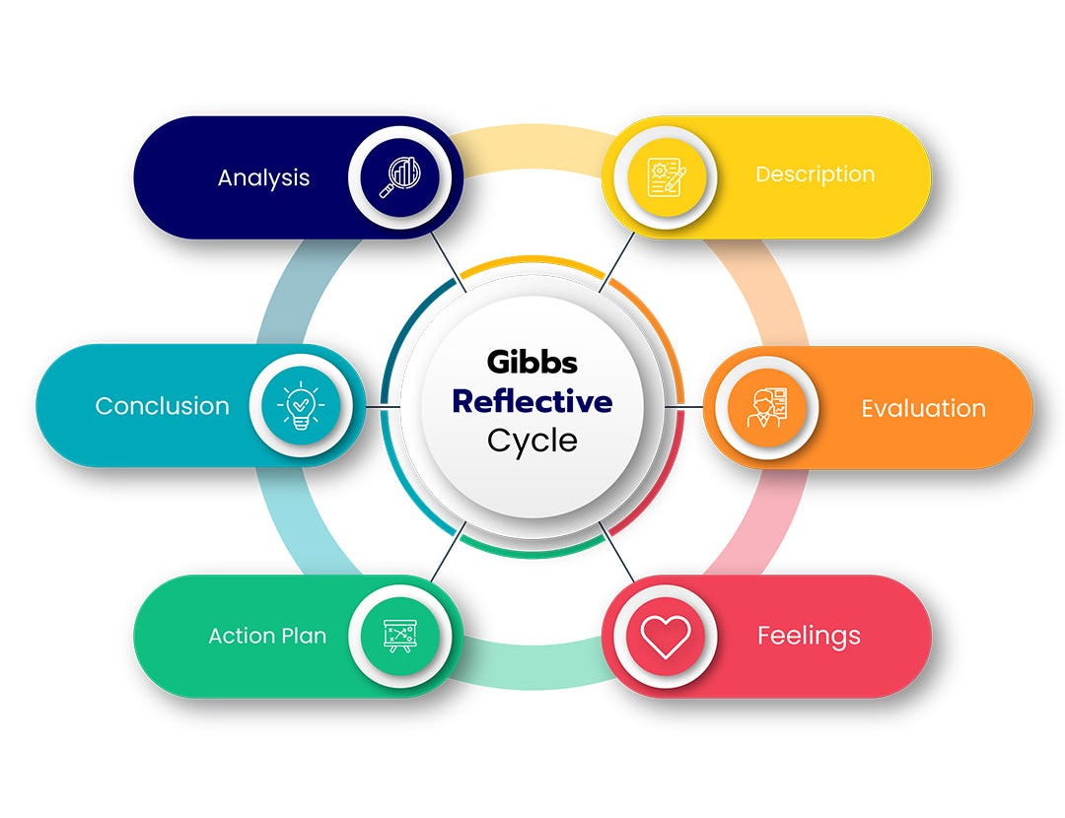
Fig 2. Gibbs Reflective Cycle (Lizunova, 2017)

Description
My initial understanding of how important cultural awareness is in the hospitality industry was not fully developed at first. I knew that being sensitive to other cultures was important in general, but I didn't fully understand how important it was when I spoke to people. But as time went on and as I experienced different scenarios during my work, I became more understanding of this matter. When a Japanese customer asked for "weak" coffee at breakfast at the Novotel Hotel, there was a cultural misunderstanding. This made it clear that F&B staff needs to improve how they communicate with each other and understand different cultures (Ghaye, 2021).
Feelings
To avoid further embarrassment and stress, I had to immediately rethink my plan. When I realised how awful it was for the guests, I felt compelled to look for ways to improve cultural understanding. As my self-reflection deepened, I became determined to elevate my cultural awareness. This shift in how I thought pushed me to act, and ever since then, I've been constantly looking for ways to learn and grow. This experience has made me even more determined to develop my awareness and accept cultural differences so that I can better serve our wide range of customers.
Evaluation
Critical thinking and constructive feedback from my superiors and coworkers taught me that cultural awareness is more than just understanding things on a surface level. It requires a genuine desire to learn and an openness to different points of view that let one change the approach as needed (Fontaine, 2017). Beyond just knowing a lot about a subject, this insight showed me that cultural competence is a way of thinking that is necessary for providing great service in the hospitality business. Seeing things from this point of view helps me connect with customers on a deeper level, which improves their experiences and makes the hospitality business thrive.
Analysis
I learned that my idea of cultural understanding was shaped by several things as I learned more about the subject. For a better understanding of cultural norms and tastes, I interact with guests and coworkers with diverse backgrounds. Further, career development programmes and ongoing education taught me a great deal about the intricacies of cross-cultural communication.
Conclusion
Thought-provoking reflection has increased my belief in how important it is to understand other cultures in the hospitality industry. I have learned that cultural competence is not so much a fixed idea but an ongoing learning matter. There are more open-minded and culturally sensitive people working in the hotel business, which will make guests feel more welcome and appreciated (Fons and Peter Trompenaars, 2020).
Action Plan
I plan to keep working on my cultural skills so that I can help myself as well as my team to continue improving and make the whole experience more satisfactory for our guests.

Component 4 - Presentation
Slide 1: Welcome Slide
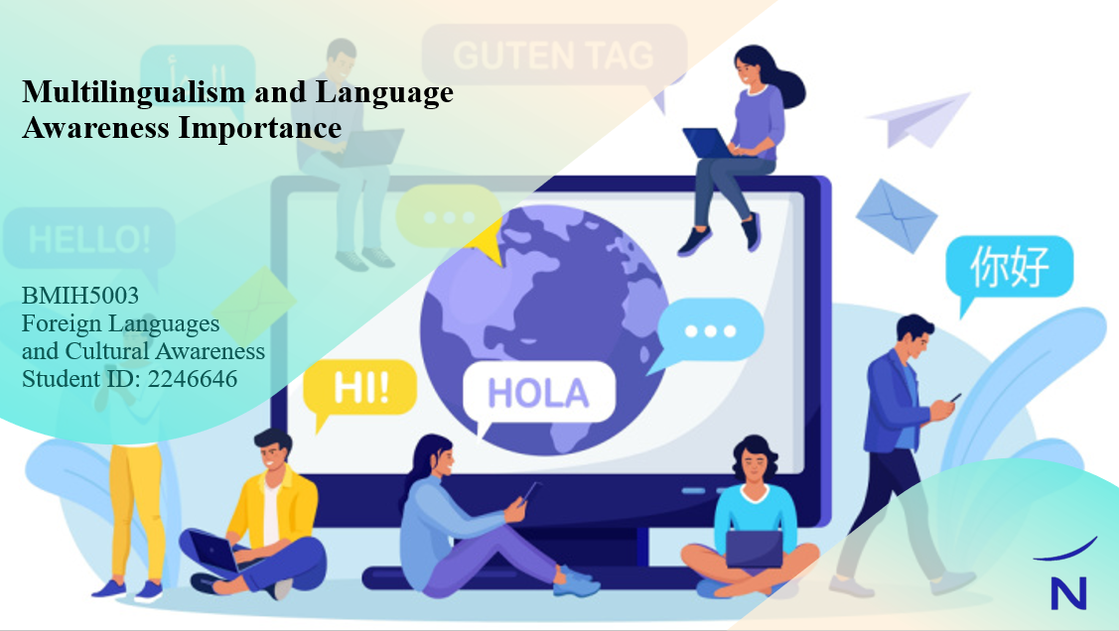
Slide 2: Introduction
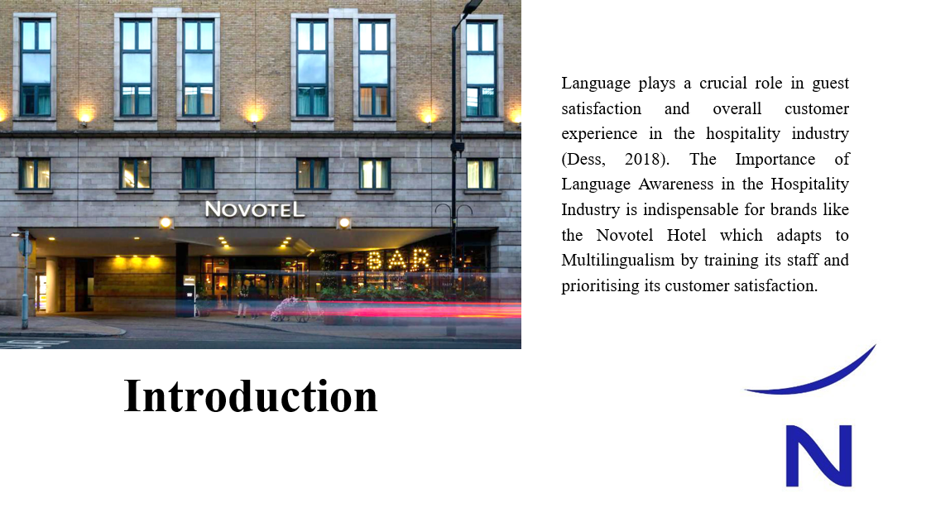
Language plays a crucial role in guest satisfaction and overall customer experience in the hospitality industry (Dess, 2018). The Importance of Language Awareness in the Hospitality Industry is indispensable for brands like the Novotel Hotel which adapts to Multilingualism by training its staff and prioritising its customer satisfaction.
Slide 3: Benefits of Multilingualism
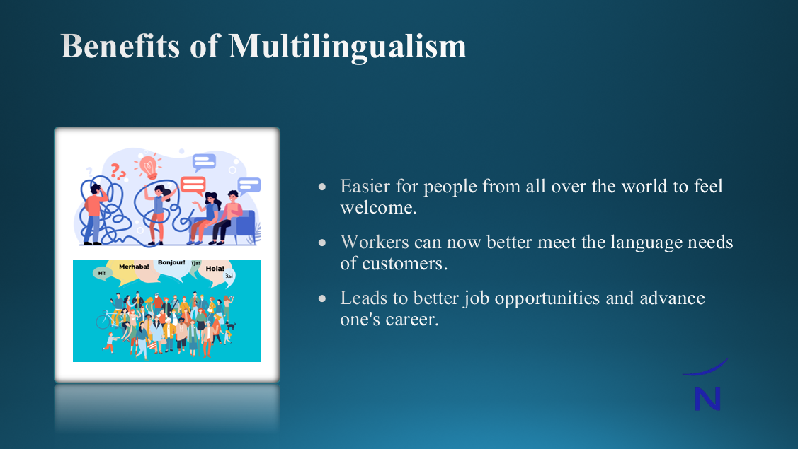
Benefits of Multilingualism
- Being able to speak more than one language makes it easier for people from all over the world to feel welcome.
- Quality of service has greatly improved because workers can now better meet the language needs of customers.
- Knowing more than one language could help lead to better job opportunities and advance one's career.

Slide 4: Example Language – Spanish

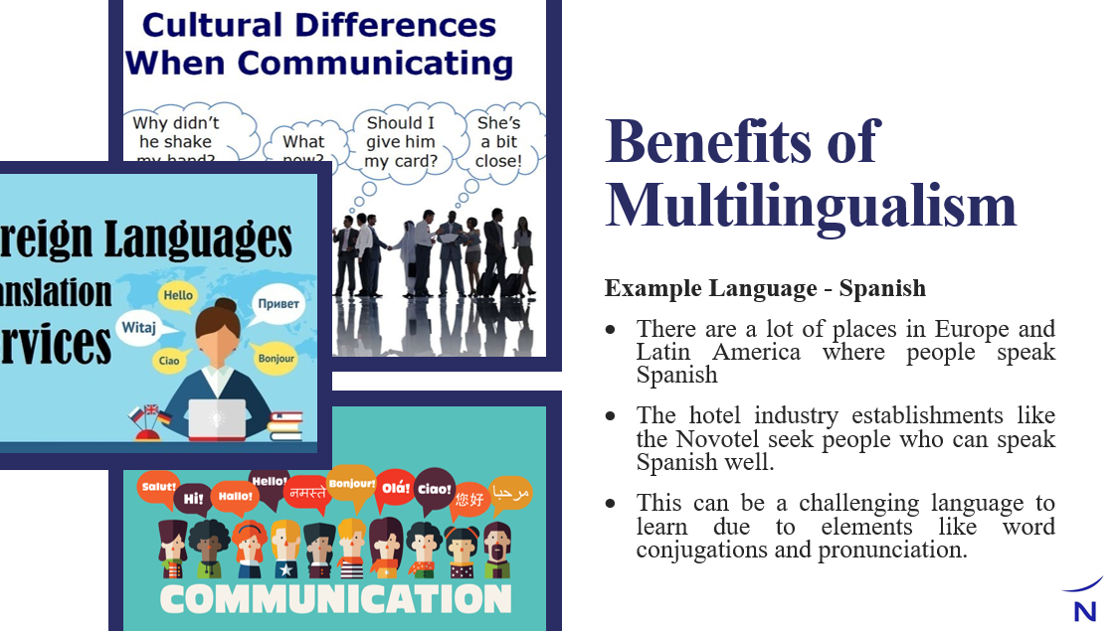
Example Language - Spanish
- There are a lot of places in Europe and Latin America where people speak Spanish, even though it is mostly spoken in Spain.
- The hotel industry establishments like the Novotel seek people who can speak Spanish well, even though it can be difficult to learn because of elements like word conjugations and pronunciation.

Slide 5: Politeness in Business Context
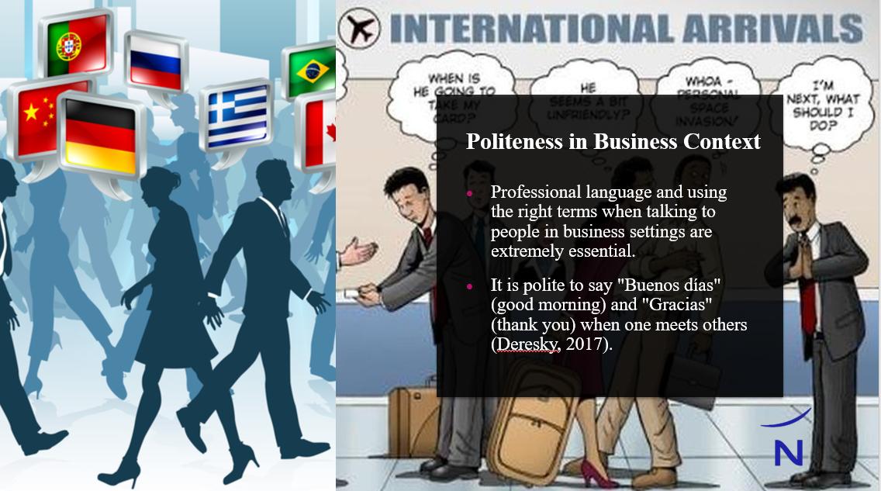

- Professional language and using the right terms when talking to people in business settings are extremely essential.
- It is polite to say "Buenos días" (good morning) and "Gracias" (thank you) when one meets others (Deresky, 2017). It sounds pleasant to use these phrases.

Slide 6: Example Scenario - Check-in Process
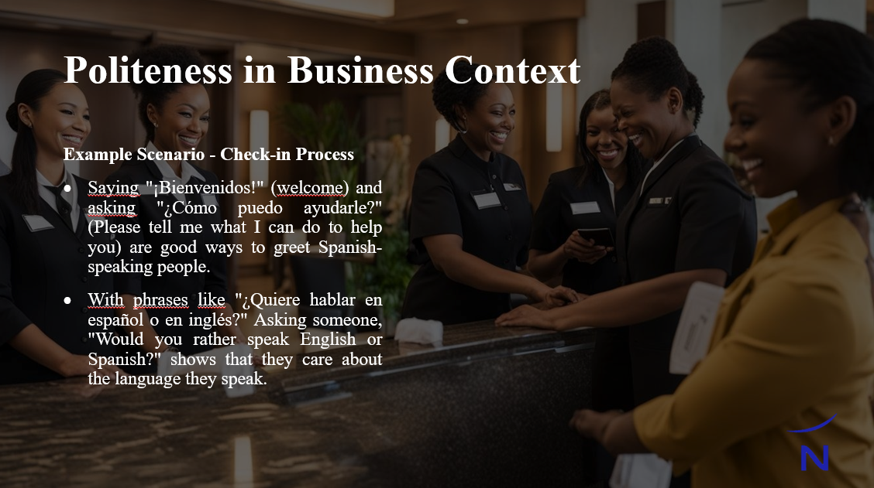
Example Scenario - Check-in Process
- Saying "¡Bienvenidos!" (welcome) and asking "¿Cómo puedo ayudarle?" (Please tell me what I can do to help you) are good ways to greet Spanish-speaking people.
- With phrases like "¿Quiere hablar en español o en inglés?" Asking someone, "Would you rather speak English or Spanish?" shows that they care about the language they speak.

Slide 7: Importance of Language Awareness
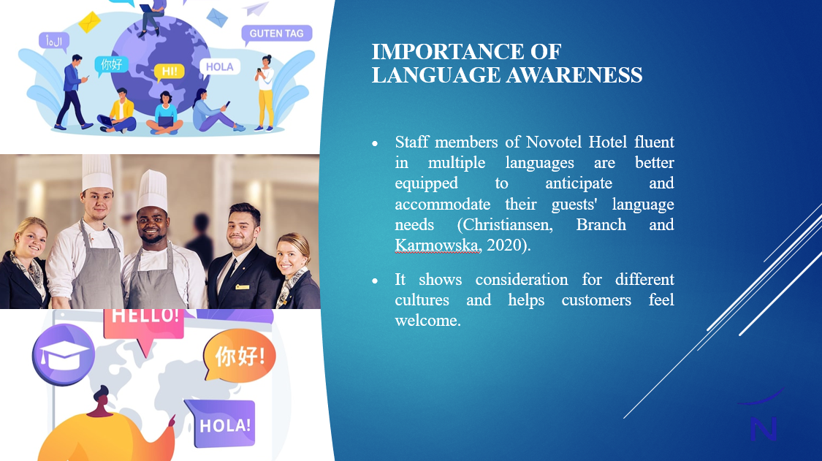
- Staff members of Novotel Hotel who are fluent in multiple languages are better equipped to anticipate and accommodate their guests' language needs (Christiansen, Branch and Karmowska, 2020).
- It shows consideration for different cultures and helps to make guests feel welcome.

Slide 8: Example Scenario - Room Service
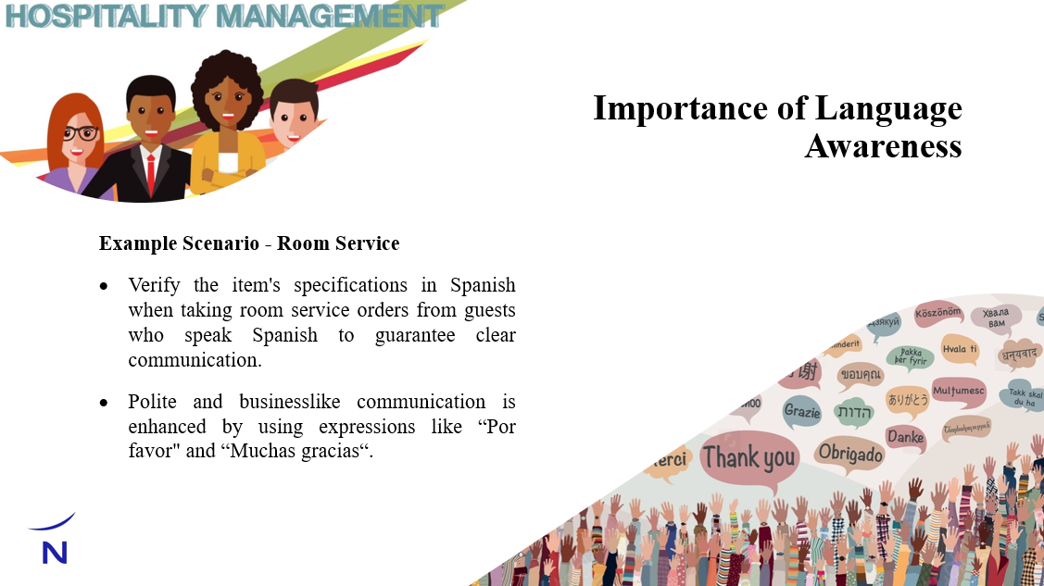
Example Scenario - Room Service
- Verify the item's specifications in Spanish when taking room service orders from guests who speak Spanish to guarantee clear communication.
- Polite and business-like communication is enhanced by using expressions like “Por favor" (please) and “Muchas gracias" (thank you very much).

Slide 9: Training and Development
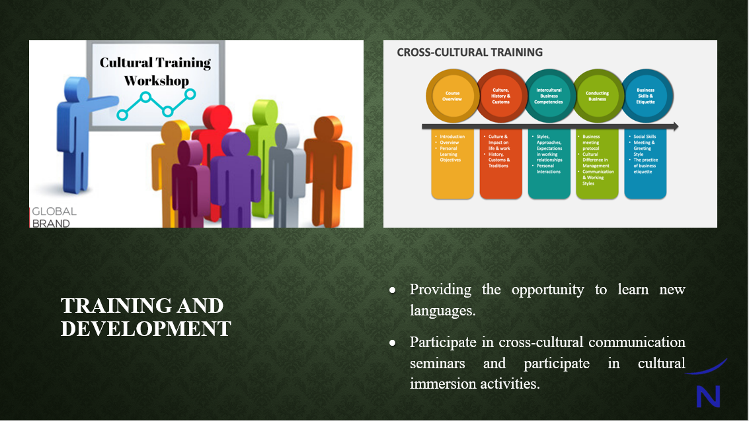
- Help the staff become fluent in more than one language by providing them with the opportunity to learn new ones.
- To improve one's language awareness skills, it is recommended to participate in cross-cultural communication seminars and participate in cultural immersion activities.

Slide 10: Conclusion
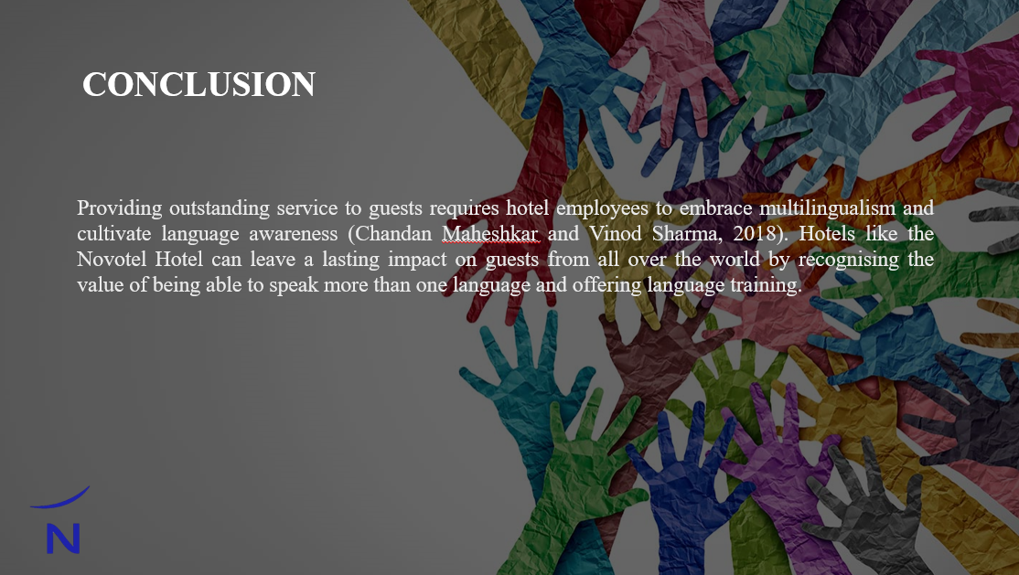
Providing outstanding service to guests requires hotel employees to embrace multilingualism and cultivate language awareness (Chandan Maheshkar and Vinod Sharma, 2018). Hotels like the Novotel Hotel can leave a lasting impact on guests from all over the world by recognising the value of being able to speak more than one language and offering language training.

Slide 11: References
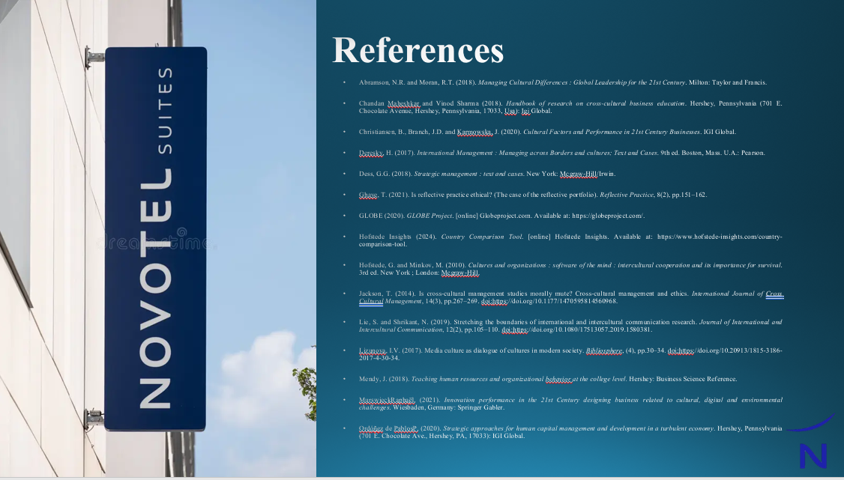

Slide 12: Thank you slide
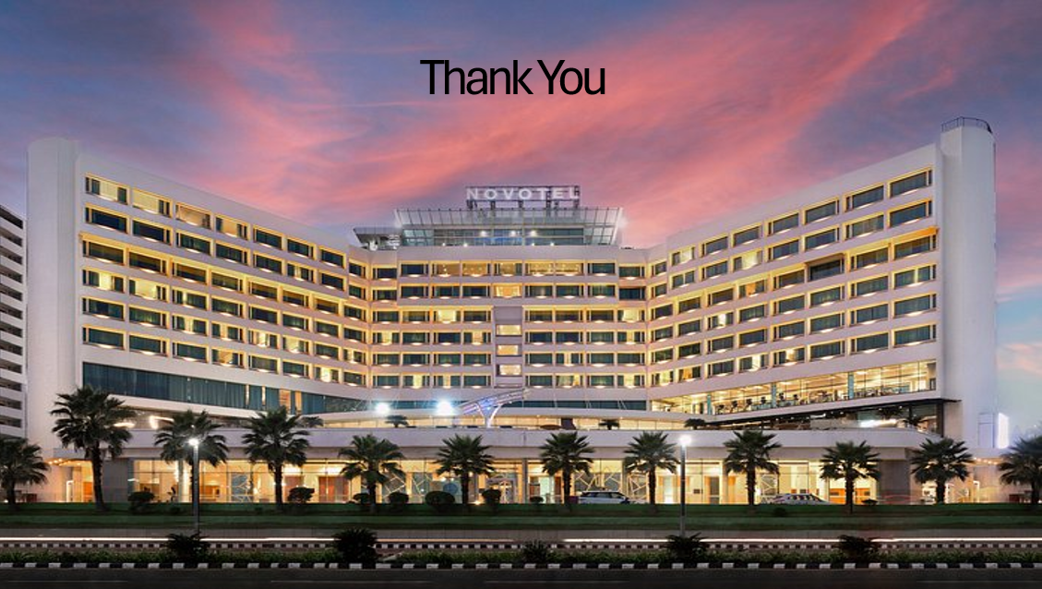

Conclusion

Staff members at hotels that value their customers' satisfaction above all else should strive to be bilingual and prioritise language awareness training (Abramson and Moran, 2018). By providing once-in-a-lifetime experiences to guests from all corners of the globe, hoteliers like Novotel may further establish themselves as industry leaders. They can achieve this by investment into employee training and by acknowledging the importance of cultural diversity.
References
Abramson, N.R. and Moran, R.T. (2018). Managing Cultural Differences : Global Leadership for the 21st Century. Milton: Taylor and Francis.
Chandan Maheshkar and Vinod Sharma (2018). Handbook of research on cross-cultural business education. Hershey, Pennsylvania (701 E. Chocolate Avenue, Hershey, Pennsylvania, 17033, Usa): Igi Global.
Christiansen, B., Branch, J.D. and Karmowska, J. (2020). Cultural Factors and Performance in 21st Century Businesses. IGI Global.
Deresky, H. (2017). International Management : Managing across Borders and cultures; Text and Cases. 9th ed. Boston, Mass. U.A.: Pearson.
Dess, G.G. (2018). Strategic management : text and cases. New York: Mcgraw-Hill/Irwin.
Fons and Peter Trompenaars (2020). RIDING THE WAVES OF CULTURE, FOURTH EDITION : understanding diversity in global business. New York: Mcgraw-Hill Education.
Fontaine, R. (2017). Cross‐cultural management: six perspectives. Cross Cultural Management: An International Journal, 14(2), pp.125–135.
Ghaye, T. (2021). Is reflective practice ethical? (The case of the reflective portfolio). Reflective Practice, 8(2), pp.151–162.
GLOBE (2020). GLOBE Project. [online] Globeproject.com. Available at: https://globeproject.com/.
Hofstede Insights (2024). Country Comparison Tool. [online] Hofstede Insights. Available at: https://www.hofstede-insights.com/country-comparison-tool.
Hofstede, G. and Minkov, M. (2010). Cultures and organizations : software of the mind : intercultural cooperation and its importance for survival. 3rd ed. New York ; London: Mcgraw-Hill.
Jackson, T. (2014). Is cross-cultural management studies morally mute? Cross-cultural management and ethics. International Journal of Cross Cultural Management, 14(3), pp.267–269.
Lie, S. and Shrikant, N. (2019). Stretching the boundaries of international and intercultural communication research. Journal of International and Intercultural Communication, 12(2), pp.105–110.
Lizunova, I.V. (2017). Media culture as dialogue of cultures in modern society. Bibliosphere, (4), pp.30–34.
Mendy, J. (2018). Teaching human resources and organizational behavior at the college level. Hershey: Business Science Reference.
MurswieckRaphaël. (2021). Innovation performance in the 21st Century designing business related to cultural, digital and environmental challenges. Wiesbaden, Germany: Springer Gabler.
Ordóñez de PablosP. (2020). Strategic approaches for human capital management and development in a turbulent economy. Hershey, Pennsylvania (701 E. Chocolate Ave., Hershey, PA, 17033): IGI Global.

