EXAMINATION SOLUTIONS
(to accompany the examination paper sent to the external examiner
but NOT to be seen by students)

Programme: |  | HND/HNC Computing and Information Systems | Level: | 4
Module: |  | Information Engineering
Author: |  | Clive Prosser | Page: | 1 of 4
 | Question |  |  |  | Marks
Context Level DFD
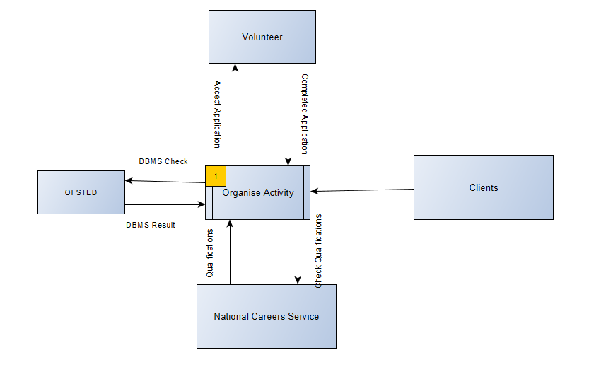

Continuation Sheet
Module/Unit: | Computer Systems and Networks | Page: | 2 of 4

 | Question | Marks
System Level DFD

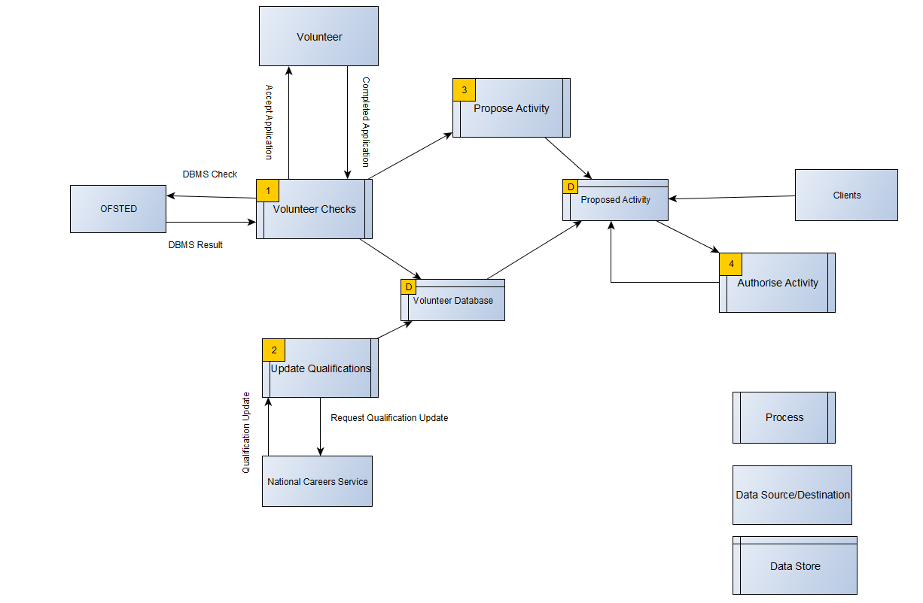

Continuation Sheet
Module/Unit: | Computer Systems and Networks | Page: | 3 of 4

 | Question | Marks
ER-Diagram

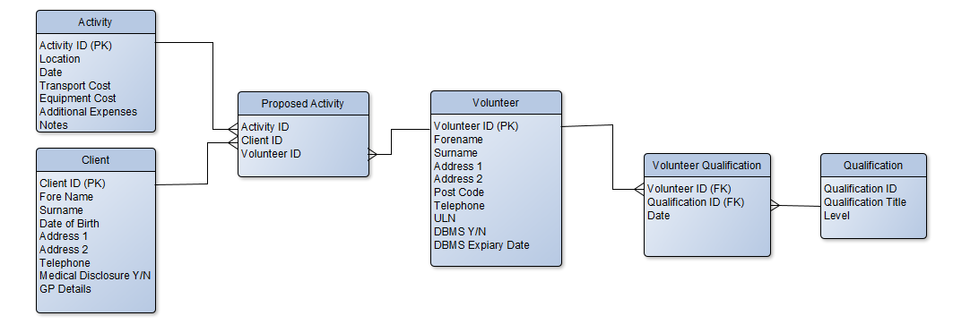

Continuation Sheet
Module/Unit: | Computer Systems and Networks | Page: | 4 of 4

 | Question | Marks
 | All marks relate to Marking Criteria and Student Feedback, where:  Knowledge and Understanding of Subject Matter  Knowledge and Understanding and use of Context level DFD  Knowledge and Understanding and use of System Level DFD  Knowledge and Understanding and use of ERD  Analysis  How close does the student understanding meets the needs of the scenario  Practical Application and Deployment  Accuracy of Context Level DFD in comparison to suggested model solution  Accuracy of System Level DFD in comparison to suggested model solution  Accuracy of ERD in comparison to model suggested module solution  Skills for Professional Practice  Appropriate use of tools for generating report | 0-10  0-10  0-10  0-30  0-10  0-10  0-10  0-10

