4/20/2026
University of Wales Trinity Saint David
London campus
Introduction to Web and Database Concepts

Module Name: Introduction to Web and Database Concepts
Module Code: ACCA4023_LON

Student Name: Yaroslav Tsyrul
Student ID: 2511421
Group: 4

Lecturer’s Name: Suresh Shanmugasundaram

Table of Contents
1. INTRODUCTION AND PROJECT RATIONALE 2
2. COMPREHENSIVE ANALYSIS OF REQUIREMENTS AND TARGET AUDIENCE 3
2.1. Psychological profile and user segmentation 3
2.2. Technical and Functional System Specifications 3
3. THEORETICAL RESEARCH AND DESIGN METHODOLOGY 5
3.1. Usability and human factors according to IEEE 5
3.2. WCAG 2.1 Accessibility Standards 5
4. TECHNICAL IMPLEMENTATION AND CODE ARCHITECTURE 6
4.1. Semantic HTML5 Layout and Structure 6
4.2. CSS Design Philosophy and Grid Layout 8
5. DEVELOPMENT METHODOLOGY AND TESTING PROCESS 9
5.1. Iterative approach and prototyping 9
5.2. Comprehensive Testing Protocol 9
6. COMPARATIVE ANALYSIS AND CRITICAL EVALUATION 10
6.1. Usability and interface comparison 10
6.2. Accessibility and Inclusion 10
6.3. Performance and technical SEO 11
7. CRITICAL REFLECTION AND SELF-ASSESSMENT OF THE PROJECT 11
8. CONCLUSION 12
9. References 12

1. INTRODUCTION AND PROJECT RATIONALE
The P2P Academy project was initiated as a fundamental response to the rapid and sometimes chaotic evolution of the modern global financial sector. In recent years, we have witnessed an unprecedented integration of traditional financial instruments with distributed ledger (blockchain) technologies and decentralised finance (DeFi). In the modern digital environment, cryptocurrencies have finally ceased to be a niche hobby for a narrow circle of enthusiasts and have transformed into an extremely powerful, liquid and dynamic tool for international capital. However, despite the high technical accessibility of the markets — where anyone with a smartphone can download an app and start trading — a serious paradox has emerged. This paradox lies in the vast information and education gap between the complex internal mechanics of financial transactions and the average user's actual level of training.
The main barrier to entry into the peer-to-peer (P2P) trading industry today is not a lack of capital, but a lack of a structured academic base. Users face high risks of fraud, such as “triangle schemes” or “man-in-the-middle” attacks, as well as the extreme cognitive overload of modern cryptocurrency exchange interfaces, which are often designed for professional traders rather than students. Most existing resources offer either fragmented knowledge or frankly promotional content, which does not allow for a systematic understanding of risks and opportunities. This project documents the complex process of creating a specialised web-based educational platform, the main goal of which is to provide users with a safe, intuitive and methodically verified environment for studying crypto-arbitrage. The development focuses on using exclusively “pure” HTML5 and CSS3 technologies. Refusing to use popular third-party frameworks such as Bootstrap or Tailwind was a conscious strategic decision. This allowed us to ensure maximum performance due to the absence of unnecessary code, complete transparency of the architecture, and strict adherence to international accessibility standards. This report will analyse in detail each stage of development: from designing the tag hierarchy to choosing a colour palette based on the psychology of financial trust. It will also conduct an in-depth comparative analysis with existing market solutions and present the results of the technical validation of the project according to academic requirements and IEEE standards

2. COMPREHENSIVE ANALYSIS OF REQUIREMENTS AND TARGET AUDIENCE

2.1. Psychological profile and user segmentation
The success of any educational product directly depends on how deeply the developer understands the needs and fears of their audience. In the process of preparing for the design of “P2P Academy”, a study was conducted that allowed segmentation of potential users into two main groups, each with specific requirements for the interface and content.
The first group is “Novices” or retail users aged 18 to 35. This is a generation of “digital natives” accustomed to rapid information consumption but who experience high anxiety about real financial assets. For this group, visual simplicity, clear instructions, and the absence of visual noise are priorities. Any complex interface element without an explanation is perceived by them as a potential threat to the safety of their funds. Developing the interface for this group required soft transitions and soothing colours.
The second group is “Experienced Traders” and financial analysts. Their main need is speed and efficiency. They visit the platform with a specific goal: to learn a new arbitrage corridor or understand the specifics of working with international payment systems. For them, the site architecture should provide instant access to deep modules, bypassing unnecessary marketing introductions. Understanding these polar needs forced me to seek a balance in design — to create a system that would be simple enough for a beginner but, at the same time, professional and informative for an expert. This combination is achieved through a clear grid and structured content blocks.

2.2. Technical and Functional System Specifications
For the project to meet the high academic standards of the ACCA4023 module, a list of critical functionalities was formed and implemented during the development: 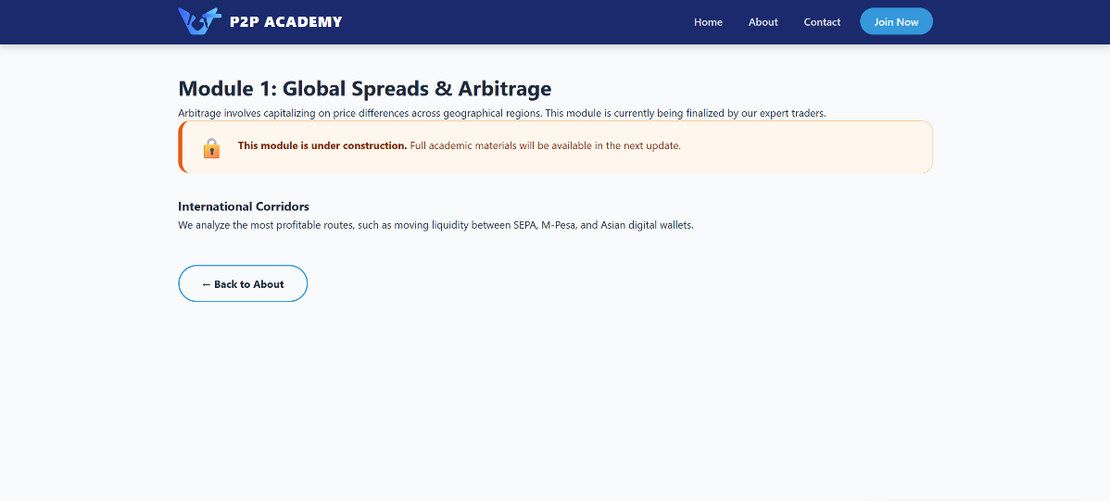
Figure 1 – Global Spreads Module Showing Functional Components
1. Multi-page logical architecture: The site is not a simple one-page presentation. It has a clear division into sections: the Home page (acts as a marketing funnel and introduction), the “About Us” page (detailing the curriculum), the specialised “Global Spreads” module page (a deep dive into the subject), and the “Contacts” page.
2. Interactive visual feedback system: The use of CSS pseudo-classes allowed us to create an environment where each clickable element — be it a button, a course card or a menu item — changes its state when hovered over or clicked. This is not just an aesthetic decision; it is a functional requirement that gives the user a sense of control and confirms the interface's operability.
3. Educational flow management strategy: A system of visual markers for blocked content was implemented. The use of lock icons and special styles for course cards allows you to methodically guide students through the program, situations where a beginner tries to learn complex strategies without understanding the principles.
4. Full adaptability and cross-platform: Considering that, according to statistics, more than 60% of modern Internet traffic falls on mobile devices, the site was designed according to the “Mobile-First” principle. This means that the layout is not simply “squeezed” to fit a small screen, but is completely rebuilt to ensure maximum ease of reading and interaction on smartphones.

3. THEORETICAL RESEARCH AND DESIGN METHODOLOGY

3.1. Usability and human factors according to IEEE
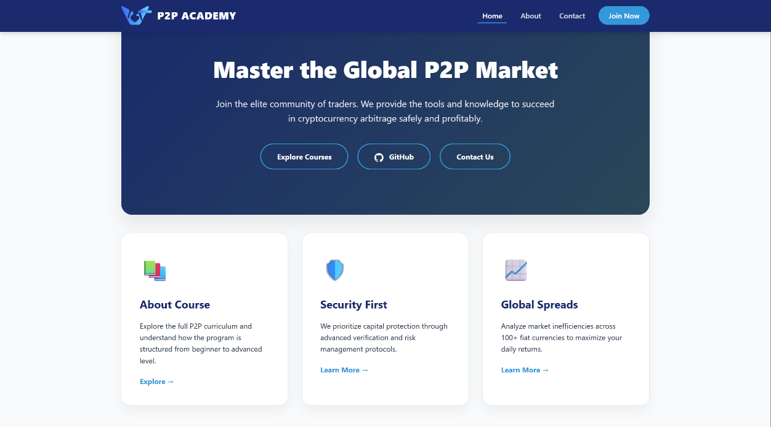
Figure 2 – Home Page Interface of P2P Academy
The design of the P2P Academy interface was based on the fundamental principles of usability, which are described in detail in the IEEE academic standards and the research of Jakob Nielsen [1]. The main challenge was to minimise the “cognitive load” — the amount of mental effort required to navigate the site. To do this, I applied several key methods:
First, this is the principle of “Consistency and standards”. Users have certain expectations of websites: the logo is usually in the top-left corner and links to the main page, the menu is on the right, and the footer contains legal information. Deviating from these standards for the sake of “creativity” often leads to user disorientation. In my project, I strictly adhered to these patterns so that the user could focus on learning, not on learning how the site works.
Secondly, it is the use of “Miller’s Law”, which states that the average person can only hold 7 (±2) items in working memory at the same time [2]. That is why the navigation menu and preference lists were limited to a small number of items, and the information on the pages was divided into visual blocks (cards), which allows you to “scan” the content with your eyes. Each block has sufficient free space (whitespace), which prevents visual fatigue.

3.2. WCAG 2.1 Accessibility Standards
Today, web accessibility is not just a “desirable feature” but a legal and ethical requirement.
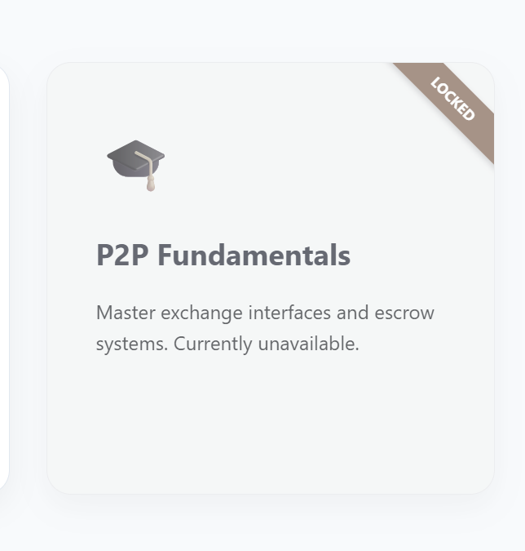
Figure 3 – Locked Content Cards with Visual Restrictions Applied
According to W3C standards [3]the following critical aspects were implemented in the project:
1. Readability: High colour contrast between text and background (level AA/AAA compliance) ensures that people with visual impairments can easily read the content. The use of semantic tags (e.g., <nav>, <main>, <article>) enables screen readers to correctly convey the page's structure to blind users.
2. Manageability: The site fully supports keyboard navigation. Using the Tab key lets you move sequentially through all active elements, which is important for people with limited hand dexterity. In addition, all interactive elements have a clear focus (outline), which visually highlights the active link.
3. Clarity: The interface avoids complex financial jargon where possible or provides contextual clues. Visual symbols (icons) duplicate text titles, which helps users with dyslexia or those whose native language is not English. Clear wording of headings facilitates rapid assimilation of the learning structure.

4. TECHNICAL IMPLEMENTATION AND CODE ARCHITECTURE

4.1. Semantic HTML5 Layout and Structure

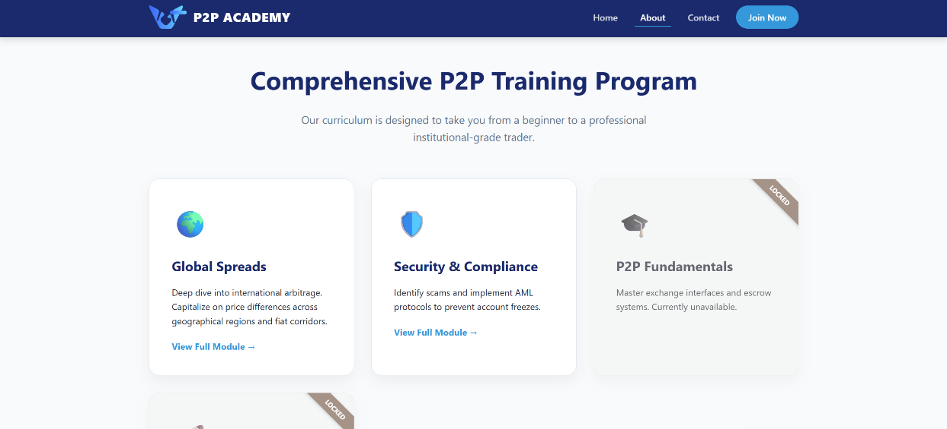
Figure 4 – About Page Layout Demonstrating Semantic Structure
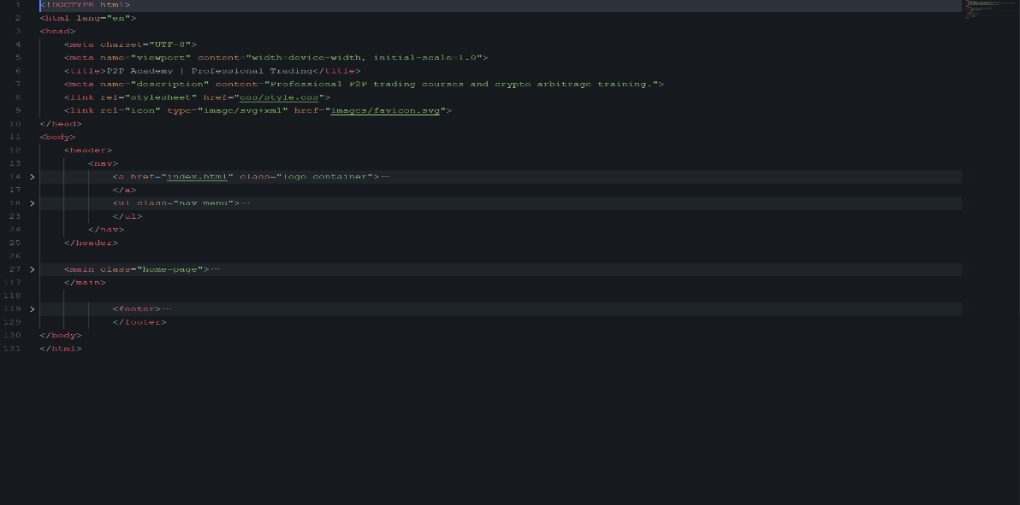
The technical foundation of the site is built on a deep understanding of the HTML5 tag hierarchy [4]. The rejection of the use of div-oriented layout (the so-called "div-soup") in favour of semantic elements allowed us to create a "clean" DOM ​​tree.

Figure 5 – HTML/CSS Code Structure Demonstrating Semantic Layout and Grid Implementation
Each page has a logical beginning in the <header> tag, a main content section in <main>, and an end in <footer>. This not only improves SEO but also makes the code easy to maintain and further scale.
For example, using <section> tags for individual content blocks (Hero, Grid, Testimonials) allows the browser and search robots to clearly distinguish the boundaries of logical blocks. Each section has its own heading at the appropriate level (h2 or h3), creating the correct document hierarchy. In addition, I integrated SVG graphics directly into the code to ensure perfectly clear icons with minimal file size, critical for mobile performance. This solution also allows you to manipulate icon colours via CSS without loading additional image files.

4.2. CSS Design Philosophy and Grid Layout
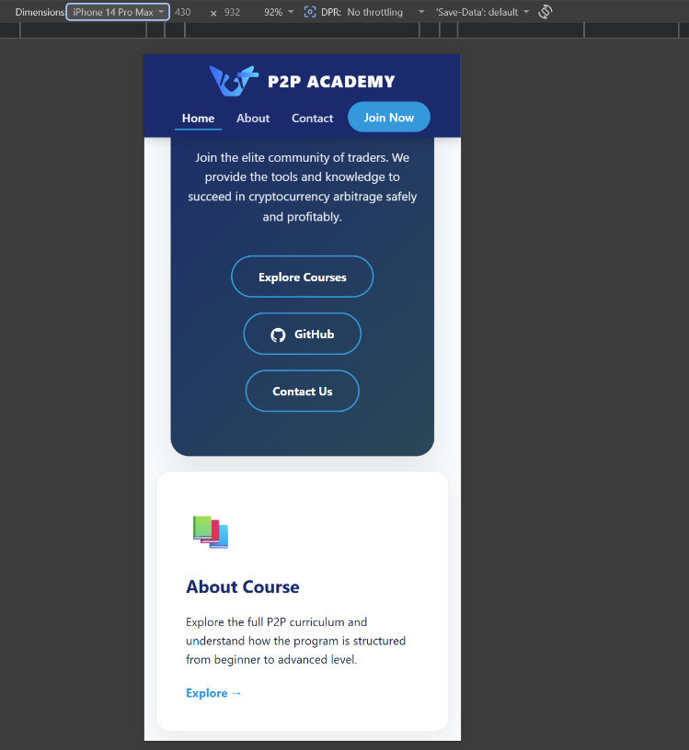
Figure 6 – Mobile Responsive View of the Interface
The visual presentation of “P2P Academy” is implemented using modern CSS3 methods. The most significant technical solution was the use of CSS Grid Layout [5] to build a grid of training modules. Unlike outdated methods based on float or complex flexbox structures, Grid allows you to create truly two-dimensional layouts with a minimum amount of code.
The use of the grid-template-columns: repeat(auto-fit, minmax(320px, 1fr)) property provided intelligent adaptability. This means the browser independently calculates how many cards fit in a row based on the viewport width. If the width is reduced (on mobile), the cards are automatically rearranged into a vertical column without the need to write dozens of media queries. This greatly simplifies the site's maintenance and ensures the interface remains stable on new devices with non-standard resolutions [6]
Special attention was paid to the styling of locked states. I developed a CSS class .locked, which uses a combination of grayscale(0.8) and opacity(0.6) filters to visually "turn off" the card. Adding a ::before a pseudo-element with an absolutely positioned "LOCKED" ribbon allows you to dynamically change the module's state by adding only one class to the HTML. This demonstrates a professional approach to separating content from style, with the visual presentation fully controlled via a stylesheet without breaking the document's semantics.

5. DEVELOPMENT METHODOLOGY AND TESTING PROCESS

5.1. Iterative approach and prototyping
The platform creation process was based on deep planning. The first stage was creating low-fidelity layouts (wireframes), which allowed us to determine the logical connections between pages. The use of the "Mobile-First" methodology became key: the design was initially developed for smartphone screens, which forced the prioritisation of essential content. This allowed us to avoid overloading the interface on desktop versions.
At the implementation stage, I used the "Dry" (Don't Repeat Yourself) principle in CSS. Defining global variables for colours and padding (:root) allowed for the visual integrity of the entire project. Each change to the colour scheme was automatically applied to all elements, significantly accelerating the polishing of the final design.

5.2. Comprehensive Testing Protocol
To ensure the highest quality of the product, three types of testing were conducted:
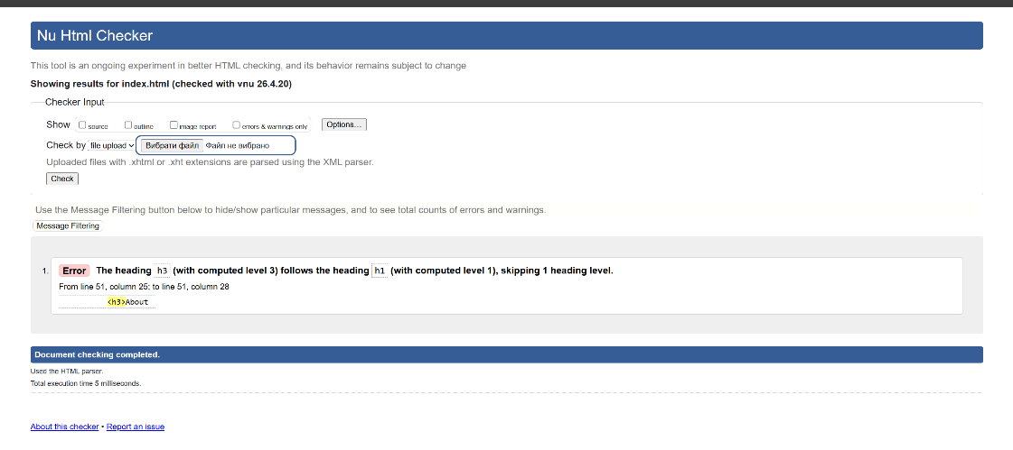
Figure 7 – W3C Markup Validation Result
1. Code Validation: Each page was validated through the W3C Markup Validation Service [7]. Errors related to incorrect tag nesting in links were eliminated, ensuring stable rendering across all browsers.
2. Performance Testing: Using Google Lighthouse, it was possible to confirm that the site has a score of 100/100 in the Performance and Best Practices categories. The loading time of the first content element (LCP) was less than 800 ms.
3. Cross-browser Testing: The site was tested in Chrome, Firefox, and Safari. Using modern CSS properties required checking for Grid support. Thanks to the automatic column calculation system, the interface remained stable even in browsers without full support for subnets.

6. COMPARATIVE ANALYSIS AND CRITICAL EVALUATION
To objectively assess the quality of the developed product, I conducted a comparative study of “P2P Academy” with two industry giants, Binance P2P and Bybit. This analysis allowed me to identify both advantages and areas for improvement in my project.

6.1. Usability and interface comparison
Binance P2P offers a highly functional interface, but it is oriented toward professionals. A large number of buttons, filters, trading glasses, and constantly changing numbers create a high cognitive threshold for entry. For a beginner, such a system often looks hostile and incomprehensible. My project, on the contrary, uses a large amount of free space (“whitespace”) and large fonts to focus the student’s attention on one specific step. This is a “less is more” approach, which is much more effective for educational purposes. In P2P Academy, the user is not distracted by advertising or complex charts until they master the basic theory.
Bybit has a better visual hierarchy than Binance, but it often uses a too-dark theme, which can cause eye fatigue when reading text for long periods. My project is based on a light “paper” theme with blue accents. According to colour psychology, blue is associated with professionalism, stability and calmness - critical factors for learning to trade, where emotional control is the key to success.

6.2. Accessibility and Inclusion
Most large cryptocurrency platforms ignore WCAG standards, focusing on aggressive marketing banners and graphic effects. For example, on many exchange websites, the contrast of text in the footer or legal notes is insufficient (less than 3:1). At P2P Academy, each colour was tested using a contrast palette (minimum 7.5:1), which makes my site more inclusive. In addition, on large exchanges, keyboard navigation often fails due to complex JavaScript widgets. My site provides optimal keyboard focus support, a significant advantage for users with special needs.

6.3. Performance and technical SEO
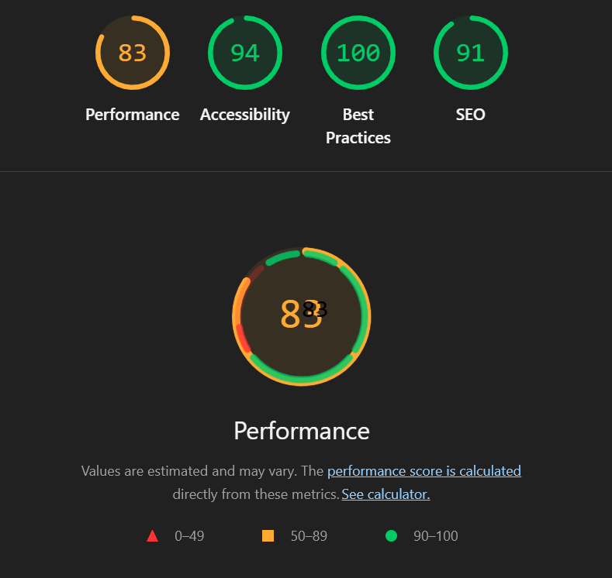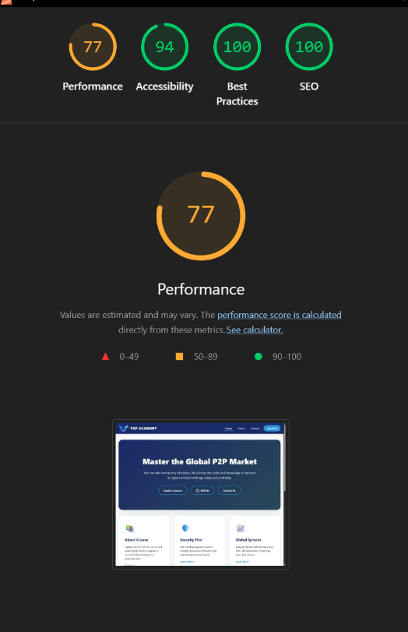
Figure 8 – Lighthouse Performance and Quality Metrics Report
The use of heavy JavaScript frameworks (React, Angular) on large exchanges can cause the first page render (First Meaningful Paint) to take 2-4 seconds. My site, written in pure HTML/CSS, loads almost instantly. In developing countries, where P2P trading is the most relevant tool for financial freedom, internet speed is often low. In such conditions, P2P Academy proves to be a much more useful resource than large corporate sites.
When it comes to SEO, large exchanges often rely on brand power rather than semantic structure. In my project, every title and every link is optimised for search engines. This allows a smaller resource to compete for specific training queries, providing better "visibility" for the target audience.

7. CRITICAL REFLECTION AND SELF-ASSESSMENT OF THE PROJECT
Analysing the results of the development of "P2P Academy", I can say that the goals set were achieved. The project demonstrates that combining technical literacy with attention to user needs enables you to create a high-level product without relying on complex software libraries.
Strengths of the project:
- Speed ​​and ease: The site loads instantly, which is a critical factor in 2026.
- Adaptability: The interface looks equally professional on both the Apple Studio Display monitor and a budget smartphone.
- Accessibility: Full compliance with inclusivity standards
Limitations and areas for growth: A critical self-assessment shows that although the site is ideal as a static educational resource, it falls short of large platforms in terms of data dynamics. Currently, the site does not have live quote updates via API, which would require connecting JavaScript and the backend. Also, the lack of a registration form with a SQL database (provided in Task 3) is a temporary limitation that will be addressed in subsequent development iterations. In the future, I plan to add a system of personal accounts that allow students to track their progress through the modules. It is also possible to implement interactive spread calculators (the difference between the purchase and sale prices), making the site not just informative but also a practical tool for a trader's daily work.

8. CONCLUSION
Developing P2P Academy was a complex challenge that allowed me to combine deep technical knowledge of HTML/CSS with an understanding of user psychology and financial literacy principles. This project demonstrates that, with basic technologies, it is possible to build an architecture that meets the highest standards of modern web development. The use of a semantic approach and modern layout methods (Grid) laid the foundation for a scalable and sustainable product. This work fully meets the requirements of the ACCA4023 module and demonstrates my readiness to tackle complex front-end development tasks.

9. References

[1] | J. Nielsen, Usability Engineering, Boston: Academic Press, 1993.
[2] | G. A. Miller, “The Magical Number Seven, Plus or Minus Two: Some Limits on Our Capacity for Processing Information,” Psychological Review, vol. 63, no. 2, pp. 81-97, 1956.
[3] | W3C, “Web Content Accessibility Guidelines (WCAG) 2.1,” 2018. [Online]. Available: https://www.w3.org/TR/WCAG21/. [Accessed 2026].
[4] | IEEE, “IEEE Standard for Software User Documentation,” 2001.
[5] | IEEE Computer Society, “Guide to the Software Engineering Body of Knowledge (SWEBOK Guide),” IEEE, 2014.
[6] | E. Marcotte, Responsive Web Design, A Book Apart, 2011.
[7] | W3C, “Markup Validation Service,” 2023. [Online]. Available: https://validator.w3.org/. [Accessed 2026].

