

Practical based Research on AI Assisted Painting - Redesigning the Characters of Qinhuai Eight Beauties

By
Xiuyuan Chen

A report submitted to the University of Wales Trinity Saint David
For the degree of
Doctor of Professional Studies

Wales Institute of Science and Art
University of Wales Trinity Saint David
September 2024

Table of Contents

Introduction 3
Literature Review 4
Practical Work 6
The practice based research 6
Exploration through AI painting 7
AI-assisted digital painting Workfow 8
Using AI painting to depict traditional Chinese elements 8
Discussion 11
Interpreting and Synthesizing Findings 11
Exploring the Organic Relationship Between Practical Work and the Report 11
Reflecting on the Creative Nature of the Project 11
Future Directions 12
Conclusion 13
Reference 15

Introduction
Artificial intelligence (AI) has been integrated into the world of art creation, leading to a monumental shift in perspectives towards visual arts. This research focus on the specific question : How do artists/designers adapt to new AI technologies? This project uses AI painting as an assistant tool to intersect with traditional Chinese cultural elements, specifically focusing on reinterpreting the "Qinhuai Eight Beauties" through AI-assisted digital painting. As AI develops and spreads into different areas of human creativity, it is important for us to study its use as a tool for both art and cultural preservation.

AI painting is currently facing various challenges in today's era, which involve the issue of copyright ownership: do AI created paintings belong to the authors of the AI trained portfolio? Or an AI engineer? Or are they people who use AI? This kind of problem often confuses everyone in the AI field. Instead of trying to define the essence of creativity, this study focuses on a specific question: how to create digital art using AI that avoids major controversies and still expresses human creativity. Through this exploration, the practice aim to create an artwork where AI is used as a tool, but human stays as the author, proving that AI-assisted art can still reflect human creativity.

Based on these considerations, the first goal of this work were to explore and illustrate some capacity for AI tools that have emerged recently in expanding artistic creation capabilities via a re-interpretation with traditional cultural contexts. Moreover, second goal is to produce new and original work flow which combines AI strengths with conventional digital painting methods proving a cutting-edge art creation. Finally, it aims to think about how creating art with AI affects artistic expression, cultural preservation, and how the role of an artist is changing in this digital age.

The core of this project is the close connection between practical work and theoretical research. The theoretical part includes data collection on artificial intelligence and literature overview. The practical part is to use AI painting as a tool to draw a series of digital painting artworks depicting the "Qinhuai Eight Beauties" to express traditional Chinese culture. This practical approach is highly relevant to the theoretical exploration of the role of artificial intelligence in art. In today's era, how to challenge traditional concepts of creativity, provide new opportunities for innovation, and influence cultural expression is a very meaningful topic.

In this project, the connection between practice and theory is complementary. On the one hand, theoretical research guides practice, as theories about the application of artificial intelligence in the field of art provide necessary basic information for the creation of practical artworks: what are the artificial intelligence models? How to use them correctly? What issues should be noted during the application process? These questions will be explained through theoretical research. On the other hand, practical experience in the creative process provides new ideas for theoretical discussions: what creative ideas should artists in the new era explore? This bidirectional relationship maintains a balance between academic research and artistic creation in the project.

By using a practice based integrated research approach, this project aims to contribute to the art and design industry. This study will provide practical insights into using artificial intelligence as an assistant, offering new perspectives in the fields of art and design. This study attempts to demonstrate that as long as we apply artificial intelligence in the right way, it can become a powerful tool for artistic innovation rather than a threat to human creativity.

Literature Review
- Introduction to AI in Art
Artificial intelligence (AI) technology has been making strides across the art world, calling into question what it means for works to be authentic and original. The advent of AI tools such as DALL-E (Dall-E 3, 2024), Midjourney (Midjourney, 2024), Stable Diffusion (Stability ai, 2024), and FLUX (FLUX, 2024) are commented by people questioning whether AI-generated art is "real" art as well as its implications for human creativity / art worlds or the whole field.

Using AI in art has not only changed how artists create, but also started debates about who owns the work and whether it’s truly original. Studies show that sometimes, AI-created art can be seen as a mix of random pieces or recycled existing content, leading to questions about who holds the copyright and ownership (Sarkar, 2023).

- Discussion on copyright of AI-created artworks
When it comes to the creative process, Drexl et al. (2019) mentioned that although artificial intelligence can work independently to some extent, humans still need to play a role at various stages. This has sparked a debate about whether works generated by artificial intelligence truly possess originality or creativity. Gervais (2019) argues that artificial intelligence decision-making focuses on efficiency and practicality, which makes it difficult for AI to demonstrate true creativity. On the other hand, Bridy (2011) argues that the unpredictability of artificial intelligence can actually be seen as a form of creativity.

Regarding copyright issues, Fink Hedrick (2019) pointed out six potential author allocation methods, taking into account artificial intelligence itself, programmers, users, and others. Ramalho (2017) proposed a new framework suggesting that works created by artificial intelligence should enter the public domain and grant publishers specific rights. These ideas highlight different perspectives in the academic community on how to handle copyright protection for artificial intelligence works.

Regarding the use of artificial intelligence training data, Sobel (2017) pointed out that unauthorized use of copyrighted works may infringe on data portability and adaptation rights. Chiou (2020) analyzed the exceptions under the EU copyright law framework, but believed that existing regulations are difficult to fully meet the needs of artificial intelligence training.

Overall, existing research has revealed that it is highly complex of artificial intelligence in terms of the creative process, originality of works, and copyright ownership. However, further exploration is still needed to promote the development of artificial intelligence technology and protect traditional artists.

- The Role of AI in Enhancing Creativity in Art Industry
The latest developments in generative artificial intelligence (AI) have had a significant impact on the current field of creativity. The work that artists used to spend a lot of time and energy on now can be completed by AI in just a few seconds, challenging traditional concepts of human originality and value creation. The research by Zhou&Lee (2024) shows that the use of artificial intelligence tools such as “text to image” and “image to image” can improve creative productivity and increase the value of artistic output. However, although these tools greatly improve the efficiency of art production, their low threshold for use has also led to a decrease in average content and visual novelty, indicating a homogenization trend of AI assisted art. This highlights that human thinking and filtering are crucial for maintaining originality and quality. Therefore, the concept of co creation has been proposed. The collaborative creation between humans and artificial intelligence is becoming an important research field.

- Human-AI Collaboration in Art
Artificial intelligence as a tool is becoming more and more powerful for artists. During the collaborative creative process, human input is important for filtering and refining the content generated by AI (Wingström et al., 2021).

Chatterjee (2022) studied how artificial intelligence challenges traditional art concepts, especially about the importance of artists' agency, intention, and emotional expression (Hawley Dolan and Winner, 2011; Newman and Bloom, 2012). Traditionally, these human attributes have been considered indicators for evaluating the value of art. However, Chatterjee believes that although artificial intelligence does not possess sufficient human attributes such as autonomy, intention, and emotion, it can still create meaningful and impactful works of art.

Research has shown that the usage of AI in art creation is becoming more and more, our understanding of what are originality and value in art is no longer perfectly suitable for today. With advancements in technology, AI can not only imitate existing artistic styles but also create entirely new forms of art through techniques such as Generative Adversarial Networks (GANs) (Elgammal et al., 2017). People have to reconsider what means originality and value in a digital age where artworks can be easily replicated and are lack of the traditional "aura" associated with physical works (Benjamin, 1936/2018).

Furthermore, Chatterjee (2022) discusses the potential of AI in art creation, not only as a tool for artists but also as a collaborative partner that pushes the artistic expression to the boundary. This idea maches with other researches which suggest that AI and human artists can support each other in the creative process (Mazzone and Elgammal, 2019).

- Perceptions and Biases Toward AI Art
Horton et al. (2023) investigates the psychological impacts of artificial intelligence (AI) on the evaluation of art and human creativity. They studied how biases against AI-created art impact the way people see human-made art.
This study examined many indicators related to art, such as price, skill, and creativity.
Among the 2965 participants in these six experiments, the authors found that art labeled as AI-made is always devalued compared with art labeled as human-made, even when the art itself has the indistinguishable quality. Interestingly, the study also suggests that when comparing artificial art with AI art, it enhances people's perception of human creativity. This indicates that human participation is an inseparable part of artistic creation. These findings provide strong evidence for evaluating the value of art, uncovering people's biases, and discussing the potential of art.

- Redefining Creativity in the AI Era
The component of AI in art required a reevaluation of what makes creativity. As artificial intelligence becomes increasingly capable of showcasing creative works of art, the definition of human unique agency and creativity is being challenged (Wingström et al., 2021). This shift calls for new frameworks to understand creativity in the context of human-AI collaboration (Mineo, 2024).

Because there is AI component in art, we need to rethink what means creativity. Traditional ideas of creativity, which focus on uniqueness and human involvement, are being questioned. This is because AI systems can now create new and beautiful artworks (Wingström et al., 2021). This change requires new ways to understand creativity when humans and AI work together (Mineo, 2024).

Practical Work

The practice based research
Since the popularity of AI painting in 2023, I have spent a lot of time and energy researching AI painting, and in this process, I have been thinking about the future development of AI painting from the perspectives of designers and artists. At the same time, I have also seen many negative cases, such as using AI painting for unfair profits, and some voices opposing AI painting, which are not conducive to the development of AI. However, I personally hold an optimistic attitude towards the future development of AI, believing that as long as AI generative art is used with the correct methods and principles, artists can use AI as the most powerful tool for better innovation and expression.
The practical work includes AI model testing and research in the early stage, establishment and deepening of exhibition related themes, exhibit production process, and final outcomes.
The purpose of this exhibition is to demonstrate to people the infinite potential of generative art in cultivating creativity, originality, and artistic exploration; Simultaneously expressing AI generated art is not simply copying existing art, but becoming a powerful tool for generating innovative and unique forms of expression and communication.

Exploration through AI painting
AI painting is currently a technology that everyone can easily grasp. Due to the extremely low difficulty of getting started with AI painting, the average content and visual novelty of art works created by AI have decreased, and AI assisted art has shown a trend of homogenization (Zhou&Lee, 2024). As an artist and designer, I will strive to create high-quality artworks with unique artistic styles while breaking away from the homogenization of production.

First, I conducted thousands of image generation tests on the current mainstream AI models, focusing primarily on DALL-E 3, Midjourney v5, and a wide range of open-source SD1.5 models, including but not limited to: majicMix realistic, majicMix fantasy, majicMix lux, Dream Shaper v7, Rev Animated, Anything, Dark Sushi 2.5D, GhostMix, and Moxin.
Under the same prompts, models like Midjourney and DALL-E excelled in overall composition, color, and camera angle. However, in terms of high-definition upscaling, fine detail enhancement, and specific style transfers, various SD1.5 models performed better with the help of ControlNet plugin. Notably, due to the open-source nature of Stable Diffusion, many plugins have been developed by users to control image generation, making the SD series models significantly more controllable than other models. This is evident in several aspects: excellent partial re-drawing functionality allows specific parts of an image to be re-generated under human guidance; the powerful ControlNet plugin adds more rules beyond prompt guidance (such as openpose skeleton maps and line drawings), enabling images to be generated more closely in line with the creator’s intentions; CFG scale adjustments allow for the tuning of prompt guidance coefficients, controlling the AI model's response to prompts and thus the quality of the generated images; and the adjustment of the redraw degree permits the modification of the percentage of changes during the image-to-image process, thereby controlling the extent of variation in the generated images.

AI-assisted digital painting Workfow
Based on the research findings mentioned above, this artistic creation will attempt to leverage the strengths of each AI model in combination with digital drawing software to iteratively synthesize the final work. The specific workflow is as follows: first, using Midjourney's excellent color effects and composition capabilities to generate an initial draft of the artwork; then, optimizing the image with a Stable Diffusion model. Next, various drawing tools in Photoshop will be used to adjust the details of the image. Certain sections will be selectively taken back to Stable Diffusion for multiple iterations until the desired artistic effect is achieved. (see the iteration video in the supporting materials)

Using AI painting to depict traditional Chinese elements
The theme of this work is artistic re-creation based on ancient Chinese famous historical figures "秦淮八艳", which refers to the Eight Beauties of Qinhuai, who were famous courtesans in the late Ming and early Qing dynasties, living in the Qinhuai district of Nanjing, China. These women were renowned not only for their beauty but also for their talents in arts, literature, and poetry. The Eight Beauties include Ma Xianglan, Bian Yujing, Li Xiangjun, Liu Rushi, Kou Baimen, Gu Hengbo, Chen Yuanyuan, and Dong Xiaowan. Their stories have become legendary, symbolizing the cultural and artistic richness of that era.

Using ChatGPT can quickly and accurately organize the background story information of the eight characters in Qinhuai Eight Beauties (秦淮八艳), quickly convert this information into keyword prompts describing them, and analyze their respective characteristics and the most suitable representative tones for them.
The analysis is shown as the following:

Image 1:
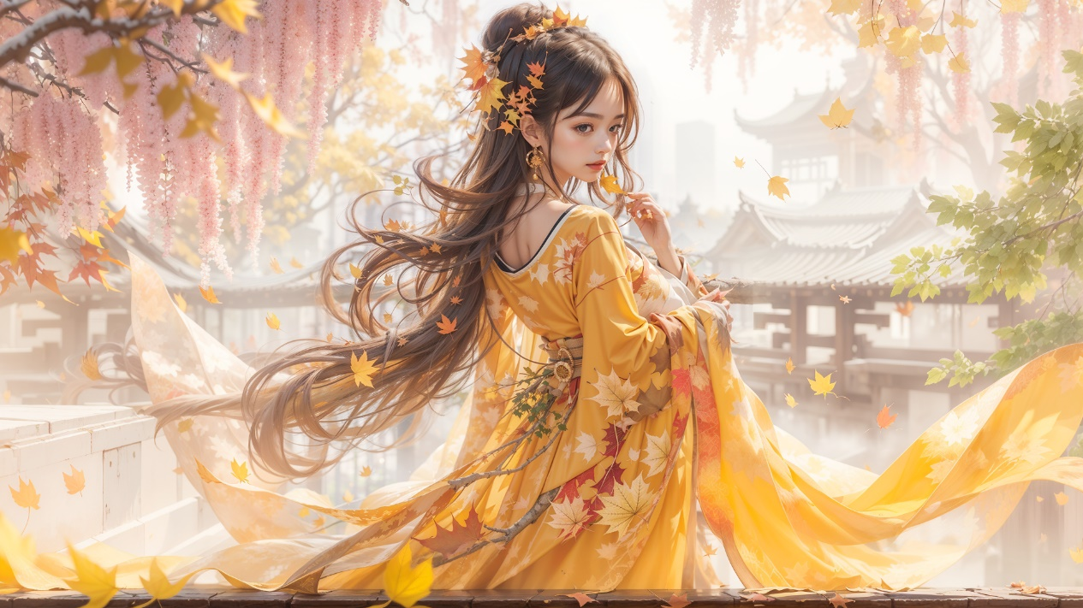
Person: 顾横波 (Gu Hengbo)
Description: Wearing a bright yellow robe and surrounded by falling autumn leaves, the character is in a setting filled with warm tones and autumn foliage. This matches Gu Hengbo’s strong and independent character, who maintained a distinct identity despite her circumstances.
Representative Color Tone: Bright Yellow - symbolizes wisdom, energy, and an independent spirit.

Image 2:
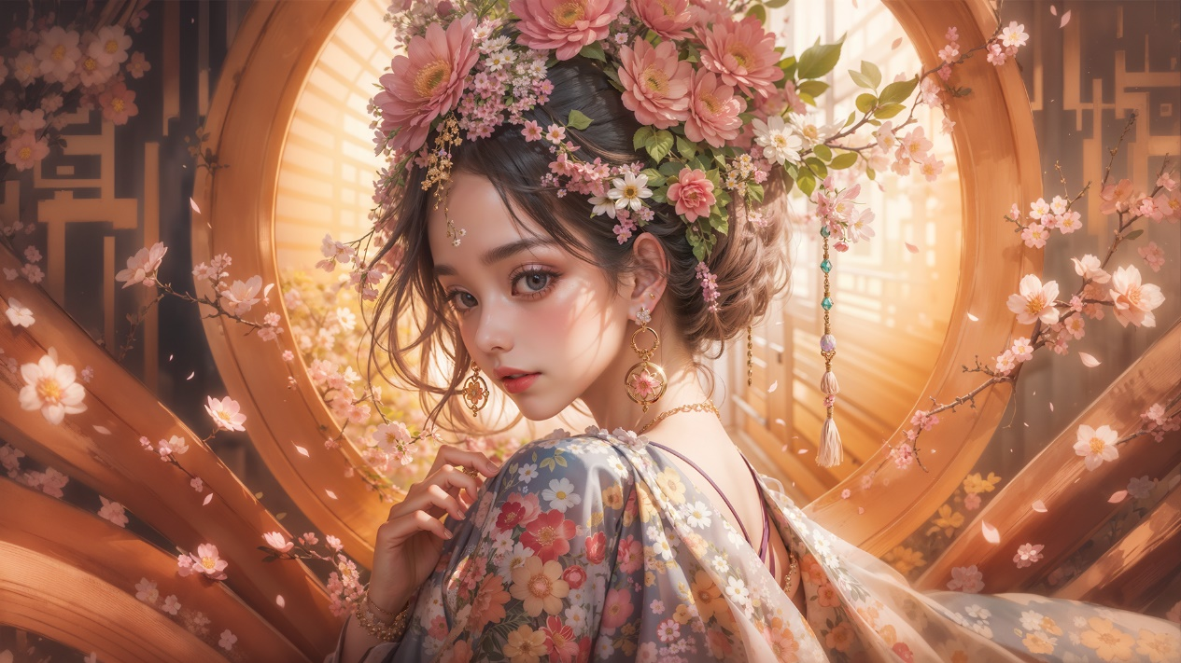
Person: 卞玉京 (Bian Yujing)
Description: Adorned with a crown of flowers and wearing a floral gown, the character exudes grace and beauty, reminiscent of Bian Yujing, known for her exceptional beauty and her involvement in historical events.
Representative Color Tone: Soft Pink and Gold - represents her beauty and the complex emotions associated with her life.

Image 3:
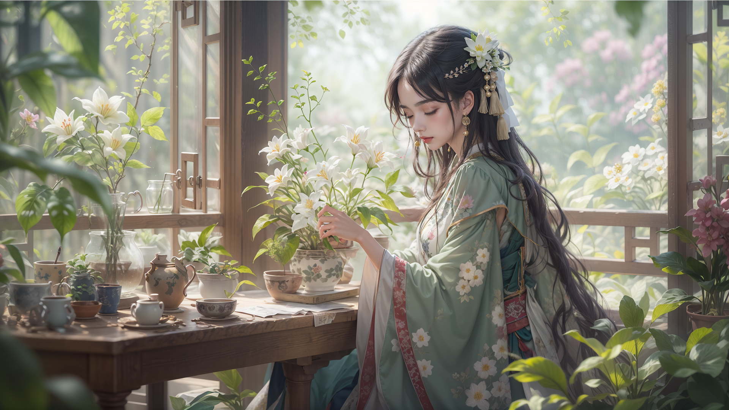
Person: 董小宛 (Dong Xiaowan)
Description: The character is dressed in a calming green outfit, surrounded by white lilies and a serene indoor garden setting. This represents Dong Xiaowan’s refined, elegant nature and her life spent in relative peace with her lover.
Representative Color Tone: Green and White - symbolizes tranquility, elegance, and a life of quiet retreat.

Image 4:
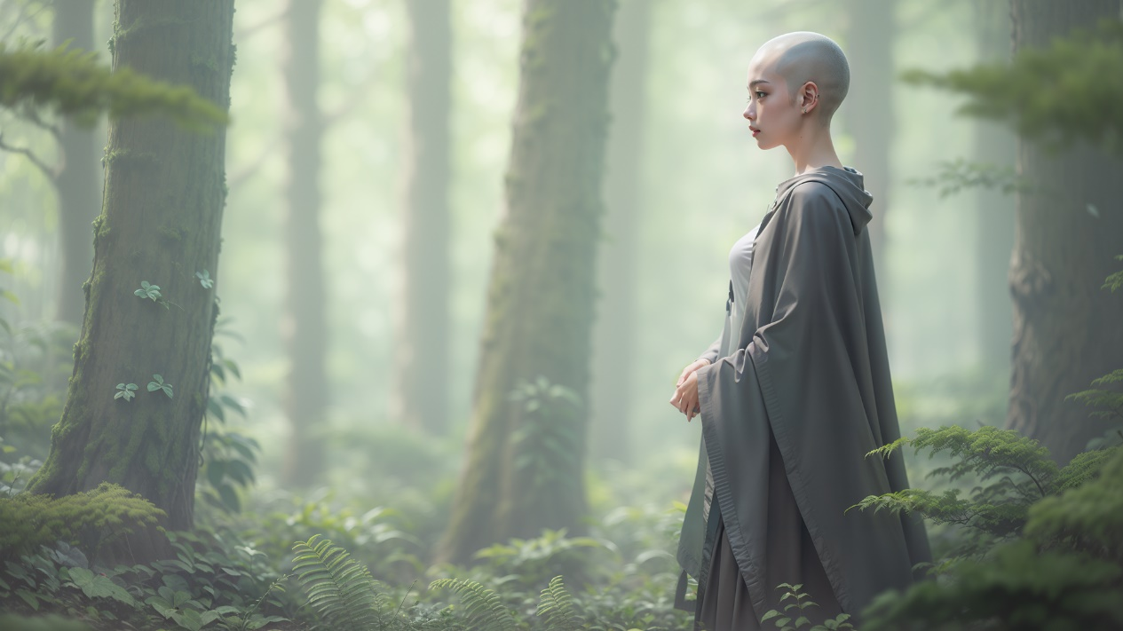
Person: 陈圆圆 (Chen Yuanyuan)
Description: The character is depicted with a shaved head, wearing a simple gray robe, standing quietly in a misty forest. This serene and contemplative setting reflects her later life after she chose to become a nun, seeking solace and peace away from the turmoil of the world. The simplicity of her attire and the tranquil forest background symbolize her renunciation of worldly affairs and her pursuit of inner calm and spiritual freedom.
Representative Color Tone: Muted Greens and Grays - represents introspection, spiritual retreat, and a life of seclusion away from the complexities of the world.

Image 5:
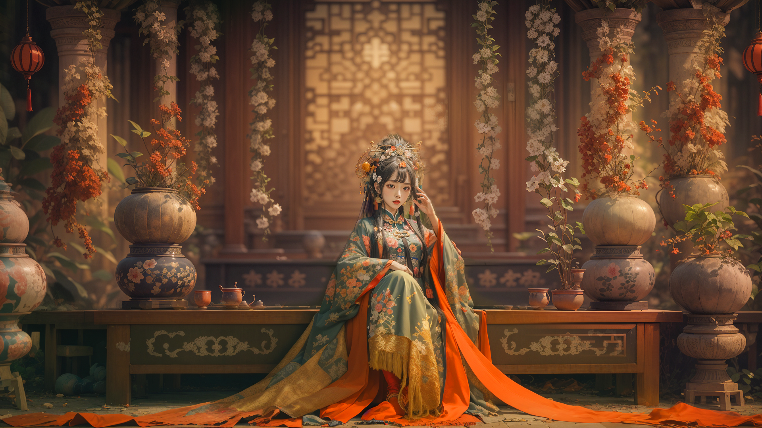
Person: 李香君 (Li Xiangjun)
Description: The character is seated amidst a beautiful traditional setting with flowing garments, exuding a sense of poise and artistry, matching Li Xiangjun's strong personality and her deep connection to art and culture.
Representative Color Tone: Deep Red and Green - symbolizes her bold spirit and artistic nature.

Image 6:
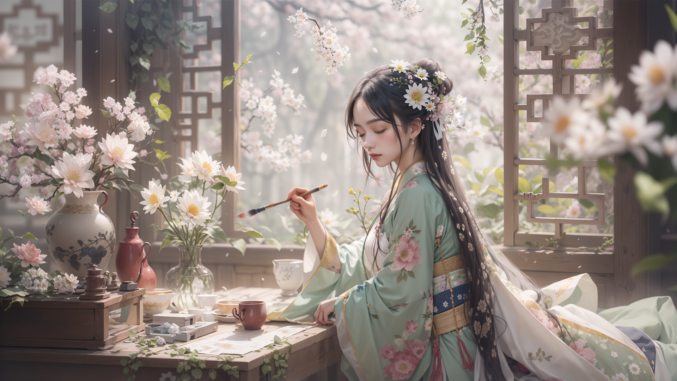
Person: 柳如是 (Liu Rushi)
Description: Surrounded by an elegant room filled with flowers, the character is portrayed painting, showing her creative and poetic nature. This aligns well with Liu Rushi, who was known for her intelligence and artistic talents.
Representative Color Tone: Light Pink and White - reflects her delicate beauty and artistic soul.

Image 7:
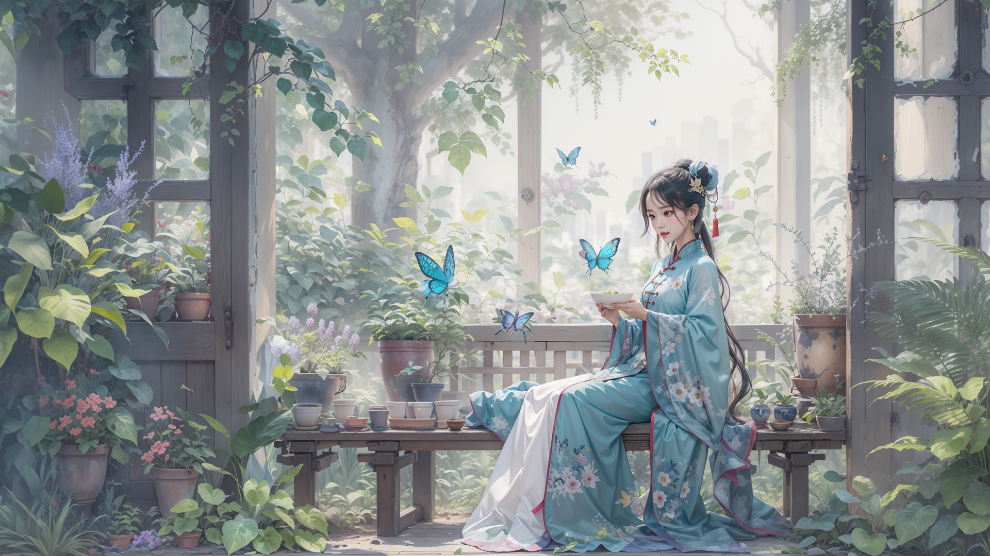
Person: 马湘兰 (Ma Xianglan)
Description: In a bright room filled with green plants and butterflies, the character holds a bowl, suggesting a nurturing and delicate nature, paralleling Ma Xianglan’s refined and gentle character, known for her artistic ability with orchids.
Representative Color Tone: Blue and Green - symbolizes serenity, delicacy, and her artistic finesse with nature.

Image 8:
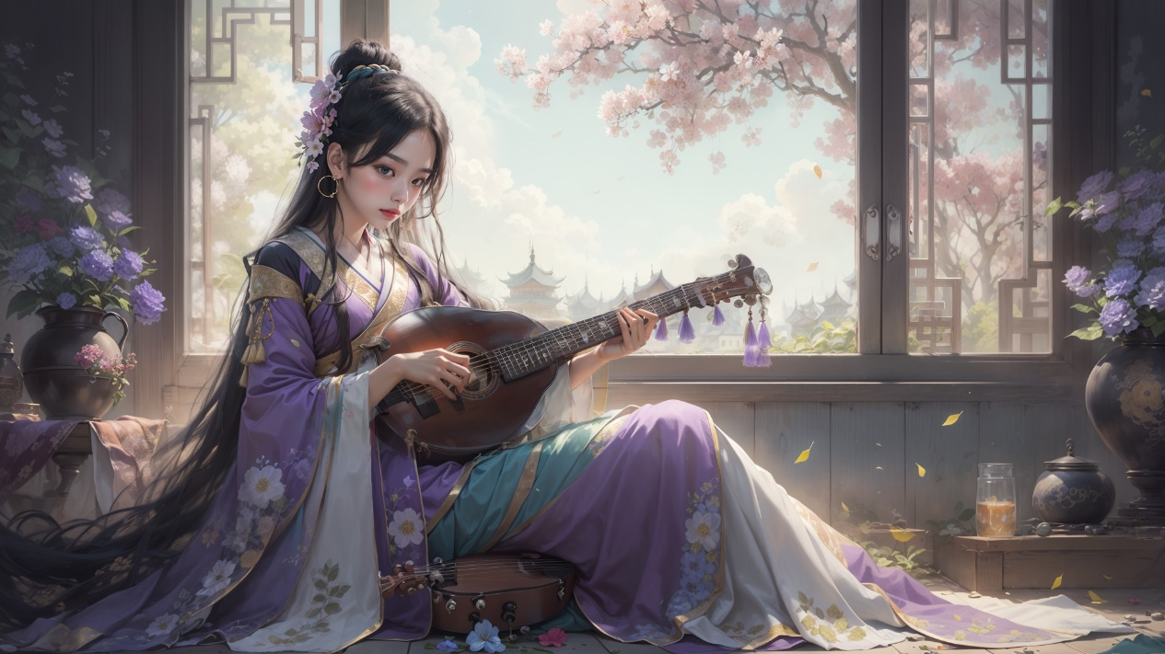
Person: 寇白门 (Kou Baimen)
Description: Dressed in a purple robe and holding a musical instrument, set against a tranquil background of cherry blossoms, this image captures a quiet, reflective moment, similar to Kou Baimen’s later years.
Representative Color Tone: Lavender and Purple - represents her musical talents and her more secluded, introspective later life.

Participate in exhibitions

After multiple rounds of human corrections and AI-assisted painting, the creation process culminated in a series of high-definition and highly detailed image works. These refined artworks, embodying a seamless blend of human creativity and AI painting, are printed in high definition to ensure that every detail is vividly captured.

For the exhibition, eight meticulously crafted pieces are prepared for display. To enhance the viewer's experience and provide deeper insight into the creative process, the exhibition booth is thoughtfully arranged with a comprehensive setup. The artworks are accompanied by a theme poster that encapsulates the essence of the piece, setting the tone for the viewer's experience. Additionally, videos documenting the iterative process of creation—from initial image from Midjourney to final output—are showcased, offering a behind-the-scenes look at how the collaboration between human and machine brought these works to life.

Furthermore, detailed introduction texts are provided, elaborating on the conceptual framework, the role of AI in the creative process, and the significance of each piece. This comprehensive presentation not only highlights the technical prowess involved but also invites viewers to engage with the artworks on a comment book, which received unanimous praise from the audience. Through this carefully curated exhibition, the final display achieves an immersive and educational effect, allowing visitors to explore the interplay between human imagination and artificial intelligence.

Discussion

Interpreting and Synthesizing Findings
The emergence of generative artificial intelligence has brought new challenges to artistic creation in the new era. The literature review demonstrates the complexity of artificial intelligence in various aspects, including copyright disputes. It also demonstrates its strength in enhancing creativity performance. At the same time, sufficient human intervention is an indispensable part of the creative process. In the use of AI models like DALL-E 3, Midjourney v5, and various Stable Diffusion models, it is obvious that AI have been playing an important role in expanding the creative possibilities for artists. The practical work shows how these AI tools can be used to create art that is both innovative and reflective of Chinese traditional culture. By focusing on the depiction of traditional Chinese elements - "Qinhuai Eight Beauties," the project demonstrates the ability of AI to reinterpret historical and cultural narratives. This aligns with the findings of Zhou and Lee (2024), who pointed out that AI has the potential to enhance creative productivity and increase the value of artistic outputs.

Exploring the Organic Relationship Between Practical Work and the Report
The practical work and the report are intrinsically linked, with each informing and enhancing the other. The report provides a theoretical framework that guides the practical exploration of AI tools, while the practical work offers empirical insights that enrich the theoretical discourse. This symbiotic relationship ensures that the project is both grounded in academic research and reflective of real-world artistic practices. The iterative workflow described in practical work involves using artificial intelligence models to generate initial drafts, which are then improved through human intervention. This example illustrates the concept of "o-creation" very well. This process not only demonstrates the great technical advantage of AI but also highlights the important role of human creativity in guiding AI-generated content. By combining AI's strengths in composition and detail with human creativity, the project achieves a balance between technology and creativity.

Reflecting on the Creative Nature of the Project
In the replies to the message board, the audience expressed their recognition of the artistic works of this human-AI collaboration, and they unanimously believed that this practice had sufficient creativity. The choice of theme and style in this work demonstrates respect for historical background. The project's focus on depicting the "Qinhuai Eight Beauties" emphasized cultural preservation and reinterpretation. By using AI to explore historical narratives, the project contributes to a broader understanding of how technology can be used to bridge the past and the present, creating art that endorses by the audiences.

Future Directions
Looking ahead, there are several potential avenues for further exploration and development in the field of AI-assisted art. These include:
- Improving Artistic Expression by using AI as a tool: Future explorations could focus on refining the use of AI tools to create images with greater artistic depth. This could include but not limited to developing new workflows for artists to guide AI outputs more precisely, allowing for finer control over stylistic elements, textures, and emotional resonance in the artwork. The goal is to create art assisted by artificial intelligence, enabling better collaboration between AI and artists to break through the boundaries of digital art creation.

- Interactive and responsive art: Developing interactive art installations that detects to audiences’ input, and provides them feedbacks in real time. The interactive art installations can provide new possibilities for attracting audiences and creating immersive experiences. This may involve combining artificial intelligence with technologies such as microcontrollers, various sensors, augmented reality, virtual reality, etc.

- Interdisciplinary Collaboration: Exploring collaboration between artists and experts in other fields such as Architecture and Industrial Design. The communication can enrich our understanding of the impact of artificial intelligence on art and design. This interdisciplinary approach can bring new insight, benefiting the art world and other fields.

- Ethical and Legal Considerations: As AI continues to play a larger role in art creation, solving the ethical and legal issues related to authorship, copyright, and data usage will be more and more important. Helping with the development of clear guidelines and frameworks will make clear that AI is used responsibly and that artists' rights are protected.

- Educational integration: Discuss the application of artificial intelligence in educational environments, help students make good use of generative AI under ethical and moral conditions, and thus assist art students in better learning and refining their creative skills. This may involve developing course materials that include artificial intelligence tools and technologies, and assigning tasks for students to use artificial intelligence for artistic creation.

In short, the integration of artificial intelligence into the art world is both an opportunity and a challenge. Utilizing the advantages of artificial intelligence tools and promoting collaboration between humans and artificial intelligence will be a long-term goal. Future research will strive to provide possibilities for artists to innovate more and contribute to the constantly evolving exchange of art and technology.

Conclusion

This project has explored the integration of AI tools in the creation of digital art, specifically focusing on the reinterpretation of traditional Chinese cultural elements through the usage of modern technology. The key findings of this research and practical work have significant implications for the future of art creation and cultural expression.

The exploration of AI painting models including DALL-E 3, Midjourney v5, and multiple fine-tuning models of Stable Diffusion, finds their unique advantages and limitations in artistic creation. This art project demonstrates that as long as the methods are appropriate, artists can use generative artificial intelligence to create innovative and culturally significant artworks. The successful artwork "Qinhuai Eight Beauties" using AI shows how technology can connect culture with modern art.

Evaluating the degree of achievement of the objectives, the project successfully achieved the goal of "using artificial intelligence as a tool for artistic innovation to reinterpret culture". In addition, the project has contributed to the exploration of artificial intelligence in the field of art, challenging people's preconceived notion that the art generated by artificial intelligence is merely a replication.

However, the project has certain limitations: due to time and geographical constraints, the research lacks communication with other AI artists, which may result in more excellent AI assisted art creation workflows not being explored. In addition, the exhibition of this project is located at the end of the exhibition hall, which is difficult for the audience to discover, resulting in insufficient feedback from the exhibition.

Looking ahead, future research will continue the successes and make up for the shortcomings:
- Further explore the ability of artificial intelligence models to express different cultural elements, expanding them from Chinese themes to global cultural backgrounds.

- Investigate more AI artists and enthusiasts, collect more excellent workflows for "human AI collaboration", and promote the exploration of cutting-edge art.

- Study the long-term impact of AI assisted art on art education and develop new curricula that integrate AI tools into art education.

- Explore interactive artificial intelligence art installations that allow audiences to experience participation and influence the art creation process, creating bridges between artists, artificial intelligence, and audiences.

- Collect more opinions from the audience on the collaboration between art and artificial intelligence in artworks, analyze the patterns involved, and attempt to find reliable principles for using artificial intelligence to create artworks

In summary, this project demonstrates the powerful potential of artificial intelligence in artistic creation, while highlighting the irreplaceable role of human creativity and cultural expression. With the continuous development of artificial intelligence technology, artists have more possibilities to break through the boundaries of creativity, better express culture, and resonate with audiences.

Reference
Benjamin, W. (1936/2018). The work of art in the age of mechanical reproduction. A museum studies approach to Heritage. London: Routledge. doi: 10.4324/ 9781315668505-19

Chatterjee A. Art in an age of artificial intelligence. Front Psychol. 2022 Nov 30;13:1024449. doi: 10.3389/fpsyg.2022.1024449. PMID: 36533018; PMCID: PMC9749485.

Chiou, T. (2020) Copyright lessons on machine learning: What impact on algorithmic art?, JIPITEC. Available at: https://www.jipitec.eu/issues/jipitec-10-3-2019/5025 (Accessed: 01 September 2024).

Dall-E 3. Available at: https://openai.com/index/dall-e-3 (Accessed: 31 August 2024).

Drexl, J. (2019) technical aspects of Artificial Intelligence: An understanding from an intellectual property law perspective | semantic scholar. Available at: https://www.semanticscholar.org/paper/Technical-Aspects-of-Artificial-Intelligence:-An-an-Drexl-Hilty/014b1a92ef5eb00bcf70b49aba2c8345efe46de6 (Accessed: 01 September 2024).

Elgammal, A., Liu, B., Elhoseiny, M., and Mazzone, M. (2017). Can: Creative adversarial networks, generating “art” by learning about styles and deviating from style norms. arXiv [Preprint]. arXiv:1706.07068.

FLUX.1 A new era of creation (2024) Black Forest Labs. Available at: https://blackforestlabs.ai/ (Accessed: 31 August 2024).

Gervais, D.J. (2020) The machine as author, SSRN. Available at: https://ssrn.com/abstract=3359524 (Accessed: 01 September 2024).

Hawley-Dolan, A., and Winner, E. (2011). Seeing the mind behind the art: People can distinguish abstract expressionist paintings from highly similar paintings by children, chimps, monkeys, and elephants. Psychol. Sci. 22, 435–441. doi: 10.1177/0956797611400915

Hedrick, S.F. (2019) I ‘think’, therefore I create: Claiming copyright in the outputs of algorithms, SSRN. Available at: https://ssrn.com/abstract=3367169 (Accessed: 01 September 2024).

Horton Jr, C.B., White, M.W. & Iyengar, S.S. Bias against AI art can enhance perceptions of human creativity. Sci Rep 13, 19001 (2023). https://doi.org/10.1038/s41598-023-45202-3

Mazzone, M., and Elgammal, A. (2019). Art, creativity, and the potential of artificial intelligence. Arts 8:26. doi: 10.3390/arts8010026

Midjourney. Available at: https://www.midjourney.com/ (Accessed: 31 August 2024).

Mineo, L. (2024) Is art generated by Artificial Intelligence Real Art?, Harvard Gazette. Available at: https://news.harvard.edu/gazette/story/2023/08/is-art-generated-by-artificial-intelligence-real-art/ (Accessed: 02 September 2024).

Newman, G. E., and Bloom, P. (2012). Art and authenticity: The importance of originals in judgments of value. J. Exp. Psychol 141, 558–569. doi: 10.1037/ a0026035

Ramalho, A. (2017) Will robots rule the (artistic) world? A proposed model for the legal status of creations by Artificial Intelligence Systems, SSRN. Available at: https://ssrn.com/abstract=2987757 (Accessed: 01 September 2024).

Sarkar, A. (2023) Exploring perspectives on the impact of artificial intelligence on the creativity of knowledge work: Beyond mechanised plagiarism and stochastic parrots, ar5iv. Available at: https://ar5iv.labs.arxiv.org/html/2307.10751?_immersive_translate_auto_translate=1 (Accessed: 31 August 2024).

Sobel, B. (2017) Artificial Intelligence’s fair use crisis, SSRN. Available at: https://ssrn.com/abstract=3032076 (Accessed: 01 September 2024).

Stability AI. Available at: https://stability.ai/ (Accessed: 31 August 2024).

Wingström, R., Hautala, J. and Lundman, R. (2021) Redefining creativity in the era of ai? perspectives of computer scientists and New Media Artists. Available at: https://www.tandfonline.com/doi/full/10.1080/10400419.2022.2107850 (Accessed: 01 September 2024).

Zhou, E. and Lee, D. (2024) Generative Artificial Intelligence, human creativity, and art, OUP Academic. Available at: https://academic.oup.com/pnasnexus/article/3/3/pgae052/7618478?login=false (Accessed: 01 September 2024).

