Rianne Morgan (1902343)

Academic Skills for Students
Module number: ECGE4002P

BA Primary Education with QTS
Academic Study Skills Assignment- Level 4
Contents
Component 1: A portfolio of tasks reflecting the skills, knowledge and dispositions needed for Higher Education Study. 2
Portfolio Task 1 2
Developing your skills: vision of success as a student teacher 2
Digital Mind-Map of Resources Available as a University Student 2
Current Skills Audit 3
What Success Looks Like for Me 4
Portfolio Task 2 5
Developing Critical Thinking 5
Summary of Critical Thinking Skills by Stella Cottrell 5
Portfolio Task 3 7
Developing Critical Writing 7
What I think about Education in Wales 7
References 9

Component 1: A portfolio of tasks reflecting the skills, knowledge and dispositions needed for Higher Education Study.

Portfolio Task 1

Developing your skills: vision of success as a student teacher

Digital Mind-Map of Resources Available as a University Student

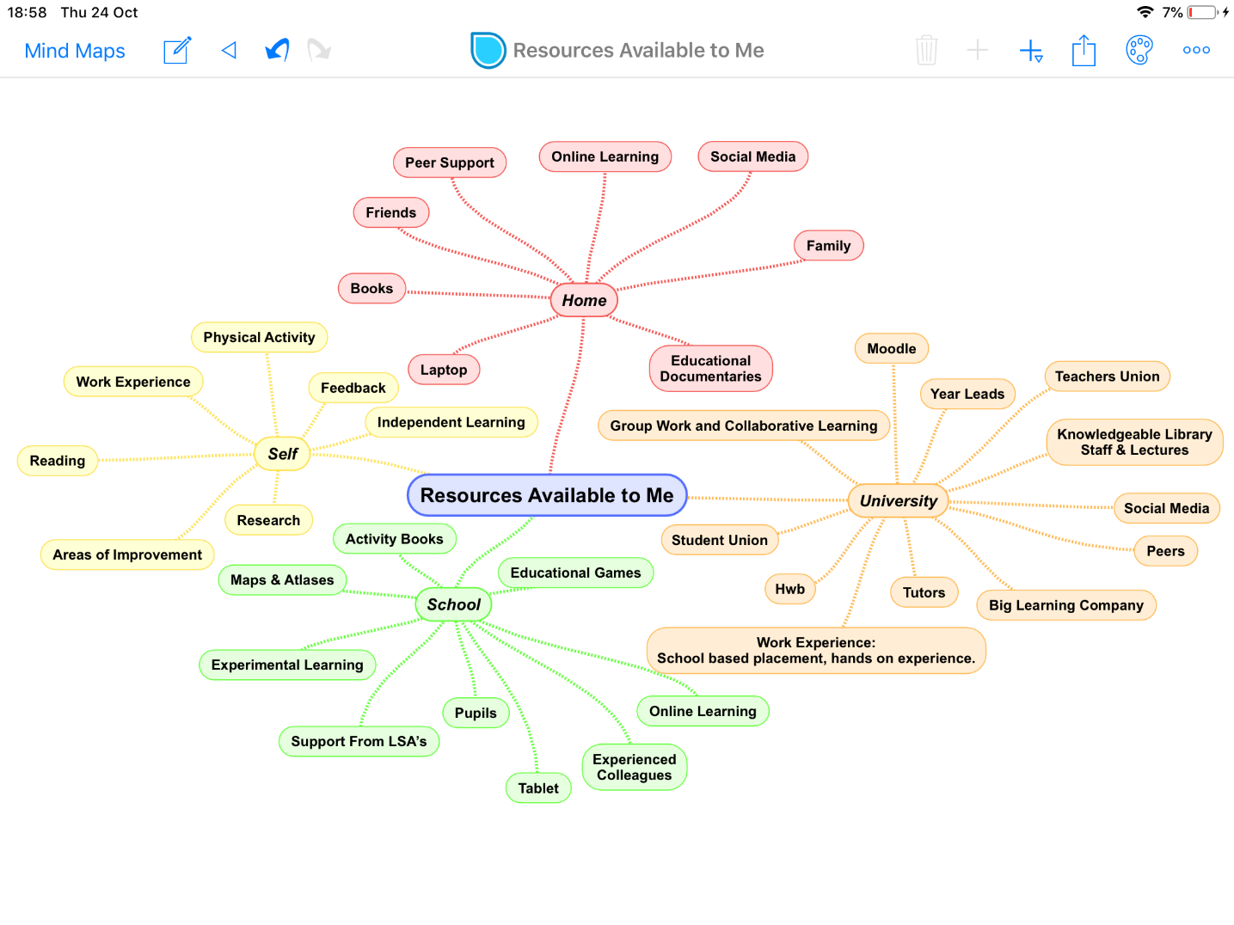

Current Skills Audit
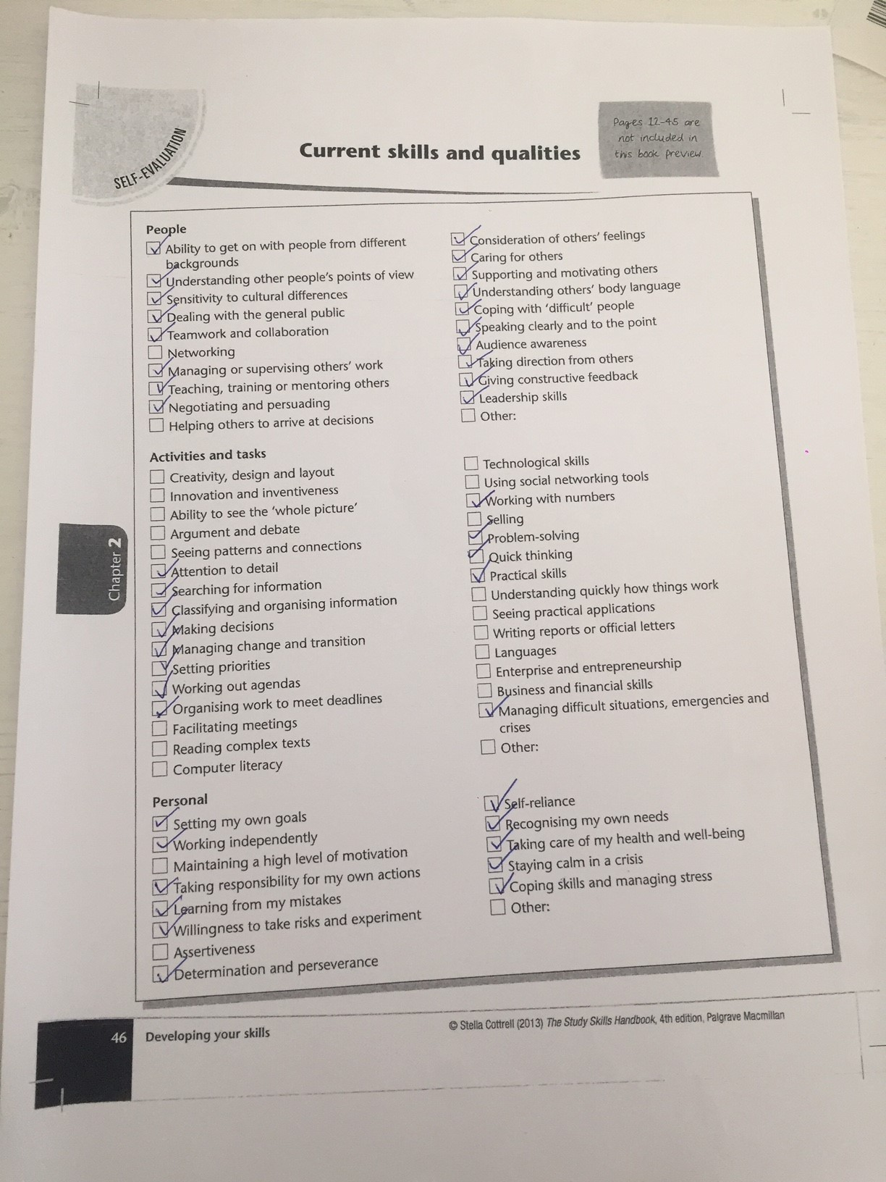

What Success Looks Like for Me
To me, success would look like reaching and achieving a goal that I have set for myself. I have implemented a plan and, I hope to use this plan to achieve my ambition of becoming a qualified primary school teacher with QTS. Education in Wales is going through a very exciting change and I am honoured to be a part of studying and teaching the new curriculum to the children of Wales. I value education and want to encourage children to thrive in an increasing digital world where advanced technology has changed the way in which we live and work. The new curriculum has more emphasis on setting each child up for life by teaching him/her new life skills and showing them to appreciate education. Education can be challenging but very rewarding to young children as it gives them the confidence and the ability to succeed in life. This new approach was introduced by Professor Graham Donaldson. He wrote a report which suggests that we as teachers, “should encourage children and young people to take responsibility for their own learning”. I am a confident, hardworking and resilient student who is dedicated to encouraging children to become capable independent learners ready to succeed throughout their lives. My confidence has helped me to overcome many challenges that I have faced in my life. I hope to succeed with the help of using my past experiences and knowledge. I have the ability to recover quickly from setbacks, learn from my mistakes and move forward. I will use these qualities to help me develop into an excellent teacher.

Portfolio Task 2

Developing Critical Thinking

Summary of Critical Thinking Skills by Stella Cottrell

Critical thinking is the way we analyse facts to form a judgement on something; it involves using mental processes to make sense of the world around us. Being able to identify whether someone is telling the truth or making false assumptions are forms of critical thinking. Being able to critically think helps you make better and informed decisions. The aim of critical thinking is to locate the argument to help understand the basis on how the argument has been built. It is important while thinking critically that you can locate the message that is being portrayed in order to develop necessary skills to either trust what is being discussed or doubt the individual. This text suggests that we should critically analyse the individual’s reasons by evaluating their form of events and explore evidence to identify faults in their reasoning.
It is important to develop your own critical thinking skills for a variety of reasons. Critical thinking does not come easy to all students as it involves “precision and accuracy” (Cottrell, 2005) that improves with practice. Critical thinking allows you to gain a broader range of skills which is key to success. Some such skills are analysis, evaluation and problem solving. To have the ability to browse through a text and identify key facts is an example of analysis. The more skilled you are as a person the more likely you can take on complex tasks with confidence of a successful outcome. Critical thinking can come across like a sluggish procedure for many people however, once you develop these skills it can save you time in the long run as it will help you to distinguish what is applicable information and what is not. A lack of critical thinking skills can result in failed structures and numerous mistakes.
Having background knowledge not only helps you find out more about a subject but allows you to make a more precise judgement. Being a good critical thinker allows you to detect a poor argument which proves that background information is not necessary though your “thinking might not be accurate if we are not fully aware of the influences that affect it” (Cottrell, 2005).
Being able to critically evaluate the work of others is a vital skill to have. It allows us to dig deeper into the subject being studied and engage in a critical dialogue with the individual to evaluate what works well and what does not, in turn, this can broaden your knowledge on the subject. People can take feedback as a negative and refer to it as “criticism”. In the text above, it states that criticism “refers to an analysis of positive features as well as negative” (Cottrell, 2005) yet, people can take criticism personally. Some people would rather not critically evaluate someone else’s work in case they look like a nasty person. Giving constructive feedback is crucial in helping the individual to succeed.
Having undertaken the activities in chapter 1 I was able to reflect on my personal critical thinking skills. I found these activities particularly useful in helping me identify what skills I need to work on. In particular, I have learnt that I can offer criticism to fellow students without feeling like an unpleasant person. I will look forward to testing/practising my critically thinking skills throughout my university degree.

Portfolio Task 3

Developing Critical Writing

What I think about Education in Wales

In my opinion education in Wales today is at one of the most inciting times as we are in the process of developing a new curriculum. We are in a world now where technology is hugely important to children therefore, a different approach to educating young people was needed. There are many challenges that face children in Wales today such as, homelife, social media, mental health, poverty, and the use of two languages (Welsh, English) in our schools. Professor John Furlong’s report looks at the current strengths and weaknesses of teacher education training in Wales; he suggests that the “teachers of tomorrow” will have to respond to the changing nature of knowledge in society. Teachers not only need to be experienced in teaching history, mathematics etc, but they will also need to be educated in teaching their students to “learn how to learn” (Furlong, 2015).
The new curriculum aims to improve opportunities for students that come from disadvantaged backgrounds and bring about better learning and higher standards. I feel it is only fair that every child has an equal chance at education. According to Donaldson, G (2017) education in Wales has risen concerns and suggests that a different direction for the Welsh curriculum and assessment was needed throughout the country in primary schools. The new curriculum is being developed by teachers with the intention of creating students who are “ambitious capable learners, creative contributors, informed citizens of Wales and the world and healthy and confident individuals”. There are six “areas of learning and experience” rather than specific subjects that the students will engage in in the new curriculum: Expressive arts, humanities, health and well-being, science and technology, mathematics and numeracy, language, literacy and communication. By promoting the use of arts to help improve literacy and numeracy skills, the attainment gap in education in Wales will reduce as it will help a student to develop numeracy skills in a range of engaging contexts (Expressive Arts, 2019: 11). I feel the new curriculum will help improve the education system in Wales by teaching students to have a range of wider skills necessary for current life and work e.g. it will teach the children to be more creative, innovative and encourage them how to “participate successfully in the modern world” (Expressive Arts, 2019).
According to Nettle and Romaine (2000) the world’s languages are dying. Language is “a system of communication between human beings. It can only exist where there is a community to speak and transmit it”. Nettle and Romaine also went on to say, “when languages lose their speakers, they die”. This is a grim thought but also very true.
It is recommended by Donaldson (2015) that Welsh language should be treated with a stronger focus in schools and in the classroom. Having originally come from Ireland, I have noticed how popular the cultural Welsh language is with the older generation compared to the Irish language with the older generation in Ireland, where very few can speak their cultural language. Wales as a country has a lot more pride in its culture and this new curriculum will help the younger generation build on this.

References
Cottrell, S. (2005) Critical Thinking Skills Hampshire: Palgrave Macmillan
Curriculum for Wales 2022 (2019) Expressive Arts. Available at: https://s3-eu-west-1.amazonaws.com/hwb-live-storage/a2/59/d2/72/a63544998390b2fb11b8828a/draft-statutory-guidance-expressive-arts.pdf (Assessed: 28th October 2019)
Donaldson, G. (2017) “A Systematic Approach to Curriculum Reform in Wales”, Wales Journal of Education.
Furlong, J. (2015). Teaching Tomorrow’s Teachers. Cardiff: Welsh Government.
Nettle, D. and Romaine, S. (2000) Vanishing Voices: The extinction of the world’s languages. Reading: Oxford University Press
Professor Graham Donaldson (2015) Successful Futures. Available at:https://gov.wales/sites/default/files/publications/2018-03/succesful-futures-a-summary-of-professor-graham-donaldsons-report.pdf (Assessed: 9th October 2019].

