Chapter 3 – Methodology
3.0 Introduction
In the previous chapter I have looked into the current literature and statistics available to see how the use of officer’s appointments has changed and how figures of assaults are changing with the use of these appointments and their development. The purpose of this chapter is to look at the methods of research that I will be conducting in order to achieve objective three of the dissertation which is: Do officers feel that the carrying of their appointments makes them feel safer and would they use them in order to subdue an aggressive offender? I will also be aiming to see the impact on research conducted around objective four which is: Are officers safer when a taser officer is deployed to a call rather than only officers with normal PPE/appointments?
3.1 Research strategy
The strategy and aim of research is to gather primary data and one of the most used methods in academic writing is to follow the “The Research Onion” created by Saunders (Saunders et al. 2019).

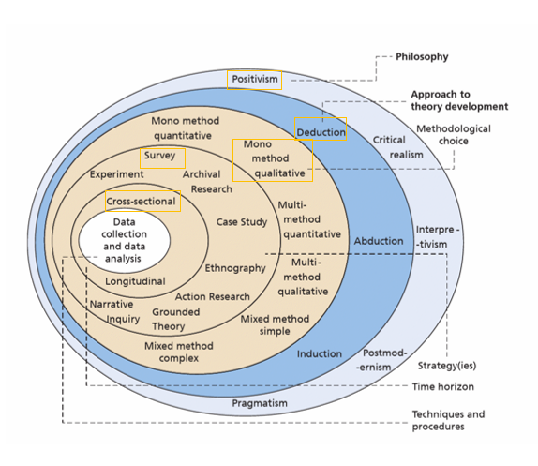
Figure 3.1 – annotated diagram – Research Onion (Saunders et al. 2019).

Above is a diagram of the research onion created by Saunders (Saunders et al. 2019) which has been annotated to highlight my chosen research path and technique in order to achieve my objectives.

3.1.2 Research plan
The initial plan for this research was going to be a mixed method approach utilising both questionnaires and the use of interviews but with the time constraints placed onto response officers who are my main demographic and myself as a response officer a more focused approach through the use of a detailed questionnaire will be taken with the aim of achieving a wide range of responses throughout the force area chosen for the research.

3.2 Data Collection
The purpose of this dissertation is to discover how officers feel when it comes to their appointments and to their safety when using them and as such can be objective to the individual officer’s opinion. That being said it is the opinion of the officers that matters most when it comes down to their safety. For this reason, a questionnaire released primarily to response officers but also to other officers within the police will be used.
The questionnaire for this research will look to take samples from a minimum of 30 officers across the South Wales Police force area in order to obtain a broad view. The reason for utilising the South Wales Police for the questionnaire is due to the fact I am able to easily distribute the questionnaire to officers within this area and the questionnaire will be open for a period of 1 Month in order to allow for officers to complete it.
The questionnaire will focus on gather information regarding four main categories. The first being information gathered surrounding the officer themselves including their rank and department. The information gathered in this section does not include personal information such as name or gender. The second category is surrounding assaults on police officers and looking at what the officers’ experiences. The questions include a list of yes/no questions with the option for officers to write a brief explanation if they selected yes to explain what has taken place. The second section also gathers data surrounding the offence a suspect was arrested for and whether they were charged and found guilty at court in order to analyse assault police figures within the South Wales Police force area.
The third section of the questionnaire focuses on the appointments carried by officers and askes a crucial question of officers of what they believe any limitations of the appointments may be. The final section relates to the use of taser within incidents and asks officers if they would benefit from having a taser officer at a incident and asks them to explain why. This section is specifically aimed at answering objective four. A full and complete copy of the questions asked can be found in Annex A

3.3 Data analysis
Data that has been obtained by the research questionnaire will be inputted into spreadsheets so as to provide a comprehensive chart showing the results to the multiple-choice questions included. Any questions that require a typed response from the participant will be taken and analysed for key themes and words so as to find any common themes and experiences that officers have regarding the questions asked of them.

3.4 Limitations and potential problems
Due to utilisation of only the questionnaire I am limiting the responses received by officers to the questions asked whereas including an interview of officers could potentially add in a more detailed analysis of responses. The reason for focussing on the use of the questionnaire is due to time constraints and ensuring that I am able to receive a broad spectrum of answers from officers within my chosen time frame. Although officers will not be able to answer in great detail, they will be able to provide quantitative data that will be able to be used to analyse a broad spectrum of results.

3.4.1 Ethical considerations
I have considered the ethical considerations when releasing my questionnaire. Some of the questions ask officers to provide a brief description of the incident but there has been a proviso attached to the answers they provide that they do not disclose any personal details including dates and locations so as to not breach any GDPR regulations and release personal details. Any answers that include personal details as listed above will not be included within the final research submission and this has been made clear at the start of the questionnaire.

3.5 Conclusion
This chapter has provided a clear and comprehensive analysis of the research method chosen for this dissertation. It has also highlighted that by conducting this method of research I have hoped to achieve both objectives three and four from my initial research proposal and that it is intended that a broad section of officers from within the South Wales Police force area will be asked to contribute in order to provide a cross section of answers that will be able to answer the question asked at the start of this dissertation.

