Name: Amber Turner

Student Number: 1802391

Module course and number: Research in context ADAD5003

BA course title: Illustration

Tutor name: Julia Lockheart

Full Question: Question 3: The distinction lies in the fact that fine art is the idea (brought to life) while an illustration is a depiction (or explanation) of an idea. Fine art is simply art for art’s sake. (Apatoff 2011). Discuss the factors that typically determine whether an artwork is labelled fine art or illustration (giving examples), and the connotations of this labelling.

Word Count: 2,321

Throughout history many artists have questioned what is the difference between fine art and illustration? Is an illustrator truly categorised as an artist or do they have certain limitations that may constrain them from expressing their freedom? These restraints could possibly lead to other artists substantially believing that illustration cannot be art but authentically only a branch of advertising.

So what is the difference between fine art and illustration? If we were referring back to the statement “Fine art is simply art for art’s sake” which originated in the late 19th and early 20th centuries with the rise of abstract art (art that exists for its own purposes) this refers to an art form that is primarily judged for its authentic beauty and aesthetic value, it overlooks its functional expense. Fine art is so much more personal to the artist, it exclusively comes down to how we perceive the world and the experiences that we have had. Art is an expression of our thoughts, desires, emotions and intuitions. Fine art also focuses on design-based works such as sculpting, painting and printmaking and as of recently, photography and architecture has additionally been branded as fine art.
Illustration is purported to be more of a commercial kind of art. It is essentially solving a problem through visualisation for example a client may have their own concept that they want to develop but struggle to visualise the appearance. An illustrator would take it upon themselves to communicate this image. Your job as an illustrator is to collaborate with the client to get an appropriate solution.
Both illustrators and fine artists communicate a message. Art is a language - It’s a message that wants to be portrayed visually.

I read an article by an illustrator called Keith Bond, he is also a regular contributing writer for FineArtViews and what he had to say really intrigued me to find out more and keep reading, it was interesting reading about what he had once been told and pondered over for years “I once heard someone define the difference between a fine artist and an illustrator as: an illustrator answers questions while a fine artist asks questions.” Is it really that simple to categorise fine artists and illustrators in this way? The altercation was that as an illustrator you are paid by a client to do what they have commissioned you to do, an illustrator needs to be a problem solver. The client will have to question ‘how do they get their target audience and consumers to want their product?’ and the illustrator needs to find the answers and communicate that message through their artwork.
The fine artist on the other hand is searching and seeking some elusive idea, thought or meaning. “It is a quest for understanding or truth. Questions are being asked in an effort to make sense of the world or of one’s self.” In other words there is nothing anyone else could say that may throw off what a fine artist is trying to communicate as a fine artist is only working to please themselves. It is their message and they will communicate it how they want.

There is such a fine line between fine art and illustration that is still being explored. Many artists actually crossover between them both, take Pablo Picasso as an example “Primarily famous as a painter and sculptor, he also left a lesser-known body of work as an illustrator, graphic designer, and political activist.” He was constantly changing his style of work as well, there were periods of time where Pablo Picasso would explore through more of a cubist style and then furthermore explore realism for a while and then changed his style to surrealism, for a while he even became a prolific sculptor. He was an artist who consistently changed the way that he worked. Picasso hardly ever accepted commissions due to the fact that he believed it would disrupt the natural flow and development of his personal artistic ideas. The result of this was that his canvases would explore what he was feeling and personal experiences in life, his relationships with people and certain political theories. Many of his portraits are actually inspired by his family and friends and if you look throughout the development of his artwork you would find that he drew the same woman (known as Eva) multiple times.
One of his most famous paintings ‘Guernica’ was actually an illustration, it decried a terrible war crime in real time and a majority of his other works, are works completed in ‘the now’. Illustrators in particular must respond to the now as they are often called upon to complete briefs and commissions at such short notice. Picasso also balanced his styles of abstraction and realism, it characterises so much of his work and is also seen as crucial in the work of illustrators.

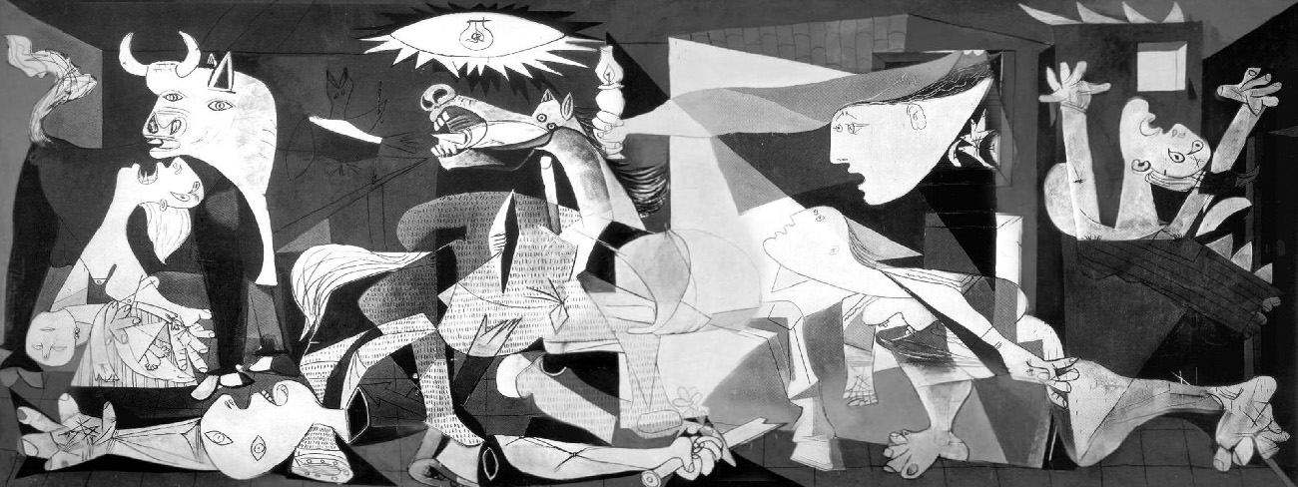
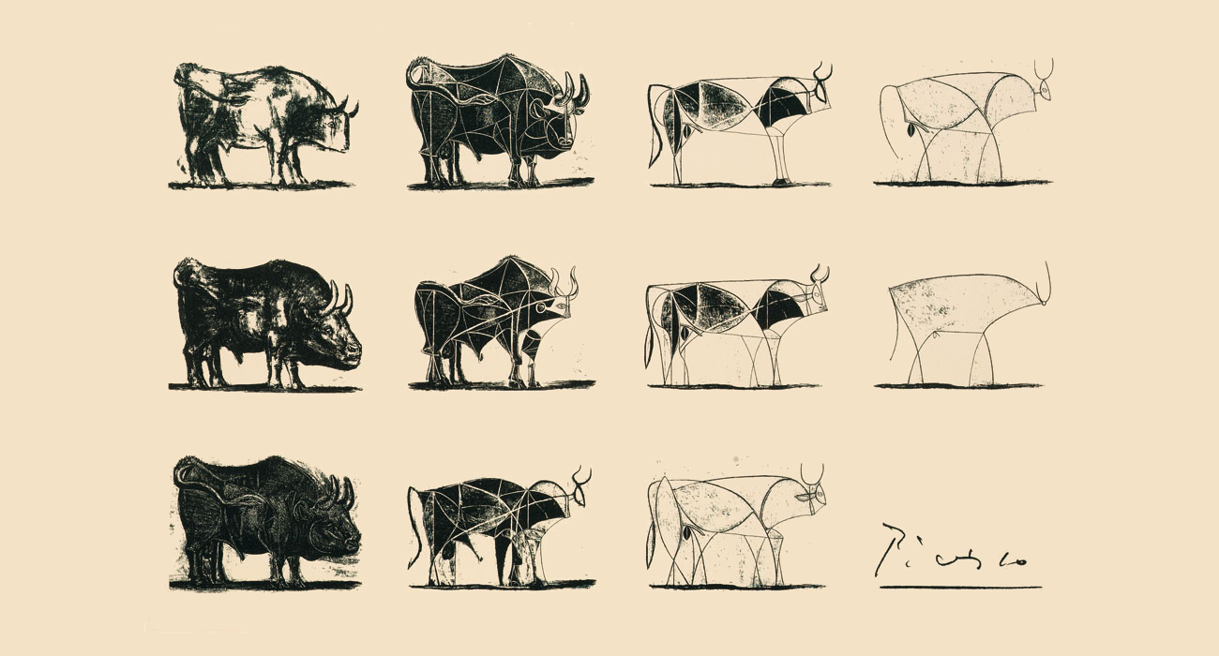

Fine art is purportedly communication, and throughout the art history there has been some extensive and paramount movements. We can use the Pre-Raphaelites as an example, the Pre-Raphaelites were a group of artists in the Victorian era and they believed that art should be seen as similar to the real word as possible for example everyone knows the sky is blue, so therefore - you should paint it blue. In this era, one of the most famous artists of all time was Raphael; he was painting up to nearly 400 years before the Raphaelites came to exist. Raphael found beauty in creating masterpieces of Jesus’s life and the pre-Raphaelites did not like this because they wanted to paint what they knew to be real and this is how they got their name (before Raphael).
The Pre-Raphaelites were a substantial scandal, when people saw their paintings they were horrified, this was by reason of the fact that the Pre-Raphaelites used an emphatically amount of bright colours to make their work stand out. The scenery in these images where still imagined they just wanted to make them look as real as possible. John Everett Millais created one of the most famous paintings of the pre-Raphaelite era ‘Ophelia’. Ophelia is a character based on one of Shakespeare's plays ‘Hamlet’. The river bank in this piece looks exactly like the one you may see on a walk. Millais thought that this was so important that he decided to paint the river bank before even painting Ophelia herself. The Pre-Raphaelites really enjoyed painting women, these women had very similar features such as long, red hair and pale skin which was what the Pre-Raphaelites considered as beautiful.

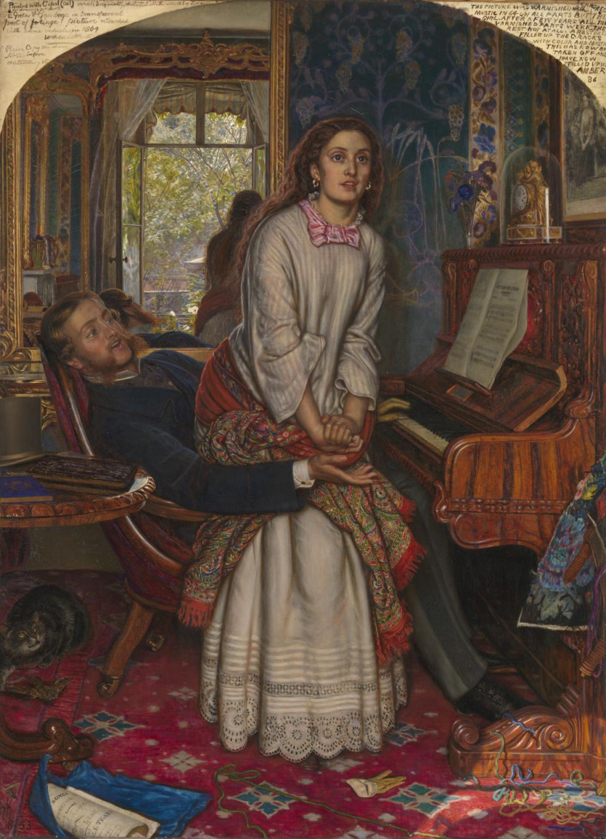

The Pre-Raphaelites really enjoyed focusing on all of the little symbols. If we look through Hunt’s painting “The Awakening Conscience” He added so many little symbols that bring the painting to life (The cat trapping a mouse, the forgotten glove just lying on the floor, the loose thread tied around the bottom of the piano) This piece of artwork is like a puzzle piece, one that people can try and find links to figure out what the painting is trying to portray to understand it better.

Another very important Historical art movement was the Renaissance. “One of the fields that embodied the Renaissance was fine art, especially painting and sculpture. Works from this period were inspired by Classical Greek and Roman art and were known for their grace, harmony, and beauty.” It was the artwork created by Leonardo da Vinci, Michelangelo and Raphael that really brought the Renaissance to life this is because they focused on bringing images of God to life and his creations, and religion was very important throughout this era. It was even considered a science as a result of discoveries and the exploration of nature. The artwork was practiced according to mathematical principles and focused a lot on perspective.
Leonardo was a very popular artist in his time but his love, fascination and endless research into anatomy, the nature of flight and animal and plant life left him very little time to paint. Though, his completed works such as the Mona Lisa, the virgin of the rocks and the Last Supper paintings brought him a lot of fame.
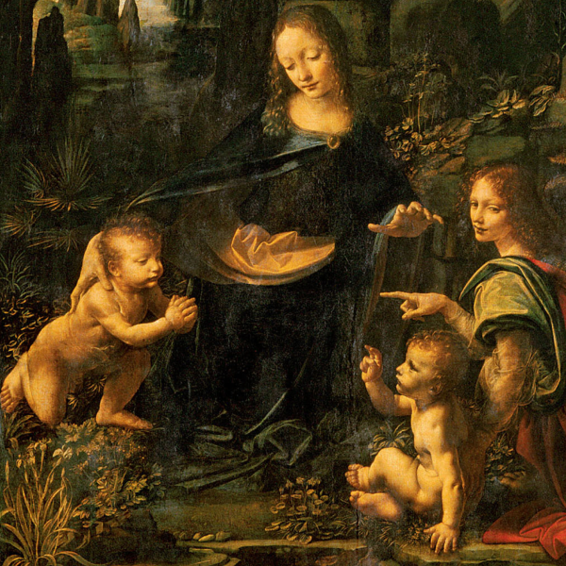
Leonardo’s ‘Virgin on the rocks’ masterpiece portrays the infant Jesus finding himself in a shadowy cave with baby John the Baptist. Watched over by the Virgin Mary and the archangel Uriel
Michelangelo was thought to be a brilliant sculptor; however one of his most famous designs is the giant ceiling fresco of the Sistine chapel in the Vatican. It took him four years to complete and presents an incredibly complex composition.
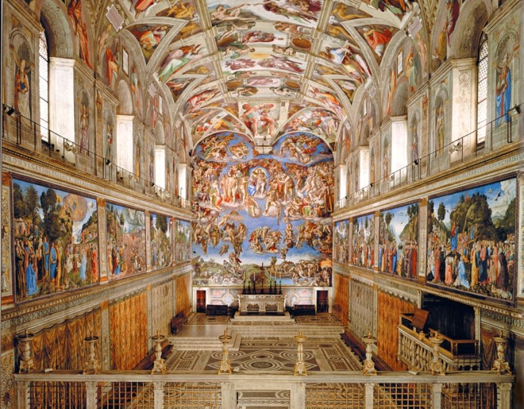
“The centre of the ceiling depicts nine scenes from the book of Genesis: God separating light and darkness during creation, God creating the solar system, God dividing water from land, God creating Adam, God creating Eve, Adam and Eve falling into sin and being expelled from Eden, Noah’s family sacrificing to God, The great flood, The drunkenness of Noah.”
One of Raphael's greatest pieces of work was called “The School of Athens” and this was actually painted around the same time that Michelangelo was working on the Sistine chapel in the Vatican.
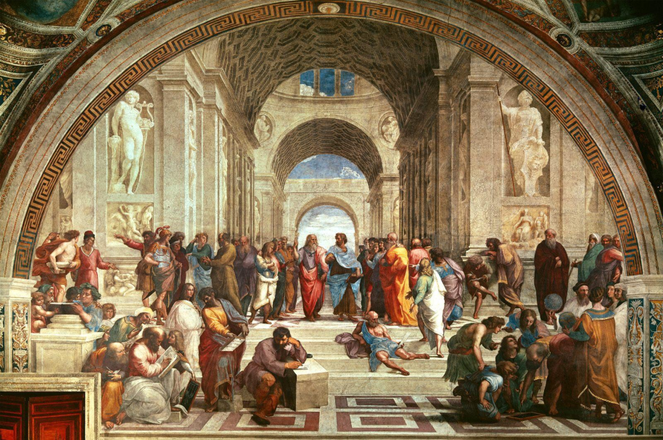
The school of Athens visually represents an intellectual concept. Raphael used famous figures to represent a lesson on the history of philosophy and different beliefs of Greek philosophers. The two main figures in the work are Plato and Aristotle; they are placed directly under the archway to grab the viewer's attention. To the left of Plato we have Socrates and his students. In the foreground, Pythagoras sits with a book and inkwell and also surrounded by his students. On the other side of Pythagoras we have Euclid who is bent over demonstrating to his students something with a compass. The mathematician and astronomer Ptolemy is right next to Euclid, he holds a globe in his hand. The elderly gentleman sprawled out on the steps is believed to be Diogenes he is the founder of the Cynic philosophy. Two large statues are displayed at the back of the school, on Plato’s right there is Apollo who represents the natural philosophy side as the god of light and healing and on Aristotle’s left we have Minerva who is the Goddess of wisdom and Justice.

A variety of new styles and techniques arose from the Renaissance, this includes sfumato which was created by Leonardo this was a glazing affect and this revolutionised blending and tone of colour, another ground-breaking rise were ceiling paintings, the purpose of these ceiling paintings and architecture was to try and captivate people into gazing into a heavenly visual.

In this day and age you will find that a lot of fine artists are actually changing their styles and adapting to becoming illustrators, this is simply because it is a way of making money and you are able to take up a hobby as a career and hopefully stay financially stable. Though the freedom in fine art is great, it is a way of expressing your character and emotions you may find that the fine art industry is actually dying out which I personally find unusual for the reason that fine art is often respected and critically acclaimed, whereas commercial art might be appreciated and acknowledged, it is still very unlikely that commercial art would be found in galleries such as the Louvre. When it comes to commercial art you will find that most artists have acquired the skill and developed their styles to get to the point that they are at whereas fine artists are seen to have that natural talent, it requires inborn talent.
The difference between fine art and commercial art was pretty clear up until around the 20th Century on the grounds that the art movement known as ‘pop art’ started originating.
Focusing on the pop artist Andy Warhol - He produced mass images using the tools of a commercial artist. Warhol's Brillo Boxes is a fine example of how commercial art merged with fine art.
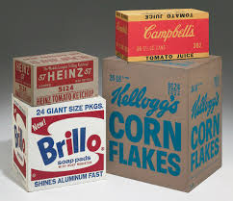
Some more crossover examples would include the work of Pipilotti Rist, she is a video artist and her videos resemble those of music videos yet her work is exhibited in art galleries and museums which is unexpected of a commercial artist.

On the other hand, you may find that commercial artists use examples of fine art into their advertising campaigns or packaging. Understanding the difference between these two majors are very important for the reason that even though in this day and age you will find that almost every piece of artwork combines elements of both fine art and commercial art, art schools still maintain a division between the two. Students must choose between majoring in fine art, illustration, graphic design etc. when it comes to pursuing degrees.

In conclusion, when we look back at the history of art and how it was produced centuries ago before the design of technology etc. Whether you categorise that as an illustration or fine art is a matter of opinion, you will find that the differences between the two are very limited. Does a painting that was created with the intent of communicating a personal message (Something to be categorised as fine art) suddenly become an illustration the moment you have them scanned, bound and sold? Does art need a purpose? The purpose of art is a question that many people have contemplated through centuries and yet it still does not have a definitive answer. There are so many theories and opinions on what art should truly be considered to be. For me the process is the most rewarding, you ask questions along the way as you are making your art. Every piece of art should have some sort of connection and memory behind it even if you are an illustrator you can find job offers based on themes and categories that you enjoy making artwork for; there should be no need to feel restricted in the art industry. Art is art whether its fine, illustrative, graphic etc.

Bibliography

Andrew, D. (2018). Art. Dorling Kindersley Ltd. London, United Kingdom

Farthing, S. (2018). Art: The Whole Story. Thames & Hudson Ltd, London, United Kingdom

Stauble, C. (2015). The Paintings That Revolutionized Art. Prestel, Munich, Germany

Dorling, K. (2013). The Illustrated Story of Art: The Great Art Movements and the Paintings that inspired them. Dorling Kindersley, London, United Kingdom

Andrew, W (2017). The Picasso You Didn’t Know: Pablo Picasso’s Illustration and Design Work [Online] trydesignlab.
Available at: https://trydesignlab.com/blog/pablo-picasso-you-dont-know-illustration-design/

Tate, (2016). Who are the pre-Raphaelites? [Online] Tate
Available at: https://www.tate.org.uk/kids/explore/who-is/who-are-pre-raphaelites

The editors of Encyclopaedia Britannica (2017) Renaissance European History [Online] Britannica
Available at: https://www.britannica.com/event/Renaissance

April, (2018). Commercial art vs. Fine art [Online] The yellow brick road gallery
Available at: https://www.theyellowbrickroadgallery.com/commercial-art-vs-fine-art/

Eric, P. (2018) Michelangelo & the Painting of Sistine Chapel [Online] Study
Available at: https://study.com/academy/lesson/michelangelo-the-painting-of-sistine-chapel.html

