Applied Leadership and Management in the
Workplace
Moodle Assignment Submission

Student Name: | Shanice Hodgson
Student Number: | 2238725
Module No: | BMSK4013
Module Title | Management Communication

Section 1: Communication
1.1 Explain the relevance of the communication cycle for effective communication and management.
“Communication, n. The imparting or exchanging of information by speaking, writing, or using some other medium. The successful conveying or sharing of ideas and feelings.” Oxford English Dictionary.
Communication is the sending and receiving of a message, either face to face, by telephone, or through online messages such as WhatsApp, email, or messenger.
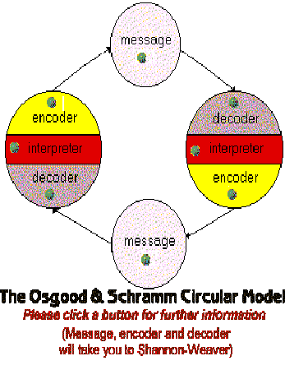
Schramm’s model of communication identifies five components that help explain the communication process. Which includes the sender, receiver, message, feedback, and semantic noise. Schramm’s model of communication is a good form of communication as the messages that are being sent are clear and relevant. It also shows that the message does not just end with the receiver. It gives opportunity for the receiver to communicate back with the sender.
The relevance of the communication cycle in the workplace for communication in management, is that without having thoughts, information, or ideas from our staff we cannot improve services that we implement in the workplace. A manager should always take on board every member of staff's idea or problems as it helps build staff motivation, to perform well, and builds a more positive workplace.
The Shannon and Weaver model, 1949 is most well-known and influential formal model of communication. This model of communication consists of seven components: sender, transmitter, channel, noise, decoder, and receiver. With this model of communication, it would not always be effective because there is not always a clear message. For example, if a secretary were phoning their manager to relay an important message and the line was not clear the manager would not be able to relay the full message and could cause confusion. The model also shows that the message is not being relayed back to the sender by the receiver which then stops the receiver from relaying that message back to the sender.
In the book: Information Communication by Feicheng Ma (2015), it highlights the Shannon and weaver model and that he examined several basic theoretical problems in communication, proposed the methods and generalized formulas for computing source of information volume and information channel capacity, and obtained a set of theorems regarding transmission of information. Shannon defined information as a reduction of scholastic uncertainty.
1.2 Explain, with examples, the importance of selecting an appropriate tone, language, and level of formality in management communications.
- Tone
The importance of selecting an appropriate tone when speaking to employees is that your tone clarifies meaning. Your tone when speaking can affect how people perceive you and they will make presumptions of you as a manager.
If you are coming across as sarcastic your employees will not feel they can come to you as they will feel that their feelings are not valid, and they do not matter.
Speaking more emphatically the employee will feel that you care about their thoughts and will be confident that they can communicate with you.
Verbal communication:
When working for The Village hotel I experienced a situation where I wanted to hold a one to one meeting with my manager where I could communicate with a worry I had because of my deputy manager, when speaking to her I had hopes that the concerns I had with the deputy manager would be kept between myself and her, but it had been taken to him and they went on to joke about the situation and my feelings. The manager seemed like she was sympathetic at first but after speaking with the other employee she was not interested or sympathetic at all with what I had to say, and she disregarded my concerns and feelings.
Written communication:
In the salon I am currently working in there has been instances where we have had messages through our salon WhatsApp group, and most recently one of our makeup artists had not shown up for a client that was sat waiting. Over 20 minutes later I had rung the makeup artist to see if she was on her way, she did not answer the phone. To then message myself saying she did not have this girl booked in. I explained that she needed to phone this client and explain to her that she was not going to be coming in as there was an obvious confusion. She would not ring the client but only messaged her. Which put me and another colleague in an awkward situation. There were a few messages being sent into our salon WhatsApp group from this makeup artist and her tone through messages were incredibly angry and abrupt towards me and the other colleague as she could not see that she the way she had acted was completely unprofessional and rude towards us and her client.
- Language
The importance of selecting the right language in the workplace is that if you are holding a formal meeting, you would not go into that meeting swearing in conversation with the employees, that would come across unprofessional.
When I am with regular clients that I see every 3 to 4 weeks for their nails I get to know them and know how to speak to them, some are close friends so sometimes we do say the odd swear word on occasion. But if I had a brand-new client or an older client, I would be more careful about my choice of language.
Also, another importance of selecting the right language is that you could have a member of staff that has a language barrier, it is important to have a translator in the meeting to help them have a clear understanding of what you are trying to say.
There can also be an employee that has a disability that can prevent them from understanding what you are asking. Before holding a meeting, you should have an aid depending on their disability for the employee so they can understand.
- Formality
The importance of the level of formality is that it will clearly define and establish authority between the management and the employees.
If a manager must hold an important meeting such as a disciplinary with an employee, you would not address them in an informal manor, such as “Babe, mate, or pal” if a manager addressed an employee with these phrases, the employee would preconceive a relationship that they are friends. To then hold a meeting which the employee had done something wrong they would be upset and confused at the relationship that you had initially put across to them.
Verbal communication:
In previous employment I had been called into a meeting that my manager addressed me as “babe” that was a meeting to tell me I was no longer required for my role in that job, and they had passed my role onto another member of staff. When addressing me and did not use my name which would have been the formal way to go into that meeting. The tone in the managers voice was not that I was going to be let go, more she approached me as a friend. I did not feel that this was appropriate, and I had felt let down by her, as the manager did not treat me as an employee but a friend to begin with but then went on to dismiss me from the company.
Written communication:
In my workplace we are all in a WhatsApp group that we communicate through. There have been instances where the proprietor has put messages into the group that have come across very blunt. Sometimes in these situations messages can be read in the wrong way. And staff members can worry that they have done something wrong because messages have been perceived differently than they were meant to be.
Another form of formality is as a manger if you are not dressed the correct way that is required by the company, employees will then not follow company dress policy. Employees will only follow the examples that are being set from the people higher than them.
1.3 Access the effectiveness of a range of verbal and written communication methods within your area of the organisation.
The effectiveness of a range of verbal and written communication methods within my area of the organisation from previous experience, as a manager in a sunbed salon when communicating with members of my staff through text message things that were being said from both parties were and could be misinterpreted. That would then lead to the staff member feeling as if I had been attacking them through message. Whereas a verbal conversation would have been better in that circumstance as she then went on to resign from here position, without wanting to resolve the issue with myself. That resulted in me losing a member of staff and not being confident in my role as a manager with the rest of my team. In this situation this form of communication was not effective.
Verbal communication is especially important in my job role, a client sits with me for two hours whilst I do their nails. It is so important to build a relationship with every client. They tell me their personal problems, exciting news and just use their time with me as a form of therapy. If I were to sit there and not speak a word to the client, it would make them feel uncomfortable and they would move on to find a more appropriate nail technician. This form of communication is especially important in my role as I would not be able to communicate through written as I would be too busy working with my hands.
Written communication is also particularly important in my job role as all my bookings are made through an Instagram page which I operate most evenings to keep on top of clients that want to book appointments, clients wanting to rearrange their appointments due to other commitments, or clients sending me photos of sets for inspiration for their next sets. It is so important I reply in a professional manner because if there are new clients that want to book in, and my replies are blunt, or they feel as if I am not bothered, they could make the decision to book with another nail technician. This is an appropriate form of communication for my role but sometimes it is difficult to keep on top of with a busy schedule.
Section 2: Motivation
2.1 Evaluate theories of motivation relevant to your workplace.
“Motivation theory is not synonymous with behaviour theory. The motivations are only one class of determinants of behaviour. While behaviour is always motivated, it is also always biologically, culturally, and situationally determined as well.” Abraham H. Maslow, A Theory of Human Motivation, 1943.
There are 4 theories of motivation that can be relevant to the workplace.
Maslow's hierarchy of needs, (1943)
This theory of motivation is that we need to make sure that the lower needs are set before we focus on the higher needs. Which are:
- Physiological: such as food and clothing.
- Safety: employment, resources, the family, property, and health.
- Love/belonging: friendship, family, and sexual intimacy.
- Esteem: self-esteem, confidence, achievement, respect of others, respect by others.
- Self-actualisation: morality, creativity, spontaneity, acceptance, experience purpose, meaning and inner potential.
This theory of motivation fits well with my workplace, once we have earned our wages to cover our basic needs, we thrive to earn more so we can afford to book days out, which boosts morale in the salon when everyone has something to look forward to.
Herzberg's two factor motivation theory
Herzberg theorized that employee satisfaction has two dimensions: “hygiene” and motivation. Hygiene issues, such as salary and supervision, decrease employees’ dissatisfaction with the work environment. Motivators, such as recognition and achievement, make employees more productive, creative, and committed.
In my workplace this motivation theory fits with the girls that feel they pay too much rent weekly compared to others, which then demotivates them.
McClelland’s human motivation theory, (1965)
McClelland’s human motivation theory states that every person has one of the three main driving motivators. These are the need for achievement, affiliation, or power. These motivators are not inherent: we develop them through our culture and life experiences.
Mcgregor’s two contrasting theory, (1960s)
This theory explains how managers beliefs about what motivates their people can affect their management style. He labelled these Theory X and Theory Y. these theories continue to be important now. Management track employee behaviour and their work patterns. For the employees that would rather be on their phone than help the customer, impose top-down expectations and consequences. Compared to the employee that goes above expectations, constantly wanting to hit targets that are set for them.

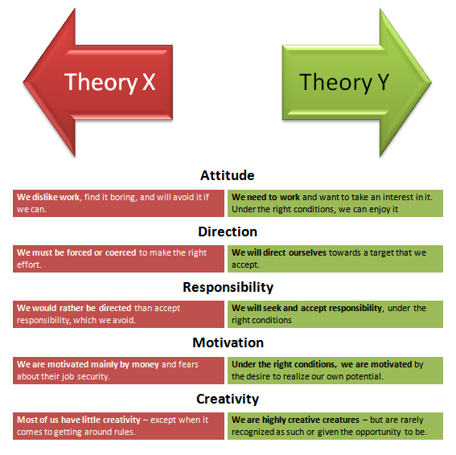
McGregor's theory of X and Y is relevant to my workplace because there is a small amount of the girls that are not willing to work and must be coerced into doing their daily appointments. Also, down to the cleanliness in the salon, people must be told to clean up their dishes after them, they fall into theory X. The rest of the girls I feel fall into theory Y, they are keener to be in work and they enjoy when they are there, they love to be around their clients and really enjoy their jobs. I fall into theory Y as I enjoy the feeling I get after the client walks away happy with their nails.
2.2 Evaluate the principal factors that may affect performance and motivation in the workplace.
The principal factors that may affect performance and motivation in the workplace would be:
- Job security: If an employee does not feel like their jobs are secure, they might not feel that they want to stay at that company and will look for employment elsewhere.
- Recognition: When working for a company if you are giving ideas and the manager passes it off as their ideas, then that employee will not feel happy to stay at that company as they are not getting the recognition that they deserve.
- Participation: Employees like to feel like they are part of a team, whether its group work or setting goals for them to work on. If you are not involving your full team some might feel like they do not belong and will result in them looking for another job.
- Promotion: People like to know there is constant ways to grow in the company they work in. Promotion helps keep staff confident in their role, and they will want to stay.
- Social needs: We like to have things planned, holidays, nights out with friends, days out with children. These plans cost money, which helps people want to stay in employment to be able to afford the lives they want to live.
- Conflict: There maybe situations in the workplace which end in employee conflict. Meetings between the employees to discuss their problems and to figure out how to resolve them as a manager and them together, so they can eventually work together without the conflict.
2.3 Select a theory of motivation – apply it to your workplace – evaluate the impact.
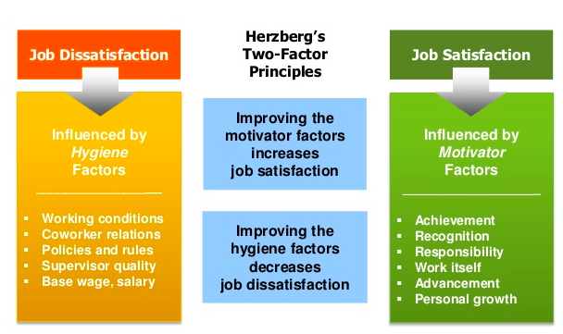
I have picked Herzberg's two factor theory of motivation for my theory of motivation in my workplace. I feel that with this theory of motivation and my workplace we work off job satisfaction, we are influenced by achievement in what we do, the makeup artists in the salon will do a wedding and know they have come away and made the bride feel beautiful and confident. They will also get recognition from their brides on social media which makes them feel confident in their work. I have felt the same feeling when I have done a set of nails that my client has loved which has made me feel a sense of achievement. When they post the photo of their nails on social media tagging my page their followers follow me and then message to book in, I then feel grateful with the sense of recognition that I have done well with my job. Not only with my client walking away happy, but to then gain more clients through the clients' post. I feel my personal growth in 6 years has been fantastic, from starting out as a self-employed nail technician 4 years ago to now I have grown so much as a manager and a person. I have previously managed a sunbed salon and the growth since then has come on exceptionally. I am now confident I could go on to open my own salon and grow from there.
Some of the job dissatisfaction in my workplace has been co-worker relations, we have had situations in the salon where a team member has not gotten on with everyone in the salon, which then makes the other team members feel uncomfortable in work, instances of arguments between co-workers has led to a member of staff feeling as they do not belong in the team and has resulted in them leaving.
Policies and rules are also in place through contracts that we all sign individually. Some members of the team have breached confidentiality agreements, by looking at each member of the team's contract, some rent little spaces which results in them paying less rent, whereas others rent larger rooms that they must pay more for. These rules are in place for us to abide by a small amount of the team will not and will feel that they are superior to the rest of the team. The rules do not always get followed so when this happens there is normally a message of warning from the girls, and if it continues there will be a one-to-one meeting held to decide how to deal with the situation, or to motivate that employee to enjoy working again.
3. Communication for motivation
3.1 Develop appropriate criteria to evaluate own ability to communicate effectively prepare development plans for yourself and another person.
The criteria I would use to evaluate my ability to communicate would be asking clients to evaluate my communication skills through questionnaires, where they think I do well with communication and where they think I need to improve.
The key areas of effective communication would be:
Active listening: if I am not present and listening to my client then they will not want to communicate with me in future which could result in them leaving unhappy with their service.
Body language: if I am tense and folding my arms, they will see me as guarded. Also, if I sound angry or frustrated when they come to their appointment they might not want to continue with the service.
Listening: needing to listen effectively. Taking time to take in and listen to what my client is saying.
Empathy: it is so important I feel the empathy with the client if emotions are low and they are upset I need to feel those emotions with the client.
3.2 Collect and analyse feedback on own verbal and written communication skills.
During this time, I sent a questionnaire to clients where they could give me feedback on my communication skills. I asked them to rate my communication skills between 1-10, for them to describe my strengths, and to describe my weaknesses.
- All clients rated 10 for my communication skills.
- When asked about my strengths clients had written, I always make sure they are comfortable, all designs are explained thoroughly, I am always open to current ideas and improvements.
- When asked about my weaknesses clients had written, I do not take enough time for myself, and I am too frightened to turn clients away. I also do not charge my worth and should not be scared to lose clients over this.
Communication skills table.
Communication rating 1-10 | Communication strengths. | Communication weaknesses.
10 | - Always open to listen to ideas.  - Always inform people in advance if there are any changes to the appointment  - Easy to talk to and make people feel heard. | - Needing to be confident in communicating correct prices with people.
10 | - Make sure that I am comfortable.  - Communicate ideas well.  - Happy to listen to any changes that might want to be made. | - Frequent communication through social media platforms.
10 | - Communicate ideas very well, open to any changes.  - Easy to talk to, feels more like a therapy session. | - Communicating clear set price lists, to not worry about losing the clientele.

I agree with the strengths and weaknesses they have highlighted above. I would like to think I am very empathetic in my job which I find would be one of my biggest strengths, I listen to every client whether it be good or bad conversations, if they are upset, I will always remember to check in on them by popping them a message on social media after they leave their appointment. I can sympathise with some clients because I have been in similar situations or I have a friend that has been through those situations so I know to try my best to just advise that client, I would never tell them what to do with their lives. I would also say that my weakness is getting too comfortable that I can let my language slip which may come across as unprofessional to other clients in the salon.
3.3 Evaluate own communication skills as a manager, identifying strengths and areas for improvement. Then produce a PDP to address these.
My strengths in communication as a manager would be:
- Listening, I would say I am very present when clients are in talking to me.
- Talking things through with them, I always like to think that my clients would be confident to tell me if they are unhappy with their nails, of the designs. I would be happier that they are walking away happy than not communicating with me.
- Empathetic, I am always empathetic with clients. I want them to feel comfortable in my company and they know they can trust me when they confide in me at their appointments.
My weaknesses in communication as a manager would be:
- Business Language skills, sometimes when talking to clients I forget that I am not with my friends and sometimes I overshare, and my language can slip. Forgetting where I am and that I am not at home, I am in work in a professional setting.
- Improving on replies communicating online, a lot of the time life gets in the way and my replies can be very delayed.
PDP
What do I want to learn? | How can I do it? | What resources will I need? | How will I measure success? | Target date for review
I would like to improve my management skills. | Online management courses. | I will need to research courses that are the best suited to what I want to achieve. | I would measure my success through evaluating growth from previous management. | I give myself a target date of 8 months to review.
I want to learn how to improve my business language skills. | Ask for feedback from colleges and clientele. | I will need to use questionaries which I can send to clients through social media platforms. | To measure success, I will ask the clients and colleges to re-evaluate my skills after a space of time. | The date of review I would like to give myself is 3 months.
I want to improve on my online communication skills. | Having an online booking system can help clients make their own appointments. Also set a day a week for all admin. | I will need to review online booking systems and decide which one would be easier for clients to use. | To measure my success, I will ask all clients which method of booking they prefer. | The target date to review I would give myself is 5 months.

References
- Oxford English Dictionary. Online, skills you need. 6/04/2023.
- Schramm's model of communication, 1954.
- The Shannon and Weaver model of communication, 1949.
- Information Communication by Feicheng Ma, 2015. Online library at UWTSD 5/04/2023.
- Abraham H. Maslow, A Theory of Human Motivation, 1943. Online, good reads, 06/04/2023.
- Maslow's hierarchy of needs, 1943. Online, Google 5/04/2023.
- Herzberg's two factor motivation theory. Online, Google 5/04/2023.
- McClelland's human motivation theory, 1965. Online, Google 5/04/2023.
- Mcgregor’s two contrasting theory, 1960. Online, Google 5/04/2023.
- Hertzberg's two factor motivation theory. Online, Google 5/04/2023.

