
Changemakers
Assignment 2: Project Management and Innovation
Student ID: 2311568
Nate Fox

Contents
Introductory Page 3
Task 1 4
Research Design 4
Data Collection Tools 5
Findings and Analysis 6
Evaluation of Methodology 8
Project Timeline and Gantt Chart 9
Project Design Artefacts 10
Task 2 11
Enterprise Pathway 11
Start-Up Concept for WellMind 13
Task 3 15
Project Reflection 15
Conclusion 16
References 17
Appendix 19

Introductory Page

In today’s fast-paced, digitally connected world, mental health and emotional wellbeing have become critical areas of concern for individuals, organisations, and wider society. The need for innovative, data-driven solutions to support mental wellness has grown significantly in recent years. This research project explores the feasibility and implementation of WellMind, a mental health insights platform that leverages wearable technology and community-level data to monitor, predict, and support mental wellbeing.

The primary aim of this research is to investigate how a platform like WellMind could collect and analyse wellbeing data to generate actionable insights for individuals and organisations. By combining predictive analytics, ethical data practices, and user-centred design, the platform seeks to contribute to early detection of stress, anxiety, and burnout, while promoting proactive strategies for emotional resilience.

This report will outline the research design, data collection tools, implementation plan, and analysis strategy for the proposed study. It will also reflect on the development of the researcher’s skills throughout the process. The intention is to build a practical and ethical foundation for future research.

Task 1

Research Design

This project will adopt a mixed-methods research design, combining both quantitative and qualitative approaches to gain a comprehensive understanding of user attitudes, data sharing behaviors, and the perceived value of a platform like WellMind. A mixed-methods approach is appropriate for this type of exploratory study, as it allows for both statistical analysis and deeper contextual insights, aligning with a pragmatist research philosophy [1].

The quantitative component will involve a structured online survey aimed at individuals, HR professionals, and local authority staff. The purpose of the survey is to collect measurable data on wellbeing behaviors, willingness to share mental health data, interest in personalized wellbeing recommendations, and views on organizational use of anonymized health dashboards. This will enable trend analysis and generalization of findings across different demographic and professional groups.

The qualitative component will involve semi-structured interviews with mental health professionals, wearable technology specialists, and representatives from organizations such as local councils or universities. These interviews will provide rich insights into the ethical, technical, and practical implications of implementing WellMind. By allowing participants to elaborate on their experiences and perspectives, the qualitative data will enhance understanding of the challenges and opportunities associated with mental health data analytics.

A non-probability purposive sampling technique will be used to select participants for both the survey and interviews. For the survey, the target sample will include approximately 10 to 30 individuals, with recruitment through online forums, social media, and student or workplace wellbeing networks. For the interviews, 5 to 7 professionals from relevant sectors will be approached based on their expertise and relevance to the project. This purposive sampling is suitable for small-scale feasibility studies, where the aim is to gain relevant insights rather than statistical representativeness [2].

The combination of survey and interview data will allow for triangulation [3], increasing the validity and depth of the findings while supporting the iterative development of the WellMind concept. And potential real-world deployment of the WellMind platform.

Data Collection Tools

To support the mixed-methods design of this study, two primary data collection tools will be used: a structured online survey and a set of semi-structured interview questions. These tools have been designed to capture both measurable patterns in attitudes and behaviours, as well as in-depth insights into ethical, technical, and organisational considerations.

The online survey has been developed using Microsoft Forms and includes both closed and scaled questions focused on user wellbeing behaviours, interest in mental health apps, data sharing comfort levels, and perceived usefulness of personalized wellbeing insights (please see appendix). Likert scales will be used to quantify attitudes towards the use of wearable devices, data privacy, and organisational monitoring of wellbeing. Demographic questions are included to allow for segmentation and analysis across groups. The pilot version of this survey was reviewed internally, and adjustments would be made based on feedback to improve clarity and reduce ambiguity.

The semi-structured interviews are intended for professionals in the fields of mental health, data analytics, wearable technology, and public health. A flexible interview guide has been designed to allow participants to express their experiences and opinions freely, while still addressing key research areas such as ethical data collection, technology adoption, privacy legislation, and platform design (please see appendix). This tool supports open-ended discussion while maintaining consistency across interviews. The guide was refined following a review against ethical research practices, ensuring appropriateness and sensitivity when discussing mental health-related topics.

Both tools will be included in the appendices of this report for reference and transparency. Together, they are designed to ensure that the data collected is relevant, reliable, and ethically obtained, aligning with the goals and objectives of the WellMind project.

Findings and Analysis

Overview of Respondent Demographics

The pilot survey received 10 responses from individuals aged primarily between 18 and 35, an age range that aligns well with WellMind’s target demographic of young professionals, students, and early career employees. Participants included full-time workers, students, and part-time employees, indicating a mixture of lifestyles and mental health needs.

Digital Wellbeing Engagement & Needs

Survey data showed a strong interest in digital mental health solutions:

- 80% rated their mental wellbeing as "important" or "extremely important."
- 70% said they already used digital tools such as Headspace, Fitbit, or Calm.

The most frequently cited features respondents wanted in a wellbeing app included stress tracking, mood logs, and sleep monitoring.

This supports the rationale for WellMind’s dual-data approach, combining subjective (self-reported mood) and objective (wearables) data to personalise recommendations and monitor emotional trends.

Openness to Data Sharing & Privacy Sensitivity

Respondents were generally open to sharing anonymised wellbeing data with 60% stating they would feel “comfortable” or “very comfortable” doing so. However, concerns were raised in open comments regarding:

- Who has access to data
- How securely it's stored

Whether employers misuse wellbeing insights

These concerns align with literature emphasising the importance of data transparency, informed consent, and compliance with GDPR in mental health technology [4]. It also highlights that trust is a critical factor in user adoption and must be built into the design and communication strategy of the platform.

Organizational Usage Attitudes

Opinions on sharing aggregated wellbeing data with organisations (like employers or universities) were more divided. Some respondents valued the potential for HR teams monitor mental wellbeing across teams, while others expressed scepticism and unease about surveillance or judgment.

This mixed feedback supports the decision to prioritise data aggregation and anonymisation within WellMind, particularly for enterprise clients, and reflects the importance of establishing clear ethical boundaries.

Pilot Survey Limitations

While the insights were useful, it’s important to recognise the limitations:

- A small sample size (n=10) limits the generalisability of findings.
- All respondents were self-selected and may already have a pre-existing interest in mental wellbeing or digital tools.
- Open-ended questions, while helpful, yielded varied depth in responses.

Nonetheless, the pilot findings provide directionally strong insights that validate there is a genuine demand for the platform, positive user interest and areas where ethical concerns must be carefully managed during development.

Evaluation of Methodology

The research methodology for this project combined a short online survey and a set of semi-structured interview questions, reflecting a mixed-methods approach aligned with pragmatist philosophy. Overall, this method was effective for exploring the potential feasibility of WellMind and gaining insights into user preferences and ethical considerations around mental health data usage.
The online survey created in Microsoft Forms proved efficient and accessible for rapid data collection. It allowed for both quantitative (e.g., Likert scales) and qualitative (open-ended) responses, which enriched the data. Participants could complete the survey quickly, and the platform provided automatic graphs and analytics, which aided in the early identification of user trends (please see appendix). However, the use of a small, self-selected sample (n=10) limits the generalisability of findings. The short timeframe also meant that further demographic segmentation or statistical testing was not possible. In a full project rollout, a larger, more diverse sample would be required to ensure representative data.
The inclusion of semi-structured interview questions, though not conducted in real time for this pilot, added an important qualitative dimension to the project design. These questions were developed to explore themes such as organisational ethics, user trust, and data-sharing attitudes from the perspective of professionals in healthcare, tech, and local government (please see appendix). Their value lies in offering deeper insight than surveys alone, especially when aiming to understand implementation risks or enterprise viability. In future research, actual interviews would need to be conducted and transcribed, requiring ethical approval and time management.
Another strength of the methodology was the alignment of tools and questions with the project’s core objectives. The survey directly addressed areas such as digital wellbeing, privacy concerns, and data-sharing attitudes, which are central to WellMind’s mission. However, due to time and scope constraints, the study did not include a usability prototype or live demonstration of the platform, which could have produced richer insights through observational or experiential data.
In summary, while the methods were appropriate and produced valuable direction for the development of WellMind, the pilot nature of the study, with limited time, participants, and interaction, means that future iterations should scale up participant numbers, include interviews with real stakeholders, and potentially pilot test a minimum viable product (MVP) to explore usability in more depth.

Project Timeline and Gantt Chart

To ensure the successful delivery of the WellMind pilot project, a structured timeline was developed using a Gantt chart. This visual tool outlines the key research activities, their start times, and durations across a 9-week period. It provides a clear framework for managing workload, allocating time effectively, and maintaining momentum throughout the project. By using this approach, the researcher can balance overlapping tasks such as survey distribution and data collation while allowing adequate time for reflection, evaluation, and final submission.
The Gantt chart in Figure 1 illustrates the planned sequence of activities and supports the overall project management strategy.

Figure 1: Gantt Chart Showing Timeline of Research Activities for the WellMind Pilot Study

Project Design Artefacts

WellMind’s Requirements Specification Table
The table below (figure 2) outlines the functional and non-functional requirements for the WellMind platform. These include user needs, system capabilities, data handling procedures, and security expectations.
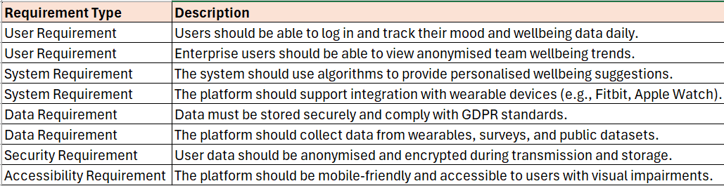
Figure 2: Functional and Non-Functional Requirements for the WellMind Platform

System Flowchart

The diagram below (figure 3) illustrates the core data flow of the WellMind platform, showing how user and organisational interactions result in wellbeing analytics and suggestions.

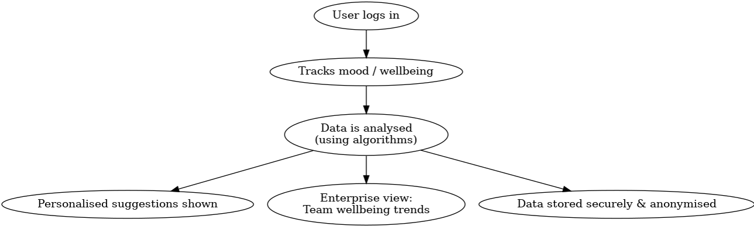
Figure 3: System Flowchart Showing Data Journey Within the WellMind Platform

Task 2

Enterprise Pathway

PEST & SWOT analysis for a Tech Start-Up (WellMind)
PEST Analysis
The following PEST analysis explores the external factors that may impact WellMind, a mental health analytics start-up leveraging wearable and community-based data insights.
- Political: UK Government support for mental health initiatives and digital health funding post-COVID-19 creates a positive regulatory climate [5]. Data protection laws such as the UK GDPR impose strict requirements for consent, security, and anonymisation.
- Economic: The cost-of-living crisis and rising workplace stress contribute to increased demand for affordable, preventive mental health solutions [6]. However, limited budgets in the NHS and small organisations may hinder adoption.
- Social: Mental health awareness is growing, especially among Gen Z and Millennials. Users now expect holistic wellbeing tools with strong ethical values and privacy assurances [7].
- Technological: Advancements in wearable technology, AI, and cloud computing allow for predictive analytics, real-time monitoring, and personalised support. Integration with Apple Health, Garmin, and Fitbit opens strong technical opportunities [8].
Legal and ethical considerations: WellMind must ensure compliance with data protection laws (UK GDPR) and medical ethics standards. Handling sensitive health data raises ethical concerns around user consent, data bias, and digital exclusion. Transparency and user control must be prioritised to maintain trust [9].
SWOT Analysis
This SWOT analysis identifies internal strengths and weaknesses alongside external opportunities and threats for WellMind as it enters the mental health tech space.
Strengths
- Innovative use of wearables & machine learning for wellbeing prediction.
- Addresses both individual and enterprise clients.
- Ethical-first approach with strong anonymisation.
Weaknesses
- Requires technical expertise and initial funding.
- Trust issues around data privacy may delay user adoption.
- Competing with established apps like headspace and Calm.
Opportunities
- Partner with universities, NHS trusts, and employers.
- Tap into growing B2B (business to business) mental wellbeing market.
- Potential for NHS pilot schemes and digital grants.

Threats
- Regulatory changes could increase compliance costs.
- Ethical scrutiny if AI systems show bias or fake alerts.
- Fast-changing tech market may outpace small start-ups

The analysis suggests that WellMind is well-positioned to succeed in a climate of growing mental health awareness and technological opportunity. However, legal and ethical frameworks must be built into the core design, particularly around consent, data minimisation, and algorithmic fairness. Strategic partnerships and transparent practices will be key to mitigating risks and scaling responsibly.

Start-Up Concept for WellMind

Start-Up Name and Logo
The proposed name of the tech start-up is WellMind, a fusion of wellbeing and mindfulness, reflecting the platform’s goal of supporting emotional health through smart data insights.

The logo for WellMind features a minimalist brain icon with a heart shown on one side with sparks coming off of one side to represent the tech element along with soft pastel colour palette to evoke calm, trust, and clarity. The design aims to blend tech innovation with warmth, reflecting the human-centred mission of the brand (please see appendix).

Business Type (Legal Classification)

WellMind will be registered as a Private Limited Company (Ltd) under UK law. This structure is ideal for tech start-ups as it limits personal liability for founders, enables investment opportunities, and provides legitimacy when partnering with enterprise clients or healthcare bodies [10]. As the platform may handle sensitive health-related data, a Ltd company also allows WellMind to register with the Information Commissioner’s Office (ICO) and meet Data Controller obligations under the UK GDPR framework.

Business Strategy

WellMind will follow a phased business strategy focused on lean development, ethical innovation, and scalable growth:
Minimum Viable Product (MVP) Launch: A basic but functional version of WellMind will be developed using open-source tools and wearable integrations (e.g. Fitbit API). This will focus on individual wellbeing tracking and personalised feedback.
Pilot Testing & Feedback Loops: Early pilots with university students and SMEs (subject matter experts) will provide real-world data, inform feature development and ensure UX is inclusive and effective.
B2B Expansion (Enterprise Dashboards): Once validated, WellMind will expand into the B2B space by offering team wellbeing dashboards to HR departments and local authorities. These will be anonymised and GDPR-compliant.
Geo-Insights & Predictive Features: Advanced features such as mental health heatmaps, AI-driven nudges, and burnout prediction algorithms will be developed, alongside enhanced privacy controls.
Marketing & Brand Building: Through partnerships with wellbeing influencers, TikTok creators, and mental health charities, WellMind will grow its audience and build community trust.

Funding Initiatives

To bring WellMind to life, several funding pathways will be explored:

Innovation Grants: Apply for government-backed funds such as Innovate UK’s Smart Grants [11].

Angel Investors (wealthy individuals who invest their own money into early-stage businesses) & Seed Funding (the very first round of formal funding a startup gets): Pitch to Health tech investors and early-stage VCs who specialise in digital wellbeing, mental health, or AI.

University Enterprise Support: As a student-led concept, WellMind could be supported through Swansea University’s enterprise programme or similar local innovation hubs.

Crowdfunding Campaigns: A platform like CrowdCube or Kickstarter could be used to attract mental health advocates and raise awareness alongside funds.

Freemium Model for Early Revenue: Offer a free version of the app with paid upgrades for additional insights or premium support, helping build trust while generating income [12].

Task 3

Project Reflection

Undertaking the WellMind project has provided me with a valuable opportunity to grow both academically and professionally. Through the research and design process, I have developed a stronger understanding of mixed-methods research, data analysis, and the ethical frameworks that underpin digital innovation in mental health. Going forward, I intend to use this opportunity to enhance my skills in data analytics, particularly in working with real-world datasets and visualising insights in ways that are accessible and actionable for non-technical stakeholders. I also aim to deepen my knowledge of UX design and user-centred development, as I believe empathy and accessibility must be at the heart of digital health platforms.
This project has encouraged me to develop my project management capabilities too, using tools such as Gantt charts and requirement specifications has given me insight into how structured planning and agile iteration can support successful innovation. I’ve gained experience in stakeholder mapping, user feedback analysis, and platform ideation, which are highly transferable skills for tech innovation and start-up environments.
From a societal perspective, I believe WellMind has the potential to create significant positive impact. Mental health challenges such as anxiety, burnout, and emotional fatigue are on the rise globally. Digital platforms that provide proactive, data-driven insights can help people manage their wellbeing before problems escalate. This preventative approach not only improves personal health outcomes but also reduces strain on healthcare systems and employers. By focusing on both individual users and enterprise clients, WellMind creates value on multiple levels, supporting emotional resilience in students, professionals, and communities alike. Looking to the future, the scalability of the project on a global scale aligns with the United Nations Sustainable Development Goal 3: “Good Health and Well-being” [13], even though achieving this impact is a long-term ambition for a start-up at its early stages.
However, I recognise there are several challenges and risks that must be addressed. One of the biggest risks is data privacy. Collecting sensitive wellbeing data requires strict compliance with data protection regulations such as the UK GDPR. I will mitigate this by ensuring the platform only uses anonymised and aggregated data wherever possible, and by integrating user consent protocols at every stage. Another challenge is ensuring that the predictive algorithms do not reinforce bias or deliver inaccurate suggestions. To reduce this risk, I would work with diverse datasets and mental health professionals to validate outputs before wider deployment. There is also the potential challenge of user trust, if the platform does not feel safe, empathetic, and non-judgmental, adoption rates will be low. To counter this, co-design with target users is essential, alongside transparency in how insights are generated.
Reflective practice, such as using Gibbs’ Reflective Cycle [2], has been instrumental in helping me evaluate my own learning and growth throughout this project. It has allowed me to think critically about how I make decisions, how I respond to uncertainty, and how I balance technical ambition with human-centred design. I also see the importance of intrapreneurship, using innovative thinking within larger systems, and believe that projects like WellMind could be adapted for NHS innovation programmes or public health campaigns.

Conclusion

In conclusion, the WellMind project has given me a powerful platform to grow my digital, analytical,
and ethical competencies. It has encouraged me to think more deeply about how innovation can create social good while also challenging me to consider the practicalities of turning an idea into a real-world product. I feel more confident in my ability to manage digital projects, collaborate with stakeholders, and think like a changemaker.

I intend to take these skills forward into the next phase of my studies and future career, continuing to pursue projects that combine data, empathy, and impact.

References

[1] M. N. Saunders, P. Lewis, and A. Thornhill, “Research Methods for Business Students,” ResearchGate, Mar. 2023. https://www.researchgate.net/publication/240218229_Research_Methods_for_Business_Students accessed on 03/08/2025
[2] “Social Research Methods,” Google Books, 2016. https://books.google.co.uk/books?hl=en&lr=&id=N2zQCgAAQBAJ&oi=fnd&pg=PP1&dq=A.+Bryman (accessed Aug. 03, 2025).

[3] O. Castiblanco and D. Vizcaino, “Tittle book: An introduction to qualitative research. Author: Uwe Flick,” Góndola, enseñanza y aprendizaje de las ciencias, vol. 15, no. 1, pp. 171–175, Dec. 2019, doi: https://doi.org/10.14483/23464712.15330. Accessed on 03/08/2025

[4] B. D. Mittelstadt and L. Floridi, “The Ethics of Big Data: Current and Foreseeable Issues in Biomedical Contexts,” Science and Engineering Ethics, vol. 22, no. 2, pp. 303–341, May 2015, doi: https://doi.org/10.1007/s11948-015-9652-2. Accessed on 03/08/2025

[5] GOV.UK, “Mental Health and Wellbeing plan: Discussion Paper,” GOV.UK, 2023. https://www.gov.uk/government/calls-for-evidence/mental-health-and-wellbeing-plan-discussion-paper-and-call-for-evidence/mental-health-and-wellbeing-plan-discussion-paper Accessed on 03/08/2025

[6] Deloitte, “Mental health and employers - the case for investment | Deloitte UK,” www.deloitte.com, 2022. https://www.deloitte.com/uk/en/services/consulting/analysis/mental-health-and-employers-the-case-for-investment.html Accessed on 03/08/2025

[7] Mental Health Foundation, “Stigma and Discrimination,” www.mentalhealth.org.uk, 2021. https://www.mentalhealth.org.uk/explore-mental-health/a-z-topics/stigma-and-discrimination Accessed on 03/08/2025

[8] NHS, “NHS England» Medical devices and digital tools,” www.england.nhs.uk, May 25, 2023. https://www.england.nhs.uk/long-read/medical-devices-and-digital-tools/ Accessed on 03/08/2025

[9] UK Government, “UK General Data Protection Regulation,” legislation.gov.uk, 2018. https://www.legislation.gov.uk/eur/2016/679/contents Accessed on 03/08/2025

[10] GOV.UK, “Set up a Business,” GOV.UK, 2023. https://www.gov.uk/set-up-business accessed on 03/08/2025

[11] UK Research and Innovation, “Home - UK Research and Innovation,” Ukri.org, 2018. https://www.ukri.org/ accessed on 03/08/2025

[12] “East Midlands Digital Health Accelerator.” Accessed: Aug. 03, 2025. [Online]. Available: https://healthinnovation-em.org.uk/images/EMDHA%2024%20Website%20FAQs.pdf accessed on 03/08/2025

[13] United Nations, “Goal 3: Ensure healthy lives and promote well-being for all at all ages,” United Nations, 2025. https://sdgs.un.org/goals/goal3 Accessed on 03/08/2025

[14] G. Gibbs, “Learning by doing, a guide to teaching and learning methods,” Oxford Brookes University, 1988. Accessed on 03/08/2025

Appendix

WellMind Feasibility Survey

Below is a link to the survey online:

https://forms.office.com/Pages/ResponsePage.aspx?id=-REPTm4EBUWcuNshUjEeIXhU1s49B_tBgGrirQ8tRHVUNzZLUkRLT0VaUUJGMTFLWTIwMzcwMDVHMy4u

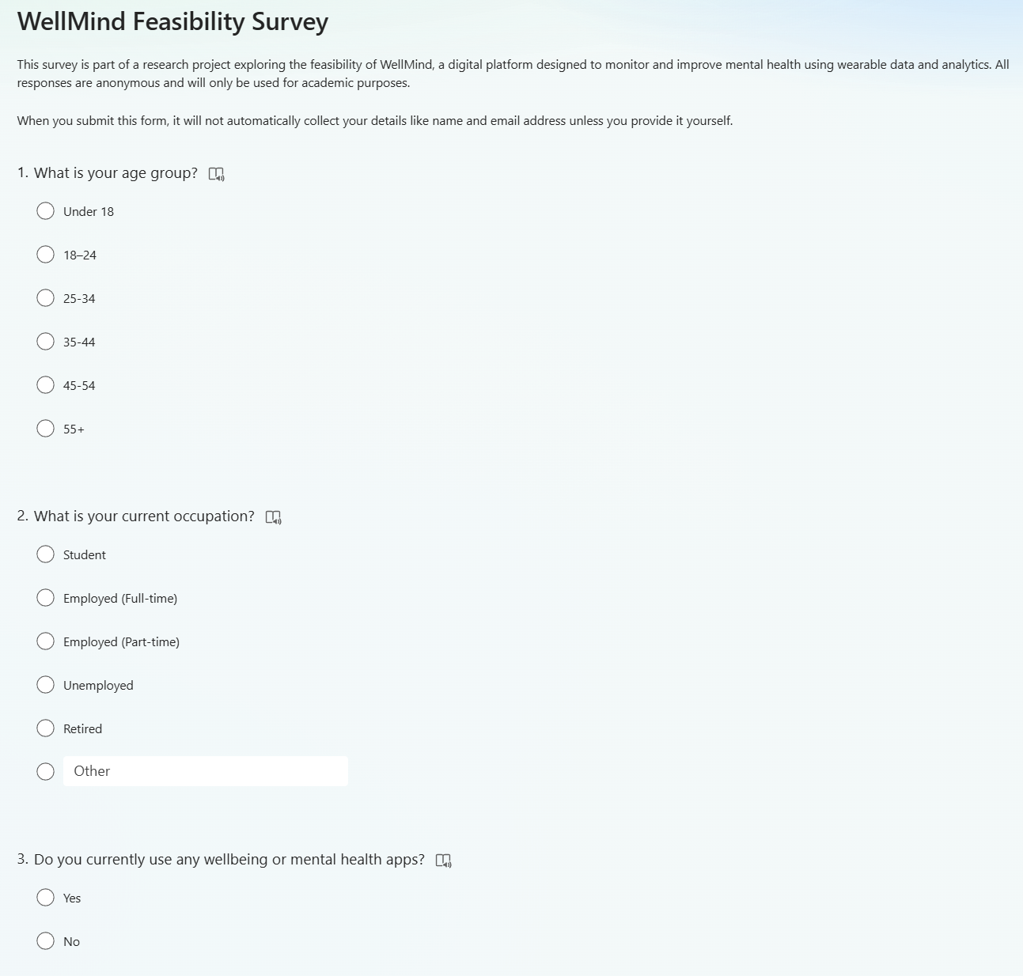

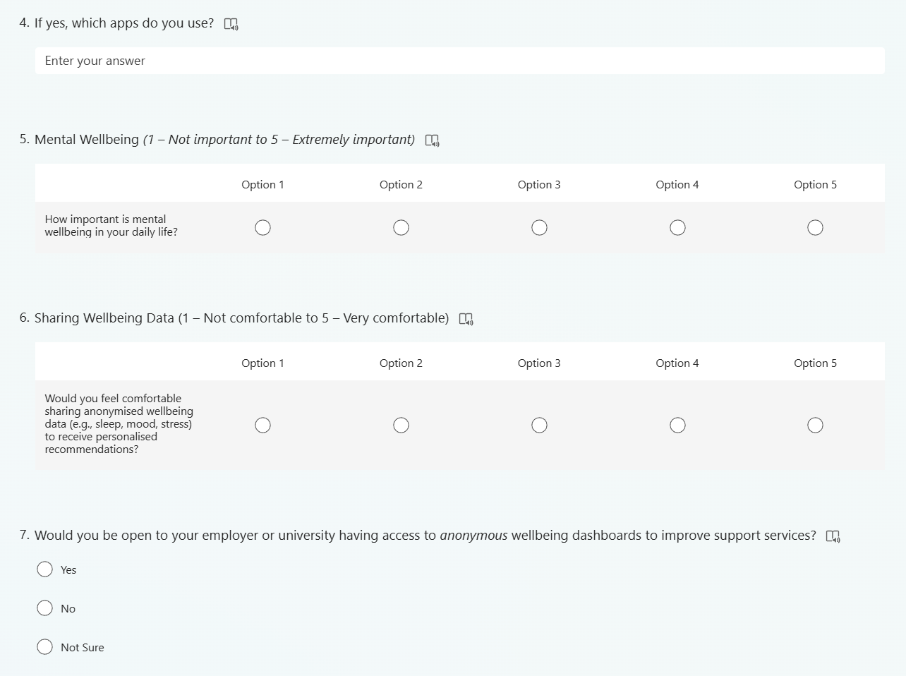

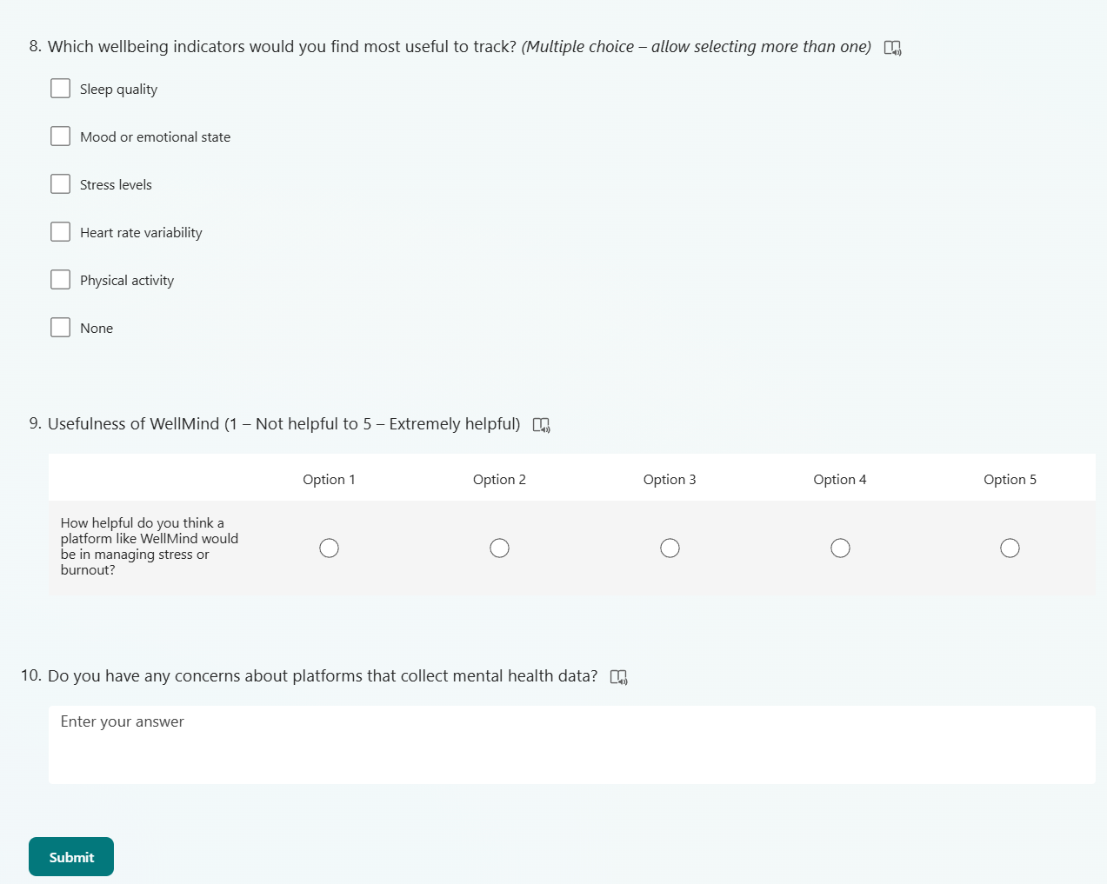

WellMind Feasibility Survey - Response overview

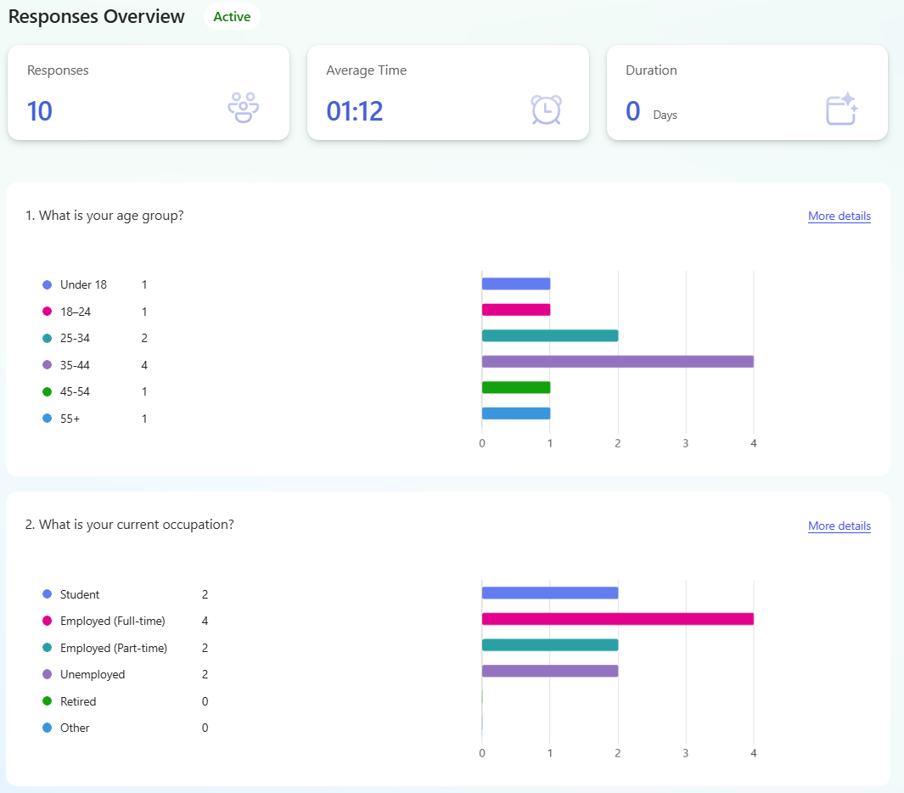
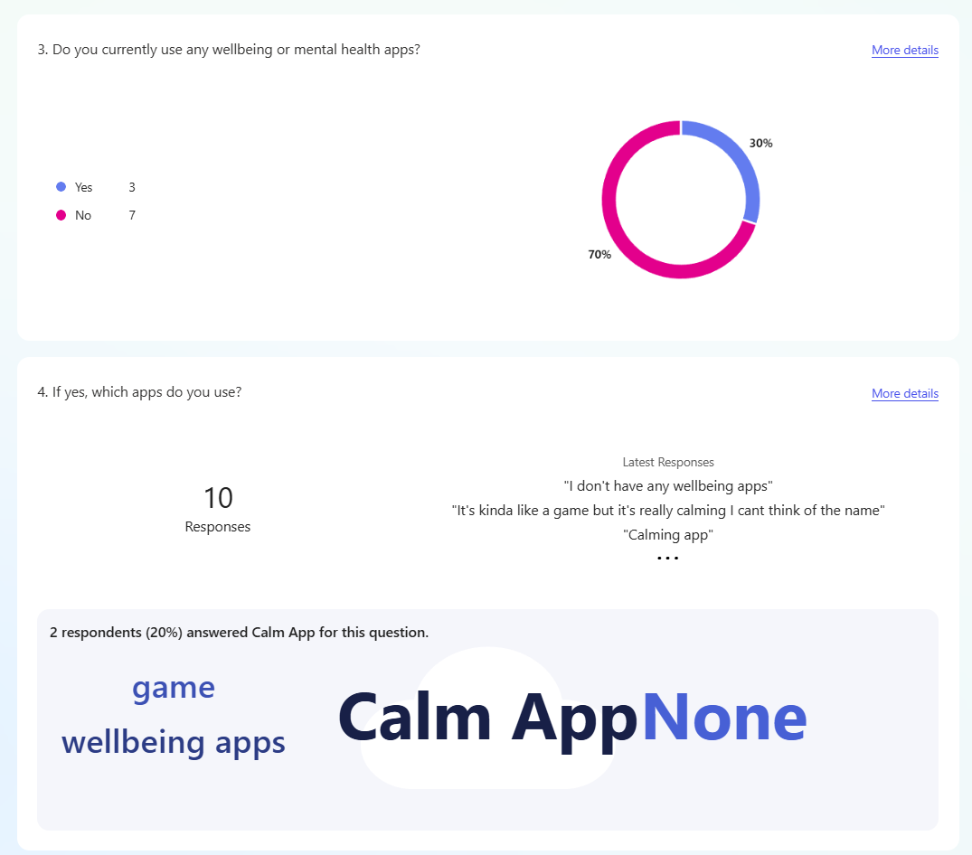

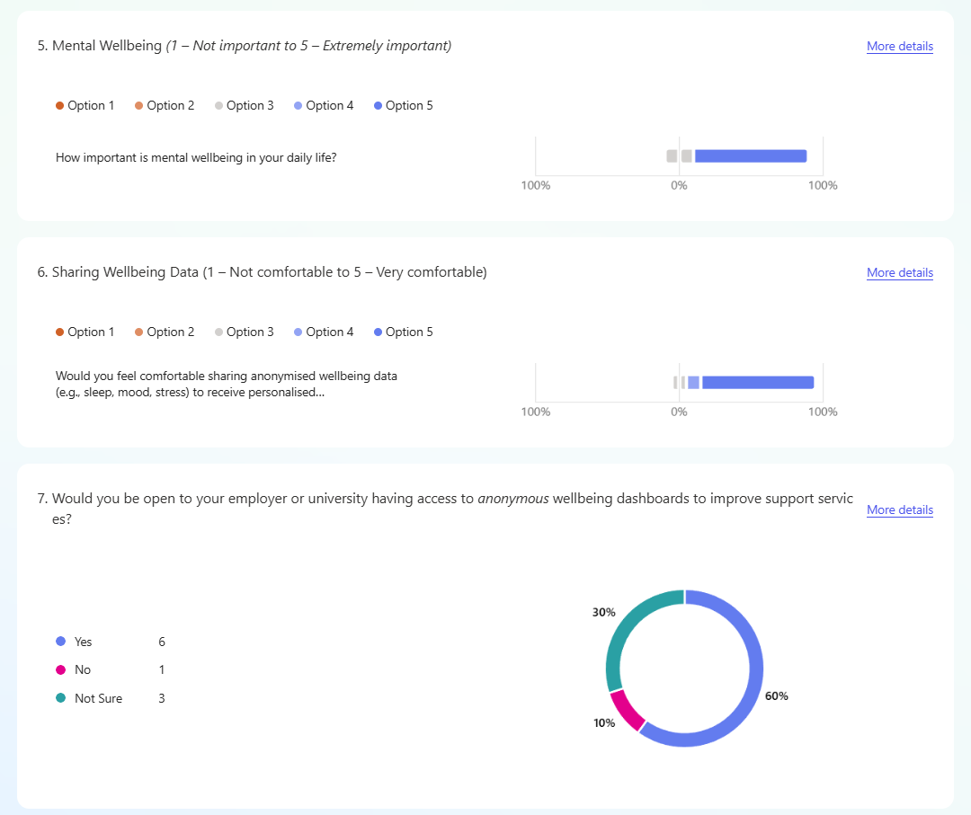

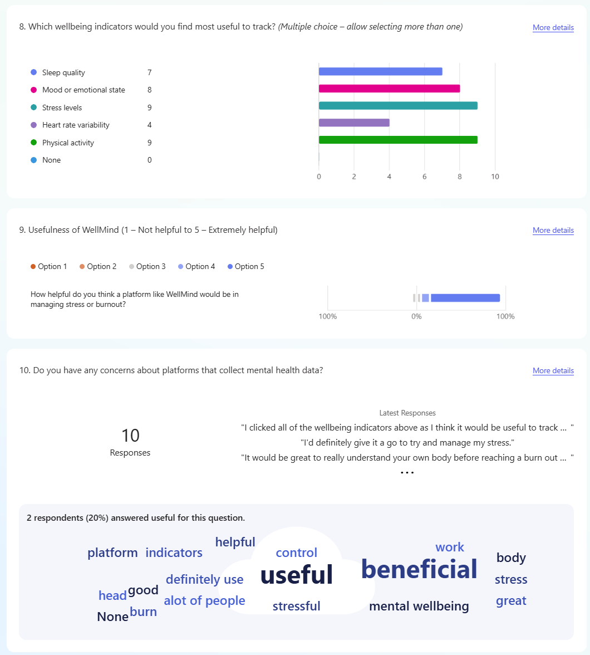

Interview Questions for Semi-Structured Interviews

- From your perspective, how has the demand for mental health support tools changed in recent years?

- How comfortable do you think users are with sharing their mental wellbeing data through digital platforms?

- What are your key concerns regarding data privacy in platforms that track mental health using wearables or app inputs?

- In your experience, what makes a wellbeing platform trustworthy to end users or clients?

- How useful would you find anonymised wellbeing dashboards to inform decisions or interventions in your organisation?

- What challenges do you foresee in adopting a data-driven tool like WellMind in a workplace, council, or healthcare setting?

- Do you believe predictive analytics can be reliable for identifying early signs of burnout, anxiety, or emotional fatigue? Why or why not?

- What features or functionalities would you expect in a mental health analytics platform aimed at enterprise use?

- Are there any specific data types (e.g. heart rate, sleep, mood logs) you consider most important or relevant for mental health tracking?

- Would you consider partnering with or supporting a platform like WellMind in a professional context? What would make that decision easier for you?

WellMind Logo



