Topic: The impact of Virtual Learning Environment (VLE; as an example Moodle of our university) on the learning experience of the students at UWTSD London campus.
Name: Razvan-Ion Mucenic
Student id: 2120426
Module code: BMSW4003
Module: Digital Skills and Research Method

Table of Contents
Introduction 3
Aim of This Research: 3
Research Objectives: 3
Literature Review 3
Research Methodology 5
Data, Primary and secondary data 6
Data collection process 6
Population, Sample and Sample size 6
Ethics in the data collection 6
Findings, analysis and discussion 7
Primary data analysis 7
Secondary data analysis 7
Summary of the findings 8
Conclusion and Recommendation 9
Reference 10
Appendices 12
Appendix 1 (Class activity 1-Questionnaire) 12
Appendix 2 (Class activity 2-Excel Result table) 13

Introduction
The purpose of the report is to discuss the services Virtual Learning Environment provides briefly. To find out the positive and negative impact of Virtual Learning environments on the educational institutions of the UK and the ways to improve the services of Virtual Learning environments.
OVERVIEW OF VIRTUAL LEARNING ENVIRONMENT:
A virtual learning environment is a space designed to teach and learn. It provides a space for teaching and learning as well as to be together with students, teachers, and learners to feel at ease.
This concept was introduced first in early 1953 with televised classes, and by 2010, this became popular in all educational institutions through e-learning.
The students and teachers are using this technology to communicate with each other (Govindarajan and Srivastava, 2020). It is important to have knowledge of this topic and research the topic.

Aim of This Research:
- To find out the positive and negative impact created on the virtual learning environment of the educational institutions of the UK.
- To discuss the relevant ways to make an upgrade in the quality of the virtual learning environment.
- To gather valuable knowledge about the virtual learning environment.

Research Objectives:
- Conducting research in both primary and secondary ways to collect qualitative and quantitative data.
- Make an analysis of the outcomes of the research.

Literature Review
VIRTUAL LEARNING ENVIRONMENT:
The services teachers and students can get from the virtual learning environment are an environment for learning to the students, allowing the students with restrictions and special needs to take the offer of the courses, providing the students with the access of various courses geographically. Not only that the students can enjoy their notes at their own speed, and the students can enjoy the process of enrolling many students in the learning environment (Tan, Chan and Mohd Said, 2021).
Building Relationships and Community
The virtual learning environment provides the student to make relationships with the other students in the learning environment to do projects together.
Saving Cost
The system is provided in such a way that it saves travel costs for the students and helps to reduce the carbon footprint.
Improve Accessibility
With the virtual learning environment, any student can get access to learning with the help of an internet connection, and the student can enjoy access to their courses anytime.
Increased Inclusivity
The shy students get the benefit of getting access to any online courses through the virtual learning environment. As a result, the students do not have to feel pressured or anxious (Kurbakova, Volkova and Kurbakov, 2020).
Time Management
One thing the student can miss out on is that there are no scheduled timings of the class, and a student without discipline can not learn the courses properly. As a result, the student can miss homework, tasks, and many other things.
Connection of Classrooms through Online Learning:
Some students can not imagine the picture of learning through the professors on the phone online as one student faces many problems such as concentrating, proper understanding, focusing, learning, etc from online classes (Gourlay, 2021). The technologies that are needed for a virtual learning environment are audio-video technology with quality, quality recordings to record the videos and sessions, a platform for communication, a reliable laptop/ computer, survey platforms, etc. The virtual learning environment platform made terrible changes in the educational sector, but there are a few risks that wrap up with the technology that is being used for the virtual learning environment (Rivas et al., 2021).
Violations
Some unauthorised party gains access to the information used in the e-learning platform.
Denial of the Services:
One unauthorised party disrupted the traffic to prevent legitimate access in the time of payment transactions of the users in the e-learning platform.
Wrong Users:
The legitimate users exploit the privileges of the users in the e-learning platform.
Repudiation:
Such unauthorised persons deny participation in any kind of transactions of important documents.
Analysis of Traffic:
The unauthorised party abuses the communication channel through the leakage of any kind of information. There is some legislation that is attached to the technologies used for e-learning to be aware of the official procedures that exist for creating a curriculum, to follow all the current curriculum approval and standards, and to make a consideration about how the courses for education need development for the students.
With the virtual learning platforms, there will be a reduction in the rate of constraints geographically, the young students also will be able to access the learning through the technology, and create a chance for the teachers and professors to differentiate from the institutions providing support and material to the students (Williams, 2022).

Research Methodology
This "Research Methodology" concept centres on adaptability in the research setting in terms of how data is coordinated, processed and laid out. In a presentation or study, the significance of research techniques cannot be stressed. A research plan outlines the necessary procedures for moving on with the study and instructs researchers on how to carry them out. In addition, the study highlights the relevance of the most likely approaches to determining the present task at hand (Mohajan, 2018). Although quantitative methods are used, this study primarily serves a descriptive and qualitative purpose. The all-inclusive approach does this by integrating primary and secondary quantitative data. Without using a wide variety of techniques and tools, qualitative research would not have yielded the same results. The goal of qualitative research is to learn about people's and communities' perspectives on a social or human issue. The research entails four stages: question and technique development; data collection in the participant's environment; inductive analysis of the data, moving from specific to general topics; and final interpretation of the results.

Data, Primary and secondary data
This research's methodology will be evaluated using the positivist research philosophy. To further influence the outcome of this research, the deductive technique will be used to make sense of the given facts, diagrams, and information. A questionnaire schedule consisting of interview questions will be regarded as a key data collection method. In addition, a variety of scholarly works, academic journals, and news stories on the issue have been considered for secondary data collecting.

Data collection process
A student survey was designed to elicit information regarding students' experiences with virtual learning environments (VLEs), opinions on incorporating ICT into the classroom, and knowledge of various technological resources. The chosen group of 25 students' opinions were gathered using an online survey administered by office.com. Students were given five questions to complete in this online survey. Time limitations were the only reason why paper surveys were not converted to online versions. It took respondents an average of ten minutes to complete the questionnaires, all of which consisted of multiple-choice questions.

Population, Sample and Sample size
The representative group for this study consisted of twenty-five students attending classes at the London location of the University of Wales Trinity Saint David. To guarantee that the findings are objective, diversified, reflective, and representative of the whole student body, each participant for the survey was chosen using a random sample method. This was done so that the data could be presented in an accurate manner.

Ethics in the data collection
According to Kara (2018), research that does not take enough measures to safeguard its data and keep its secrecy to a suitable level is unsatisfactory. Those in the classroom are freely offering their insights for the greater good of education and the system as a whole. It was of the highest significance that the participants' privacy and well-being be protected. To protect the students' anonymity, their replies were stored in a password-protected area of Moodle.

Findings, analysis and discussion

Primary data analysis
The first question concerned the learner's previous experience with the online learning platform moodle. It has been observed that all pupils are conversant with moodle for obvious reasons. After receiving instructions from the university, pupils are ready to use moodle in their studies. A large majority of respondents (80%) agree that they feel comfortable using moodle, as seen by the diagram.
All of the respondents were positive in their assessment of moodle's usefulness in their own personal situations. That's why they want to use it often. It helps them out academically by giving them simple directions on how to complete tasks or how to effectively cover challenging topics. With the platform's resources, students may learn on their own time. Students may go through the material at their own speed.
Most of the class gave imprecise answers to the third question. As a result, the responses gathered were inadequate. The vast majority of students who were polled said they only use moodle, although many others declined to answer. A small percentage of respondents admitted to using supplementary learning sites for supplementary resources.
Almost all of the students felt that moodle was beneficial to their development. That's why they're so invested in staying with Moodle for the long haul. They see Moot as similar to a study buddy and are optimistic that it may assist them further their education and careers. However, some students have trouble using moodle because they lack access to high-speed internet or modern technological gear. So, it's time for the government to step in.
Nearly all of the students who have responded thus far agree that they would suggest Moodle to their peers. However, some students have complained that the Moodle system is too complicated, and they would rather see new users try out alternative platforms first.
Sixty per cent of students think that moodle is improving the online learning space. More support is required to help students succeed in an online classroom. However, even in this mode, there are restrictions on how long kids may spend in the library before it locks them out. However, the convenience and openness of online education remove these limitations.

Secondary data analysis
In the UK, where a state of emergency was declared in the middle of March and where all remaining teaching and learning for the 2019-2020 school year was subsequently mandated by state and university academic authorities, the COVID-19 epidemic had a significant impact on higher education around the world (KOURAK and KADI, 2021). Because of this, institutions have included tools for their continued development with accessible online learning resources. Because of the constraints imposed by the coronavirus, it seems that the complete adoption of the online mode in methodological adaptation has been mandated, and its inclusion hastened as a test of organisational agility and promoted a process of transformative learning. It is because of these modifications that the educational model is now more solid (Salim and Şahan, 2021).
There are substantial challenges for higher education in adapting teaching methods to new requirements. Clearly, technological aids to teaching and learning are crucial in higher education in light of the significance of acquiring skills and capabilities appropriate for the 21st century. Educators at the university level are increasingly incorporating hybrid learning methods into the classroom to aid students in making the most of their time spent in both online and face-to-face settings (UWTSD, 2016). Professionals in higher education have a responsibility to keep up with the ever-evolving state of scientific and pedagogical actualisation by maintaining, improving, and updating their own digital competence (Mayor et al., 2018).
Several authors have suggested that the failure of online learning to revolutionise the educational system is due to the superficial and fundamentally instrumental integration of the online mode in the teaching and learning processes. Institutions need to emphasise the lack of formation lamented by teachers from a range of educational levels in order to adapt to the technological shift in education, which in turn leads to strategies for making effective use of online learning from the very beginning of formation and persistently throughout professional development (Larsen and Hole, 2020).

Summary of the findings
Multiple studies have shown that students have a positive view of VLEs (virtual learning environments). This is because students have a positive attitude about VLEs as learning tools that promote activity, motivation, and interaction, and because instructors are able to accommodate students' unique learning styles in these settings (Daniela, 2020).
Limits are highlighted by the research, which highlights the insufficient technological knowledge, traditional education, and financial investment needed to implement these technologies. The following examples illustrate these restraints: There is a paradigm change associated with the implementation of digital transformation in higher education because of the interconnected nature of the environment that makes digital learning possible. Technological and cultural shifts toward digitalization have prompted this change, which calls for a more exclusive focus on the development of students and their learning experiences (James, Strevens SFHEA and Field, 2020). These movements were sparked by the need to adapt to the changes in lifestyle that new technology imposed on society.

Conclusion and Recommendation
Those students who first saw Internet use and its accompanying resources as useless, overwhelming, and unhelpful probably formed a much smaller proportion after getting some practice with VLEs. This was particularly true of the Internet's use as a research and education resource. These learners appreciate the usefulness of a virtual learning environment and have faith in the effectiveness of the technology used to implement it. The great majority of today's students would much rather utilise a digital or online resource than a paper textbook.
Any problems that occur from students' use of different internet platforms must be dealt with by the institution. In addition to the difficulty some students may have gaining access to a reliable internet connection, others may lack the technical expertise necessary to make the most of the many online resources available to them. The school is responsible for providing these people with high-quality technological gadgets and upgraded internet service. The university may tailor its education to each student's needs by offering them specialised learning programmes. Students will learn how to study well and make use of a variety of technology tools thanks to these programmes.
Students who are considered digital natives typically have a difficult time using the technology that is utilised in the classroom while being proficient with the devices and programmes they use most often for communication and leisure. On the other hand, today's students think that classroom technology should be more heavily used by educators.

Reference
Daniela, L. ed., 2020. Pedagogies of Digital Learning in Higher Education. Routledge.
Gourlay, L., 2021. There is no'virtual learning': The materiality of digital education. Journal of New Approaches in Educational Research, 10(1), pp.57-66.
Govindarajan, V. and Srivastava, A., 2020. What the shift to virtual learning could mean for the future of higher ed. Harvard Business Review, 31(1), pp.3-8.
James, C.G., Strevens SFHEA, C. and Field, R., 2020. Law Teachers Speak Out: What do Law Schools Need to Change. Wellbeing in a Changing World: The Impact of Technology and Innovation on the Legal Profession, Intersentia (2020), ANU College of Law Research Paper, (20.26).
Kara, H., 2018. Research ethics in the real world (pp. 109-120). Bristol: Policy Press.
KOURAK, M.E.A. and KADI, A., 2021. ntegrating Flipped learning pedagogy at Algerian Higher education during COVID-19 Students’ perceptions and Teachers’ attitudes (Doctoral dissertation, Université Ibn Khaldoun-Tiaret-).
Kurbakova, S., Volkova, Z. and Kurbakov, A., 2020, July. Virtual learning and educational environment: New opportunities and challenges under the COVID-19 pandemic. In 2020 The 4th International Conference on Education and Multimedia Technology (pp. 167-171).
Larsen, A.K. and Hole, G.O., 2020. 15 years experiences from digital teaching and learning within international social work online courses: Competences achieved and challenges solved. In Pedagogies of Digital Learning in Higher Education (pp. 198-214). Routledge.
Mayor, P., Heinonen, V., Teneva, I., Hämäläinen, M. and Kostia, S., 2018, June. Teaching and Learning Leadership Skills Online: Experiences of Developing Leadership Skills in a Blended Learning Educational Leadership Programme. In EdMedia+ Innovate Learning (pp. 1903-1908). Association for the Advancement of Computing in Education (AACE).
Mohajan, H.K., 2018. Qualitative research methodology in social sciences and related subjects. Journal of Economic Development, Environment and People, 7(1), pp.23-48.
Rivas, A., Gonzalez-Briones, A., Hernandez, G., Prieto, J. and Chamoso, P., 2021. Artificial neural network analysis of the academic performance of students in virtual learning environments. Neurocomputing, 423, pp.713-720.
Salim, R.A.Z.I. and Şahan, Ö., 2021. Emergency Online Language Education and Academic Integrity. The Literacy Trek, 7(1), pp.1-4.
Tan, K.H., Chan, P.P. and Mohd Said, N.E., 2021. Higher education students’ online instruction perceptions: A quality virtual learning environment. Sustainability, 13(19), p.10840.
UWTSD, 2016, “Engaging professional learners using the Virtual Learning Environment (VLE): a case study from social care”, Available at https://repository.uwtsd.ac.uk/id/eprint/1309/1/Davies-and-Harris[2016_article].pdf [Accessed on 20th August 2022]
Williams, R., 2022. An Academic Review of Virtual Learning Environments. ICRRD Quality Index Research Journal, 3(2), pp.143-145.

Appendices

Appendix 1 (Class activity 1-Questionnaire)

1. Are you familiar with moodle?
A) Yes
B) No
C) Maybe

2. Do you regularly use moodle?
A) Yes
B) No
C) Maybe

3. Do you use some more platforms other than moodle?
A) Yes
B) No
C) Maybe

4. Moodle has benefitted you to get better in your academic career.
A) Strongly Agree
B) Agree
C) Neutral
D) Disagree
E) Strongly Disagree

5. Would you like to recommend the platform to new web users?
A) Yes
B) No
C) Maybe

6. Moodle is helping institutions to progress in Virtual Learning Environment.
A) Strongly Agree
B) Agree
C) Neutral
D) Disagree
E) Strongly Disagree

Appendix 2 (Class activity 2-Excel Result table)
1.

Options | Percentage | Received response | Total number of respondents
YES | 80.00% | 20 | 25
NO | 12.00% | 3 | 25
MAYBE | 8.00% | 2 | 25

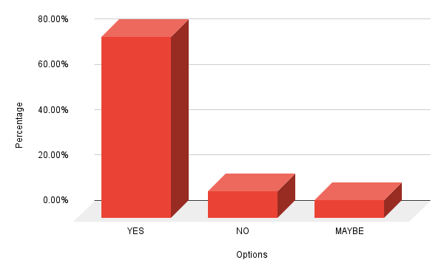
2.

Options | Percentage | Received response | Total number of respondents
YES | 88.00% | 22 | 25
NO | 12.00% | 3 | 25
MAYBE | 0.00% | 0 | 25

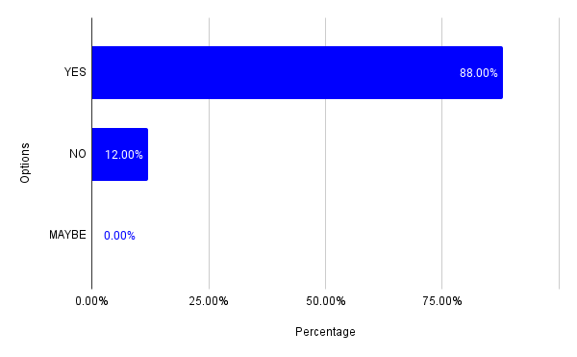

3.

Options | Percentage | Received response | Total number of respondents
YES | 20.00% | 5 | 25
NO | 76.00% | 19 | 25
MAYBE | 4.00% | 1 | 25
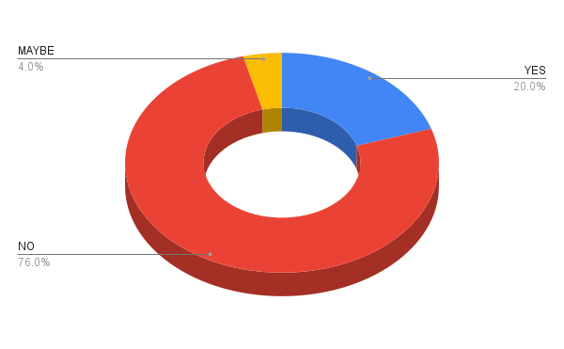

4.

Options | Percentage | Received response | Total number of respondents
Strongly Agree | 20.00% | 5 | 25
Agree | 40.00% | 10 | 25
Neutral | 12.00% | 3 | 25
Disagree | 8.00% | 2 | 25
Strongly Disagree | 0.00% | 0 | 25

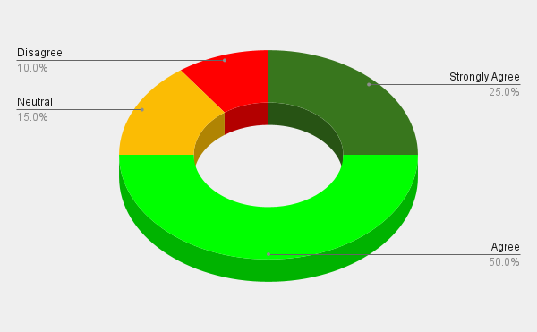
5.

Options | Percentage | Received response | Total number of respondents
YES | 88.00% | 22 | 25
NO | 4.00% | 1 | 25
MAYBE | 8.00% | 2 | 25

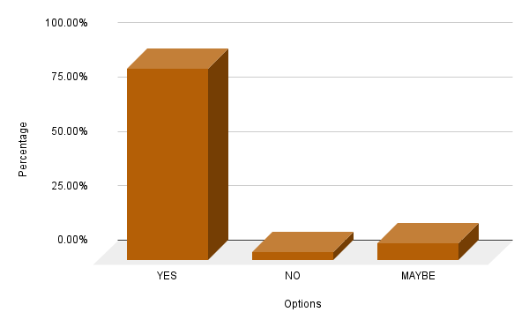
6.

Options | Percentage | Received response | Total number of respondents
Strongly Agree | 60.00% | 15 | 25
Agree | 20.00% | 5 | 25
Neutral | 12.00% | 3 | 25
Disagree | 8.00% | 2 | 25
Strongly Disagree | 0.00% | 0 | 25



