MSc Public Health and Social Care in Practice
LCHS7009 Population Health and Digital Health Promotion

Component 1


BLOG 1: Managing Diabetes in the Digital Age: A Critical Look at the MySugr App

Public Health Problem: Diabetes Burden
D
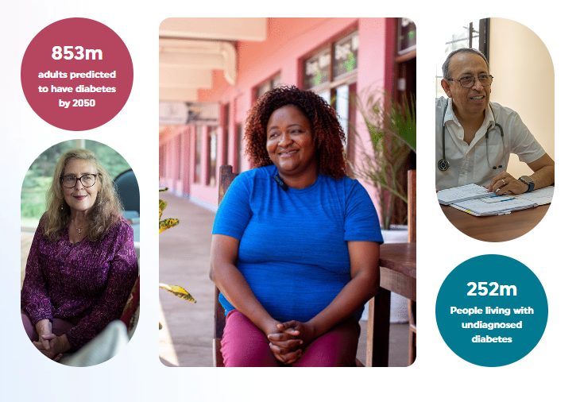
iabetes is considered one of the fastest-growing public health challenges in the present times. According to IDF (2025), around 589 million adults were living with diabetes in 2024. By 2050, the International Diabetes Federation predicts that 1 in 8 adults, approximately 853 million, will be living with diabetes, an increase of 46% (IDF, 2025). It is essential to note that over 90% of people with diabetes are known to have type 2 diabetes. It is mainly driven by socio-economic, demographic, environmental, and genetic factors (IDF, 2025). Diabetes can cause blindness, kidney failure, heart attacks, stroke and lower limb amputation (WHO, 2025).

Digital Technology Overview
mySugr was founded in 2012 and is known for being a digital health company, aiming to simplify life with diabetes. The brand assists in monitoring and managing one’s diabetes with relevant information that is stored on a smartphone alongside ready-to-use features, which ease the complexity of their daily diabetes routine (mySugr, 2025a). The app’s core features include logging, connecting one’s devices and services, mySugr bolus calculator, precise statistics, estimated HbA1c, food logging and easy-to-share reports, all of which are aimed to transform tedious tracking into a habit (mySugr 2025a).

Evidence of Its Effectiveness in Health Promotion
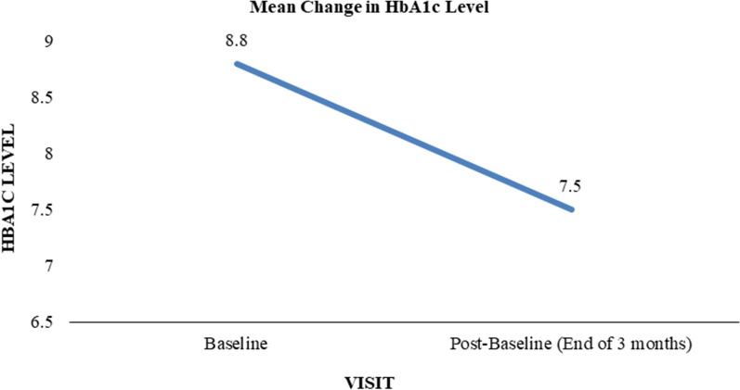
A study by Mohan et al. (2025) indicates the effectiveness of mySugr when used consistently. People with diabetes were able to significantly lower the mean HbA1c from 8.8% to 7.5% using the mySugr app in conjunction with the Accu-Chek. On the other hand, Singh et al. (2025), also concluded that mySugr is an engaging diabetes app and it has the possibility to assist users in improving glycaemic levels over 12 weeks.
Effectiveness of mySugr
(Source: Mohan et al., 2025)

Critical Discussion of Impact

Advantages
mySugr is known for being able to boost overall self-efficacy. Its app provides real-time visual feedback on the method in which food, activity, along with insulin affect glucose levels. This results in assisting users to make informed decisions. The interface of the app is also intuitive alongside enjoyable for users, which is quite a rarity in medical apps. On the other hand, hardware integration also helps in reducing overall friction. The base version of the app is available, which helps in lowering financial barriers (mySugr 2025b).

Limitations
However, due to manual carbohydrate entry alongside insulin, the overall process remains time-consuming. Although the food database is vast, it is limited to Western-centric along with struggles with diverse dish cultures, which are common in other regions. Another significant barrier is digital inequality, as access to smartphones and the internet is not available in many places globally, along with excluding elderly users (Purple Griffon, 2024). Lastly, due to it being a digital brand, there are various concerns regarding data privacy (Mohan et al. 2025).

Addressing Identified Shortfalls
Such gaps are possible to be addressed through various methods. The brand could implement AI-powered photo-based food recognition, along with partnering with other brands for providing low-cost or offline-capable devices. It could focus on expanding to diverse cultural dishes in its food library, along with implementing strict data policies with full transparency reports.

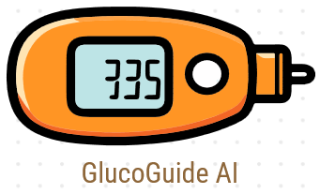
BLOG 2: Beyond Tracking: Designing GlucoGuide AI to Transform Diabetes Self-Management

Introducing GlucoGuide AI
G
lucoGuide AI is a proposed next-generation intelligent self-management platform. The platform will include a feature that will automatically recognise food using camera-based AI. It will also have predictive glucose modelling, which will combine the personal historical data, continuous glucose trends, and activity from wearables of the user. The platform will include culturally tailored meal suggestions along with offline support for users with low connectivity.

Application in Health Promotion
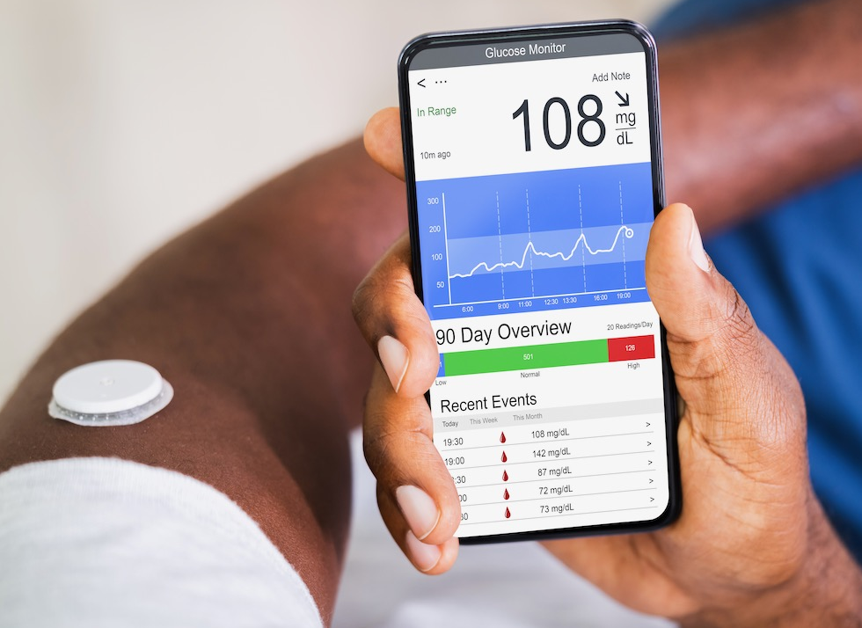
GlucoGuide AI will be able to remove one major barrier in mobile health applications, which is manual entry (Feldacker et al., 2024). This will help the platform to increase overall sustained adherence. It will also be supporting health education by providing various personalised insights. For example, it will provide users with messages, including their glucose level spike rates after eating a particular food, along with providing suggestions. This will help in building a legitimate understanding compared to only tracking. On the other hand, by providing culturally relevant suggestions, it will be possible to make sustainable dietary change feel achievable.

Expected Impact: Critical Discussion

Advantages
The proposed platform will be helping in reducing the overall burden of manual data entry. It will also be providing users with hyper-personalised feedback, which will help in controlling and lowering HbA1c effectively. The platform will also be provided with diverse food libraries, which will align with the diverse cultural dishes around the world. It will also be promoting and improving long-term self-management habits.

Risks
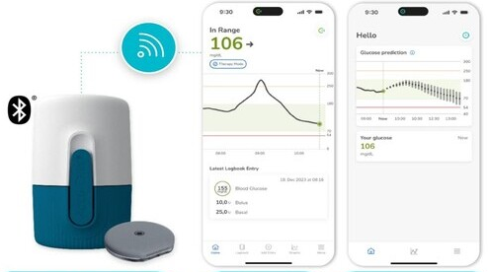
One major risk is related with AI implementation, which is possible imprecision (Caballar, 2025). The food-recognition AI could be misidentifying various dishes that are mixed or home-cooked, which will be a major issue regarding various underrepresented cuisines. There are also risks of algorithmic bias in the prediction models, particularly against minority groups. Due to it analysing images, there could also be various privacy risks (Yadav et al., 2023). Lastly, over-reliance, along with automation, could result in eroding the carb-counting skills of the user.

Addressing the Shortfalls
It will be possible to implement transparent and ethically audited algorithms, which will help in reducing overall data privacy issues (Marshall, 2025). By focusing on training the datasets, such as the diverse diet dataset, it will be possible to avoid algorithmic bias in prediction models. Users could be provided with mandatory in-app education modules, which could help improve manual estimation skills. Additionally, implementing end-to-end encrypted image processing will help in avoiding feature leakage (Lu, Feng and Li, 2022).

References
Caballar, R., (2025). 10 AI dangers and risks and how to manage them | IBM [online]. IBM. [Viewed 18 November 2025]. Available from: https://www.ibm.com/think/insights/10-ai-dangers-and-risks-and-how-to-manage-them
Cantrell, A., Booth, A. and Chambers, D., (2024). Signposting services for people with health and care needs: a rapid realist review. Health and Social Care Delivery Research, 12(26), pp.1-86.
Feldacker, C., Usiri, J., Kiruthu-Kamamia, C., Waehrer, G., Weldemariam, H., Huwa, J., Hau, J., Thawani, A., Chapanda, M. and Tweya, H., (2024). Crossing the digital divide: the workload of manual data entry and integration between mobile health applications and eHealth infrastructure. Oxford Open Digital Health, 2(Supplement_2), pp.ii9-ii17.
IDF (2025). Diabetes Facts & Figures. [online] International Diabetes Federation. Available at: https://idf.org/about-diabetes/diabetes-facts-figures/ [Accessed 18 Nov. 2025].
Lu, Z., Feng, Q. and Li, P., (2022), December. A privacy-preserving and end-to-end-based encrypted image retrieval scheme. In 2022 IEEE International Conference on Visual Communications and Image Processing (VCIP) (pp. 1-5). IEEE.
Marshall, C. (2025). What is AI transparency? A comprehensive guide [online]. Zendesk. [Viewed 18 November 2025]. Available from: https://www.zendesk.com/in/blog/ai-transparency/
Mohan, V., Kalra, S., Augustine, A. and Kober, J., (2025). Evaluating the Impact of mySugr® Mobile Health Application on Glycemic Control in People with Diabetes Mellitus in India: A Real-World Data Analysis. Diabetes Therapy [online]. [Viewed 18 November 2025]. Available from: doi: 10.1007/s13300-025-01768-x
mySugr, (2025a). Who we are - the story of mySugr [online]. Welcome to mySugr - simplifying life with diabetes | mySugr. [Viewed 18 November 2025]. Available from: https://www.mysugr.com/en/about-us
mySugr, (2025b). Welcome to mySugr - simplifying life with diabetes [online]. Welcome to mySugr - simplifying life with diabetes | mySugr. [Viewed 18 November 2025]. Available from: https://www.mysugr.com/en
Purple Griffon, (2024). What Is Digital Poverty And Exclusion? [online]. Purple Griffon. [Viewed 18 November 2025]. Available from: https://purplegriffon.com/blog/digital-poverty-exclusion
Singh, A. A., Babbott, K. M., Young, S., Wu, Z. and Serlachius, A., (2025). Evaluating the mySugr diabetes app: A randomised controlled trial exploring changes in HbA1c and psychological outcomes in adults with type 1 diabetes. Primary Care Diabetes [online]. [Viewed 18 November 2025]. Available from: doi: 10.1016/j.pcd.2025.07.002
WHO, (2025). Diabetes [online]. World Health Organization (WHO). [Viewed 18 November 2025]. Available from: https://www.who.int/news-room/fact-sheets/detail/diabetes
Yadav, N., Pandey, S., Gupta, A., Dudani, P., Gupta, S. and Rangarajan, K., (2023). Data Privacy in Healthcare: In the Era of Artificial Intelligence. Indian Dermatology Online Journal [online]. 14(6), 788–792. [Viewed 18 November 2025]. Available from: doi: 10.4103/idoj.idoj_543_23

