Childminding - Employee’s Handbook- Children’s Learning and Development during Transitions.

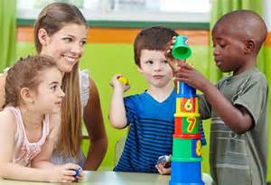

(Google images, no date)

What is meant by transition?
Aline-Wendy and Fabian (2007: p.7) suggest that transition is a change from what you are familiar with. This could be leaving their ‘comfort zone’ (2007) meaning their parents, friends, familiar spaces such as their homes and going into a new environment which they are not familiar with and that makes them feel uncomfortable.

Introduction.
This handbook is to help practitioners understand how to help children, parents/ guardians and practitioners through the process of transition. In this childminding setting we take care of children aged between 6 months and 4 years of age. Therefor we have children who are new to the setting and children that are preparing to transition into a primary school setting.
This handbook will give you the information needed to help all parties in the process of transitioning into a new, unfamiliar setting, and to help the parties that are moving on to a new setting such as primary school.

Contents page:
What is meant by transition?........................ 1
Introduction……………………………………1
How to support transition………………… 3-4
Working in partnership……………………… 4
Importance of play during transition……. 5-6
How does our setting cater for all children?.................................................. 6-7
Our setting- different rooms………………… 7
Outcomes for the child……………………… 8
Reference list………………………………… 9

How to support the transitions.
Tassoni et al (1999) maintain that to support all parties during the time of transitioning we need to make sure we develop a relationship with the child and the parent/ guardian that is entering our setting, plan a settling in period with the parent/ guardian and to exchange as much information as possible about their child/ children that are beginning in our childcare setting.
In order to create a welcoming environment for the parent and child we will need to organise a time and day that will suit the parent to come in to the setting and have an informal conversation where the parent can enjoy a session of play to settle their child into the setting and once the child has become familiar with their surroundings we can then have an informal conversation with mum to discuss the child/ children in order for us as practitioners to fully understand the child’s needs and wants. We can then plan activities around the child’s interests and hobbies for the child to enjoy and settle into the childminding setting, the practitioners will do these activities with the child for them to create a relationship with the child so that the child will have a set worker in the setting that they feel comfortable with.

We can also ask the parent/ guardian about the child’s abilities and if they have any care needs, this could be that the child cannot use the bathroom yet and will need to have regular nappy changes, we also need to find out if the child has any allergies for us as a setting to be able to care for that child appropriately.

If we have a child joining our setting we need to find out if that child has any specific needs or any disabilities for the setting to be able to adapt to suit that child, this may mean that practitioners may need to have extra training or speak to a health professional on how we can best care and help the child to develop.

We also need to consider the child’s environment outside of the setting, whether they live in a big house with a large garden where they have plenty of room to run around, or if the child/ children live in a small flat that has no garden for them to play, these children might settle into the setting more comfortably if they have the chance to run around freely and interact with other children outside, children’s home environment can affect the way that child acts when they enter a new, unfamiliar area therefore it is important for the practitioners to understand what the child wants in order for the practitioner to create activities that the children will enjoy.

It is important that we know all about children’s backgrounds and the families they come from, for example:
- Their culture
- Their beliefs and religion
- Their languages, for example do they speak a different language to the children in the setting and how are we going to adapt to ensure that child has equal opportunities and is included with the other children.
- Do they live in an advantaged or disadvantaged area?

All the above can impact on how a child settles into a new setting and for practitioners to be able to support the child/ parent/ carer we will need to know about the child’s life beyond the setting.

Working in partnership.
When working in partnership with parents and families it is important that practitioners remember to respect the families’ traditions, beliefs and that we as practitioners ‘comply with parents wishes for their children’ (Tassoni, P. et al. 2002). We must give regular feedback to the parent/ carer on their child’s development and if we have any concerns we need to be working with the parents/ carer to overcome the problem we are facing.
In some circumstances we as practitioners may need to work with other agencies such as health professionals, this may be the case if we have a child entering the setting that has a disability, we as practitioners need to be in contact with the health professionals so that we know how to take care of the child properly and that we understand the child’s specific needs.
Some children may need help with a hoist therefore the setting will need training and help off the health professionals to be able to equip to that child’s needs and give them the opportunities that every other child may have.
Working in partnership with parents McMillan (1860-1931) believed that settings were merely an extension of home (Tassoni et al. 2002: p. 368).

Importance of play during transition.
Tassoni et al. believe that play is an important part of a child’s life and is an essential part of the early years curriculum (Tassoni et al. 2002: p. 366-367).
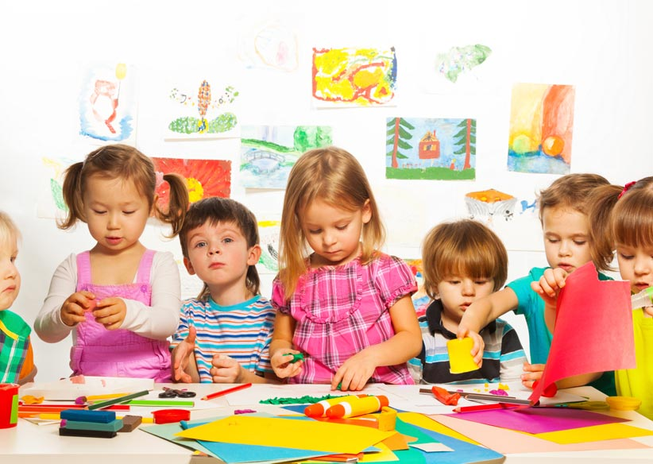
For us as practitioners to understand children and what they enjoy, we need to first assess the child. If we see that the child likes to certain developmental areas such as; creativity, mathematics, imaginary, free play we can then use one of the theorists below to help construct an activity that the child will enjoy, this will help the child to feel safe and
comfortable in our setting.
(Google images, no date)
Froebel (1782-1852) suggested that children learn at their best when using imaginary play, for example: a child could be playing with a strainer on their head pretending to be an astronaut, Froebel valued symbolic behaviour. Froebel also stimulated the development of mathematical skills by using block play, he managed to make children understand relationship concepts through play. (Tassoni et al 2002: p. 367).
In our setting there are resources in place for children to use their imaginations, we have a dress up area with all different outfits where children can use their imagination and become a certain character, also we could give them a certain craft activity however we will not be using a structured approach where we give them the exact colours, paints, glue, glitters we give them the freedom of choice to be able to choose for themselves and use their own imaginations on what they would like to create.

McMillan (1860-1931) believed that children developed into the holistic individual through active- learning and first-hand experiences. She also encouraged early years training and had confidence in imagination and inventiveness.
In our setting we promote this by being very hands for example: Instead of explaining to a child how builders build a tower, we encourage the child to be hands on and built a tower of their own out of different materials to encourage their imagination and inventiveness.
When a new child enters our setting, this is what we like the children to see that we as a setting are not structured where we sit at our desks to learn but that we let them learn through play and using their own imaginations.
Isaacs (1885-1948) also discouraged desk- based learning and encouraged the hands-on approach to learning this was thought to help children explore their feelings.

In our setting we try to promote all the above as we believe that children benefit from spontaneous play and can settle into the environment a lot better when they are aloud to make their own decisions and be independent with their learning. We do not believe that children who come into the setting will be comfortable being told by a person they do not know how they should be learning, what they should be learning and that they must learn in a certain way. If they are left to be independent and have staff who will encourage their spontaneous play we hope that they child will become more confident with the staff and in the setting therefore will settle into the setting nicely.

How does our setting cater for all children?

Children with additional needs and abilities:

In our setting we cater to every child as it is important for us to remember every child is and individual and should be given equal opportunities.
We have in place picture and word signs to help children understand the different areas in our setting such as the reading corner, fancy dress area or the outdoor area, this is in place to help children who may have difficulty with languages, they could use the pictures to understand clearly and to help children who may have a learning delay.
We provide a quiet area in our setting where children who have difficulty socialising with others can go and play and be on their own for a while if they are finding socializing difficult, this corner is also helpful for children who may have challenging behaviour and want/ need a few minutes to gather themselves.
We also make sure all play resources are on low shelving so that children with physical difficulties or children who cannot communicate to tell the staff what they want to play with can go and get their choice of toys independently and make their own decisions on what they would like to play with. (Owens, 2007).

Different Cultures, Religions and Beliefs:
In our setting we realise that coming from different culture, religion or belief can be difficult therefore we have in place in our setting a variety of different toys that are played with around the world in different countries we make sure all our dolls are respectful in race and we teach and celebrate many of the worlds celebrations in our setting, we celebrate the Chinese new year and celebrate the festival, St Patricks Day, Yi Peng Lantern Festival- Thailand and many more, this enables us to teach the children about all different cultures, religions and beliefs and allow them to have fun and understand the differences between people. Our setting believes encouraging children to celebrate these events will allow children to have equal opportunities, enjoy learning and celebrating and ensures that all children feel included in our setting. (Lindon, J. 2017).

Disabilities:
We as a setting do everything we can to make sure that we cater for any child that enters our setting, with children with disabilities we take care and ensure that we have trained staff to help the children with their daily care duties. We ensure that all access ways are ramped for a child that may be in a wheelchair can gain access to all areas and ensure that they are able to move around feely, in doing this we make sure that there is enough room between equipment such as table and chairs for the child to be able to manoeuvre around easily. We also ensure that all resources are on low shelving for children to be able to choose their own toys independently.
We make sure we have members off staff that have had training in sign language and that we have staff on hand to help children who have eyesight difficulties, we also have braille on our books and walls for children who have eyesight difficulty to be able to know where they are in the setting by what is scripted on the wall. (Fuandai, C, M., 2010).

When working in a childcare setting this quotation given by Arthur, L (1993) is something all practitioners should remember:

“Changing attitudes and beliefs takes time. Remember that each individual need…to change at their own pace…The overall message is one of valuing everyone for the skills and background they have. This includes their family background, race, beliefs, language and so on. Each individual sees the world through their own perspectives and with assistance through the perspectives of others.” Arthur, L (1993).
(No Author, December 2006)

Our setting.
In this setting we believe that it is essential to have rooms for different ages, therefor we have a 6- 18 months room and a room for toddlers up to 4 years of age. We believe this is important as younger children need a quieter area to be able to rest when needed and toddlers to four-year olds may need a busier area where they can be active and explore.

Baby Room- The room for the younger children provides an area where they can relax and feel calm, this is accomplished by having a neutral colour in the room. We also have softer resources in this room and a sensory area for the younger children. Sensory is important for children to develop their sensory skills such as, taste, touch, smell, hearing and sight (Morin, A. 2017). We also have a carpet in this room for the younger children who are crawling around to feel comfortable and have a sleeping area where they can have a sleep when needed. All these aspects will make the children feel comfortable when entering the setting as they will not be entering a noisy room where it may be very busy and other children running around the younger children making them feel nervous.

Toddler to 4-year-old room-
This area of the setting is a lot more bright and colourful, the children will enjoy coming into a setting that looks like fun and will feel more comfortable to be able to go and play if the area looks inviting and they can see all the resources as they walk in through the room, this room has toys that are more suited to the older children, harder, smaller toys that they are likely to find more appealing than the soft younger children toys. This room also provides a quieter corner for children that prefer a small place to sit whilst they investigate the area before they feel confident enough to go and play. We also have patio doors in this area so that children can go in and out as they please. We believe that this area is a stimulating area that has all the resources needed to help children develop and feel safe and secure in our setting.

Outdoor Area-
We also have separated the outdoor areas as the older children are aloud trikes and the younger children have foam mats on the floor where they are able to crawl along the floor, they have again softer outdoor toys such as soft play balls, tubes and foam blocks to play with. The older children are aloud the bigger footballs and have concrete and grass to play on.

Outcome for the children.
Our setting believes in learning through play and believe that children who enter our setting will become independent individuals that will be able to make their own decisions and choose their own resources, we maintain that the children become more confident when able to independently think for themselves. I hope this handbook has been of help to any practitioners who needed any help through the process of transitioning and helping children transition, if there is anything further you would like information on please ask your manager in the setting.

Reference List
Aline-Wendy, D. and Hilary, F. (2007) Informing transitions in the early years. London: McGraw-Hill. (Accessed 26/11/17)

Fuandai, C, M. (2010) CATERING FOR CHILDREN WITH SPECIAL NEEDS IN THE REGULAR CLASSROOM: CHALLENGES AND THE WAY FORWARD. https://www.ajol.info/index.php/ejc/article/viewFile/52693/41297 (Accessed 28/11/17)

Image 1: Google Images (No Date) (Accessed 25/11/17) https://www.bing.com/images/search?view=detailV2&ccid=sOk0wdUk&id=A17007B2635078FE4E6FF9295B1853C4ED21D8C1&thid=OIP.sOk0wdUkkIKn_s3QiB5iFwEsDN&q=transition+in+children+&simid=608029098798024707&selectedIndex=61&ajaxhist=0

Image 2: Google image (No date) (Accessed 28/11/17) https://www.google.co.uk/search?q=a+childs+need+to+play+diploma+childcare+and+education&dcr=0&source=lnms&tbm=isch&sa=X&ved=0ahUKEwjW9KOOqtjXAhXnLMAKHcGUAkIQ_AUICygC&biw=1366&bih=652#imgrc=_s44frQVN4NEJM

Lindon, J. (2017) Cultural diversity in the early years. https://www.communityplaythings.co.uk/learning-library/articles/cultural-diversity-in-the-early-years# (Accessed 28/11/17)

Morin, A. (2017) Why Sensory Play is Important- How Sensory Play Helps Your Child Learn. https://www.thespruce.com/why-sensory-play-is-important-2086510 (Accessed 28/11/17)

No Author. (December 2006) Diversity and equality guidelines for childcare providers. https://www.dcya.gov.ie/documents/childcare/diversity_and_equality.pdf (Accessed 28/11/17)

Owens, A. (2007) Supporting children with additional needs. http://ncac.acecqa.gov.au/educator-resources/pcf-articles/Supporting_Children_with_Additional_Needs_Sept07.pdf (Accessed 28/11/16)

Tassoni, P., Beith, K., Eldridge, H. and Gough, A. (2002) Diploma Child Care and Education. Oxford: Heinemann (Accessed 26/11/17)

Tassoni, P., Bulman, K., Beith, K., Burnham, L. and Eldridge, H. (1999) Early Years Care and Education. Level 3. Bath: Bath Press. (Accessed 26/11/17)

Tassoni, P., Horne, S., Smith, M., Boak, A., Butcher, J., Eldridge, H. and Runciman, C. (2002) BTEC NATIONAL Early Years. Great Britain: Scotprint, East Lothian. (Accessed 26/11/17)

