Name: Shaymaa Al Abbasi
Student ID Number: 1817837
Module code: BMSW4005
Title: Professional and Career Development
Name of lecturer: Daminabo Pokubo
Task title: Reflective Portfolio

March 27th,2020

reflevtive protifolio
Contents
Introduction 2
Self-awareness 3
Ways to improv self-awareness 3
Johari window 4
Mock interview reflection 7
The advantages of the interview: 7
STAR method 8
Career development plan 9
Career planning progress 9
Benefits of the career development plan 10
Conclusion 11
References 12
Appendences 14

Introduction
This report will be examining the most common methods of the career development plan and its process. Also, the paper will be dissecting in depth the stages of the career development plan and how could it help to build up and enhance our opportunities to find the dream employment position and develop our professional career. In addition, the report will be covering and addressing the following tactics in order to make a demanded potential employee:
- Self-awareness method to be used in relevance to future employment.
- Mock interview reflection.
- Career development plan with SMART objectives, strategies, and detailed actions
The following section will be identifying the self-awareness and its types as well as ways to improve it.

Self-awareness
Self-awareness is also translated as a self-consciousness and it is when individuals are transparent with themselves and aware of their weaknesses and strength, what they can/cannot do as well as like and dislike. It is very fundamental to be that aware and transparent in our day to day life in order to keep succeeding whether on the practical or personal private level (Goldsmith, 2015).
Self-awareness is categorised onto two types:
- Internal, this type shows how distinctly we tend to view our affections and ambitions are matching with our surroundings and response, such as beliefs, emotions, morals as well as courage and feebleness and effect on others (Alexander, 2018).
- External, this type shows our perception of how others would think of us in defining of the above listed elements (Alexander, 2018).

Ways to improv self-awareness
The following points are essential in order to improve our self-awareness in our personal and professional life:
- Heedfully allow your feelings.
Life cognize us to count on logical concept to create choices and to retain our feelings from imperious with the method. In fact, our emotions usually stick up for our ideas as closing them out will take us offshore. It is better to merge emotions with logical thinking when making very crucial decisions. Scout about your emotions and listen to your instinct, if they do not match and not making enough sense then do not give it a go (Mindworks Meditation, 2020).
- Make a note of your feelings.
Monitoring out feelings and thoughts is an efficient way to convey with our inner self and discover what we are looking for. To practice this point of recording our feelings and thoughts we can use our smart devices to help us to improve our self-awareness and to give us the chance to get to know our principles, beliefs, and goals. Also, when practising such an exercise frequently, you likely will begin to see directions and modality and you will start to recognise your expectation and fearfulness even without recording them (Mindworks Meditation, 2020).
- Develop your self-consciousness over your emotions.
The exercise of heedfulness surely provides the thoughts area to find itself: that's real consciousness. heedfulness thinking. Additionally, it indicates you that not every feeling or thought is well value reacting to. It helps you range and use your strength and time precisely and expeditiously (Mindworks Meditation, 2020).
By understanding the above details explanation of the self-awareness this has inspired my self-reflection on the following:
- Who am I as an individual in an upper management?
- Who am I as an employee?
- How good am I to utilise my intellect and abilities to my entire prospect?
- What my principles are?
- Which one is crucial to me?
- What my strengths are?
- What my weakness are?
- How other people would understand me? (Keyser, 2013).

Johari window
The Johari Window is a cognitive method to help to enhance the self-consciousness, it was discovered by Joseph Luft and Harry Ingham in 1955. It is a straightforward analysis shows emotions, opinions, practice, information, stance, proficiency, goals and stimulus. Also, it is a practical way for comprehending and guidance on both personal and professional life. In addition, it helps to develop communication skills and social interrelationship by seeking feedback and improve teamwork (Luft and Ingham,1961).
Basically, this Johari window is a great model for every individual to increase their understanding on others.
This window is divided into:
- The open area
This area is reflecting the knowledge regarding the individual’s position, manner, feelings, proficiency and opinions which are going to be well-known by the individual him/herself as well as by others (Saxena, 2015).
- The Blind self
This area is regarding the person him/herself which other understand within a cohort. However, they may be uninformed of it. Others could translate you otherwise than you would think (Nair and Naik, 2010).

- The hidden area
This area is regarding your very personal private life details which you don’t want to reveal it to anyone, such as emotions, private past, concerns etc. We should not reveal everything about our private life from others as it may be used against us and effect our practical life as well as professionalism (Newstrom and Rubenfeld, 1983).
- Unknown area
This is reflecting the Information which are unaware to yourselves as well as others. This includes the information, feelings, capabilities, talents etc. This can be due to traumatic past experiences or events which can be unknown for a lifetime. The person will be unaware till he discovers his hidden qualities and capabilities or through observation of others. Open communication is also an effective way to decrease the unknown area and thus to communicate effectively This area covers the abilities that you have but you still don’t know about yourself and so your surroundings don’t know about you (Shenton, 2007).

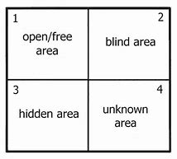
Figure 1 The Johari window model
Source: (Saxena, 2015).
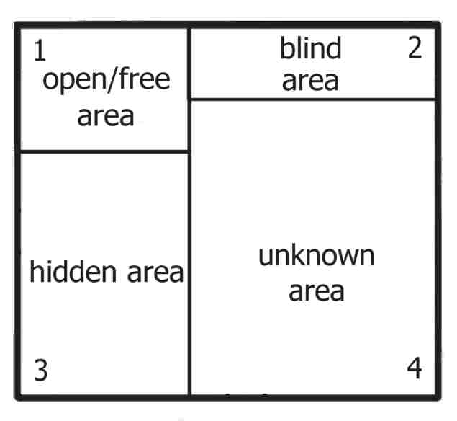
Figure 2
Source: (Saxena, 2015).

The above diagram of figure 2 is showing how the open area starts very small as when I first start a new job for example, others’ knowledge about me is limited and based on their first impression about me. Basically, in order to make the open area bigger I should be more communicative and boost my relationship with my colleagues and boss to get their feedback and understand it, see figure 3. On the other hand, the blind spot area being small too as when starting in a new place as it is shown in figure 2 as I might not notice certain attitudes or acts that others notice about me.
However, figure 3 is showing the blind spot can be increased dynamically for an effective communicating by considering feedback from other colleagues. Also, figure 2 is showing that the hidden area seems very big as my colleagues and boss still know nothing about my personal life such as, if I was married, how many children I have, how much financial commitment I have and so on so forth. The hidden area can be reduced by shifting the knowledge to the open area, see figure 3.

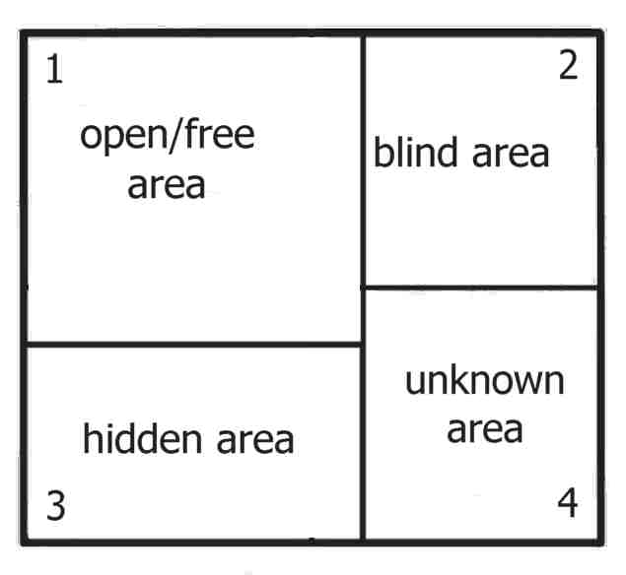
Figure 3
Source: (Saxena, 2015).

Mock interview reflection
What is an interview?
It is basically an official session among tow individuals where the manager questions the applicant to gain knowledge about a certain job position (National Careers Service, n.d.).

The advantages of the interview:

- It benefits to certify the data given by the interviewee and aid to achieve the validity of the given verities as well as knowledge about the applicant.
- Associates in founding the common link among the candidate and the organisation.
- It is beneficial for the applicants to get to understand their career, the kind of job they are applying for and type as well as to get to understand more about the organization.
- The interview is very important and advantageous for the assessor or the company and the candidate as either of them build up knowledge about each other whether ethically, executively or privately.
- It supports the applicants to examine their abilities and understand their weaknesses and how/where it requires transformation.
- The interview supports the establishments to enhance their achievements and reputation between those who are looking for a certain job (Reddy, 2016).

STAR method
STAR stands for Situation, Task, Action and Result. It’s a method which is utilised by companies to interview their candidates to analyse all the related knowledge around certain skills that the vacancy demand. The main point of this interview style is to get a high level of liability of the work production than a standard interview (University of Leeds Careers Centre, 2020).
From the abovementioned information I have gained a good knowledge of the interview and how it should be done properly as well as the suitable methods for it to make it successful. Also, what made it better for me is the mock interview that I had on week 7 with my lecturers. It seemed to me like practical career SWOT analyses to analyses my strengths, weaknesses, opportunities and threats as I was provided with a feedback sheet for my record.
For example, according to both of my interviewers that I was Excellent-Very Good on First Impression and Verbal Behaviour and ticked most of the boxes with this good grade such as professionally dressed, passionate about the job, good eye contact, clarity of highlighting relevant skills, good examples given to answer questions, good demonstration for teaching skills as well as suitability for the vacancy. This obviously has shown all my strengths. However, I had few weaknesses were mentioned by both interviewers which were under the grade of Average-Poor like displaying enthusiasm as I did not detail how enthusiastic I was towards the position and also did not verbally provide enough references on specific details on my CV such as mentioning the places I worked at and different situations I went through and how did I respond to them and solved them. In addition, another weakness according to one of the interviewers who marked me as Poor for it is that I did not ask appropriate question of the interviewer whereas the other interviewer marked me as Very good for it, so I still have to get myself more prepared for this verbal skill during the interview to avoid any possible mistakes.
Moreover, I realised during the mock interview that Johari Window method was already naturally practiced in place as while me and the interviewers were speaking about the details of the job I was interested in, I was increasing the window of the open area by providing more information about myself, my experience and knowledge regarding my current position, manner, feelings as well as proficiency and this automatically was decreasing the hidden area window which is my very personal private life details which I do not want to reveal it to anyone, such as emotions, private past, concerns etc. Also, the blind area started big as I did not know what to expect of their feedback and did not know how well or not did I do, but by getting provided the feedback sheet then the blind spot got decreased as I have a full knowledge of what they thought of me and how I can amend my mistakes. Additionally, I have the unknown area decreased to the minimum as I still do not know how good or not I would do and same applies on my employer about me.
Career development plan this method is to support peoples to evaluate their profession, assess their preparation and academical necessity and to improve other ambitions to strengthen and re-examine the current proficiency and management expertise within a workplace which estimates prompt variation and transformation. Also, the main principles of the career development are to get the co-ordinate amongst employee and job position. In addition, it could be explained as the developing technique of directing individual’s life, experience and job in general not just in a workplace to progress to get to the wanted future goals (Peterson and Sampson and Reardon, 1991).
Career planning progress: it is to recognise the suitable profession, session or a course to assist individuals to concentrate on what they ought to do in the time of starting new job and alter their profession or develop their present profession (Career planning process, 2020).
This progression maybe split into the following elements:
- Discover yourself by characterising your targets, such as asking yourself, what is my current occupation/profession? What skills do I have? Where do I see myself in the next five years of my career? Am I enjoying my current job/studying? what are my potential problems?
- Explore options by determine possible options by researching what is there demanding your talents and abilities, ensure that your strategies are achievable, always find out if there is any opportunity to get training and credentials you would require and look for a job advertisement.
- Make a choice by arranging on how you would accomplish your targets. May be increase knowledge on basic level or volunteer to work into any fields to expand your profession. Be reasonable on your expectancies.
- Take an action: increase profession background, build connection with others, make yourself familiar within the higher education degree work demand, explore vacant positions whether through the online or the normal media such as the ordinary newspaper (Career planning process, 2020).

The figure below displays my personal career development plan.

Discover yourself  - Student  - Transferable skills and willingness  - Graduated and in full time interpretation job  - I love the course I am studying  - Finding the right job that suits my circumstances | Explore options  - NHS and councils in needs of translators due the amount of immigration that we have in the UK  - My plan is to graduate this course to add it to my CV and to apply for a part time interpretation vacancy as well as seek training provided by the interpretation agencies  - Regularly check the demand for my talent and ability
Take an action  - Apply for interpretation position whether paid or voluntary  - Make connection with relevant networks on LinkedIn to increase the opportunity of getting a job as well as with interpretation companies | Make a choice  - Expand my knowledge on the profession of the interpretation field  - Consider to be a volunteer translator to enhance my knowledge in regards of this vacancy

Figure 1 My personal Career Development Plan

Benefits of the career development plan
The benefits of the career development plan from an employee perspective is very essential as it can:
- Provide a block or a boost to gain their rationales that can be every little thing from getting a pay rise and obtain extra commissions, to attaining work pliability and fulfilment.
- Progress common aims.
- Progress coordination to complete specific tasks/aims.
- Progress the plan implementation (Aggarwal, 2013).

From the above statement in regards of the career development progress I have understood that it is still all about self-awareness how this can help individuals to progress their career planning. This has enlightened me on how to develop my career development plan and put it in an action

Conclusion
The above report has shown the importance of the self-awareness and how beneficial it is in all our life aspects and the positive impact of it on individuals. Also, the report highlighted on the Johari Window and how dose work hand in hand with self-awareness in order to make the best of our efficiency in our current or future career. In addition, the study has detailed how essential the interview is in order to both employer and employee to exchange knowledge in regards of a career and how beneficial the mock interview was for me as an individual to identify my strengths and weaknesses. Moreover, the study has indicated the career development plan and career development progress as both are very important and play a vital role in evaluating, assessing as well as progressing whether in our current or futer career within a workplace.

References
Alexander, C. (2018). The 2 important types of self-awareness: Which one are you lacking?. [online] Aleteia — Catholic Spirituality, Lifestyle, World News, and Culture. Available at: https://aleteia.org/2018/08/03/the-2-important-types-of-self-awareness-which-one-are-you-lacking/ [Accessed 28 Jan 2020].
Aggarwal, N., 2013. A manuscript on career planning and development plan for the managers. Indian Journal of Health and Wellbeing, 4(3), pp. 664-668. [online] Available at: https://search-proquest-com.ezproxy.uwtsd.ac.uk/docview/1795522640?accountid=130472&rfr_id=info%3Axri%2Fsid%3Aprimo [ Accessed 5 Mar 2020].
Careerweb.leeds.ac.uk. 2020. STAR Method - University Of Leeds Careers Centre. [online] Available at: <http://careerweb.leeds.ac.uk/info/21/interviews/216/star_method> [Accessed 4 March 2020].
Goldsmith, B., 2015, May 07. Self-awareness leads to self-assuredness. The Spectator. ISSN 11899417. [Online] Available at: https://search-proquest-com.ezproxy.uwtsd.ac.uk/docview/1679018125?accountid=130472&rfr_id=info%3Axri%2Fsid%3Aprimo
Keyser, J. (2013). Self-Reflection for Self-Awareness. [online] Td.org. Available at: https://www.td.org/insights/self-reflection-for-self-awareness [Accessed 5 Feb. 2020].
Luft, J. and Ingham, H., 1961. The johari window. Human relations training news, 5(1), pp.6-7. [online] Available at: http://www.richerexperiences.com/wp-content/uploads/2014/02/Johari-Window.pdf [Accessed 1 Feb. 2020].
Mindworks Meditation. (2020). What Does Self Awareness Mean? How Do You Practice Self Awareness?. [online] Available at: https://mindworks.org/blog/what-does-self-awareness-mean/ [Accessed 31 Jan. 2020].
Nair, S. and Naik, N., 2010. The Johari Window Profile of Executives of a Public Sector Undertaking. Management and Labour Studies, [online] 35(2), pp.137-148. Available at: <https://journals.sagepub.com/doi/abs/10.1177/0258042x1003500201?casa_token=WihfMcLFfqwAAAAA:5EtgqAEGOO6AuxbmfCGVIjeQMxkFq3mARjlNGBGpICw4ydyxka2gJJ6a6FHO9FiATGz90_8R6VlG> [Accessed 11 March 2020].
Nationalcareers.service.gov.uk. n.d. Interview Advice | Get A Job | National Careers Service. [online] Available at: <https://nationalcareers.service.gov.uk/get-a-job/interview-advice> [Accessed 12 March 2020].

Newstrom, J.W. and Rubenfeld, S.A., 1983, March. The johari window: A reconceptualization. In Developments in Business Simulation and Experiential Learning: Proceedings of the Annual ABSEL conference (Vol. 10). [online] Available at: https://absel-ojs-ttu.tdl.org/absel/index.php/absel/article/view/2298 [Accessed 10 Fab 2020].
Peterson, G.W., Sampson Jr, J.P. and Reardon, R.C., 1991. Career development and services: A cognitive approach. Thomson Brooks/Cole Publishing Co
Reddy, K., 2016. What Is An Interview: Definition, Objectives, Types & Guidelines - Wisestep. [online] WiseStep. Available at: <https://content.wisestep.com/what-is-an-interview/> [Accessed 3 March 2020].
Saxena, P., 2015. Johari Window: An effective model for improving interpersonal communication and managerial effectiveness. SIT Journal of Management, 5(2), pp.134-146. [online] Available at: https://s3.amazonaws.com/academia.edu.documents/57905519/journal13.pdf?response-content-disposition=inline%3B%20filename%3DJOHARI_WINDOW_An_Effective_Model_for_Imp.pdf&X-Amz-Algorithm=AWS4-HMAC-SHA256&X-Amz-Credential=AKIAIWOWYYGZ2Y53UL3A%2F20200311%2Fus-east-1%2Fs3%2Faws4_request&X-Amz-Date=20200311T221123Z&X-Amz-Expires=3600&X-Amz-SignedHeaders=host&X-Amz-Signature=520e97ae801242ba90436253dbd7e2d4b67bdc2ffcd3815ce294c01c0eea6aae [Accessed 6 Fab 2020].
Shenton, A.K., 2007. Viewing information needs through a Johari Window. Reference Services Review. [online] Available at: https://www.emerald.com/insight/content/doi/10.1108/00907320710774337/full/html?casa_token=ZCya9xG6nAIAAAAA:MfsWBB5T__B9wuR7m84w0Ozcl9izV_j7n6vw4Dqyc1lgJYrTBIDMKAm2N4EkxVcPM_WlNapzW01dur_eqhbD2NJL_6Z2VEBA7rUTVcHoCHcZ_usWpWE [Accessed 13 Fab 2020].
The Open University.ac.uk. 2020. Career Planning Process. Help Centre. [online] Available at: <https://help.open.ac.uk/career-planning> [Accessed 12 March 2020].

Appendences

Appendix 1

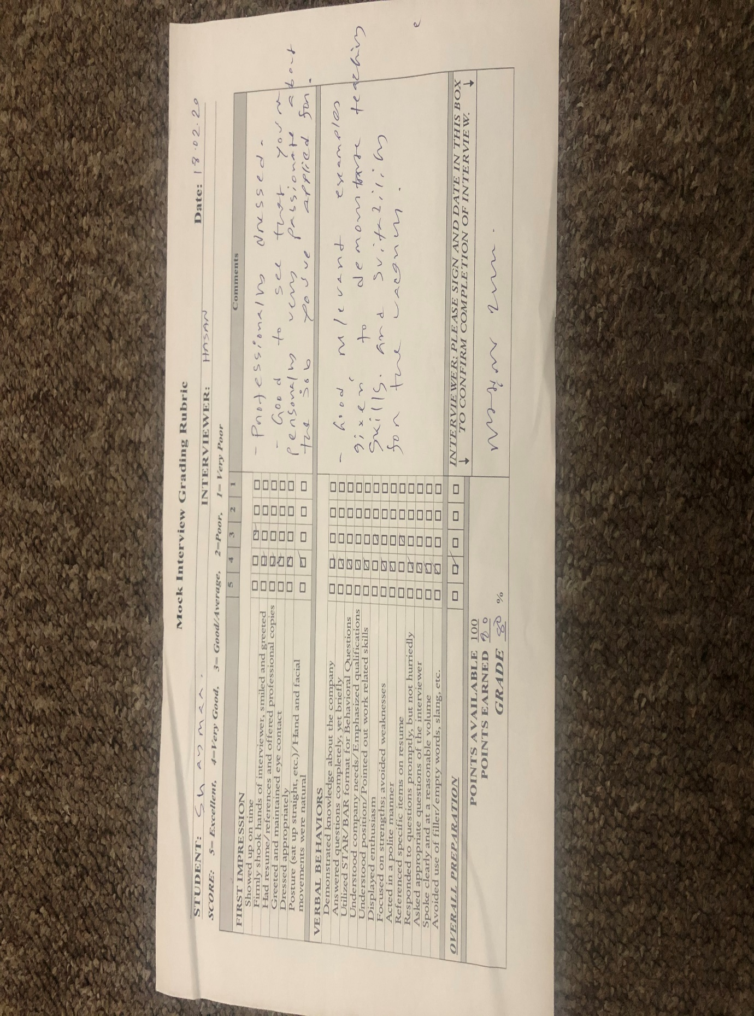
Appendix 2



